Slide 1:

Title: Card Detection and Counting

Subtitle: Computer Vision Project

Names: Noah Jauchmann – 00817016  
Muhammad Arsalan – 12303218  
Alexander Glaser – 00819454  
Harsh Gurawaliya – 22109730

Slide 2:

Title: Introduction

* Accurate playing card detection when shown to a webcam.
* Keeping the count of cards detected and remaining (from a deck of 52)
* Marking out the cards already drawn.
* YOLOv5 model architecture for object detection

Slide 3:

Title: Motivation

* To mimic Raymond from Rainman who managed to count a six-deck shoe to win big.
* Applications in:  
  casino surveilience  
  Training card players  
  Game Analysis and Research  
  Automated card games

[Rainman picture]

Slide 4:

Main Title: METHODOLOGY  
Subtitle: Dataset Preparation

Recorded 1 video per card with different lightings and perspectives.

Extracted cards from videos using OpenCV video capture methodology.

Bounding boxes drawn using shapely.

Delimited negative spaces around by formation of convex hulls.

Around 40-50 images were extracted for each card with convex hulls bounding rank and suit portion to be trained.

[Card recording video] ; [Images extracted picture collage] ; [Hulls image]

Slide 5:

Main Title: METHODOLOGY  
Subtitle: Dataset Preparation

Scenes created using image augmentation.

Each scene has multiple cards randomly scaled, rotated translated and overlapped.

Describable Textures Dataset (DTD) was used for random background images behind each scene.

Created 20,000 images for dataset with random backgrounds and cards.

[2 images of random setting]

Slide 6:

Main Title: METHODOLOGY  
Subtitle: Training

Trained using state of the art object detection algorithm YOLOv5

High speed and efficient object detection with CSPDarknet53 backbone network

Easier and flexible with user-friendly implementation with active community

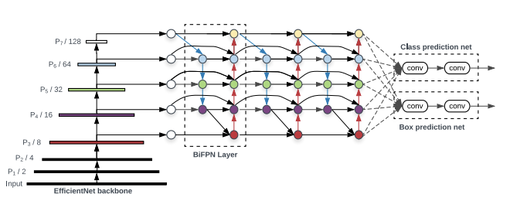

Fine-tuning of hyperparameters i.e. batch size, learning rates.

2 hours of training for 16 epochs.

Slide 7:

Main Title: METHODOLOGY  
Subtitle: Validation

[Images of validation results]

Slide 8:

Main Title: METHODOLOGY  
Subtitle: Results

[Images of Loss and F1 curves]

Slide 9:

Main Title: METHODOLOGY  
Subtitle: UI and counting system:

A simple UI with 52 cards

Drawn and remaining card counters

Webcam screen for simultaneous live feed

[Image of UI]

Slide 10:

Main Title: DETECTION/DEMO

Slide 11:

Main Title:  
Subtitle: LESSONS LEARNED/CHALLENGES

* Dataset challenges
* Model selection considerations
* Pre-trained weights and their usage
* Importance of hyperparameter tuning
* Real-world considerations and possible fallacies
* Improvements using better computational resources.

[Trash image]

Slide 12:

THANK YOU

Slide 13:

Q&A