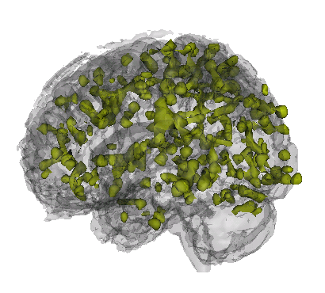

John Muschelli

Education

2008–2010 **ScM**, *Johns Hopkins School of Public Health*, Baltimore, MD.

Area of Study: fMRI brain image data analysis

Thesis Topic: *An Iterative Approach to Hemodynamic Response Function Temporal Deriva- tives in Statistical Parametric Mapping for Functional Neuroimaging*

Adviser: Professor Brian Caffo

2004–2008 **BS**, *The University of Scranton*, Scranton, PA, GPA: 3.87.

Majors: Biomathematics and Neuroscience

Summa Cum Laude

Advisers: Professor Jakub Jasinski, Professor J. Timothy Cannon

Professional Experience

2009–Present **Research Associate**, *Johns Hopkins Biostatistics Center (JHBC)*, Baltimore, MD.

Collaborated on statistical projects with senior consultants.

Report writing and analyzing data using statistical software: R, Stata. Cleaning and checking quality of data

2010–Present **Data Analyst**, *Laboratory for Neurocognitive and Imaging Research at Kennedy*

*Krieger Institute*, Baltimore, MD.

Analysis of functional MRI (fMRI) imaging studies Programming consultant: Matlab & R. Participation in the ADHD 200 Competition

2008 **Intern**, *Analysis & Inference*, Swarthmore, PA.

Cooperated on statistical projects and conferenced with clients about possible analysis options. Report writing of analyses: Stata

Data cleaning

2007 **Research Intern**, *Dupont Stine-Haskell Laboratory*, Wilmington, DE.

Developed lab skills and techniques: cell culturing, making and sterilizing broth media, optical density readings, inoculations, quality control, cell counts, screening for fungicidal properties of compounds.

Publications

[1] H.E. Hinson, E. Melnychuk, **Muschelli, J.**, D.F. Hanley, I.A. Awad, and W.C. Ziai. Drainage efficiency with dual versus single catheters in severe intraventricular hemorrhage. *Neurocritical Care*, pages 1–7, 2011.

[2] J. Jaffe, E. Melnychuk, **Muschelli, J.**, W. Ziai, T. Morgan, D.F. Hanley, and I.A. Awad.

Ventricular catheter location and the clearance of intraventricular hemorrhage. *Neurosurgery*,

2011.

[3] D.W. Newell, M.M. Shah, R. Wilcox, D.R. Hansmann, E. Melnychuk, **Muschelli, J.**, and D.F. Hanley. Minimally invasive evacuation of spontaneous intracerebral hemorrhage using sonothrombolysis. *Journal of neurosurgery*, pages 1–10, 2011.

*2221 E Lombard Street, Baltimore MD – 21231*

H *610-291-7685* • B [*muschellij2@gmail.com 1/2*](mailto:muschellij2@gmail.com)

[4] M.F. Niedner, W.C. Huskins, E. Colantuoni, **Muschelli, J.**, JM Ii, T.B. Rice, R.J. Brilli, and M.R. Miller. Epidemiology of central line-associated bloodstream infections in the pediatric intensive care unit. *Infection control and hospital epidemiology: the official journal of the Society of Hospital Epidemiologists of America*, 32(12):1200, 2011.

Computer skills

**Scripting** Proficient: R, Stata, Matlab, Novice: SAS

**Programming** [C++, Visual Basic](http://www.cplusplus.com/)

**Markup** TEX, [LATEX, B](http://www.latex-project.org/)ibTEX, TeXShop, WinEdt

Honors and Awards

2007–2008 **Presidential Scholar (Full Tuition Scholarship)**.

2004–2008 **Dean’s List**.

2004 **Alpha Lambda Delta**.

2008 **Alpha Sigma Nu**.

Academic Service

2010–Present **Mentor, Head of Household**, [*Incentive Mentoring Program*.](http://incentivementoringprogram.org/)

Mentor and tutor a student from Dunbar High School, teaching coursework, life skills, support as needed.

*2221 E Lombard Street, Baltimore MD – 21231*

H *610-291-7685* • B [*muschellij2@gmail.com 2/2*](mailto:muschellij2@gmail.com)