Being Google

Users will search for articles in a topic, select an article from the ones available, and (possibly) take it with them to read.

Available Topics:
  - computer science research (R)
  - games (G)
  - computer science activities (H)
  - computer science jobs (J)
  - webcomics (W)

Being Twitter

Users will write tweets, and the site should post them (tape them on a wall). Users can reply, retweet, or post an attachment (an article, a picture).


Being Gmail

Users will send messages to other people in the room. Users can also reply to messages (so make sure there is a return address!) The website should deliver the messages.

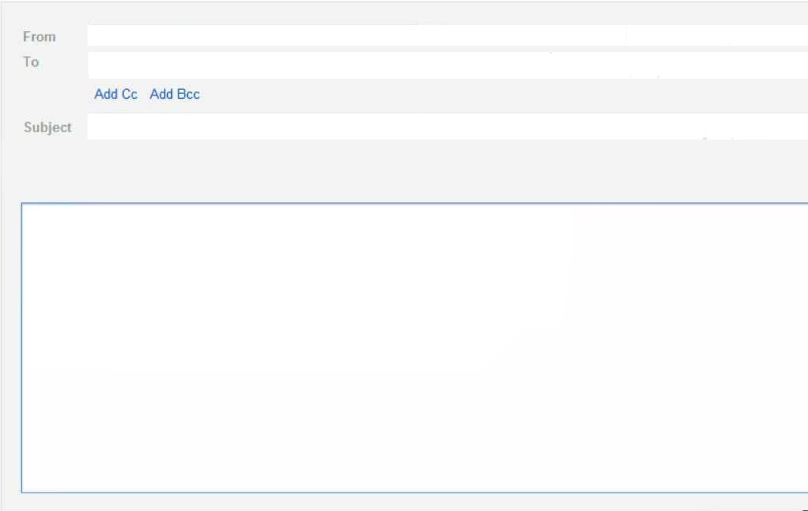
Being Amazon

Users can buy or return items. Every person starts out with 2 credits, and each item is 1 credit. Keep track of how many credits everyone uses!

