Assignment 2

Build This Simple Webpage

LIB2024 - Internet Applications

Marsha Jang - 041064099

March 4th, 2023

Contents

Introduction…………………………………………………………………………………………3

The title …………………………………………………………………………………..………….4

The word - wrap in div …..……………………………………………………………………5

The watermark and the image in the center ….…………………………………….9

The six images in a table ……………………….……………………….…………………..12

Conclusion…………………………………………………………………………………………..14

References…………………………………………………………………………………………..15

Introduction

For the purposes of this assignment, my goal is to achieve a clear understanding of HTML, and CSS relationships as well as the detailed implementation of CSS.

Overall, there are separate sections that have different usages and approaches. By structuring this webpage in a specific way, I expect that my knowledge of what it takes to build a website will improve.

It took some time to understand some of the CSS properties and values I had to apply for the assignment. I still find some of the CSS elements applied in the webpage, such as pseudo-elements, difficult to understand. It will take more practice to understand them properly.

Taking the four sections of the webpage into account, three of them were relatively intuitive. This was not the case, however, for the second section, the word wrap.

I spent a lot of time finding a tool or an attribute to position the word wrap in the middle of the second section. Most of the examples describe it as left-aligned, or right-aligned.

It was fantastic to find an example that had two images in the middle overlapping, but I still had a long way to go to adjust the size and alignment of the webpage.

**The title:**

Required Effect:

* Bold outline with a large font title

Implementation:

* Set up the **border** as a **solid thick black value** to set the border.

<html>

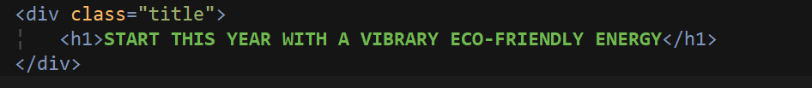

<CSS>

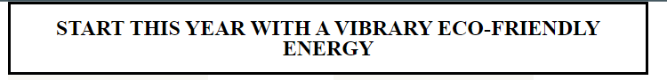

The word wrap in div

Required Effect:

* Align right and left sections to have word-wrap circle images in the center

Implementation:

* There would be several ways to implement this effect, and I searched through internet sources, and learned a widely used one.
* First apply class container in div by using display property and flex value, and align.

<CSS>

* The inside of the div element with the class container, there are two divs, as left-section class and the right-section class, and they both have individual images and paragraphs, eventually those separated images will be merged together (at least visually).
* The images should have a float property so push the words away, (in this case float to right for the left section, and left for the right section).

<CSS>

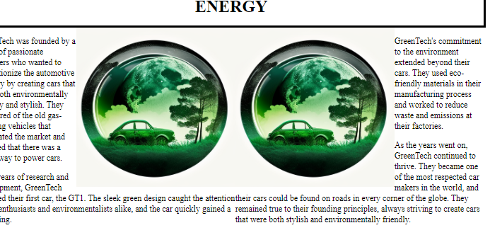

* Now set the two images to be merged together by setting the margin property with the proper value

<CSS>

* Text

  Description automatically generated

* The image is rectangular, so change the shape to a circle having **border-radius**, as well as to have a word wrap circled by setting **shape-outside**

<CSS>

* Currently the paragraphs are both merged as well, so separate them by having each individual margin for the paragraphs

<CSS>

* Since the image is not in the center vertically, put **before** pseudo-element to have a gap between the image and the starting point
* A picture containing graphical user interface

  Description automatically generated<CSS>

* The text is not exactly circled around due to the word length, so put the **justify** attribute to align to the end of the line. ( also added the padding to look better)
* <CSS>

The watermark and the image in the center

Required Effect:

* Put an image centered
* Put a watermark behind

Implementation:

* Put the image, and watermark into the HTML page.
* The watermark could be there as an image repeated, but just using the text paragraph was an easier way to do it.

* Make the watermark big, gray-colored, and rotated.
* Since it was off-center after the rotation, the translate value has been added as well.
* <CSS>

* The watermark is out of the boundary, so **overflow: hidden** is required not to show them out of the div
* <CSS>

* The image is not in the center, to put it in the center, set the **position** property and the **absolute** value.
* <CSS>

The six images in a table element

Required Effect:

* Put 6 images arranged as a 3*2 table

Implementation:

* Using a table element, have a frame, and located all those images as an item.

* The images are shown up, but with the original sizes, so add width as % variable for setting them to the body size altogether.
* <CSS>

Conclusion

Over the course of this assignment, I was able to see how HTML and CSS work. It was nice to see the results of my hard work, once the assignment was completed. The W3C school examples were the helpful references while working through this assignment. It also was helpful to try examples using CSS references through Mozilla Developer Network(MDN), and CSS properties and values, through the W3C school, to gain a more thorough understanding of CSS.

CSS can define styles of the HTML page such as the ids, classes, and tag names in HTML elements. To adjust the location of the elements, it is essential to understand element structure; this includes content, padding, border, and margin. The advantage of this assignment was that it offered me a chance to develop a clearer picture of each of these relationships using practical experience. Although there are several ways to implement a webpage that is similar in design, this project was much more complex.

I learned the importance of defining a clear name, and creating a structure that is as simple as possible. It is particularly important to use the correct ids or classes to link an item to CSS. Perhaps, I did not use the most appropriate tools during this assignment. Through all the ups and downs, I learned how to implement the necessary steps to design a simple webpage. I did my best to complete this challenging assignment.

**References**

CodePen (n.d.). *Shape-outside centred image*. Codepen.io.

https://codepen.io/paulobrien/pen/RMrrBd

MDN (n.d.) *CSS Reference*. Developer.mozilla.org.

https://developer.mozilla.org/en-US/docs/Web/CSS/::before

W3C. (n.d.). *CSS Validation Service*. Jigsaw.w3.org.

https://jigsaw.w3.org/css-validator/validator

W3C. (n.d.). *Markup Validation Service*. Validator.w3.org.

https://validator.w3.org/nu/#file

W3Schools (n.d.). CSS Properties. W3schools.com. <https://www.w3schools.com/cssref/pr_class_clear.php>

W3Schools (n.d.). *HTML* Tutorial. W3schools.com.

https://www.w3schools.com/html/html_classes.asp