correspondence.R

fredy

2023-05-19

########### Chem Correspondence Analysis  
## Creating the Contingency table for the correspondence Analysis  
var <- c("N", "S", "Fe", "P", "Ammonia", "TC", "TOC", "Salinity", "Moisture", "pH")  
SHU.RP <- c(0.83, 0.693666667, 0.531174053, 0.127220714, 0.030056689, 0.007936022, 0.001517322, 0.607222222, 42.53555556, 7.16)  
SHU.RS <- c(0.708888889, 0.504666667, 0.480772516, 0.128445776, 0.025989744, 0.008049256, 0.003064978, 0.532666667, 41.15555556, 7.46)  
  
SUL1.RP <- c(0.32, 0.203222222, 0.663724986, 0.026900873, 0.005146301, 0.0064202, 0.003255489, 0.330555556, 0.787777778, 7.67)  
  
SUL1.RS <- c(0.161111111, 0.271888889, 0.559399386, 0.03147415, 0.003448443, 0.006356044, 0.0037098, 0.273777778, 0.676666667, 8.07)  
  
SUL2.RP <- c(0.376666667, 0.364, 1.170469078, 0.037545694, 0.002260256, 0.003654744, 0.002127622, 0.574111111, 31.42555556, 7.56)  
  
SUL2.RS <- c(0.357777778, 0.328111111, 1.318044392, 0.03904692, 0.004985608, 0.003865722, 0.001407889, 0.704222222, 20.12333333, 8.5)  
  
SULR.RP <- c(0.133333333, 0.192444444, 0.543998317, 0.026753938, 0.001404455, 0.005975989, 0.003269978, 0.244, 0.554444444, 8.19)  
  
SULR.RS <- c(0.251111111, 0.210222222, 0.697601318, 0.031111511, 0.001927854, 0.005911167, 0.002438422, 0.310888889, 0.607777778, 8.19)  
ctable <- data.frame(rbind(SHU.RP, SHU.RS, SUL1.RP, SUL1.RS, SUL2.RP, SUL2.RS, SULR.RP, SULR.RS))  
colnames(ctable) <- var  
ctable

## N S Fe P Ammonia TC  
## SHU.RP 0.8300000 0.6936667 0.5311741 0.12722071 0.030056689 0.007936022  
## SHU.RS 0.7088889 0.5046667 0.4807725 0.12844578 0.025989744 0.008049256  
## SUL1.RP 0.3200000 0.2032222 0.6637250 0.02690087 0.005146301 0.006420200  
## SUL1.RS 0.1611111 0.2718889 0.5593994 0.03147415 0.003448443 0.006356044  
## SUL2.RP 0.3766667 0.3640000 1.1704691 0.03754569 0.002260256 0.003654744  
## SUL2.RS 0.3577778 0.3281111 1.3180444 0.03904692 0.004985608 0.003865722  
## SULR.RP 0.1333333 0.1924444 0.5439983 0.02675394 0.001404455 0.005975989  
## SULR.RS 0.2511111 0.2102222 0.6976013 0.03111151 0.001927854 0.005911167  
## TOC Salinity Moisture pH  
## SHU.RP 0.001517322 0.6072222 42.5355556 7.16  
## SHU.RS 0.003064978 0.5326667 41.1555556 7.46  
## SUL1.RP 0.003255489 0.3305556 0.7877778 7.67  
## SUL1.RS 0.003709800 0.2737778 0.6766667 8.07  
## SUL2.RP 0.002127622 0.5741111 31.4255556 7.56  
## SUL2.RS 0.001407889 0.7042222 20.1233333 8.50  
## SULR.RP 0.003269978 0.2440000 0.5544444 8.19  
## SULR.RS 0.002438422 0.3108889 0.6077778 8.19

#chi-square to evaluate row and column  
chisq.test(ctable)

## Warning in chisq.test(ctable): Chi-squared approximation may be incorrect

##   
## Pearson's Chi-squared test  
##   
## data: ctable  
## X-squared = 76.634, df = 63, p-value = 0.116

library(FactoMineR)  
library(factoextra)

## Loading required package: ggplot2

## Welcome! Want to learn more? See two factoextra-related books at https://goo.gl/ve3WBa

library(gplots)

##   
## Attaching package: 'gplots'

## The following object is masked from 'package:stats':  
##   
## lowess

#computing correspondence analysis  
res.ca <- CA(ctable, graph = FALSE)  
#Getting the eigenvalue  
ev<- get_eigenvalue(res.ca)  
ev

## eigenvalue variance.percent cumulative.variance.percent  
## Dim.1 3.480574e-01 9.842510e+01 98.42510  
## Dim.2 3.979597e-03 1.125367e+00 99.55046  
## Dim.3 1.254654e-03 3.547962e-01 99.90526  
## Dim.4 2.559257e-04 7.237171e-02 99.97763  
## Dim.5 6.307579e-05 1.783683e-02 99.99547  
## Dim.6 1.302713e-05 3.683865e-03 99.99915  
## Dim.7 3.002323e-06 8.490092e-04 100.00000

#scree plot  
fviz_screeplot(res.ca, addlables = TRUE, ylim = c(0,50))

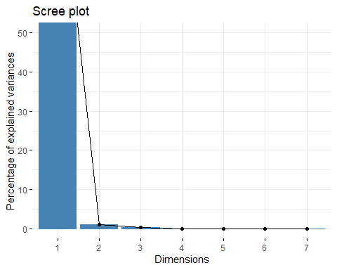

#Row variables  
row <- get_ca_row(res.ca)  
#Coordinates  
head(row$coord)

## Dim 1 Dim 2 Dim 3 Dim 4 Dim 5  
## SHU.RP -0.37215961 0.050153543 0.019449777 0.01316014 -0.002997013  
## SHU.RS -0.35948805 0.048975004 -0.004974367 -0.01384340 0.006174526  
## SUL1.RP 1.16484929 -0.003640344 0.104341901 -0.01881542 -0.004409027  
## SUL1.RS 1.20894705 0.058382045 -0.044241417 0.04684594 -0.001900879  
## SUL2.RP -0.25043661 -0.063530885 -0.027305975 -0.00647966 -0.011604267  
## SUL2.RS -0.01380954 -0.109832603 0.009425844 0.01060518 0.012041345

#cos2: quality on factore map  
head(row$cos2)

## Dim 1 Dim 2 Dim 3 Dim 4 Dim 5  
## SHU.RP 0.97825429 1.776628e-02 0.0026719144 0.0012232476 6.344108e-05  
## SHU.RS 0.97986182 1.818632e-02 0.0001876168 0.0014530540 2.890701e-04  
## SUL1.RP 0.99170117 9.685592e-06 0.0079571735 0.0002587432 1.420780e-05  
## SUL1.RS 0.99483962 2.320049e-03 0.0013322833 0.0014937658 2.459503e-06  
## SUL2.RP 0.92671900 5.963789e-02 0.0110171125 0.0006203786 1.989701e-03  
## SUL2.RS 0.01513469 9.573645e-01 0.0070510737 0.0089258693 1.150707e-02

#contributions to the principal component  
head(row$contrib)

## Dim 1 Dim 2 Dim 3 Dim 4 Dim 5  
## SHU.RP 9.644754707 15.3196083 7.3078362 16.401774 3.4514230  
## SHU.RS 8.739368985 14.1863886 0.4642092 17.625198 14.2267789  
## SUL1.RP 18.019773436 0.0153924 40.1101396 6.394027 1.4245692  
## SUL1.RS 19.489063510 3.9750879 7.2403792 39.797650 0.2658725  
## SUL2.RP 3.452130938 19.4300153 11.3850206 3.142918 40.8992359  
## SUL2.RS 0.007934045 43.8945129 1.0254236 6.363686 33.2869625

##Biplot  
fviz_ca_row(res.ca, repel = TRUE)##only row values

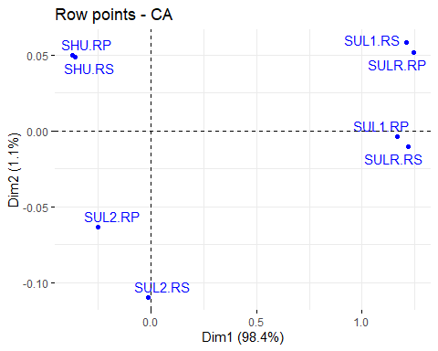

fviz_ca_biplot(res.ca, repel = TRUE)## Both rows and columns

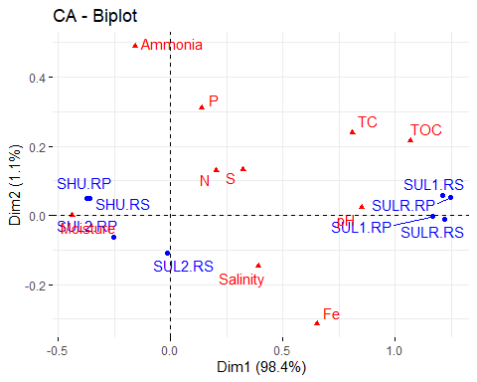

##draws a standard asymmetric biplot  
fviz_ca_biplot(res.ca, map="rowprincipal", arrow = c(TRUE, TRUE), repel = TRUE)

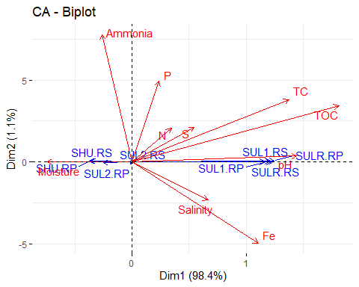

## Summary of the correspondence Analysis Including significance, variance and p-value of the significant variables  
summary(res.ca)

##   
## Call:  
## CA(X = ctable, graph = FALSE)   
##   
## The chi square of independence between the two variables is equal to 76.63411 (p-value = 0.1160304 ).  
##   
## Eigenvalues  
## Dim.1 Dim.2 Dim.3 Dim.4 Dim.5 Dim.6 Dim.7  
## Variance 0.348 0.004 0.001 0.000 0.000 0.000 0.000  
## % of var. 98.425 1.125 0.355 0.072 0.018 0.004 0.001  
## Cumulative % of var. 98.425 99.550 99.905 99.978 99.995 99.999 100.000  
##   
## Rows  
## Iner*1000 Dim.1 ctr cos2 Dim.2 ctr cos2 Dim.3  
## SHU.RP | 34.315 | -0.372 9.645 0.978 | 0.050 15.320 0.018 | 0.019  
## SHU.RS | 31.043 | -0.359 8.739 0.980 | 0.049 14.186 0.018 | -0.005  
## SUL1.RP | 63.244 | 1.165 18.020 0.992 | -0.004 0.015 0.000 | 0.104  
## SUL1.RS | 68.185 | 1.209 19.489 0.995 | 0.058 3.975 0.002 | -0.044  
## SUL2.RP | 12.966 | -0.250 3.452 0.927 | -0.064 19.430 0.060 | -0.027  
## SUL2.RS | 1.825 | -0.014 0.008 0.015 | -0.110 43.895 0.957 | 0.009  
## SULR.RP | 71.408 | 1.246 20.373 0.993 | 0.052 3.046 0.002 | -0.088  
## SULR.RS | 70.641 | 1.218 20.274 0.999 | -0.011 0.133 0.000 | 0.033  
## ctr cos2   
## SHU.RP 7.308 0.003 |  
## SHU.RS 0.464 0.000 |  
## SUL1.RP 40.110 0.008 |  
## SUL1.RS 7.240 0.001 |  
## SUL2.RP 11.385 0.011 |  
## SUL2.RS 1.025 0.007 |  
## SULR.RP 28.289 0.005 |  
## SULR.RS 4.178 0.001 |  
##   
## Columns  
## Iner*1000 Dim.1 ctr cos2 Dim.2 ctr cos2   
## N | 1.821 | 0.203 0.172 0.329 | 0.129 6.074 0.133 |  
## S | 1.776 | 0.322 0.381 0.746 | 0.133 5.653 0.127 |  
## Fe | 14.462 | 0.652 3.364 0.810 | -0.314 68.045 0.187 |  
## P | 0.274 | 0.140 0.012 0.149 | 0.311 5.016 0.729 |  
## Ammonia | 0.128 | -0.156 0.002 0.066 | 0.490 2.092 0.650 |  
## TC | 0.160 | 0.809 0.042 0.911 | 0.240 0.321 0.080 |  
## TOC | 0.120 | 1.068 0.031 0.914 | 0.216 0.113 0.038 |  
## Salinity | 3.081 | 0.392 0.730 0.824 | -0.147 8.981 0.116 |  
## Moisture | 121.930 | -0.438 35.028 1.000 | 0.000 0.000 0.000 |  
## pH | 209.875 | 0.851 60.239 0.999 | 0.023 3.705 0.001 |  
## Dim.3 ctr cos2   
## N 0.257 76.103 0.524 |  
## S 0.034 1.169 0.008 |  
## Fe 0.038 3.228 0.003 |  
## P 0.080 1.049 0.048 |  
## Ammonia 0.287 2.282 0.223 |  
## TC 0.064 0.072 0.006 |  
## TOC -0.085 0.055 0.006 |  
## Salinity 0.089 10.479 0.043 |  
## Moisture -0.005 1.056 0.000 |  
## pH -0.014 4.507 0.000 |