EW_regression.R

fredy

2023-05-07

library(readxl)# Loads a package for reading an excel file  
Alpha_Regression_EW <- read_excel("C:/Users/fredy/Desktop/Alpha_Regression_EW.xlsx")# The code imports the Equal weighted portfolio dataset file from Desktop  
View(Alpha_Regression_EW)# Viewing the dataset  
# Conducting the Multivariate Linear Regression for Equally Weighted portfolios  
library(GGally)

## Loading required package: ggplot2

## Registered S3 method overwritten by 'GGally':  
## method from   
## +.gg ggplot2

ggpairs(Alpha_Regression_EW)# Plotting the variables

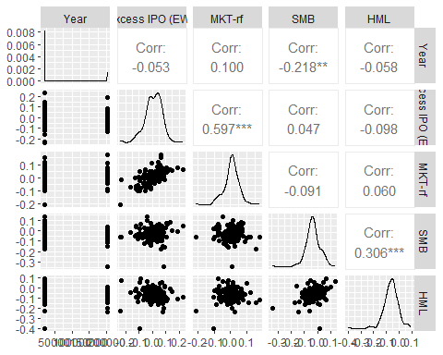

attach(Alpha_Regression_EW)# Attaching the dataset so that we can easily use the variables  
RegModel.1 <- lm(`Excess IPO (EW)`~`MKT-rf`+SMB+HML, data = Alpha_Regression_EW)# This code runs the multivariate linear regression of the Equally weighted portfolios and assigns the results to RegModel.1  
summary(RegModel.1)# This code obtains the summary of the regression results

##   
## Call:  
## lm(formula = `Excess IPO (EW)` ~ `MKT-rf` + SMB + HML, data = Alpha_Regression_EW)  
##   
## Residuals:  
## Min 1Q Median 3Q Max   
## -0.18710 -0.02799 0.00477 0.03603 0.15358   
##   
## Coefficients:  
## Estimate Std. Error t value Pr(>|t|)   
## (Intercept) -0.003167 0.006445 -0.491 0.62388   
## `MKT-rf` 0.869588 0.090424 9.617 < 2e-16 ***  
## SMB 0.192491 0.081823 2.353 0.01998 *   
## HML -0.207464 0.076200 -2.723 0.00727 **   
## ---  
## Signif. codes: 0 '***' 0.001 '**' 0.01 '*' 0.05 '.' 0.1 ' ' 1  
##   
## Residual standard error: 0.05331 on 146 degrees of freedom  
## Multiple R-squared: 0.3977, Adjusted R-squared: 0.3853   
## F-statistic: 32.13 on 3 and 146 DF, p-value: 5.239e-16

plot(RegModel.1)# Plotting the results of the regression model

