EV_regression.R

fredy

2023-05-07

library(readxl)# Loads a package for reading an excel file  
Alpha_Regression_VW <- read_excel("C:/Users/fredy/Desktop/Alpha_Regression_VW.xlsx")# The code imports the Equal weighted portfolio dataset file from Desktop  
View(Alpha_Regression_VW)# Viewing the dataset  
#Conducting the Multivariate Linear Regression for Equally Weighted portfolios  
library(GGally)

## Loading required package: ggplot2

## Registered S3 method overwritten by 'GGally':  
## method from   
## +.gg ggplot2

ggpairs(Alpha_Regression_VW)# Plotting the variables

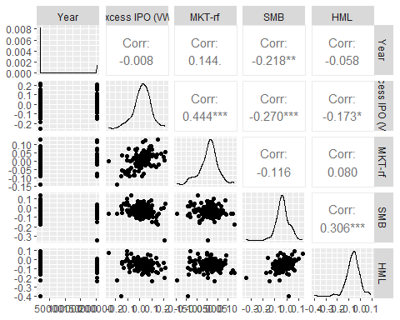

attach(Alpha_Regression_VW)# Attaching the dataset so that we can easily use the variables  
RegModel.1 <- lm(`Excess IPO (VW)`~`MKT-rf`+SMB+HML, data = Alpha_Regression_VW)# This code runs the multivariate linear regression of the Equally weighted portfolios and assigns the results to RegModel.1  
summary(RegModel.1)# This code obtains the summary of the regression results

##   
## Call:  
## lm(formula = `Excess IPO (VW)` ~ `MKT-rf` + SMB + HML, data = Alpha_Regression_VW)  
##   
## Residuals:  
## Min 1Q Median 3Q Max   
## -0.247105 -0.032391 0.003714 0.037516 0.179340   
##   
## Coefficients:  
## Estimate Std. Error t value Pr(>|t|)   
## (Intercept) -0.005063 0.007826 -0.647 0.5187   
## `MKT-rf` 0.741240 0.122237 6.064 1.08e-08 ***  
## SMB -0.225452 0.098999 -2.277 0.0242 *   
## HML -0.190809 0.092077 -2.072 0.0400 *   
## ---  
## Signif. codes: 0 '***' 0.001 '**' 0.01 '*' 0.05 '.' 0.1 ' ' 1  
##   
## Residual standard error: 0.06422 on 146 degrees of freedom  
## Multiple R-squared: 0.2665, Adjusted R-squared: 0.2515   
## F-statistic: 17.69 on 3 and 146 DF, p-value: 7.576e-10

plot(RegModel.1)# Plotting the results of the regression model

