SHANGRI-LA HOTELS MALAYSIA

2023-07-28

# Load the required libraries  
library(readxl)  
library(dplyr)

##   
## Attaching package: 'dplyr'

## The following objects are masked from 'package:stats':  
##   
## filter, lag

## The following objects are masked from 'package:base':  
##   
## intersect, setdiff, setequal, union

library(ggplot2)  
library(forecast)

## Registered S3 method overwritten by 'quantmod':  
## method from  
## as.zoo.data.frame zoo

library(rugarch)

## Loading required package: parallel

##   
## Attaching package: 'rugarch'

## The following object is masked from 'package:stats':  
##   
## sigma

library(tseries)  
  
# Read the Excel data  
data <- read_excel("C:/Users/fredy/Desktop/SHANGRI-LA HOTELS MALAYSIA.xlsx")

## Warning: Expecting numeric in B4049 / R4049C2: got 'null'

## Warning: Expecting numeric in C4049 / R4049C3: got 'null'

## Warning: Expecting numeric in D4049 / R4049C4: got 'null'

## Warning: Expecting numeric in E4049 / R4049C5: got 'null'

## Warning: Expecting numeric in F4049 / R4049C6: got 'null'

## Warning: Expecting numeric in G4049 / R4049C7: got 'null'

# Replace "null" with NA in numeric columns  
numeric_columns <- c("Open", "High", "Low", "Close", "Adj Close", "Volume")  
data[, numeric_columns][data[, numeric_columns] == "null"] <- NA  
data[, numeric_columns] <- apply(data[, numeric_columns], 2, as.numeric)  
  
# Convert the "Date" column to the correct date format  
data$Date <- as.Date(data$Date, format = "%m/%d/%Y")  
# Calculate log returns of the stock  
data$log_returns <- log(data$Close) - log(lag(data$Close))  
# Remove the first row (NAs due to the lag operation)  
data <- na.omit(data)  
# Plot the log returns to visualize the time series  
ggplot(data, aes(x = Date, y = log_returns)) +  
 geom_line() +  
 labs(title = "Log Returns of the Stock", x = "Date", y = "Log Returns")

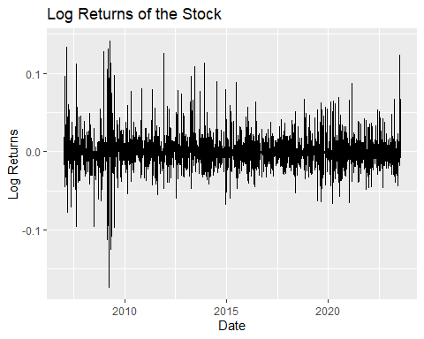

# Perform the Augmented Dickey-Fuller (ADF) test  
adf_test <- adf.test(data$log_returns, alternative = "stationary")

## Warning in adf.test(data$log_returns, alternative = "stationary"): p-value  
## smaller than printed p-value

#Extract the p-value from the test results  
p_value <- adf_test$p.value  
# Print the p-value  
cat("ADF Test p-value:", p_value, "\n")

## ADF Test p-value: 0.01

# Check if the time series is stationary based on the p-value  
if (p_value < 0.05) {  
 print("The log returns time series is stationary.")  
} else {  
 print("The log returns time series is not stationary.")  
}

## [1] "The log returns time series is stationary."

#The data is stationary, therefore, we continue modelling the arima  
arima_model <- Arima(data$log_returns, order = c(1, 0, 1))  
# Print the ARIMA model summary  
summary(arima_model)

## Series: data$log_returns   
## ARIMA(1,0,1) with non-zero mean   
##   
## Coefficients:  
## ar1 ma1 mean  
## -0.038 -0.1424 0e+00  
## s.e. 0.093 0.0922 2e-04  
##   
## sigma^2 = 0.0003277: log likelihood = 10590.51  
## AIC=-21173.02 AICc=-21173.01 BIC=-21147.76  
##   
## Training set error measures:  
## ME RMSE MAE MPE MAPE MASE  
## Training set -7.407859e-06 0.01809512 0.01042783 NaN Inf 0.609215  
## ACF1  
## Training set -0.0001085848

# Extract the residuals from the ARIMA model  
residuals <- residuals(arima_model)  
# Plot the residuals to check for any patterns or trends  
plot(residuals, main = "Residuals of ARIMA Model", ylab = "Residuals")

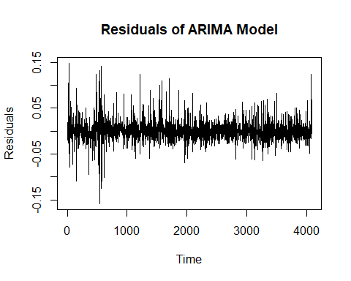

# Plot the ACF (Autocorrelation Function) of the residuals  
acf(residuals)

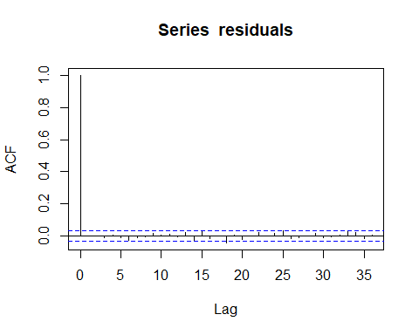

# Plot the PACF (Partial Autocorrelation Function) of the residuals  
pacf(residuals)

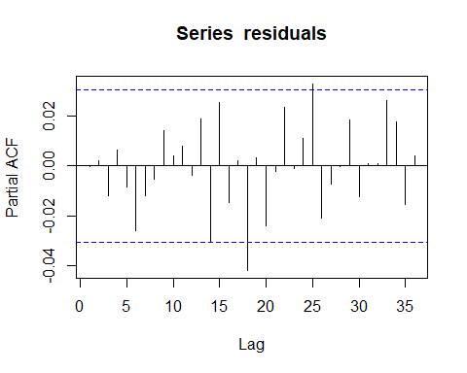

# Fit the GARCH(1,1) model  
garch_spec <- ugarchspec(variance.model = list(model = "sGARCH", garchOrder = c(1, 1)))  
garch_model <- ugarchfit(spec = garch_spec, data = data$log_returns)  
# Print the GARCH model summary  
print(garch_model)

##   
## *---------------------------------*  
## * GARCH Model Fit *  
## *---------------------------------*  
##   
## Conditional Variance Dynamics   
## -----------------------------------  
## GARCH Model : sGARCH(1,1)  
## Mean Model : ARFIMA(1,0,1)  
## Distribution : norm   
##   
## Optimal Parameters  
## ------------------------------------  
## Estimate Std. Error t value Pr(>|t|)  
## mu -0.000053 0.000177 -0.30075 0.763602  
## ar1 0.032575 0.083733 0.38904 0.697246  
## ma1 -0.275569 0.080823 -3.40955 0.000651  
## omega 0.000083 0.000008 10.18631 0.000000  
## alpha1 0.244538 0.026092 9.37214 0.000000  
## beta1 0.504254 0.040761 12.37095 0.000000  
##   
## Robust Standard Errors:  
## Estimate Std. Error t value Pr(>|t|)  
## mu -0.000053 0.000179 -0.29700 0.766465  
## ar1 0.032575 0.109097 0.29859 0.765252  
## ma1 -0.275569 0.116743 -2.36047 0.018252  
## omega 0.000083 0.000033 2.48684 0.012888  
## alpha1 0.244538 0.086932 2.81297 0.004909  
## beta1 0.504254 0.175197 2.87821 0.003999  
##   
## LogLikelihood : 11041.46   
##   
## Information Criteria  
## ------------------------------------  
##   
## Akaike -5.4042  
## Bayes -5.3950  
## Shibata -5.4042  
## Hannan-Quinn -5.4010  
##   
## Weighted Ljung-Box Test on Standardized Residuals  
## ------------------------------------  
## statistic p-value  
## Lag[1] 7.087 7.765e-03  
## Lag[2*(p+q)+(p+q)-1][5] 7.827 2.222e-08  
## Lag[4*(p+q)+(p+q)-1][9] 8.663 3.243e-02  
## d.o.f=2  
## H0 : No serial correlation  
##   
## Weighted Ljung-Box Test on Standardized Squared Residuals  
## ------------------------------------  
## statistic p-value  
## Lag[1] 0.1914 0.6618  
## Lag[2*(p+q)+(p+q)-1][5] 1.4872 0.7431  
## Lag[4*(p+q)+(p+q)-1][9] 5.9713 0.3015  
## d.o.f=2  
##   
## Weighted ARCH LM Tests  
## ------------------------------------  
## Statistic Shape Scale P-Value  
## ARCH Lag[3] 0.9876 0.500 2.000 0.3203  
## ARCH Lag[5] 2.1954 1.440 1.667 0.4296  
## ARCH Lag[7] 2.4607 2.315 1.543 0.6205  
##   
## Nyblom stability test  
## ------------------------------------  
## Joint Statistic: 5.8402  
## Individual Statistics:   
## mu 0.6107  
## ar1 1.7480  
## ma1 2.0338  
## omega 0.5242  
## alpha1 1.7974  
## beta1 0.8648  
##   
## Asymptotic Critical Values (10% 5% 1%)  
## Joint Statistic: 1.49 1.68 2.12  
## Individual Statistic: 0.35 0.47 0.75  
##   
## Sign Bias Test  
## ------------------------------------  
## t-value prob sig  
## Sign Bias 0.16644 0.8678   
## Negative Sign Bias 0.56315 0.5734   
## Positive Sign Bias 0.08905 0.9290   
## Joint Effect 0.34836 0.9507   
##   
##   
## Adjusted Pearson Goodness-of-Fit Test:  
## ------------------------------------  
## group statistic p-value(g-1)  
## 1 20 1762 0  
## 2 30 1941 0  
## 3 40 2151 0  
## 4 50 2261 0  
##   
##   
## Elapsed time : 2.400473

# Plot the GARCH model diagnostics  
plot(garch_model, which = 1)

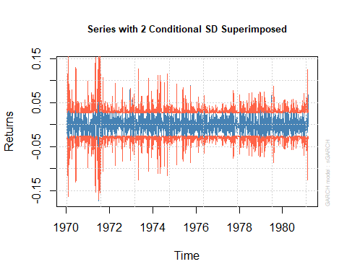

plot(garch_model, which = 2)

##   
## please wait...calculating quantiles...

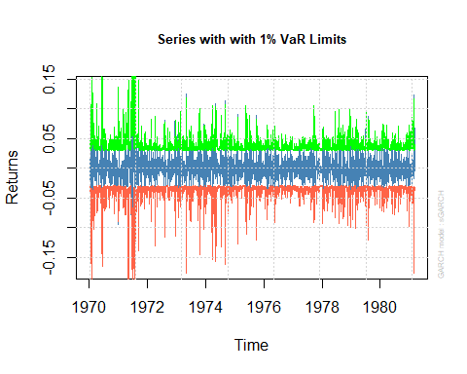

plot(garch_model, which = 3)

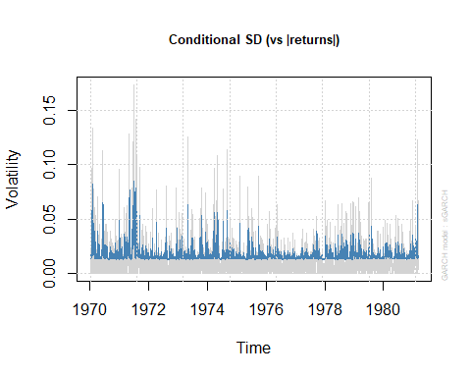

plot(garch_model, which = 4)

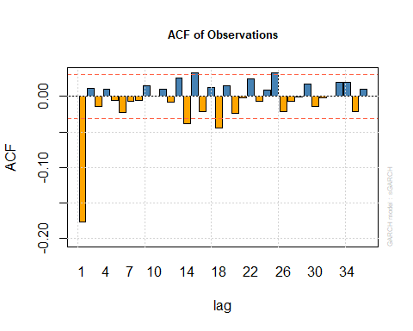

plot(garch_model, which = 5)

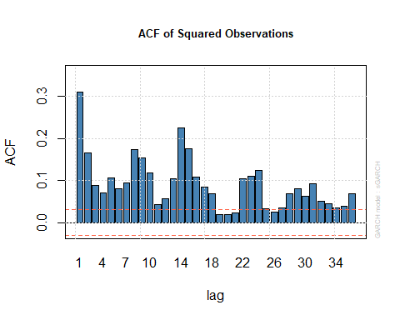

plot(garch_model, which = 6)

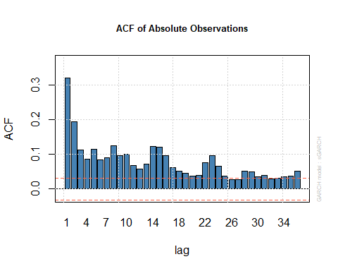

plot(garch_model, which = 7)

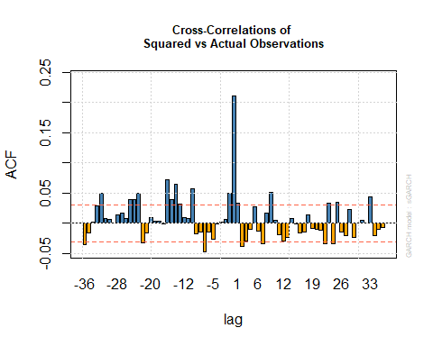

plot(garch_model, which = 8)

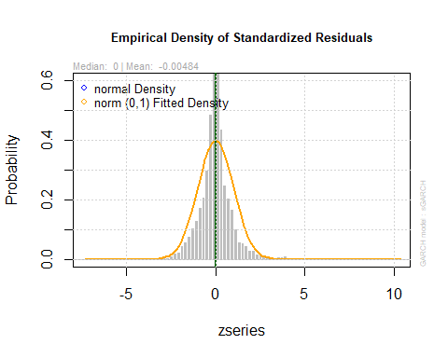

plot(garch_model, which = 9)

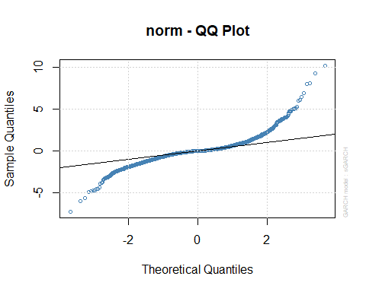

plot(garch_model, which = 10)

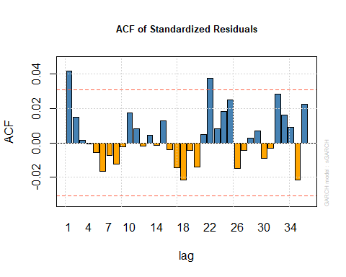

plot(garch_model, which = 11)

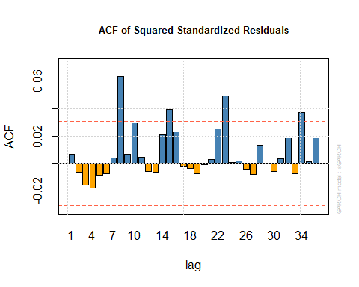

plot(garch_model, which = 12)

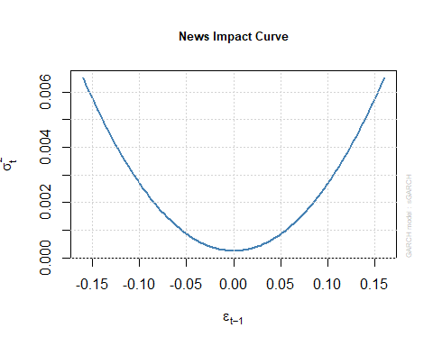

2# Fit sGARCH model

## [1] 2

sgarch_spec <- ugarchspec(variance.model = list(model = "sGARCH", garchOrder = c(1, 1)))  
sgarch_model <- ugarchfit(spec = sgarch_spec, data = data$log_returns)  
  
# Fit sGARCH-sstd model  
sgarch_sstd_spec <- ugarchspec(variance.model = list(model = "sGARCH", garchOrder = c(1, 1)),  
 mean.model = list(armaOrder = c(0, 0), include.mean = TRUE, archm = TRUE))  
sgarch_sstd_model <- ugarchfit(spec = sgarch_sstd_spec, data = data$log_returns)  
  
# Fit GJR-GARCH model  
gjrgarch_spec <- ugarchspec(variance.model = list(model = "gjrGARCH", garchOrder = c(1, 1, 1)))  
gjrgarch_model <- ugarchfit(spec = gjrgarch_spec, data = data$log_returns)  
  
# Fit TGARCH model  
tgarch_spec <- ugarchspec(variance.model = list(model = "iGARCH", garchOrder = c(1, 1), submodel = NULL, external.regressors = NULL))  
tgarch_model <- ugarchfit(spec = tgarch_spec, data = data$log_returns)  
  
# Function to get AIC and BIC for uGARCHfit objects  
get_garch_aic_bic <- function(fit_model) {  
 n <- length(fit_model@fit$data)  
 loglik <- -0.5 * (fit_model@fit$sigma2 + log(2 * pi) + fit_model@fit$residuals^2 / fit_model@fit$sigma2)  
 bic <- -2 * sum(loglik) + log(n) * (length(fit_model@fit$coef) + 1)  
 aic <- -2 * sum(loglik) + 2 * (length(fit_model@fit$coef) + 1)  
 return(c(AIC = aic, BIC = bic))  
}  
  
# Get AIC and BIC for each model  
sgarch_aic_bic <- get_garch_aic_bic(sgarch_model)  
sgarch_sstd_aic_bic <- get_garch_aic_bic(sgarch_sstd_model)  
gjrgarch_aic_bic <- get_garch_aic_bic(gjrgarch_model)  
tgarch_aic_bic <- get_garch_aic_bic(tgarch_model)  
  
# Print the AIC and BIC for each model  
print("sGARCH Model AIC and BIC:")

## [1] "sGARCH Model AIC and BIC:"

print(sgarch_aic_bic)

## AIC BIC   
## 14 -Inf

print("sGARCH-sstd Model AIC and BIC:")

## [1] "sGARCH-sstd Model AIC and BIC:"

print(sgarch_sstd_aic_bic)

## AIC BIC   
## 12 -Inf

print("GJR-GARCH Model AIC and BIC:")

## [1] "GJR-GARCH Model AIC and BIC:"

print(gjrgarch_aic_bic)

## AIC BIC   
## 16 -Inf

print("TGARCH Model AIC and BIC:")

## [1] "TGARCH Model AIC and BIC:"

print(tgarch_aic_bic)

## AIC BIC   
## 14 -Inf