Statistics.R

2023-05-11

library(haven)  
library(data.table)  
library(JWileymisc)  
library(ggplot2)  
library(ggpubr)  
library(visreg)  
## read in the dataset  
data(aces_daily)  
d <- as.data.table(aces_daily)  
## between person data, no missing  
davg <- na.omit(d[, .(  
 Female = factor(na.omit(Female)[1], levels = 0:1),  
 Age = na.omit(Age)[1],  
 STRESS = mean(STRESS, na.rm = TRUE),  
 PosAff = mean(PosAff, na.rm =  
 TRUE), NegAff = mean(NegAff, na.rm  
 = TRUE)), by = UserID])  
## create missing data   
davgmiss <- copy(davg);   
davgmiss[STRESS < 1, NegAff := NA]  
davgmiss[STRESS > 4, PosAff := NA]   
## random missingness on age   
set.seed(1234)   
davgmiss[, Age := ifelse(rbinom(.N, size = 1, prob = .1) == 1, NA, Age)]  
## drop unneeded variables to make analysis easier   
davgmiss[, UserID := NULL]  
library(mice)

##   
## Attaching package: 'mice'

## The following object is masked from 'package:stats':  
##   
## filter

## The following objects are masked from 'package:base':  
##   
## cbind, rbind

# Multiply impute the missing data  
imp <- mice(davgmiss, m = 5, maxit = 50, meth = c("logreg", "norm", "norm", "norm", "norm"))

##   
## iter imp variable  
## 1 1 Age PosAff NegAff  
## 1 2 Age PosAff NegAff  
## 1 3 Age PosAff NegAff  
## 1 4 Age PosAff NegAff  
## 1 5 Age PosAff NegAff  
## 2 1 Age PosAff NegAff  
## 2 2 Age PosAff NegAff  
## 2 3 Age PosAff NegAff  
## 2 4 Age PosAff NegAff  
## 2 5 Age PosAff NegAff  
## 3 1 Age PosAff NegAff  
## 3 2 Age PosAff NegAff  
## 3 3 Age PosAff NegAff  
## 3 4 Age PosAff NegAff  
## 3 5 Age PosAff NegAff  
## 4 1 Age PosAff NegAff  
## 4 2 Age PosAff NegAff  
## 4 3 Age PosAff NegAff  
## 4 4 Age PosAff NegAff  
## 4 5 Age PosAff NegAff  
## 5 1 Age PosAff NegAff  
## 5 2 Age PosAff NegAff  
## 5 3 Age PosAff NegAff  
## 5 4 Age PosAff NegAff  
## 5 5 Age PosAff NegAff  
## 6 1 Age PosAff NegAff  
## 6 2 Age PosAff NegAff  
## 6 3 Age PosAff NegAff  
## 6 4 Age PosAff NegAff  
## 6 5 Age PosAff NegAff  
## 7 1 Age PosAff NegAff  
## 7 2 Age PosAff NegAff  
## 7 3 Age PosAff NegAff  
## 7 4 Age PosAff NegAff  
## 7 5 Age PosAff NegAff  
## 8 1 Age PosAff NegAff  
## 8 2 Age PosAff NegAff  
## 8 3 Age PosAff NegAff  
## 8 4 Age PosAff NegAff  
## 8 5 Age PosAff NegAff  
## 9 1 Age PosAff NegAff  
## 9 2 Age PosAff NegAff  
## 9 3 Age PosAff NegAff  
## 9 4 Age PosAff NegAff  
## 9 5 Age PosAff NegAff  
## 10 1 Age PosAff NegAff  
## 10 2 Age PosAff NegAff  
## 10 3 Age PosAff NegAff  
## 10 4 Age PosAff NegAff  
## 10 5 Age PosAff NegAff  
## 11 1 Age PosAff NegAff  
## 11 2 Age PosAff NegAff  
## 11 3 Age PosAff NegAff  
## 11 4 Age PosAff NegAff  
## 11 5 Age PosAff NegAff  
## 12 1 Age PosAff NegAff  
## 12 2 Age PosAff NegAff  
## 12 3 Age PosAff NegAff  
## 12 4 Age PosAff NegAff  
## 12 5 Age PosAff NegAff  
## 13 1 Age PosAff NegAff  
## 13 2 Age PosAff NegAff  
## 13 3 Age PosAff NegAff  
## 13 4 Age PosAff NegAff  
## 13 5 Age PosAff NegAff  
## 14 1 Age PosAff NegAff  
## 14 2 Age PosAff NegAff  
## 14 3 Age PosAff NegAff  
## 14 4 Age PosAff NegAff  
## 14 5 Age PosAff NegAff  
## 15 1 Age PosAff NegAff  
## 15 2 Age PosAff NegAff  
## 15 3 Age PosAff NegAff  
## 15 4 Age PosAff NegAff  
## 15 5 Age PosAff NegAff  
## 16 1 Age PosAff NegAff  
## 16 2 Age PosAff NegAff  
## 16 3 Age PosAff NegAff  
## 16 4 Age PosAff NegAff  
## 16 5 Age PosAff NegAff  
## 17 1 Age PosAff NegAff  
## 17 2 Age PosAff NegAff  
## 17 3 Age PosAff NegAff  
## 17 4 Age PosAff NegAff  
## 17 5 Age PosAff NegAff  
## 18 1 Age PosAff NegAff  
## 18 2 Age PosAff NegAff  
## 18 3 Age PosAff NegAff  
## 18 4 Age PosAff NegAff  
## 18 5 Age PosAff NegAff  
## 19 1 Age PosAff NegAff  
## 19 2 Age PosAff NegAff  
## 19 3 Age PosAff NegAff  
## 19 4 Age PosAff NegAff  
## 19 5 Age PosAff NegAff  
## 20 1 Age PosAff NegAff  
## 20 2 Age PosAff NegAff  
## 20 3 Age PosAff NegAff  
## 20 4 Age PosAff NegAff  
## 20 5 Age PosAff NegAff  
## 21 1 Age PosAff NegAff  
## 21 2 Age PosAff NegAff  
## 21 3 Age PosAff NegAff  
## 21 4 Age PosAff NegAff  
## 21 5 Age PosAff NegAff  
## 22 1 Age PosAff NegAff  
## 22 2 Age PosAff NegAff  
## 22 3 Age PosAff NegAff  
## 22 4 Age PosAff NegAff  
## 22 5 Age PosAff NegAff  
## 23 1 Age PosAff NegAff  
## 23 2 Age PosAff NegAff  
## 23 3 Age PosAff NegAff  
## 23 4 Age PosAff NegAff  
## 23 5 Age PosAff NegAff  
## 24 1 Age PosAff NegAff  
## 24 2 Age PosAff NegAff  
## 24 3 Age PosAff NegAff  
## 24 4 Age PosAff NegAff  
## 24 5 Age PosAff NegAff  
## 25 1 Age PosAff NegAff  
## 25 2 Age PosAff NegAff  
## 25 3 Age PosAff NegAff  
## 25 4 Age PosAff NegAff  
## 25 5 Age PosAff NegAff  
## 26 1 Age PosAff NegAff  
## 26 2 Age PosAff NegAff  
## 26 3 Age PosAff NegAff  
## 26 4 Age PosAff NegAff  
## 26 5 Age PosAff NegAff  
## 27 1 Age PosAff NegAff  
## 27 2 Age PosAff NegAff  
## 27 3 Age PosAff NegAff  
## 27 4 Age PosAff NegAff  
## 27 5 Age PosAff NegAff  
## 28 1 Age PosAff NegAff  
## 28 2 Age PosAff NegAff  
## 28 3 Age PosAff NegAff  
## 28 4 Age PosAff NegAff  
## 28 5 Age PosAff NegAff  
## 29 1 Age PosAff NegAff  
## 29 2 Age PosAff NegAff  
## 29 3 Age PosAff NegAff  
## 29 4 Age PosAff NegAff  
## 29 5 Age PosAff NegAff  
## 30 1 Age PosAff NegAff  
## 30 2 Age PosAff NegAff  
## 30 3 Age PosAff NegAff  
## 30 4 Age PosAff NegAff  
## 30 5 Age PosAff NegAff  
## 31 1 Age PosAff NegAff  
## 31 2 Age PosAff NegAff  
## 31 3 Age PosAff NegAff  
## 31 4 Age PosAff NegAff  
## 31 5 Age PosAff NegAff  
## 32 1 Age PosAff NegAff  
## 32 2 Age PosAff NegAff  
## 32 3 Age PosAff NegAff  
## 32 4 Age PosAff NegAff  
## 32 5 Age PosAff NegAff  
## 33 1 Age PosAff NegAff  
## 33 2 Age PosAff NegAff  
## 33 3 Age PosAff NegAff  
## 33 4 Age PosAff NegAff  
## 33 5 Age PosAff NegAff  
## 34 1 Age PosAff NegAff  
## 34 2 Age PosAff NegAff  
## 34 3 Age PosAff NegAff  
## 34 4 Age PosAff NegAff  
## 34 5 Age PosAff NegAff  
## 35 1 Age PosAff NegAff  
## 35 2 Age PosAff NegAff  
## 35 3 Age PosAff NegAff  
## 35 4 Age PosAff NegAff  
## 35 5 Age PosAff NegAff  
## 36 1 Age PosAff NegAff  
## 36 2 Age PosAff NegAff  
## 36 3 Age PosAff NegAff  
## 36 4 Age PosAff NegAff  
## 36 5 Age PosAff NegAff  
## 37 1 Age PosAff NegAff  
## 37 2 Age PosAff NegAff  
## 37 3 Age PosAff NegAff  
## 37 4 Age PosAff NegAff  
## 37 5 Age PosAff NegAff  
## 38 1 Age PosAff NegAff  
## 38 2 Age PosAff NegAff  
## 38 3 Age PosAff NegAff  
## 38 4 Age PosAff NegAff  
## 38 5 Age PosAff NegAff  
## 39 1 Age PosAff NegAff  
## 39 2 Age PosAff NegAff  
## 39 3 Age PosAff NegAff  
## 39 4 Age PosAff NegAff  
## 39 5 Age PosAff NegAff  
## 40 1 Age PosAff NegAff  
## 40 2 Age PosAff NegAff  
## 40 3 Age PosAff NegAff  
## 40 4 Age PosAff NegAff  
## 40 5 Age PosAff NegAff  
## 41 1 Age PosAff NegAff  
## 41 2 Age PosAff NegAff  
## 41 3 Age PosAff NegAff  
## 41 4 Age PosAff NegAff  
## 41 5 Age PosAff NegAff  
## 42 1 Age PosAff NegAff  
## 42 2 Age PosAff NegAff  
## 42 3 Age PosAff NegAff  
## 42 4 Age PosAff NegAff  
## 42 5 Age PosAff NegAff  
## 43 1 Age PosAff NegAff  
## 43 2 Age PosAff NegAff  
## 43 3 Age PosAff NegAff  
## 43 4 Age PosAff NegAff  
## 43 5 Age PosAff NegAff  
## 44 1 Age PosAff NegAff  
## 44 2 Age PosAff NegAff  
## 44 3 Age PosAff NegAff  
## 44 4 Age PosAff NegAff  
## 44 5 Age PosAff NegAff  
## 45 1 Age PosAff NegAff  
## 45 2 Age PosAff NegAff  
## 45 3 Age PosAff NegAff  
## 45 4 Age PosAff NegAff  
## 45 5 Age PosAff NegAff  
## 46 1 Age PosAff NegAff  
## 46 2 Age PosAff NegAff  
## 46 3 Age PosAff NegAff  
## 46 4 Age PosAff NegAff  
## 46 5 Age PosAff NegAff  
## 47 1 Age PosAff NegAff  
## 47 2 Age PosAff NegAff  
## 47 3 Age PosAff NegAff  
## 47 4 Age PosAff NegAff  
## 47 5 Age PosAff NegAff  
## 48 1 Age PosAff NegAff  
## 48 2 Age PosAff NegAff  
## 48 3 Age PosAff NegAff  
## 48 4 Age PosAff NegAff  
## 48 5 Age PosAff NegAff  
## 49 1 Age PosAff NegAff  
## 49 2 Age PosAff NegAff  
## 49 3 Age PosAff NegAff  
## 49 4 Age PosAff NegAff  
## 49 5 Age PosAff NegAff  
## 50 1 Age PosAff NegAff  
## 50 2 Age PosAff NegAff  
## 50 3 Age PosAff NegAff  
## 50 4 Age PosAff NegAff  
## 50 5 Age PosAff NegAff

# Show convergence plots  
library(visreg)  
plot(imp)

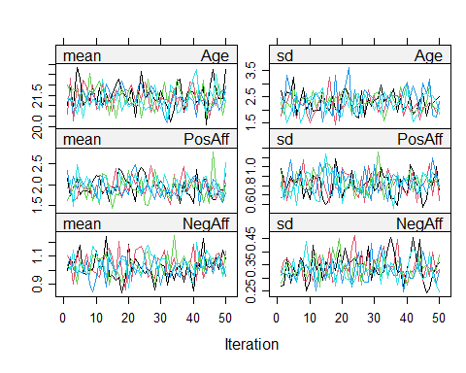

# Run a linear regression with the imputed dataset  
fit <- with(imp, lm(PosAff ~ STRESS + NegAff))  
# Pool the results from the imputed datasets  
library(pool)  
pool_fit <- pool(fit)  
# Print the pooled results  
summary(pool_fit)

## term estimate std.error statistic df p.value  
## 1 (Intercept) 3.4177584 0.2028417 16.8493869 58.410256 4.250217e-24  
## 2 STRESS -0.1948015 0.1182145 -1.6478645 6.140118 1.493476e-01  
## 3 NegAff -0.1878786 0.2495598 -0.7528402 11.830180 4.662635e-01

#Extract R-squared value  
pool.r.squared(pool_fit)

## est lo 95 hi 95 fmi  
## R^2 0.1969609 0.06016839 0.3679565 0.6564616

For one unit of change in Stress, positive effect ratings decrease by -0.194(95% CI). On the other hand, for one unit change in negative effects, positive effects ratings decrease by -0.1879. 19.7% of the variability in positive effects ratings can be explained by Stress and Negative effects ratings.

########################################### Question 2  
library(JWileymisc)  
data(aces_daily)   
d <-  
 as.data.table(aces_daily)  
## write your code for models here. Use the lecture topic examples as a guide  
library(lme4)

## Loading required package: Matrix

#run the linear mix model  
model <- lmer(PosAff ~ 1 + (1 | UserID), data = d, REML=TRUE)  
summary(model)

## Linear mixed model fit by REML ['lmerMod']  
## Formula: PosAff ~ 1 + (1 | UserID)  
## Data: d  
##   
## REML criterion at convergence: 14794.6  
##   
## Scaled residuals:   
## Min 1Q Median 3Q Max   
## -4.3450 -0.6468 -0.0341 0.6169 4.0577   
##   
## Random effects:  
## Groups Name Variance Std.Dev.  
## UserID (Intercept) 0.6289 0.7930   
## Residual 0.5290 0.7273   
## Number of obs: 6399, groups: UserID, 191  
##   
## Fixed effects:  
## Estimate Std. Error t value  
## (Intercept) 2.67866 0.05811 46.1

#calculate the ICC  
library(lmerTest)

##   
## Attaching package: 'lmerTest'

## The following object is masked from 'package:lme4':  
##   
## lmer

## The following object is masked from 'package:stats':  
##   
## step

library(multilevelTools)  
iccMixed("PosAff", id = "UserID", data = d)

## Var Sigma ICC  
## 1: UserID 0.6289049 0.5431473  
## 2: Residual 0.5289851 0.4568527

## Model Diagnostics  
md <- modelDiagnostics(model, ev.perc = .001)  
plot(md, ask = FALSE, ncol= 2,nrow = 2)

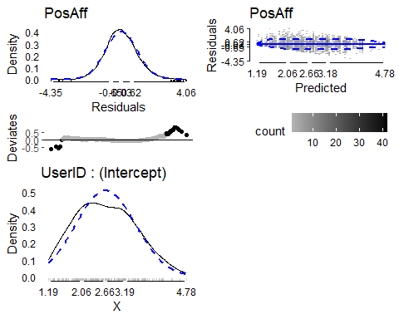

**Summary**

An intercept only linear mixed model was fit to 6399 positive affect ratings from 191 people. The density plot indicates that the assumption of normality was met. Homogeneity of variance was violated at the high and low ends of the data as shown in the residual plot. The ICC is 0.54, which implies that 54% of the total variation is between person. 46% of variation can be attributed to difference between days. The fixed effect intercept shows that the average [95% CI] positive affect was 2.67 [2.56, 2.79].

############################################################## Question 3  
library(JWileymisc)  
library(lme4)  
library(ggplot2)  
library(gridExtra)  
  
# Load the aces_daily dataset  
# Load the aces_daily dataset  
data(aces_daily)  
d <- as.data.table(aces_daily)  
## make between person and within person stress  
d[, c("Bstress", "Wstress") := meanDeviations(STRESS), by = UserID]  
## run linear mixed model with both the between and within version of stress included as fixed effects and both a random intercept and random slope for the within version of stress  
lmm <- lmer(SUPPORT ~ Bstress + Wstress + (Wstress | UserID), data = d)  
lmm.md <- modelDiagnostics(lmm, ev.perc = .001)  
plot(lmm.md, ask = FALSE, ncol = 2, nrow = 2)

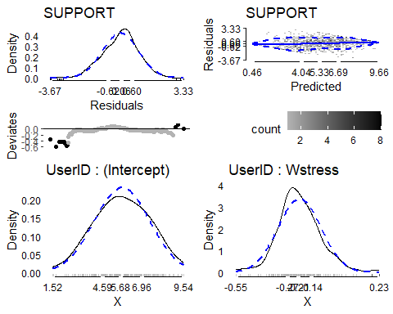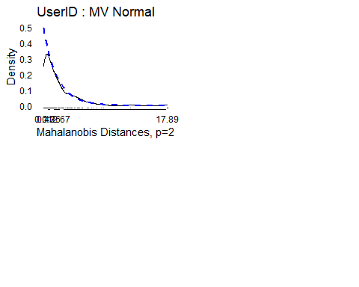

## remove outliers   
lmm.md$extremeValues

## SUPPORT UserID Index EffectType  
## 1: 0.33744722 9 273 Residuals  
## 2: 0.00000000 12 394 Residuals  
## 3: 0.00000000 12 400 Residuals  
## 4: 1.36898422 19 631 Residuals  
## 5: 1.52065041 19 643 Residuals  
## 6: 0.00000000 75 2588 Residuals  
## 7: 0.76026374 75 2609 Residuals  
## 8: 10.00000000 97 3329 Residuals  
## 9: 0.00000000 98 3373 Residuals  
## 10: 0.44581106 108 3716 Residuals  
## 11: 0.70943453 117 4022 Residuals  
## 12: 9.39224694 135 4647 Residuals  
## 13: 9.39741464 154 5326 Residuals  
## 14: 3.71539797 67 2296 Random Effect UserID : Wstress  
## 15: 0.70475312 67 2299 Random Effect UserID : Wstress  
## 16: 0.05905785 67 2302 Random Effect UserID : Wstress  
## 17: 3.51222852 67 2305 Random Effect UserID : Wstress  
## 18: 1.64901116 67 2308 Random Effect UserID : Wstress  
## 19: 2.04100785 67 2311 Random Effect UserID : Wstress  
## 20: 8.51653426 67 2314 Random Effect UserID : Wstress  
## 21: 9.10268704 67 2317 Random Effect UserID : Wstress  
## 22: 3.67570322 67 2320 Random Effect UserID : Wstress  
## 23: 3.05623782 67 2323 Random Effect UserID : Wstress  
## 24: 2.37536564 67 2326 Random Effect UserID : Wstress  
## 25: 5.96875113 67 2329 Random Effect UserID : Wstress  
## 26: 8.02684440 92 3146 Random Effect UserID : Wstress  
## 27: 4.57739883 92 3149 Random Effect UserID : Wstress  
## 28: 0.00000000 92 3152 Random Effect UserID : Wstress  
## 29: 0.08087353 92 3155 Random Effect UserID : Wstress  
## 30: 6.90382678 92 3158 Random Effect UserID : Wstress  
## 31: 9.79360987 92 3161 Random Effect UserID : Wstress  
## 32: 4.12676114 92 3164 Random Effect UserID : Wstress  
## 33: 1.12680047 92 3167 Random Effect UserID : Wstress  
## 34: 5.79055586 92 3170 Random Effect UserID : Wstress  
## 35: 5.71980549 92 3173 Random Effect UserID : Wstress  
## 36: 7.75583221 92 3176 Random Effect UserID : Wstress  
## 37: 8.02684440 92 3146 Multivariate Random Effect UserID  
## 38: 4.57739883 92 3149 Multivariate Random Effect UserID  
## 39: 0.00000000 92 3152 Multivariate Random Effect UserID  
## 40: 0.08087353 92 3155 Multivariate Random Effect UserID  
## 41: 6.90382678 92 3158 Multivariate Random Effect UserID  
## 42: 9.79360987 92 3161 Multivariate Random Effect UserID  
## 43: 4.12676114 92 3164 Multivariate Random Effect UserID  
## 44: 1.12680047 92 3167 Multivariate Random Effect UserID  
## 45: 5.79055586 92 3170 Multivariate Random Effect UserID  
## 46: 5.71980549 92 3173 Multivariate Random Effect UserID  
## 47: 7.75583221 92 3176 Multivariate Random Effect UserID  
## SUPPORT UserID Index EffectType

d.noev <- d[-unique(lmm.md$extremeValues$Index)]  
  
## rerun analysis  
lmm.noev <- lmer(SUPPORT ~ Bstress + Wstress + (Wstress | UserID), data = d.noev)  
md.noev <- modelDiagnostics(lmm.noev, ev.perc = .001)  
plot(md.noev, ask = FALSE, ncol = 2, nrow = 2)

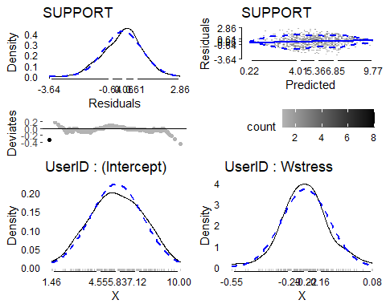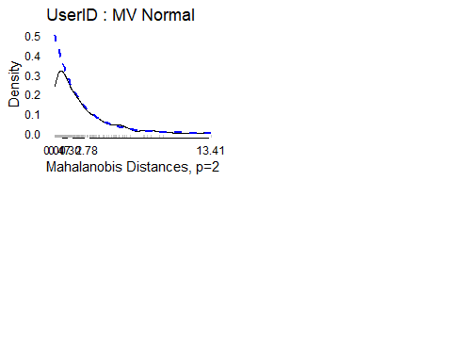

summary(lmm.noev)

## Linear mixed model fit by REML. t-tests use Satterthwaite's method [  
## lmerModLmerTest]  
## Formula: SUPPORT ~ Bstress + Wstress + (Wstress | UserID)  
## Data: d.noev  
##   
## REML criterion at convergence: 9293.6  
##   
## Scaled residuals:   
## Min 1Q Median 3Q Max   
## -3.6396 -0.6387 0.0627 0.6142 2.8556   
##   
## Random effects:  
## Groups Name Variance Std.Dev. Corr   
## UserID (Intercept) 3.49668 1.8699   
## Wstress 0.03714 0.1927 -0.25  
## Residual 3.49728 1.8701   
## Number of obs: 2139, groups: UserID, 189  
##   
## Fixed effects:  
## Estimate Std. Error df t value Pr(>|t|)   
## (Intercept) 5.77813 0.26583 187.58976 21.736 < 2e-16 ***  
## Bstress -0.14960 0.09600 188.37212 -1.558 0.121   
## Wstress -0.22128 0.02626 141.10200 -8.428 3.67e-14 ***  
## ---  
## Signif. codes: 0 '***' 0.001 '**' 0.01 '*' 0.05 '.' 0.1 ' ' 1  
##   
## Correlation of Fixed Effects:  
## (Intr) Bstrss  
## Bstress -0.845   
## Wstress -0.033 -0.040

confint(lmm.noev, oldNames = FALSE)

## Computing profile confidence intervals ...

## 2.5 % 97.5 %  
## sd_(Intercept)|UserID 1.6690878 2.08178554  
## cor_Wstress.(Intercept)|UserID -0.5063809 0.03140000  
## sd_Wstress|UserID 0.1285724 0.25398430  
## sigma 1.8106828 1.93279615  
## (Intercept) 5.2560740 6.29979875  
## Bstress -0.3380796 0.03899413  
## Wstress -0.2733786 -0.16980609

**Summary**

A statistical analysis was conducted on 2139 support scores collected from 189 individuals using a linear mixed model. The results showed that the estimated average support score was 5.78 [95% CI: 5.26, 6.30] when both Bstress and Wstress were zero, with a significance level of p < .001. Additionally, there was a non-significant effect of average stress on support, which indicated that each unit increase in average stress was associated with a decrease in support score by -0.14 [95% CI: -0.34, -0.04], with a p-value of .12. Moreover, there was a significant effect of within-person stress on support, such that for every unit increase in stress above an individual's own average, there was a decrease in support score by -0.22 [95% CI: -0.27, -0.16], with a p-value of < .001. Finally, there was a negative correlation between the random intercept and slope (-0.25), which suggested that individuals with relatively higher intercepts tended to have steeper negative slopes, indicating that they experienced a larger decrease in support scores as their stress levels increased compared to the population averages. support when support was 0 also tended to have a more negative within person association between stress and support.

## Computing profile confidence intervals ...  
########################################## Question 4  
#Step 1: Read in the data  
library(JWileymisc)  
data(aces_daily)  
d <- as.data.table(aces_daily)  
  
#Step 2: Fit a linear mixed model with interaction  
library(lme4)  
library(emmeans)  
model <- lmer(STRESS~SUPPORT*COPEPrc + (1 | UserID), data = d)  
### Calculating Simple Slopes  
sl<- emtrends(model, var = "COPEPrc", at = list(support = c(6.05 - 2.41, 6.05 + 2.41)), lmer.df = "satterthwaite")  
summary(sl, infer=TRUE)

## SUPPORT COPEPrc COPEPrc.trend SE df lower.CL upper.CL t.ratio p.value  
## 5.36 2.29 0.342 0.0897 1928 0.166 0.518 3.814 0.0001  
##   
## Degrees-of-freedom method: satterthwaite   
## Confidence level used: 0.95

### Creating simple slopes   
egltable("SUPPORT", data = d[!duplicated(UserID)])

## M (SD)  
## 1: SUPPORT 6.05 (2.41)

visreg(model, xvar = "COPEPrc", by = "SUPPORT", overlay=TRUE, breaks = c(6.05 - 2.41, 6.05 + 2.41), partial = FALSE, rug = FALSE)

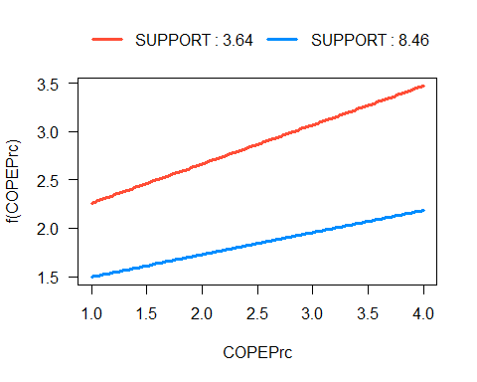

**Summary**

A simple slope analysis was conducted to examine the relationship between positive affect and stress at low (M - 1SD) and high (M + 1SD) levels of support. The analysis revealed a significant negative association between positive affect and stress at both high and low levels of support. This result was graphically represented and showed that as positive affect increased, stress levels decreased, regardless of the level of support.