|  |
| --- |
| Energy and Environmental Economics, Inc |
| Avoided Costs  2018 Update |
|  |

|  |
| --- |
| Brian Horii  Eric Cutter  May 14, 2018 |

Table of Contents

Overview 3

Summary of Results 5

Natural Gas Avoided Cost Updates 9

Overview of Electricity Avoided Cost Components 12

Generation Energy 17

Determination of energy market values 17

Hourly Shaping of Energy Costs 20

Generation Capacity 21

Generation resource balance year 22

CT dispatch 22

Temperature effect on unit performance 24

Planning reserve margin and losses 27

Hourly allocation of capacity value 27

Ancillary Services (AS) 29

T&D Capacity 29

Hourly allocation of T&D capacity cost 32

CO2 Monetized and GHG Adder Values 36

Monetized Carbon (cap and trade) 36

GHG Adder 39

Avoided RPS Cost 41

Components Not Included 42

Appendix: Key Data Sources and Specific Methodology 44

Power plant cost assumptions 44

Generation Loss Factors 45

Climate Zones 47

T&D Allocation Factors 48

Distribution Load Simulation Regression Model *Specifications* 59

User Quick Guide ACC 2018 v1d 73

Purpose 73

Using the Model 73

Exporting Hourly Results 74

DR Reporting and PLS Tool Interface 76

Inputs 77

Remaining tabs 78

Version Change Summary 79

Avoided Cost Model Version ACC_2018_v1e 79

Avoided Cost Model Version ACC_2018_v1b 79

Avoided Cost Model Version ACC_2018_v1 79

Avoided Cost Model Version ACC_2017_v1 80

Avoided Cost Model Version ACC_2016_v1 81

# Overview

This technical memo describes the inputs and methods used to update the avoided costs for cost-effectiveness valuation for 2018 through 2040. The focus of this update is to incorporate historical market and weather information from 2017, as well as forecast market and commodity prices as of April 2018. This update builds upon ACC_2017_v1 of the avoided cost calculator. Methodology changes were not considered. The new avoided cost calculator is ACC_2018_v1d.

The data updates are listed below

1. Natural gas prices
   1. NYMEX natural gas futures prices from most recent 22 trading days
   2. Long-term natural gas forecast using revised 2017 IEPR Mid-Demand case, and EIA 2018 AEO Report
   3. SoCal, PG&E BB and PG&E LT natural gas transportation rates from 2017 IEPR
   4. Municipal surcharge rate for PG&E
2. Electricity Forward prices. On-peak and Off-peak forwards for NP-15 and SP-15 using most recent 22 trading days
3. Ancillary service costs updated to 1.6% for annual energy from CAISO 2016 Annual Report on Market Issues and Performance (p. 142)
4. Hourly Market Price Shapes
   1. Day ahead and real time prices for 2017 for NP-15 and SP-15.
   2. Daily 2017 natural gas spot prices (used to derive inferred heat rates)
   3. Average 2017 CO2 trading price
5. CO2 market price forecast from Revised 2017 IEPR Mid-Demand forecast
6. GHG adder from values adopted in CPUC Decision D18.02-018, Table 6. The GHG adder is the CPUC adopted values adjusted to nominal dollars and then reduced by the CO2 market price forecast from the IEPR (to avoid double counting the cap and trade allowance costs)
7. RPS adder removed (set to zero) to be consistent with the use of the RESOLVE-based GHG adder.
8. (1-RPS) adjustment removed from calculation of marginal emission changes for GHG adder and criteria pollutants.
9. T&D hourly allocation factors updated based on 2017 recorded weather by climate zone, and 2017 weekend and holiday schedules.
10. Generation capacity hourly allocation factors updated using 2017 recorded weather
11. New natural gas generation costs and performance updated based on 2017 IRP assumptions.

## Summary of Results

The natural gas prices, and therefore the long-run cost of generation costs are substantially lower than the values used in the 2016 avoided cost update (and retained in the 2017 GHG adder update). This is offset by the GHG adder in the 2018 being larger than the adder used in 2017, although some of the increase in avoided costs due to the GHG adder is tempered by the removal of the RPS adder. The net effect is that the 2018 avoided costs excluding T&D are lower than the 2017 forecast through 2034, and higher thereafter .

Figure 1: Average Annual Total Avoided Cost, Excluding T&D. NP-15

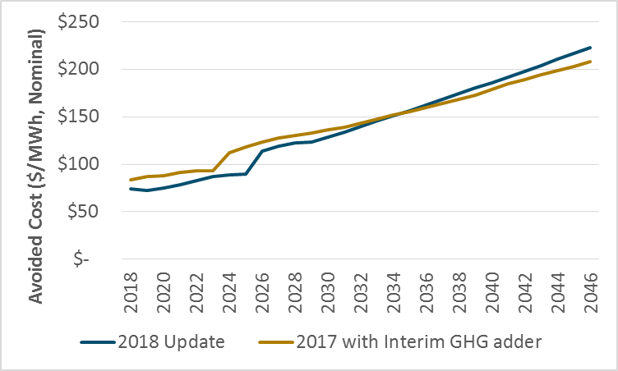

Figure 2: Average Annual Total Avoided Cost, Excluding T&D. SP-15

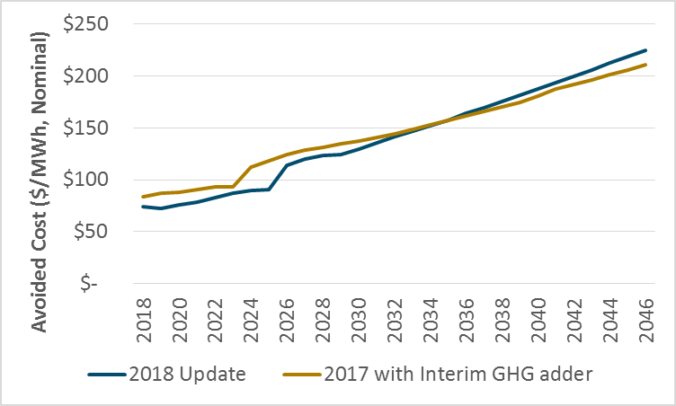

The updated hourly market prices and allocation of generation of capacity costs reflect relatively less peak value in the near term, but a larger variation in value between the low mid-day hours, and the other higher value hours in the longer term. This is illustrated with the figures below that show the average annual non-T&D avoided cost for each hour of the day. The figures show NP-15, and the same figures for SP-15 would essentially be the same.

Figure 3: 2020 NP-15 Average Annual Total Avoided Cost by Hour of the Day, Excluding T&D

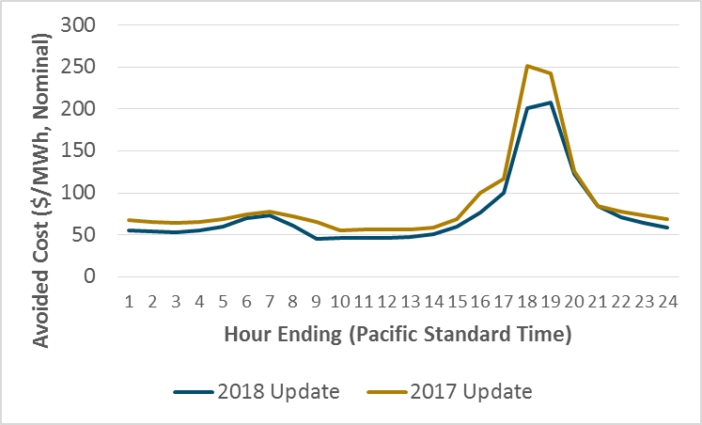

Figure 4: 2030 NP-15 Average Annual Total Avoided Cost by Hour of the Day, Excluding T&D

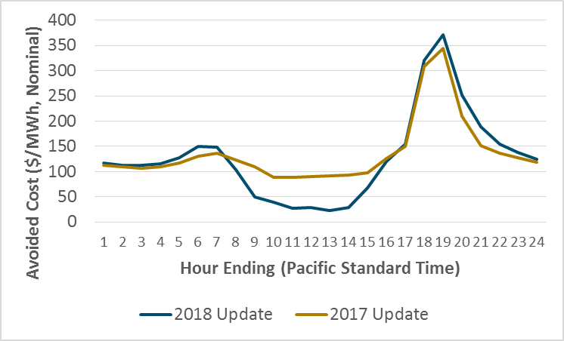

T&D unit marginal costs ($/kW-yr values) were not changed in this update. The allocation of those costs to hour, however, was updated using 2017 weather data. Details on the updated allocation factors can be found toward the end of this report.

The remainder of this report presents the avoided cost methodology and documents the inputs updated for 2018.

# Natural Gas Avoided Cost Updates

The natural gas price forecast is updated using a modified version of the Market Price Referent (MPR) methodology. The methodology uses market forwards through 2024, long-run forecasts from the IEPR and the US DOE Annual Energy Outlook report for 2028 and beyond. The prices for the interim years are a linear interpolation between 2024 and 2028.

The market forward prices are averages from S&P Global Intelligence for the most recent 22 trading days (March 27, 2018 through April 17, 2018) for Henry Hub, PG&E Citygate, and SoCal Border. The natural gas forecast for 2018 through 2024 is the average of the PG&E Citygate and SoCal Border forward prices, plus transportation rates, franchises fees and hedging transaction costs.

The long-term forecast is the 2018 EIA Annual Energy Outlook report forecast for Henry Hub, plus the average of the PG&E Citygate and SoCal Border basis spreads plus transportation, franchise fees and hedging transaction costs. The basis spreads are the average spreads in the NYMEX market forwards between Henry Hub and the California locations (from S&P Global Intelligence for most recent 22 trading days).

We have updated the intrastate natural gas transportation rates using the CEC IEPR April 2018 Staff Report. The updated natural gas price forecast is shown in Figure 5.

Figure 5. Natural gas price forecast

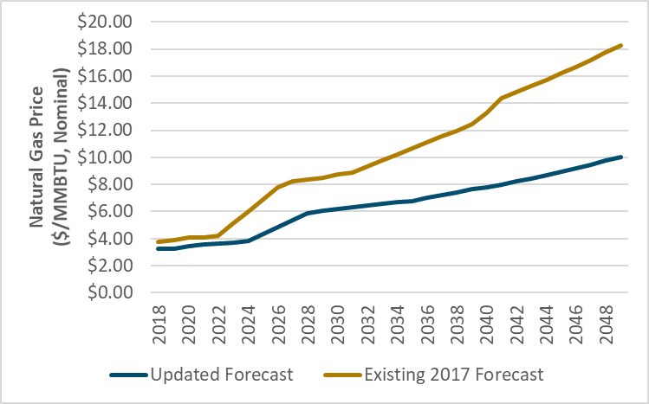

The natural gas forecast also incorporates monthly variations in natural gas prices—commodity prices tend to rise in the winter when demand for natural gas as a heating fuel increases. The monthly price profiles are based on the monthly NYMEX Henry Hub natural gas prices through 2027 and then the monthly price profile is held constant thereafter. The market price also reflects municipal surcharges, of which the value for PG&E territory was updated based on a 2018 Tariff change. Figure 6 shows four snapshots of the monthly shape of the natural gas price forecast.

Figure 6. Snapshot of monthly gas price forecast shapes

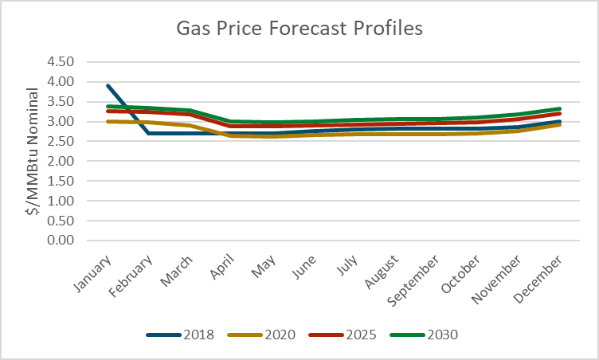

*Note that values for January 2018 through March 2018 are actual market prices, rather than market forwards*

For the avoided costs used to evaluate natural gas EE reductions, the following costs are added to the commodity cost.

* compression (0.39%),
* losses and unaccounted for (1.37%),
* marginal transmission and delivery costs (varies by utility),
* NOX and CO2

Of these additional cost items, only the CO2 $/short ton value has been updated. The cost of CO2 is discussed in more detail in the electricity avoided cost section of this memo.

The marginal cost of gas distribution capacity has not been revised in this update.

# Overview of Electricity Avoided Cost Components

This section provides a brief overview of the electricity avoided cost components and their contribution to the total electricity avoided costs. This is followed by detailed discussions of the updates for each component in the subsequent sections.

The avoided cost used for electricity energy efficiency evaluation is calculated as the sum of six components shown in Table 1.

Table 1. Components of electricity avoided cost

|  |  |
| --- | --- |
| Component | Description |
| Generation Energy | Estimate of hourly wholesale value of energy |
| Generation Capacity | The costs of building new generation capacity to meet system peak loads |
| Ancillary Services | The marginal costs of providing system operations and reserves for electricity grid reliability |
| T&D Capacity | The costs of expanding transmission and distribution capacity to meet peak loads |
| Monetized Carbon (cap and trade) | The cost of Cap and Trade allowance permits for carbon dioxide emissions associated with the marginal generating resource |
| GHG adder | The difference between the CPUC-adopted total value of CO2 and the Cap and Trade value of CO2. |
| Avoided RPS | This component has been set to zero. |

Each of these avoided costs is must be determined for every hour of the year. The hourly granularity is obtained by shaping forecasts of the average value of each component with historical day-ahead and real-time energy prices and actual system loads; Table 2 summarizes the methodology applied to each component to develop this level of granularity.

Table 2. Summary of methodology for electricity avoided cost component forecasts

|  |  |  |
| --- | --- | --- |
| Component | Basis of Annual Forecast | Basis of Hourly Shape |
| Generation Energy | Forward market prices and the $/kWh fixed and variable operating costs of a CCGT. | Historical hourly day-ahead market price shapes from MRTU OASIS |
| Generation Capacity | Residual capacity value a new simple-cycle combustion turbine | RECAP model that generates outage probabilities by month/hour and allocates the probabilities within each month/hour based on 2017 weather. |
| Ancillary Services | Percentage of Generation Energy value | Directly linked with energy shape |
| T&D Capacity | Marginal transmission and distribution costs from utility ratemaking filings. | Hourly 2017 temperature data by climate zone. |
| Monetized Carbon (cap and trade) | CO2 cost forecast from revised 2017 IEPR mid-demand forecast, escalated at inflation beyond 2030. | Directly linked with energy shape with bounds on the maximum and minimum hourly value |
| GHG Adder | Difference between total value of CO2 and monetized carbon cost in the energy market prices. | Same as monetized carbon |
| Avoided RPS | Set to zero to be consistent with GHG adder. | NA |

Figure 7, below, shows a three-day snapshot of the avoided costs, broken out by component, in Climate Zone 4. As shown, the cost of providing an additional unit of electricity is significantly higher in the summer afternoons than in the very early morning hours. This chart also shows the relative magnitude of different components in this region in the summer for these days. The highest peaks of total cost shown in Figure 7 of over $20,000/MWh are driven primarily by the allocation of generation and T&D capacity to the peak hours (because of high demand in those hours), but also by higher energy market prices during the late afternoon, early evening.

Figure 7. Three-day snapshot of energy values in CZ4 in 2018 (Pacific Standard Time)

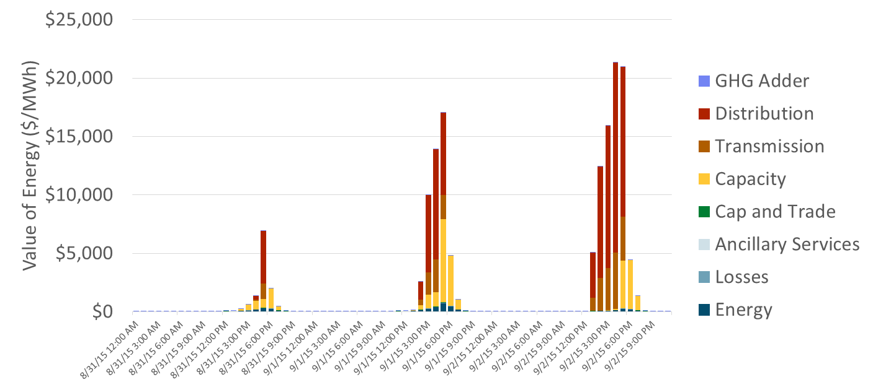

Figure 8 shows average monthly value of electricity reductions, revealing the seasonal characteristics of the avoided costs. The energy component dips in the spring, reflecting low energy prices due to increased hydro supplies and imports from the Northwest; and peaks in the summer months when demand for electricity is highest. The value of capacity—both generation and T&D—is concentrated in the summer months and results in significantly more value on average in these months.

Figure 8: Average monthly avoided cost in CZ4 in 2018

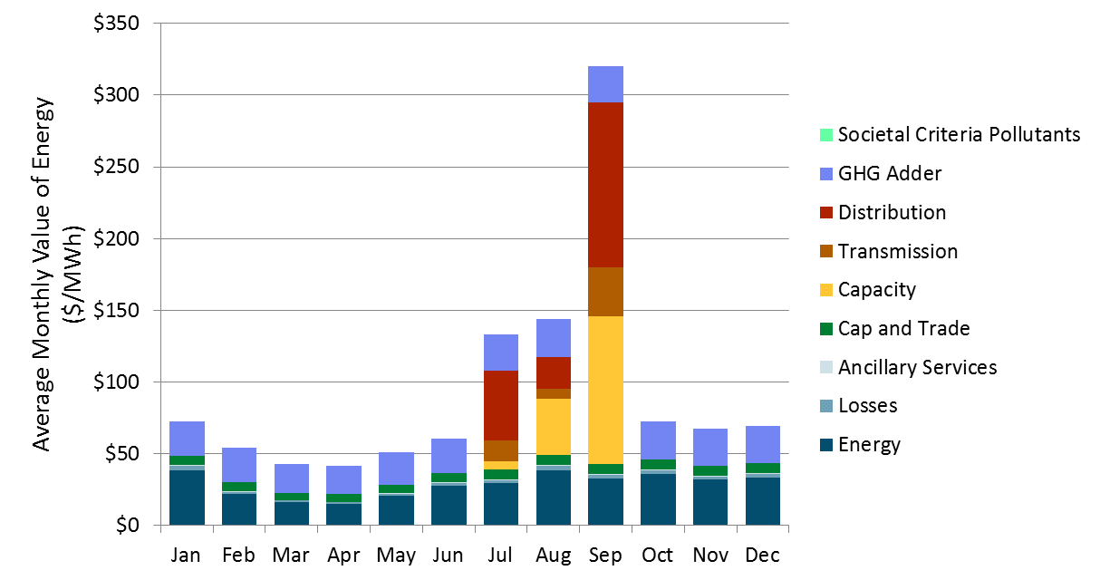

*Societal criteria pollutants have zero value, consistent with the 2017 update.*

Figure 9: Average monthly avoided cost in CZ4 by hour of the day in 2018

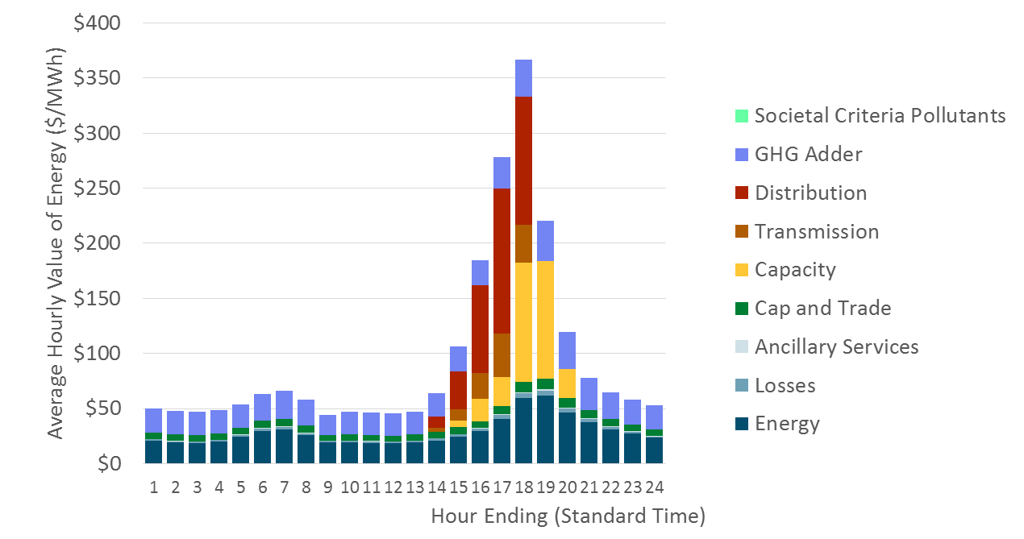

*Societal criteria pollutants have zero value, consistent with the 2017 update.*

Figure 10 shows the components of value for the highest value hours in sorted order of cost. This chart shows the relative contribution to the highest hours of the year by component. Note that most of the high cost hours occur in approximately the top 100 to 400 hours—this is because most of the value associated with capacity is concentrated in a limited number of hours. While the timing and magnitude of these high costs differ by climate zone, the concentration of value in the high load hours is a characteristic of the avoided costs in all of California.

Figure 10. Price duration curve showing top 1,000 hours for CZ4 in 2018

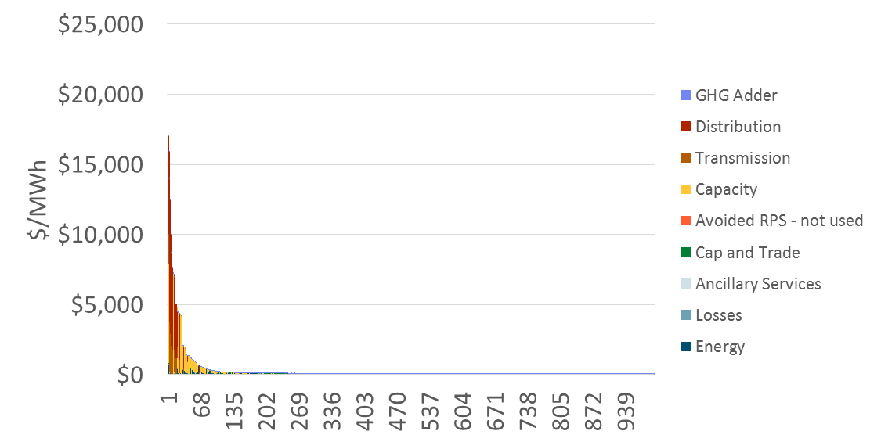Avoided Cost Methodology

## Generation Energy

The avoided cost methodology starts with market prices that include CO2 costs, and decomposes the market price into an energy component and a CO2 component based on the most recent IEPR CO2 prices and the inferred market heat rates. The market prices are also adjusted by projected changes in the daily profile of market prices due to increased penetration of solar resources on the system.

* Capital costs and performance information for a CT and CCGT are from the 2017 IEPR assumptions. As with the prior avoided cost update, a book life of 20 years is assumed for both the CT and CCGT. Financing assumptions have not been changed in this update.
* The day ahead market price shapes are updated using SNL day-ahead hourly price data for 207. The real-time market price shapes are calculated using the 3rd highest 5-min price within each hourly interval. Those quartile values are then calibrated so that the annual average of those quartile values matches the annual average of all 5-minute interval prices in 2017.

### Determination of energy market values

The average energy cost in the near term is based on the latest 22 trading day average on-peak and off-peak market price forecasts for NP-15 and SP-15, which are then averaged to calculate the system value (available through 2025 for the update in 2018). For the period after the available forward market prices, the method interpolates between the last available futures market price and the long-run energy market price. The long-run energy market price is used for the resource balance and all subsequent years. Note that if the resource balance year is set to present, the long-run energy market price is used in all years.

The annual long-run energy market price is set so that the CCGT’s energy market revenues plus the capacity market payment equal the fixed and variable costs plus carbon costs of the CCGT (i.e., the CCGT is made whole).

The long-run energy market price begins with the implied heat rate in the last year that electricity market forwards are available. This implied heat rate is then held constant for all subsequent years. The market energy price is calculated using the corresponding gas and carbon prices in each subsequent year along with variable O&M costs. This market energy price is then increased or decreased with an energy market calibration factor so that the CCGT is made whole. The energy market calibration factor is applied to both 1) the real-time market prices used to determine CT energy revenues and the value of capacity, and 2) the day-ahead energy market used to determine CCGT energy revenues. This creates a feedback effect between the energy and capacity avoided costs. The feedback effect is illustrated with the following example.

*Assume that the CCGT would collect more revenue through the capacity and energy markets than is needed to cover its costs. The methodology decreases the calibration factor to decrease the day-ahead energy market prices and market revenues to make the CCGT whole. To keep the real-time and day-ahead markets in sync, the methodology also would decrease the real-time energy market prices by the calibration factor. The decrease in real-time energy market prices would result in lower net revenues for a CT, and therefore raise the value of capacity (as higher capacity payment revenue is needed to incent a new CT to build). When we re-examine the CCGT, the raised value of capacity results in the CCGT collecting excess revenues, so the calibration factor needs to be decreased more, and the process repeats[1].*

Figure 11: Annual Average Energy Avoided Costs 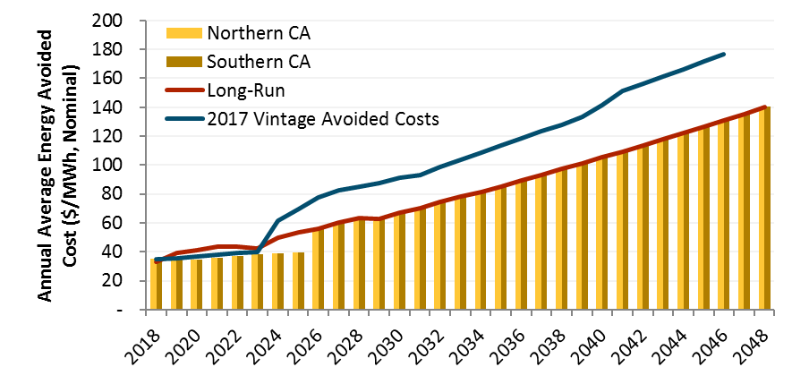

### Hourly Shaping of Energy Costs

The annual energy avoided costs are converted to hourly values by multiplying the annual value by 8760 hourly market shapes. The hourly shape is derived from day-ahead LMPs at load-aggregation points in northern and southern California obtained from the S&P Global’s day-ahead hourly pricing data for 2017. To account for the effects of historical volatility in the spot market for natural gas, the hourly market prices are adjusted by the average daily gas price in California, the cost of carbon, and variable O&M. The resulting hourly inferred heat rates are then adjusted for forecasted changes in market clearing heat rates based on the RPS Calculator (RPSCalculator1xAAEE.xlsm[2]). The RPS calculator estimated monthly average prices by hour of the day (1-24) through 2046, and the changes in the marginal heat rates relative to the base year (2017) are added to or subtracted from the inferred 2017 heat rates to reflect expected changes in market price profiles.

The resulting hourly market heat rate curve is integrated into the avoided cost calculator, where, in combination with a monthly natural gas price forecast, forecasted carbon prices, and variable O&M, it yields an hourly shape for wholesale market energy prices in California.

Total energy avoided costs are shown in Figure 12. The energy avoided costs are shown in descending order of total avoided costs for all 8760 hours of the year.

Figure 12: Hourly Energy Avoided Costs for 2018

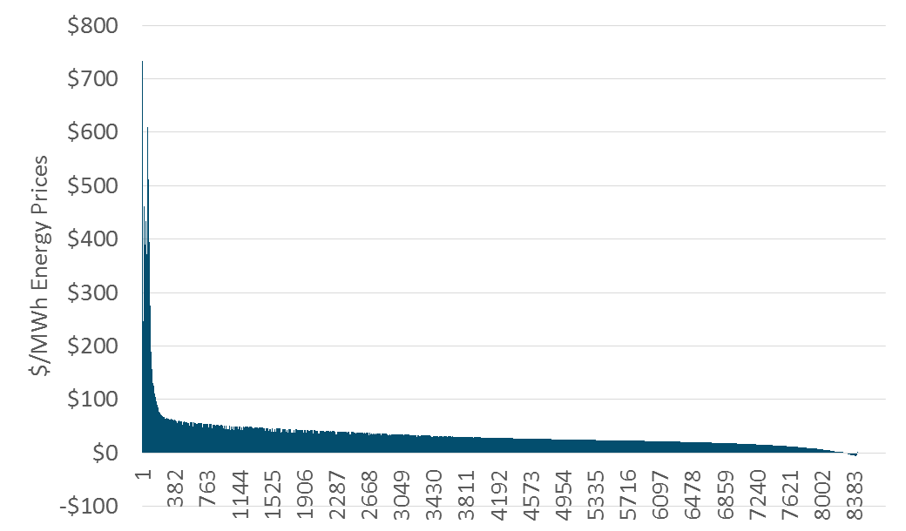

## Generation Capacity

The long-run generation capacity cost is the levelized capital cost of a new simple cycle CT unit less the margin that the CT could earn from the energy and ancillary service markets. The calculation has been updated to include carbon costs in both the bid prices for the CT and the market prices for energy. Minor adjustments have also been made to the calculation of the CT levelized cost of capacity to be consistent with the method used for the CCGT calculations.

Previously, the generation capacity cost has transitioned from a near-term capacity cost based on Resource Adequacy costs, to the long-run capacity cost based on the Resource Balance Year. D.16-06-007 essentially set the Resource Balance Year to zero, which resulted in the use of the long-run capacity cost for all years. That is the approach taken starting with the 2016 Avoided Cost Calculator update.

### Generation resource balance year

Consistent with past Decisions on the resource balance year, we assume that the first year of the forecast is the resource balance year

### CT dispatch

To determine the long-run value of capacity, the avoided cost model performs an hourly dispatch of a new CT to determine energy market net revenues. The CT’s net margin is calculated assuming that the unit dispatches at full capacity in each hour that the real-time price exceeds its operating cost (the sum of fuel costs, variable O&M, and carbon costs). In each hour that it operates, the unit earns the difference between the market price and its operating costs, plus an additional 2.74% of the market price for ancillary services[3]. In each hour where the market prices are below the operating cost, the unit is assumed to shut down. The dispatch uses the real-time market shape (not the day-ahead market shape), and adjusts for changes in natural gas prices, temperature performance degradation using average monthly 9am – 10pm temperatures (see the section *Temperature effect on unit performance* on page 24), and a market calibration factor[4].

The market revenues earned in the energy and AS markets are subtracted from the fixed and variable costs (including carbon allowance costs) of operating a CT to determine the residual capacity cost. The residual capacity cost is the additional revenue that a new CT would require to fully cover its fixed costs and return on investment, and is used as a proxy for the long-term avoided cost of generation capacity. The generation capacity cost calculations are performed using both Northern California and Southern California market prices and weather information. The cost of a new CT, however, is the same for both Northern and Southern California. Consistent with the DR methodology implemented in the prior avoided cost model, the final generation capacity cost for each year is the average of the results for Northern and Southern California (50% Northern and 50% Southern).

In addition to data updates, the CT dispatch incorporates two methodology changes

1. Carbon and variable O&M costs are included in the CT dispatch bids and market revenue calculations because such carbon costs are recovered through the energy market.
2. The hourly real-time market shape is based on the 2015 shape and held constant for all future years. This shape is not adjusted in the same way as the day-ahead price shape due to the disconnect between the two as well as large increase in volatility seen in the real-time price shape.
3. The hourly real time shape is based on the 3rd highest 5-minute interval value within the hour, rather than a simple average of all 12 intervals within the hour.

Figure 13: Statewide Generation Capacity Value before Temperature and Loss Adjustments

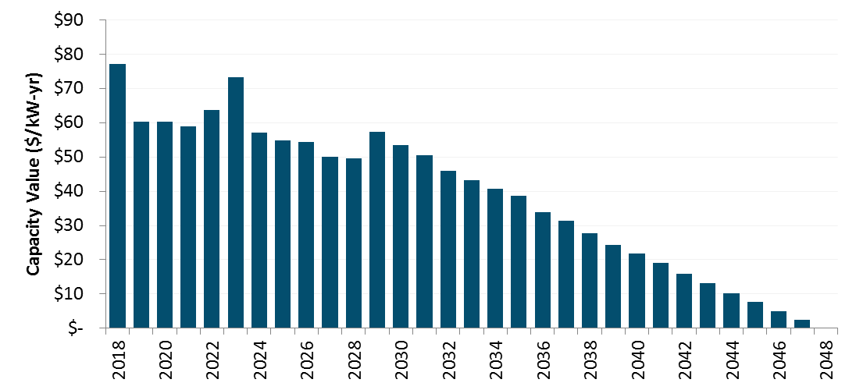

Note that the avoided cost methodology update process has not allowed for a re-visiting of the long-run energy and capacity estimation methods. There has been a substantial shift in the composition of the grid and nature of resource additions since the methodology was originally formulated in 2004. The constant decline in capacity value after 2030 further suggests that a reexamination of the methodology is warranted.

### Temperature effect on unit performance

The capacity value as $ per kW of degraded capacity, rather than $ per kW of nameplate capacity to account for the effects of temperature. This re-expression increases the $/kW capacity value by about 8%. The use of the degraded capacity was introduced in the DR proceeding to more precisely model to operation of a combustion turbine at different ambient temperature conditions throughout the year. Use of degraded, rather than nameplate, capacity value results an increase in the capacity value because combustion turbines perform at lower efficiencies when the ambient temperature is high.

The CT’s rated heat rate and nameplate capacity characterize the unit’s performance at ISO conditions,[5] but the unit’s actual performance deviates substantially from these ratings throughout the year. In California, deviations from rated performance are due primarily to hourly variations in temperature. Figure 14 shows the relationship between temperature and performance for a GE LM6000 SPRINT gas turbine, a reasonable proxy for current CT technology.

Figure 14. Temperature-performance curve for a GE LM6000 SPRINT combustion turbine.



The effect of temperature on performance is incorporated into the calculation of the CT residual; several performance corrections are considered:

* In the calculation of the CT’s dispatch, the heat rate is assumed to vary on a monthly basis. In each month, E3 calculates an average day-time temperature based on hourly temperature data throughout the state and uses this value to adjust the heat rate—and thereby the operating cost—within that month.
* Plant output is also assumed to vary on a monthly basis; the same average day-time temperature is used to determine the correct adjustment. This adjustment affects the revenue collected by the plant in the real-time market. For instance, if the plant’s output is 90% of nameplate capacity in a given month, its net revenues will equal 90% of what it would have received had it been able to operate at nameplate capacity.
* The resulting capacity residual is originally calculated as the value per nameplate kilowatt—however, during the peak periods during which a CT is necessary for resource adequacy, high temperatures will result in a significant capacity deration. Consequently, the value of capacity is increased by approximately 10% to reflect the plant’s reduced output during the top 250 load hours of the year as shown in Figure 15.

The forecast annual generation capacity values are shown below.

Figure 15. Adjustment of capacity value to account for temperature derating during periods of peak load (losses still excluded)

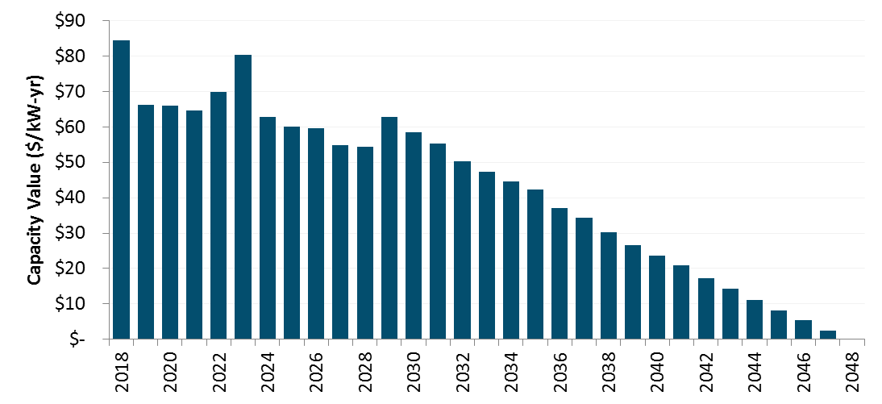

### Planning reserve margin and losses

The capacity value is increased to account for both the Planning Reserve Margin (PRM) and losses. Resource Adequacy rules set capacity procurement targets for Load Serving Entities based on 1.15% of their forecasted load.[6] The must also account for losses in delivering electricity from the generator to the customer, based on peak loss factors for each utility. The capacity value is therefore increased by the PRM and the applicable loss factors for each utility. Note that peak loss factors are used for generation and T&D capacity while TOU loss factors are used for energy.

### Hourly allocation of capacity value

The capacity values ($/kW-yr), after adjusting for temperature, losses, and planning reserve margin, are then allocated to the hours of the year with highest system capacity need using the E3 RECAP model. Using 63 years of historical load and generation data, the model determines the expected unserved energy (EUE) for each month/hour/day-type time period in the year. As renewable penetrations increase, EUE shifts from the afternoon to evenings as well as to a relatively more weekends. A snapshot of these hourly EUE values in 2020 is shown below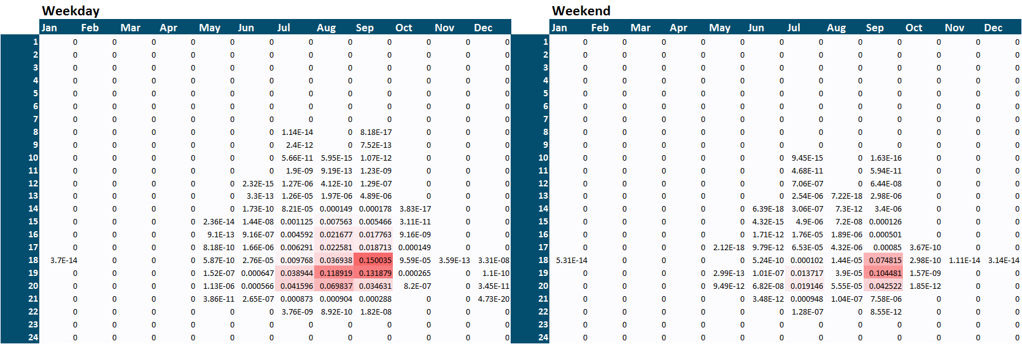

These month/hour/day-type EUE values are then allocated to days of the year using the 2017 daily temperature record for consistency with energy prices. A load-weighted daily maximum statewide temperature is calculated and all hours in days where this value exceeds 90 degrees F receive the corresponding month/hour/day-type EUE value from RECAP. The resulting 8760 hourly capacity allocators are shown below.

Figure 16: Generation Capacity Hourly Allocation Factors (2020)

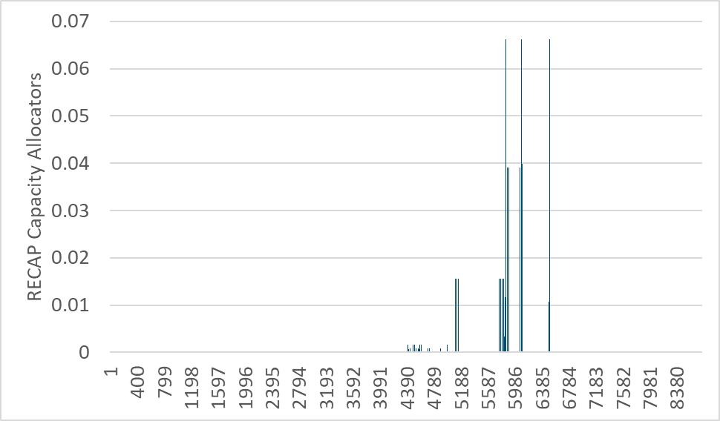

A downloadable version of RECAP can be found online.[7] The results shown above use this version of the model along with load and renewable generation forecasts consistent with the LTPP “Default – AAEE Sensitivity” scenario. While the hourly allocations were updated, the underlying RECAP analysis was not changed in this update.

## Ancillary Services (AS)

Besides reducing the cost of wholesale purchases, reductions in demand at the meter result in additional value from the associated reduction in required procurement of ancillary services. The CAISO MRTU markets include four types of ancillary services: regulation up and down, spinning reserves, and non-spinning reserves. The procurement of regulation services is generally independent of load; consequently, behind-the-meter load reductions and distributed generation exports will not affect their procurement. However, both spinning and non-spinning reserves are directly linked to load—in accordance with WECC reliability standards, the California ISO must maintain an operating reserve equal to 5% of load served by hydro generators and 7% of load served by thermal generators.

As a result, load reductions do result in a reduction in the procurement of reserves; the value of this reduced procurement is included as a value stream in the Avoided Cost Calculator. It is assumed that the value of avoided reserves procurement scales with the value of energy in each hour throughout the year. According to the CAISO’s 2015 Annual Report on Market Issues and Performance[8], ancillary service costs in 2015 averaged 1.6% of the wholesale energy costs. E3 uses this percentage to assess the value of avoided A/S procurement in each hour.

## T&D Capacity

The avoided electricity avoided costs include the value of reducing the need for transmission and distribution capacity expansion. Of the six avoided cost components, T&D costs are unique in that both the value and hourly allocation are location specific. Avoided T&D costs are determined separately for each utility. The avoided T&D costs are the same as those used in the 2017 Avoided Cost Update. The T&D avoided costs escalate by 2% per year in nominal terms.

Table 3: T&D Capacity Costs for SCE and SDG&E



SCE 2015 General Rate Case: http://docs.cpuc.ca.gov/PublishedDocs/Efile/G000/M155/K034/155034804.PDF, p.6

SDG&E 2015 General Rate Case: https://www.sdge.com/sites/default/files/regulatory/Saxe%20Clean%20w_Attachments.pdf Attachment A

Table 4: T&D Capacity Costs for PG&E



*\* Secondary values converted from $/FLT to $/PCAF using ratios of FLT demand to PCAF demand in each Division*

*PG&E 2014 General Rate Case: http://docs.cpuc.ca.gov/PublishedDocs/Efile/G000/M099/K767/99767963.PDF pg A2-A3*

The value of deferring distribution investments is highly dependent the type and size of the equipment deferred and the rate of load growth, both of which vary significantly by location. Furthermore, some distribution costs are driven by distance or number of customers rather than load and are therefore not avoided with reduced energy consumption. However, expediency and data limitations preclude analysis at a feeder by feeder level for a statewide analysis of avoided costs. A more detailed examination of distribution avoided costs is currently underway for the IOUs as part of the Distribution Resource Plan proceeding (R.14-08-013). The costs taken from utility rate case filings are used as a reasonable proxy for the long-run marginal cost T&D investment that is avoided over time with the addition of distributed energy resources.

The value of deferring transmission and distribution investments is adjusted for losses during the peak period using the factors shown in Table 5 and Table 6. These factors are lower than the energy and generation capacity loss factors because they represent losses from secondary meter to only the distribution or transmission facilities.

Table 5. Losses factors for SCE and SDG&E transmission and distribution capacity.

|  |  |  |
| --- | --- | --- |
|  | SCE | SDG&E |
| Distribution | 1.022 | 1.043 |
| Transmission | 1.054 | 1.071 |

Table 6: Losses factors for PG&E transmission and distribution capacity.

|  |  |  |
| --- | --- | --- |
|  | Transmission | Distribution |
| CENTRAL COAST | 1.053 | 1.019 |
| DE ANZA | 1.050 | 1.019 |
| DIABLO | 1.045 | 1.020 |
| EAST BAY | 1.042 | 1.020 |
| FRESNO | 1.076 | 1.020 |
| KERN | 1.065 | 1.023 |
| LOS PADRES | 1.060 | 1.019 |
| MISSION | 1.047 | 1.019 |
| NORTH BAY | 1.053 | 1.019 |
| NORTH COAST | 1.060 | 1.019 |
| NORTH VALLEY | 1.073 | 1.021 |
| PENINSULA | 1.050 | 1.019 |
| SACRAMENTO | 1.052 | 1.019 |
| SAN FRANCISCO | 1.045 | 1.020 |
| SAN JOSE | 1.052 | 1.018 |
| SIERRA | 1.054 | 1.020 |
| STOCKTON | 1.066 | 1.019 |
| YOSEMITE | 1.067 | 1.019 |

### Hourly allocation of T&D capacity cost

The allocation of T&D capacity costs to hours of year is based on regression estimates of distribution hourly loads[9]. The regression models are based on actual utility hourly distribution demands and the corresponding temperature in the distribution area. Using dummy variables, lag terms, and cross product terms, the regression models are able to simulate the distribution loads with about 90% accuracy (adjusted r-square)[10]. To forecast the impact of local solar PV on the distribution loads, the analysis also subtracts off a forecast level of hourly PV generation from the distribution load to produce an adjusted distribution load shape. The PV generation shape is based on the local area solar insolation, and the magnitude of the PV generation is based on the incremental statewide 2015 IEPR Mid-Demand forecast of solar penetration. 50 percent of the statewide incremental PV is assumed to be installed equally on a per-capital basis across the state, and the remaining 50% is assumed to be installed in proportion to the 2013 per-capita installations.

Once the adjusted distribution loads are simulated using 2017 weather data for each climate zone and the PV penetrations, we allocate the T&D capacity value in each climate zone to the hours of the year during which the system is most likely to be constrained and require upgrades—the hours of highest local load. The allocation factors are derived using the peak capacity allocation factors method, with the additional constraint that the peak period contain between 20 and 250 hours for the year.

PCAF[a,h] = (Load[a,h] – Threshold[a]) / Sum of all positive (Load[a,h] – Threshold[a])

Where

a is the climate zone area,

h is hour of the year,

Load is the net distribution load, and

Threshold is the area maximum demand less one standard deviation, or the closest value that satisfies the constraint of between 20 and 250 hours with loads above the threshold.

Figure 17 shows a summary of the updated T&D allocation factors for Climate Zone 3 (San Francisco) in 2020. The blue line shows the total allocation weight for each hour of the day (in Pacific Standard Time) and the gray bars show the total allocation weight by month (top axis, and right axis). The chart title also indicates that the allocation factors are based on behind-the-meter PV proving an additional 6.4% of the electricity needs in the climate zone since 2010. The PV values are incremental to 2010 because that is the year of the utility load data used as the basis for the simulated area loads. The additional PV output is subtracted from the simulated loads to estimate the adjusted net loads for the climate zone.

Figure 17. Updated T&D Allocation Factors for CZ3 in 2020

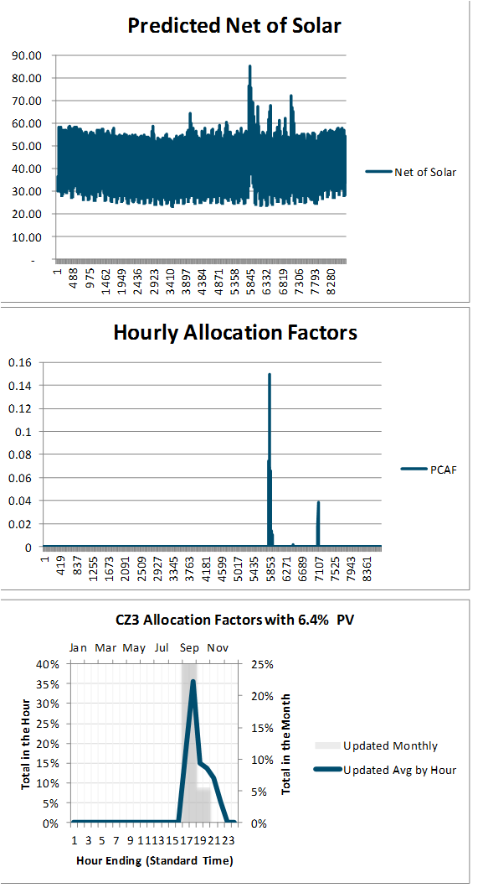

Figure 18 shows the same information for climate zone 3 in 2030. In 2030 the behind-the-meter PV is modeled as providing 20.2% of the electricity needs in the climate zone. This higher PV output results in less need for summer afternoon peak capacity. This shits the allocation factors to later in the day/evening, as well as shifting more weight to the non-summer months. Summary charts for all 16 climate zones are presented in the Appendix.

Figure 18. Updated T&D Allocation Factors for CZ3 in 2030

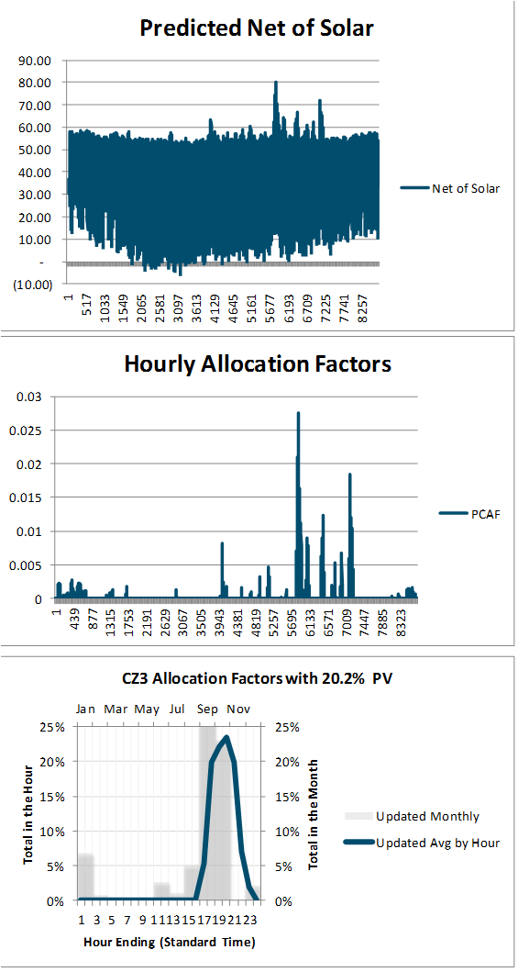

The 2020 allocation factors are used for all years up to and including 2020, and the 2030 shapes are used for 2030 and all subsequent years. A simple linear interpolation is applied to the interim years.

Table 7: Percentage of Electricity Demand Met by Behind-the-Meter PV

|  |  |  |
| --- | --- | --- |
| Climate Zone | 2020 | 2030 |
| CZ1 | 6.2% | 18.1% |
| CZ2 | 10.1% | 24.2% |
| CZ3 | 6.4% | 20.2% |
| CZ4 | 9.5% | 24.3% |
| CZ5 | 4.9% | 13.3% |
| CZ6 | 2.5% | 10.3% |
| CZ7 | 3.4% | 11.5% |
| CZ8 | 2.3% | 10.1% |
| CZ9 | 2.2% | 10.2% |
| CZ10 | 3.5% | 11.8% |
| CZ11 | 9.2% | 23.6% |
| CZ12 | 5.1% | 13.0% |
| CZ13 | 8.5% | 22.9% |
| CZ14 | 5.0% | 14.0% |
| CZ15 | 3.2% | 11.7% |
| CZ16 | 7.0% | 21.5% |

## CO2 Monetized and GHG Adder Values

### Monetized Carbon (cap and trade)

The monetized cost of carbon represents the cap and trade allowance cost that the utility must pay to purchase or generate fossil energy. While this value is currently embedded in energy prices in the CAISO market, we separate this value for avoided cost purposes[11]. This component has been updated to use the Revised 2017 IEPR Mid-Case forecast values. The IEPR forecast extends to 2030. For later years, the forecast is extrapolated using a linear trend of the values in the final five years of the IEPR forecast. Figure 19 shows the updated CO2 price forecasts. The blue line is the IEPR forecast series that is embedded in the market price. The dashed gold line is the total GHG adder plus cap and trade allowance cost of CO2. The difference between the two series is included as the GHG adder for CO2.

Figure 19. The CO2 cap and trade price series

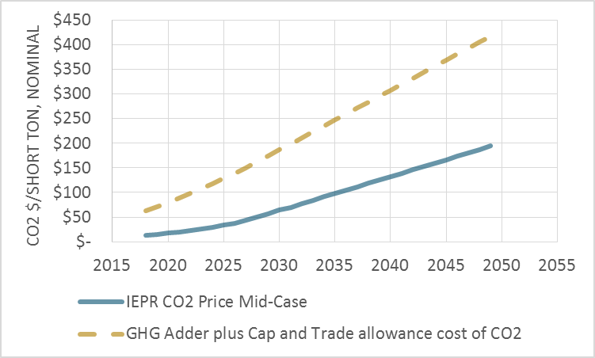

The marginal rate of carbon emissions is calculated using a slight modification to the prior avoided cost model method. Assuming that natural gas is the marginal fuel in all hours, the hourly emissions rate of the marginal generator is calculated based on the day-ahead market price curve (with the assumption that the price curve also includes the cost of CO2).

HeatRate[h] = (MP[h] – VOM) / (GasPrice + EF * CO2Cost)

Where

MP is the hourly market price of energy (including cap and trade costs)

VOM is the variable O&M cost for a natural gas plant

GasPrice is the cost of natural gas delivered to an electric generator

CO2Cost is the $/ton cost of CO2

EF is the emission factor for tons of CO2 per MMBTU of natural gas

The link between higher market prices and higher emissions rates is intuitive: higher market prices enable lower-efficiency generators to operate, resulting in increased rates of emissions at the margin. Of course, this relationship holds for a reasonable range of prices but breaks down when prices are extremely high or low. For this reason, the avoided cost methodology bounds the maximum and minimum emissions rates based on the range of heat rates of gas turbine technologies. The maximum and minimum emissions rates are bounded by a range of heat rates for proxy natural gas plants shown in Table 8; the hourly emissions rates derived from this process are shown in Figure 20. The emission rate bounds are unchanged from the prior avoided cost model.

Table 8. Bounds on electric sector carbon emissions.

|  |  |  |
| --- | --- | --- |
|  | Proxy Low Efficiency Plant | Proxy High Efficiency Plant |
| Heat Rate (Btu/kWh) | 12,500 | 6,900 |
| Emissions Rate (tons/MWh) | 0.731 | 0.404 |

Additionally, if the implied heat rate is calculated to be at or below zero, it is then assumed that the system is in a period of overgeneration and therefore the marginal emission factor is correspondingly zero as well. The hourly marginal emission rates are shown below.

Figure 20. Hourly marginal emissions rates derived from market prices (hourly values shown in descending order)

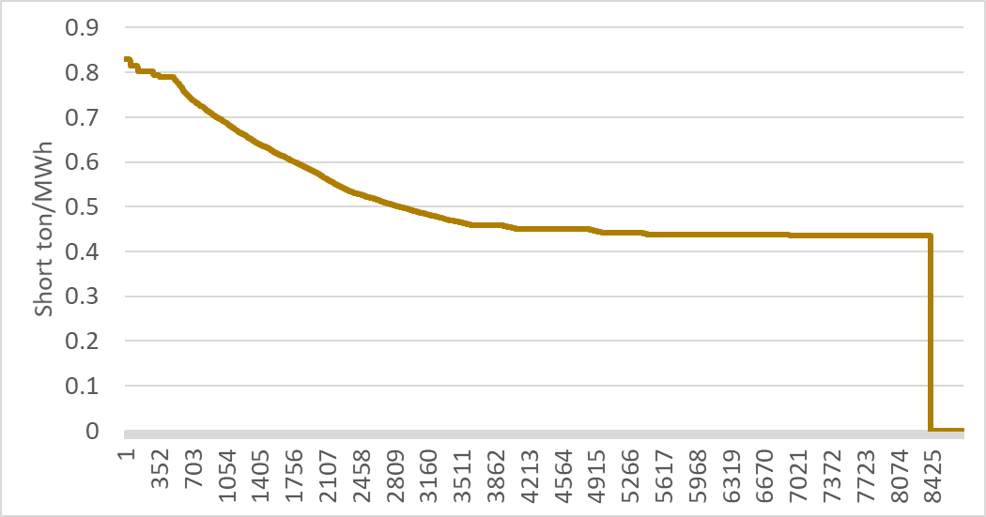

### GHG Adder

CPUC Decision D.18-02-018 adopted CO2 costs as reproduced below for the purpose of calculating a greenhouse gas (GHG) adder value. The CPUC adopted values are in 2016 constant dollars. Once converted to nominal dollars[12] per short ton, the difference between the costs in the table and the CO2 monetized cost embedded in the market prices is included in the avoided costs as the GHG adder. (Note that while the table has “GHG Adder” in the title, the values are the total of the cap and trade allowance cost plus the GHG adder as defined in the avoided cost calculator).

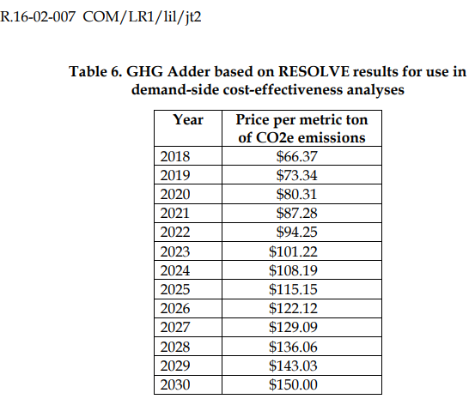

Table 9: GHG Adder and Cap and Trade Allowance Cost



The next step to calculating the GHG adder is determining the GHG emission rate in each hour. To determine this, we first calculate an implied heat rate (Btu/kWh) in each hour. The implied heat rate is calculated by subtracting the cap-and-trade emission value and variable operations and maintenance (O&M) expense of a CCGT from the energy price in each hour and then dividing by the natural gas price. This implied heat rate is then multiplied by the GHG intensity of natural gas (tonne/Btu) which yields the emission factor in tonne/kWh.

Finally, the incremental portion of the GHG adder price ($/tonne) is multiplied by the emission rate (tonne/kWh) to yield a final GHG adder value ($/kWh) in each hour.

## Avoided RPS Cost

This component reflected the fact that as energy usage declines, the amount of utility renewable purchases required to meet the RPS goals also declines. Since the cost of renewable energy is higher than the forecasted cost of wholesale energy and capacity market purchases, energy reductions provide some value above the wholesale energy and capacity markets.

With the introduction of the RESOLVE-based GHG adder, the need for CO2 reductions, rather than the need to meet RPS goals, becomes the binding constraint on the electricity sector. Renewable levels are expected to exceed the RPS goals in the future, so there is no longer an expected one-to-one correspondence between usage reductions and renewable energy reductions. Therefore the RPS adder is no longer an expected avoided cost benefit of usage reductions, and has been removed.

Components Not Included

Several components suggested by stakeholders in various proceedings are not currently included in the calculation of avoided costs. Non-energy Benefits (NEBs), by their nature, are difficult – if not impossible – to quantify. Work has been done to quantify some of these benefits for low income energy efficiency programs.[13] NEBs are not, however, currently included in the avoided cost methodology. The CPUC has authorized studies and pilot programs regarding embedded energy in water. To date a comprehensive framework for calculating embedded energy in water savings or water avoided costs in energy on a statewide basis has not yet been developed.[14] Avoided costs of current or future Ancillary Services associated with renewable integration or overgeneration are also not included. The need for flexible resources to provide services such as load following or ramping capability are driven primarily by the variation in, rather than the absolute level of, loads and generation. Finally the impacts of power factor and reactive loads are not currently included in the avoided cost methodology. An EM&V study for the CPUC Operational Energy Efficiency Program for water pumping produced by E3 found that the value of reduced reactive loads (kVAR) and associated line loss reductions ranged from 5 to 12 percent of the $/kWh avoided cost savings.[15] However the savings associated with improved power factor and reduced reactive load depend to a large extent on the type and location of loads on the feeder. As with embedded energy in water, a generalized framework for a statewide analysis has not yet been performed.

# Appendix: Key Data Sources and Specific Methodology

This section provides further discussion of data sources and methods used in the calculation of the hourly avoided costs.

## Power plant cost assumptions

The cost and performance assumptions for the new simple cycle plants and combined cycle plants are from the CPUC 2017 IRP (R.16-02-007). The IRP ProForma spreadsheet with the data inputs can be found at <http://cpuc.ca.gov/irp/proposedrsp/>

Where the IRP does not specify an input variable, the values from the 2017 avoided cost model are retained. Those retained values are from the California Energy Commission’s Cost of Generation report (CEC 2015 Cost of New Renewable and Fossil Generation in California, http://www.energy.ca.gov/2014publications/CEC-200-2014-003/index.htmlTable 8.)

Table 10. Power plant cost and performance data source for new generation

**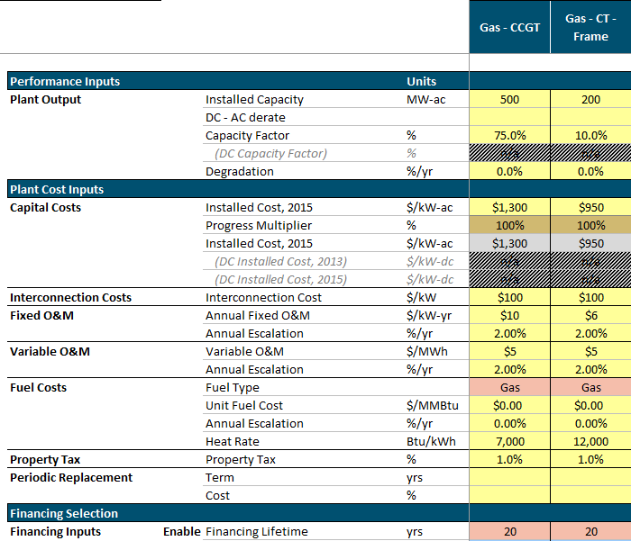***Source: RESOLVE_User_Interface 2017-09-07.xlsm, COSTS_Resource_Char tab. (*<http://cpuc.ca.gov/irp/proposedrsp/>)

## Generation Loss Factors

The updated avoided costs incorporate loss factors from the DR proceeding. The capacity loss factors are applied to the capacity avoided costs to reflect the fact that dispatched generation capacity is greater than metered loads because of losses. The adjustments assume that the metered load is at the secondary voltage level. The loss factors are representative of average peak losses, not incremental losses.

Table 11: Generation capacity loss factors

|  |  |  |  |
| --- | --- | --- | --- |
|  | PG&E | SCE | SDG&E |
| Generation to meter | 1.109 | 1.084 | 1.081 |

The energy loss factors are applied to the electricity energy costs to reflect energy losses down to the customer secondary meter. The loss factors vary by utility time of user period, and represent average losses in each time period.

Energy Generated[h] = Metered Load[h] * Energy Loss Factor[TOU]

Cost of Energy Losses = Energy Cost[h] * Metered Load [h] * (Energy Loss Factor[TOU] – 1)

where h = hour, TOU = TOU period corresponding to hour h.

Table 12. Marginal energy loss factors by time-of-use period and utility.

|  |  |  |  |
| --- | --- | --- | --- |
| Time Period | PG&E | SCE | SDG&E |
| Summer Peak | 1.109 | 1.084 | 1.081 |
| Summer Shoulder | 1.073 | 1.080 | 1.077 |
| Summer Off-Peak | 1.057 | 1.073 | 1.068 |
| Winter Peak | - | - | 1.083 |
| Winter Shoulder | 1.090 | 1.077 | 1.076 |
| Winter Off-Peak | 1.061 | 1.070 | 1.068 |

## Climate Zones

In each hour, the value of electricity delivered to the grid depends on the point of delivery. The DG Cost-effectiveness Framework adopts the sixteen California climate zones defined by the Title 24 building standards in order to differentiate between the value of electricity in different regions in the California. These climate zones group together areas with similar climates, temperature profiles, and energy use patterns in order to differentiate regions in a manner that captures the effects of weather on energy use. Figure 21 is a map of the climate zones in California.

Figure 21. California Climate Zones

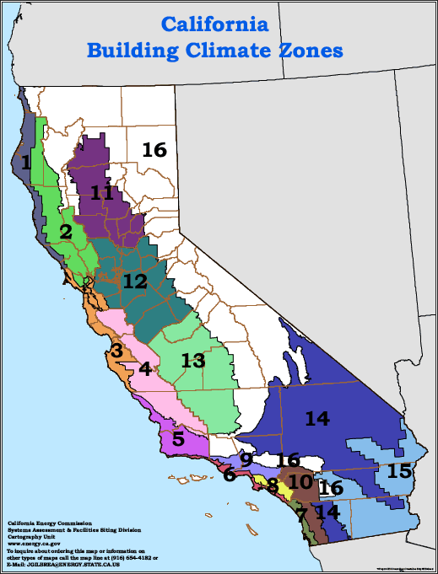

Each climate zone has a single representative city, which is specified by the California Energy Commission. These cities are listed in Table 13. Hourly avoided costs are calculated for each climate zone.

Table 13. Representative cities and utilities for the California climate zones.

|  |  |  |
| --- | --- | --- |
| Climate Zone | Utility Territory | Representative City |
| CEC Zone 1 | PG&E | Arcata |
| CEC Zone 2 | PG&E | Santa Rosa |
| CEC Zone 3 | PG&E | Oakland |
| CEC Zone 4 | PG&E | Sunnyvale |
| CEC Zone 5 | PG&E/SCE | Santa Maria |
| CEC Zone 6 | SCE | Los Angeles |
| CEC Zone 7 | SDG&E | San Diego |
| CEC Zone 8 | SCE | El Toro |
| CEC Zone 9 | SCE | Pasadena |
| CEC Zone 10 | SCE/SDG&E | Riverside |
| CEC Zone 11 | PG&E | Red Bluff |
| CEC Zone 12 | PG&E | Sacramento |
| CEC Zone 13 | PG&E | Fresno |
| CEC Zone 14 | SCE/SDG&E | China Lake |
| CEC Zone 15 | SCE/SDG&E | El Centro |
| CEC Zone 16 | PG&E/SCE | Mount Shasta |

## T&D Allocation Factors

For a description of the charts, refer to the discussion of Figure 17 and Figure 18 on page 34.

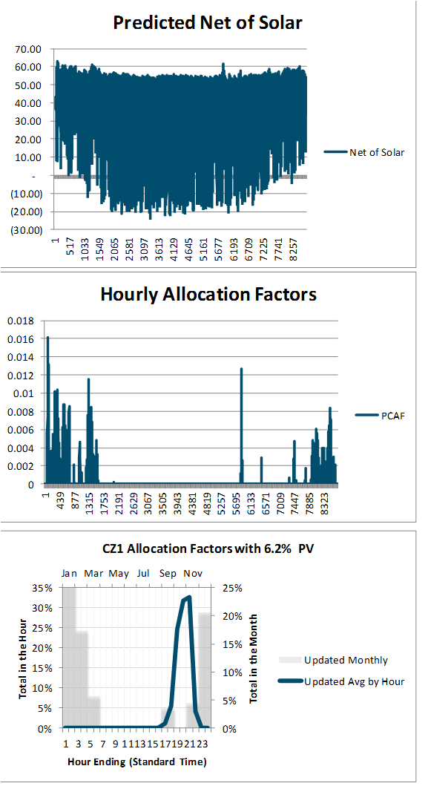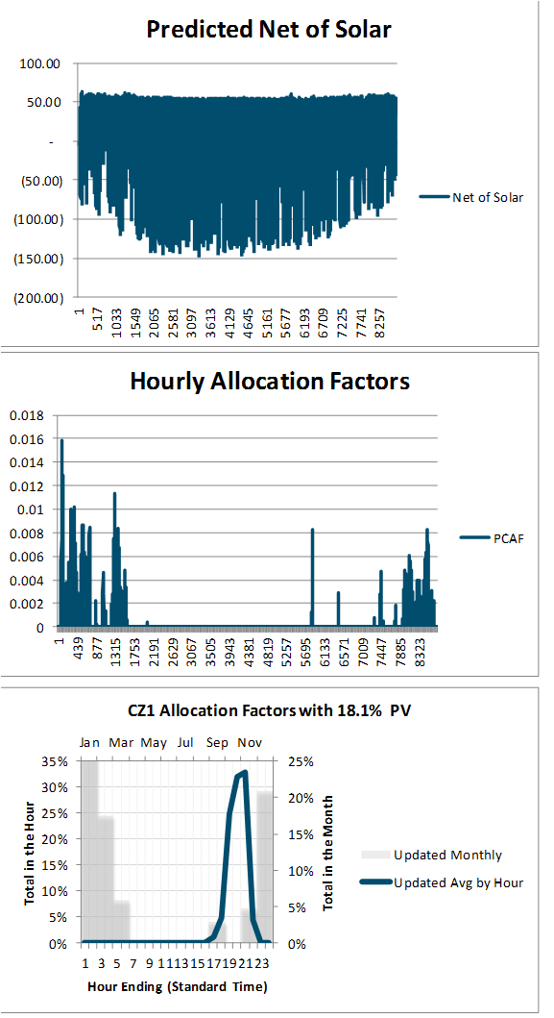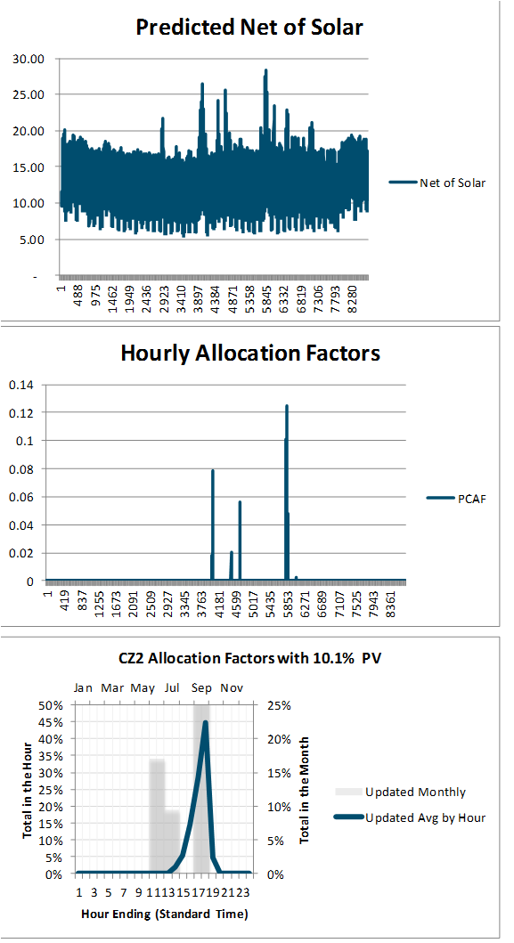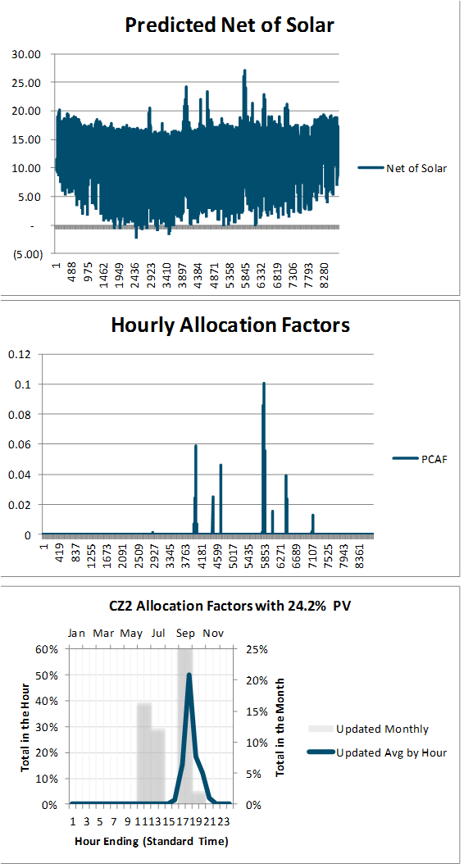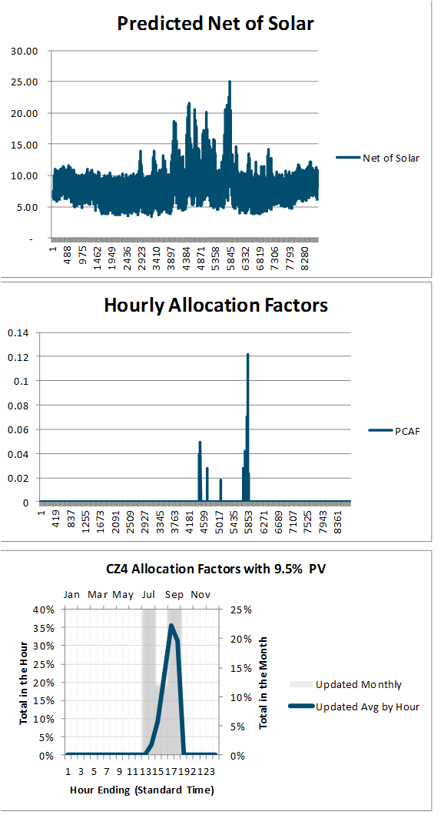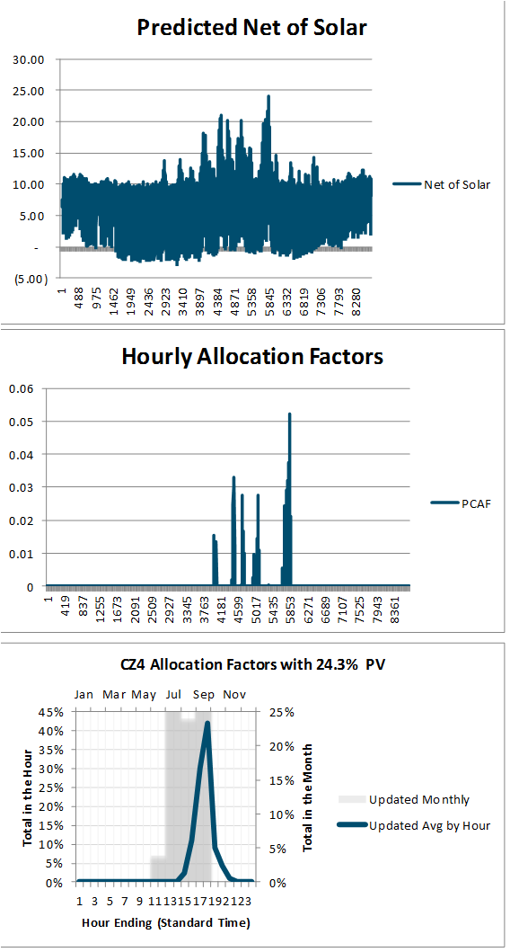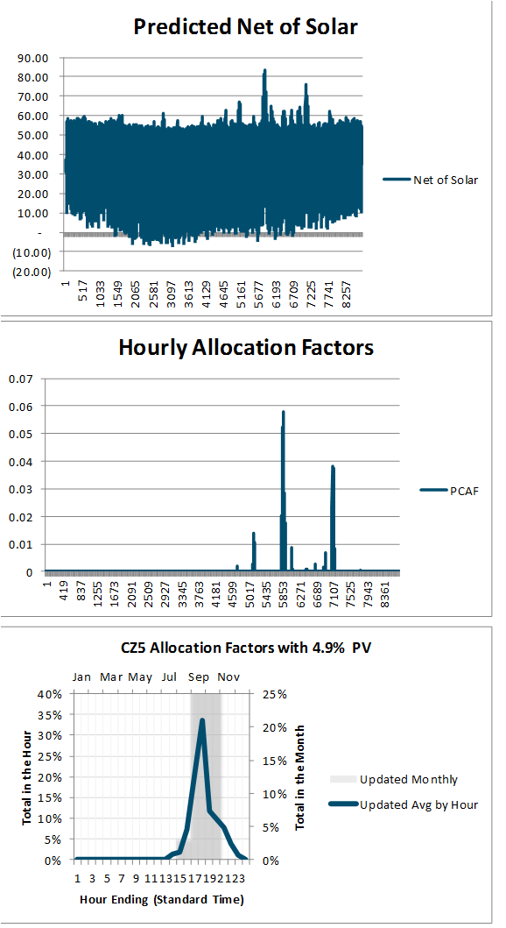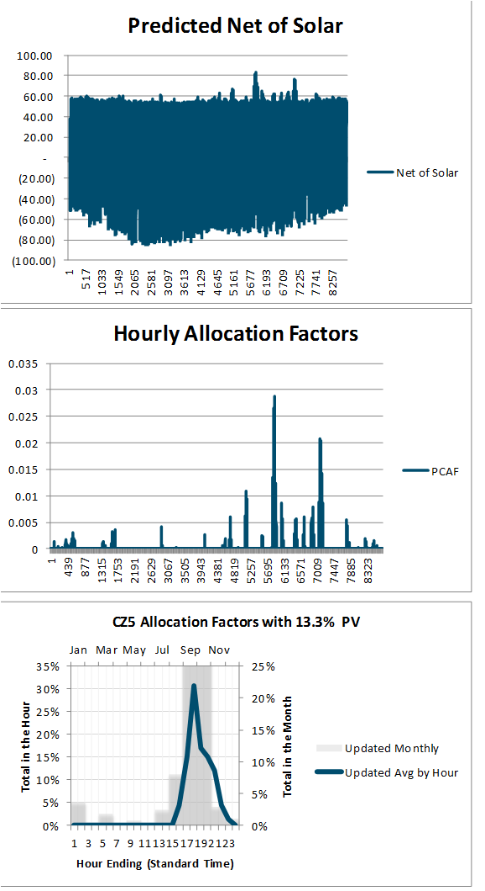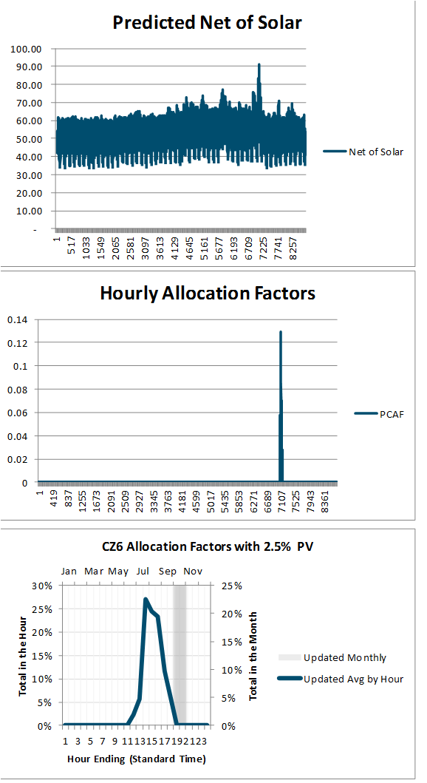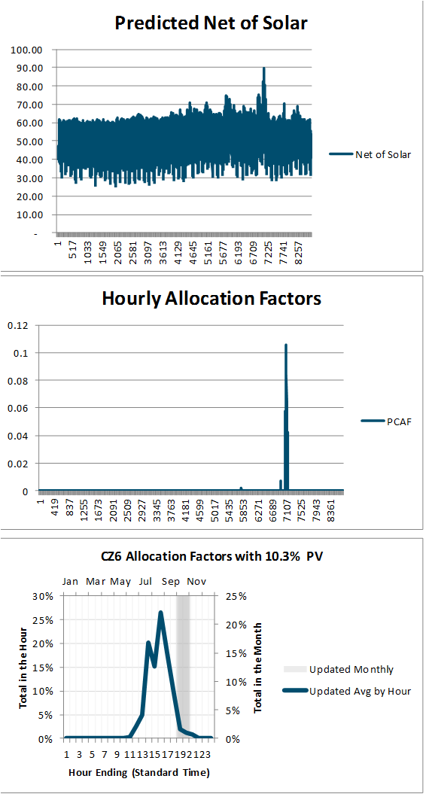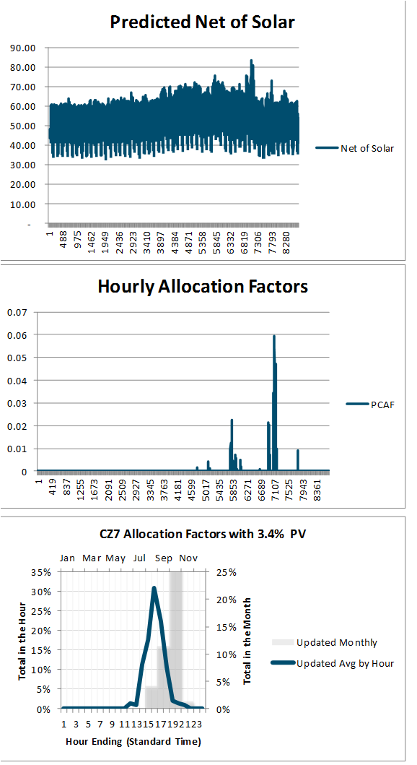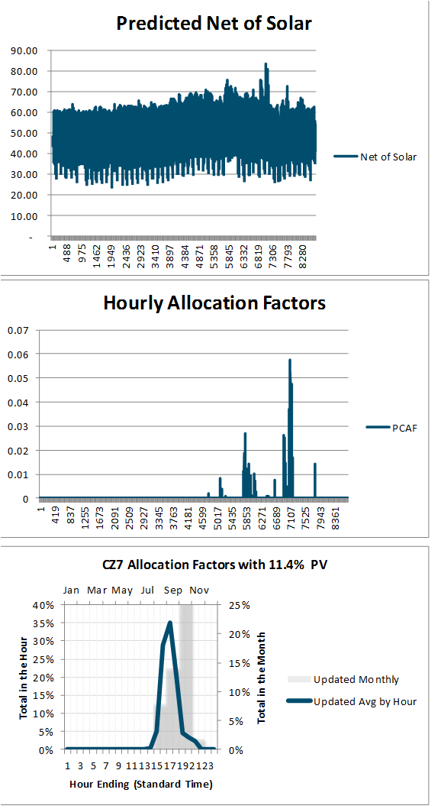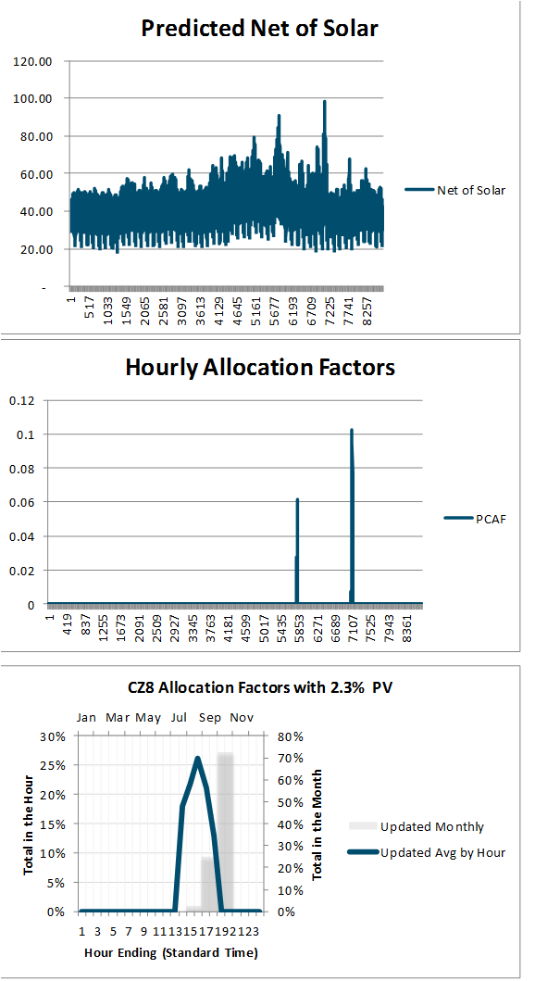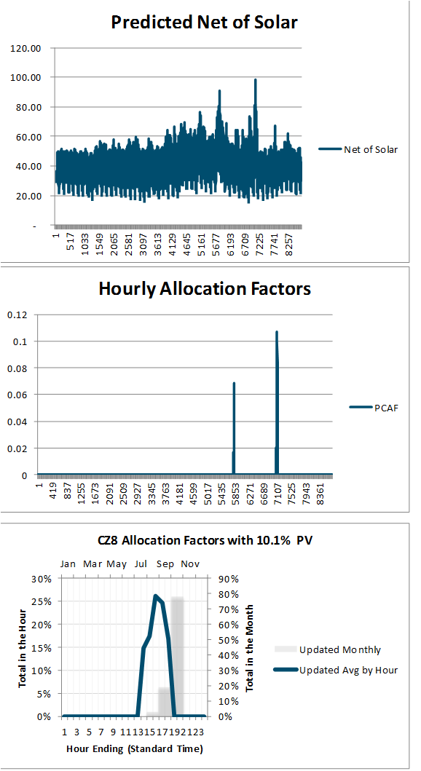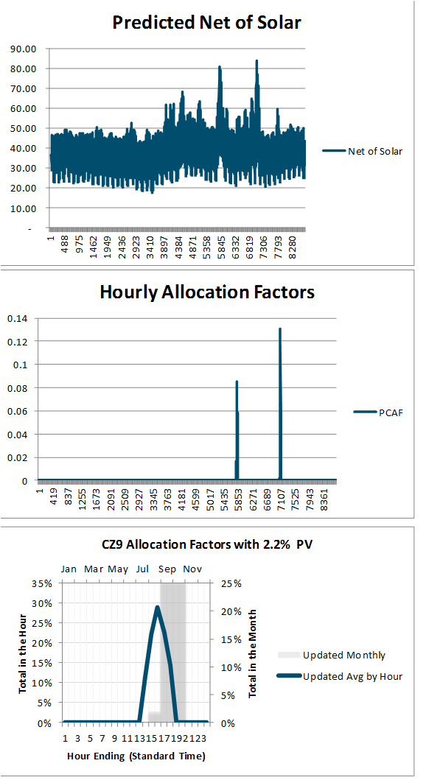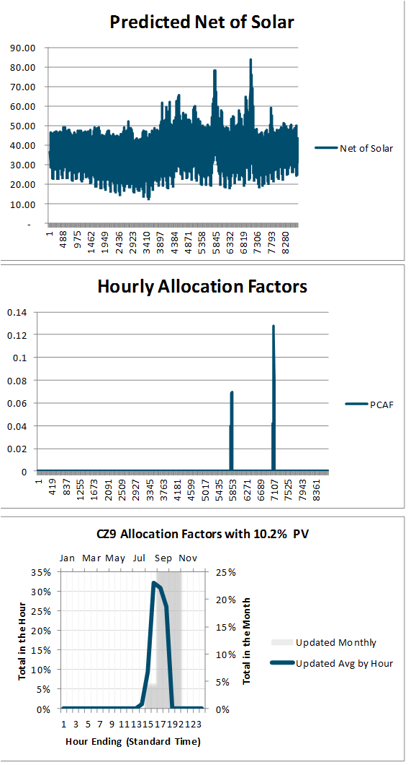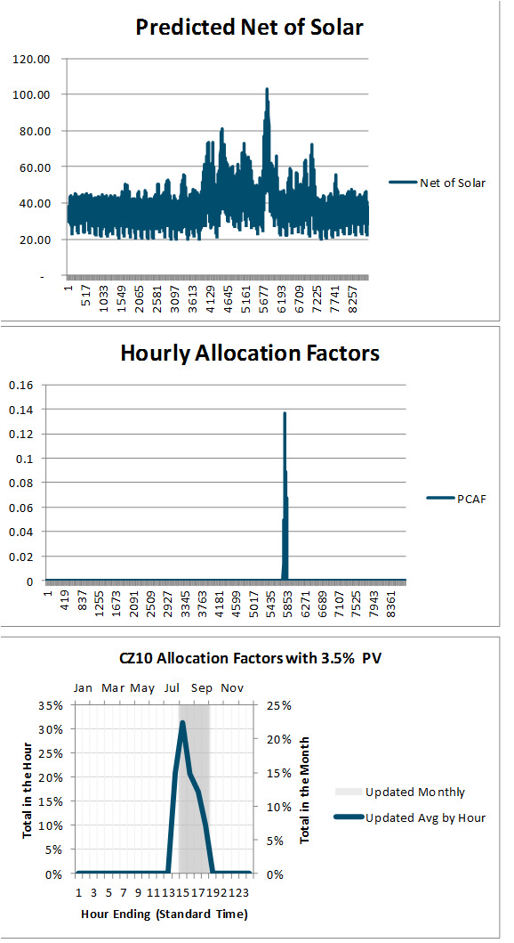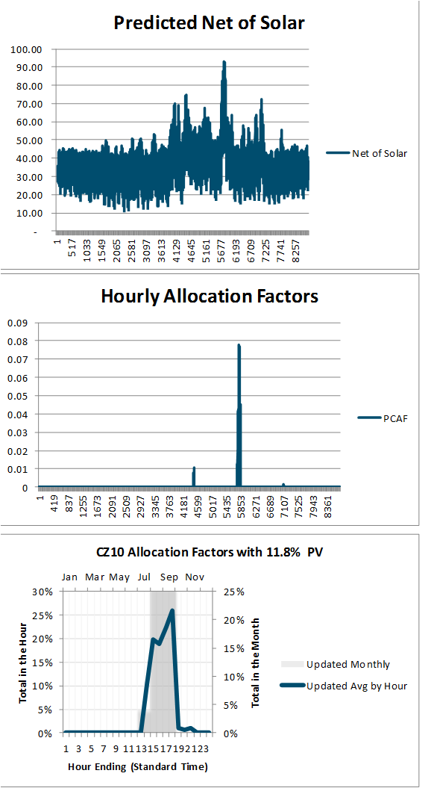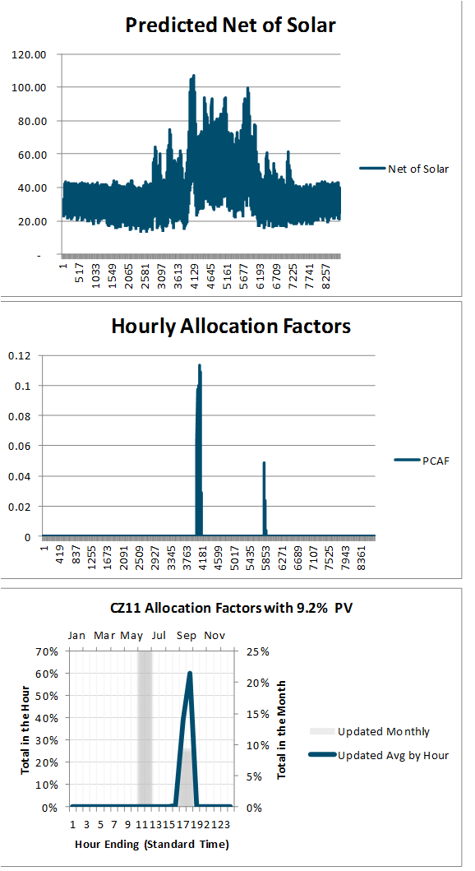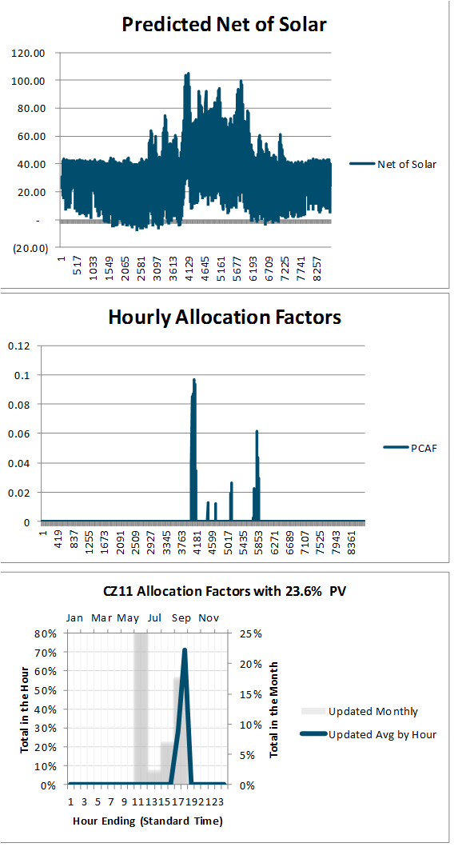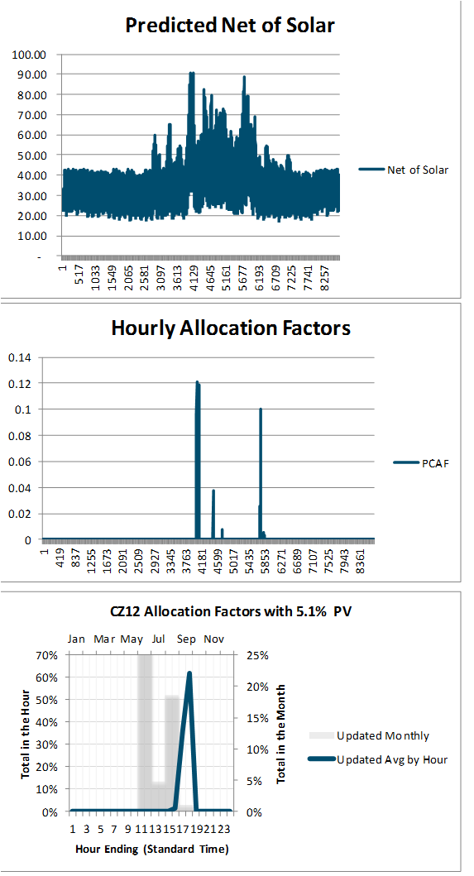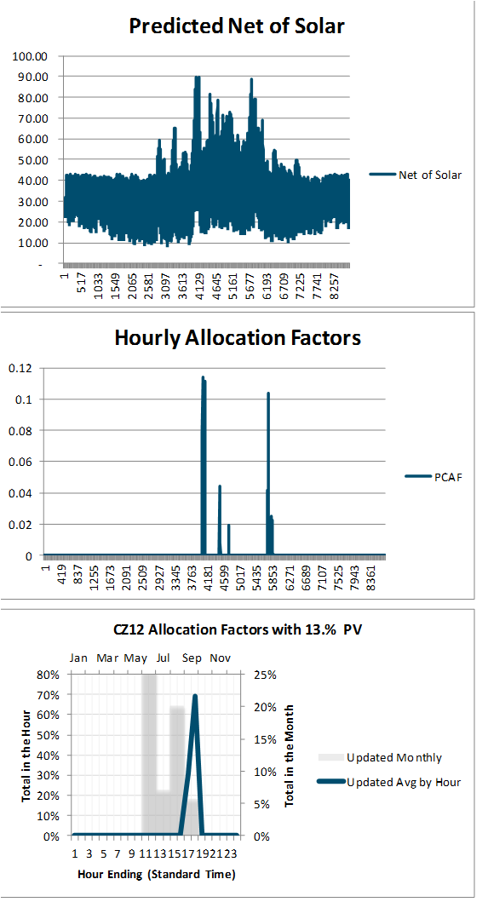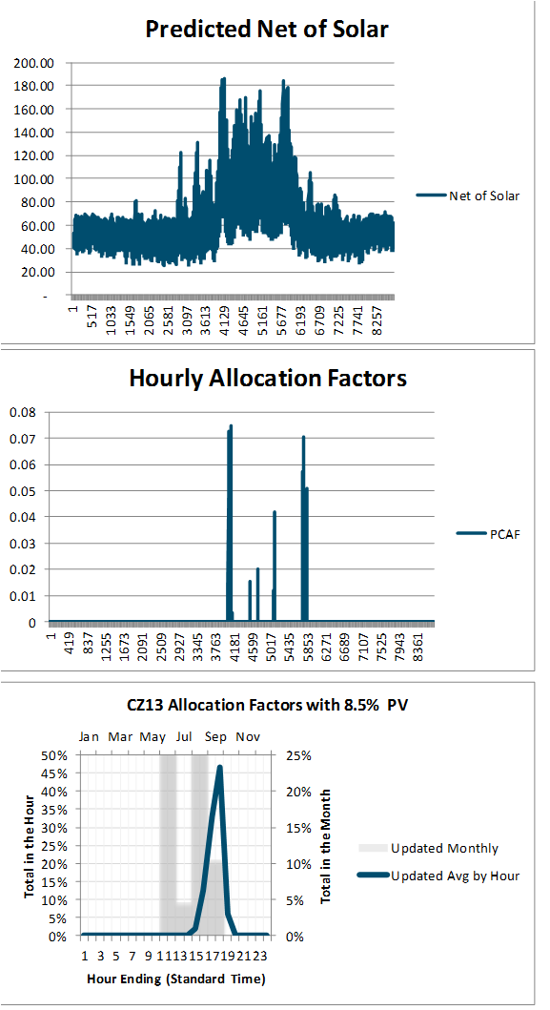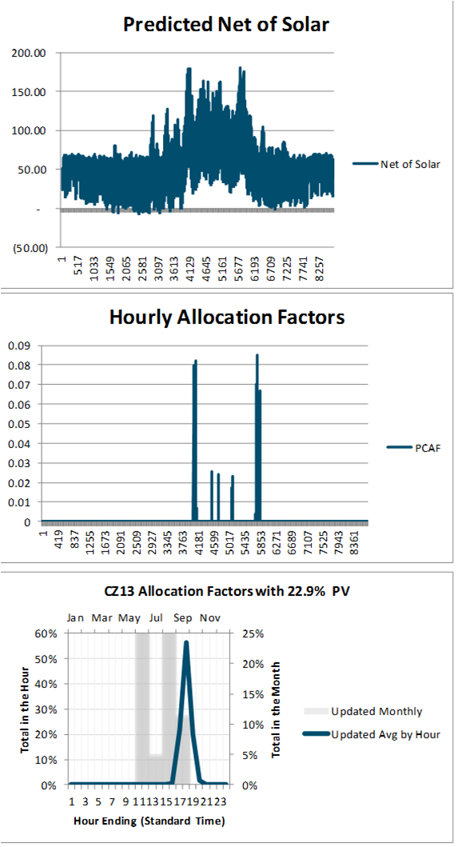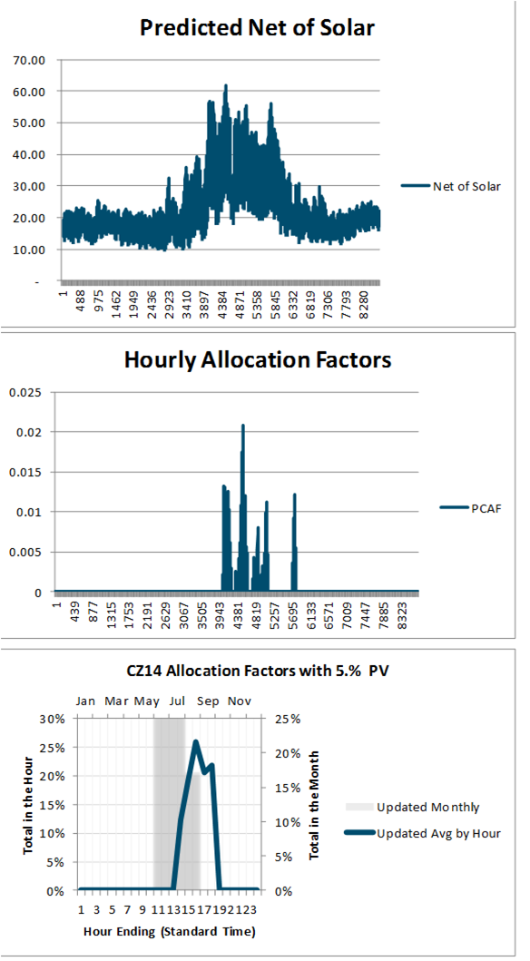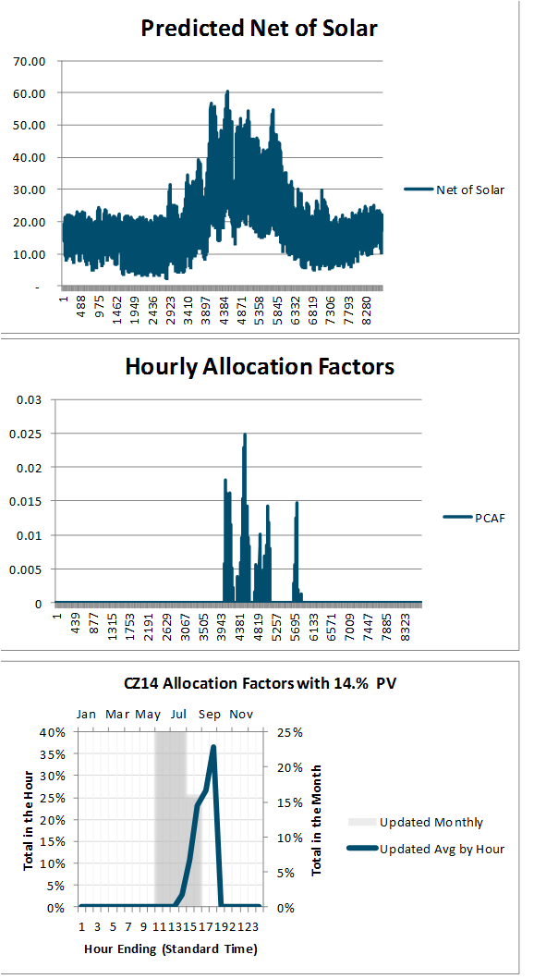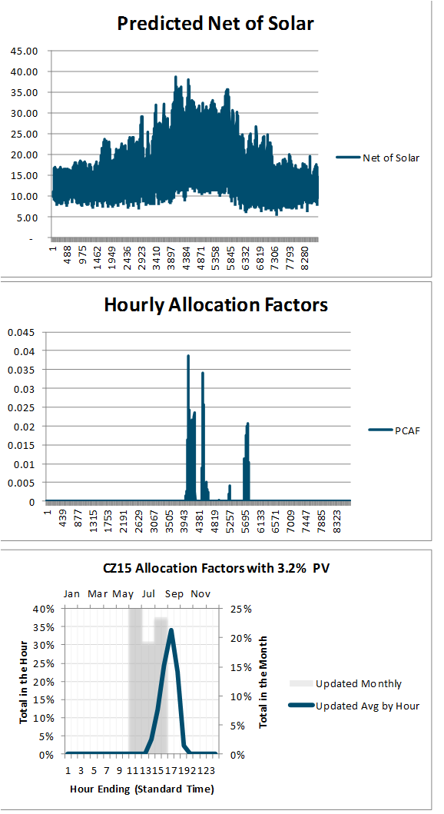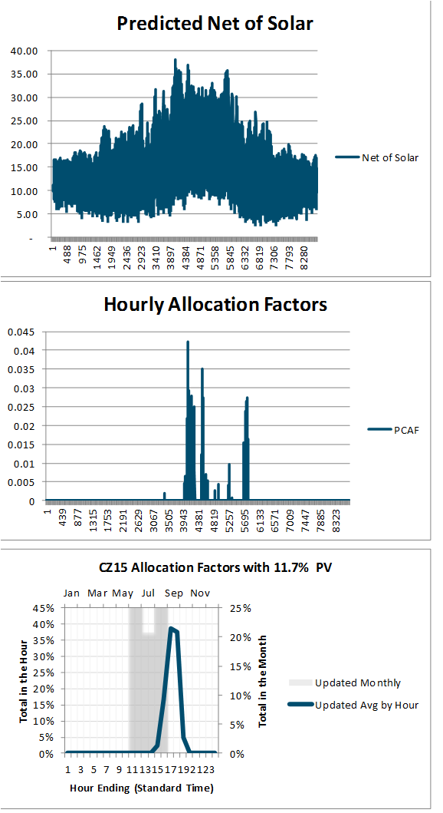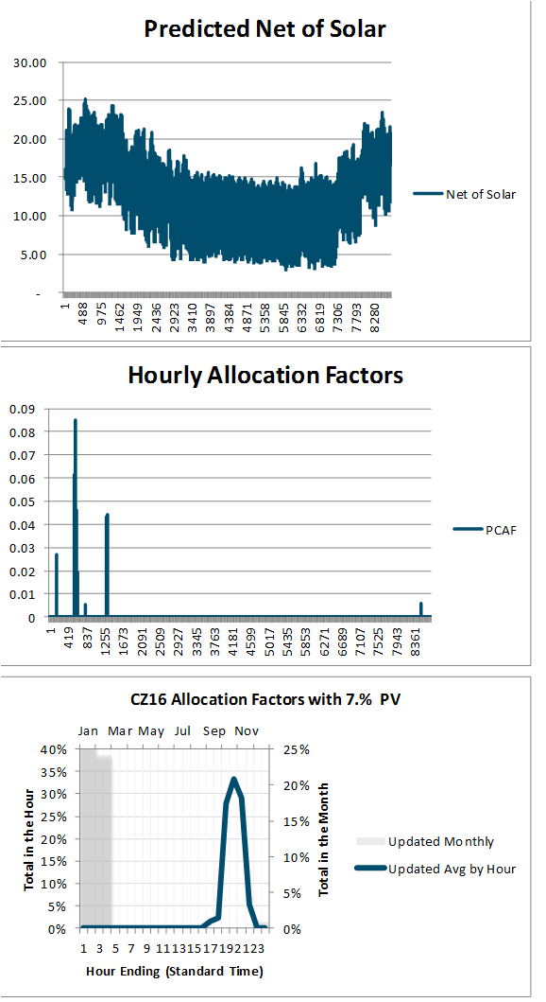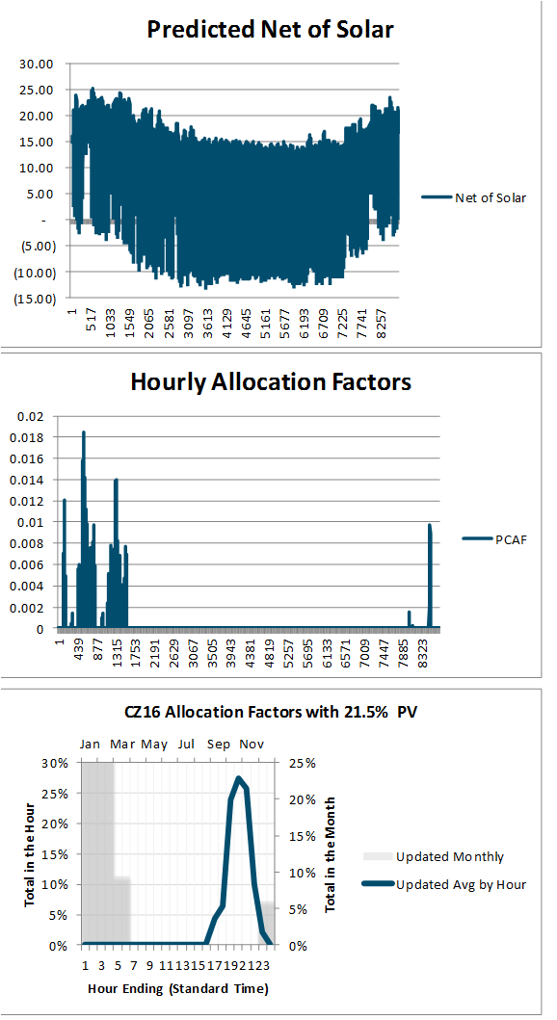

Table 14: Distribution Demand Regression Variables



Table 15: Distribution Demand Regression Model Fit



*Note that not all climate zones have readily available load data. In those cases, the regression equations from comparable climate zones were applied.*

## Distribution Load Simulation Regression Model *Specifications*

CZ2

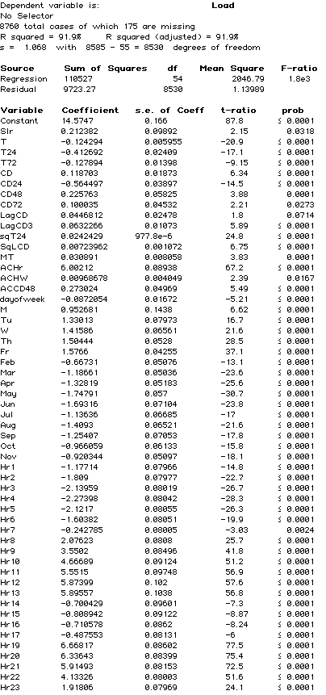

CZ3

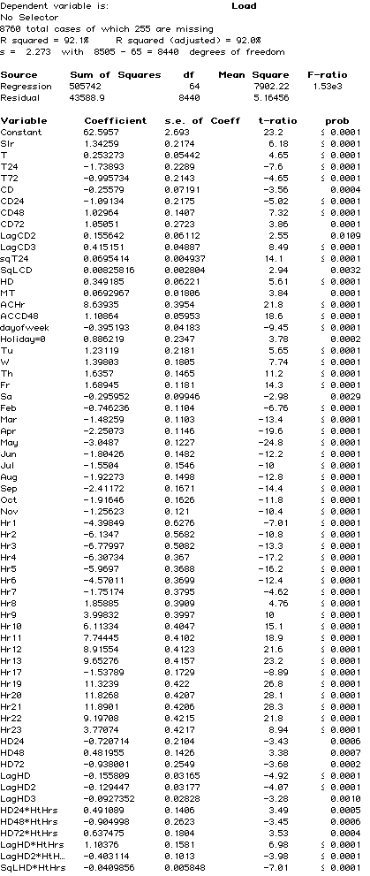

CZ4

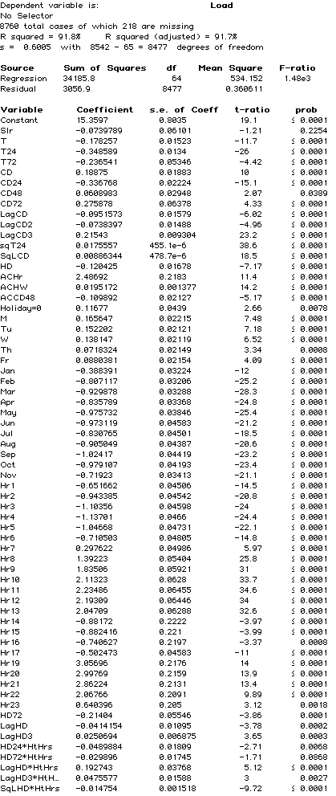

CZ6

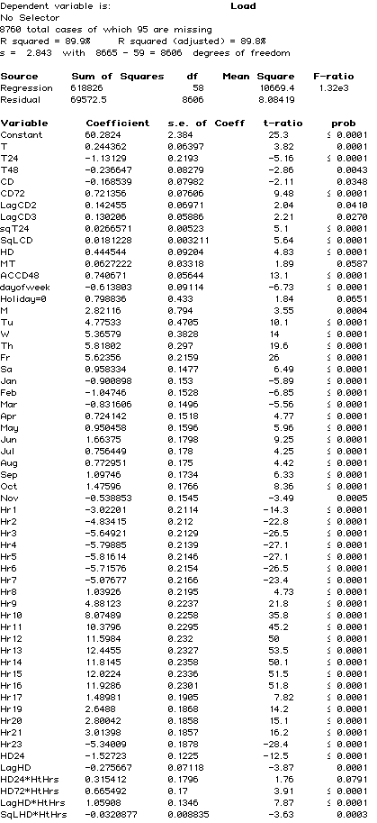

CZ7

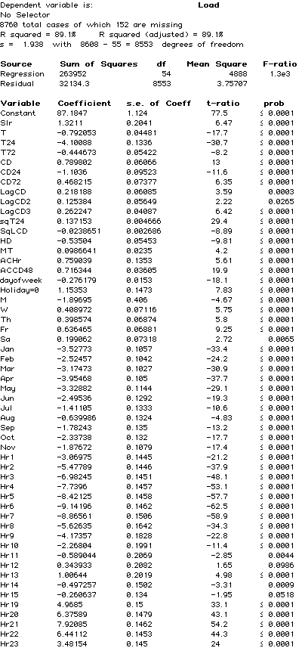

CZ8

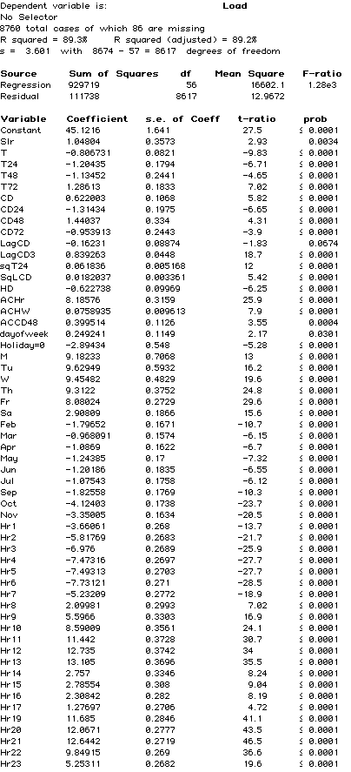

CZ9

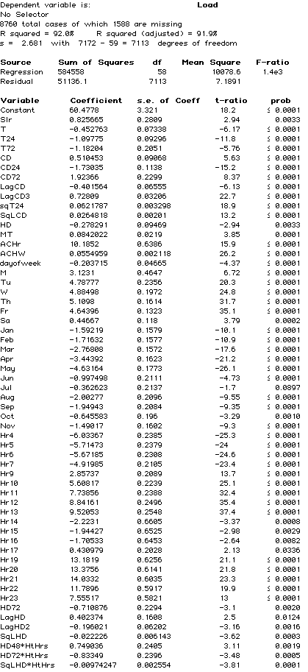

CZ 10

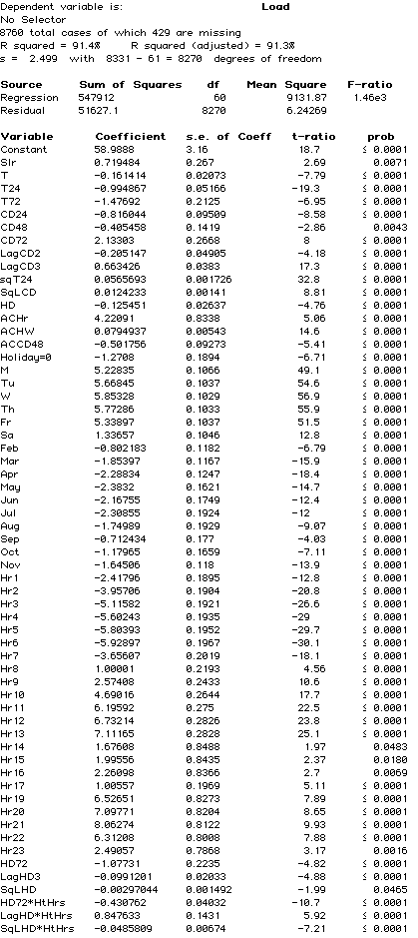

CZ12

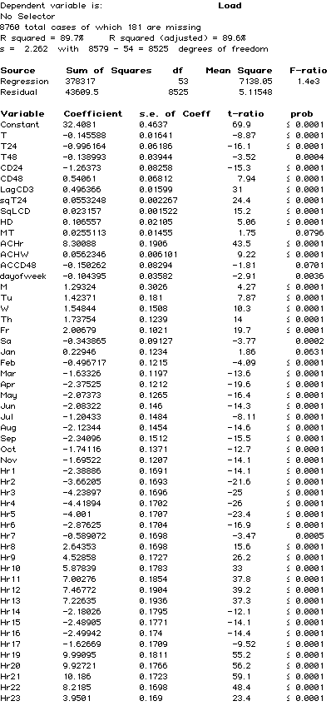

CZ13

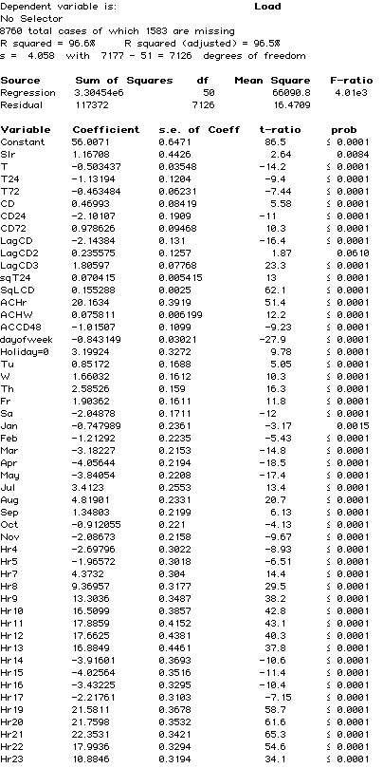

CZ 14



CZ15

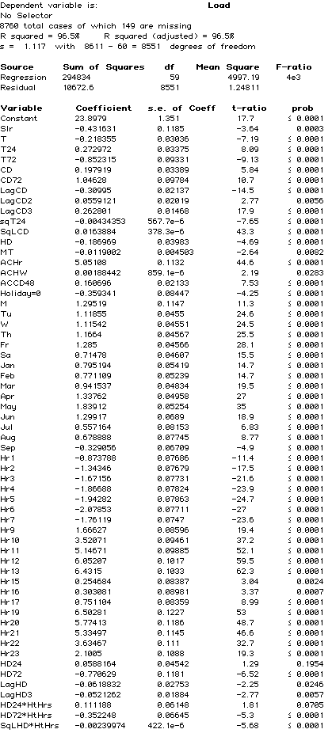

CZ16

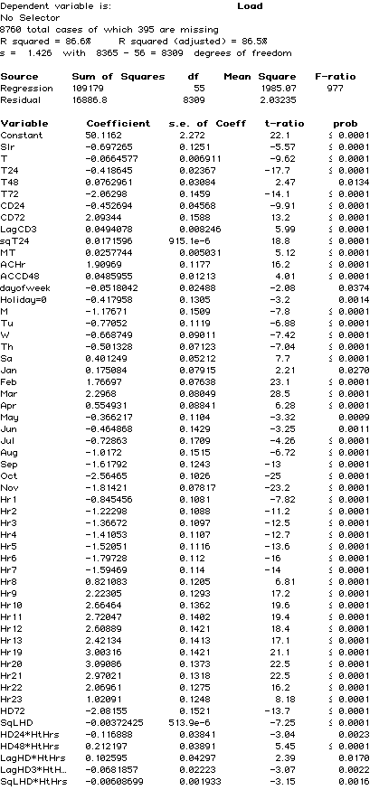

# User Quick Guide ACC 2018 v1d

## Purpose

The Avoided Cost Calculator (ACC) is a Microsoft Excel-based tool to calculate electricity avoided costs by hour and component. The ACC shows levelized hourly costs by component for one year on the **Dashboard** tab. The ACC can also generate the 31 year matrices of hourly costs by climate zone that are used for energy efficiency evaluation in California. These 31 year matrices are generated via VBA code and executed via the **Export Annual Avoided Costs – ALL CZ** and **Export Gen 7 Env for EE** buttosn on the **Dashboard** tab.

## Using the Model

The **Dashboard** tab will be the primary tab used by most users of the ACC. The tab provides user controls for the electricity avoided cost components to include in the output. The tab also allows the user to control which year, or which stream of years is represented in the tab output. The **Dashboard** tab also provides figures that summarize the results of the user's avoided cost choices, as well as the associated levelized hourly avoided costs by component (located just below the user controls).

Table 16: Summary of Controls

|  |  |
| --- | --- |
| Control | Note |
| Utility | PG&E, SCE, or SDG&E |
| Climate Zone | The ACC produces avoided costs that are specific to climate zones. The climate zones correspond to those used by the California Energy Commission for the Title-24 Building Energy Standards. Climate zone 3 has been divided into 3A (San Francisco and Peninsula) and 3B (Oakland and East Bay) because of the large historical difference in distribution capacity costs for those areas within climate zone 3. |
| Include Reserve Margin | (1 or 0) The default value of 1 should be used for avoided costs at the customer-level, that is avoided costs for demand-side actions. For generators that do not reduce customer load, this value should be set to zero. Reductions in load produce additional value compared to generation because of the planning reserve margin. Setting the value to zero removes the extra planning reserve margin generation capacity benefit from the avoided cost stream. |
| Start year | (2018 – 2048) This is the first year for reported avoided cost results. The avoided cost results will be expressed in this year's dollars. If a levelization period of one year is used, then the levelization results will be the avoided costs for this year only. Otherwise, this is the first year of the levelization stream.  Note that the ACC only contains avoided costs through 2047, so the combination of this entry and the Levelization Period should not exceed 2047. |
| Levelization Period | (1-30) The number of years to include in the levelization period. The levelization uses the real discount rate from the Inputs tab, and therefore is constant in real dollars, not nominal dollars. To convert the levelized values into annual values in nominal dollars, the levelized results should be escalated by inflation each year. |
| Electricity Components | (TRUE. FALSE) Indicates which components to include in the avoided costs displayed in the charts, and represented in the hourly results. Note that Losses are energy-related losses and are included or excluded based on the selection for Energy. Capacity-related losses are incorporated into the respective capacity avoided costs, and not reported separately. |
| Three-day shapshot Month | (1-12) The Dashboard can graph the component avoided costs for any continuous three-day period. This is the month for the first day in that period. |
| Starting Day | (1-31). This is the day of the month for the start of the three-day period. |

## Exporting Hourly Results

In addition to the levelized or single year results discussed above, the Avoided Cost Calculator can produce hourly avoided costs for 2018 through 2048. Because the amount of data associated with 31 years of hourly avoided costs, these results are output to separate Excel files, rather than added to the model itself. In addition, the results are written to the output files as the total avoided cost by year and hour, but not by avoided cost component[16]. All results are reported in $/MWh at the secondary voltage level.

The output files are written to a subfolder in the same directory as the Avoided Cost Model. The subfolder is named according the date the macro is run.

There are three macros included in the Avoided Cost Calculator. The buttons for each macro are located below Cell F20 on the Dashboard tab. Each macro is described below.

|  |  |
| --- | --- |
| Macro | Comment |
| Export Annual Avoided Costs – All CZ | Using the user-selected utility, the macro will iterate through each climate zone that applies to the utility. The macro will write the total hourly avoided costs for the components indicated by the *Electricity Component* inputs, and will include or exclude the planning reserve margin benefit base on the user input for *Incl Reserve Margin*. Note that because the macro is outputting results by year for all years, instead of levelized results, the Levelization Period and the Start year are ignored. |
| Export Annual Avoided Costs – One CZ | Same functionality as the macro above, but only outputs results for the user selected Climate Zone. |
| Export Gen & Env for EE | This is a specialized macro used to create output files used for the E3 Calculator and CET. It overrides the user selections to generate the needed transfer file for the selected utility. This should not be used by the general user of the model. |

## DR Reporting and PLS Tool Interface

Finally, the model aggregates specific outputs for input into the DR Reporting Tempate which is used to determine the cost-effectiveness of demand response.

The *DR Outputs* tab is an exact replica of the Inputs tab in the DR Reporting Template. Thus, the tab can be directly copy/pasted into the DR Reporting Template. A screenshot of this tab is shown below.

Figure 22: DR Outputs Tab in Avoided Cost Calculator

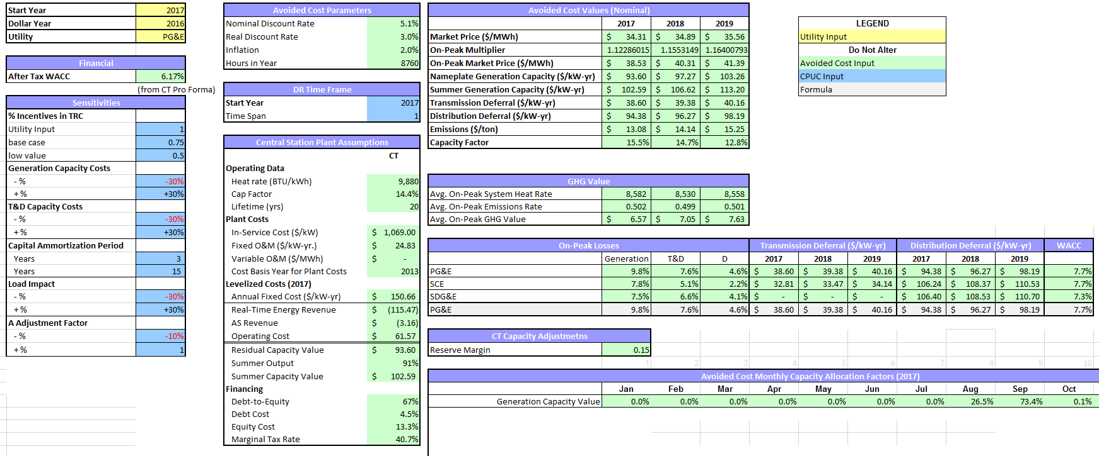

Additionally, the *PLS Outputs* tab organizes outputs of the Avoided Cost Calculator that can be copy/pasted as inputs into the *PLS Inputs* tab of the DR Reporting Template. A screenshot of this tab is shown below.

Figure 23: PLS Outputs tab in Avoided Cost Calculator

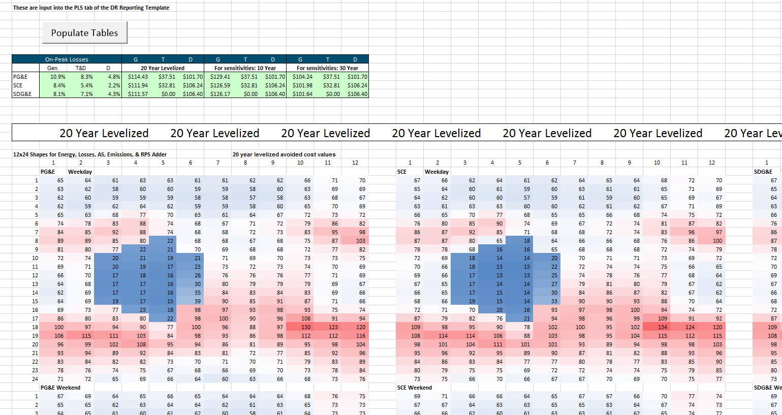

## Inputs

The data inputs for the model are on two tabs. The Hourly Data tab contains the hourly inputs for the model such as energy price shapes and capacity allocation factors. The Inputs tab contains the other inputs for the ACC, including natural gas costs, CO2 costs per ton, CT and CCGT plant costs, and T&D capacity costs.

If the user alters an input that affects energy or capacity, the calibration macro will need to be re-run. This can be done by pressing the “Calibrate Energy and Capacity Costs” button on either the Inputs or Market Dynamics tab. Note that the calibration process can be time consuming and takes about 10 minutes on a corei7 desktop PC.

## Remaining tabs

The remainder of the ACC tabs are calculation tabs, or associate with model control or tracking. These tabs are described briefly on the Cover tab for the ACC.

# Version Change Summary

## Avoided Cost Model Version ACC_2018_v1e

Revision Date: 5/10/2018 and 5/14/2018

Remove RPS adder (set model to zero out RPS adder when RPS busbar cost equals zero in the General Inputs tab.

Remove (1-RPS%) adjustment factor from calculation of marginal heat rates on emissions tab, and GHG adder and criteria pollutant costs on Dashboard tab

Update labels on dashboard figures

## Avoided Cost Model Version ACC_2018_v1b

Revision Date: 5/4/2018

Correct GHG Adder for 2016 constant dollars instead of 2015 constant dollars

## Avoided Cost Model Version ACC_2018_v1

Revision Date: 4/30/2018

1. **Data Updates**
   1. Natural gas prices
      1. NYMEX natural gas futures prices from most recent 22 trading days
      2. Long-term natural gas forecast using revised 2017 IEPR Mid-Demand case, and EIA 2018 AEO Report
      3. SoCal, PG&E BB and PG&E LT natural gas transportation rates from 2017 IEPR
      4. Municipal surcharge rate for PG&E
   2. Electricity Forward prices. On-peak and Off-peak forwards for NP-15 and SP-15 using most recent 22 trading days
   3. Ancillary service costs updated to 1.6% for annual energy from CAISO 2016 Annual Report on Market Issues and Performance (p. 142)
   4. Hourly Market Price Shapes
      1. Day ahead and real time prices for 2017 for NP-15 and SP-15.
      2. Daily 2017 natural gas spot prices (used to derive inferred heat rates)
      3. Average 2017 CO2 trading price
   5. CO2 market price forecast from Revised 2017 IEPR Mid-Demand forecast
   6. Societal cost of carbon from values adopted in CPUC Decision D18.02-018, Table 6
   7. T&D hourly allocation factors updated based on 2017 recorded weather by climate zone, and 2017 weekend and holiday schedules.
   8. Generation capacity hourly allocation factors updated using 2017 recorded weather
   9. New natural gas generation costs and performance updated based on 2017 IRP assumptions.

## Avoided Cost Model Version ACC_2017_v1

Revision Date: 9/18/2017

1. **Methodology enhancements**
   1. Add societal cost of CO2 forecast, and include residual value of Societal Value – Market value of CO2 as a GHG adder component

## Avoided Cost Model Version ACC_2016_v1

Revision Date: 5/31/2016

1. **Methodology corrections and enhancements**
   1. Update T&D allocation factors to reflect recent IOU distribution loading patterns and simulate increased PV impacts on net distribution loads
   2. Replace 250 peak hour method for generation capacity allocation with unserved energy probabilities based on E3 RECAP model[17].
   3. Replace use of private long-run gas forecasts (as no longer procured by the CPUC) with IEPR and EIA escalation rate.
   4. Replace 2010 MRTU hourly energy price shapes with 2015 data and update the hourly price shapes to reflect changes in market prices expected to occur due to increased renewable generation as California continues to move toward the 50% RPS goal.
   5. Include the carbon price and variable O&M in the dispatch logic for calculating the residual net cost of generation capacity.
   6. Forecast annual energy prices that include CO2 costs (consistent with the cap and trade market), and decompose those prices into energy and monetized carbon (cap and trade) components.
   7. Include adjustments to the hourly energy price profile using the CPUC RPS Calculator to account for projected increases in renewable generation. RPS Calculator implied heat rate changes by month/hour are incorporated into the price shape for 2020. Adjustments prior to 2020 are linearly interpolated, and adjustments after 2020 are held at the 2020 levels.
   8. CT levelized cost changes
      1. Change from use of instant costs to installed costs as CT plant cost input
      2. Remove manufacturer tax credit
      3. Remove short term tax effect scaling factor (as installed costs are used instead of instant costs)
2. **Simple Data Updates**
   1. Move the resource balance year (the year when the avoided costs for are based on sustaining new CT and CCGT units in the market) to 2015.
   2. Update the cost and operating characteristics of a simple cycle gas turbine (CT) and a combined cycle gas turbine (CCGT) unit with data from the CEC Estimated Cost of New Renewable and Fossil Generation in California report[18].
   3. Update the ancillary service percentage relative to energy costs to reflect 2015 markets
   4. Update the CT ancillary revenues adder with the CAISO 2015 market performance and monitoring report.
   5. Update T&D capacity costs for latest utility General Rate Case (GRC) filings.
   6. Replace Synapse forecast of CO2 price forecast with 2015 IEPR mid-case forecast values
   7. Update the marginal RPS cost (used to calculate the RPS premium) with values from the latest RPS Calculator spreadsheet model (version 6.2)
   8. Updated RECAP model to incorporate 2015 LTPP net qualifying capacity generator data, updated NREL wind profiles from the western wind dataset, and load and renewable penetrations consistent with SB 350 i.e. 2x energy efficiency and 50% RPS by 2030

1. The actual process steps for determining the calibration factor for each year (and therefore the real-time and day-ahead market prices) are listed below.

   1. Set the annual day-ahead energy price at the 2017 level increased by the percentage change in the forecast annual gas burner tip price.
   2. Set the energy market calibration factor to 100%
   3. Multiply (1) by (2) to yield the adjusted annual day-ahead price
   4. Calculate capacity cost
      1. Multiply the real-time hourly price shape by the adjusted annual day ahead price
      2. Dispatch a new CT against the hourly prices in Northern and Southern CA from 4a to determine real time dispatch revenue in Northern and Southern CA
      3. Calculate ancillary service revenues as 2.74% of the real-time dispatch revenue
      4. Capacity value is the net capacity cost. Net capacity cost = the levelized cost of the new CT plus fuel and O&M costs less 4.b and 4.c.
      5. Adjust capacity value ($/kW-yr) to reflect degraded output at system peak weather conditions
      6. Set the capacity value at the average of Northern and Southern CA capacity values
   5. Calculate energy cost
      1. Multiply the day-ahead hourly price shape by the adjusted annual day ahead price
      2. Dispatch a new CCGT against the hourly prices from 5.a to determine the day-ahead dispatch revenue
      3. Calculate the excess (deficient) margin of a CCGT unit as the levelized cost of a new CCGT plus fuel and O&M costs less 5.b and less 4.e (adjusted for CCGT output degradation)
   6. If there is excess or deficient margin for the CCGT unit, decrease or increase the energy market calibration factor, and repeat from step 2.

  
2. https://e3.sharefile.com/d-s517ef02de3740209
3. . According to the CAISO’s 2015 Annual Report on Market Issues and Performance CT A/S revenues from 2012 through 2015 averaged 2.74% of the CT energy market revenue <http://caiso.com/Documents/2015AnnualReportonMarketIssuesandPerformance.pdf> Table 1.10 Financial analysis of a new combustion turbine (2012-2015). An updated value was not available in the CAISO’s 2016 annual report.
4. The market calibration factor is used to adjust the energy market prices to a level each year such that a new CCGT would not over or under collect its return on and of capital from the energy market margins, and is described in more detail in the energy market section.
5. ISO conditions assume 59ºF, 60% relative humidity, and elevation at sea level.
6. See D.10-06-036 OP 6b, and the 2012 Final RA Guide at <http://www.cpuc.ca.gov/PUC/energy/Procurement/RA/ra_compliance_materials.htm>
7. <https://ethree.com/public_projects/recap.php>
8. <http://caiso.com/Documents/2015AnnualReportonMarketIssuesandPerformance.pdf> p. 9
9. While the updated allocation factors are superior to the prior values, they are not substitutes or replacements for the work that utilities are currently undertaking as part of the DRP proceeding. These allocation factors are simulations based on a limited number of 2010 circuit and substation load patterns. Actual loading for a specific local distribution area within a climate zone could vary significantly from the loading assumed herein. Moreover, the IOUs may develop alternate methods for determining the peak contribution of distributed energy resources.
10. The complete list of regression variables and model fit can be found in the Appendix.
11. The monetized carbon (cap & trade) cost separates out the cost of CO2. Costs for NOx and PM-10 are typically minimal for natural gas units, and those costs have not been separated out from the energy component.
12. 2.3 percent per year annual inflation was used. The value is from the 2/9/2018 Long-term inflation forecast from the Federal Reserve Bank of Philadelphia Survey of Professional Forecasters, rounded to the nearest tenth of a percent. https://www.philadelphiafed.org/research-and-data/real-time-center/survey-of-professional-forecasters/historical-data/inflation-forecasts
13. More information about the use of non-energy benefits to evaluate Low Income programs can be found in the revised final report “ *Non-Energy Benefits: Status, Findings, Next Steps, and Implications for Low Income Program Analyses in California*” issued May 11, 2010. <http://www.liob.org/docs/LIEE%20Non-Energy%20Benefits%20Revised%20Report.pdf>
14. <http://www.cpuc.ca.gov/PUC/energy/Energy+Efficiency/EM+and+V/Embedded+Energy+in+Water+Studies1_and_2.htm>
15. <http://www.ethree.com/public_projects/cpucOEEP.php>
16. Costs by component could be generated by running the export macros with only the desired component set to TRUE in the Dashboard Electricity Components section.
17. <https://ethree.com/public_projects/recap.php>
18. <http://www.energy.ca.gov/2014publications/CEC-200-2014-003/index.html>