Energy and Environmental Economics, Inc
Avoided Costs
2019 Update
Brian Horii
Eric Cutter
Ben Shapiro
Christa Heavey

June 26, 2019

Table of Contents

1 Overview 5
1.1 Data Updates and Corrections 5
1.2 Summary of Results 8
1.3 Model Overview 11
2 Natural Gas Avoided Cost Updates 13
3 Overview of Electricity Avoided Cost Components 17
4 Avoided Cost Methodology 21
4.1 Natural Gas 21
4.1.1 Continental natural gas market 21
4.1.2 Natural gas commodity 24
4.1.3 Avoidable marginal distribution costs for core customers 25
4.1.4 Transportation charges for electric generators 25
4.2 Generation Energy 26
4.2.1 Determination of energy market values 27
4.2.2 Hourly Allocation of Energy Costs 29
4.3 Generation Capacity 30
4.3.1 Generation resource balance year 31
4.3.2 CT dispatch 31
4.3.3 Temperature effect on unit performance 33
4.3.4 Planning reserve margin and losses 35
4.3.5 Hourly allocation of capacity value 36
4.4 Ancillary Services (AS) 38
4.5 T&D Capacity 38
4.5.1 Hourly Allocation of T&D Capacity Cost 42
4.6 Cap & Trade and GHG Adder Values 46
4.6.1 Monetized Carbon (Cap and Trade) 46
4.6.2 GHG Adder 49
4.6.3 GHG for Natural Gas Avoided Costs 51
4.7 Avoided RPS Cost 51
Components Not Included 53
5 Appendix: Key Data Sources and Specific Methodology 54
5.1 Power plant cost assumptions 54
5.2 Generation Loss Factors 55
5.3 Climate Zones 57
5.4 T&D Allocation Factors 59
5.5 Distribution Load Simulation Regression Model Specifications 70
5.6 Low Efficiency Threshold Analysis 83
6 User Quick Guide ACC 2019 v1 85
6.1 Purpose 85
6.2 Using the Model 85
6.3 Exporting Hourly Results 86
6.4 DR Reporting Interface 88
6.5 Inputs 88
6.6 Remaining tabs 89
7 User Quick Guide GasModel 89
7.1 Purpose 89
7.2 Using the Model 89
7.3 Results 90
7.4 Inputs 90
8 MPR Gas Model 2019 91
8.1 Purpose 91
8.2 Using the Model 92
9 Version Change Summary 93
9.1 Avoided Cost Model Version ACC_2019_v1b 93
9.2 Avoided Cost Model Version ACC_2018_v1h 96
9.3 Avoided Cost Model Version ACC_2017_v1 97
9.4 Avoided Cost Model Version ACC_2016_v1 98

Overview
This technical memo describes the inputs and methods used to update the avoided costs for cost-effectiveness valuation for 2019 through 2049. The focus of this update is to incorporate historical market and weather information from 2018, as well as forecast market and commodity prices as of May 2019. This update builds upon ACC_2018_v1h of the avoided cost calculator (ACC). Major methodological changes were not considered.
The new avoided cost calculator is ACC_2019_v1b.

Data Updates and Corrections
Data updates included in ACC_2019_v1b are listed below:
- Natural gas prices
  - New York Mercantile Exchange (NYMEX) natural gas futures prices from most recent 22 trading days
  - Long-term natural gas forecast using revised 2019 Integrated Energy Policy report (IEPR) Mid-Demand case, and Energy Information Administration (EIA) 2019 Annual Energy Outlook (AEO) Report
  - SoCal, PG&E BB and PG&E LT natural gas transportation rates from 2019 tariff sheets (effective April 1, 2019)
  - Municipal surcharge rate for SoCal Gas
- Electricity Forward prices. On-peak and Off-peak forwards for NP-15 and SP-15 using most recent 22 trading days
- Ancillary service costs updated to 0.9% for annual energy from the CAISO 2018 Annual Report on Market Issues and Performance, excluding regulation services. (from pp. 141-142 of that report)
- Hourly Market Price Shapes
  - Day-ahead and real-time prices for 2018 for NP-15 and SP-15.
  - Daily 2018 natural gas spot prices for PG&E Citygate and SoCal Border hubs (used to derive implied heat rates)
  - Average 2018 CO₂ trading price, from March 2019 IEPR (Preliminary Carbon Allowance Price Scenarios)
- CO₂ market price forecast from Revised 2019 IEPR Mid-Demand forecast
- Transmission and distribution (T&D) marginal costs ($/kW-yr values) were updated from the following sources:
- PG&E: settlement agreement in the utility’s 2017 Phase II General Rate Case (GRC) proceeding.
- SCE: estimates by SCE’s regression analysis of cumulative distribution capacity-related investments and cumulative peak loads, consistent with avoided distribution capacity costs that have been used for SCE in prior avoided cost updates.
- SDG&E: testimony filed by the utility in its 2016 GRC (as these costs were not adopted in the proceeding or related settlement agreement).
- T&D hourly allocation factors were updated based on 2018 recorded weather by climate zone, and 2018 weekend and holiday schedules.
- Generation capacity hourly allocation factors were updated using 2018 recorded weather.
- New natural gas generation costs and performance remain based on 2017 Integrated Resource Plan (IRP) assumptions (no change from 2018 version of the ACC), while financing costs for new generation have been updated based on the CEC’s 2019 Estimated Cost of New Utility-Scale Generation in California: 2018 Update.
- Several inputs for natural gas avoided costs were updated, in addition to the market prices used for electricity avoided costs:
  - California electric generation gas price forecast from the updated “MPR Gas Forecast 2019”
  - Gas transportation rates sourced directly from current utility tariffs
  - Inflation rate and nominal discount rate to reflect values used in the electricity ACC model.
In addition to the updates described above, several corrections to the ACC have been made:
- Inconsistent calculation references to Northern California vs. Southern California price and temperature adjustments and heat rate multipliers were resolved (on the “Market Dynamics” tab).
- The model was updated to account for hours with negative energy prices but positive GHG emissions (a situation which will no longer occur).
- The regression equations used to estimate T&D allocation factors were corrected to include an improved forecast of distributed PV by climate zone (see Section 4.5.1 for additional detail).
- The “DR Outputs” tab was corrected to report outputs for five years, rather than three.
Finally, the following methodological change was made for the 2019 ACC update.
- The assumed high efficiency heat rate threshold for natural gas generators was reduced from 6,900 to zero Btu/kWh, to reflect that hours with low implied marginal heat rates may represent averaging of marginal fossil fuel and renewable resources within that hour, either temporally or spatially. The low efficiency heat rate threshold was maintained at 12,500 Btu/kWh. Please see Sections 4.6.1 and 5.6 for additional detail on the change to the high efficiency threshold and the maintenance of the low efficiency threshold.

Summary of Results
The avoided costs – excluding transmission and distribution (T&D) – in the 2019 ACC update are similar to those included in the 2018 version in the first several years, and slightly below those estimates during the later years of the forecast period. This is driven by an increased short-term yet decreased long-term natural gas forecast (based on market forwards and the EIA Annual Energy Outlook (AEO), respectively).
Figure 1: Average Annual Total Avoided Cost, Excluding T&D. NP-15
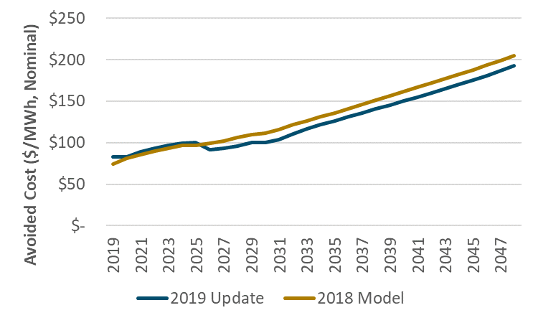
Figure 2: Average Annual Total Avoided Cost, Excluding T&D. SP-15
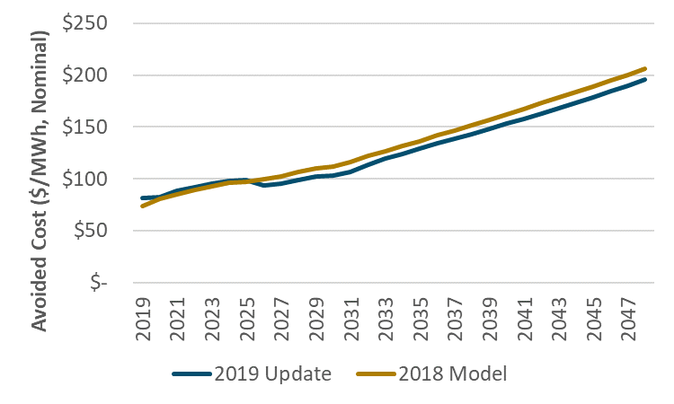
The updated hourly market prices and allocation of generation capacity costs reflect a similar variation in value between the low mid-day hours and the other higher value hours as was seen in the 2018 update. This is illustrated in the figures below, which show the average annual non-T&D avoided cost for each hour of the day. These figures show NP-15, specifically, but analogous figures for SP-15 would essentially be the same.
Figure 3: 2020 NP-15 Average Annual Total Avoided Cost by Hour of the Day, Excluding T&D
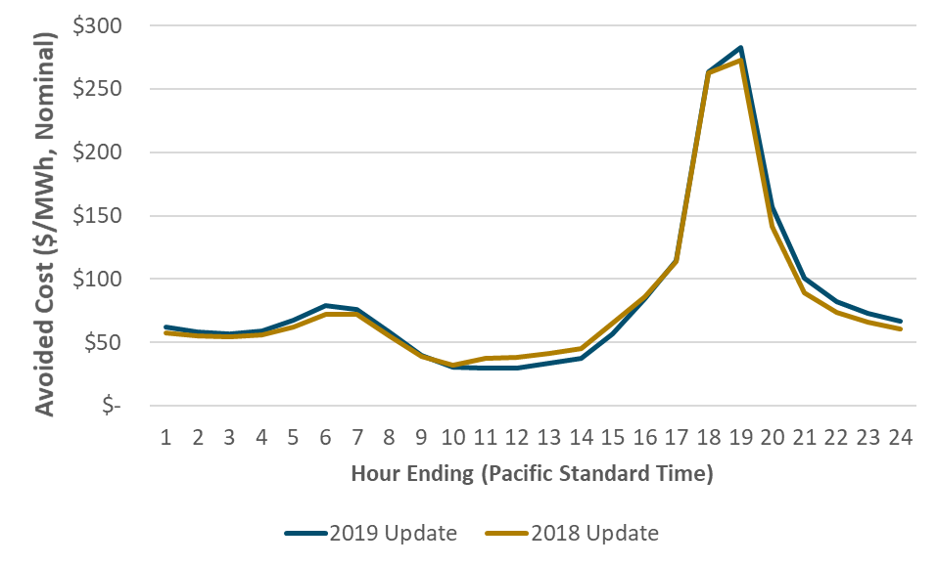
Figure 4: 2030 NP-15 Average Annual Total Avoided Cost by Hour of the Day, Excluding T&D
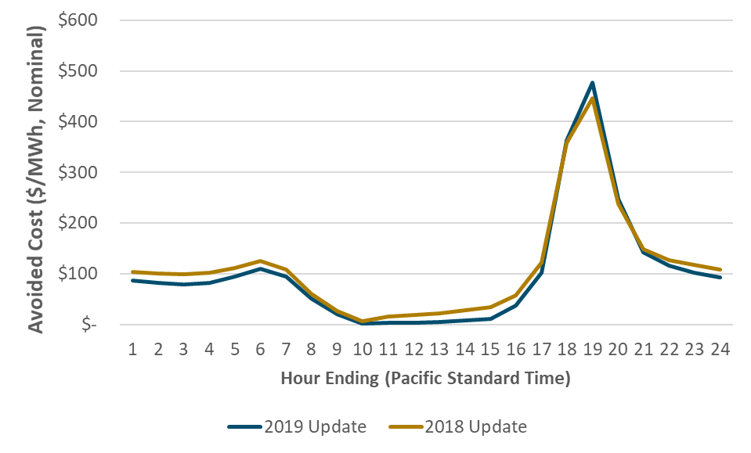

T&D unit marginal costs ($/kW-yr values) were updated for the 2019 ACC, as described further in Section 4.5 of this report. The hourly allocation of these marginal unit costs was also updated, using 2018 weather data and revised estimates of distributed solar generation by climate zone. Details on the updated allocation factors can be found in Section 4.5.1.

Model Overview
Figure 5, below, provides a high-level overview of the ACC model, depicting the primary inputs used to calculate each avoided cost component. Additional detail on each of these calculations is provided in Sections 3 and 4 of this report.
Figure 5: Avoided Cost Calculator Model Overview
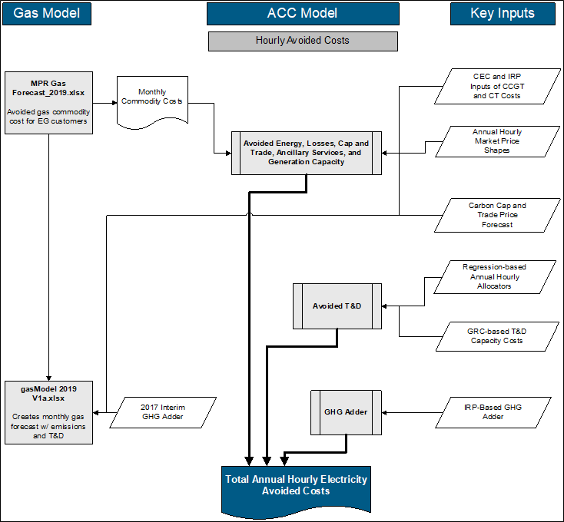

The remainder of this report presents the avoided cost methodology and documents the inputs updated for 2019.

Natural Gas Avoided Cost Updates
The Natural Gas Avoided Cost Calculator is a separate model, distinct from the ACC which most of this document focuses on. The two models share some inputs but are used for distinct purposes. Namely, while the (electricity) ACC is used to evaluate the long-run marginal avoided costs on the electric grid attributable to demand-side resources, the Natural Gas Avoided Cost Calculator is instead used specifically to evaluate measures designed to decrease natural gas usage.
The natural gas price forecast is updated using a modified version of the Market Price Referent (MPR) methodology. The methodology uses market forwards through 2024, and long-run forecasts from the IEPR and the U.S. EIA Annual Energy Outlook (AEO) report for 2029 and beyond. The prices for the interim years are a linear interpolation.
The market forward prices are averages from S&P Global Intelligence for the most recent 22 trading days (April 22, 2019 through May 21, 2019) for Henry Hub, PG&E Citygate, and SoCal Border. The natural gas forecast for 2019 through 2024 is the average of the PG&E Citygate and SoCal Border forward prices, plus transportation rates, franchises fees and hedging transaction costs.
The long-term forecast is the 2019 EIA AEO report forecast for Henry Hub, plus the average of the PG&E Citygate and SoCal Border basis spreads, plus transportation, franchise fees and hedging transaction costs. The basis spreads are the average spreads in the NYMEX market forwards between Henry Hub and the California locations (from S&P Global Intelligence for the most recent 22 trading days).
We have updated the intrastate natural gas transportation rates using the CEC IEPR April 2018 Staff Report. The gas price forecast also includes the following price adjustments:
- Transaction Cost (hedging Cost): $0.084/MMBTU
- Municipal Surcharge (Franchise Fees): 1.18%.
The updated natural gas price forecast is shown in Figure 6.
Figure 6. Natural Gas Price Forecast for Electric Generators
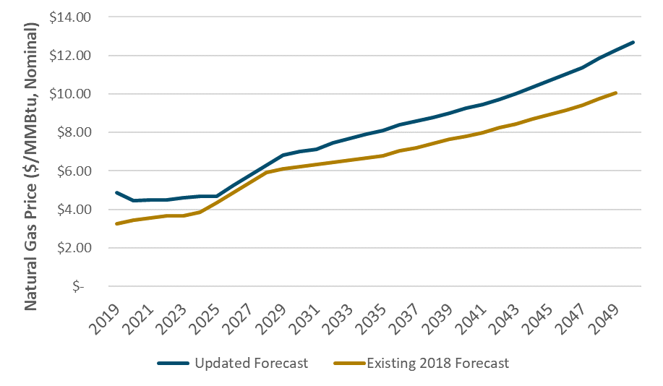
Relative to the 2018 forecast, the 2019 update both begins at a higher value and escalates more quickly beginning after the 2020s. As shown in Figure 7 below, the fundamental natural gas commodity forecast (from the EIA AEO 2019) is actually lower than the previous year’s outlook; however, the increased transportation rates included in the 2019 ACC have driven the natural gas electric generator price forecast above the 2018 version.
Figure 7. EIA Natural Gas Forecast: 2019
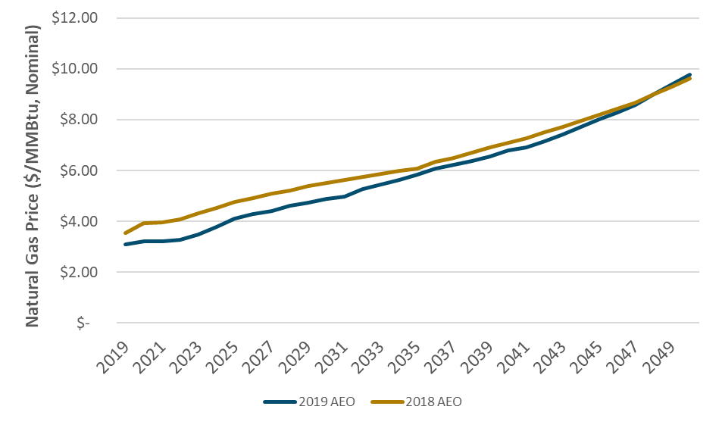
The natural gas forecast also incorporates monthly variations in natural gas prices—commodity prices tend to rise in the winter when demand for natural gas as a heating fuel increases. The monthly price profiles are based on the monthly NYMEX Henry Hub natural gas prices through 2025 and then the monthly price profile is held constant thereafter. The market price also reflects municipal surcharges, of which the value for SoCal Gas territory was updated based on a 2019 tariff change. Figure 8 shows four snapshots of the monthly shape of the natural gas price forecast.
Figure 8. Snapshot of Monthly Gas Price Forecast Shapes
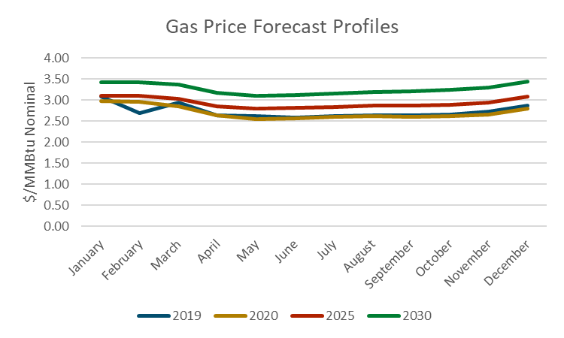
Note that values for January 2019 through March 2019 are actual market prices, rather than market forwards.

For the avoided costs used to evaluate natural gas EE reductions, the following costs are added to the commodity cost.
- Compression (0.39%),
- Losses and unaccounted for (1.37%),
- Marginal transmission and delivery costs (varies by utility),
- NO_{X} and CO₂

None of these additional cost items has been changed in this update. Specifically, the emission cost of CO₂ continues to use the interim GHG adder from 2017. The cost of CO₂ has been updated for electricity avoided costs, and is discussed in the electricity avoided cost section of this memo.
The marginal cost of gas distribution capacity has not been revised in this update.

Overview of Electricity Avoided Cost Components
This section provides a brief overview of the electricity avoided cost components and their contribution to the total electricity avoided costs. This is followed by detailed discussions of the updates for each component in the subsequent sections.
The avoided cost used for electricity energy efficiency evaluation is calculated as the sum of six components shown in Table 1.
Table 1. Components of Electricity Avoided Cost
Component | Description
Generation Energy | Estimate of hourly wholesale value of energy
Generation Capacity | The costs of building new generation capacity to meet system peak loads
Ancillary Services | The marginal costs of providing system operations and reserves for electricity grid reliability
T&D Capacity | The costs of expanding transmission and distribution capacity to meet peak loads
Cap and Trade Costs | The cost of Cap and Trade allowance permits for carbon dioxide emissions associated with the marginal generating resource; i.e., the carbon value explicitly included as a cost in electricity generation
GHG Adder | The difference between the CPUC-adopted total value of CO₂ and the Cap and Trade value of CO₂; i.e., the incremental value of GHG abatement, above the Cap and Trade price
Avoided RPS | This component has been set to zero
Each of these avoided cost components is determined for every hour of the year, for a period of 31 years starting in 2019. The hourly granularity is obtained by shaping forecasts of the average value of each component with historical day-ahead and real-time energy prices and actual system loads. Table 2 summarizes the methodology applied to each component to develop this level of granularity.
Table 2. Summary of Methodology for Electricity Avoided Cost Component Forecasts
Component | Basis of Annual Forecast | Basis of Hourly Allocation
Generation Energy | Forward market prices and the $/kWh fixed and variable operating costs of a CCGT | Historical hourly day-ahead market price shapes from CAISO OASIS
Generation Capacity | Residual capacity value a new simple-cycle combustion turbine | RECAP model that generates outage probabilities by month/hour and allocates the probabilities within each month/hour based on 2018 weather
Ancillary Services | Percentage of Generation Energy value | Directly linked with hourly energy allocation
T&D Capacity | Marginal transmission and distribution costs from utility ratemaking filings | Hourly 2018 temperature data by climate zone
Cap and Trade Costs | CO₂ cost forecast from revised 2019 IEPR mid-demand forecast, escalated at inflation beyond 2030 | Directly linked with energy shape with bounds on the maximum and minimum hourly value
GHG Adder | Difference between total value of CO₂ and monetized carbon cost in the energy market prices. | Same as Cap and Trade costs
Avoided RPS | Set to zero to be consistent with GHG adder | NA

Figure 9, below, shows a three-day snapshot of the avoided costs, broken out by component, in Climate Zone 4. As shown, the cost of providing an additional unit of electricity is significantly higher in the summer afternoons than in the very early morning hours. This chart also shows the relative magnitude of different components in this region in the summer for these days. The highest peaks of total cost shown in Figure 9 of over $7,500/MWh are driven primarily by the allocation of T&D capacity to the peak hours (because of high demand in those hours), but also by higher energy market prices during the late afternoon and early evening.
Figure 9. Three-day Snapshot of Energy Values in CZ4 in 2019 (Pacific Standard Time)
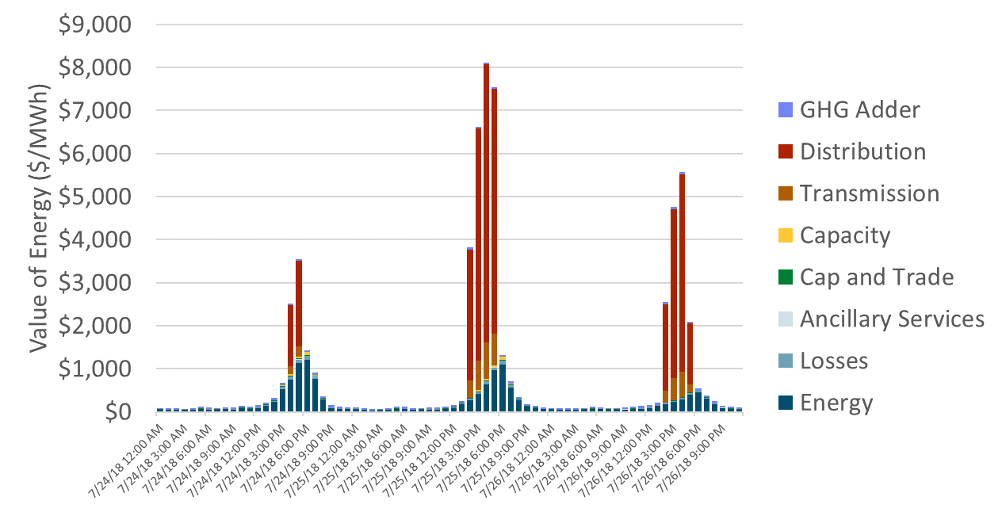
Figure 10 shows average monthly value of electricity reductions, revealing the seasonal characteristics of the avoided costs. The energy component dips in the spring, reflecting low energy prices due to increased hydro supplies and imports from the Northwest; and peaks in the summer months when demand for electricity is highest. The value of capacity—both generation and T&D—is concentrated in the summer months and results in significantly more value on average in these months.
Figure 10: Average Monthly Avoided Cost in CZ4 in 2019
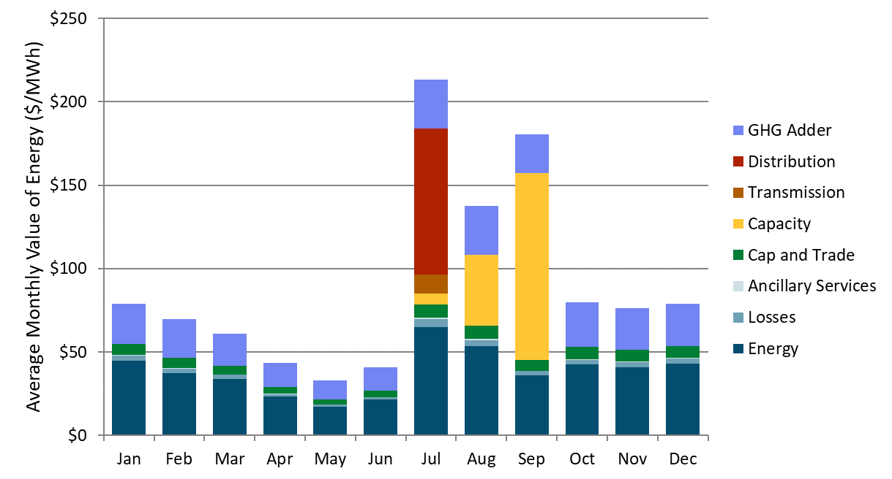
Figure 11: Average Monthly Avoided Cost in CZ4 by Hour of the Day in 2019
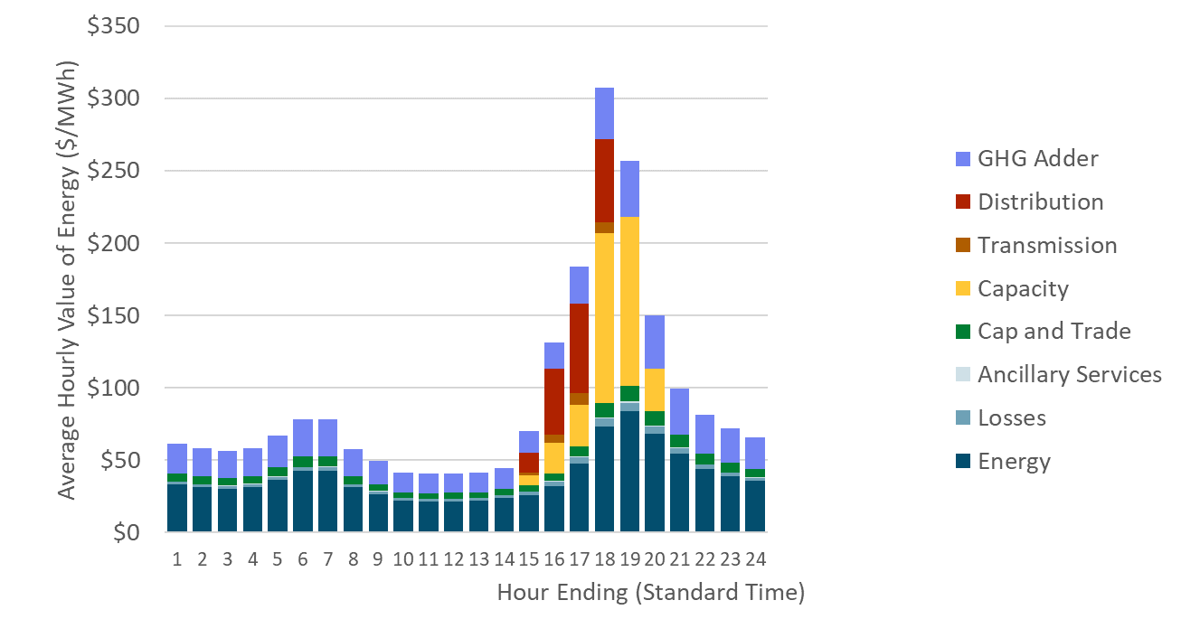
Figure 12 shows the components of value for the highest value hours in sorted order of cost. This chart shows the relative contribution to the highest hours of the year by component. Note that most of the high cost hours occur in approximately the top 100 to 300 hours—this is because most of the value associated with capacity is concentrated in a limited number of hours. While the timing and magnitude of these high costs differ by climate zone, the concentration of value in the high load hours is a characteristic of the avoided costs in all of California.
Figure 12. Price Duration Curve Showing Top 1,000 Hours for CZ4 in 2019
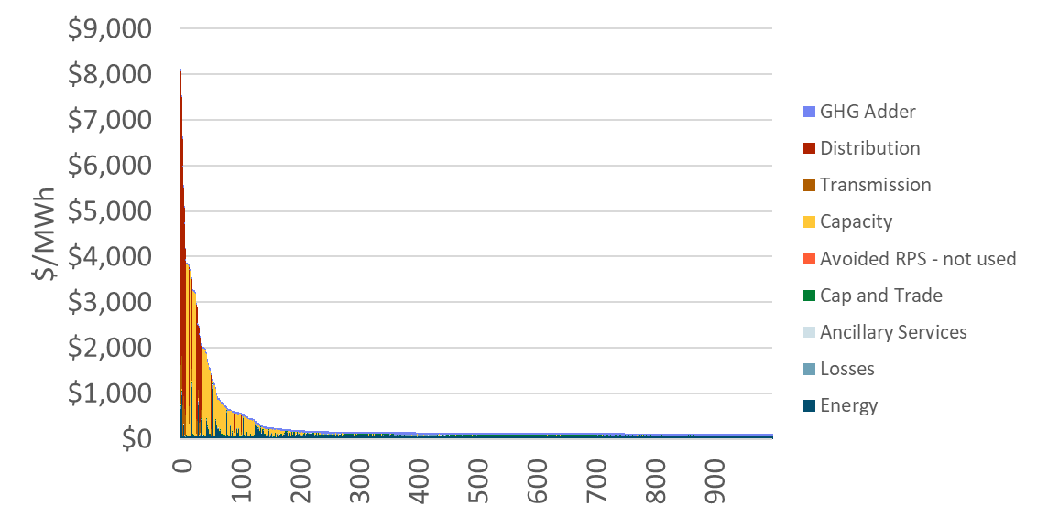

Avoided Cost Methodology

Natural Gas

Continental natural gas market
Natural gas delivered to California consumers is traded in an aggregate wholesale market that spans most of North America. Natural gas is produced at many locations, the most important of which are the Gulf of Mexico, southern Great Plains, Western Canadian Sedimentary Basin, and the Rocky Mountains regions. Interstate natural gas pipelines transport the gas from the wellhead to wholesale market centers or “pricing points”, where buyers include marketers, large retail customers, electric generators, and local distribution companies (LDCs) that purchase gas on behalf of small retail customers. These points are typically intersections of major pipelines, where buyers and sellers from different regions interact to form a spot market.
Spot gas trading
Spot gas is traded in monthly and daily packages. Monthly deals are made during the last week of each month (“bid week”) for delivery the following month. Daily trading is generally for delivery the following day. Spot gas trading is overwhelmingly bilateral, with buyers and sellers trading standard contracts by telephone or on electronic bulletin boards. Gas traders voluntarily report price and volume information to publishers such as Platts, which in turn report indexes based on representative prices for dozens of pricing points throughout the United States and Canada.
Two locations have emerged as particularly important trading hubs: AECO, in Alberta, Canada and Henry Hub, in Louisiana. These trading hubs are located near major producing regions in the Western Canadian Sedimentary Basin and the Gulf of Mexico, respectively. Henry Hub, the delivery location for the NYMEX futures contracts, serves as a benchmark for the continental natural gas market.
NYMEX futures contracts
The New York Mercantile Exchange (NYMEX) offers trading in natural gas futures contracts. A NYMEX contract is for 10,000 MMBtu delivered uniformly across a calendar month to Henry Hub. Prices are quoted in dollars per MMBtu. At any given time, 72 consecutive monthly contracts are open for trading, beginning with the next calendar month. NYMEX futures contracts are settled daily on a mark-to-market basis; all traders holding “open” positions either pay or receive funds (“margins”) each day depending on the change in the settlement price from the previous day.
NYMEX futures trading is extremely liquid, especially in the early months, and the gas futures contract has become a closely watched barometer of market expectations for future price movements. NYMEX gas futures prices help discover the spot gas prices in a future delivery period via trading activities of futures buyers and sellers.
Basis trading
Traders typically link prices at different locations through “basis differentials.” A basis differential is the difference in the market value of natural gas at two separate physical locations at the same point in time. Basis differentials respond to temporary events such as localized shortages or surpluses of natural gas supply or reductions in pipeline capacity. They can also vary over time with the introduction of new pipeline or storage capacity, changes in production costs at various locations, or permanent demand shifts.
Forward basis differentials are traded as financial derivatives known as “basis swaps.” The holder of one side of a basis swap agrees to pay the counterparty the difference between the spot prices at the two specified locations at the designated time. NYMEX offers clearing services and calculates settlement prices for forward natural gas basis swaps contracts between Henry Hub and a number of pricing points, including two California locations: PG&E Citygate and SoCal Border. NYMEX forward basis swaps contracts are for 2,500 MMBtu, and are settled as the monthly bidweek spot price (as defined by a particular price index such as Natural Gas Intelligence) minus the final settlement price of a Henry Hub futures contract for the corresponding month. NYMEX will clear trades for basis swaps up to 36 months out in time, although settlement prices are only calculated for those months in which traders hold open positions.

Natural gas commodity
E3’s approach divides the forecast time frame into three periods, defined by the availability of market data. This hybrid approach combines a market-based forecast for the near-term, when futures contracts are traded, and a model-based forecast for the long-term when there is no futures trading.
- Market Period (2019-2024). During this period, the average future contract prices are used for the SoCal Border and PG&E Citygate hubs from NYMEX. The average is over the year and is based on the 22 most recent trading day prices available at the time of update (4/22/2019 through 5/21/2019 for this version). For the months Jan-Mar in 2019, NYMEX actual values are used.
- Transition (2025-2028). Three-year transition period that is the linear interpolation between the 2025 and 2028 price forecasts.
- Model Period (2029 and beyond). No futures contracts are traded for this period. Hence, E3 relies on forecasts of long-term natural gas prices from the U.S. DOE EIA Annual Energy outlook Forecast for Henry Hub. The Henry Hub prices are converted to SoCal Border and PG&E Citygate prices by adding the average basis price differential from 2019 through 2025 based on the NYMEX futures data described in the Market Period above. These basis differentials are held constant for all years of the Model Period forecast. For the 2026 basis spread, the 2026 Henry Hub NYMEX price is compared to the trend of the SoCal Border and PG&E Citygate NYMEX futures prices from the prior five years.
E3 translates the annual forecast values into monthly values using multipliers derived from the last year of NYMEX actual and futures trading.

Avoidable marginal distribution costs for core customers
Avoided distribution costs reflect avoided or deferred upgrades to the distribution systems of each of the three major LDCs in California. Unlike with electricity, hourly allocations are not necessary because of the ability of utilities to “pack the pipe,” making use of the natural storage capacity of gas pipelines. Costs are allocated to winter peak months, however, to reflect the winter-peak driven capacity costs (especially for distribution pipe serving core customers). The avoided costs are from the Original 2005 Avoided Cost Report, and have only been updated for inflation.
Figure 13: Natural Gas T&D Avoided Costs by Utility

Transportation charges for electric generators
Avoided natural gas costs for electric generators serve as inputs to electricity avoided costs. Electric generators in California purchase natural gas directly from the wholesale market, paying only transportation charges to LDCs. Because generators are not core customers, the appropriate measure of avoidable transportation charges is the applicable LDC tariff rate. The rates we used in our analysis are from recent SoCal Gas and PG&E tariff sheets, effective as of April 1, 2019.
Table 3: Gas Transportation Charges for Electric Generators ($/MMBtu)
SoCal Transportation Rate | PG&E BB Transportation Rate | PG&E LT Transportation Rate
$1.363 | $0.680 | $1.697

In addition to the transportation rates, the natural gas price forecast includes adjustments for franchise fees and hedging costs. The hedging cost is $0.082/MMBTU, from D.04-06-015 (p. 26). The franchise fee is calculated as the average of the SoCal Border and PG&E Citygate forecasts multiplied by 1.18%.

Generation Energy
The avoided cost methodology starts with market prices that include CO₂ costs, and decomposes the market price into an energy component and a CO₂ component based on the most recent IEPR CO₂ prices and the implied market heat rates. The market prices are also adjusted by projected changes in the daily profile of market prices due to increased penetration of solar resources on the system.
- Capital costs and performance information for a combustion turbine (CT) and combined cycle gas turbine (CCGT) are from the 2017 IRP assumptions. As with the prior avoided cost update, a book life of 20 years is assumed for both the CT and CCGT. In the 2019 ACC, financing assumptions have been updated based on the CEC’s Estimated Cost of New Utility-Scale Generation in California: 2018 Update.
- The day-ahead market price shapes are updated using 2018 day-ahead hourly price data taken directly from the CAISO OASIS database. The real-time market price shapes (also from CAISO OASIS) are also updated using 2018 prices, averaged across the twelve 5-minute intervals in each hour.

Determination of energy market values
The average energy cost in the near term is based on the latest 22 trading day average on-peak and off-peak market price forecasts for NP-15 and SP-15, which are then averaged to calculate the system value (available through 2025 for the update in 2019). For the period after the available forward market prices, the method interpolates between the last available futures market price and the long-run energy market price.
The annual long-run energy market price is set so that the CCGT’s energy market revenues plus the capacity market payment equal the fixed and variable costs plus carbon costs of the CCGT (i.e., the CCGT is made whole).
The long-run energy market price begins with the implied heat rate in the last year that electricity market forwards are available. This implied heat rate is then held constant for all subsequent years. The market energy price is calculated using the corresponding gas and carbon prices in each subsequent year along with variable O&M costs. This market energy price is then increased or decreased with an energy market calibration factor so that the CCGT is made whole. The energy market calibration factor is applied to both 1) the real-time market prices used to determine CT energy revenues and the value of capacity, and 2) the day-ahead energy market used to determine CCGT energy revenues. This creates a feedback effect between the energy and capacity avoided costs. The feedback effect is illustrated with the following example.
Assume that the CCGT would collect more revenue through the capacity and energy markets than is needed to cover its costs. The methodology decreases the calibration factor to decrease the day-ahead energy market prices and market revenues to make the CCGT whole. To keep the real-time and day-ahead markets in sync, the methodology also would decrease the real-time energy market prices by the calibration factor. The decrease in real-time energy market prices would result in lower net revenues for a CT, and therefore raise the value of capacity (as higher capacity payment revenue is needed to incent a new CT to be built). When we re-examine the CCGT, the raised value of capacity results in the CCGT collecting excess revenues, so the calibration factor needs to be decreased more, and the process repeats.
Figure 14: Annual Average Energy Avoided Costs
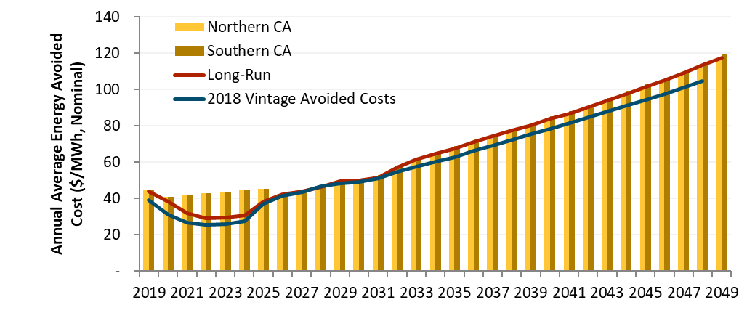

Hourly Allocation of Energy Costs
The annual energy avoided costs are converted to hourly values by multiplying the annual value by 8760 hourly market shapes. The hourly shape is derived from 2018 day-ahead locational marginal prices (LMPs) at NP-15 and SP-15, load-aggregation points in Northern and Southern California, respectively, obtained directly from the CAISO OASIS database. To account for the effects of historical volatility in the spot market for natural gas, the hourly market prices are adjusted by the average daily gas price in California, the cost of carbon, and variable O&M. The resulting hourly implied heat rates are then adjusted for forecasted changes in market clearing heat rates based on the RPS Calculator used in 2017 updated with a renewable build consistent with the CPUC 2017 IRP modeling that was used to determine the GHG adder (RPSCalculatorIRP.xlsm). The RPS calculator estimated monthly average prices by hour of the day (1-24) through 2046, and the changes in the marginal heat rates relative to the base year (2017) are added to or subtracted from the implied 2018 heat rates to reflect expected changes in market price profiles.
The resulting hourly market heat rate curve is integrated into the avoided cost calculator, where, in combination with a monthly natural gas price forecast, forecasted carbon prices, and variable O&M, it yields an hourly shape for wholesale market energy prices in California.
Total energy avoided costs are shown in Figure 15. The energy avoided costs are shown in descending order of total avoided costs for all 8760 hours of the year.
Figure 15: Hourly Energy Avoided Costs for 2019
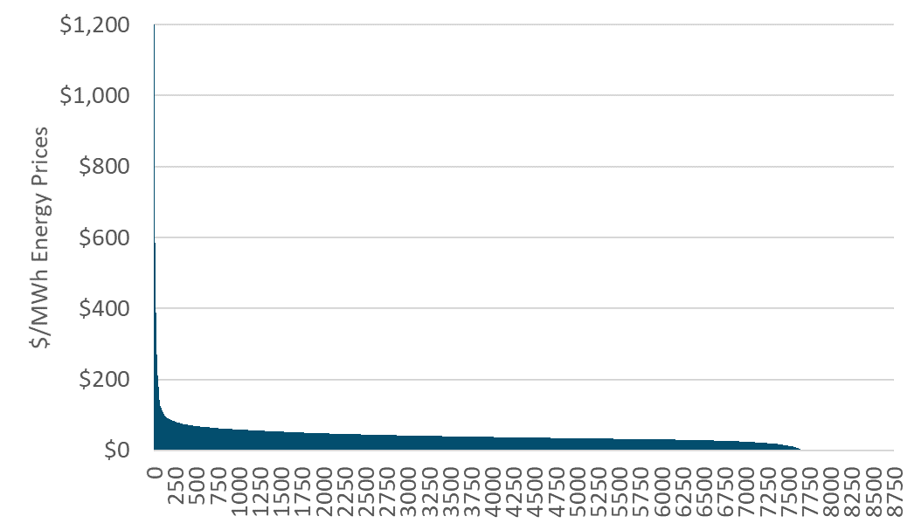

Generation Capacity
The long-run generation capacity cost is the levelized capital cost of a new simple cycle CT unit less the margin that the CT could earn from the energy and ancillary service markets. The calculation includes carbon costs in both the bid prices for the CT and the market prices for energy.
Previously, the generation capacity cost has transitioned from a near-term capacity cost based on Resource Adequacy costs, to the long-run capacity cost based on the Resource Balance Year. D.16-06-007 essentially set the Resource Balance Year to zero, which resulted in the use of the long-run capacity cost for all years. That is the approach taken starting with the 2016 Avoided Cost Calculator update.

Generation resource balance year
Consistent with past Decisions on the resource balance year, we assume that the first year of the forecast is the resource balance year.

CT dispatch
To determine the long-run value of capacity, the avoided cost model performs an hourly dispatch of a new CT to determine energy market net revenues. The CT’s net margin is calculated assuming that the unit dispatches at full capacity in each hour that the real-time price exceeds its operating cost (the sum of fuel costs, variable O&M, and carbon costs). In each hour that it operates, the unit earns the difference between the market price and its operating costs, plus an additional 2.74% of the market price for ancillary services (AS). In each hour where the market prices are below the operating cost, the unit is assumed to shut down. The dispatch uses the real-time market shape (not the day-ahead market shape), and adjusts for changes in natural gas prices, temperature performance degradation using average monthly 9am – 10pm temperatures (see the section Temperature effect on unit performance on page 33), and a market calibration factor.
The market revenues earned in the energy and AS markets are subtracted from the fixed and variable costs (including carbon allowance costs) of operating a CT to determine the residual capacity cost. The residual capacity cost is the additional revenue that a new CT would require to fully cover its fixed costs and return on investment, and is used as a proxy for the long-term avoided cost of generation capacity. The generation capacity cost calculations are performed using both Northern California and Southern California market prices and weather information. The cost of a new CT, however, is the same for both Northern and Southern California. Consistent with the methodology implemented in the 2011 avoided cost model, the final generation capacity cost for each year is the average of the results for Northern and Southern California (50% Northern and 50% Southern).
Note that carbon and variable O&M costs are included in the CT dispatch bids and market revenue calculations because such carbon costs are recovered through the energy market. Also, the hourly real-time market shape is based on the most recent calendar year shape and held constant for all future years. This shape is not adjusted in the same way as the day-ahead price shape due to the disconnect between the two as well as a large increase in volatility seen in the real-time price shape.
Figure 16: Statewide Generation Capacity Value before Temperature and Loss Adjustments
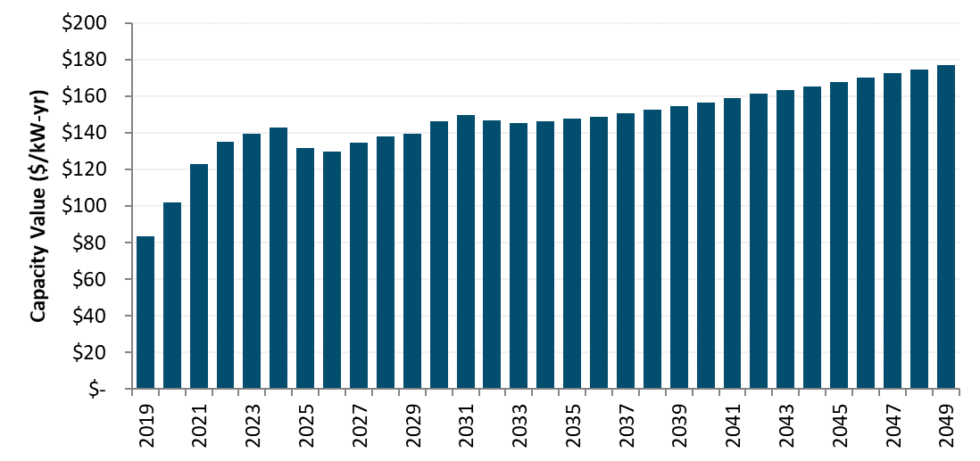

Temperature effect on unit performance
The capacity value is in $ per kW of degraded capacity, rather than in $ per kW of nameplate capacity, to account for the effects of temperature. This re-expression increases the $/kW capacity value by about 8%. The use of the degraded capacity was introduced in the DR proceeding to more precisely model operation of a combustion turbine at different ambient temperature conditions throughout the year. Use of degraded, rather than nameplate, capacity value results in an increase in the capacity value because combustion turbines perform at lower efficiencies when the ambient temperature is high.
The CT’s rated heat rate and nameplate capacity characterize the unit’s performance at ISO conditions, but the unit’s actual performance deviates substantially from these ratings throughout the year. In California, deviations from rated performance are due primarily to hourly variations in temperature. Figure 17 shows the relationship between temperature and performance for a GE LM6000 SPRINT gas turbine, a reasonable proxy for current CT technology.
Figure 17. Temperature-Performance Curve for a GE LM6000 SPRINT Combustion Turbine.
The effect of temperature on performance is incorporated into the calculation of the CT residual; several performance corrections are considered:
- In the calculation of the CT’s dispatch, the heat rate is assumed to vary on a monthly basis. In each month, E3 calculates an average day-time temperature based on hourly temperature data throughout the state and uses this value to adjust the heat rate—and thereby the operating cost—within that month.
- Plant output is also assumed to vary on a monthly basis; the same average day-time temperature is used to determine the correct adjustment. This adjustment affects the revenue collected by the plant in the real-time market. For instance, if the plant’s output is 90% of nameplate capacity in a given month, its net revenues will equal 90% of what it would have received had it been able to operate at nameplate capacity.
- The resulting capacity residual is originally calculated as the value per nameplate kW —however, during the peak periods during which a CT is necessary for resource adequacy, high temperatures will result in a significant capacity deration. Consequently, the value of capacity is increased by approximately 10% to reflect the plant’s reduced output during the top 250 load hours of the year, as shown in Figure 18.
The forecast annual generation capacity values are shown below.
Figure 18. Adjustment of Capacity Value to Account for Temperature Derating During Periods of Peak Load (losses still excluded)
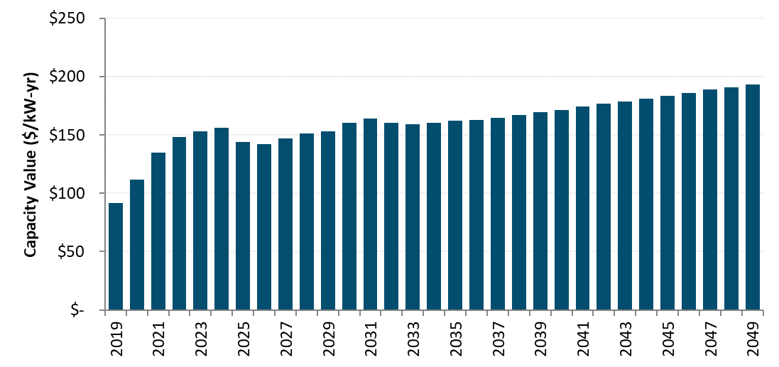

Planning reserve margin and losses
The capacity value is increased to account for both the Planning Reserve Margin (PRM) and losses. Resource Adequacy rules set capacity procurement targets for Load Serving Entities based on 1.15% of their forecasted load. They must also account for losses in delivering electricity from the generator to the customer, based on peak loss factors for each utility. The capacity value is therefore increased by the PRM and the applicable loss factors for each utility. Note that peak loss factors are used for generation and T&D capacity while TOU loss factors are used for energy.

Hourly allocation of capacity value
The capacity values ($/kW-yr), after adjusting for temperature, losses, and planning reserve margin, are then allocated to the hours of the year with highest system capacity need using the E3 RECAP model. Using 63 years of historical load and generation data, the model determines the expected unserved energy (EUE) for each month/hour/day-type time period in the year. As renewable penetrations increase, EUE shifts from the afternoon to evenings as well as to relatively more weekends. A snapshot of these hourly EUE values in 2020 is shown below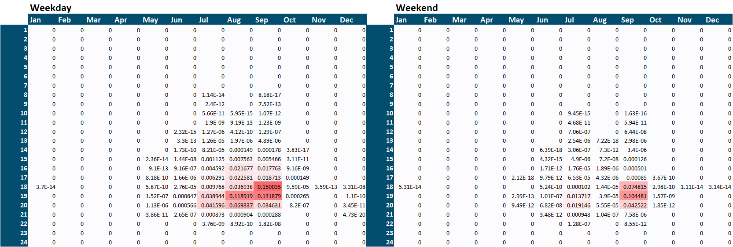
These month/hour/day-type EUE values are then allocated to days of the year using the 2018 daily temperature record for consistency with energy prices. A load-weighted daily maximum statewide temperature is calculated and all hours in days where this value exceeds 90 degrees F receive the corresponding month/hour/day-type EUE value from RECAP. The resulting 8760 hourly capacity allocators are shown below.
Figure 19: Generation Capacity Hourly Allocation Factors (2020)
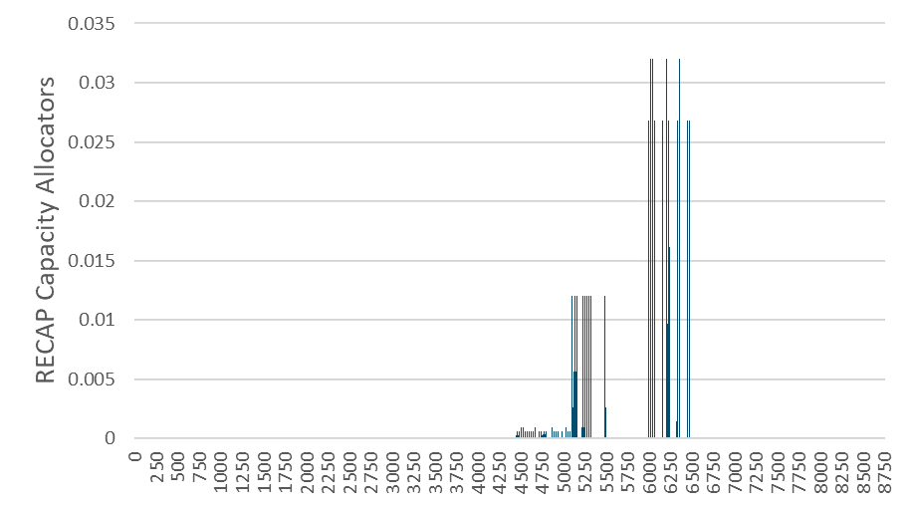
A downloadable version of RECAP can be found online. The results shown above use this version of the model along with load and renewable generation forecasts consistent with the LTPP “Default – AAEE Sensitivity” scenario. While the hourly allocations were updated, the underlying RECAP analysis was not changed in this update.

Ancillary Services (AS)
Besides reducing the cost of wholesale purchases, reductions in demand at the meter result in additional value from the associated reduction in required procurement of ancillary services. The CAISO MRTU markets include four types of ancillary services: regulation up and down, spinning reserves, and non-spinning reserves. The procurement of regulation services is generally independent of load; consequently, behind-the-meter load reductions and distributed generation exports will not affect their procurement. However, both spinning and non-spinning reserves are directly linked to load—in accordance with WECC reliability standards, the California ISO must maintain an operating reserve equal to 5% of load served by hydro generators and 7% of load served by thermal generators.
As a result, load reductions do result in a reduction in the procurement of reserves; the value of this reduced procurement is included as a value stream in the Avoided Cost Calculator. It is assumed that the value of avoided reserves procurement scales with the value of energy in each hour throughout the year. According to the CAISO’s 2018 Annual Report on Market Issues and Performance, total ancillary service costs in 2018 averaged 1.7% of the wholesale energy costs. Of this, approximately 53% was for ancillary services other than regulation up and down (CAISO Report, p. 141-142), so E3 uses 0.9% (1.7% * 53%) to assess the value of avoided AS procurement in each hour.

T&D Capacity
The electricity avoided costs include the value of reducing the need for transmission and distribution capacity expansion. Of the six avoided cost components, T&D costs are unique in that both the value and hourly allocation are location specific. Avoided T&D costs are determined separately for each utility. T&D marginal costs ($/kW-yr values) were updated for the 2019 ACC, from the following sources:
- PG&E: settlement agreement in the utility’s 2017 Phase II General Rate Case (GRC) proceeding.
- SCE: estimates by SCE’s regression analysis of cumulative distribution capacity-related investments and cumulative peak loads, consistent with avoided distribution capacity costs that have been used for SCE in prior avoided cost updates.
- SDG&E: testimony filed by the utility in its 2016 GRC (as these costs were not adopted in the proceeding or related settlement agreement).
The T&D avoided costs in the avoided cost calculator escalate by 2.3% per year in nominal terms.
Table 4: T&D Capacity Costs for SCE and SDG&E

 | SCE | SDG&E
Marginal cost year | 2018 | 2016
Subtransmission ($/kW-yr) | $40.00 | $0.00
Substation ($/kW-yr) | $25.00 | $22.05
Local Distribution ($/kW-yr) | $102.90 | $77.97

Table 5: T&D Capacity Costs for PG&E (base year of 2017)
Division | Climate Zone | Transmission $/PCAF-kW-yr | Primary Capacity $/PCAF-kW-yr | Secondary $/FLT-kW-yr
Central Coast | 4 | $7.71 | $69.09 | $1.04
De Anza | 4 | $7.71 | $35.65 | $1.01
Diablo | 12 | $7.71 | $17.78 | $1.56
East Bay | 3A | $7.71 | $19.99 | $0.88
Fresno | 13 | $7.71 | $39.52 | $1.36
Kern | 13 | $7.71 | $34.07 | $1.23
Los Padres | 5 | $7.71 | $56.49 | $1.06
Mission | 3B | $7.71 | $13.63 | $0.97
North Bay | 2 | $7.71 | $29.42 | $1.75
North Coast | 1 | $7.71 | $73.97 | $1.12
North Valley | 16 | $7.71 | $53.40 | $1.26
Peninsula | 3A | $7.71 | $31.79 | $1.06
Sacramento | 11 | $7.71 | $40.91 | $1.22
San Francisco | 3A | $7.71 | $40.41 | $1.52
San Jose | 4 | $7.71 | $40.12 | $1.16
Sierra | 11 | $7.71 | $30.65 | $1.25
Stockton | 12 | $7.71 | $33.36 | $1.34
Yosemite | 13 | $7.71 | $60.18 | $1.56

The value of deferring distribution investments is highly dependent the type and size of the equipment deferred and the rate of load growth, both of which vary significantly by location. Furthermore, some distribution costs are driven by distance or number of customers rather than load and are therefore not avoided with reduced energy consumption. However, expediency and data limitations preclude analysis at a feeder by feeder level for a statewide analysis of avoided costs. A more detailed examination of distribution avoided costs is currently underway for the IOUs as part of the Distribution Resource Plan proceeding (R.14-08-013). The costs taken from utility rate case filings are used as a reasonable proxy for the long-run marginal cost of T&D investment that is avoided over time with the addition of distributed energy resources.
The value of deferring transmission and distribution investments is adjusted for losses during the peak period using the factors shown in Table 6 and
Table 7. These factors are lower than the energy and generation capacity loss factors because they represent losses from secondary meter to only the distribution or transmission facilities.
Table 6. Loss Factors for SCE and SDG&E Transmission and Distribution Capacity.
 | SCE | SDG&E
Distribution | 1.022 | 1.043
Transmission | 1.054 | 1.071

Table 7: Loss Factors for PG&E Transmission and Distribution Capacity.
 | Transmission | Distribution
Central Coast | 1.053 | 1.019
De Anza | 1.050 | 1.019
Diablo | 1.045 | 1.020
East Bay | 1.042 | 1.020
Fresno | 1.076 | 1.020
Kern | 1.065 | 1.023
Los Padres | 1.060 | 1.019
Mission | 1.047 | 1.019
North Bay | 1.053 | 1.019
North Coast | 1.060 | 1.019
North Valley | 1.073 | 1.021
Peninsula | 1.050 | 1.019
Sacramento | 1.052 | 1.019
San Francisco | 1.045 | 1.020
San Jose | 1.052 | 1.018
Sierra | 1.054 | 1.020
Stockton | 1.066 | 1.019
Yosemite | 1.067 | 1.019

Hourly Allocation of T&D Capacity Cost
The allocation of T&D capacity costs to hours of year is based on regression estimates of distribution hourly loads. The regression models are based on actual utility hourly distribution demands and the corresponding temperature in the distribution area. Using dummy variables, lag terms, and cross product terms, the regression models are able to simulate the distribution loads with about 90% accuracy (adjusted r-square). To forecast the impact of local solar PV on the distribution loads, the analysis also subtracts off a forecast level of hourly PV generation from the distribution load to produce an adjusted distribution load shape. The PV generation shape is based on the local area solar insolation, and the magnitude of the PV generation is based on the incremental statewide 2019 IEPR Mid-Demand forecast of solar penetration. This incremental PV forecast is allocated across the climate zones based on the geographic distribution of California Solar Initiative installations and utility 2018 annual load.
Once the adjusted distribution loads are simulated using 2018 weather data for each climate zone, and the PV penetrations, we allocate the T&D capacity value in each climate zone to the hours of the year during which the system is most likely to be constrained and require upgrades—the hours of highest local load. The allocation factors are derived using the peak capacity allocation factors method, with the additional constraint that the peak period contain between 20 and 250 hours for the year.
PCAF[a,h] = (Load[a,h] – Threshold[a]) / Sum of all positive (Load[a,h] – Threshold[a])
Where
- a is the climate zone area,
- h is hour of the year,
- Load is the net distribution load, and
- Threshold is the area maximum demand less one standard deviation, or the closest value that satisfies the constraint of between 20 and 250 hours with loads above the threshold.
Figure 20 shows a summary of the updated T&D allocation factors for Climate Zone 3 (San Francisco International Airport) in 2020. The blue line shows the total allocation weight for each hour of the day (in Pacific Standard Time) and the gray bars show the total allocation weight by month (top axis, and right axis). The chart title also indicates that the allocation factors are based on behind-the-meter PV providing an additional 3.5% of the electricity needs in the climate zone since 2010. The PV values are incremental to 2010 because that is the year of the utility load data used as the basis for the simulated area loads. The additional PV output is subtracted from the simulated loads to estimate the adjusted net loads for the climate zone.
Figure 20. Updated T&D Allocation Factors for CZ3 in 2020
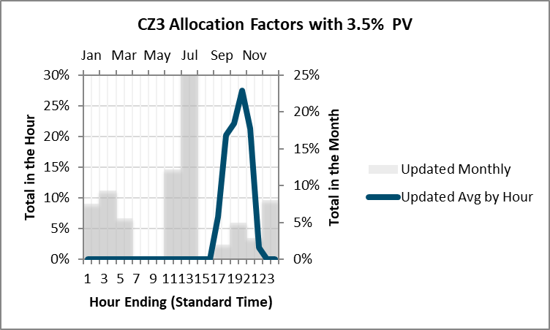
Figure 21 shows the same information for Climate Zone 3 in 2030. In 2030 the behind-the-meter PV is modeled as providing 5.7% of the electricity needs in the climate zone. This higher PV output results in less need for summer afternoon peak capacity. This shifts the allocation factors to later in the day/evening, as well as shifting more weight to the non-summer months. Summary charts for all 16 climate zones are presented in the Appendix.
Figure 21. Updated T&D Allocation Factors for CZ3 in 2030
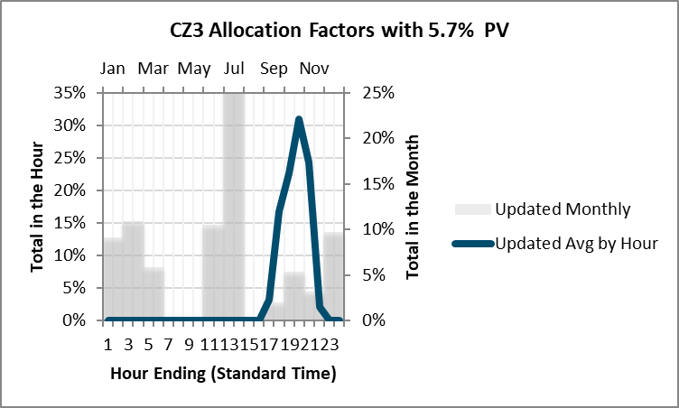
The 2020 allocation factors are used for all years up to and including 2020, and the 2030 shapes are used for 2030 and all subsequent years. A simple linear interpolation is applied to the interim years.
Table 8: Percentage of Electricity Demand Met by Behind-the-Meter PV
Climate Zone | 2020 | 2030
CZ1 | 3.5% | 5.7%
CZ2 | 8.6% | 13.6%
CZ3 | 3.5% | 5.7%
CZ4 | 5.1% | 8.2%
CZ5 | 6.0% | 9.7%
CZ6 | 2.6% | 4.4%
CZ7 | 8.5% | 11.7%
CZ8 | 3.2% | 5.8%
CZ9 | 3.8% | 6.9%
CZ10 | 8.3% | 13.2%
CZ11 | 14.6% | 22.1%
CZ12 | 10.3% | 16.0%
CZ13 | 9.4% | 15.0%
CZ14 | 9.2% | 15.7%
CZ15 | 9.3% | 15.9%
CZ16 | 4.5% | 7.8%

Cap & Trade and GHG Adder Values

Monetized Carbon (Cap and Trade)
The cap and trade allowance cost is the cost of permits that the utility must pay to purchase or generate fossil energy. While this value is currently embedded in energy prices in the CAISO market, we separate this value for avoided cost purposes. This component has been updated to use the Revised 2019 IEPR Mid-Case forecast values., which extend to 2030. For later years, the forecast is extrapolated using a linear trend of the values in the final five years of the IEPR forecast. Figure 22 shows the updated CO₂ price forecasts. The blue line is the IEPR forecast series that is embedded in the market price. The dashed gold line is the total GHG adder plus cap and trade allowance cost of CO₂. The difference between the two series is included as the GHG adder for CO₂.
Figure 22. CO₂ Cap and Trade Price Series
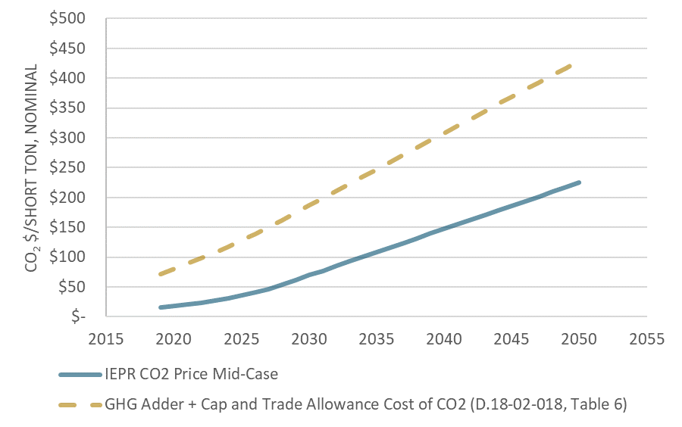
The marginal rate of carbon emissions is calculated in the following fashion: Assuming that natural gas is the marginal fuel in all hours, the hourly emissions rate of the marginal generator is calculated based on the day-ahead market price curve (with the assumption that the price curve also includes the cost of CO₂).
HeatRate[h] = (MP[h] – VOM) / (GasPrice + EF * CO₂Cost)
Where
- MP is the hourly market price of energy (including cap and trade costs)
- VOM is the variable O&M cost for a natural gas plant
- GasPrice is the cost of natural gas delivered to an electric generator
- CO₂Cost is the $/ton cost of CO₂
- EF is the emission factor for tons of CO₂ per MMBTU of natural gas
The link between higher market prices and higher emissions rates is intuitive: higher market prices enable lower-efficiency generators to operate, resulting in increased rates of emissions at the margin. Of course, this relationship holds for a reasonable range of prices but breaks down when prices are extremely high or low. For this reason, the avoided cost methodology bounds the maximum emissions rates based on the range of heat rates of gas turbine technologies. The maximum emissions rate is bounded by a range of heat rates for proxy natural gas plants shown in Table 9; the hourly emissions rates derived from this process are shown in Figure 23. The low efficiency emission rate has not been updated, while the high efficiency plant heat rate has been lowered from 6,900 to zero Btu/kWh, to reflect that hours with low implied marginal heat rates may represent averaging of marginal fossil fuel and renewable resources within that hour, either temporally or spatially.
In the past, if the implied marginal heat rate was less than the high efficiency threshold (the actual heat rate of the most efficient natural gas turbine), the heat rate was adjusted. For example, if the implied marginal heat rate was 5,000 Btu/kWh, which is lower than the previous high efficiency threshold of 6,900 Btu/kWh, the heat rate used to determine GHG emissions was adjusted to 6,900 Btu/kWh to reflect the fact that no natural gas turbine could actually be more efficient than 6,900 Btu/kWh, and that therefore a heat rate of 5,000 Btu/kWh must reflect an estimation error. However, the increased penetration of renewables means that there are other possible interpretations of a low heat rate. For example, it is possible that both a natural gas turbine and a renewable unit could be on the margin during part of an hour, or in different parts of the state. To better reflect current market conditions, the high efficiency threshold has therefore been lowered to zero Btu/kWh. The ACC retains the practice of assigning a heat rate of zero when the estimated heat rate is less than zero.
Table 9. Bounds on Electric Sector Carbon Emissions.
 | Proxy Low Efficiency Plant | Proxy High Efficiency Plant
Heat Rate (Btu/kWh) | 12,500 | 0
Emissions Rate (tons/MWh) | 0.731 | 0.000
Additionally, if the implied heat rate is calculated to be at or below zero, it is then assumed that the system is in a period of overgeneration and therefore the marginal emission factor is correspondingly zero as well. The hourly marginal emission rates are shown below.
Figure 23. 2019 Hourly Marginal Emissions Rates Derived from Market Prices (hourly values shown in descending order)
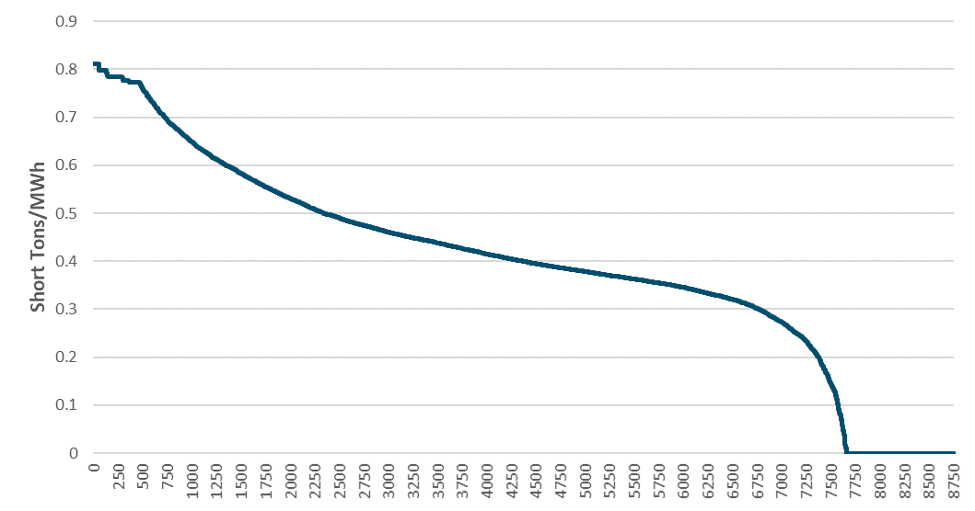

GHG Adder
CPUC Decision D.18-02-018 adopted CO₂ costs as reproduced below for the purpose of calculating a greenhouse gas (GHG) adder value. The CPUC adopted values are in 2016 constant dollars. Once converted to nominal dollars per short ton, the difference between the costs in the table and the CO₂ monetized cost embedded in the market prices is included in the avoided costs as the GHG adder. (Note that while the table has “GHG Adder” in the title, the values are the total of the cap and trade allowance cost plus the GHG adder as defined in the avoided cost calculator).
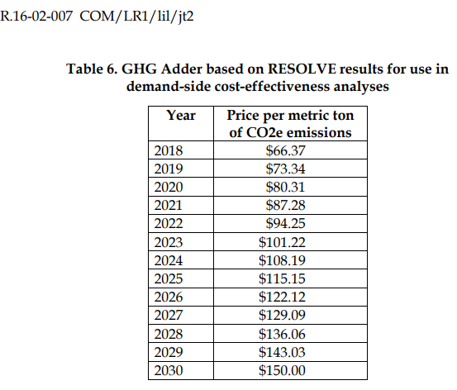
Table 10: GHG Adder and Cap and Trade Allowance Cost
The next step to calculating the GHG adder is determining the GHG emission rate in each hour. To determine this, we first calculate an implied heat rate (Btu/kWh) in each hour. The implied heat rate is calculated by subtracting the cap-and-trade emission value and variable operations and maintenance (O&M) expense of a CCGT from the energy price in each hour and then dividing by the natural gas price. This implied heat rate is then multiplied by the GHG intensity of natural gas (ton/Btu) which yields the emission factor in ton/kWh.
Finally, the incremental portion of the GHG adder price ($/ton) is multiplied by the emission rate (tons/kWh) to yield a final GHG adder value ($/kWh) in each hour.

GHG for Natural Gas Avoided Costs
For avoided natural gas costs, the Interim GHG Adder from 2017 is used, rather than the GHG Adder plus the Cap and Trade Allowance price used for the avoided electricity costs.

Avoided RPS Cost
This component reflected the fact that as energy usage declines, the amount of utility renewable purchases required to meet the RPS goals also declines. Since the cost of renewable energy is higher than the forecasted cost of wholesale energy and capacity market purchases, energy reductions provide some value above the wholesale energy and capacity markets.
With the introduction of the RESOLVE-based GHG adder, the need for CO₂ reductions, rather than the need to meet RPS goals, becomes the binding constraint on the electricity sector. Renewable levels are expected to exceed the RPS goals in the future, so there is no longer a firm correspondence between usage reductions and renewable energy reductions. Therefore, the RPS adder is no longer an expected avoided cost benefit of usage reductions and has been removed. Put another way, the additional avoided cost of renewables to meet state goals is now captured in the GHG adder due to GHG goals, and there is no benefit from reducing RPS requirements.
Components Not Included
Several components suggested by stakeholders in various proceedings are not currently included in the calculation of avoided costs. Non-energy Benefits (NEBs), by their nature, are difficult – and at times impossible – to quantify. Work has been done to quantify some of these benefits for low income energy efficiency programs. NEBs are not, however, currently included in the avoided cost methodology. The CPUC has authorized studies and pilot programs regarding embedded energy in water. To date a comprehensive framework for calculating embedded energy in water savings or water avoided costs in energy on a statewide basis has not yet been developed. Avoided costs of current or future Ancillary Services associated with renewable integration or overgeneration are also not included. The need for flexible resources to provide services such as load following or ramping capability are driven primarily by the variation in, rather than the absolute level of, loads and generation. The impacts of power factor and reactive loads are also not currently included in the avoided cost methodology. An EM&V study for the CPUC Operational Energy Efficiency Program for water pumping produced by E3 found that the value of reduced reactive loads (kVAR) and associated line loss reductions ranged from 5 to 12 percent of the $/kWh avoided cost savings. However, the savings associated with improved power factor and reduced reactive load depend to a large extent on the type and location of loads on the feeder. As with embedded energy in water, a generalized framework for a statewide analysis has not yet been developed. Finally, market and reliability benefits provided by demand-side resources are not currently included in the ACC, although E3 is collaborating with the CPUC on research into potential methodologies for quantifying these benefits.

Appendix: Key Data Sources and Specific Methodology
This section provides further discussion of data sources and methods used in the calculation of the hourly avoided costs.

Power plant cost assumptions
The cost and performance assumptions for the new simple cycle plants and combined cycle plants are from the CPUC 2017 IRP (R.16-02-007). The IRP ProForma spreadsheet with the data inputs can be found at http://cpuc.ca.gov/irp/proposedrsp/
Where the IRP does not specify an input variable, the values from the 2018 avoided cost model are retained. Those retained values are from the California Energy Commission’s Cost of Generation report (CEC 2019, Estimated Cost of New Utility-Scale Generation in California: 2018 Update, and CEC 2015 Cost of New Renewable and Fossil Generation in California, where 2018 update did not include relevant data; https://www.energy.ca.gov/2019publications/CEC-200-2019-005/CEC-200-2019-005.pdf and http://www.energy.ca.gov/2014publications/CEC-200-2014-003/index.html, Table 8, respectively.)

Table 11. Power plant cost and performance data source for new generation
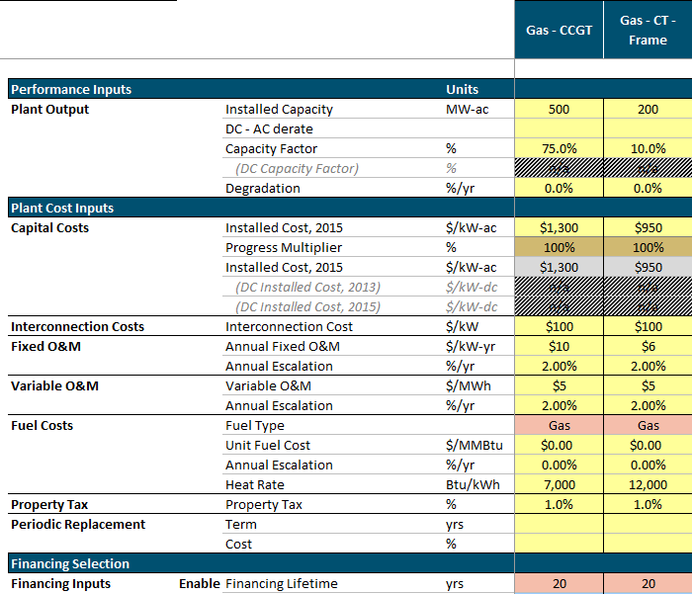Source: RESOLVE_User_Interface 2017-09-07.xlsm, COSTS_Resource_Char tab. (http://cpuc.ca.gov/irp/proposedrsp/)

Generation Loss Factors
The updated avoided costs incorporate loss factors from the DR proceeding. The capacity loss factors are applied to the capacity avoided costs to reflect the fact that dispatched generation capacity is greater than metered loads because of losses. The adjustments assume that the metered load is at the secondary voltage level. The loss factors are representative of average peak losses, not incremental losses.
Table 12: Generation Capacity Loss Factors
 | PG&E | SCE | SDG&E
Generation to meter | 1.109 | 1.084 | 1.081

The energy loss factors are applied to the electricity energy costs to reflect energy losses down to the customer secondary meter. The loss factors vary by utility time of user period, and represent average losses in each time period.
Energy Generated[h] = Metered Load[h] * Energy Loss Factor[TOU]
Cost of Energy Losses = Energy Cost[h] * Metered Load [h] * (Energy Loss Factor[TOU] – 1)
where h = hour, TOU = TOU period corresponding to hour h.
Table 13. Marginal Energy Loss Factors by Time-of-use Period and Utility.
Time Period | PG&E | SCE | SDG&E
Summer Peak | 1.109 | 1.084 | 1.081
Summer Shoulder | 1.073 | 1.080 | 1.077
Summer Off-Peak | 1.057 | 1.073 | 1.068
Winter Peak | - | - | 1.083
Winter Shoulder | 1.090 | 1.077 | 1.076
Winter Off-Peak | 1.061 | 1.070 | 1.068

Climate Zones
In each hour, the value of electricity delivered to the grid depends on the point of delivery. The DG Cost-effectiveness Framework adopts the sixteen California climate zones defined by the Title 24 building standards in order to differentiate between the value of electricity in different regions in the California. These climate zones group together areas with similar climates, temperature profiles, and energy use patterns in order to differentiate regions in a manner that captures the effects of weather on energy use. Figure 24 is a map of the climate zones in California.
Figure 24. California Climate Zones
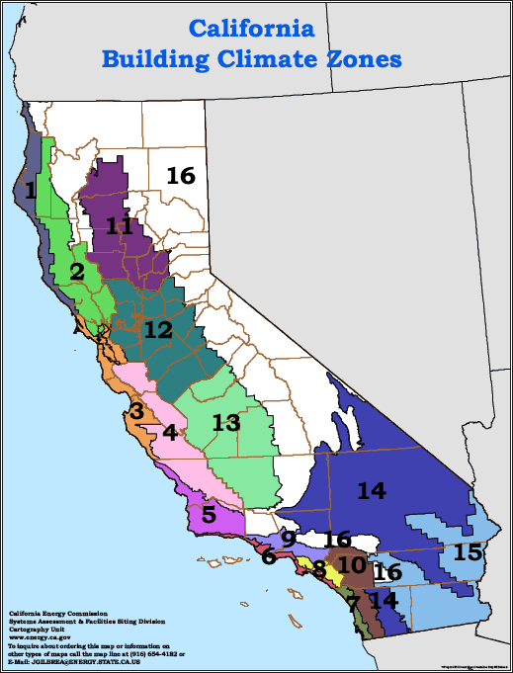
Each climate zone has a representative city, which is specified by the California Energy Commission. Hourly avoided costs are calculated for each climate zone, using representative cities unless weather data is unavailable (in which case weather from a nearby location is used instead). The cities used for weather data from each climate zone are listed in Table 14.

Table 14. Cities and Utilities Used to Represent Weather in the California Climate Zones.
Climate Zone | Utility Territory | Representative City
CEC Zone 1 | PG&E | Arcata
CEC Zone 2 | PG&E | Santa Rosa
CEC Zone 3 | PG&E | SF Peninsula (SFO)
CEC Zone 4 | PG&E | Paso Robles
CEC Zone 5 | PG&E/SCE | Santa Maria
CEC Zone 6 | SCE | Los Angeles (LAX)
CEC Zone 7 | SDG&E | San Diego
CEC Zone 8 | SCE | Long Beach
CEC Zone 9 | SCE | Downtown LA (USC)
CEC Zone 10 | SCE/SDG&E | Riverside
CEC Zone 11 | PG&E | Red Bluff
CEC Zone 12 | PG&E | Sacramento
CEC Zone 13 | PG&E | Fresno
CEC Zone 14 | SCE/SDG&E | China Lake
CEC Zone 15 | SCE/SDG&E | El Centro
CEC Zone 16 | PG&E/SCE | Bishop

T&D Allocation Factors
For a description of the charts, refer to the discussion of Figure 20. Updated T&D Allocation Factors for CZ3 in 2020 and Figure 21. Updated T&D Allocation Factors for CZ3 in 2030 in Section 4.5.1.

Table 15: Distribution Demand Regression Variables

Table 16: Distribution Demand Regression Model Fit
Climate Zone | Model Fit
CEC Zone 1 | Used CZ3
CEC Zone 2 | 91.9%
CEC Zone 3 | 92%
CEC Zone 4 | 91.7%
CEC Zone 5 | Used CZ3
CEC Zone 6 | 89.8%
CEC Zone 7 | Used CZ6
CEC Zone 8 | 89.2%
CEC Zone 9 | 91.9%
CEC Zone 10 | 91.3%
CEC Zone 11 | Used CZ12
CEC Zone 12 | 89.9%
CEC Zone 13 | 96.5%
CEC Zone 14 | 88.4%
CEC Zone 15 | 95.5%
CEC Zone 16 | 86.5%

Note that not all climate zones have readily available load data. In those cases, the regression equations from comparable climate zones were applied.

Distribution Load Simulation Regression Model Specifications
CZ2
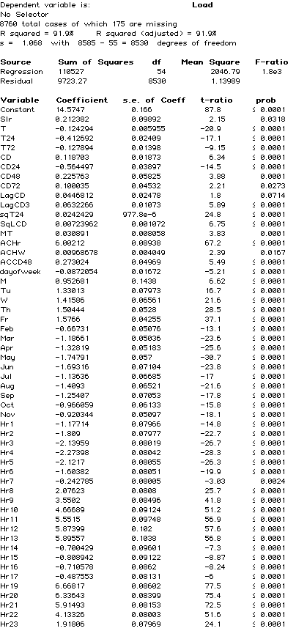
CZ3
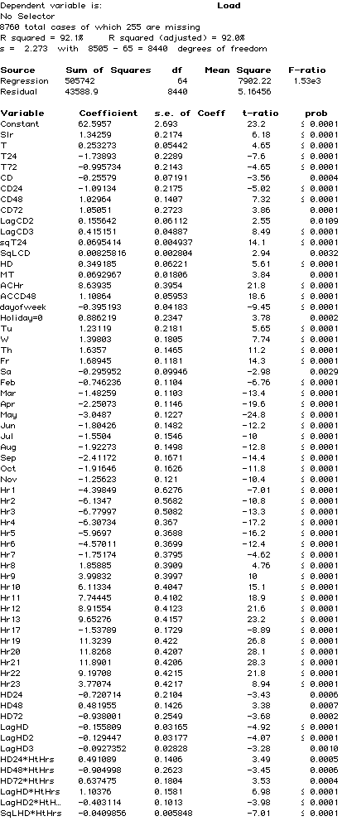
CZ4
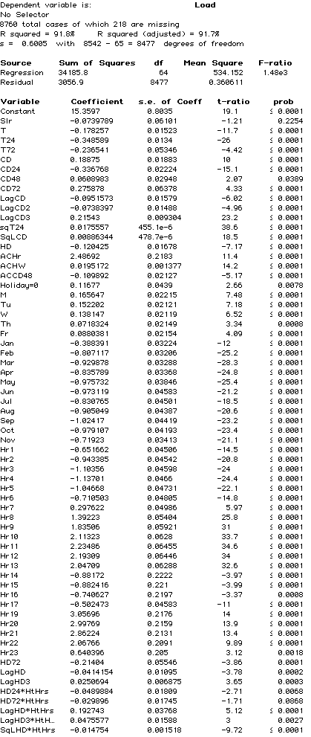

CZ6
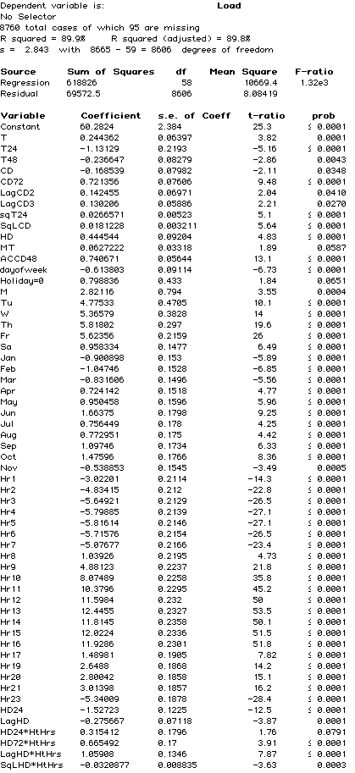
CZ7
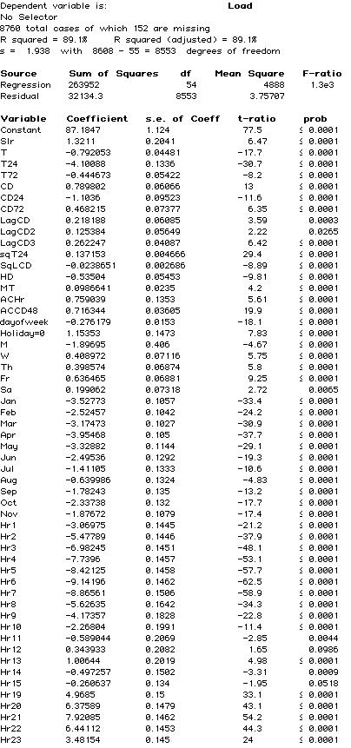
CZ8
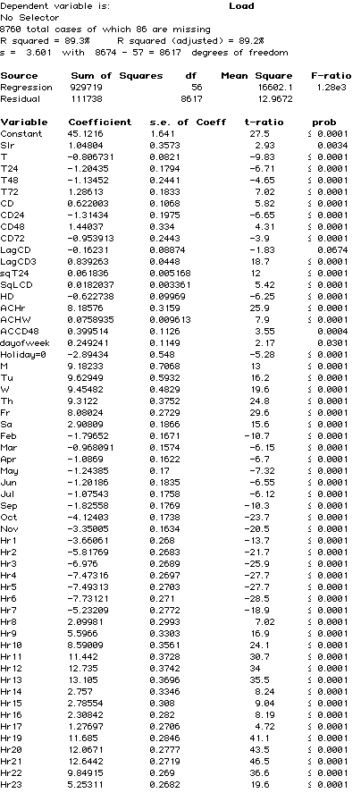
CZ9
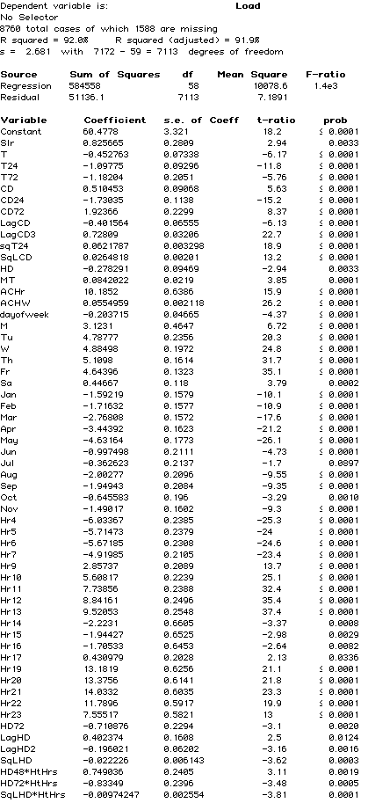
CZ 10
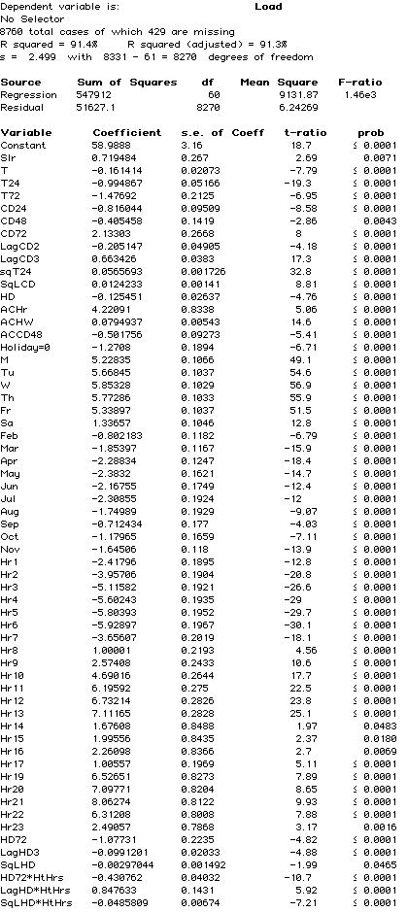
CZ12
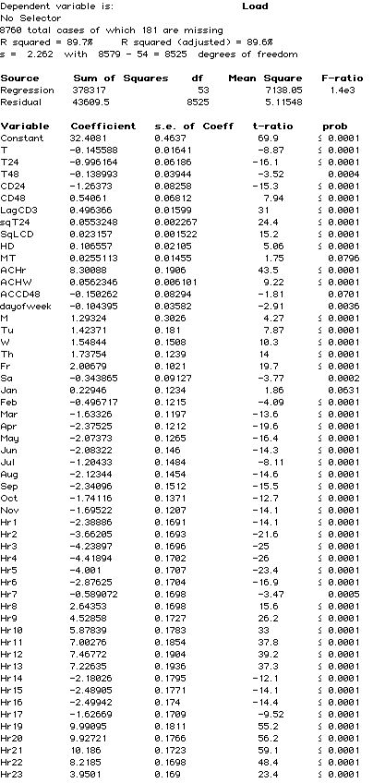
CZ13
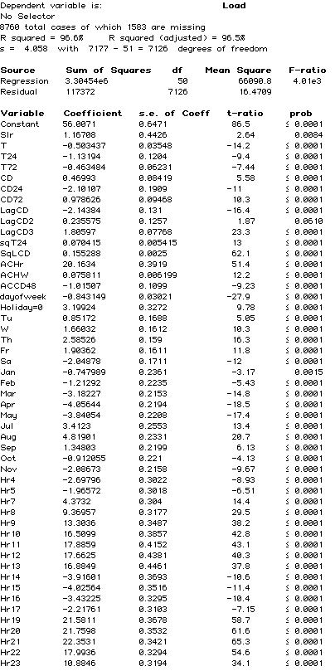
CZ 14
CZ15
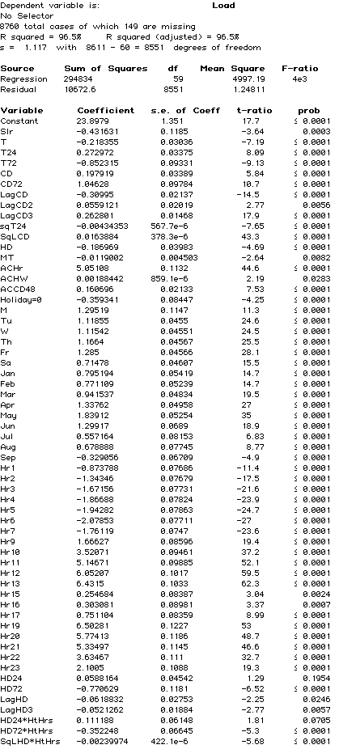
CZ16
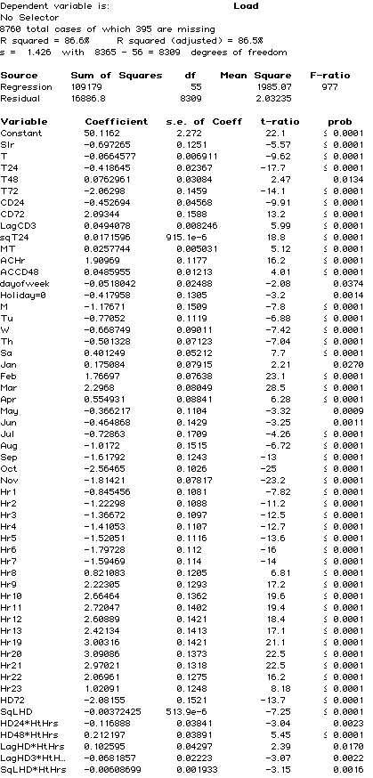

Low Efficiency Threshold Analysis
The Avoided Cost Calculator (ACC) uses implied marginal heat rates as a proxy for GHG emissions. Historically, these heat rates have been bounded by the assumption that the most efficient natural gas generators have a heat rate of 6,900 Btu/kWh, while the least efficient have a heat rate of 12,500 Btu/kWh. Implied marginal heat rates above or below these values were adjusted back to these bounds, accordingly.
In the 2019 update to the ACC the high efficiency plant heat rate has been lowered to zero Btu/kWh, to reflect that hours with low implied marginal heat rates may represent averaging of marginal fossil fuel and renewable resources within that hour, either temporally or spatially.
The low efficiency plant heat rate, however, has not been updated. After having reviewed Continuous Emissions Monitoring System (CEMS) data on California’s thermal generator fleet operation in 2018 it was determined that 12,500 Btu/kWh remains a reasonable estimate of the low efficiency threshold for natural gas plants.
The majority of generators in the CEMS dataset report at least a small number of hourly fuel consumption and electricity output pairings which together imply a heat rate above 12,500 Btu/kWh. However, not all of these values are representative of a generator’s true heat rate, given that a minority of these hourly implied heat rates are an order of magnitude larger than the range of heat rates generally accepted as representative of natural gas power plants.
To validate that there are in fact generators operating with realistic heat rates above 12,500 Btu/kWh, we analyzed several generators with relatively inefficient reported heat rates, comparing the number of operating hours in 2018 to the number of hours operating with implied heat rates above several threshold values. The results of this analysis are shown in the following table.
Table 17: Low Efficiency Threshold Analysis
Notes: 1) none of these units are cogeneration plants; 2) 10,000 and 15,000 Btu/kWh were chosen to represent +/- 20 percent of the 12,500 threshold.
While most of these units report a relatively small portion of their hours with implied heat rates above the 12,500 Btu/kWh threshold, there are nonetheless a sufficient proportion of high-heat rate hours within a reasonable range (i.e., between 12,500 and 15,000 Btu/kWh) to conclude that some operating, potentially-marginal natural gas plants in California at times have heat rates at least as inefficient as the low efficiency cutoff, indicating that lowering this value to a more efficient range is not warranted at this time.

User Quick Guide ACC 2019 v1

Purpose
The Avoided Cost Calculator (ACC) is a Microsoft Excel-based tool to calculate electricity avoided costs by hour and component. The ACC shows levelized hourly costs by component for one year on the Dashboard tab. The ACC can also generate the 31 year matrices of hourly costs by climate zone that are used for energy efficiency evaluation in California. These 31 year matrices are generated via VBA code and executed via the Export Annual Avoided Costs – ALL CZ and Export Gen & Env for EE buttons on the Dashboard tab.

Using the Model
The Dashboard tab will be the primary tab used by most users of the ACC. The tab provides user controls for the electricity avoided cost components to include in the output. The tab also allows the user to control which year, or which stream of years is represented in the tab output. The Dashboard tab also provides figures that summarize the results of the user's avoided cost choices, as well as the associated levelized hourly avoided costs by component (located just below the user controls).
Table 18: Summary of Controls
Control | Note
Utility | PG&E, SCE, or SDG&E
Climate Zone | The ACC produces avoided costs that are specific to climate zones. The climate zones correspond to those used by the California Energy Commission for the Title-24 Building Energy Standards. Climate zone 3 has been divided into 3A (San Francisco and Peninsula) and 3B (Oakland and East Bay) because of the large historical difference in distribution capacity costs for those areas within climate zone 3.
Include Reserve Margin | (1 or 0) The default value of 1 should be used for avoided costs at the customer-level, that is avoided costs for demand-side actions. For generators that do not reduce customer load, this value should be set to zero. Reductions in load produce additional value compared to generation because of the planning reserve margin. Setting the value to zero removes the extra planning reserve margin generation capacity benefit from the avoided cost stream.
Start year | (2018 – 2048) This is the first year for reported avoided cost results. The avoided cost results will be expressed in this year's dollars. If a levelization period of one year is used, then the levelization results will be the avoided costs for this year only. Otherwise, this is the first year of the levelization stream.  Note that the ACC only contains avoided costs through 2047, so the combination of this entry and the Levelization Period should not exceed 2047.
Levelization Period | (1-30) The number of years to include in the levelization period. The levelization uses the real discount rate from the Inputs tab, and therefore is constant in real dollars, not nominal dollars. To convert the levelized values into annual values in nominal dollars, the levelized results should be escalated by inflation each year.
Electricity Components | (TRUE. FALSE) Indicates which components to include in the avoided costs displayed in the charts, and represented in the hourly results. Note that Losses are energy-related losses and are included or excluded based on the selection for Energy. Capacity-related losses are incorporated into the respective capacity avoided costs, and not reported separately.
Three-day snapshot Month | (1-12) The Dashboard can graph the component avoided costs for any continuous three-day period. This is the month for the first day in that period.
Starting Day | (1-31). This is the day of the month for the start of the three-day period.

Exporting Hourly Results
In addition to the levelized or single year results discussed above, the Avoided Cost Calculator can produce hourly avoided costs for 2018 through 2048. Because the amount of data associated with 31 years of hourly avoided costs, these results are output to separate Excel files, rather than added to the model itself. In addition, the results are written to the output files as the total avoided cost by year and hour, but not by avoided cost component. All results are reported in $/MWh at the secondary voltage level.
The output files are written to a subfolder in the same directory as the Avoided Cost Model. The subfolder is named according the date the macro is run.
There are three macros included in the Avoided Cost Calculator. The buttons for each macro are located below Cell F20 on the Dashboard tab. Each macro is described below.
Macro | Comment
Export Annual Avoided Costs – All CZ | Using the user-selected utility, the macro will iterate through each climate zone that applies to the utility. The macro will write the total hourly avoided costs for the components indicated by the Electricity Component inputs, and will include or exclude the planning reserve margin benefit base on the user input for Incl Reserve Margin. Note that because the macro is outputting results by year for all years, instead of levelized results, the Levelization Period and the Start year are ignored.
Export Annual Avoided Costs – One CZ | Same functionality as the macro above, but only outputs results for the user selected Climate Zone.
Export Gen & Env for EE | This is a specialized macro used to create output files used for the E3 Calculator and CET. It overrides the user selections to generate the needed transfer file for the selected utility. This should not be used by the general user of the model.

DR Reporting Interface
Finally, the model aggregates specific outputs for input into the DR Reporting Template which is used to determine the cost-effectiveness of demand response.
The DR Outputs tab is an exact replica of the Inputs tab in the DR Reporting Template. Thus, the tab can be directly copy/pasted into the DR Reporting Template. A screenshot of this tab is shown below.
Figure 25: DR Outputs Tab in Avoided Cost Calculator

Inputs
The data inputs for the model are on two tabs. The Hourly Data tab contains the hourly inputs for the model such as energy price shapes and capacity allocation factors. The Inputs tab contains the other inputs for the ACC, including natural gas costs, CO₂ costs per ton, CT and CCGT plant costs, and T&D capacity costs.
If the user alters an input that affects energy or capacity, the calibration macro will need to be re-run. This can be done by pressing the “Calibrate Energy and Capacity Costs” button on either the Inputs or Market Dynamics tab. Note that the calibration process can be time consuming and takes about 10 minutes on a corei7 desktop PC.

Remaining tabs
The remainder of the ACC tabs are calculation tabs, or associate with model control or tracking. These tabs are described briefly on the Cover tab for the ACC.

User Quick Guide GasModel

Purpose
The Gas Avoided Cost Calculator (GACC) is a Microsoft Excel-based tool to calculate natural gas avoided costs by month and year. Avoided costs are reported in the format used by the energy efficiency evaluation tools.

Using the Model
The Settings+Results tab will be the primary tab used by most users of the GACC. The tab provides user controls for the natural gas avoided cost components to include in the output. In addition to the annual values in nominal dollars, the model also allows the user to produce a set of monthly levelized values over a specified number of years.
Table 19: Summary of Controls
Control | Note
Utility | PG&E, SCG, or SDG&E
Class | Avoided costs are reported for Residential, Commercial, or Total Core. The T&D avoided costs can vary depending on the class selected.
End Use | Air emissions used for the environmental avoided costs will vary by End Use. The model has information for small boilers, large boilers, a residential furnace.
Emission Control | Depending on the End Use, the emission levels can be further selected by selecting the type of Emission Control (if any). For energy efficiency avoided costs, the emission settings are:  Residential: Residential Furnace: Uncontrolled  Commercial: Large Boiler (> 100 MMBtu/Hr): Uncontrolled, Low NOx Burner, or Flue Gas Recirculation  Commercial: Small Boiler (< 100 MMBtu/Hr): Uncontrolled, Low NOx Burner, or Flue Gas Recirculation  Total: Residential Furnace: Uncontrolled  Total: Large Boiler (> 100 MMBtu/Hr): Uncontrolled, Low NOx Burner, or Flue Gas Recirculation  Total: Small Boiler (< 100 MMBtu/Hr): Uncontrolled, Low NOx Burner, or Flue Gas Recirculation
Component Included | (TRUE. FALSE) Indicates which components to include in the avoided costs represented in the monthly and annual results.
Start year | This is the first year for reported avoided cost results. The avoided cost annual results are reported in nominal dollars. The levelized results are reported in year dollars specified by the user.
Last Year | This defines the number of years to include in the levelization period.
Nominal discount rate | The levelization uses this nominal discount rate, and therefore is constant in nominal dollars. Note that the evaluation of energy efficiency and other DER do not use these levelized values.

Results
Results are shown at the bottom of the Settings+Results tab. The first column is the levelized monthly array. The annual nominal values start just to the right. The results are shown for each month of the year starting with January.

Inputs

Tab | Inputs
Commodity | California monthly and annual natural gas price forecast for electric generators. The inputs are from the MPR Gas Model
T&D | Gas transportation marginal costs by Res and Commercial and Total. Also contains monthly allocation factors. Note that these numbers have not been updated, with the only changes being a shift in the values to correspond to the new start year.
Emissions | NOX and CO₂ emission rates by Combustion and Control types.  Emission Unit Costs
Other Inputs | IOU Transportation rates for EG (needed to convert E% commodity market forecasts to the avoided cost of procured natural gas)  Compression factors and LUAF.

MPR Gas Model 2019

Purpose
The Gas Market Model (GMM) is a Microsoft Excel-based tool to calculate natural gas market prices for electric generators by month and year. The GMM forecasts are an input to the electricity ACC, as well as the natural gas avoided cost model, and is based on the methodology first established for the Market Price Referent forecasts.

Using the Model
The natural gas forecast is shown in the Output to ACM tab. The monthly forecast takes the annual natural gas forecast from column AD of the CA_Gas_Forecast tab and applies the monthly variations from the monthly NYMEX data.

Version Change Summary

Avoided Cost Model Version ACC_2019_v1b
Revision date: 6/26/2019
- Natural gas prices
  - New York Mercantile Exchange (NYMEX) natural gas futures prices from most recent 22 trading days
  - Long-term natural gas forecast using revised 2019 Integrated Energy Policy report (IEPR) Mid-Demand case, and Energy Information Administration (EIA) 2019 Annual Energy Outlook (AEO) Report
  - SoCal, PG&E BB and PG&E LT natural gas transportation rates from 2019 tariff sheets (effective April 1, 2019)
  - Municipal surcharge rate for SoCal Gas
- Electricity Forward prices. On-peak and Off-peak forwards for NP-15 and SP-15 using most recent 22 trading days
- Ancillary service costs updated to 0.9% for annual energy from the CAISO 2018 Annual Report on Market Issues and Performance, excluding regulation services. (from pp. 141-142 of that report)
- Hourly Market Price Shapes
  - Day-ahead and real-time prices for 2018 for NP-15 and SP-15.
  - Daily 2018 natural gas spot prices for PG&E Citygate and SoCal Border hubs (used to derive implied heat rates)
  - Average 2018 CO₂ trading price, from March 2019 IEPR (Preliminary Carbon Allowance Price Scenarios)
- CO₂ market price forecast from Revised 2019 IEPR Mid-Demand forecast
- Transmission and distribution (T&D) marginal costs ($/kW-yr values) were updated from the following sources:
- PG&E: settlement agreement in the utility’s 2017 Phase II General Rate Case (GRC) proceeding.
- SCE: estimates by SCE’s regression analysis of cumulative distribution capacity-related investments and cumulative peak loads, consistent with avoided distribution capacity costs that have been used for SCE in prior avoided cost updates.
- SDG&E: testimony filed by the utility in its 2016 GRC (as these costs were not adopted in the proceeding or related settlement agreement).
- T&D hourly allocation factors were updated based on 2018 recorded weather by climate zone, and 2018 weekend and holiday schedules.
- Generation capacity hourly allocation factors were updated using 2018 recorded weather.
- New natural gas generation costs and performance remain based on 2017 Integrated Resource Plan (IRP) assumptions (no change from 2018 version of the ACC), while financing costs for new generation have been updated based on the CEC’s 2019 Estimated Cost of New Utility-Scale Generation in California: 2018 Update.
- Several inputs for natural gas avoided costs were updated, in addition to the market prices used for electricity avoided costs:
  - California electric generation gas price forecast from the updated “MPR Gas Forecast 2019”
  - Gas transportation rates sourced directly from current utility tariffs
  - Inflation rate and nominal discount rate to reflect values used in the electricity ACC model.
In addition to the updates described above, several corrections to the ACC have been made:
- Inconsistent calculation references to Northern California vs. Southern California price and temperature adjustments and heat rate multipliers were resolved (on the “Market Dynamics” tab).
- The model was updated to account for hours with negative energy prices but positive GHG emissions (a situation which will no longer occur).
- The regression equations used to estimate T&D allocation factors were corrected to include an improved forecast of distributed PV by climate zone (see Section 4.5.1 for additional detail).
- The “DR Outputs” tab was corrected to report outputs for five years, rather than three.
Finally, the following methodological change was made for the 2019 ACC update.
- The assumed high efficiency heat rate threshold for natural gas generators was reduced from 6,900 to zero Btu/kWh, to reflect that hours with low implied marginal heat rates may represent averaging of marginal fossil fuel and renewable resources within that hour, either temporally or spatially. The low efficiency heat rate threshold was maintained at 12,500 Btu/kWh. Please see Sections 4.6.1 and 5.6 for additional detail on the change to the high efficiency threshold and the maintenance of the low efficiency threshold.

Avoided Cost Model Version ACC_2018_v1h
Revision Date: 6/28/2018
- Data Updates
  - Natural gas prices
    - NYMEX natural gas futures prices from most recent 22 trading days
    - Long-term natural gas forecast using revised 2017 IEPR Mid-Demand case, and EIA 2018 AEO Report
    - SoCal, PG&E BB and PG&E LT natural gas transportation rates from 2017 IEPR
    - Municipal surcharge rate for PG&E
  - Electricity Forward prices. On-peak and Off-peak forwards for NP-15 and SP-15 using most recent 22 trading days
  - Update AS multiple to 0.6% to exclude regulation up and down costs. CAISO 2016 Annual Report on Market Issues and Performance
  - Hourly Market Price Shapes
    - Day-ahead and real-time prices for 2017 for NP-15 and SP-15.
    - Daily 2017 natural gas spot prices (used to derive implied heat rates)
    - Average 2017 CO₂ trading price
  - CO₂ Costs
    - CO₂ market price forecast from Revised 2017 IEPR Mid-Demand forecast
    - Societal cost of carbon from values adopted in CPUC Decision D18.02-018, Table 6. Use of the resulting GHG adder also required the following updates:
      - Remove RPS adder (set model to zero out RPS adder when RPS busbar cost equals zero in the General Inputs tab.
      - Remove (1-RPS%) adjustment factor from calculation of marginal heat rates on emissions tab, and GHG adder and criteria pollutant costs on Dashboard tab
      - Update hourly day-ahead heat rate forecast with updated RPS Calculator consistent with GHG adder renewable forecast assumptions
  - T&D hourly allocation factors updated based on 2017 recorded weather by climate zone, and 2017 weekend and holiday schedules.
  - Generation capacity hourly allocation factors updated using 2017 recorded weather
  - New natural gas generation costs and performance updated based on 2017 IRP assumptions.
  - NP-15 and SP-15 hourly heat rate profiles updated based on RPSCalculatorIRP.xlsm using updated RPS Values from 2018-2030 based on 2017 CPUC IRP.
  - Inconsistencies in Hourly Inputs tab data corrected in version h
Other Changes
Update Dashboard labels.

Avoided Cost Model Version ACC_2017_v1
Revision Date: 9/18/2017
- Methodology enhancements
  - Add societal cost of CO₂ forecast, and include residual value of Societal Value – Market value of CO₂ as a GHG adder component

Avoided Cost Model Version ACC_2016_v1
Revision Date: 5/31/2016
- Methodology corrections and enhancements
  - Update T&D allocation factors to reflect recent IOU distribution loading patterns and simulate increased PV impacts on net distribution loads
  - Replace 250 peak hour method for generation capacity allocation with unserved energy probabilities based on E3 RECAP model.
  - Replace use of private long-run gas forecasts (as no longer procured by the CPUC) with IEPR and EIA escalation rate.
  - Replace 2010 MRTU hourly energy price shapes with 2015 data and update the hourly price shapes to reflect changes in market prices expected to occur due to increased renewable generation as California continues to move toward the 50% RPS goal.
  - Include the carbon price and variable O&M in the dispatch logic for calculating the residual net cost of generation capacity.
  - Forecast annual energy prices that include CO₂ costs (consistent with the cap and trade market), and decompose those prices into energy and monetized carbon (cap and trade) components.
  - Include adjustments to the hourly energy price profile using the CPUC RPS Calculator to account for projected increases in renewable generation. RPS Calculator implied heat rate changes by month/hour are incorporated into the price shape for 2020. Adjustments prior to 2020 are linearly interpolated, and adjustments after 2020 are held at the 2020 levels.
  - CT levelized cost changes
    - Change from use of instant costs to installed costs as CT plant cost input
    - Remove manufacturer tax credit
    - Remove short term tax effect scaling factor (as installed costs are used instead of instant costs)
- Simple Data Updates
  - Move the resource balance year (the year when the avoided costs for are based on sustaining new CT and CCGT units in the market) to 2015.
  - Update the cost and operating characteristics of a simple cycle gas turbine (CT) and a combined cycle gas turbine (CCGT) unit with data from the CEC Estimated Cost of New Renewable and Fossil Generation in California report.
  - Update the ancillary service percentage relative to energy costs to reflect 2015 markets
  - Update the CT ancillary revenues adder with the CAISO 2015 market performance and monitoring report.
  - Update T&D capacity costs for latest utility General Rate Case (GRC) filings.
  - Replace Synapse forecast of CO₂ price forecast with 2015 IEPR mid-case forecast values
  - Update the marginal RPS cost (used to calculate the RPS premium) with values from the latest RPS Calculator spreadsheet model (version 6.2)
  - Updated RECAP model to incorporate 2015 LTPP net qualifying capacity generator data, updated NREL wind profiles from the western wind dataset, and load and renewable penetrations consistent with SB 350 i.e. 2x energy efficiency and 50% RPS by 2030

NP-15 and SP-15 are load-aggregation points in Northern and Southern California, respectively.
Market Price Referent.
DR = Demand Response.
New York Mercantile Exchange, http://www.nymex.com/jsp/markets/ng_oth_pgbdes.jsp
SoCal Gas: GT-5NC; PG&E G-EG
Average surcharge for SoCal Gas and PG&E. See http://www.SoCalgas.com/regulatory/tariffs/tm2/pdf/G-MSUR.pdf and https://www.pge.com/tariffs/assets/pdf/tariffbook/GAS_SCHEDS_G-SUR.pdf
The actual process steps for determining the calibration factor for each year (and therefore the real-time and day-ahead market prices) are listed below. - Set the annual day-ahead energy price at the 2018 level increased by the percentage change in the forecast annual gas burner tip price - Set the energy market calibration factor to 100% - Multiply (1) by (2) to yield the adjusted annual day-ahead price - Calculate capacity cost - Multiply the real-time hourly price shape by the adjusted annual day-ahead price - Dispatch a new CT against the hourly prices in Northern and Southern CA from 4a to determine real-time dispatch revenue in Northern and Southern CA - Calculate ancillary service revenues as 2.74% of the real-time dispatch revenue - Capacity value is the net capacity cost. Net capacity cost = the levelized cost of the new CT plus fuel and O&M costs less 4.b and 4.c. - Adjust capacity value ($/kW-yr) to reflect degraded output at system peak weather conditions - Set the capacity value at the average of Northern and Southern CA capacity values - Calculate energy cost - Multiply the day-ahead hourly price shape by the adjusted annual day ahead price - Dispatch a new CCGT against the hourly prices from 5.a to determine the day-ahead dispatch revenue - Calculate the excess (deficient) margin of a CCGT unit as the levelized cost of a new CCGT plus fuel and O&M costs less 5.b and less 4.e (adjusted for CCGT output degradation) - If there is excess or deficient margin for the CCGT unit, decrease or increase the energy market calibration factor, and repeat from step 2
https://e3.sharefile.com/d-s75a44f147ac4b48a
According to the CAISO’s 2015 Annual Report on Market Issues and Performance CT A/S revenues from 2012 through 2015 averaged 2.74% of the CT energy market revenue http://caiso.com/Documents/2015AnnualReportonMarketIssuesandPerformance.pdf Table 1.10 Financial analysis of a new combustion turbine (2012-2015). An updated value was not available in the CAISO’s 2018 annual report.
The market calibration factor is used to adjust the energy market prices to a level each year such that a new CCGT would not over or under collect its return on and of capital from the energy market margins, and is described in more detail in the energy market section.
ISO conditions assume 59ºF, 60% relative humidity, and elevation at sea level.
See D.10-06-036 OP 6b, and the 2012 Final RA Guide at http://www.cpuc.ca.gov/PUC/energy/Procurement/RA/ra_compliance_materials.htm
In the 2019 update, the temperature threshold for the month of September was set to 85 degrees F (rather than 90), to account for the fact that only one non-workday in September 2018 – from which the underlying weather data is used – had an average temperature above 90 F (which is inconsistent with the September weather characterized in the RECAP assumptions).
https://ethree.com/public_projects/recap.php
https://www.caiso.com/Documents/2018AnnualReportonMarketIssuesandPerformance.pdf, p. 141
SCE: ERRATA, PHASE 2 OF 2018 GENERAL RATE CASE MARGINAL COST AND SALES FORECAST PROPOSALS, SCE-02A TABLE I-14 (SCE 2018 GRC PHASE II); SDG&E: PREPARED DIRECT TESTIMONY OF WILLIAM G. SAXE ON BEHALF OF SAN DIEGO GAS & ELECTRIC COMPANY IN SUPPORT OF SECOND AMENDED APPLICATION CHAPTER 6, P. WGS-6 (SDG&E 2016 GRC)
SETTLEMENT AGREEMENT ON MARGINAL COST AND REVENUE ALLOCATION IN PHASE II OF PACIFIC GAS AND ELECTRIC COMPANY’S 2017 GENERAL RATE CASE
In the 2019 update, the North Coast Division was assigned the T&D capacity costs reported for the “Humboldt” Division in PG&E’s 2017 GRC Phase II settlement agreement, as the naming convention appears to have changed.
While the updated allocation factors are superior to the prior values, they are not substitutes or replacements for the work that utilities are currently undertaking as part of the DRP proceeding. These allocation factors are simulations based on a limited number of 2010 circuit and substation load patterns. Actual loading for a specific local distribution area within a climate zone could vary significantly from the loading assumed herein. Moreover, the IOUs may develop alternate methods for determining the peak contribution of distributed energy resources.
The complete list of regression variables and model fit can be found in the Appendix.
2.3 percent per year annual inflation was used. The value is from the 2/9/2018 Long-term inflation forecast from the Federal Reserve Bank of Philadelphia Survey of Professional Forecasters, rounded to the nearest tenth of a percent. https://www.philadelphiafed.org/research-and-data/real-time-center/survey-of-professional-forecasters/historical-data/inflation-forecasts
In prior versions of the avoided cost calculator, the emissions factors were adjusted by the factor (1 minus the RPS%). The rationale was that when a distributed resource saves a kWh of electricity, the utility consequently procures 0.5 kWh less renewable energy (under a 50% RPS). The renewables that the utility no longer procures would have offset GHG emissions, so the resulting net GHG impact must be adjusted by (1 minus the RPS%). However, as discussed in the section on Avoided RPS Cost, renewable levels are now expected to exceed the RPS goals in the future. With the breakage of the direct link between usage and renewable procurement levels, reductions in usage would not necessarily result in an RPS% reduction in renewable procurement. Therefore, the (1 minus RPS%) adjustment to the emissions factors is no longer warranted.
More information about the use of non-energy benefits to evaluate Low Income programs can be found in the revised final report “Non-Energy Benefits: Status, Findings, Next Steps, and Implications for Low Income Program Analyses in California” issued May 11, 2010. http://www.liob.org/docs/LIEE%20Non-Energy%20Benefits%20Revised%20Report.pdf
http://www.cpuc.ca.gov/PUC/energy/Energy+Efficiency/EM+and+V/Embedded+Energy+in+Water+Studies1_and_2.htm
http://www.ethree.com/public_projects/cpucOEEP.php
https://www.energy.ca.gov/maps/renewable/building_climate_zones.html
Costs by component could be generated by running the export macros with only the desired component set to TRUE in the Dashboard Electricity Components section.
NP-15 and SP-15 are load-aggregation points in Northern and Southern California, respectively.
Market Price Referent.
DR = Demand Response.
https://ethree.com/public_projects/recap.php
http://www.energy.ca.gov/2014publications/CEC-200-2014-003/index.html

