Software Requirements Specification

for

Mentor Finder

**Version 1.0 approved**

**Prepared by Group 4**

**July 13, 2021**

**Table of Contents**

**1.** **Introduction 1**

1.1 Purpose 1

1.2 Document Conventions 1

1.3 Project Vision and Product Scope 1

1.3.1 Vision Statement 1

1.3.2 Product Scope 1

1.4 References 1

**2.** **Overall Description 1**

2.1 User Classes and Their Use Cases 1

2.1.1 Guest 1

2.1.2 Mentor 2

2.1.3 Mentee 2

2.1.4 Administrator 2

2.2 Operating Environment 2

2.3 Design and Implementation Constraint 2

2.4 User Documentation 2

2.5 Assumptions and Dependencies 3

**3.** **Functional Requirements 3**

3.1 Use Cases for Guest 3

UC-G-1: Register 3

3.2 Use Cases for Mentor 3

UC-M-1: Sign-in 3

UC-M-2: View requests and profiles of mentee 4

UC-M-3: Manage Enrollment 4

UC-M-4: Manage profile 5

UC-M-5: Manage account 5

UC-M-6: Use chat box 6

3.3 Use Cases for Mentees 6

UC-MT-1: Sign-in 6

UC-MT-2: Create, manage requests 7

UC-MT-3: Manage profile 8

UC-MT-4: Manage account 8

UC-MT-5: Use chat box 9

3.4 Use Cases for Administrators 9

UC-A-1: Manage all users 9

UC-A-2: Manage all requests 9

UC-A-3: Manage Chat Box 10

**4.** **External Interface Requirements 10**

4.1 User Interfaces 10

4.2 Software Interfaces 11

4.3 Communications Interfaces 11

4.4 Hardware Interfaces 11

**5.** **Other Nonfunctional Requirements 11**

5.1 Performance Requirements 11

5.2 Security 11

5.3 Extensibility 11

**6.** **Business Rules 11**

**Appendix A: Analysis Models 13**

**Code Packages/Namespaces 22**

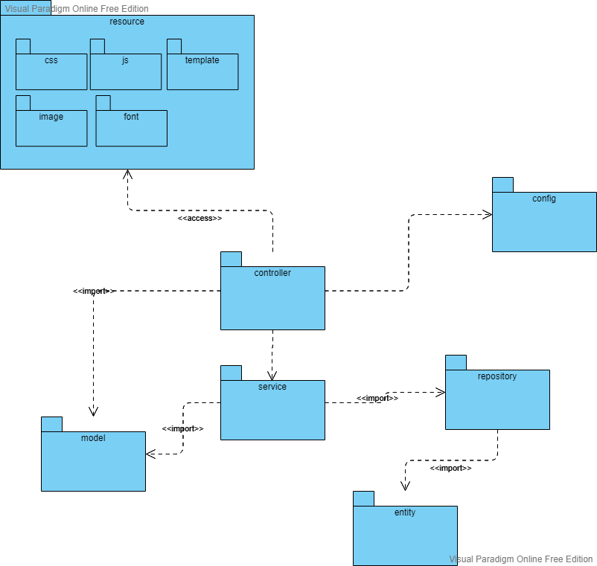 **22**

**Screen flow: 23**

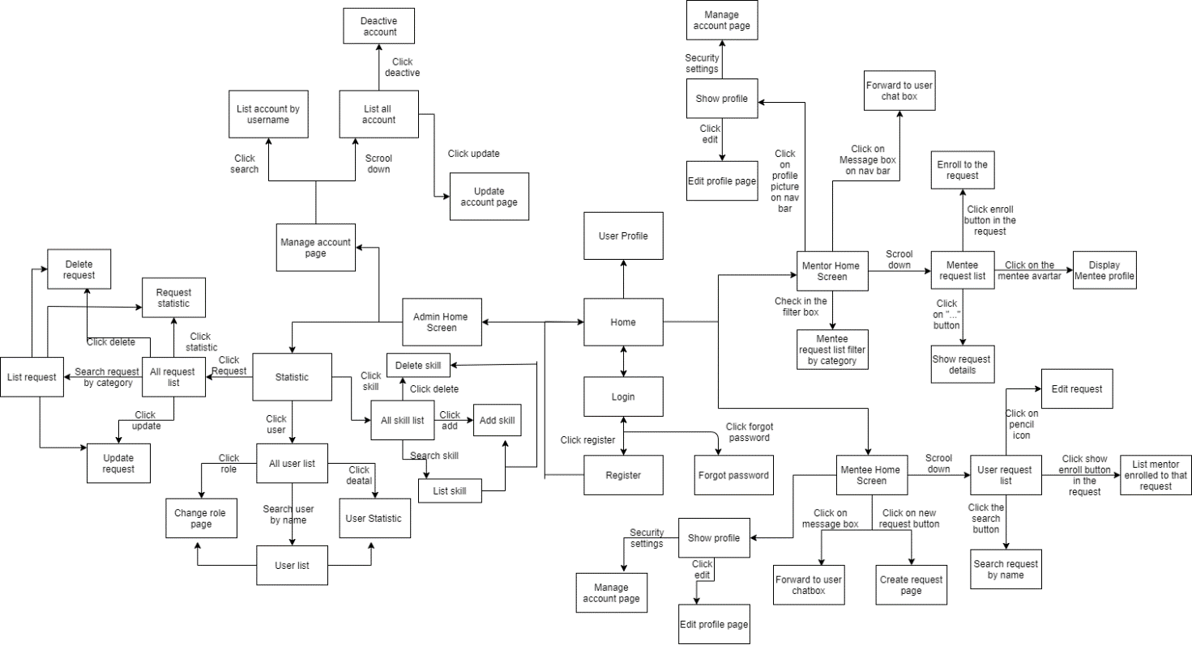 **23**

**Database 24**

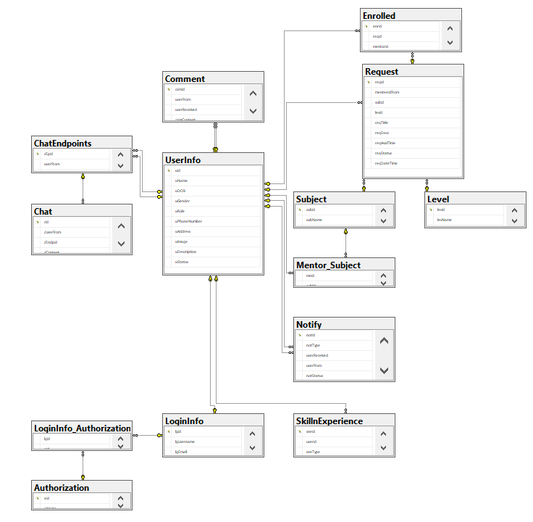 **24**

**Appendix B: Issues List 25**

**Revision History 25**

# Introduction

## Purpose

This document describes the requirements for the Mentor Finder website, which provides supporting information for tutors who are considering finding a mentor, and a cost-free source of students for mentors.

## Document Conventions

The functional requirements for this project are organized by use case within user class.

## Project Vision and Product Scope

### Vision Statement

For students who are looking for a mentor to help them to improve their score, and for mentors who are having trouble of finding a suitable student, Mentor Finder is a website that will provide a connection between mentors and mentees, allow visitors to find them a suitable mentor that can help them study or find mentees so that they can earn some more.

### Product Scope

Mentor Finder is a standalone website that provides a connection between mentors and mentees. For mentee, they have access to mentor’s public profile which will provide them information about which subjects that mentor have taught and feedback of students who had studied with that mentor, to have a better choice when choosing a mentor. For mentor, they are able to see all requests from mentee, which includes a description about students, what they expect in mentor, subject and level students want to study. With this information, mentors can pick a student that fit their teaching ability.

## References

Existing web sites used as models for ideas regarding the functionality documented here include:

www.akadon.edu.vn

www.tutorhunt.com

# Overall Description

## User Classes and Their Use Cases

### Guest

A Guest is the people who comes to Mentor Finder to learn about what the website is and its application. They can read introduction and information about the website, have a clear look on what the purpose of this website is, and process to register to use its functionalities. Use cases:

UC-G-1: Register

### Mentor

A Mentor is the person who registered into the website under “Mentor” role. They can see a list of open Requests of specific Subject or Category. They can enrolled themselves into a Request, and connect with in-needed Mentee.

UC-M-1: Sign-in

UC-M-2: View requests and profiles of mentee

UC-M-3: Manage Enrollment

UC-M-4: Manage profile

UC-M-5: Manage account

UC-M-6: Use chat box

### Mentee

A Mentee is the person who registered into the website under “Mentee” role. They can sign-in into the website, post their problem as a Request that can only be seen by Mentors. After that, they can connect with a Mentor who accepted the request via chat system Use cases:

UC-MT-1: Sign-in

UC-MT-2: Create, manage requests

UC-MT-3: Manage profile

UC-MT-4: Manage account

UC-MT-5: Use chat box

### Administrator

An Administrator is responsible for setting up, updating, managing and modifying the Mentor Finder website’s data. They can look into the statistic to have a better look of the data. Use cases:

UC-A-1: Manage all users

UC-A-2: Manage all requests

UC-A-3: Manage chat box

## Operating Environment

Mentor Finder shall be compatible with standard web browsers on Windows, Mac, and Web-enabled smart phone platforms. Supported browsers are Firefox 2 and 3; Opera 10 and 11; Google Chrome 10 and later.

## Design and Implementation Constraint

CO-1: The Administrator shall be able to maintain the site without site without requiring any specialized technical knowledge of the developers.

CO-2: The Mentor and Mentee can have their conversation via a real-time text-based chat system.

CO-3: User’s data must be protected under secured database. The password must be hashed with a Bcrypt encoder

## User Documentation

The developer shall provide necessary documentation to enable an Administrator to perform the use cases listed in section 2.1.4 Administrator.

The users must be introduced with a user-friendly documentation/guide to be able to perform their use cases listed above.

## Assumptions and Dependencies

It’s assumed that the user’s device has an internet browser listed above in section 2.2 and has average internet connectivity.

Also, it’s assumed that the users are already familiar with some forms of social-network website (MySpace, Facebook, Twiiter, Google+, etc …)

# Functional Requirements

## 1. Login

* Function Trigger: click “Login” from Landing Page
* Function Description: process user to Login

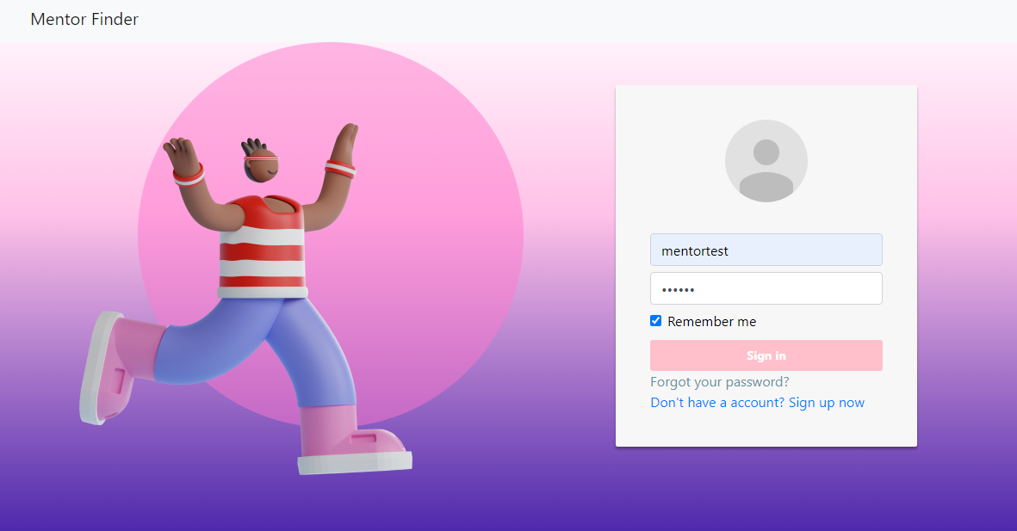

## 2. Register

* Function Trigger: click “Register” from Landing page or “Sign Up now”
* Function Description: process to Register a LoginInfo, after validation User can specify their User Info

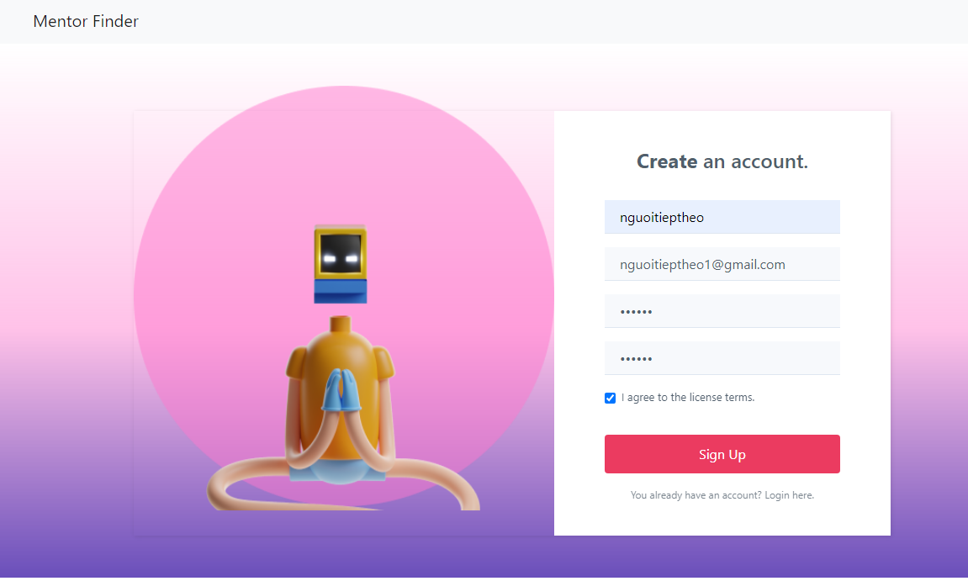

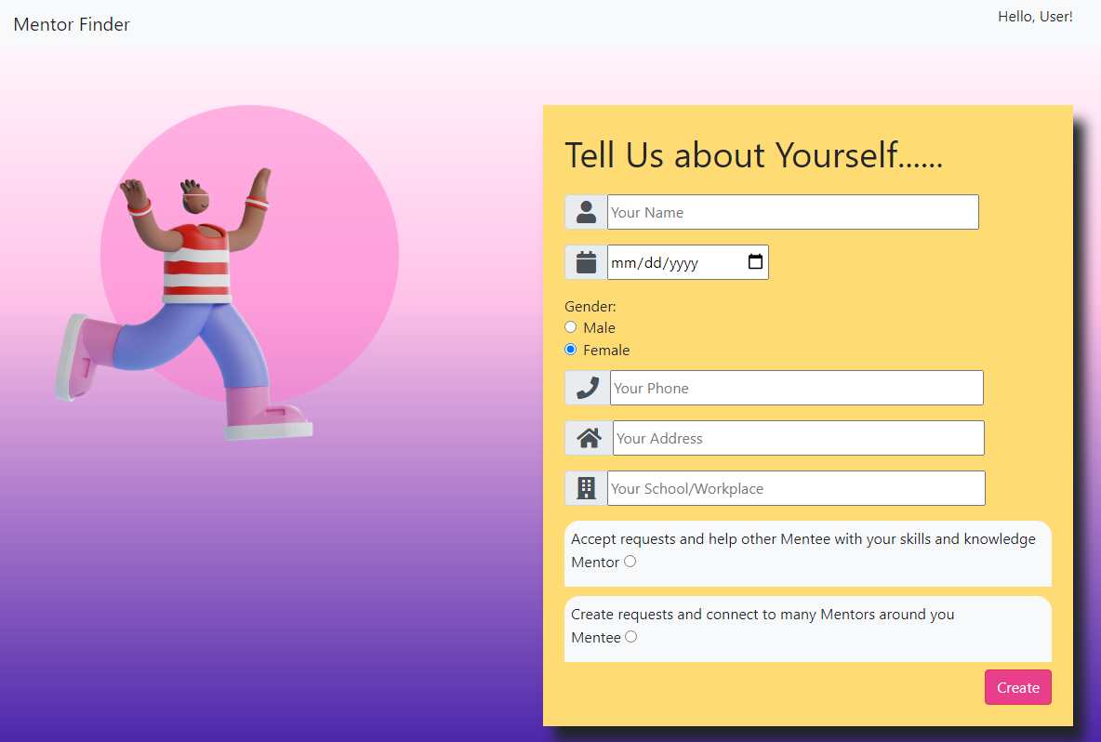

## 3. Request

* Function Trigger: click the “ Add Request”
* Function Description : Mentee can create a Request that only appear into Mentor View

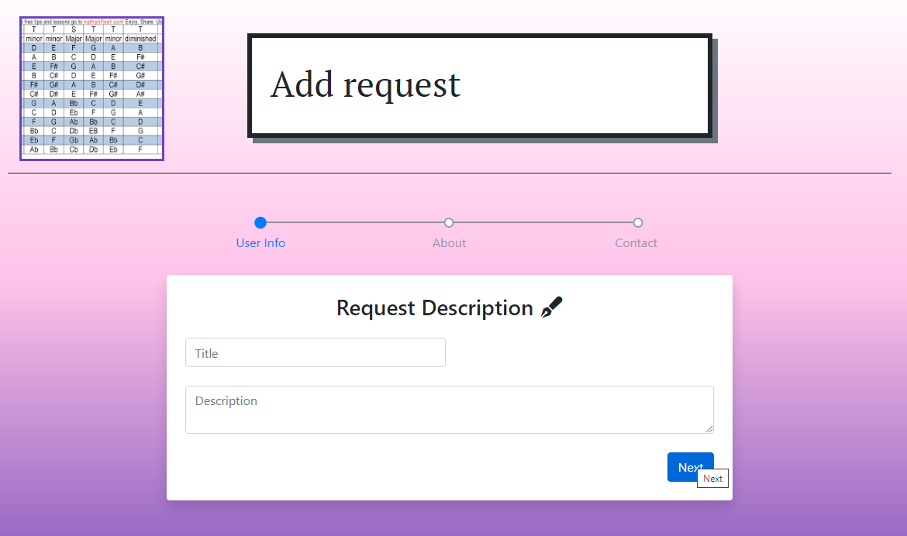

## 4. Delete A Request

* Function Trigger: click the “ Delete Request”, then confirm delete
* Function Description : Role : Mentee , Purpose : delete a request

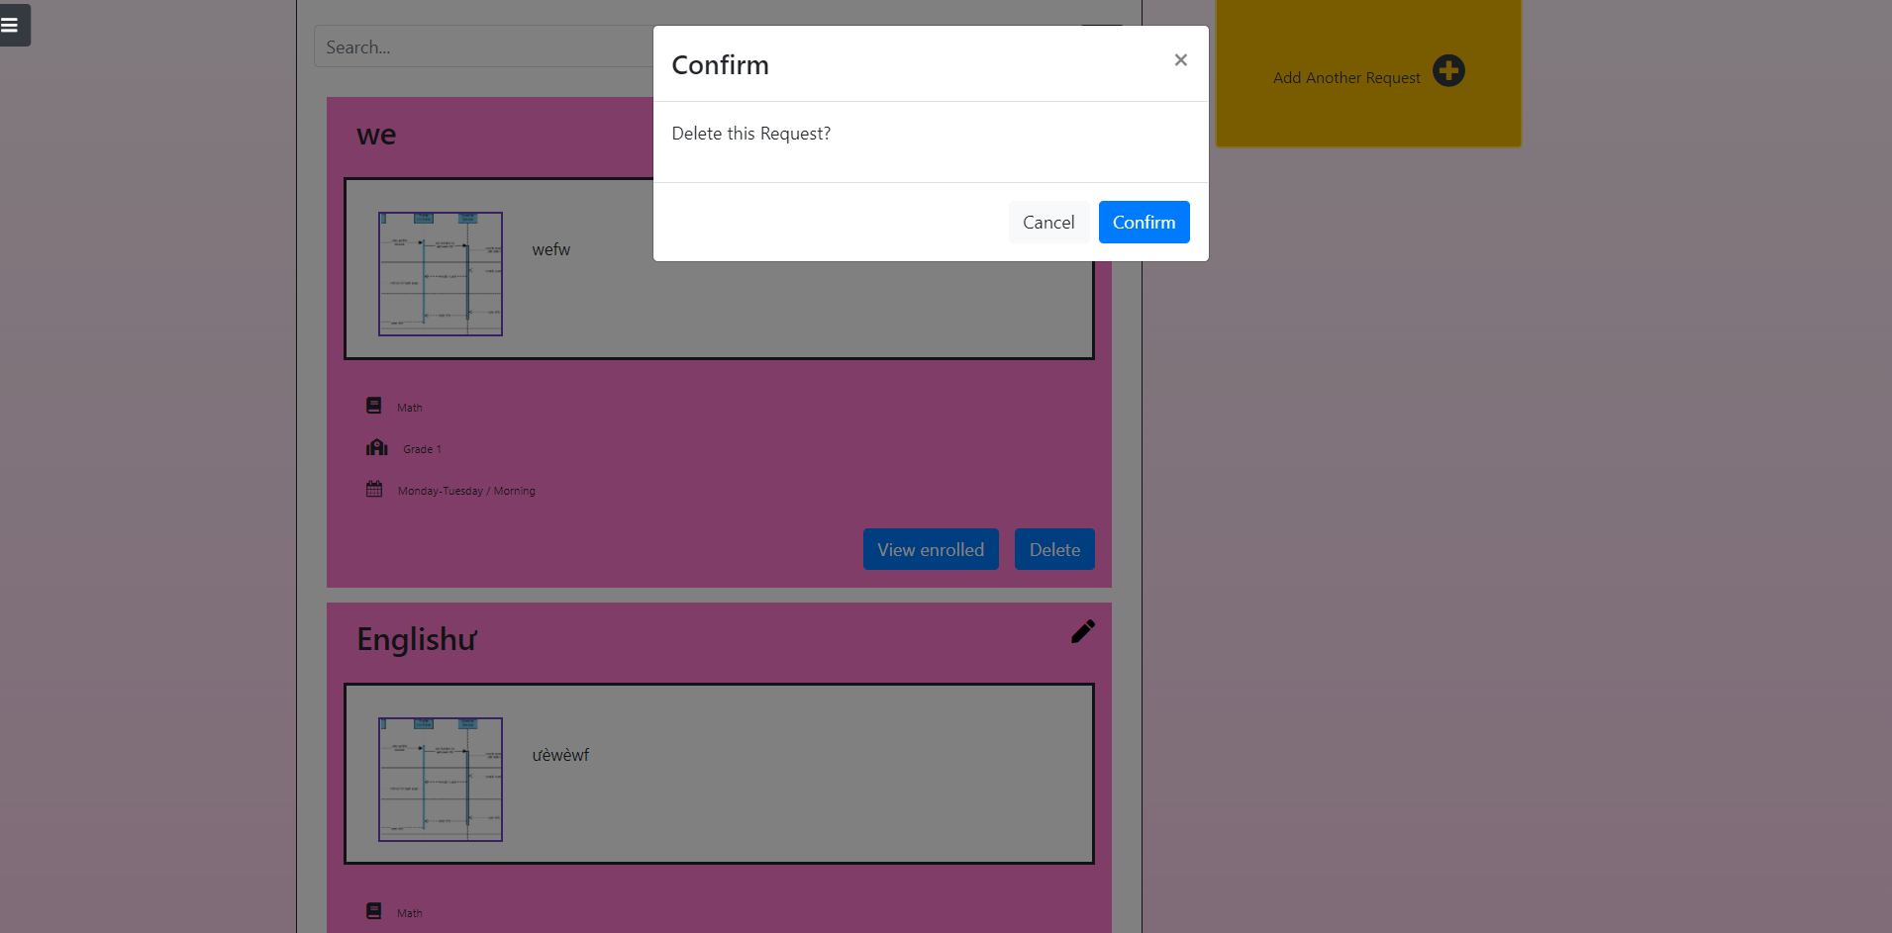

## 5. Enrolled List of A Request

* Function Trigger: click the “ View Enrolled”
* Function Description : Role : Mentee , Purpose : see List of Enrolled Mentors

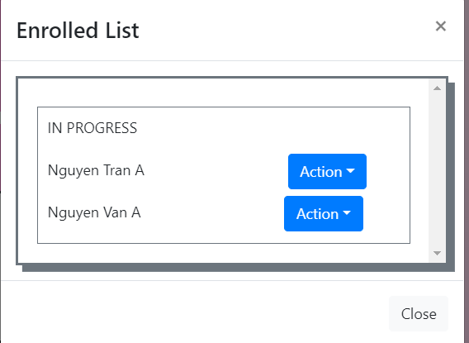

## 

## 6. Enrolled List of A Mentor

* Function Trigger: click the “ See all Enrolled” or “Enrolled List” in navbar
* Function Description : Role : Mentor , Purpose : see List of enrolled requests

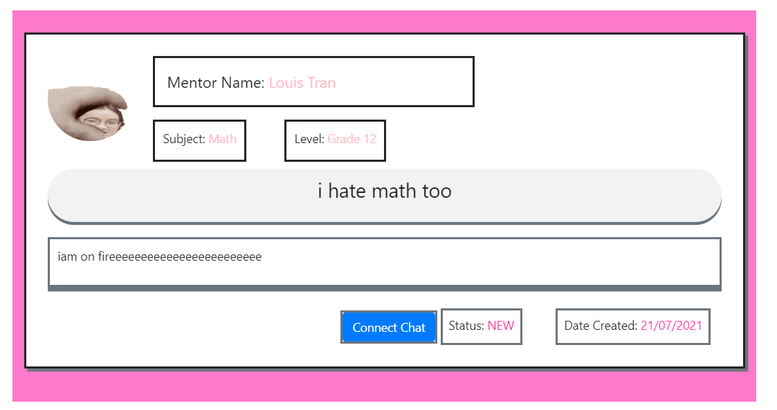

## 7. Enroll a Request

* Function Trigger: click the “Enroll this Request”
* Function Description : Role : Mentee , Purpose : enroll the request

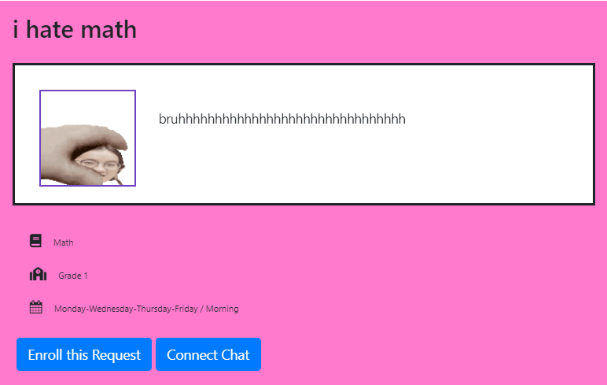

## 8. Accept/Reject a Request

* Function Trigger: click the “View Enrolled”
* Function Description : Role : Mentee , Purpose : accept enroll form a mentor

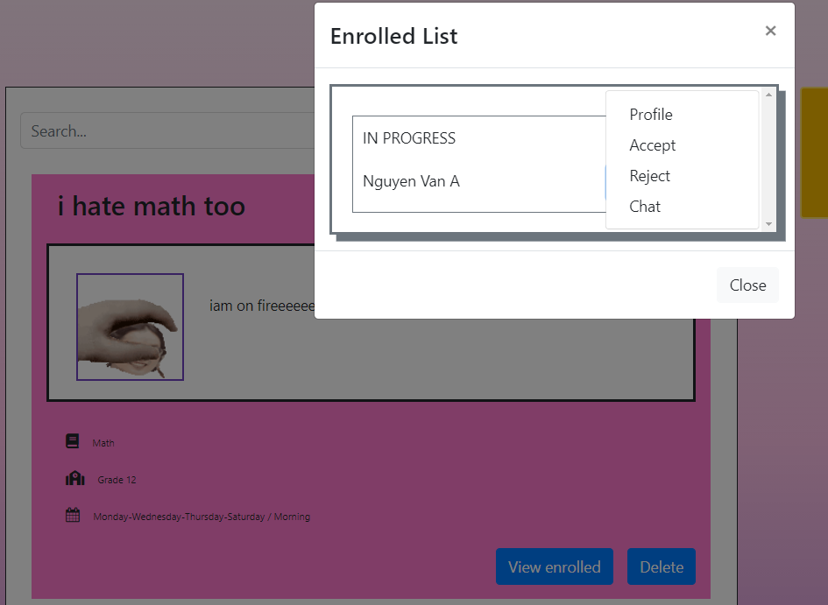

## 9. Delete a Request

* Function Trigger: click the “Delete”
* Function Description : Role : Mentee , Purpose : delete a request

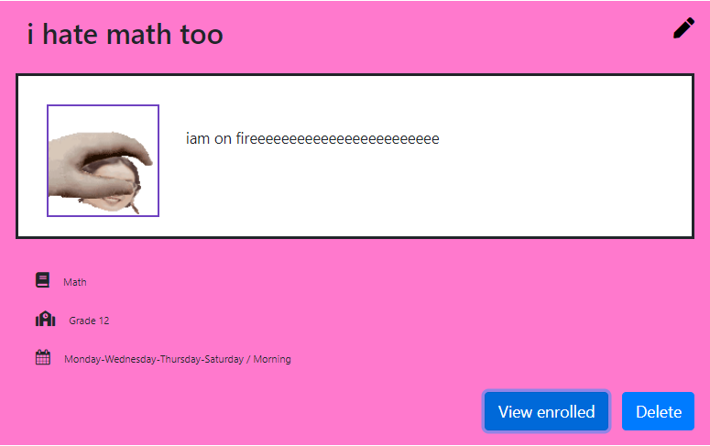

## 10. Notification

* Function Trigger: click the “Notification” in navbar
* Function Description : Role : Mentee,Mentor , Purpose : see notification of the user.

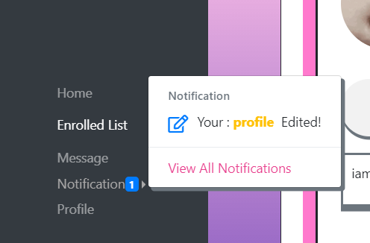

## 11. Update Status of all Notification

* Function Trigger: click the “Notification” in navbar
* Function Description : Role : Mentee,Mentor , Purpose : auto update unread notification

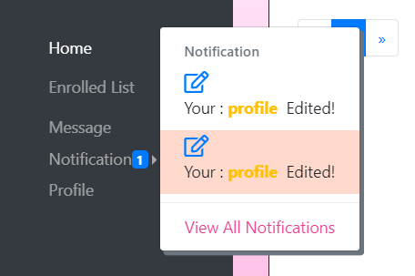

## 12. Home

* Function Trigger: click the “Home” in navbar
* Function Description : Role : Mentee,Mentor , Purpose : see home screen of 2 roles

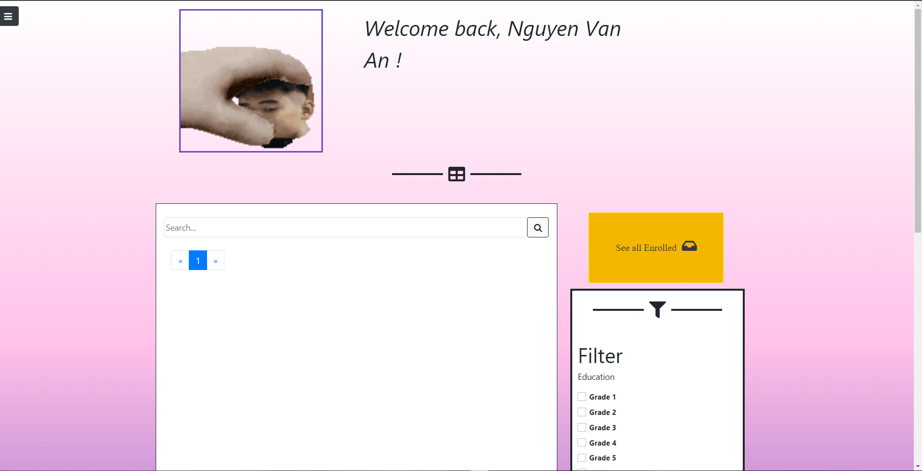

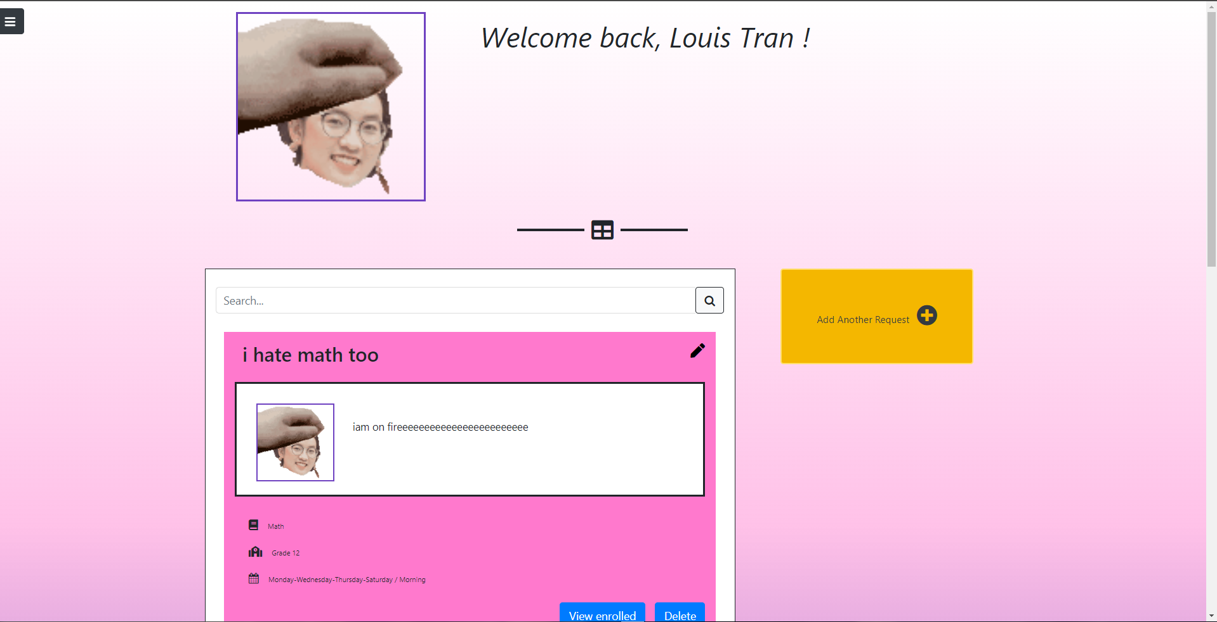

## 13. Comments a Mentor

* Function Trigger: click the “Profile” in action dropdown
* Function Description : Role : Mentee , Purpose : Comment in the profile

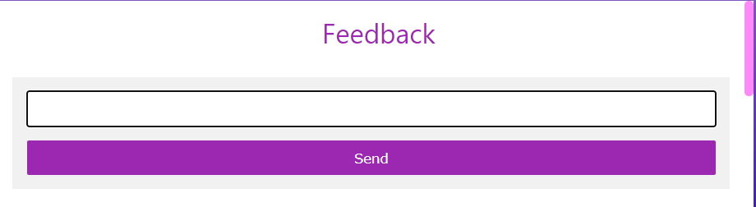

## 14. Comments a Mentee

* Function Trigger: click the “Profile” in action dropdown
* Function Description : Role : Mentee , Purpose : Comment in the profile

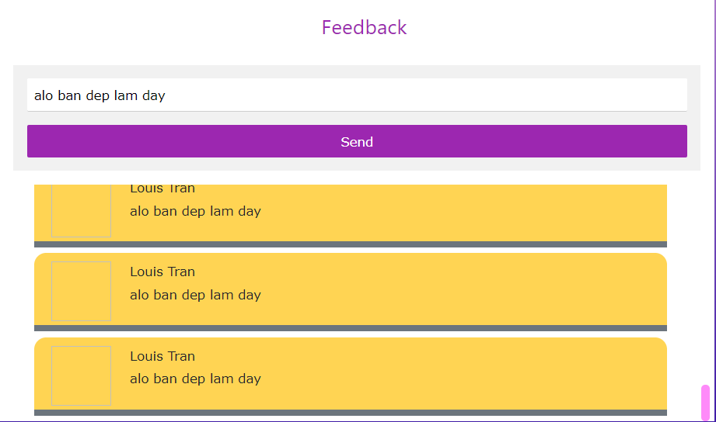

## 15. Get Profile of a mentor

* Function Trigger: click the “Profile” in action dropdown
* Function Description : Role : Mentee , Purpose : Show profile in Mentee Perspective

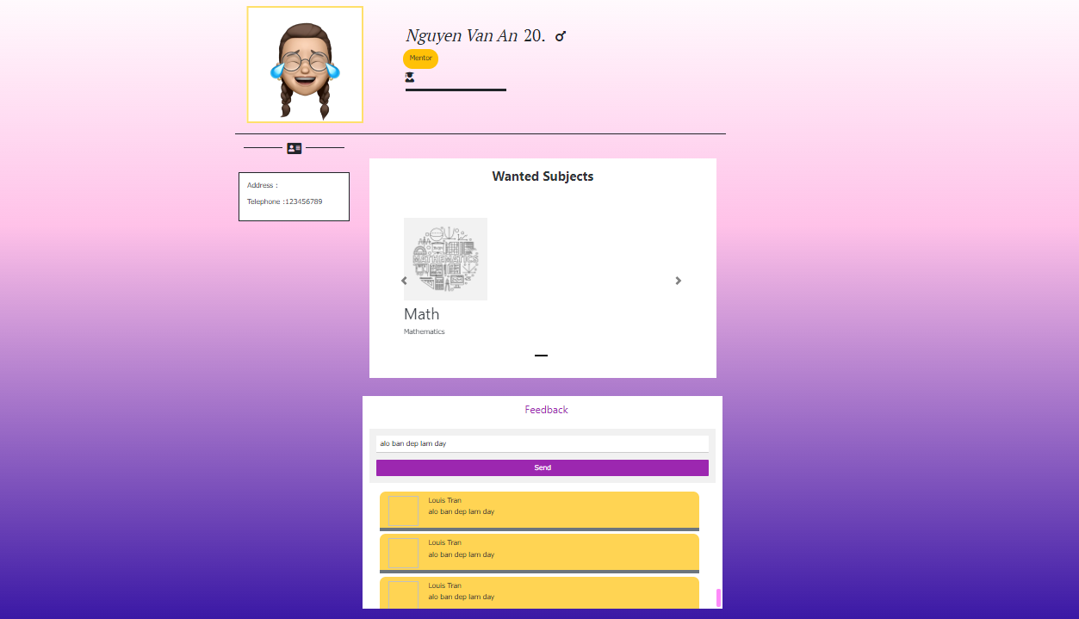

## 16. Get Profile of User

* Function Trigger: click the “Profile” in navbar
* Function Description : Role : Mentee , Purpose : Show the user Profile

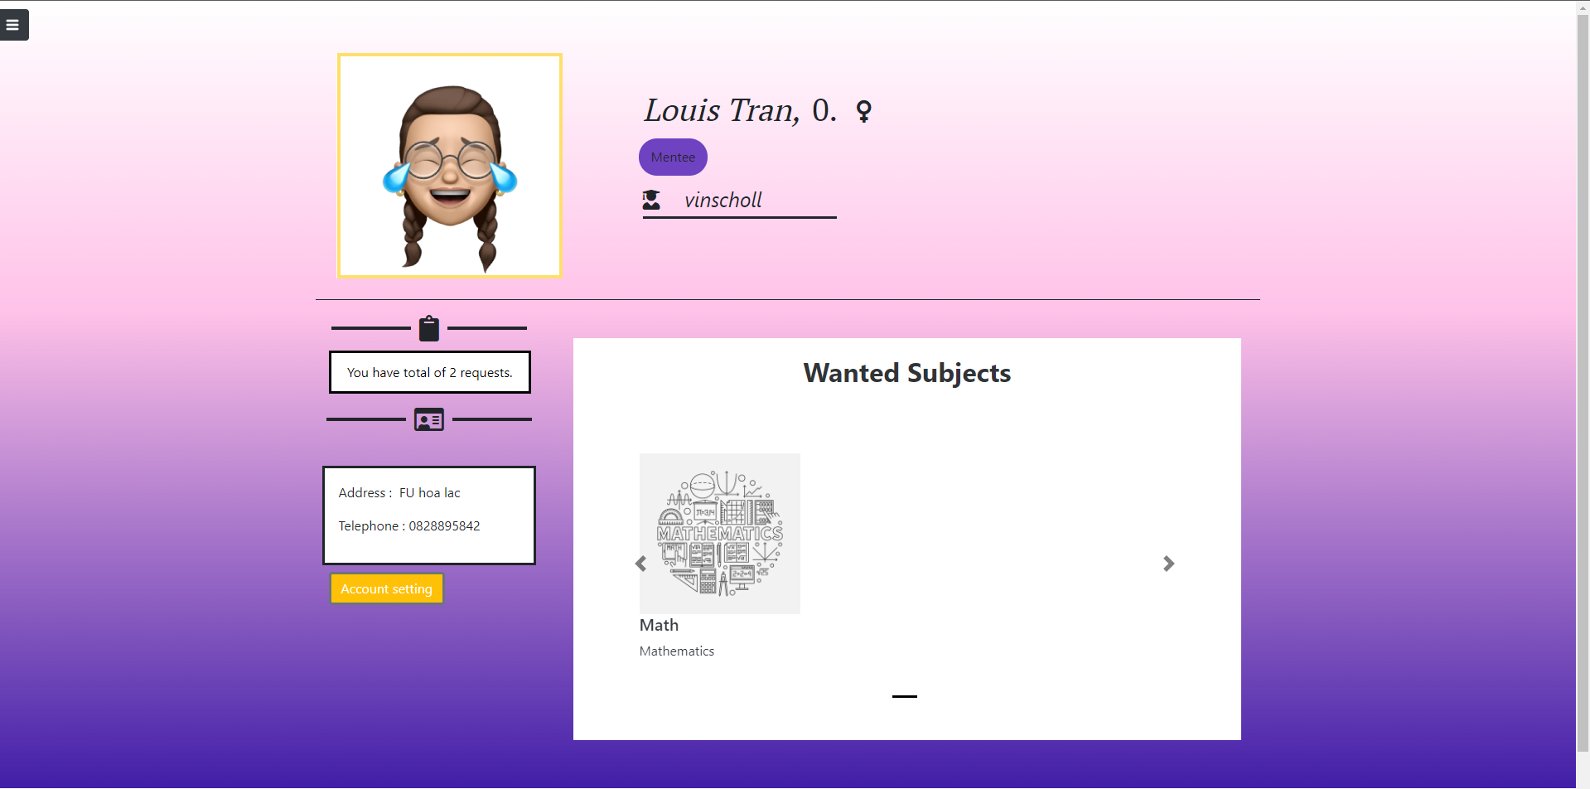

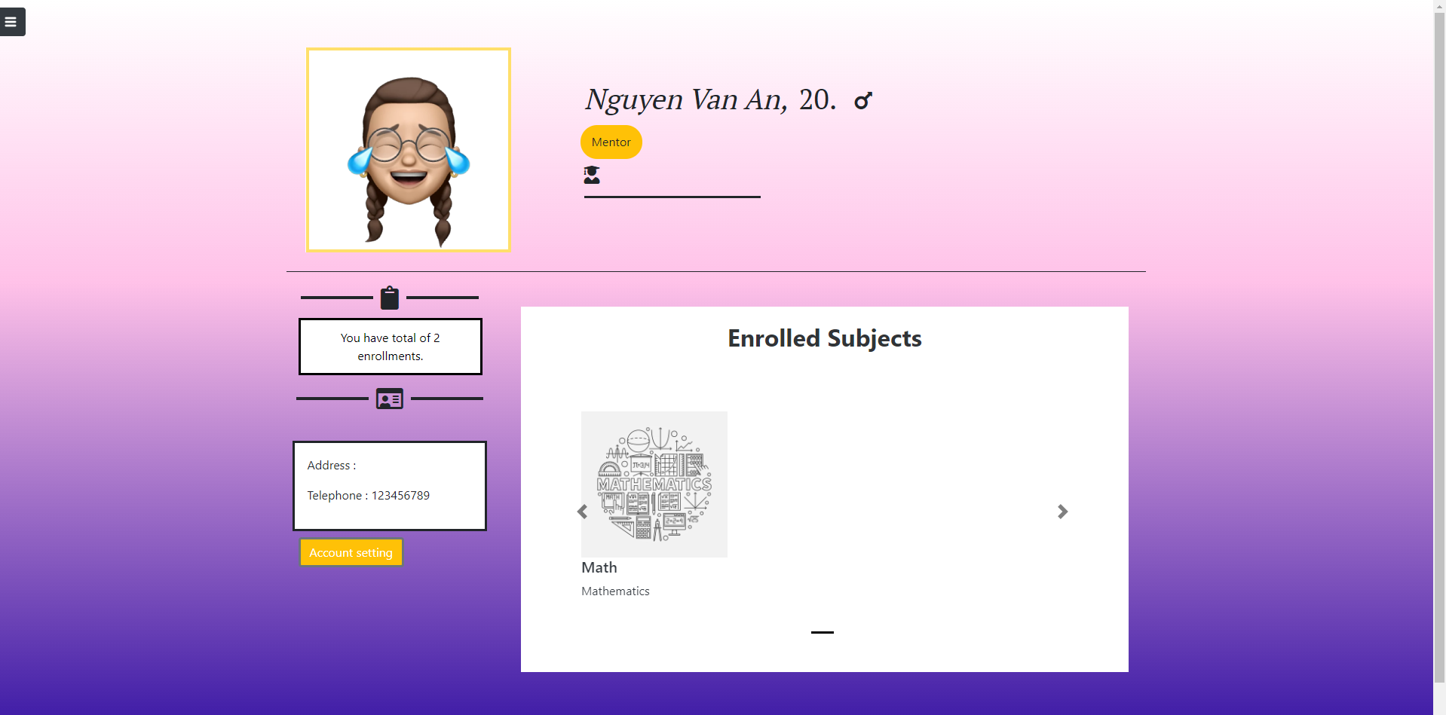

## 17. Get Account Setting of User

* Function Trigger: click the “Account Setting” in navbar
* Function Description : Role : Mentee , Purpose : Show the user Profile Setting

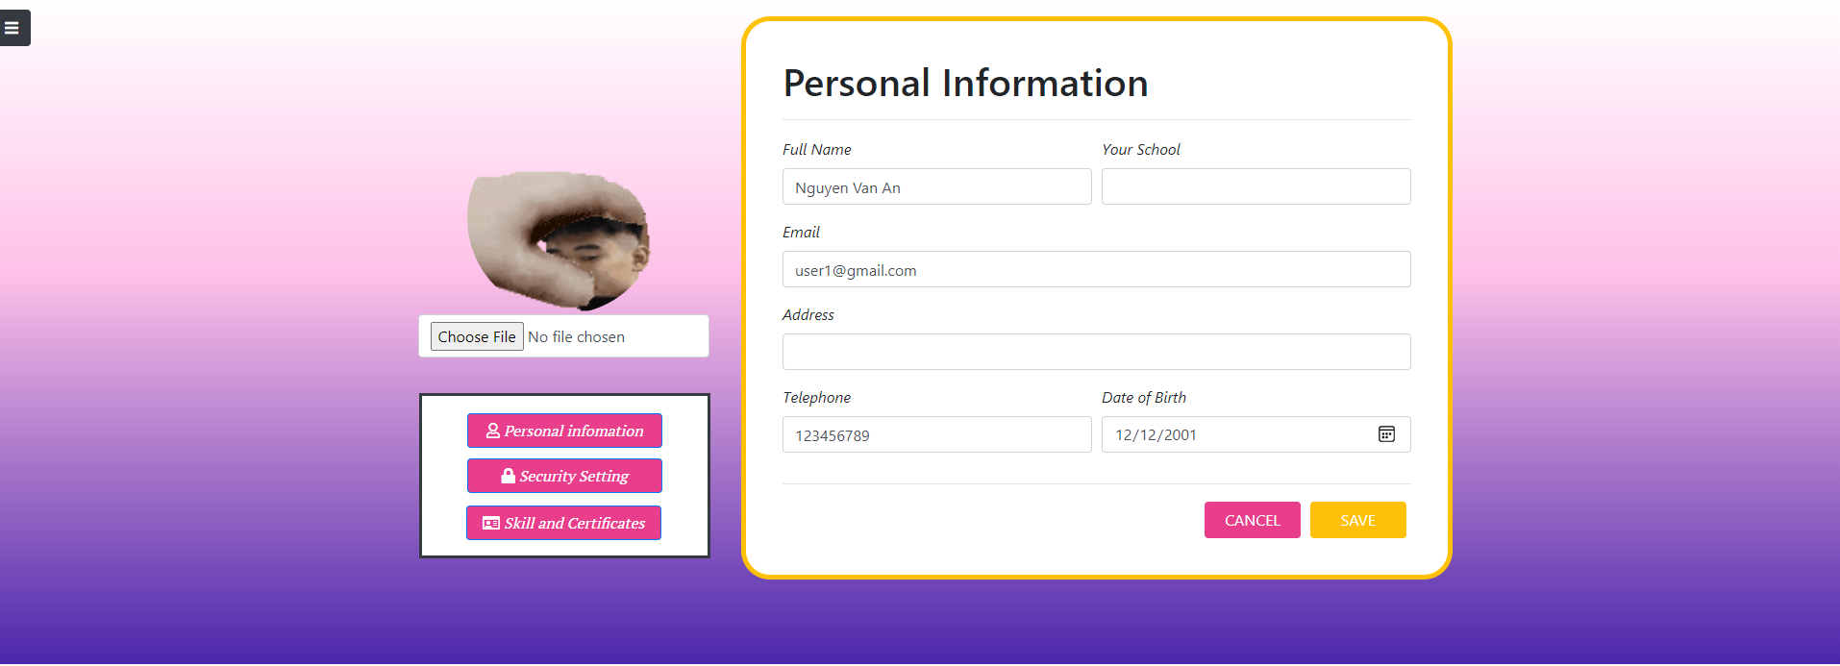

## 18. Admin view all list Request

* Function Trigger: click “request list” on navbar
* Function Description : Role : Admin , Purpose : Show all the request

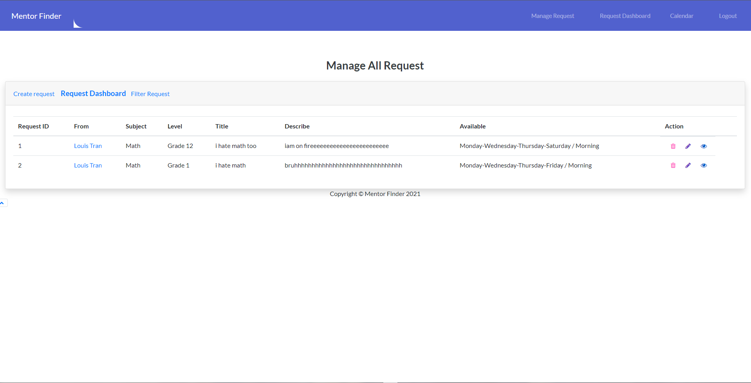

## 19. Manage Request

* Function Trigger: Action bar in Request List
* Function Description : Role : Admin , Purpose : CRUD Request

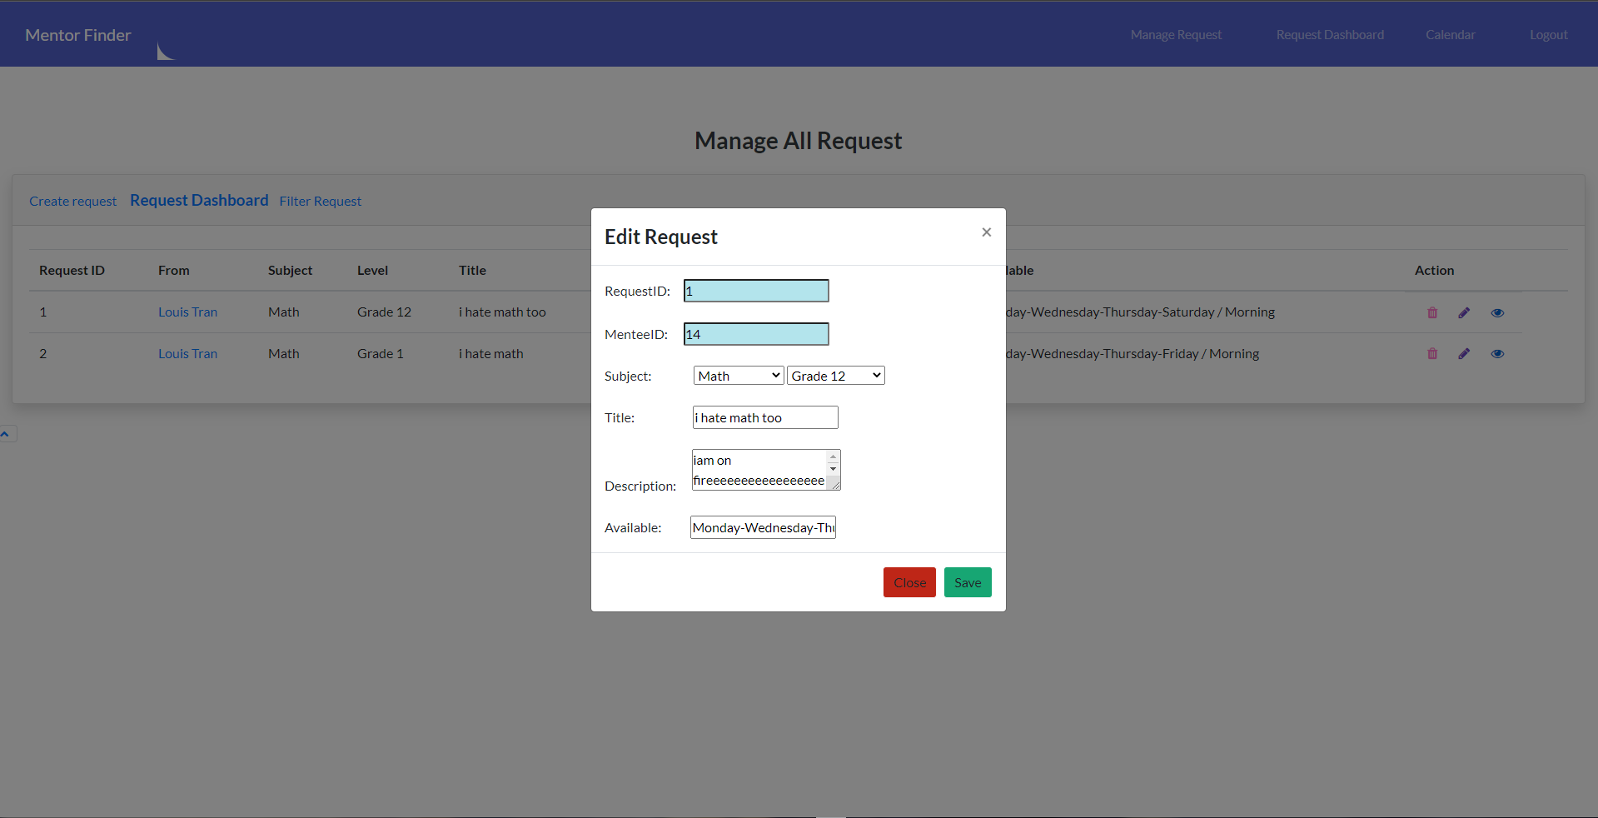

## 20. Filter Request

* Function Trigger: filter link in request list
* Function Description : Role : Admin , Purpose : Filter the request list

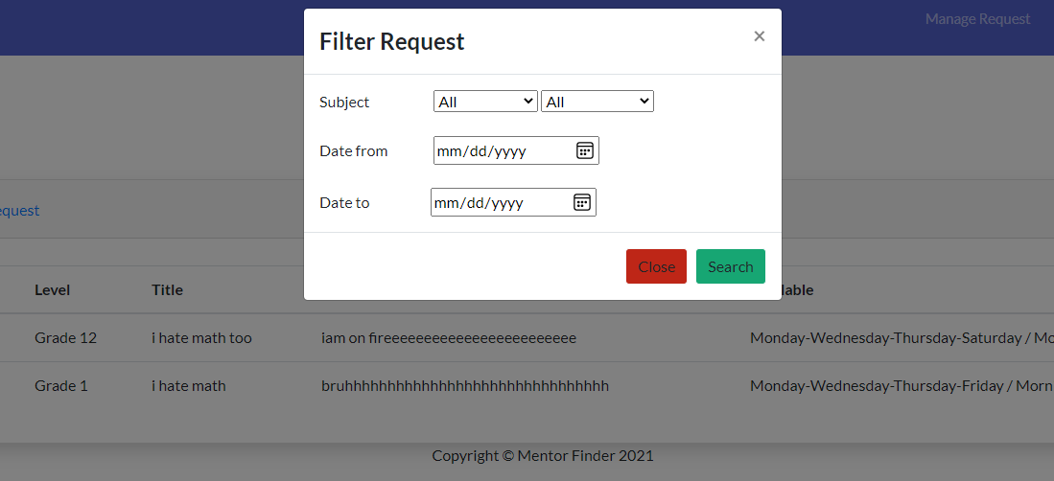

## 21. Request detail

* Function Trigger: eye icon in Action bar
* Function Description : Role : Admin , Purpose : view the request in detail

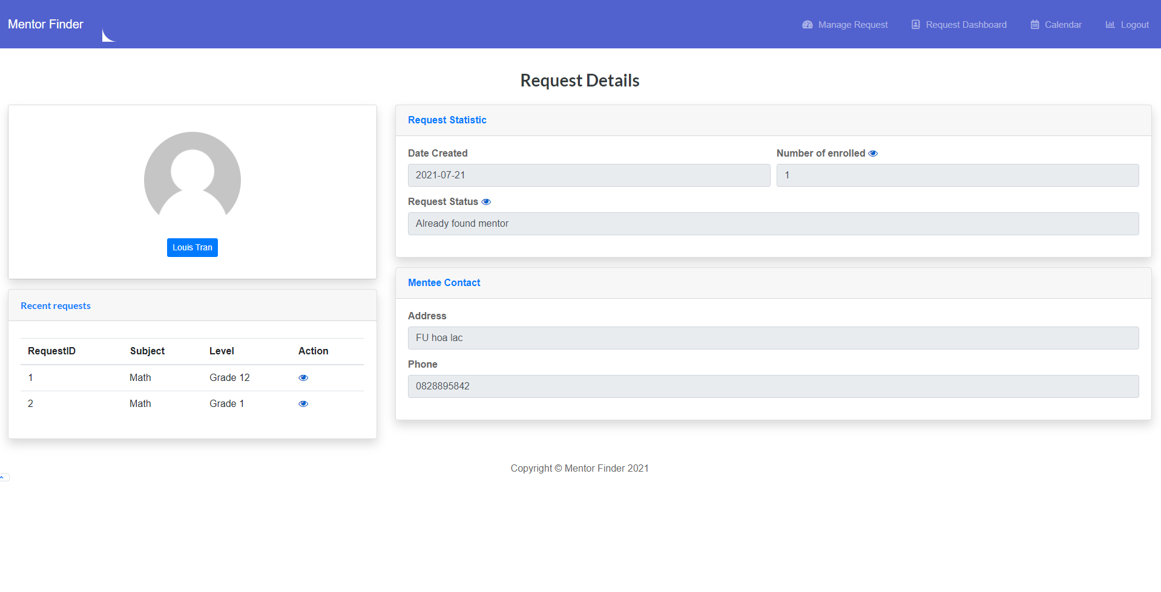

## 22. Admin Notify User

* Function Trigger: when an action is occur in Request List
* Function Description : Role : Admin , Purpose : Admin will notify an user if there any change in their request

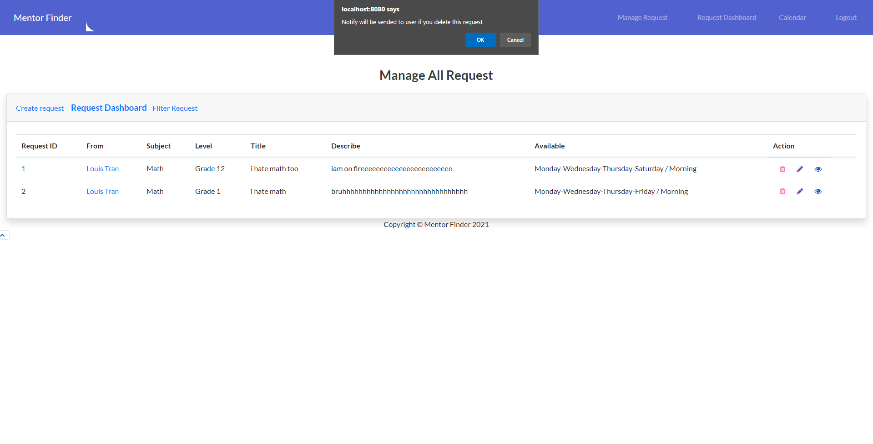

## 23. Admin Dashboard

* Function Trigger: click Dashboard button in navbar
* Function Description : Role : Admin , Purpose : Admin will have stats in the change of the request List

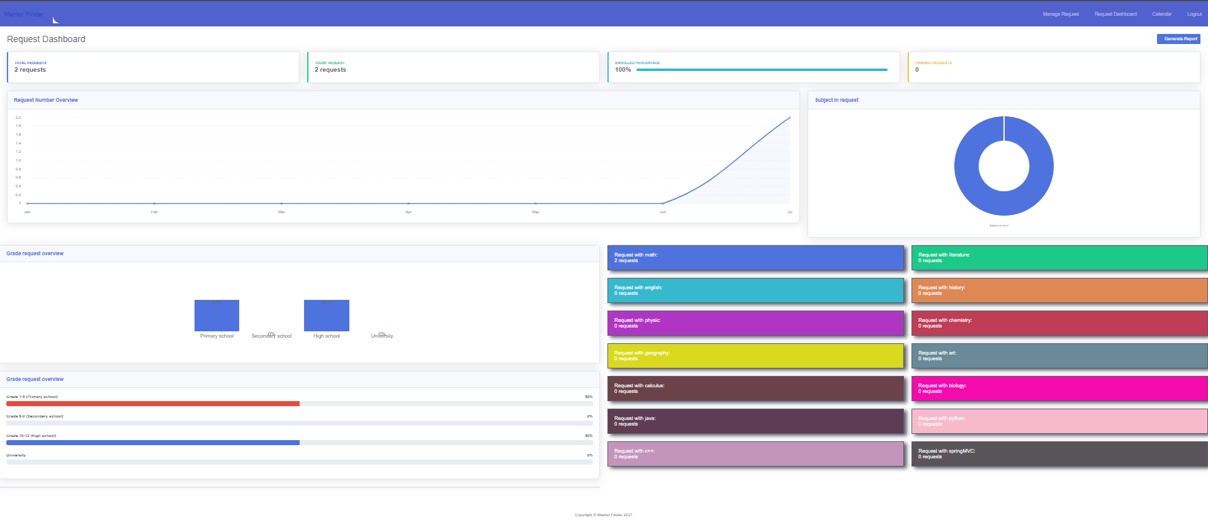

## 24. Admin Daily Report

* Function Trigger: click Calendar and choose day to see
* Function Description : Role : Admin , Purpose : Admin will have stats in daily of the change of the request List

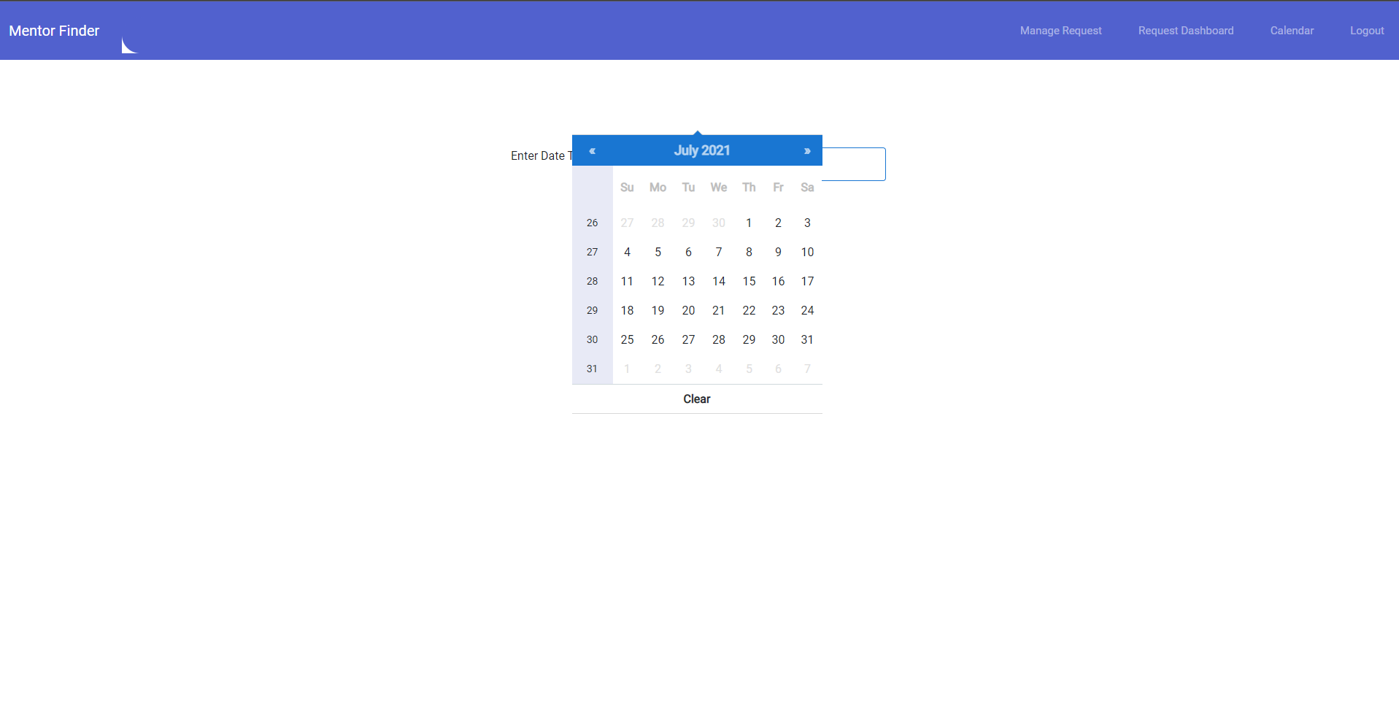

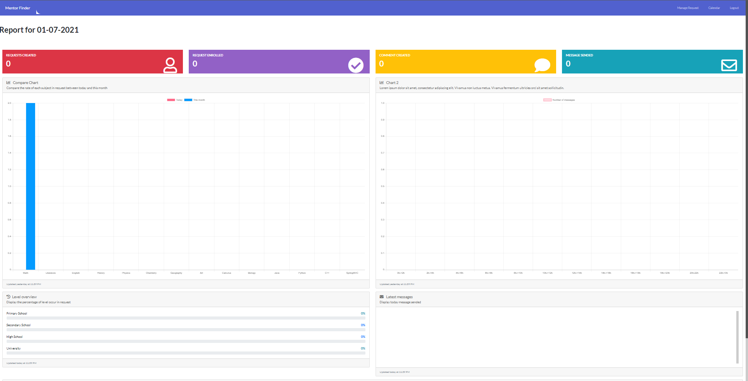

## 25. Admin View mentee list

Function Trigger: click “Manage Mentee” on AdminHome.html

* Function Description : Role : Admin , Purpose : Show all the mentees
* 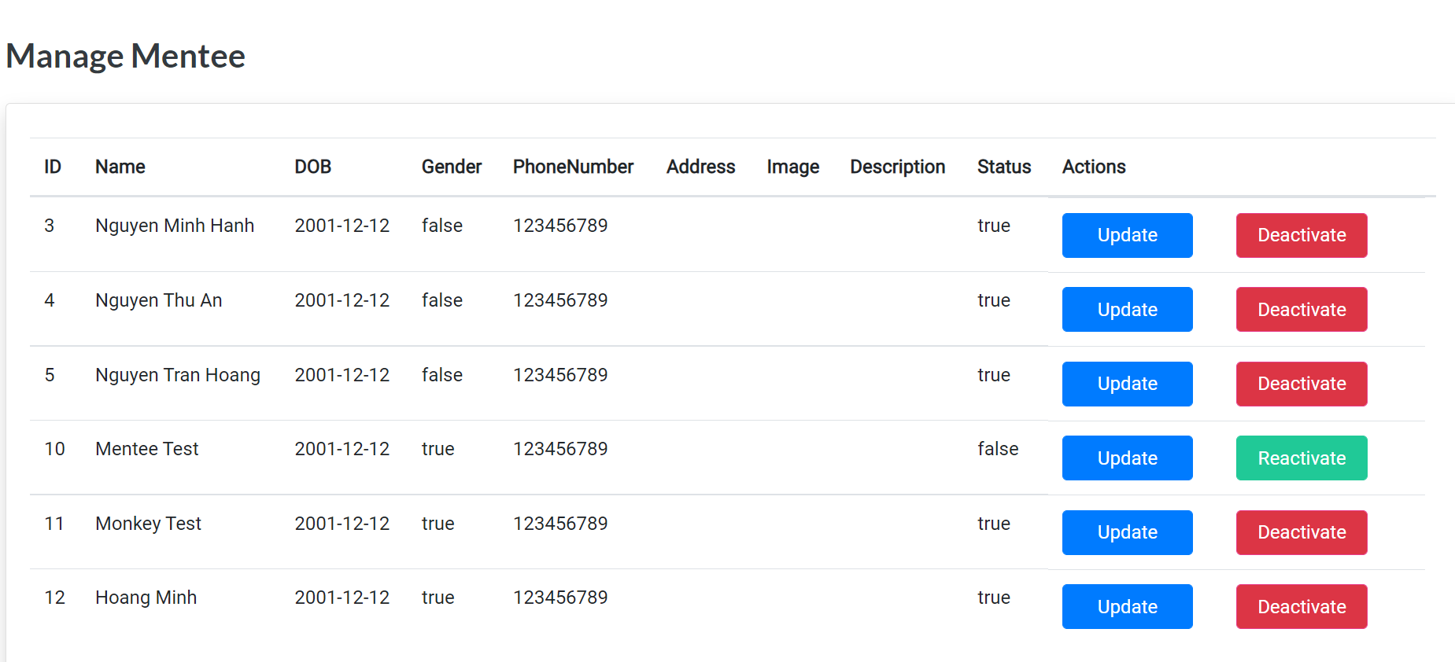

## 26. Admin Manage mentee

1. Update Mentee Info

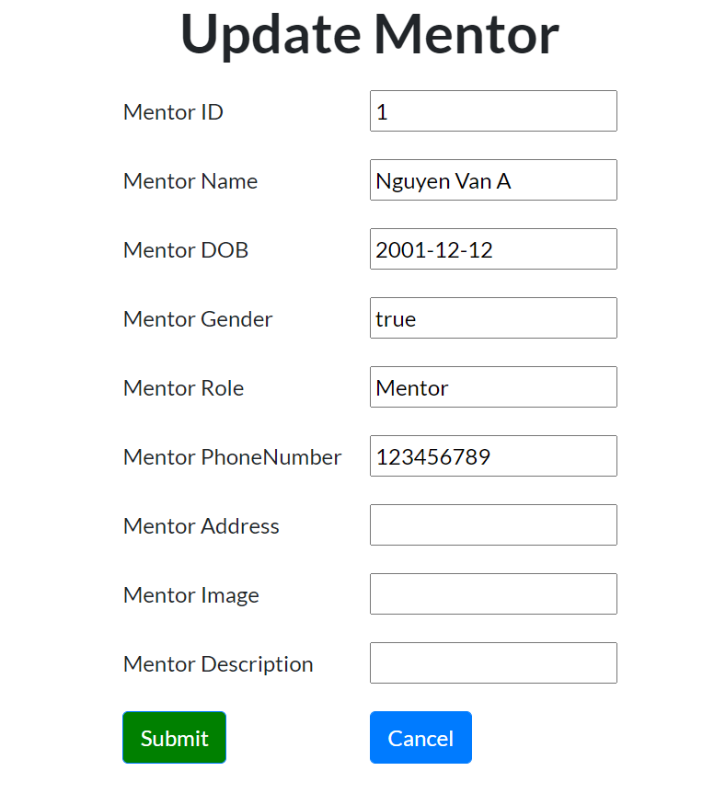

1. De/activate account

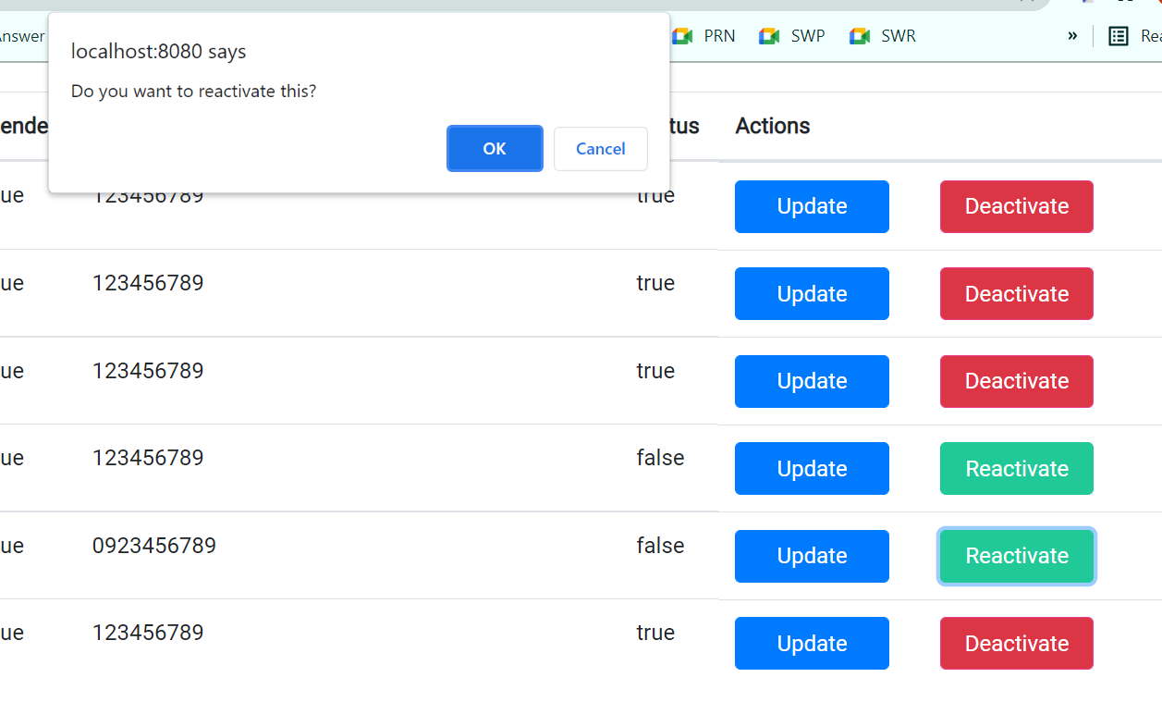

## 27. Admin View mentor list

Function Trigger: click “Manage Mentor” on AdminHome.html

* Function Description : Role : Admin , Purpose : Show all the mentors
* 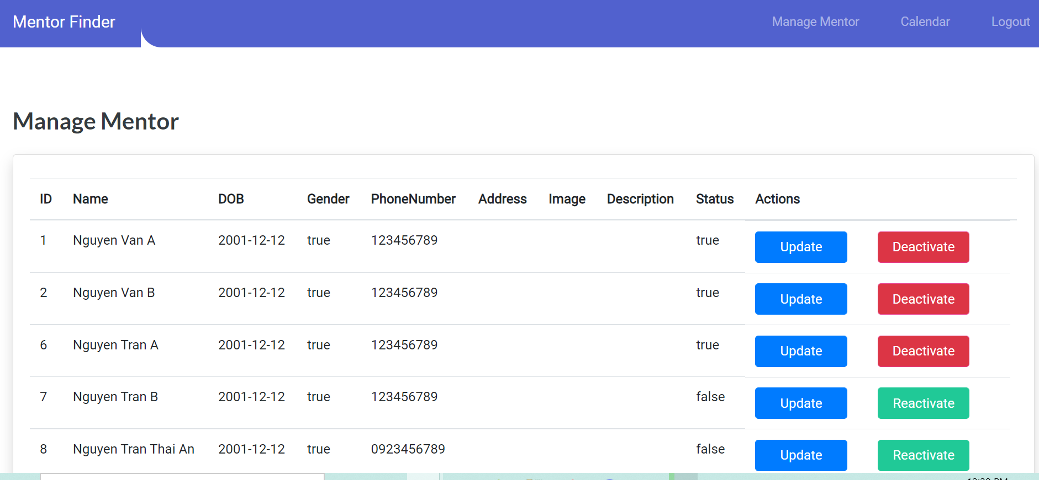

## 28. Admin Manage mentor

1. Update Mentor Info



1. De/activate account



## 29. Forgot Password

Function Trigger: click “Forgot your password” on Login.html

* Function Description : Role : Guest, Purpose : Allow guest to reset password via email
* Forgot Password form:
* 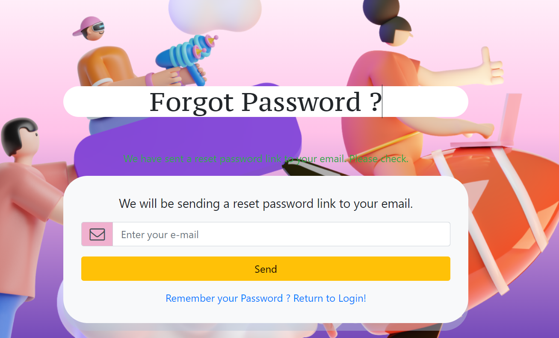
* Reset Password form: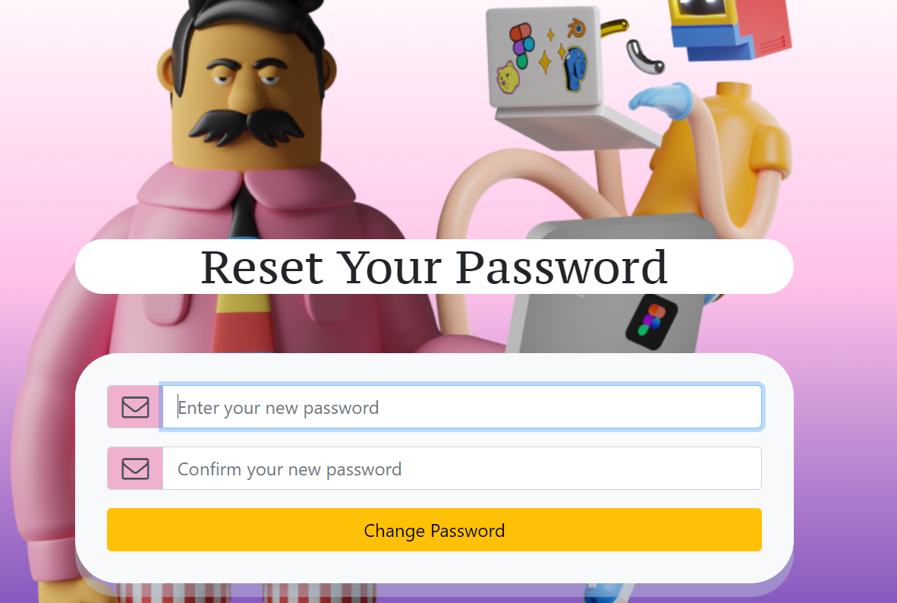

Message form:

* 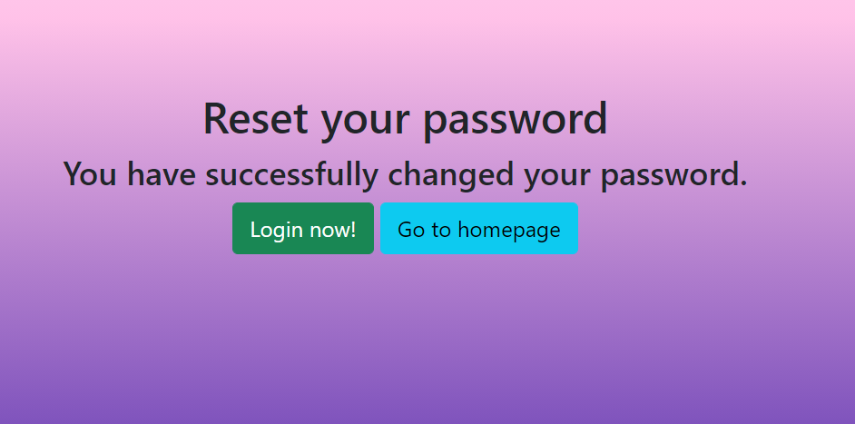

## 30. User Chat Box

* Function Trigger: click Message button in navbar, or click Chat button integrated into Request
* Function Description : Role : Mentee,Mentor , Purpose : a Communication way between Mentee and mentor

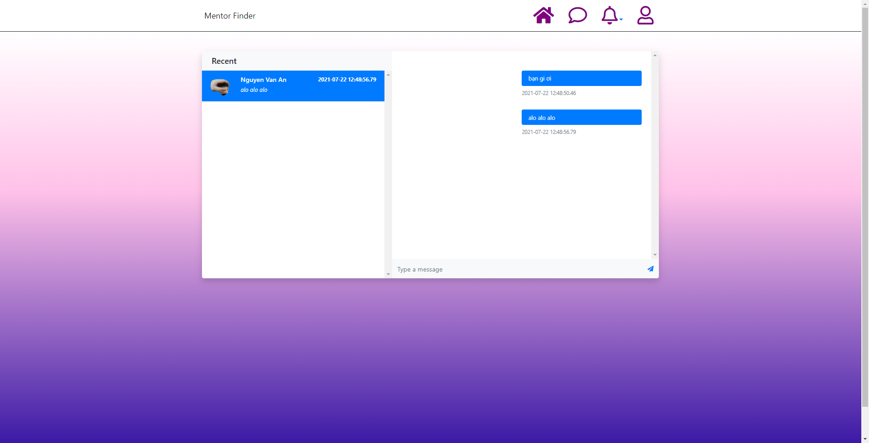

# External Interface Requirements

## User Interfaces

UI-1: The fields texts used in all forms shall be wide enough to accommodate 95% of expected entries without requiring either horizontal or vertical scrolling, except for fields whose input exceeds 50 words, where vertical scroll bars shall become enabled if the user enters enough information to force a line break.

UI-2: Easy Simple for user to interact with UI of the website, only using 1 color palette to design Frontend.

UI-3: Each page of the website shall have a navigator bar with links to all the pages (major pages being defined as the home page and those other pages directly accessible from the home page).

UI-4: Each page in the web site shall display the following copyright notice at the bottom: Copyright © 2021 Mentor Finder. All rights reserved.

UI-5: All footer of the website has access to social page of the Mentor Finder website.

UI-6: Separately Display User profile with two roles: Mentor and Mentee.

UI-7: Admin have access to dash broad, chart to easily manage activities from the website.

## Software Interfaces

External links will exist from MentorFinder.com to the following sites:

Links are expected to come into MentorFinder.com from the following sites:

4.2.1 facebook.com

## Communications Interfaces

There are no specific communications interfaces besides URL links.

## Hardware Interfaces

This website currently designing for laptop user only with no responsive to another device such as smartphone.

Targeting only to PC/Laptop users in any Browsers (Chrome, firefox, oprera, Edge, etc…)

# Other Nonfunctional Requirements

## Performance Requirements

PE-1: The web pages shall fully paint in an average response time of 3 seconds or less over a broadband (DSL or cable) Internet connection. (Priority: High)

## Security

SE-1: In case of forgotten passwords, users are offered solutions to retake the passwords. (Priority: High)

## Extensibility

EX-1: The website shall be designed to permit adding a database component in the future. (Priority: Low)

# Business Rules

BR-1 Email address is used as a username to login

BR-2 Email address must follow valid format

BR-3 Each email must be used for only one account

BR-5 Password must be encoded in the database

BR-6 Passwords must contain uppercase and lowercase and special characters and numbers

BR-7 Re-enter password must match with password.

BR-8 Phone number must contain only numbers

BR-9 Only Admin can lock/ unlock users.

BR-10 Mentor’s description must not be empty

BR-11 Mentee can see mentor’s profile

BR-12 When users want to login, they must input email and password

BR-13 When users forget their password, they will get a new password from their email.

BR-14 Users can edit their profile.

BR-15 Guests cannot view other users’ profiles until they register accounts.

BR-16 When registering, users must choose one role (mentee/mentor).

BR-17 Users are automatically logged out after an amount of inactivity time

BR-18 Only admin can view website’s statistics

BR-19 Admin can view all mentee requests and all enrolled mentors in a request

BR-20 Mentees can view enrolled mentors in their requests.

BR-21 After mentee accept mentor, they can chat through a chat box

# Appendix

## Appendix A : Screen flow

* + 1. Screen flow diagram

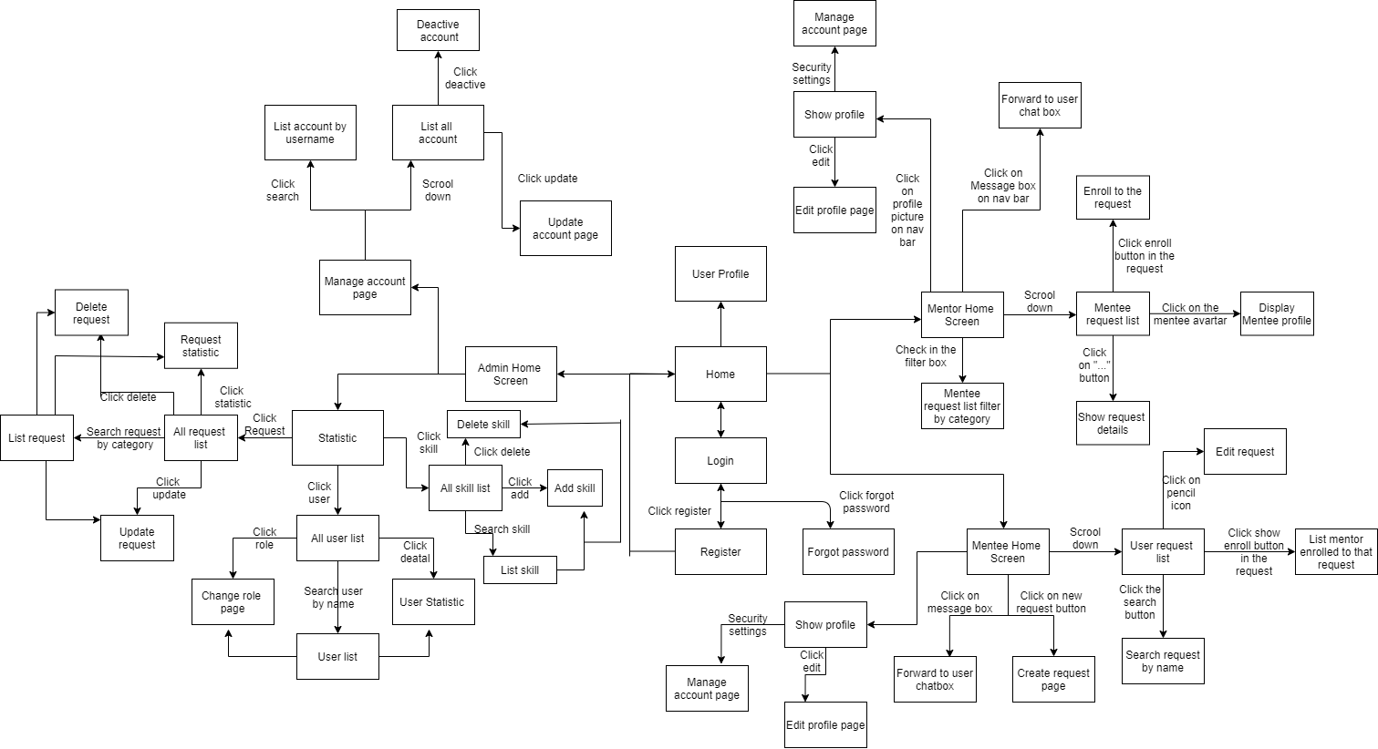

* + 1. Screen Details

| **#** | **Feature** | **Screen** | **Description** |
| --- | --- | --- | --- |
| 1 | 1. Login | 1. Login | Login |
| 2 | 2. Register | 2. Register | Register |
| 3 | 3. Request | 3. Request | Create request |
| 4 | 4. Enrolled | 4. Enrolled |  |
| 5 | 5. Notification | 5. Notification |  |
| 6 | 6. Home | 6. Home |  |
| 7 | 7. Comment | 7. Comment |  |
| 8 | 8. Enrolled List of A Request | 8. Enrolled List of A Request |  |
| 9 | 9. Enrolled List of A Mentor | 9. Enrolled List of A Mentor |  |
| 10 | 10. Enroll a Request | 10. Enroll a Request |  |
| 11 | 11. Accept/Reject a Request | 11. Accept/Reject a Request |  |
| 12 | 12. Delete a Request | 12. Delete a Request |  |
| 13 | 13. Notification | 13. Notification |  |
| 14 | 14. Update Status of all Notification | 14. Update Status of all Notification |  |
| 15 | 15. Home | 15. Home |  |
| 16 | 16. Comments a Mentor | 16. Comments a Mentor |  |
| 17 | 17. Comments a Mentee | 17. Comments a Mentee |  |
| 18 | 18. Get Profile of a mentor | 18. Get Profile of a mentor |  |
| 19 | 19. Get Profile of User | 19. Get Profile of User |  |
| 20 | 20. Get Account Setting of User | 20. Get Account Setting of User |  |
| 21 | 21. Admin view all list Request | 21. Admin view all list Request |  |
| 22 | 22. Manage Request | 22. Manage Request |  |
| 23 | 23. Filter Request | 23. Filter Request |  |
| 24 | 24. Request detail | 24. Request detail |  |
| 25 | 25. Admin Notify User | 25. Admin Notify User |  |
| 26 | 26. Admin Dashboard | 26. Admin Dashboard |  |
| 27 | 27. Admin Daily Report | 27. Admin Daily Report |  |
| 28 | 28. Admin View mentee list | 28. Admin View mentee list | Admin view all mentee list |
| 29 | 29. Admin Manage mentee | 29. Admin Manage mentee |  |
| 30 | 30. Admin View mentor list | 30. Admin View mentor list | Admin view all mentor list |
| 31 | 31. Admin Manage mentor | 31. Admin Manage mentor |  |
| 32 | 32. Forgot Password | 32. Forgot Password |  |
| 33 | 33. User Chat Box | 33. User Chat Box |  |

* + 1. Non-Screen Functions

#### 

| **#** | **Feature** | **System Function** | **Description** |
| --- | --- | --- | --- |
| 1 | User Authorization | Login | System using spring security to authorize user |

* + 1. Entity relationship diagram

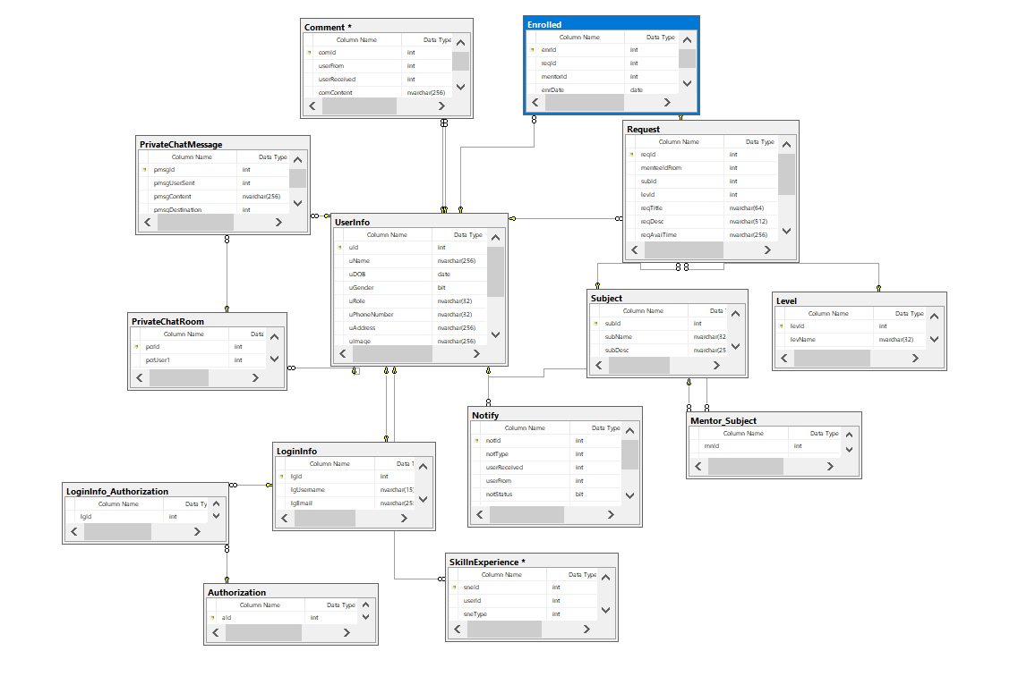

## Appendix B : Data Dictionary

| **No** | **Table** | **Description** |
| --- | --- | --- |
| 01 | LoginInfo | Basic login information  - Primary keys: lgId  - lgUsername: string  - lgEmail: string  -lgPassword: string |
| 02 | Authorization | System role: Admin and User  - lgId : int  -aId : int |
| 03 | LoginInfo_Authorization | Many to many connection of Login_Info and Authorization  -aId : int  -aName: string |
| 04 | User | Object of real User, with information  - Primary keys: uId  -userName: string  -userDOB: Date  -userGender: bit  userPhone: string  -userAddress: string  -userImage: string  -userDescription: string  -userStatus: bit |
| 05 | SkillnExperience | List of User’s skills and experience  - Primary keys: sneId  - Foreign keys: uId |
| 06 | Subject | The subjects Mentee want to study  - Primary keys: subId |
| 07 | Level | The level user want to study  - Primary keys: levId |
| 08 | Mentor_Subject | Many to many connection of User(Mentor) and Subject  - Foreign keys: mnId  - Foreign keys: subId |
| 09 | Request | Object of real Request that Users post  - Primary keys: reqId  - Foreign keys: menteeId  - Foreign keys: subId  - Foreign keys: levId |
| 10 | Enrolled | Accepted request is transferred to Enrolled  - Primary keys: enrId  - Foreign keys: reqId  - Foreign keys: mentorId |
| 11 | Notify | List of notification sent from one user to another  - Primary keys: notId  - Foreign keys: userReceived  - Foreign keys: userFrom |
| 12 | Comment | List of comment sent from one user to another  - Primary keys: comId  - Foreign keys: userReceived  - Foreign keys: userFrom |
| 13 | ChatEndpoints | List of chat rooms created between users:  - Primary keys: cEpId  - Foreign keys: userTo  - Foreign keys: userFrom |
| 14 | Chat | A chat message  - Primary keys: cId  - Foreign keys: cEndpId |

# 