

**MENTOR FINDER**

**Software Design Document**

– Hanoi, July 2021 –

**Table of Contents**

I. Overview **7**

1. Code Packages/Namespaces 7

2. Database Schema 8

II. Code Designs (Not done) **9**

1. Login 9

a. Class Diagram 9

b. Class Specifications 10

WebSecurityConfig 10

c. Sequence Diagram(s) 10

d. Database queries 11

2. Register 11

Class Diagram 11

Class Specification 11

Sequence Diagram(s) 11

Database queries 11

3. Request 12

Class Diagram 12

Class Specifications 12

RequestService 12

Request Controller 12

Sequence Diagram(s) 12

Database queries 13

4. Enrolled 13

Class Diagram 13

Class Specifications 13

EnrolledService 13

EnrolledController 14

Sequence Diagram(s) 15

Sequence Diagram for Mentee View Enrolled List of a RequestSequence Diagram for Mentee View Enrolled List of a Request 15

Database queries 16

5. Notification 17

Class Diagram 17

Class Specifications 17

Notify: THIS CLASS STORE INFORMATION OF A NOTIFY 17

NotifyService 17

NotifyController 18

Sequence Diagram(s) 18

Database queries 18

6. Home 18

Class Diagram 19

Class Specification 19

Sequence Diagram(s) 19

Database queries 20

7. Comment 20

Class Diagram 20

Class Specification 20

Sequence Diagram(s) 20

Database queries 21

8. Admin view all list request 21

Class Diagram 21

Class Specification 21

Sequence Diagram(s) 23

Database queries 24

9. Admin manage requests 24

Class Diagram 24

Class Specification 24

Sequence Diagram(s) 28

Database queries 29

10. Admin filter requests 30

Class Diagram 30

Class Specification 30

Sequence Diagram(s) 33

Database queries 33

11. Admin notify User 34

Class Diagram 34

Class Specification 34

Sequence Diagram(s) 38

Database queries 38

12. Admin request details 39

Class Diagram 39

Class Specification 39

Sequence Diagram(s) 42

Database queries 42

13. Admin Dashboard 42

Class Diagram 43

Class Specification 43

Sequence Diagram(s) 47

Database queries 47

14. Change Password 48

Class Diagram 48

Class Specification 48

Sequence Diagrams 49

Database Queries 49

15. Admin daily report 50

Class Diagram 50

Class Specification 50

Sequence Diagrams 54

Database Queries 54

16. Admin view mentee list 54

Class Diagram 54

Class Specification 55

Sequence Diagrams 56

Database Queries 57

17. Admin update mentee info 57

Class Diagram 57

Class Specification 57

Sequence Diagrams 57

Database Queries 57

18. Admin deactivate/activate mentee account 57

Class Diagram 57

Class Specification 57

Sequence Diagrams 57

Database Queries 57

19. Admin view mentor list 57

Class Diagram 57

Class Specification 57

Sequence Diagrams 57

Database Queries 57

20. Admin update mentor info 57

Class Diagram 57

Class Specification 57

Sequence Diagrams 57

Database Queries 57

21. Admin deactivate/activate mentor account 57

Class Diagram 57

Class Specification 57

Sequence Diagrams 57

Database Queries 57

22. Forgot Password 57

Class Diagram 57

Class Specification 57

Sequence Diagrams 57

Database Queries 57

III. Database Tables **57**

1. LoginInfo 57

2. Authorization 58

3. LoginInfo_Authorization 58

4. User 58

5. SkillnExperience 58

6. Subject 59

7. Level 59

8. Mentor _Subject 59

9. Request 59

10. Enrolled 60

11. ChatEndponts 60

12. Chat 60

13. Notify 60

14. Comment 60

# I. Overview

## 1. Code Packages/Namespaces

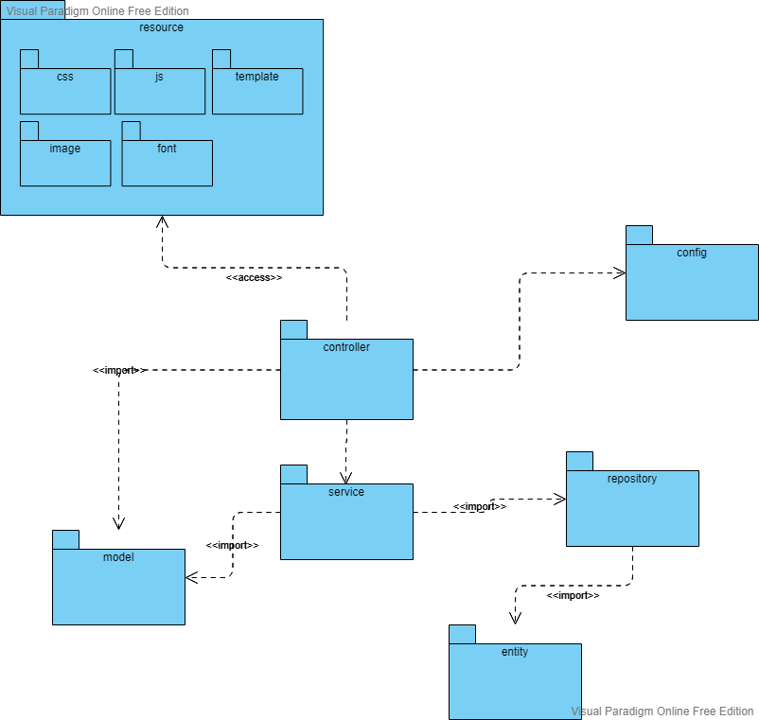

***Package descriptions & package class naming conventions***

| **No** | **Package** | **Description** |
| --- | --- | --- |
| 01 | resource | Contains static and dynamic view files:   * HTML * JS * CSS |
| 02 | config | Initial security and flow configuration |
| 03 | controller | Flow management |
| 04 | utils | Extra implementation to support web service |
| 05 | service | Implementation of logic and database serving |
| 06 | entity | Entity classes implement directly from the database, serve as a distinct business object |
| 07 | model | Objects that exist merely in the web service, nor the database |
| 08 | repository | Data extraction and I/O from the database |

## 2. Database Schema

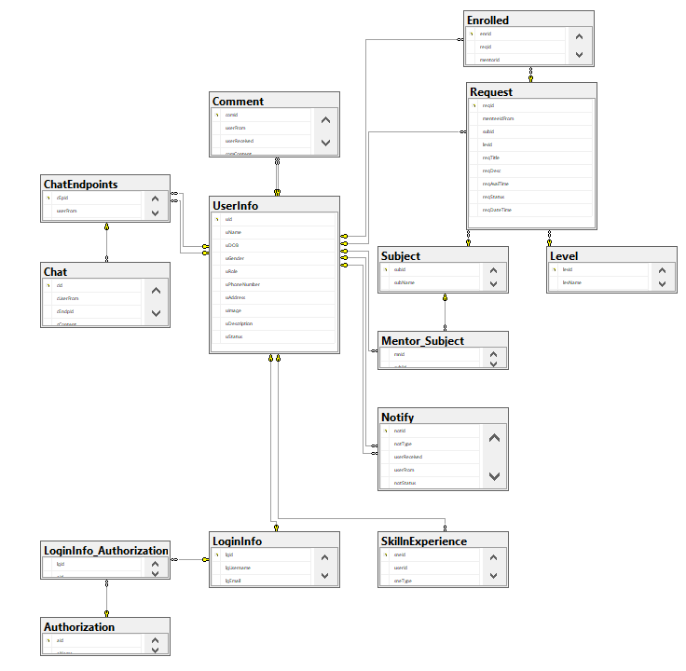

***Table descriptions & package class naming conventions are as below***

| **No** | **Table** | **Description** |
| --- | --- | --- |
| 01 | LoginInfo | Basic login information  - Primary keys: lgId |
| 02 | Authorization | System role: Admin and User  - Primary keys: rId |
| 03 | LoginInfo_Authorization | Many to many connection of Login_Info and Authorization  - Foreign keys: lgId  - Foreign keys: rId |
| 04 | User | Object of real User, with information  - Primary keys: uId |
| 05 | SkillnExperience | List of User’s skills and experience  - Primary keys: sneId  - Foreign keys: uId |
| 06 | Subject | The subjects Mentee want to study  - Primary keys: subId |
| 07 | Level | The level user want to study  - Primary keys: levId |
| 08 | Mentor_Subject | Many to many connection of User(Mentor) and Subject  - Foreign keys: mnId  - Foreign keys: subId |
| 09 | Request | Object of real Request that Users post  - Primary keys: reqId  - Foreign keys: menteeId  - Foreign keys: subId  - Foreign keys: levId |
| 10 | Enrolled | Accepted request is transferred to Enrolled  - Primary keys: enrId  - Foreign keys: reqId  - Foreign keys: mentorId |
| 11 | Notify | List of notification sent from one user to another  - Primary keys: notId  - Foreign keys: userReceived  - Foreign keys: userFrom |
| 12 | Comment | List of comment sent from one user to another  - Primary keys: comId  - Foreign keys: userReceived  - Foreign keys: userFrom |
| 13 | ChatEndpoints | List of chat rooms created between users:  - Primary keys: cEpId  - Foreign keys: userTo  - Foreign keys: userFrom |
| 14 | Chat | A chat message  - Primary keys: cId  - Foreign keys: cEndpId |

# II. Code Designs

## 1. Login

### a. Class Diagram

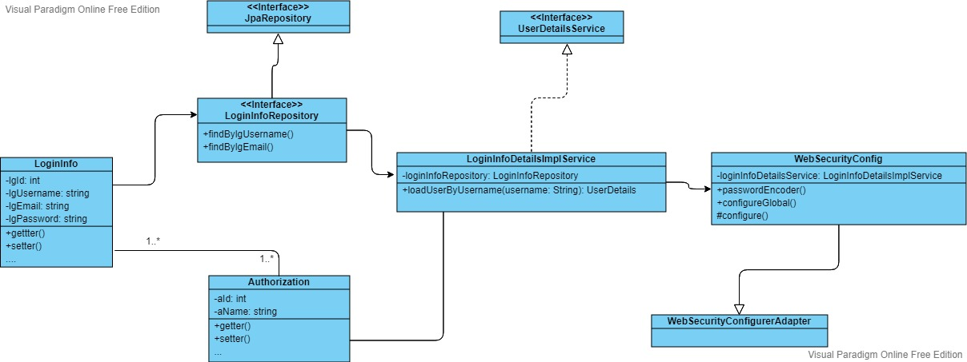

### b. Class Specifications

#### WebSecurityConfig: configure Spring Security for authentication and authorization

| **No** | **Method** | **Description** |
| --- | --- | --- |
| 01 | passwordEncoder | Encode Password into Bcrypt |
| 02 | configureGlobal | Configure Authentication for the class, using passwordEncoder |
| 03 | configure | Provide Authentication and Authorization |

***LoginInfoDetailsImplService:*** *combining with SpringSecurity to check data from database*

| **No** | **Method** | **Description** |
| --- | --- | --- |
| 01 | loadUserByUsername | Get User from the provided Info and get their Role |

### c. Sequence Diagram(s)

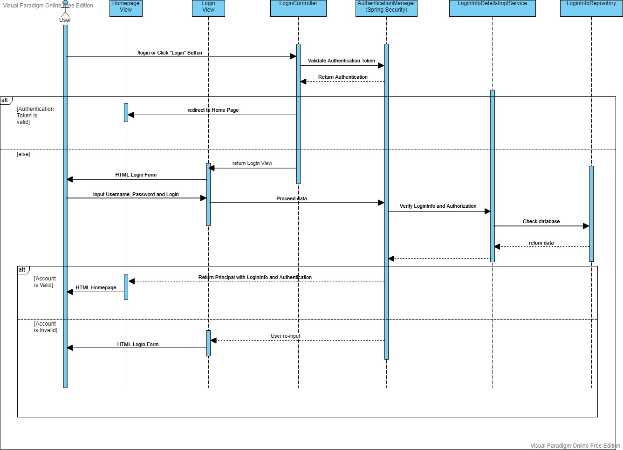

### d. Database queries

SQL Server equivalent of JPA function:

* loginInfoRepository.findByUsername(username):

**SELECT * FROM LoginInfo WHERE igUsername = username**

* Get all the Role of the User. Parameter: lgId

**SELECT rName FROM LoginInfo_Role, Role WHERE lgId = LoginInfo_Role.lgId and LoginInfo_Role.rId = Role.rId**

## 2. Register

### Class Diagram

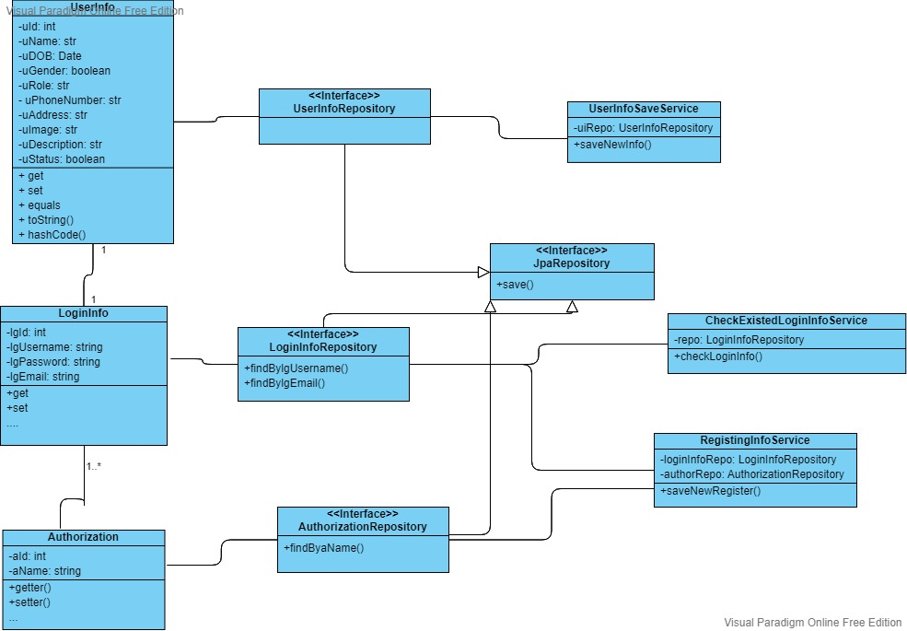

### Class Specification

***UserInfoSaveService:***

| **No** | **Method** | **Description** |
| --- | --- | --- |
| 01 | saveNewInfo | Save new UserInfo into database |

***CheckExistedLoginInfoService***

| **No** | **Method** | **Description** |
| --- | --- | --- |
| 01 | checkLoginInfo | Check if current LoginInfo is already taken |

***RegistingInfoService***

| **No** | **Method** | **Description** |
| --- | --- | --- |
| 01 | saveNewRegister | Save new LoginInfo and Authorization into database |

### Sequence Diagram(s)

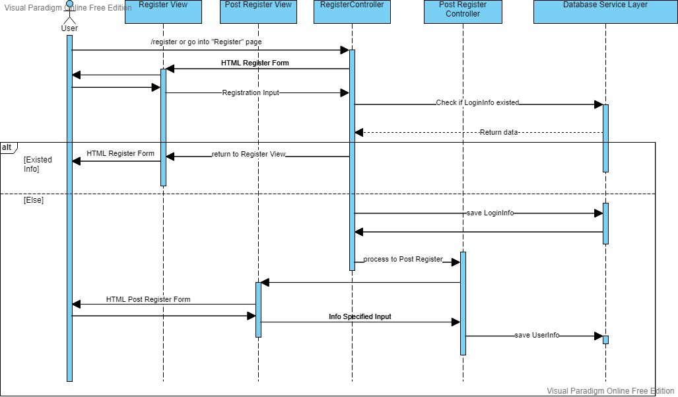

### Database queries

* findByaName(name)

SELECT * FROM Authorization WHERE aName = ?

* findBylgUsername(name)

SELECT * FROM LoginInfo WHERE lgUsername = ?

* findBylgEmail(email)

SELECT * FROM LoginInfo WHERE lgEmail =?

* save(UserInfo)

INSERT INTO UserInfo(?,?,?,?,?) VALUES (?,?,?,?,?)

* save(LoginInfo)

INSERT INTO LoginInfo(?,?,?,?) VALUES (?,?,?,?,?

## 3. Profile

### Class Diagram

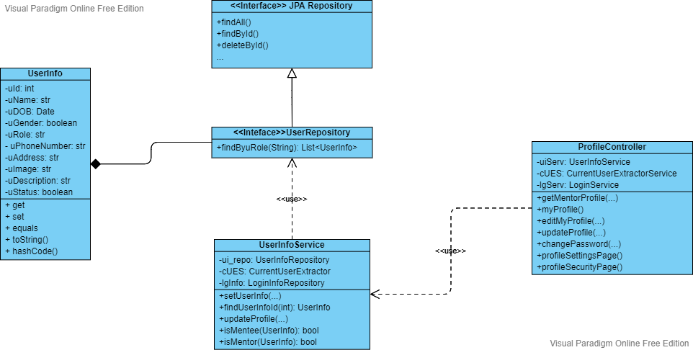

### Class Specification

#### UserInfoService

| **No** | **Method** | **Description** |
| --- | --- | --- |
| 01 | setUserInfo | update user info of current logged in user |
| 02 | updateProfile | update user info of a specific user |
| 03 | findUserInfoId | get an user by id |
| 04 | isMentee | check if user is mentee |
| 05 | isMentor | check if user is mentor |

#### 

#### UserInfoController

| **No** | **Method** | **Description** |
| --- | --- | --- |
| 01 | getMentorProfile | call function to get profile of a mentor |
| 02 | myProfile | call function to get profile of current logged in user |
| 03 | updateProfile | call function to update profile of current logged in user |
| 04 | changePassword | call function to update profile of current logged in user |
| 05 | profileSettingsPage | load edit profile template |
| 06 | profileSecurityPage | load change password template |

### Sequence Diagram(s)

**Sequence Diagram for Update Profile**

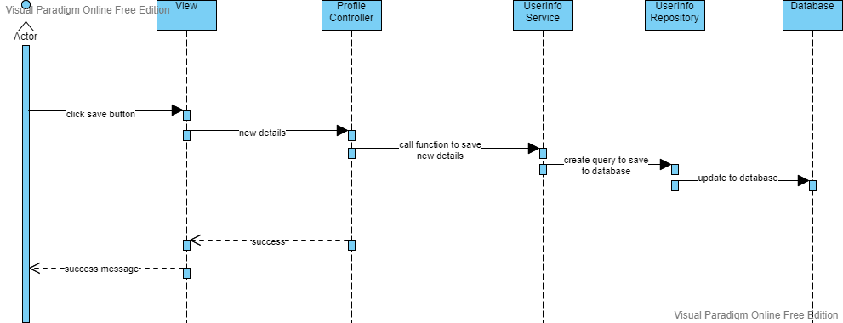

**Sequence Diagram for Update Password**

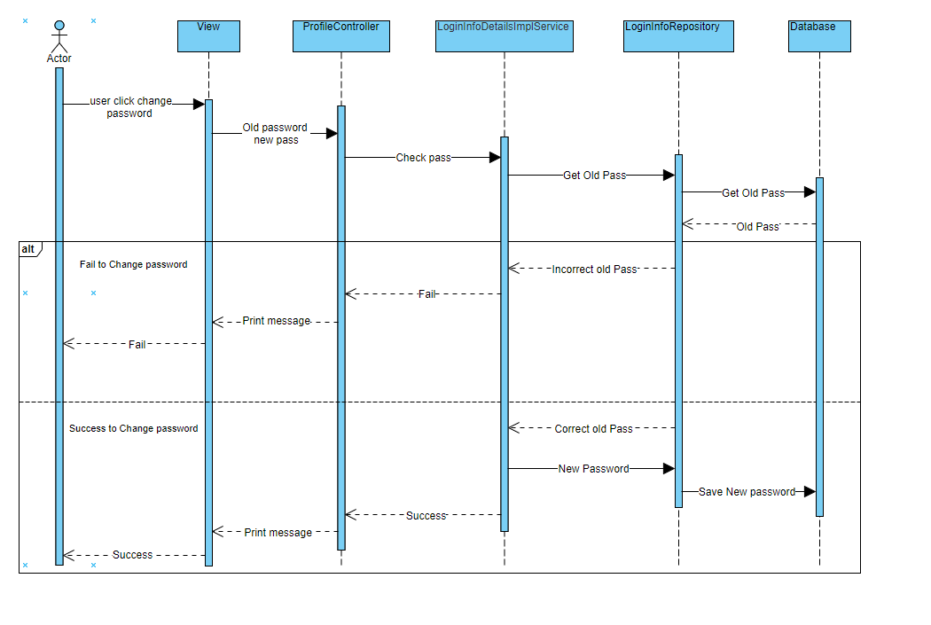

**Sequence diagram for View Mentor Profile**

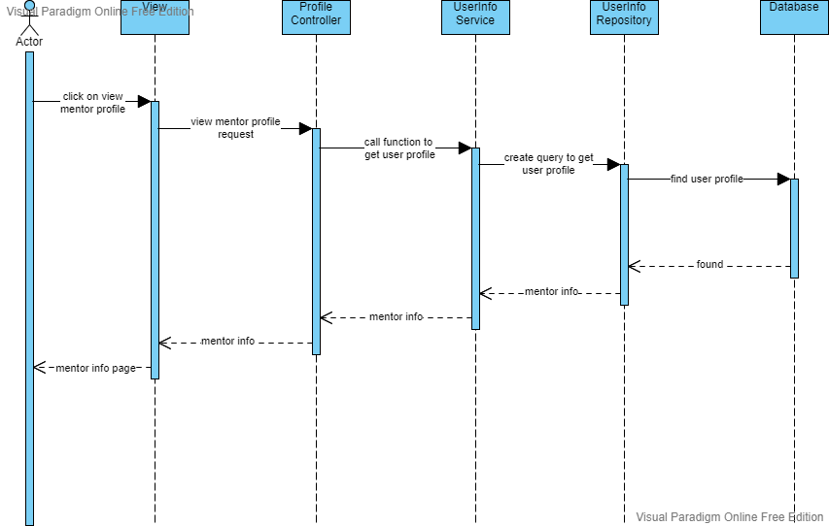

**Sequence diagram for View User Profile**

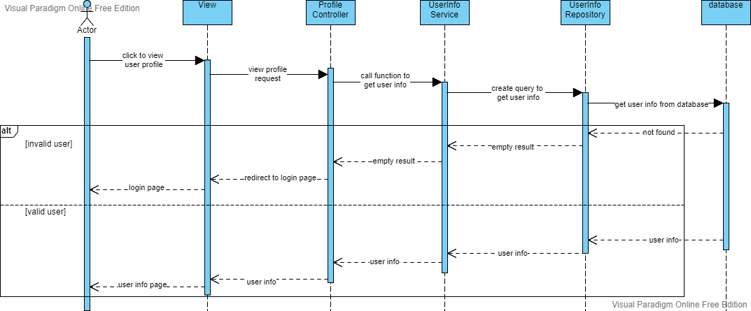

### Database queries

* findById(id)

SELECT * FROM UserInfo WHERE uId=@id

* save(userInfo)

UPDATE UserInfo

SET uName=@uName, uDOB=@uDOB, uGender=@uGender, uRole=@uRole, uPhoneNumber=@uPhoneNumber, uAddress=@uAddress, uDescription=@uDescription, uStatus=@uStatus

WHERE uId=@uId

## 4. Request

### Class Diagram

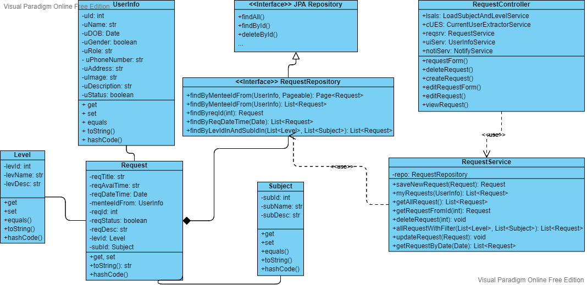

### Class Specifications

#### RequestService

| **No** | **Method** | **Description** |
| --- | --- | --- |
| 01 | saveNewRequest | save new request into database |
| 02 | myRequest | get request list of an user |
| 03 | getAllRequest | get all request in the database |
| 04 | getRequestFromId | get a request with provided id |
| 05 | deleteRequest | delete a request with provided id |
| 06 | allRequestWithFilter | get request list with level and subject filter |
| 07 | updateRequest | update an existed request |
| 08 | getRequestByDate | get a request created/updated in a provided date |

#### Request Controller

| **No** | **Method** | **Description** |
| --- | --- | --- |
| 01 | requestForm | load create request template |
| 02 | deleteRequest | call function to delete a request |
| 03 | createRequest | call function to create a request |
| 04 | editRequestForm | load edit request template |
| 05 | editRequest | call function to update a request |
| 06 | viewRequest | call function to get a request detail |

### Sequence Diagram(s)

**Sequence Diagram for Create a Request**

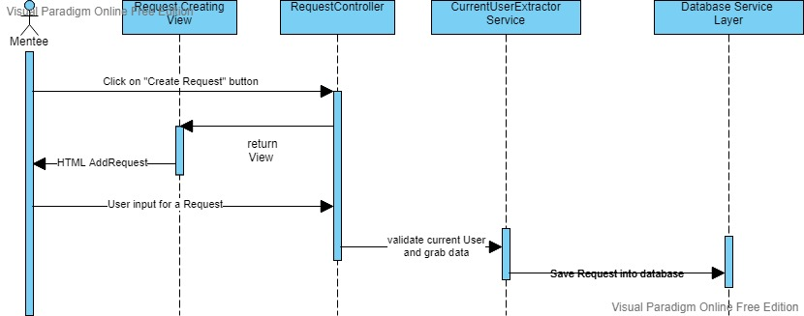

**Sequence Diagram for Delete a Request**

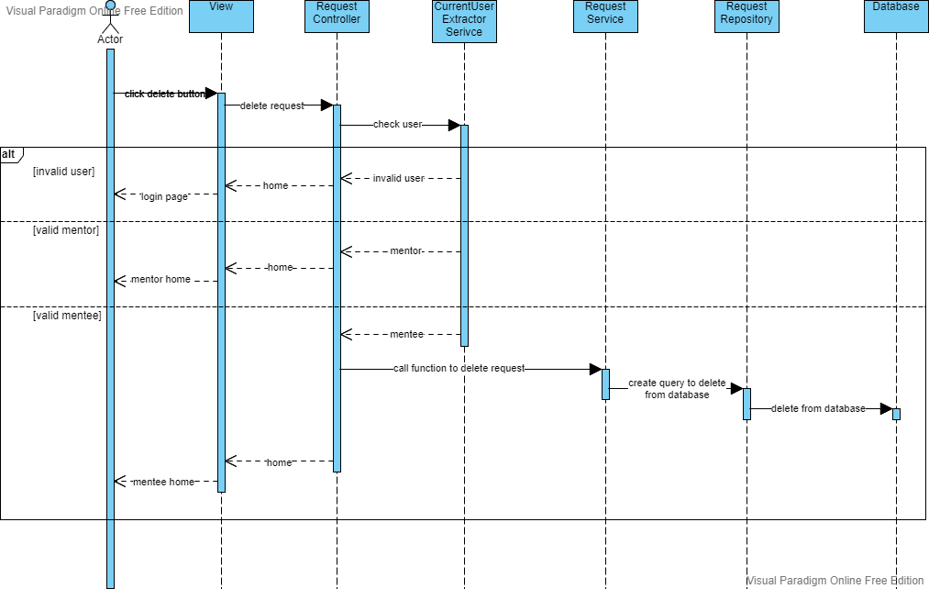

### Database queries

* findByMenteeIdFrom(menteeId)

SELECT * FROM Request WHERE menteeIdFrom=@menteeId

* findByreqId(reqId)

SELECT * FROM Request WHERE reqId=@reqId

* findByReqDateTime(reqDateTime)

SELECT * FROM Request WHERE reqDateTime=@reqDateTime

* findByLevIdInAndSubIdIn(levId, subId)

SELECT * FROM Request WHERE levId In @levId And subId In @subId

* save(request)

INSERT INTO Request(reqTitle, reqAvaiTime, reqDateTime, menteeIdFrom, reqId, reqStatus, reqDesc, levId, subId)

VALUES (@reqTitle, @reqAvaiTime, @reqDateTime, @menteeIdFrom, @reqId, @reqStatus, @reqDesc, @levId, @subId)

## 5. Enrolled

### Class Diagram

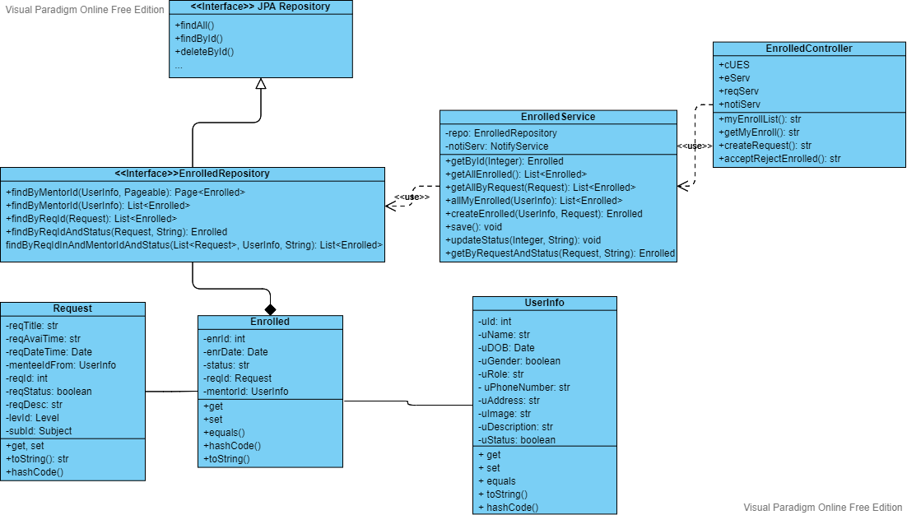

### Class Specifications

#### EnrolledService

| **No** | **Method** | **Description** |
| --- | --- | --- |
| 01 | getById | get an Enrolled by its ID |
| 02 | getAllEnrolled | get all Enrolled |
| 03 | getAllByRequest | get all Enrolled of a Request |
| 04 | allMyEnrolled | get all Enrolled of an User |
| 05 | createEnrolled | create an Enrolled |
| 06 | save | save an Enrolled |
| 07 | updateStatus | update status of an Enrolled |
| 08 | getByRequestAndStatus | get an Enrolled by its Request and Status |

#### 

#### EnrolledController

| **No** | **Method** | **Description** |
| --- | --- | --- |
| 01 | myEnrollList | get all Enrolled of a Mentor |
| 02 | getMyEnroll | get all Enrolled to a Request |
| 03 | createRequest | enroll to a Request |
| 04 | acceptRejectEnrolled | set status accept or reject to an Enrolled |

### Sequence Diagram(s)

### Sequence Diagram for Mentee View Enrolled List of a RequestSequence Diagram for Mentee View Enrolled List of a Request

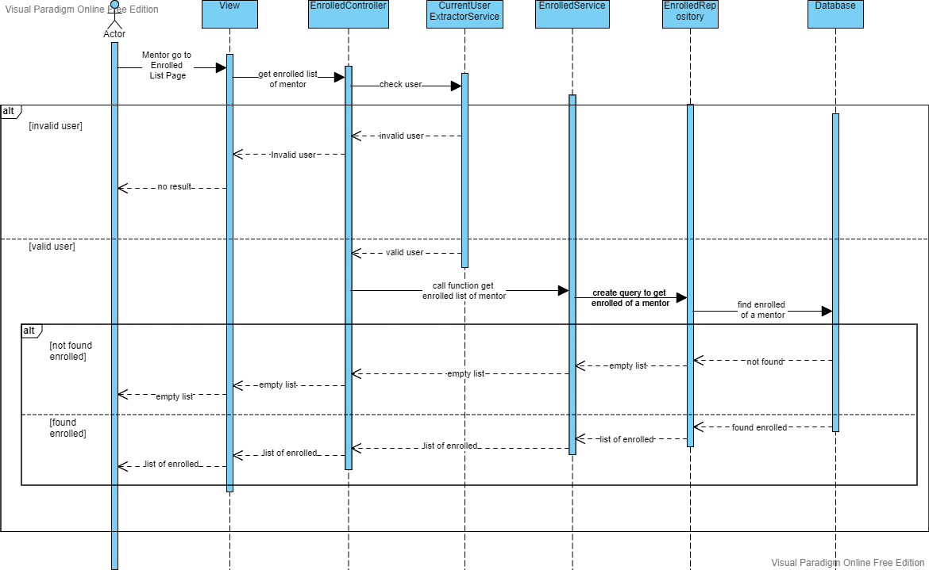**Sequence Diagram for Mentor Enrolled a Request**

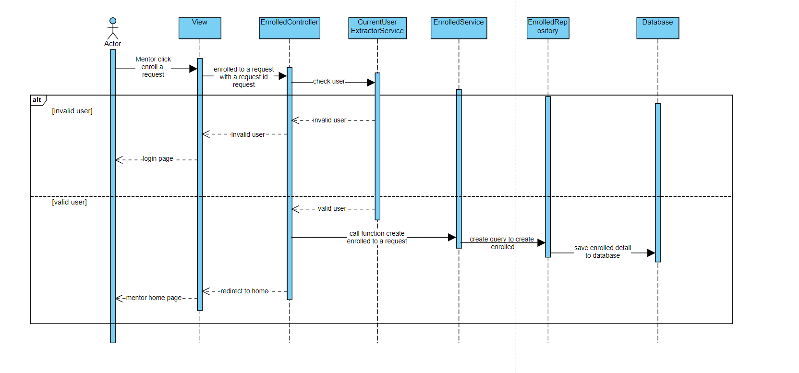

**Sequence Diagram for Decide a Request**

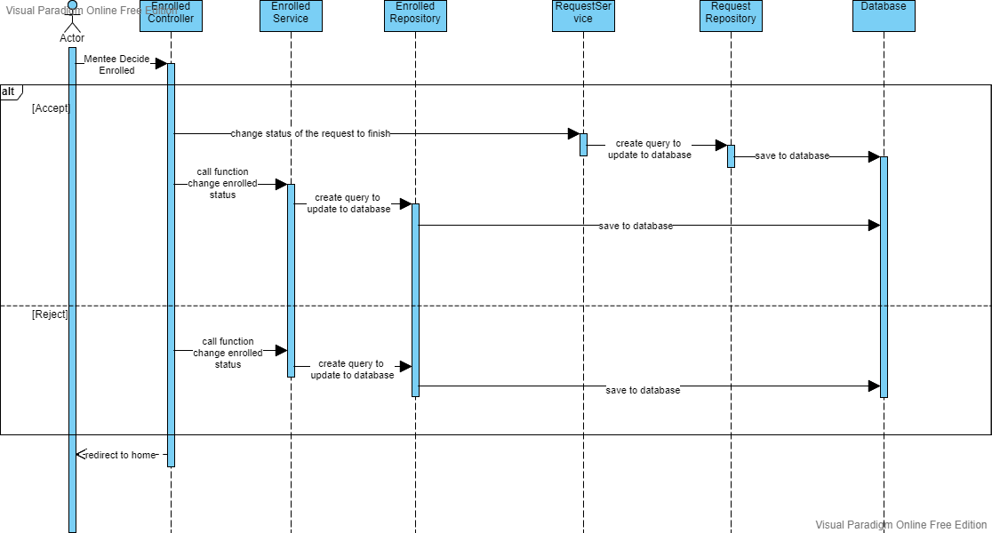

### Database queries

* findAll:

SELECT * FROM Enrolled

* findById(id):

SELECT * FROM Enrolled WHERE enrId=@id

* findByMentorId(mentorId):

SELECT * FROM Enrolled WHERE mentorId=@mentorId

* findByReqId(reqId):

SELECT * FROM Enrolled WHERE reqId=@reqId

* findByReqIdAndStatus(reqId, status):

SELECT * FROM Enrolled WHERE reqId=@reqId and status=@status

* findByReqIdAndMentorIdAndStatus(reqId, mentorId, status):

SELECT * FROM Enrolled WHERE reqId=@reqId and mentorId=@mentorId and status=@status

* save(enroll)

INSERT INTO Enrolled(enrDate, status, reqId, mentorId) VALUES(@enrDate, @status, @reqId, @mentorId)

## 6. Notification

### Class Diagram

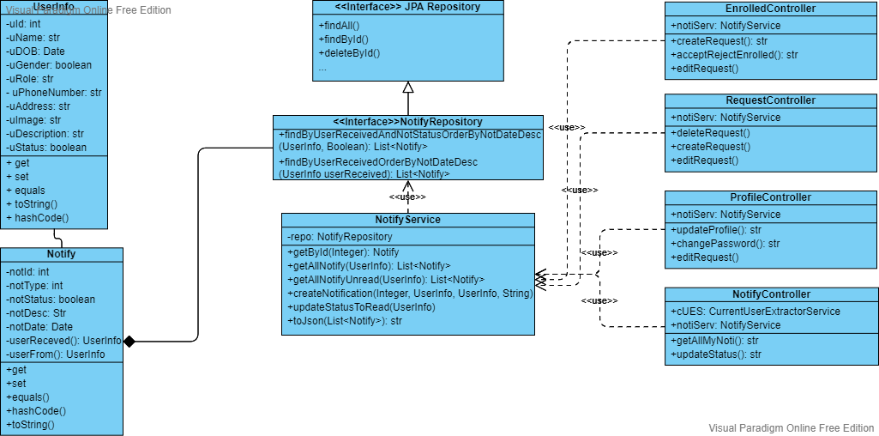

### Class Specifications

#### Notify: THIS CLASS STORE INFORMATION OF A NOTIFY

| **No** | **Method** | **Description** |
| --- | --- | --- |
| 01 | getById | get a specific notification |
| 02 | getAllNotify | get all notification of an User |
| 03 | createNotification | create a Notification |
| 04 | updateStatusToRead | update all notification of an user to status read |
| 05 | toJson | transform a List of Notification into JSON string |

#### 

#### NotifyService

| **No** | **Method** | **Description** |
| --- | --- | --- |
| 01 | getById | get a specific notification |
| 02 | getAllNotify | get all notification of an User |
| 03 | createNotification | create a Notification |
| 04 | updateStatusToRead | update all notification of an user to status read |
| 05 | toJson | transform a List of Notification into JSON string |

#### 

#### NotifyController

| **No** | **Method** | **Description** |
| --- | --- | --- |
| 01 | getAllMyNoti | get all notification of an user |
| 02 | updateStatus | update all notification of an user to status read |

### Sequence Diagram(s)

**Sequence Diagram for get All User Notification**

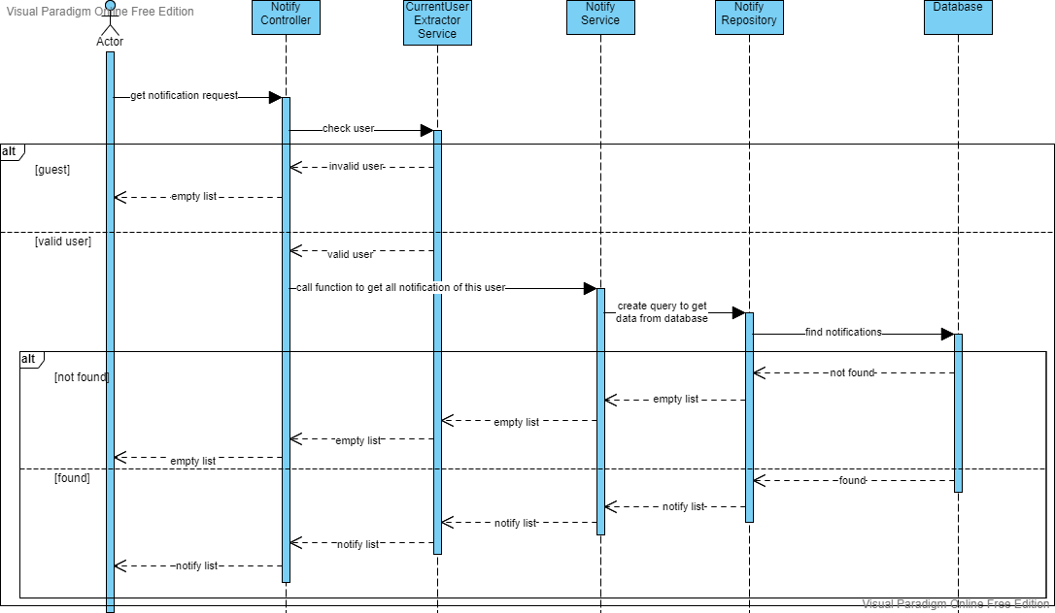

**Sequence Diagram for update Notification to Read**

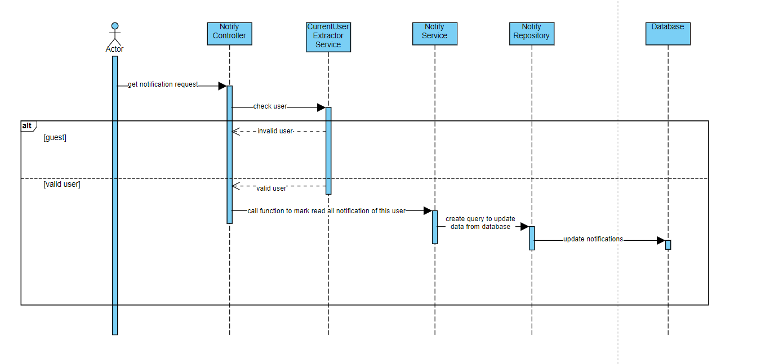

### Database queries

* findByUserReceivedAndNotStatusOrderByNotDateDesc(userReceived, notStatus)

SELECT * FROM Notify WHERE userReceived=@userReceived and notStatus=@notStatus ORDER BY notDate DESC

* findByUserReceivedOrderByNotDateDesc(userReceived)

SELECT * FROM Notify WHERE userReceived=@userReceived ORDER BY notDate DESC

save(notify)

INSERT INTO Notify(notType, notStatus, notDate, notDesc, userReceived, userFrom) VALUES (@notType, @notStatus, @notDate, @notDesc, @userReceived, @userFrom)

## 7. Home

### Class Diagram

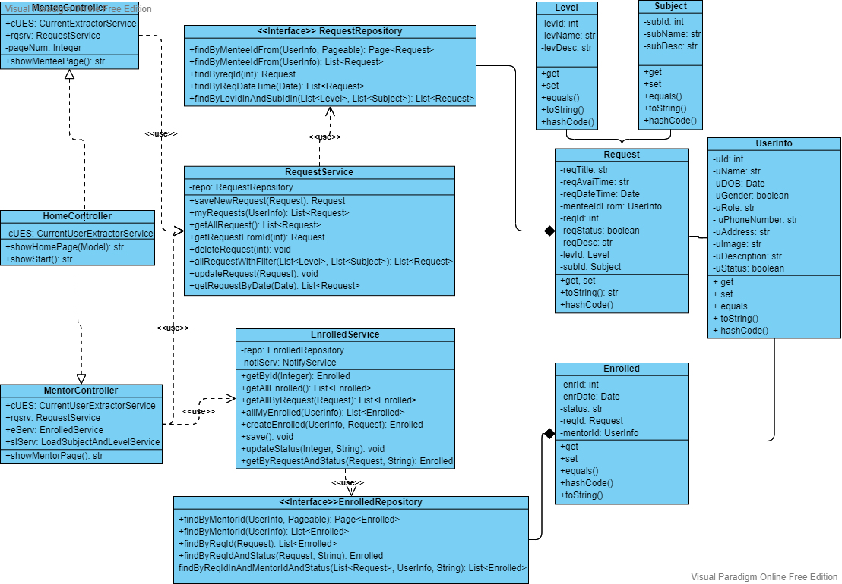

### Class Specification

***HomeController***

| **No** | **Method** | **Description** |
| --- | --- | --- |
| 01 | showHomePage | redirect user to homepage |
| 02 | showStart | redirect user to landing page |

**MenteeController**

| **No** | **Method** | **Description** |
| --- | --- | --- |
| 01 | showMenteePage | redirect user to mentee homepage |

#### 

**MentorController**

| **No** | **Method** | **Description** |
| --- | --- | --- |
| 01 | showMentorPage | redirect user to mentor homepage |

#### 

#### 

### Sequence Diagram(s)

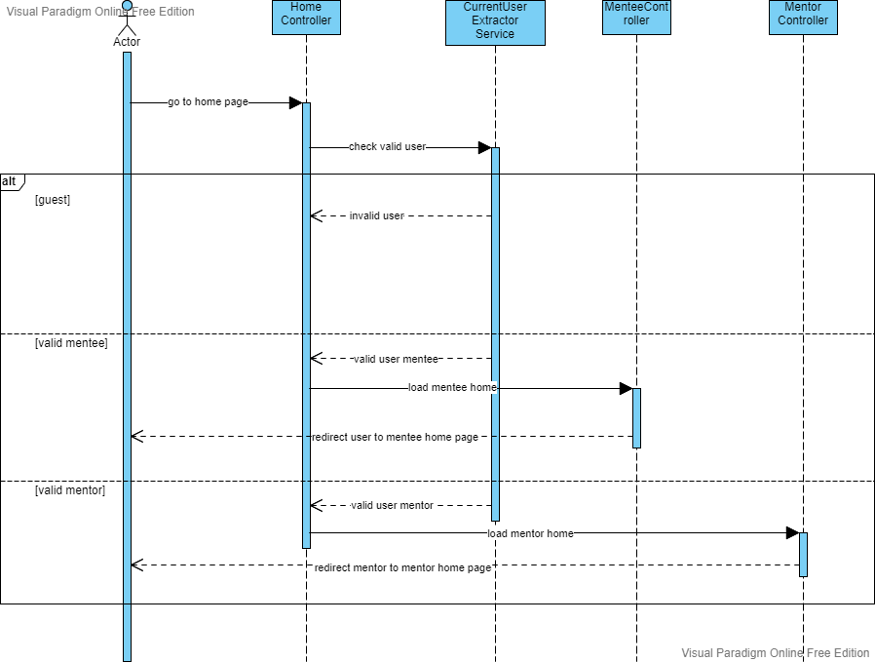

### Database queries

N/A

## 8. Comment

### Class Diagram

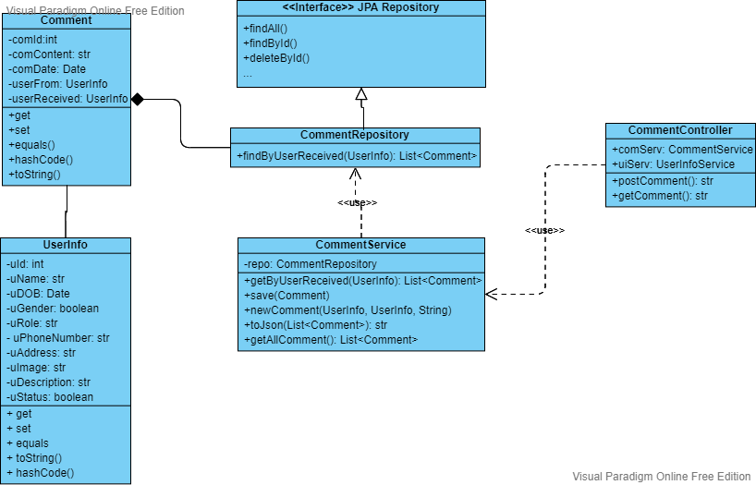

### Class Specification

***CommentService***

| **No** | **Method** | **Description** |
| --- | --- | --- |
| 01 | getByUserReceived | get all Comments about an User |
| 02 | save | save a comment |
| 03 | newComment | create a comment |
| 04 | getAllComment | get all comments |
| 05 | toJson | transform List of comments into JSON string |

#### 

**CommentController**

| **No** | **Method** | **Description** |
| --- | --- | --- |
| 01 | postComment | comment about an User |
| 02 | getComment | get all Comments about an User |

#### 

### Sequence Diagram(s)

**Sequence Diagram for Post a Comment**

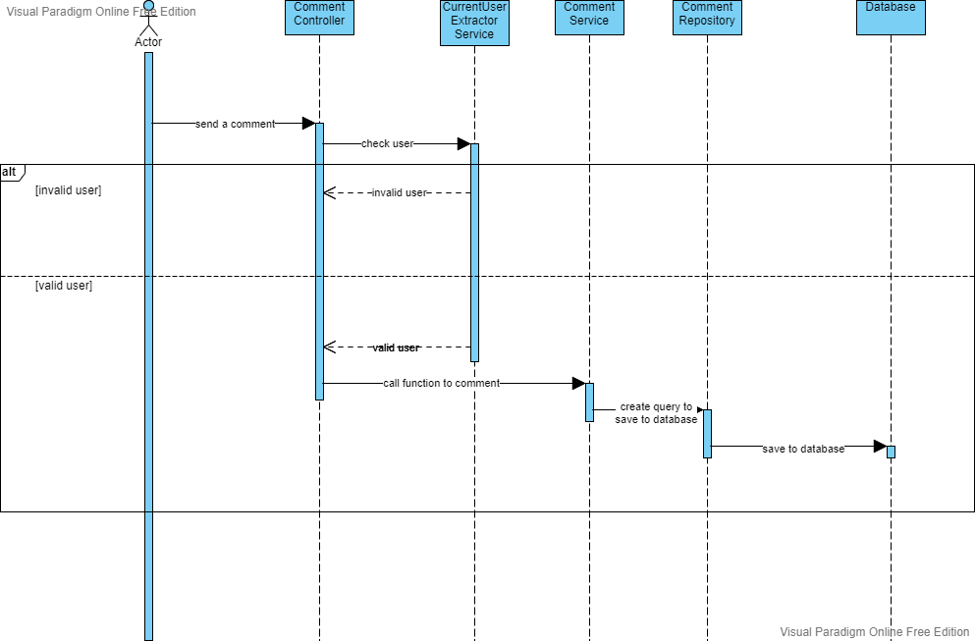

**Sequence Diagram for get all comment about an User**

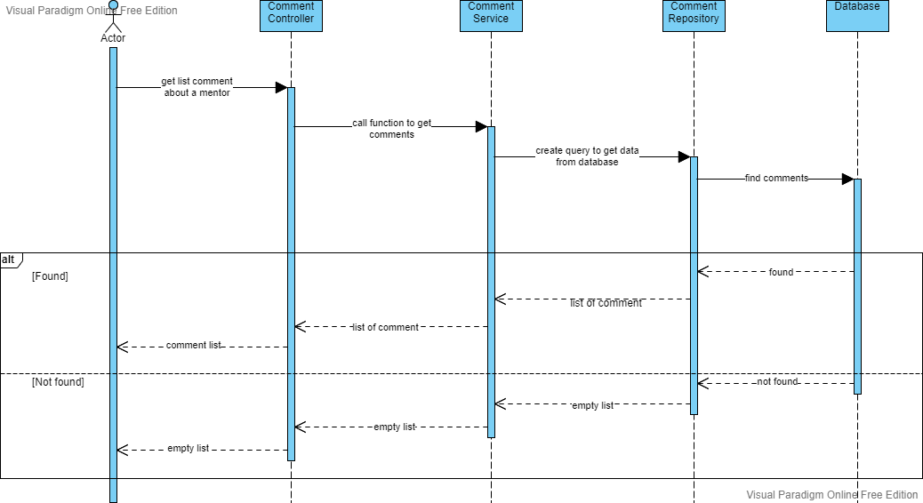

### Database queries

* findByUserReceived(userReceived):

SELECT * FROM Comment WHERE userReceived=@userReceived

* save(comment)

INSERT INTO Comment(comContent, comDate, userFrom, userReceived) VALUES (@comContent, @comDate, @userFrom, @userReceived)

## 9. Admin view all list request

### Class Diagram

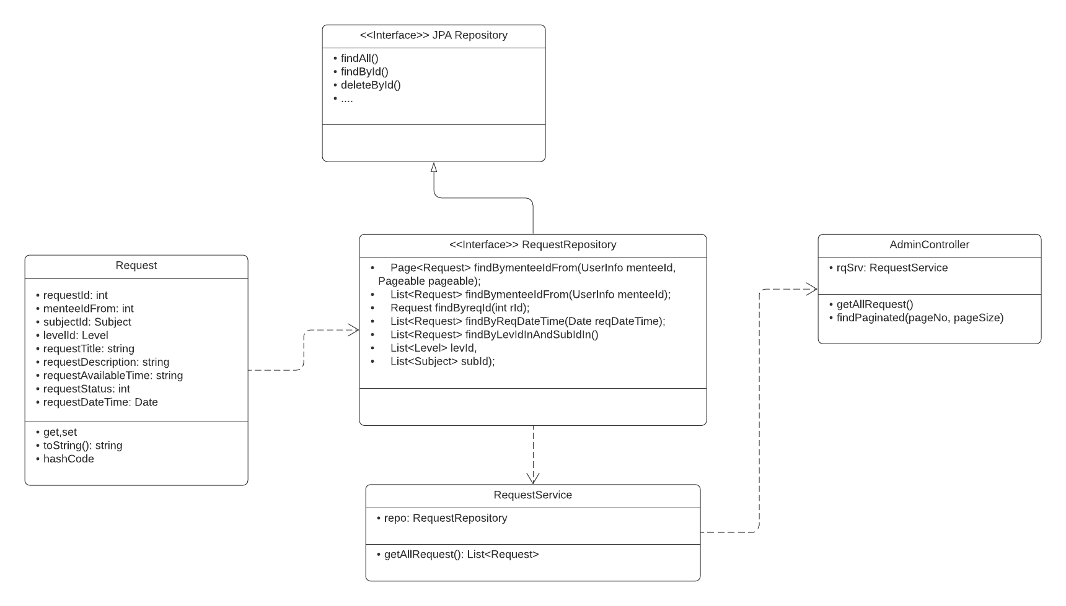

### Class Specification

Request Class: This class store information about request

| **No** | **Method** | **Description** |
| --- | --- | --- |
| 01 | getReqId() | get request ID from a request object |
| 02 | setReqId | set request ID for a request object |
| 03 | getReqStatus() | get request status from a request object |
| 04 | setReqStatus | set request status for a request object |
| 05 | getReqDesc() | get request description from a request object |
| 06 | setReqDesc() | set request description for a request object |
| 07 | getLevId() | get level from a request object |
| 08 | setLevId() | set level for a request object |
| 09 | getSubId() | get subject from a request object |
| 10 | setSubId() | set subject for a request object |
| 11 | getReqTitle() | get request title from a request object |
| 12 | setReqTitle() | set request title for a request object |
| 13 | getReqAvaiTime() | get request available time from a request object |
| 14 | setReqAvaiTime() | set request available time for a request object |
| 15 | getReqDateTime() | get request date time |
| 16 | setReqDateTime() | set request date time for a request object |
| 17 | getMenteeIdFrom() | get userinfo from a request object |
| 18 | setMenteeIdFrom() | set userinfo for a request object |
| 19 | toString() | get to string from a request object |

RequestRepository: this is an interface that helps connect with JPA

| **No** | **Method** | **Description** |
| --- | --- | --- |
| 01 | findBymenteeIdFrom() | using hibernate to connect to the database and get request by mentee user id |
| 02 | findByreqId() | using hibernate to connect to the database and get request by request id |
| 03 | findByReqDateTime() | using hibernate to connect to the database and get request by request date time |
| 04 | findByLevIdInAndSubIdIn() | using hibernate to connect to the database and get request by level id |

RequestService: implement the request repository

| **No** | **Method** | **Description** |
| --- | --- | --- |
| 01 | listAllMyByPage() | get the paginated list of request |
| 02 | listAllByPage() | get all the request list after paging |

AdminController

| **No** | **Method** | **Description** |
| --- | --- | --- |
| 01 | findPaginated() | get request ID |

### Sequence Diagram(s)

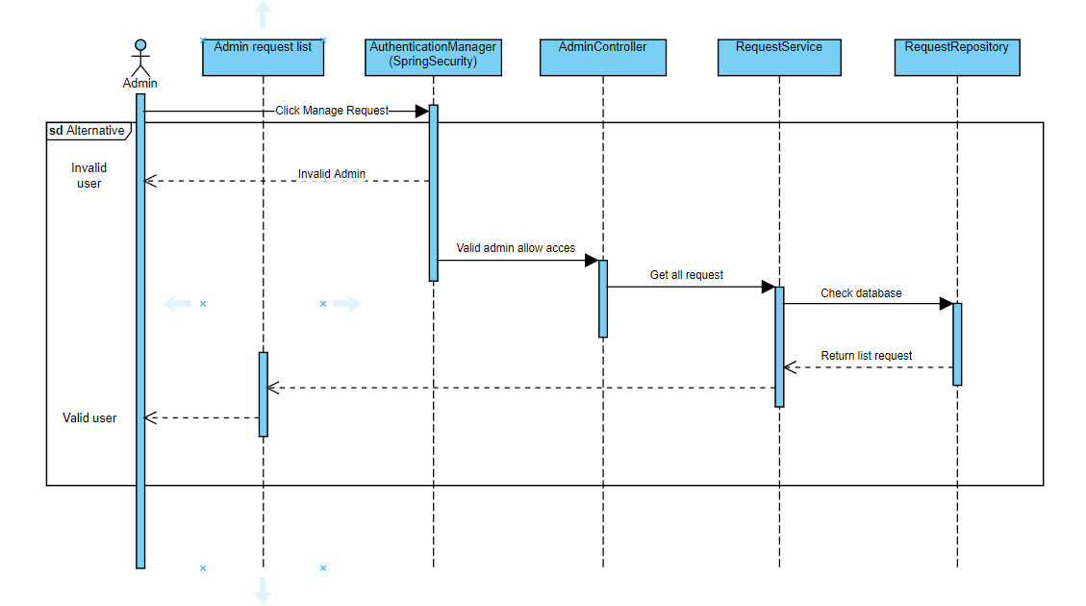

### Database queries

- repo.findAll() : select * from Request

- repo.findPaginated(): select top 15 from Request

## 10. Admin manage requests

### Class Diagram

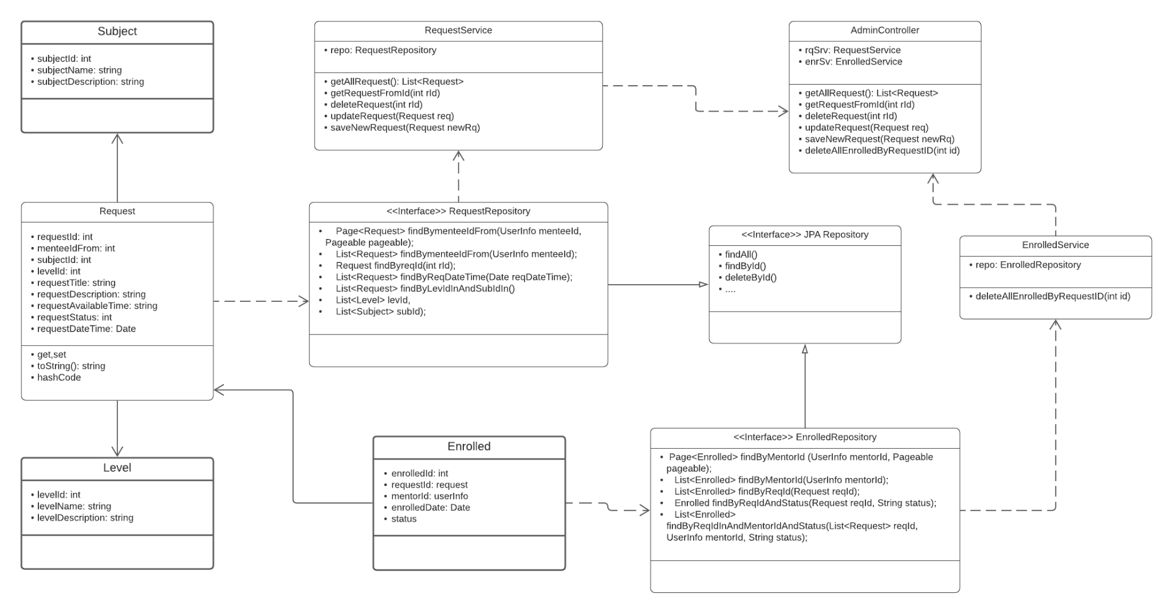

### Class Specification

Request Class: This class store information about request

| **No** | **Method** | **Description** |
| --- | --- | --- |
| 01 | getReqId() | get request ID from a request object |
| 02 | setReqId | set request ID for a request object |
| 03 | getReqStatus() | get request status from a request object |
| 04 | setReqStatus | set request status for a request object |
| 05 | getReqDesc() | get request description from a request object |
| 06 | setReqDesc() | set request description for a request object |
| 07 | getLevId() | get level from a request object |
| 08 | setLevId() | set level for a request object |
| 09 | getSubId() | get subject from a request object |
| 10 | setSubId() | set subject for a request object |
| 11 | getReqTitle() | get request title from a request object |
| 12 | setReqTitle() | set request title for a request object |
| 13 | getReqAvaiTime() | get request available time from a request object |
| 14 | setReqAvaiTime() | set request available time for a request object |
| 15 | getReqDateTime() | get request date time |
| 16 | setReqDateTime() | set request date time for a request object |
| 17 | getMenteeIdFrom() | get userinfo from a request object |
| 18 | setMenteeIdFrom() | set userinfo for a request object |
| 19 | toString() | get to string from a request object |

Level Class: This class store the information about object level

| **No** | **Method** | **Description** |
| --- | --- | --- |
| 01 | getLevId() | get level ID from a level object |
| 02 | setLevId() | set level ID for a level object |
| 03 | getLevName() | get level name from a level object |
| 04 | setLevName() | set level name for a level object |
| 05 | getLevDesc() | get level description from a level object |
| 06 | setLevDesc() | set level description for a level object |
| 07 | toString() | get to string |

Subject Class: This class store the information about object subject

| **No** | **Method** | **Description** |
| --- | --- | --- |
| 01 | getSubId() | get level ID |
| 02 | setSubId() | set level ID |
| 03 | getSubName()() | get level name |
| 04 | setSubName() | set level name |
| 05 | getSubDesc() | get level description |
| 06 | setSubDesc() | set level description |
| 07 | toString() | get to string |

Enrolled Class: This class store the information about object enrolled

| **No** | **Method** | **Description** |
| --- | --- | --- |
| 01 | getEnrId() | get request ID |
| 02 | setEnrId() | set request ID |
| 03 | getEnrDate() | get request status |
| 04 | setEnrDate() | set request status |
| 05 | getReqId() | get request description |
| 06 | setReqId() | set request description |
| 07 | getMentorId() | get level |
| 08 | setMentorId() | set level |
| 09 | getStatus() | get subject |
| 10 | setStatus() | set subject |
| 11 | toString() | get request title |

RequestService: implement the request repository

| **No** | **Method** | **Description** |
| --- | --- | --- |
| 01 | listAllMyByPage() | get the paginated list of request |
| 02 | listAllByPage() | get all the request list after paging |
| 03 | saveNewRequest() | save a new created request |
| 04 | deleteRequest() | delete a selected request |
| 05 | updateRequest() | update information in the selected request |

SubjectService: implement the subject repository

| **No** | **Method** | **Description** |
| --- | --- | --- |
| 01 | getAllSubject() | get all the subjects contain in the database |
| 02 | findSubjectbyId(int id) | get the subject by subject id |
| 03 | getAllLevel() | get all the levels contain in the database |
| 04 | findLevelbyId(int id) | get the level by level id |

Enrolled Service:

| **No** | **Method** | **Description** |
| --- | --- | --- |
| 01 | deleteAllEnrolledByRequestID | delete all enrolled object in the database by request id |
| 02 | getAllEnrolledByRequestID() | get all enrolled object in the database by request id |

### Sequence Diagram(s)

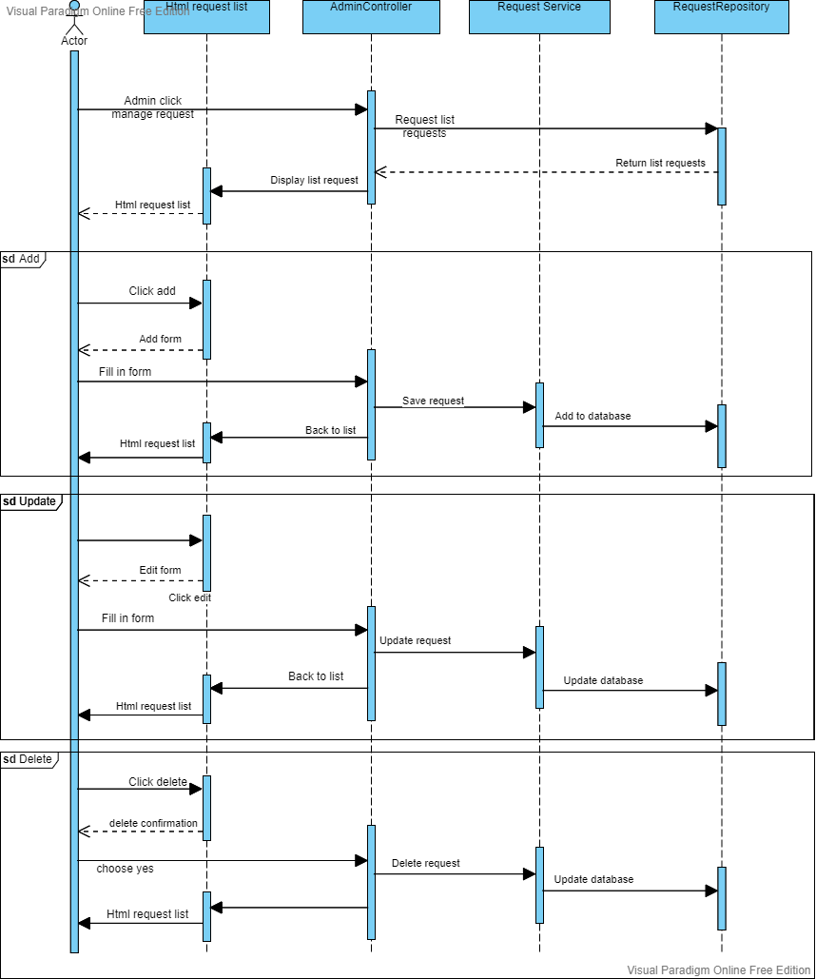

### Database queries

rqSrv.saveNewRequest(request): Insert into request(menteeIdFrom,subId,levId,reqTitle,reqDesc) values(request.getMenteeIdfrom,request.getsubId(),..)

rqSrv.deleteRequest(request) :Delete from request where reqId = request.requestId

rqSrv.updateRequest(request):Update request set menteeIdFrom = request.getMenteeIdfrom, ...

enrSrv.

## 11. Admin filter requests

### Class Diagram

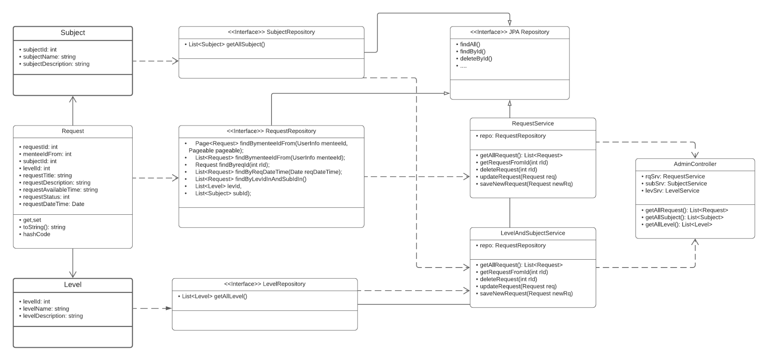

### Class Specification

Request Class: This class store information about request

| **No** | **Method** | **Description** |
| --- | --- | --- |
| 01 | getReqId() | get request ID from a request object |
| 02 | setReqId | set request ID for a request object |
| 03 | getReqStatus() | get request status from a request object |
| 04 | setReqStatus | set request status for a request object |
| 05 | getReqDesc() | get request description from a request object |
| 06 | setReqDesc() | set request description for a request object |
| 07 | getLevId() | get level from a request object |
| 08 | setLevId() | set level for a request object |
| 09 | getSubId() | get subject from a request object |
| 10 | setSubId() | set subject for a request object |
| 11 | getReqTitle() | get request title from a request object |
| 12 | setReqTitle() | set request title for a request object |
| 13 | getReqAvaiTime() | get request available time from a request object |
| 14 | setReqAvaiTime() | set request available time for a request object |
| 15 | getReqDateTime() | get request date time |
| 16 | setReqDateTime() | set request date time for a request object |
| 17 | getMenteeIdFrom() | get userinfo from a request object |
| 18 | setMenteeIdFrom() | set userinfo for a request object |
| 19 | toString() | get to string from a request object |

Level Class: This class store the information about object level

| **No** | **Method** | **Description** |
| --- | --- | --- |
| 01 | getLevId() | get level ID from a level object |
| 02 | setLevId() | set level ID for a level object |
| 03 | getLevName() | get level name from a level object |
| 04 | setLevName() | set level name for a level object |
| 05 | getLevDesc() | get level description from a level object |
| 06 | setLevDesc() | set level description for a level object |
| 07 | toString() | get to string |

Subject Class: This class store the information about object subject

| **No** | **Method** | **Description** |
| --- | --- | --- |
| 01 | getSubId() | get level ID |
| 02 | setSubId() | set level ID |
| 03 | getSubName() | get level name |
| 04 | setSubName() | set level name |
| 05 | getSubDesc() | get level description |
| 06 | setSubDesc() | set level description |
| 07 | toString() | get to string |

RequestService: implement the request repository

| **No** | **Method** | **Description** |
| --- | --- | --- |
| 01 | listAllMyByPage() | get the paginated list of request |
| 02 | listAllByPage() | get all the request list after paging |
| 03 | saveNewRequest() | save a new created request |
| 04 | deleteRequest() | delete a selected request |
| 05 | updateRequest() | update information in the selected request |

SubjectService: implement the subject repository

| **No** | **Method** | **Description** |
| --- | --- | --- |
| 01 | getAllSubject() | get all the subjects contain in the database |
| 02 | findSubjectbyId(int id) | get the subject by subject id |
| 03 | getAllLevel() | get all the levels contain in the database |
| 04 | findLevelbyId(int id) | get the level by level id |

### Sequence Diagram(s)

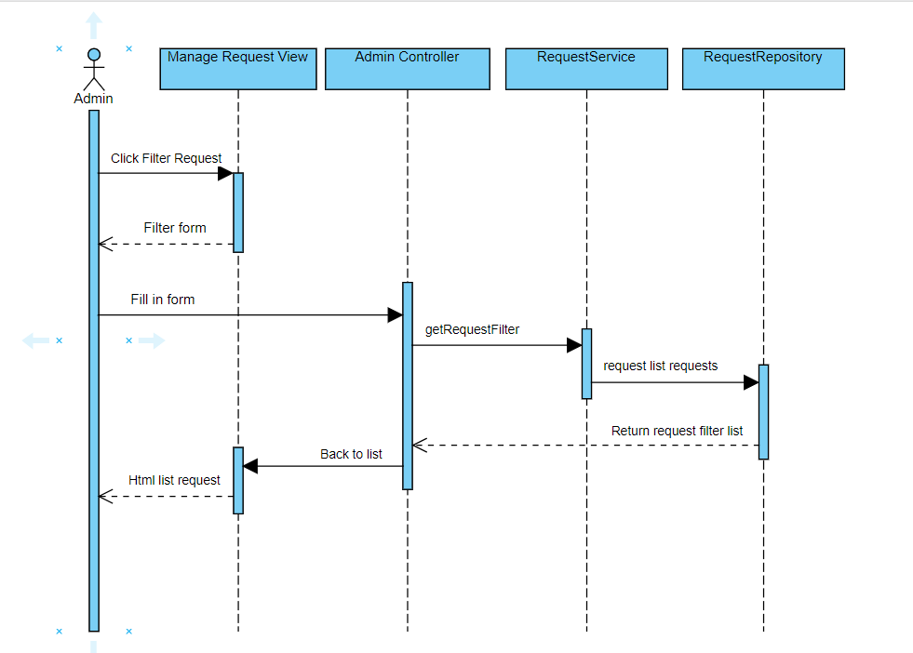

### Database queries

select * from request

select * from subject

select * from level

select * from request where subjectId = ?

select * from request where levelId = ?

select * from request where levelId = ? and subjectId = ?

select * from request where subjectId = ? and requestDateTime between ? and ?

select * from request where levelId = ? and requestDateTime between ? and ?

select * from request where levelId = ? and subjectId = ? and requestDateTime between ? and ?

## 12. Admin notify User

### Class Diagram

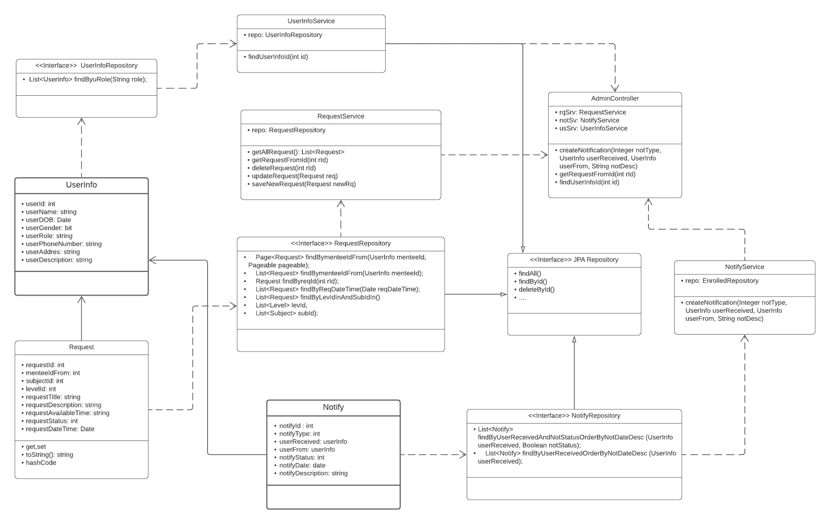

### Class Specification

Request Class: This class store information about request

| **No** | **Method** | **Description** |
| --- | --- | --- |
| 01 | getReqId() | get request ID from a request object |
| 02 | setReqId | set request ID for a request object |
| 03 | getReqStatus() | get request status from a request object |
| 04 | setReqStatus | set request status for a request object |
| 05 | getReqDesc() | get request description from a request object |
| 06 | setReqDesc() | set request description for a request object |
| 07 | getLevId() | get level from a request object |
| 08 | setLevId() | set level for a request object |
| 09 | getSubId() | get subject from a request object |
| 10 | setSubId() | set subject for a request object |
| 11 | getReqTitle() | get request title from a request object |
| 12 | setReqTitle() | set request title for a request object |
| 13 | getReqAvaiTime() | get request available time from a request object |
| 14 | setReqAvaiTime() | set request available time for a request object |
| 15 | getReqDateTime() | get request date time |
| 16 | setReqDateTime() | set request date time for a request object |
| 17 | getMenteeIdFrom() | get userinfo from a request object |
| 18 | setMenteeIdFrom() | set userinfo for a request object |
| 19 | toString() | get to string from a request object |

UserInfo Class: This class store information about user

| **No** | **Method** | **Description** |
| --- | --- | --- |
| 01 | getUId() | get user ID from a userInfo object |
| 02 | setUId() | set user ID for a request object |
| 03 | getUName() | get user name from a userInfo object |
| 04 | setUName() | set user name from a userInfo object |
| 05 | getUDOB() | get user date of birth from a userInfo object |
| 06 | setUDOB() | set user date of birth from a userInfo object |
| 07 | getUGender() | get user gender from a userInfo object |
| 08 | setUGender() | set user gender from a userInfo object |
| 09 | getURole() | get user role from a userInfo object |
| 10 | setURole() | set user role from a userInfo object |
| 11 | getUPhoneNumber() | get user phone number from a userInfo object |
| 12 | getUAddress() | get user address from a userInfo object |
| 13 | setUAddress() | set user address from a userInfo object |
| 14 | getUImage() | get user image from a userInfo object |
| 15 | setUImage() | set user image from a userInfo object |
| 16 | getUDescription() | get user description from a userInfo object |
| 17 | setUDescription() | set user description from a userInfo object |
| 18 | getUStatus() | get user status from a userInfo object |
| 19 | setUStatus() | set user status from a userInfo object |
| 20 | getLoginInfo() | get login info from a userInfo object |
| 21 | setLoginInfo() | set login info from a userInfo object |
| 22 | toString() | to string method |

Notify Class: This class store information about user

| **No** | **Method** | **Description** |
| --- | --- | --- |
| 01 | getNotId() | get request ID from a request object |
| 02 | setNotId() | set request ID for a request object |
| 03 | getNotType() | get request status from a request object |
| 04 | setNotType() | set request status for a request object |
| 05 | getNotStatus() | get request description from a request object |
| 06 | setNotStatus() | set request description for a request object |
| 07 | getNotDate() | get level from a request object |
| 08 | setNotDate() | set level for a request object |
| 09 | getNotDesc() | get subject from a request object |
| 10 | setNotDesc() | set subject for a request object |
| 11 | getUserReceived() | get request title from a request object |
| 12 | setUserReceived() | set request title for a request object |
| 13 | getUserFrom() | get request available time from a request object |
| 14 | setUserFrom() | set request available time for a request object |
| 19 | toString() | get to string from a request object |

Notify Service

| **No** | **Method** | **Description** |
| --- | --- | --- |
| 01 | getAllNotify | get request ID from a request object |

### Sequence Diagram(s)

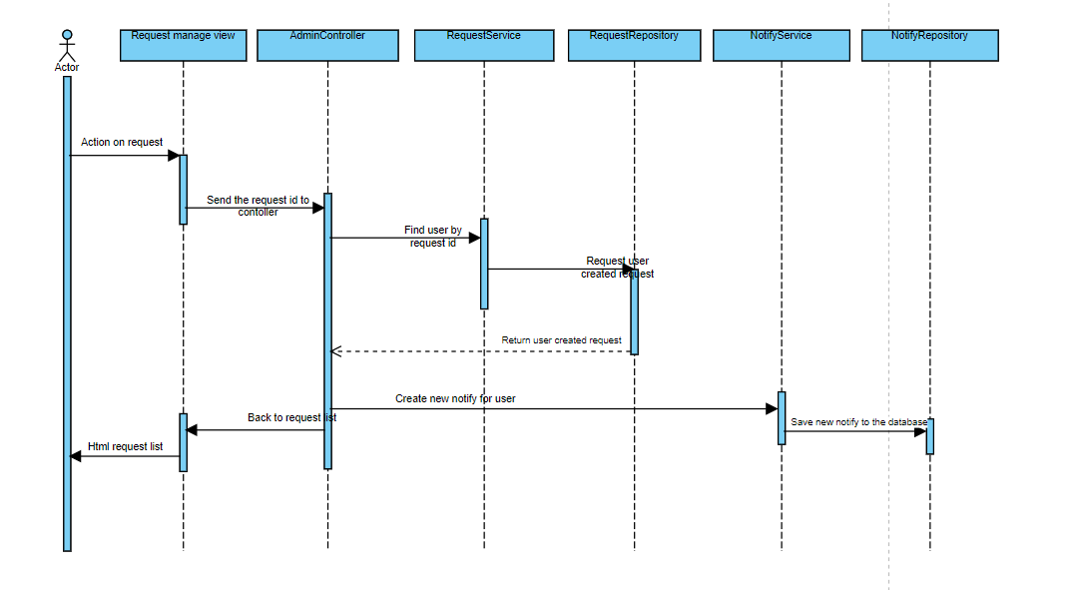

### Database queries

Insert into Notify (notType, userReceived, userFrom, notStatus, notDate, notDesc) values (?,?,?,?,?,?)

## 13. Admin request details

### Class Diagram

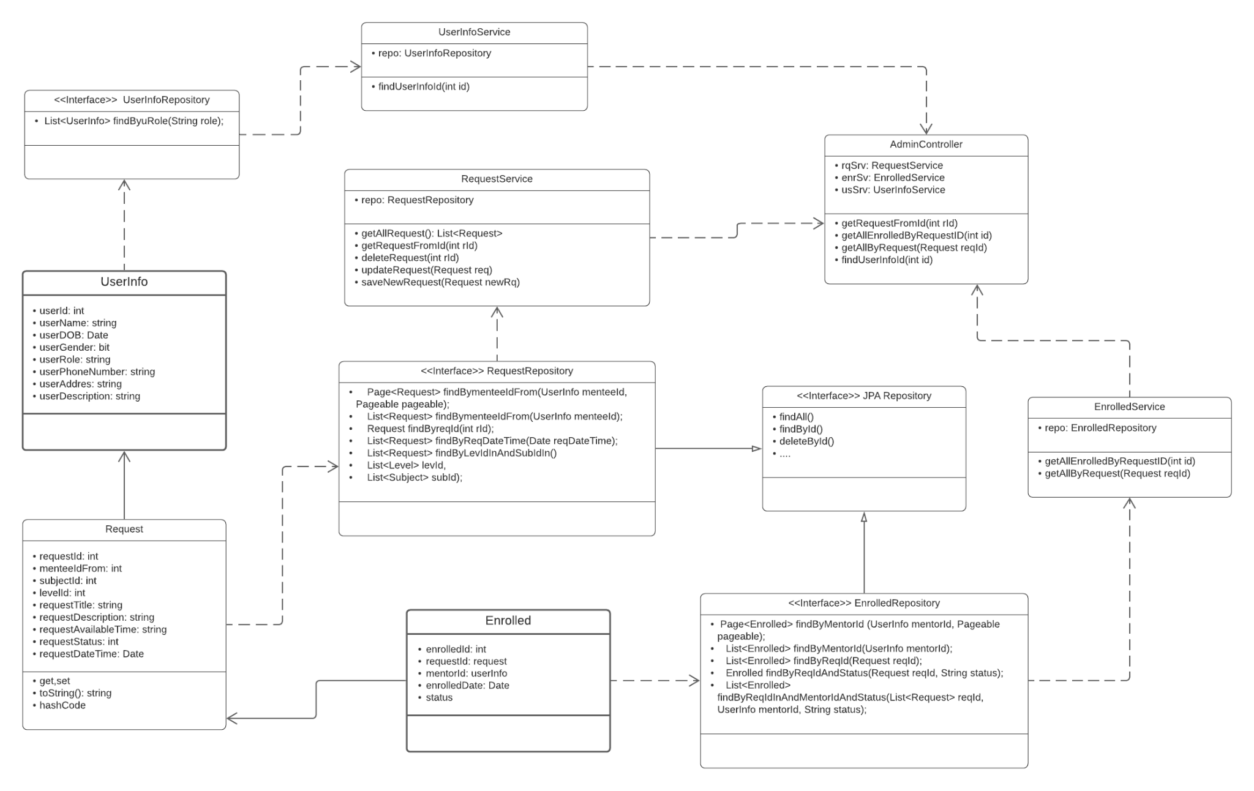

### Class Specification

Request Class: This class store information about request

| **No** | **Method** | **Description** |
| --- | --- | --- |
| 01 | getReqId() | get request ID from a request object |
| 02 | setReqId | set request ID for a request object |
| 03 | getReqStatus() | get request status from a request object |
| 04 | setReqStatus | set request status for a request object |
| 05 | getReqDesc() | get request description from a request object |
| 06 | setReqDesc() | set request description for a request object |
| 07 | getLevId() | get level from a request object |
| 08 | setLevId() | set level for a request object |
| 09 | getSubId() | get subject from a request object |
| 10 | setSubId() | set subject for a request object |
| 11 | getReqTitle() | get request title from a request object |
| 12 | setReqTitle() | set request title for a request object |
| 13 | getReqAvaiTime() | get request available time from a request object |
| 14 | setReqAvaiTime() | set request available time for a request object |
| 15 | getReqDateTime() | get request date time |
| 16 | setReqDateTime() | set request date time for a request object |
| 17 | getMenteeIdFrom() | get userinfo from a request object |
| 18 | setMenteeIdFrom() | set userinfo for a request object |
| 19 | toString() | get to string from a request object |

UserInfo Class: This class store information about user

| **No** | **Method** | **Description** |
| --- | --- | --- |
| 01 | getUId() | get user ID from a userInfo object |
| 02 | setUId() | set user ID for a request object |
| 03 | getUName() | get user name from a userInfo object |
| 04 | setUName() | set user name from a userInfo object |
| 05 | getUDOB() | get user date of birth from a userInfo object |
| 06 | setUDOB() | set user date of birth from a userInfo object |
| 07 | getUGender() | get user gender from a userInfo object |
| 08 | setUGender() | set user gender from a userInfo object |
| 09 | getURole() | get user role from a userInfo object |
| 10 | setURole() | set user role from a userInfo object |
| 11 | getUPhoneNumber() | get user phone number from a userInfo object |
| 12 | getUAddress() | get user address from a userInfo object |
| 13 | setUAddress() | set user address from a userInfo object |
| 14 | getUImage() | get user image from a userInfo object |
| 15 | setUImage() | set user image from a userInfo object |
| 16 | getUDescription() | get user description from a userInfo object |
| 17 | setUDescription() | set user description from a userInfo object |
| 18 | getUStatus() | get user status from a userInfo object |
| 19 | setUStatus() | set user status from a userInfo object |
| 20 | getLoginInfo() | get login info from a userInfo object |
| 21 | setLoginInfo() | set login info from a userInfo object |
| 22 | toString() | to string method |

RequestService: implement the request repository

| **No** | **Method** | **Description** |
| --- | --- | --- |
| 01 | listAllMyByPage() | get the paginated list of request |
| 02 | listAllByPage() | get all the request list after paging |
| 03 | saveNewRequest() | save a new created request |
| 04 | deleteRequest() | delete a selected request |
| 05 | updateRequest() | update information in the selected request |

Enrolled Service:

| **No** | **Method** | **Description** |
| --- | --- | --- |
| 01 | deleteAllEnrolledByRequestID | delete all enrolled object in the database by request id |
| 02 | getAllEnrolledByRequestID() | get all enrolled object in the database by request id |

### Sequence Diagram(s)

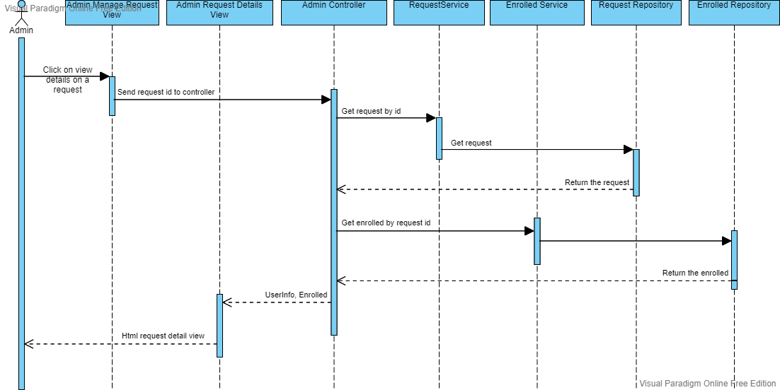

### Database queries

select * from Request where requestId = ?

select * from Enrolled where requestId = ?

select * from Enrolled where status = “ACCEPT”

## 14. Admin Dashboard

### Class Diagram

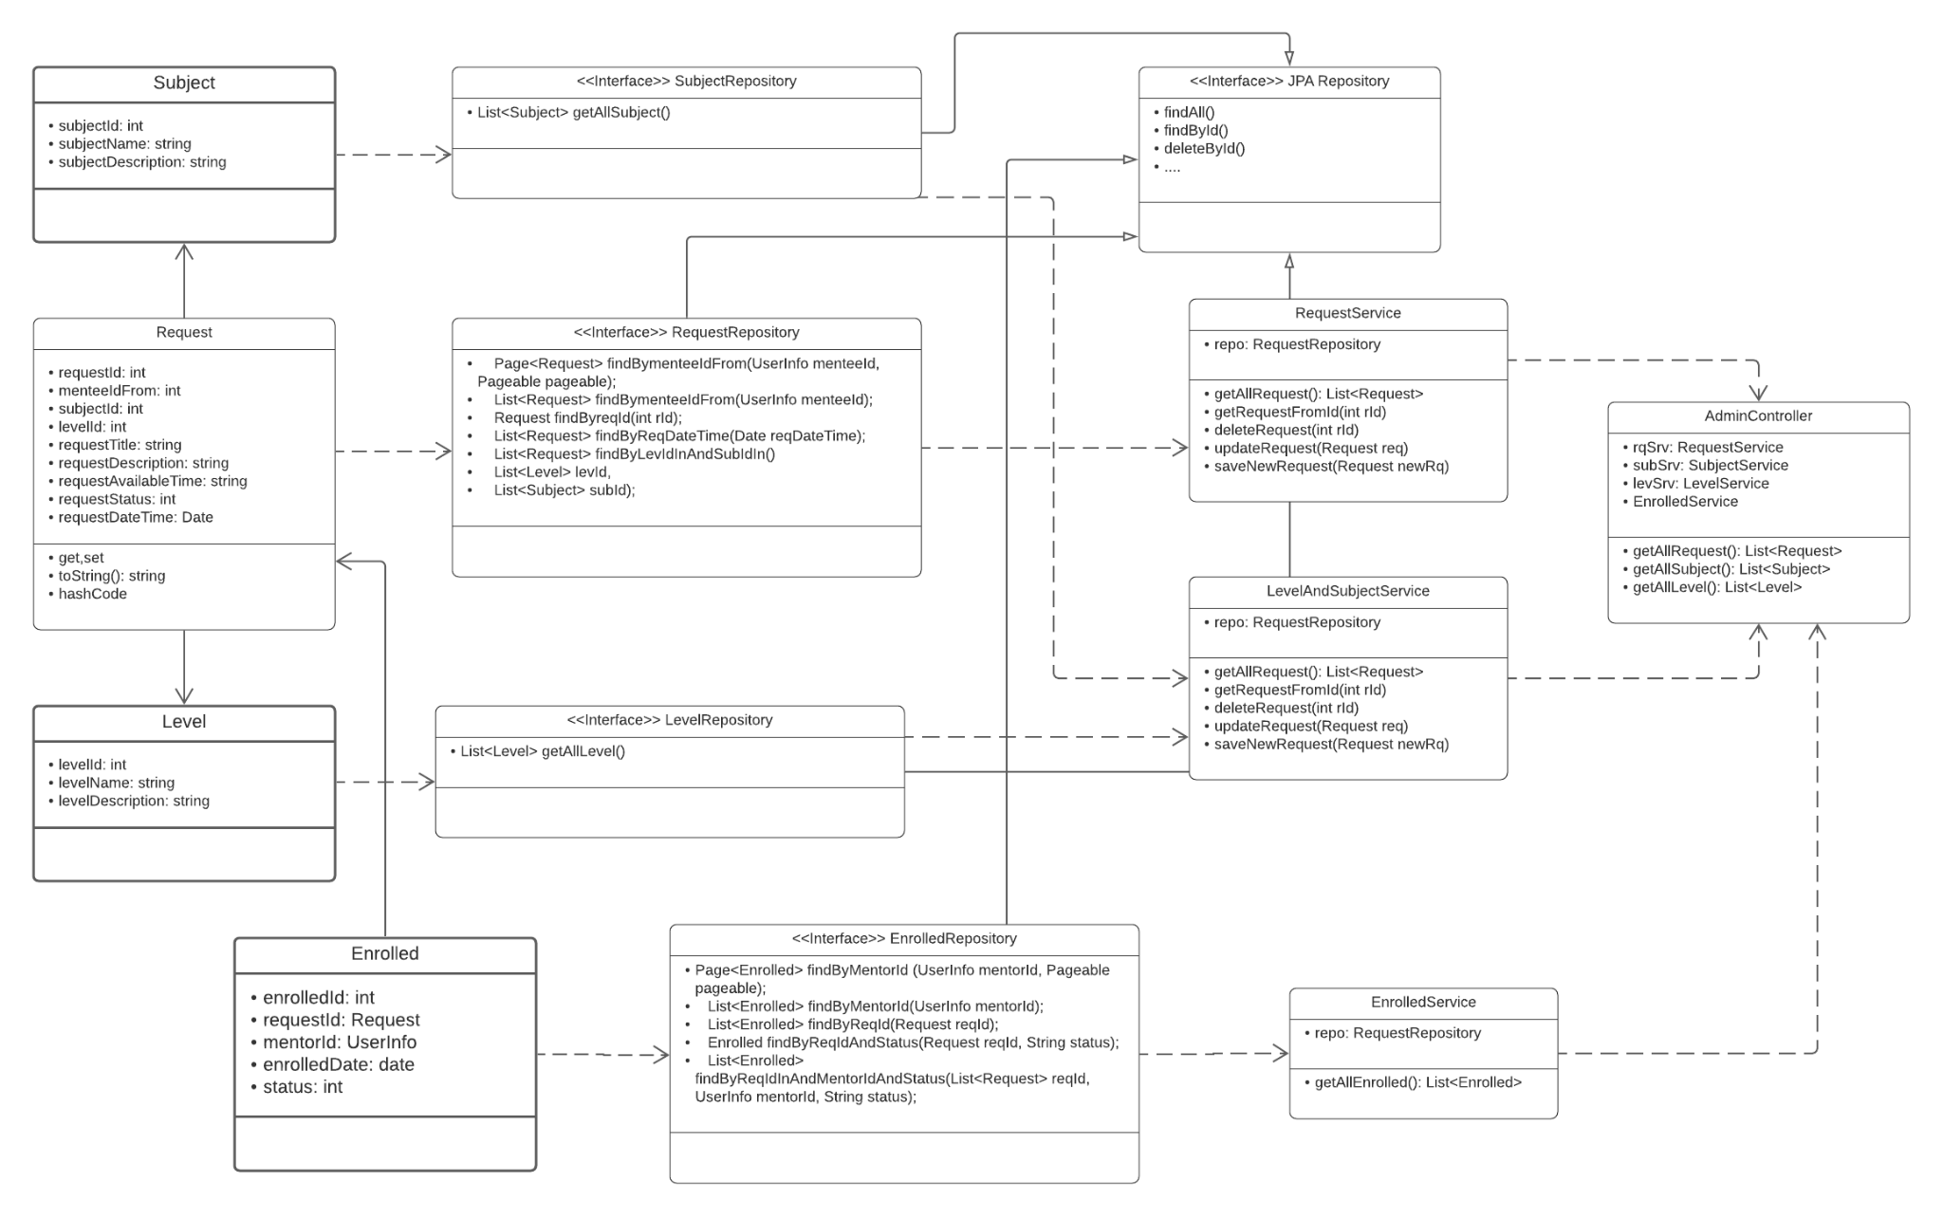

### Class Specification

Request Class: This class store information about request

| **No** | **Method** | **Description** |
| --- | --- | --- |
| 01 | getReqId() | get request ID from a request object |
| 02 | setReqId | set request ID for a request object |
| 03 | getReqStatus() | get request status from a request object |
| 04 | setReqStatus | set request status for a request object |
| 05 | getReqDesc() | get request description from a request object |
| 06 | setReqDesc() | set request description for a request object |
| 07 | getLevId() | get level from a request object |
| 08 | setLevId() | set level for a request object |
| 09 | getSubId() | get subject from a request object |
| 10 | setSubId() | set subject for a request object |
| 11 | getReqTitle() | get request title from a request object |
| 12 | setReqTitle() | set request title for a request object |
| 13 | getReqAvaiTime() | get request available time from a request object |
| 14 | setReqAvaiTime() | set request available time for a request object |
| 15 | getReqDateTime() | get request date time |
| 16 | setReqDateTime() | set request date time for a request object |
| 17 | getMenteeIdFrom() | get userinfo from a request object |
| 18 | setMenteeIdFrom() | set userinfo for a request object |
| 19 | toString() | get to string from a request object |

Level Class: This class store the information about object level

| **No** | **Method** | **Description** |
| --- | --- | --- |
| 01 | getLevId() | get level ID from a level object |
| 02 | setLevId() | set level ID for a level object |
| 03 | getLevName() | get level name from a level object |
| 04 | setLevName() | set level name for a level object |
| 05 | getLevDesc() | get level description from a level object |
| 06 | setLevDesc() | set level description for a level object |
| 07 | toString() | get to string |

Subject Class: This class store the information about object subject

| **No** | **Method** | **Description** |
| --- | --- | --- |
| 01 | getSubId() | get level ID |
| 02 | setSubId() | set level ID |
| 03 | getSubName()() | get level name |
| 04 | setSubName() | set level name |
| 05 | getSubDesc() | get level description |
| 06 | setSubDesc() | set level description |
| 07 | toString() | get to string |

Enrolled Class: This class store the information about object enrolled

| **No** | **Method** | **Description** |
| --- | --- | --- |
| 01 | getEnrId() | get request ID |
| 02 | setEnrId() | set request ID |
| 03 | getEnrDate() | get request status |
| 04 | setEnrDate() | set request status |
| 05 | getReqId() | get request description |
| 06 | setReqId() | set request description |
| 07 | getMentorId() | get level |
| 08 | setMentorId() | set level |
| 09 | getStatus() | get subject |
| 10 | setStatus() | set subject |
| 11 | toString() | get request title |

RequestService: implement the request repository

| **No** | **Method** | **Description** |
| --- | --- | --- |
| 01 | listAllMyByPage() | get the paginated list of request |
| 02 | listAllByPage() | get all the request list after paging |
| 03 | saveNewRequest() | save a new created request |
| 04 | deleteRequest() | delete a selected request |
| 05 | updateRequest() | update information in the selected request |

SubjectService: implement the subject repository

| **No** | **Method** | **Description** |
| --- | --- | --- |
| 01 | getAllSubject() | get all the subjects contain in the database |
| 02 | findSubjectbyId(int id) | get the subject by subject id |
| 03 | getAllLevel() | get all the levels contain in the database |
| 04 | findLevelbyId(int id) | get the level by level id |

Enrolled Service:

| **No** | **Method** | **Description** |
| --- | --- | --- |
| 01 | deleteAllEnrolledByRequestID | delete all enrolled object in the database by request id |
| 02 | getAllEnrolledByRequestID() | get all enrolled object in the database by request id |

### Sequence Diagram(s)

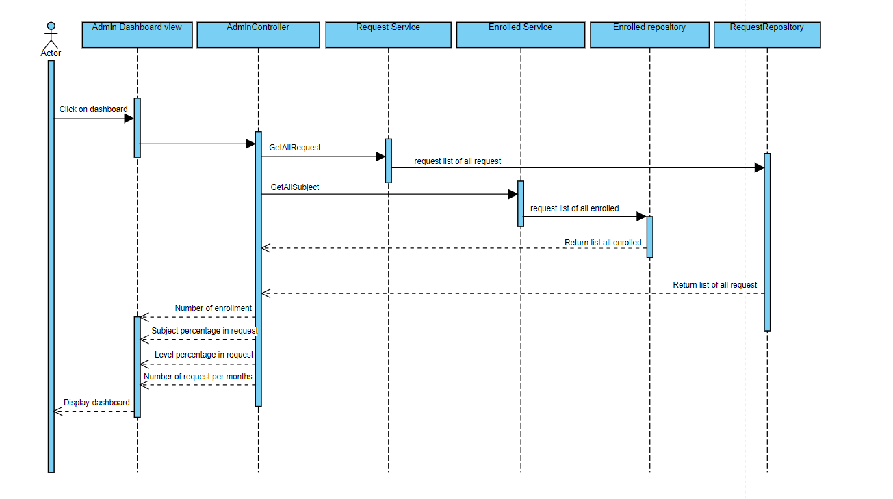

### Database queries

select * from request

select * from subject

select * from level

count * from request

## 15. Change Password

### Class Diagram

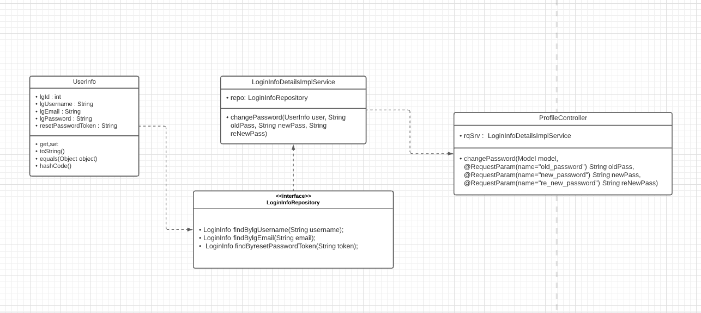

### Class Specification

UserInfo Class: This class store information about user

| **No** | **Method** | **Description** |
| --- | --- | --- |
| 01 | getUId() | get user ID from a userInfo object |
| 02 | setUId() | set user ID for a request object |
| 03 | getUName() | get user name from a userInfo object |
| 04 | setUName() | set user name from a userInfo object |
| 05 | getUDOB() | get user date of birth from a userInfo object |
| 06 | setUDOB() | set user date of birth from a userInfo object |
| 07 | getUGender() | get user gender from a userInfo object |
| 08 | setUGender() | set user gender from a userInfo object |
| 09 | getURole() | get user role from a userInfo object |
| 10 | setURole() | set user role from a userInfo object |
| 11 | getUPhoneNumber() | get user phone number from a userInfo object |
| 12 | getUAddress() | get user address from a userInfo object |
| 13 | setUAddress() | set user address from a userInfo object |
| 14 | getUImage() | get user image from a userInfo object |
| 15 | setUImage() | set user image from a userInfo object |
| 16 | getUDescription() | get user description from a userInfo object |
| 17 | setUDescription() | set user description from a userInfo object |
| 18 | getUStatus() | get user status from a userInfo object |
| 19 | setUStatus() | set user status from a userInfo object |
| 20 | getLoginInfo() | get login info from a userInfo object |
| 21 | setLoginInfo() | set login info from a userInfo object |
| 22 | toString() | to string method |

### Sequence Diagrams

### Database Queries

## 16. Admin daily report

### Class Diagram

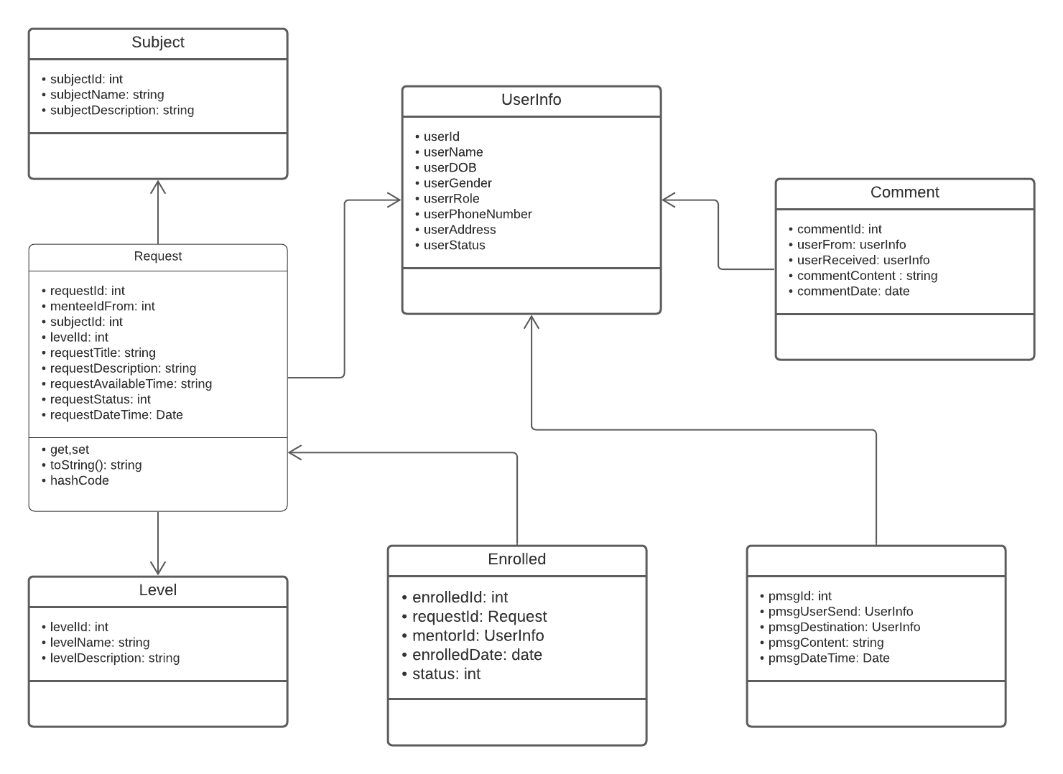

### Class Specification

Request Class: This class store information about request

| **No** | **Method** | **Description** |
| --- | --- | --- |
| 01 | getReqId() | get request ID from a request object |
| 02 | setReqId | set request ID for a request object |
| 03 | getReqStatus() | get request status from a request object |
| 04 | setReqStatus | set request status for a request object |
| 05 | getReqDesc() | get request description from a request object |
| 06 | setReqDesc() | set request description for a request object |
| 07 | getLevId() | get level from a request object |
| 08 | setLevId() | set level for a request object |
| 09 | getSubId() | get subject from a request object |
| 10 | setSubId() | set subject for a request object |
| 11 | getReqTitle() | get request title from a request object |
| 12 | setReqTitle() | set request title for a request object |
| 13 | getReqAvaiTime() | get request available time from a request object |
| 14 | setReqAvaiTime() | set request available time for a request object |
| 15 | getReqDateTime() | get request date time |
| 16 | setReqDateTime() | set request date time for a request object |
| 17 | getMenteeIdFrom() | get userinfo from a request object |
| 18 | setMenteeIdFrom() | set userinfo for a request object |
| 19 | toString() | get to string from a request object |

Level Class: This class store the information about object level

| **No** | **Method** | **Description** |
| --- | --- | --- |
| 01 | getLevId() | get level ID from a level object |
| 02 | setLevId() | set level ID for a level object |
| 03 | getLevName() | get level name from a level object |
| 04 | setLevName() | set level name for a level object |
| 05 | getLevDesc() | get level description from a level object |
| 06 | setLevDesc() | set level description for a level object |
| 07 | toString() | get to string |

Subject Class: This class store the information about object subject

| **No** | **Method** | **Description** |
| --- | --- | --- |
| 01 | getSubId() | get level ID |
| 02 | setSubId() | set level ID |
| 03 | getSubName()() | get level name |
| 04 | setSubName() | set level name |
| 05 | getSubDesc() | get level description |
| 06 | setSubDesc() | set level description |
| 07 | toString() | get to string |

Enrolled Class: This class store the information about object enrolled

| **No** | **Method** | **Description** |
| --- | --- | --- |
| 01 | getEnrId() | get request ID |
| 02 | setEnrId() | set request ID |
| 03 | getEnrDate() | get request status |
| 04 | setEnrDate() | set request status |
| 05 | getReqId() | get request description |
| 06 | setReqId() | set request description |
| 07 | getMentorId() | get level |
| 08 | setMentorId() | set level |
| 09 | getStatus() | get subject |
| 10 | setStatus() | set subject |
| 11 | toString() | get request title |

RequestService: implement the request repository

| **No** | **Method** | **Description** |
| --- | --- | --- |
| 01 | listAllMyByPage() | get the paginated list of request |
| 02 | listAllByPage() | get all the request list after paging |
| 03 | saveNewRequest() | save a new created request |
| 04 | deleteRequest() | delete a selected request |
| 05 | updateRequest() | update information in the selected request |

SubjectService: implement the subject repository

| **No** | **Method** | **Description** |
| --- | --- | --- |
| 01 | getAllSubject() | get all the subjects contain in the database |
| 02 | findSubjectbyId(int id) | get the subject by subject id |
| 03 | getAllLevel() | get all the levels contain in the database |
| 04 | findLevelbyId(int id) | get the level by level id |

Enrolled Service:

| **No** | **Method** | **Description** |
| --- | --- | --- |
| 01 | deleteAllEnrolledByRequestID | delete all enrolled object in the database by request id |
| 02 | getAllEnrolledByRequestID() | get all enrolled object in the database by request id |

### Sequence Diagrams

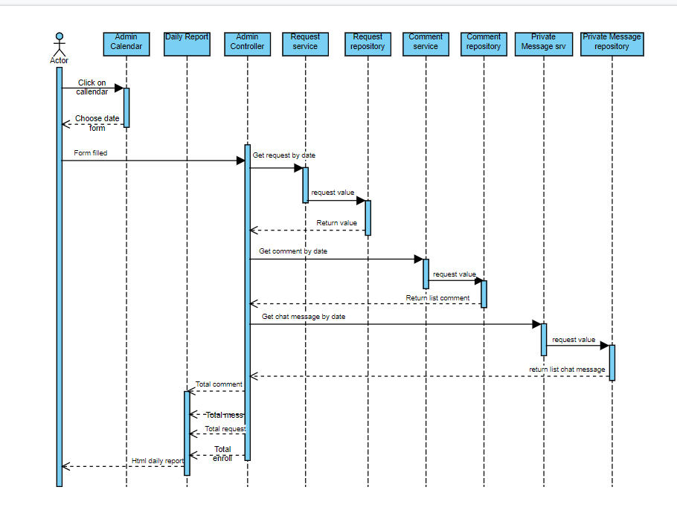

### Database Queries

## 17. Admin view mentee list

### Class Diagram

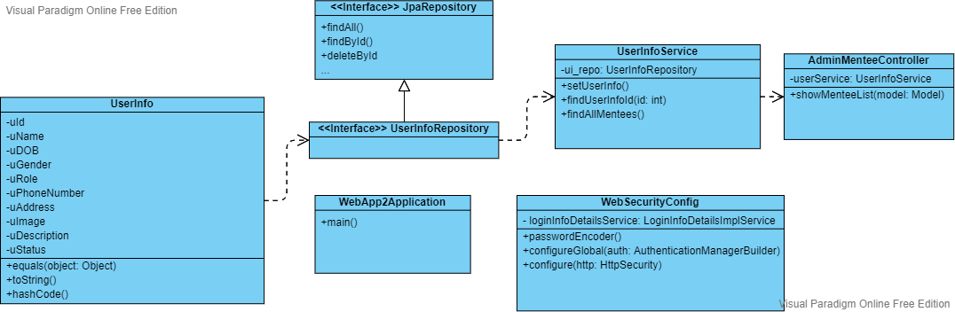

### Class Specification

UserInfo Class: This class store the information about object UserInfo

| **No** | **Method** | **Description** |
| --- | --- | --- |
| 01 | getUId() | get UserInfo ID |
| 02 | setUId() | set UserInfo ID |
| 03 | getUName() | get UserInfo Name |
| 04 | setUName() | set UserInfo Name |
| 05 | getUDOB() | get UserInfo DOB |
| 06 | setUDOB() | set UserInfo DOB |
| 07 | getUGender() | get UserInfo Gender |
| 08 | setUGender() | set UserInfo Gender |
| 09 | getURole() | get UserInfo Role |
| 10 | setURole() | set UserInfo Role |
| 11 | getUPhoneNumber | get UserInfo Phone Number |
| 12 | setUPhoneNumber | set UserInfo Phone Number |
| 13 | toString() |  |

UserInfoService: implement the User Info repository

| **No** | **Method** | **Description** |
| --- | --- | --- |
| 01 | findAllMentees | get the paginated list of request |
| 02 | saveMentee | get all the request list after paging |

AdminMenteeController:

### Sequence Diagrams

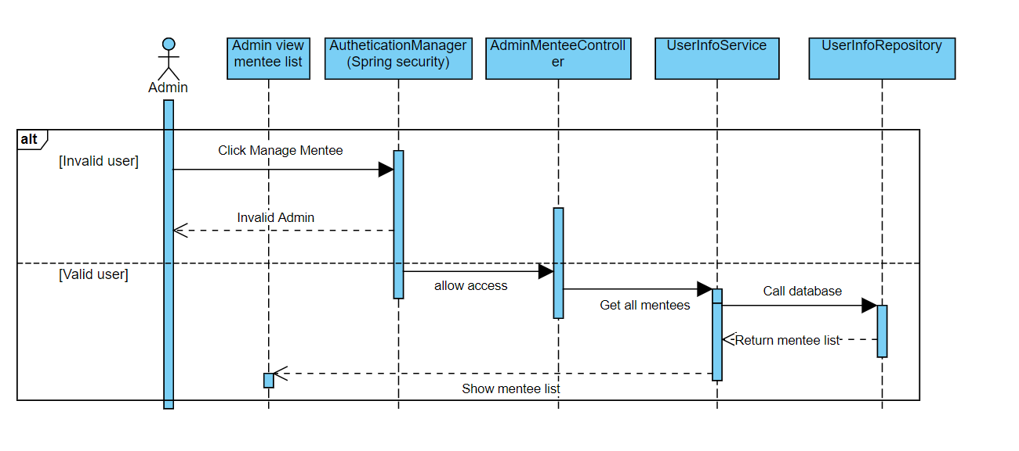

### Database Queries

## 18. Admin Manage mentee

### Class Diagram

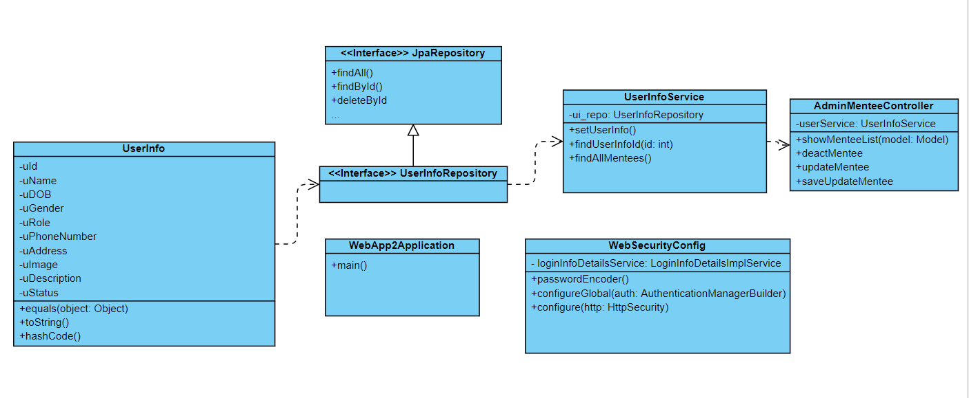

### Class Specification

UserInfo Class: This class store the information about object UserInfo

| **No** | **Method** | **Description** |
| --- | --- | --- |
| 01 | getUId() | get UserInfo ID |
| 02 | setUId() | set UserInfo ID |
| 03 | getUName() | get UserInfo Name |
| 04 | setUName() | set UserInfo Name |
| 05 | getUDOB() | get UserInfo DOB |
| 06 | setUDOB() | set UserInfo DOB |
| 07 | getUGender() | get UserInfo Gender |
| 08 | setUGender() | set UserInfo Gender |
| 09 | getURole() | get UserInfo Role |
| 10 | setURole() | set UserInfo Role |
| 11 | getUPhoneNumber | get UserInfo Phone Number |
| 12 | setUPhoneNumber | set UserInfo Phone Number |
| 13 | toString() |  |

UserInfoService: implement the User Info repository

| **No** | **Method** | **Description** |
| --- | --- | --- |
| 01 | findAllMentees | get the paginated list of request |
| 02 | saveMentee | get all the request list after paging |

### Sequence Diagrams

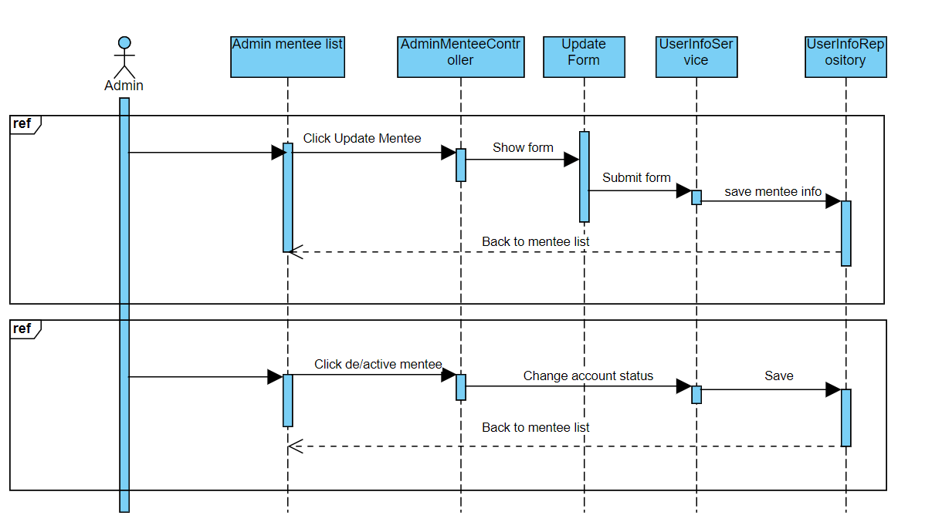

### Database Queries

## 19. Admin View mentor list

### Class Diagram



### Class Specification

UserInfo Class: This class store the information about object UserInfo

| **No** | **Method** | **Description** |
| --- | --- | --- |
| 01 | getUId() | get UserInfo ID |
| 02 | setUId() | set UserInfo ID |
| 03 | getUName() | get UserInfo Name |
| 04 | setUName() | set UserInfo Name |
| 05 | getUDOB() | get UserInfo DOB |
| 06 | setUDOB() | set UserInfo DOB |
| 07 | getUGender() | get UserInfo Gender |
| 08 | setUGender() | set UserInfo Gender |
| 09 | getURole() | get UserInfo Role |
| 10 | setURole() | set UserInfo Role |
| 11 | getUPhoneNumber | get UserInfo Phone Number |
| 12 | setUPhoneNumber | set UserInfo Phone Number |
| 13 | toString() |  |

UserInfoService: implement the User Info repository

| **No** | **Method** | **Description** |
| --- | --- | --- |
| 01 | findAllMentees | get list of all mentees |
| 02 | saveMentee | save mentee with new info |

### Sequence Diagrams

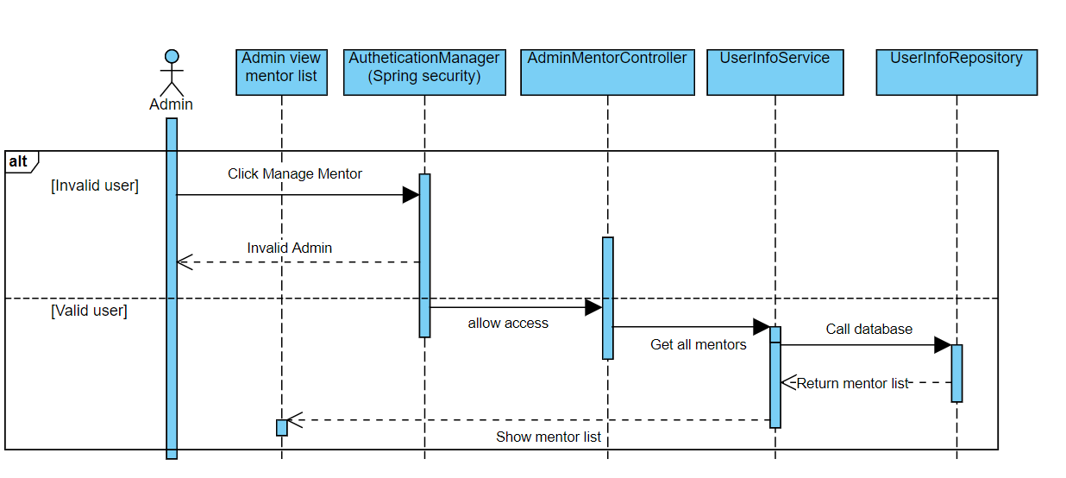

### Database Queries

## 20. Admin Manage mentor

### Class Diagram



### Class Specification

UserInfo Class: This class store the information about object UserInfo

| **No** | **Method** | **Description** |
| --- | --- | --- |
| 01 | getUId() | get UserInfo ID |
| 02 | setUId() | set UserInfo ID |
| 03 | getUName() | get UserInfo Name |
| 04 | setUName() | set UserInfo Name |
| 05 | getUDOB() | get UserInfo DOB |
| 06 | setUDOB() | set UserInfo DOB |
| 07 | getUGender() | get UserInfo Gender |
| 08 | setUGender() | set UserInfo Gender |
| 09 | getURole() | get UserInfo Role |
| 10 | setURole() | set UserInfo Role |
| 11 | getUPhoneNumber | get UserInfo Phone Number |
| 12 | setUPhoneNumber | set UserInfo Phone Number |
| 13 | toString() |  |

### Sequence Diagrams

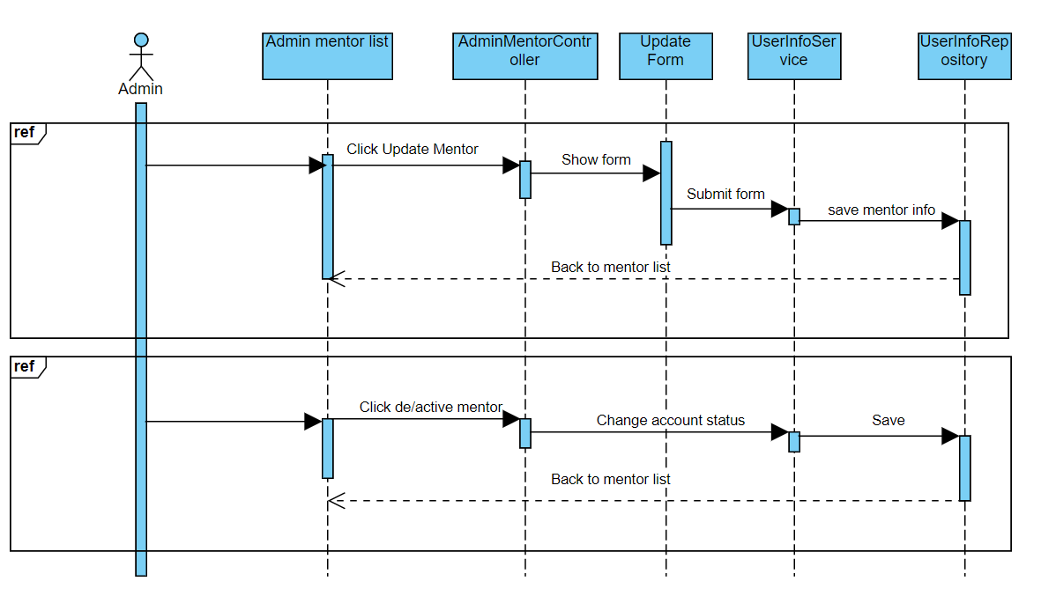

### Database Queries

## 21. Forgot Password

### Class Diagram

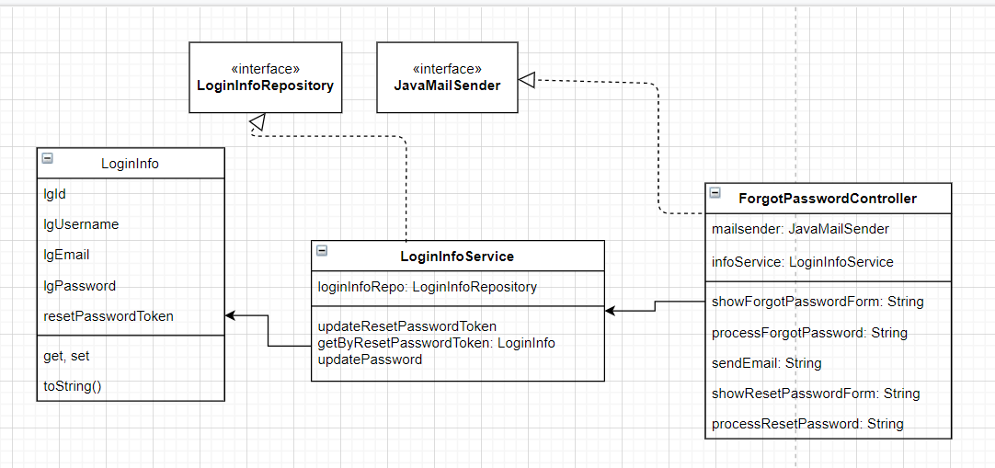

### Class Specification

LoginInfo Class: This class store the information about object LoginInfo

| **No** | **Method** | **Description** |
| --- | --- | --- |
| 01 | getUId() | get UserInfo ID |
| 02 | setUId() | set UserInfo ID |
| 03 | getUName() | get UserInfo Name |
| 04 | setUName() | set UserInfo Name |
| 05 | getUDOB() | get UserInfo DOB |
| 06 | setUDOB() | set UserInfo DOB |
| 07 | getUGender() | get UserInfo Gender |
| 08 | setUGender() | set UserInfo Gender |
| 09 | getURole() | get UserInfo Role |
| 10 | setURole() | set UserInfo Role |
| 11 | getUPhoneNumber | get UserInfo Phone Number |
| 12 | setUPhoneNumber | set UserInfo Phone Number |
| 13 | toString() |  |

LoginInfo Service: implement the LoginInfo repository

| **No** | **Method** | **Description** |
| --- | --- | --- |
| 01 | updateResetPasswordToken | set reset password token to LoginInfo |
| 02 | getByResetPasswordToken | Find loginInfo by resetPasswordToken |
| 03 | updatePassword | Update new encrypted password to LoginInfo |

ForgotPassword Controller

| **No** | **Method** | **Description** |
| --- | --- | --- |
| 01 | showForgotPasswordForm() | set reset password token to LoginInfo |
| 02 | processForgotPassword | Find loginInfo by resetPasswordToken |
| 03 | sendEmail | Update new encrypted password to LoginInfo |
| 04 | showResetPasswordForm | Show reset password form |
| 05 | processResetPassword | Encrypted & save new password |

### Sequence Diagrams

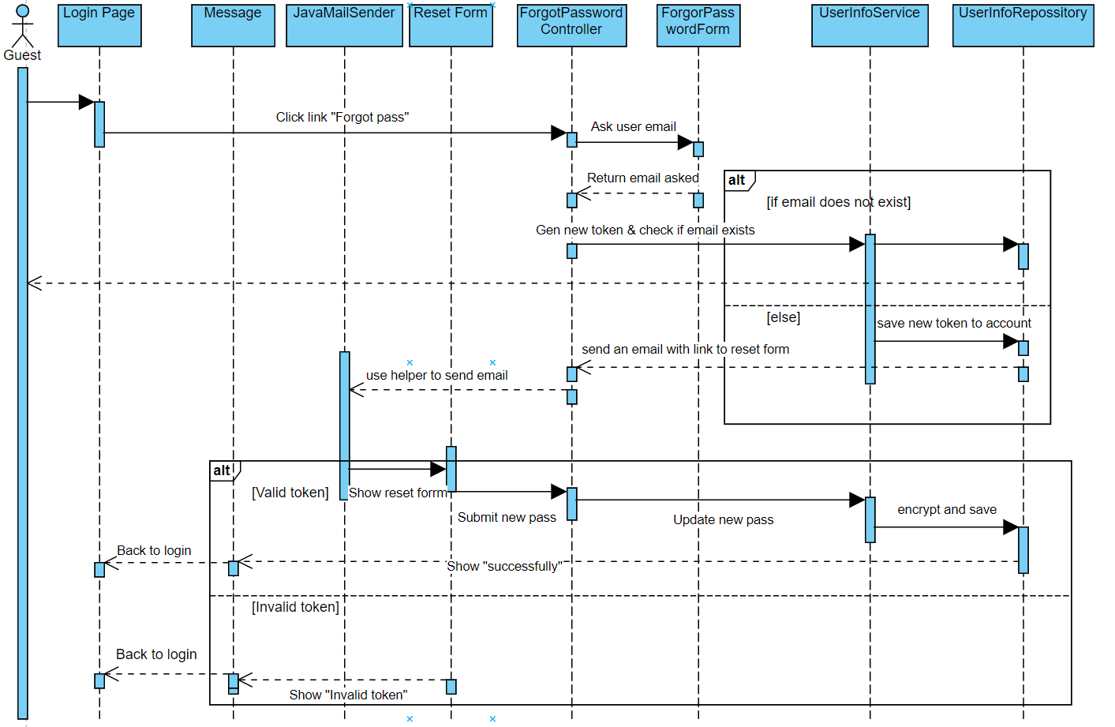

### Database Queries

## 22. Chat

### Class Diagram

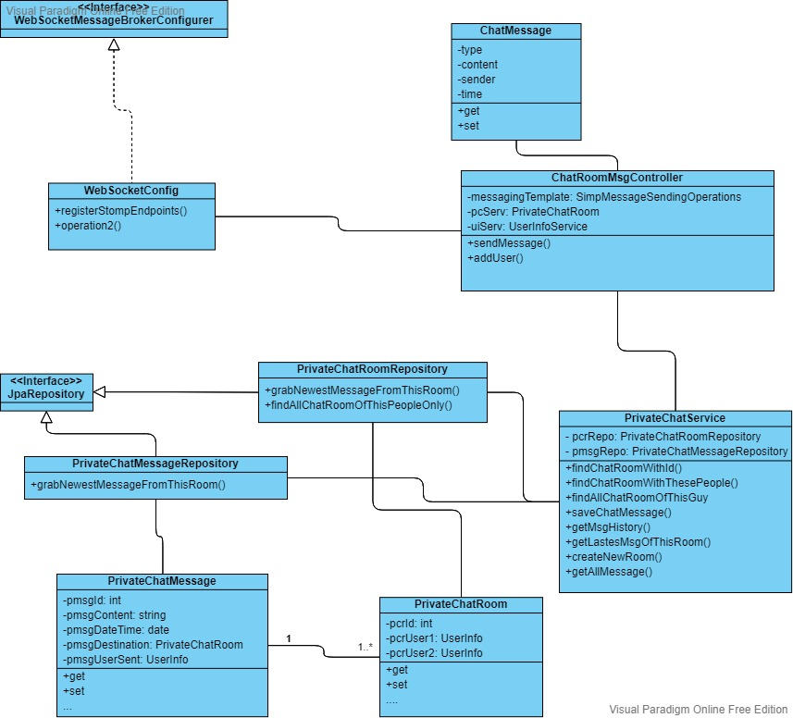

### Class Specification

***WebSocketConfig***

| **No** | **Method** | **Description** |
| --- | --- | --- |
| 01 | registerStompEndpoints | configure Endpoint to handle WebSocket |

***ChatRoomMsgController***

| **No** | **Method** | **Description** |
| --- | --- | --- |
| 01 | sendMessage | A Endpoint Handler for message sent to this path |
| 02 | addUser | A Endpoint Handler for user added to this path |

***PrivateChatRoomService***

| **No** | **Method** | **Description** |
| --- | --- | --- |
| 01 | findChatRoomWithId | Get Chatroom of Id |
| 02 | findChatRoomWithThesePeople | Get ChatRoom of Specific People in the Room |
| 03 | findAllChatRoomOfThisGuy | Find all Room have this people |
| 04 | getMsgHistory | List all Message of a Room |
| 05 | getLatestMsgOfThisRoom() | List Latest Message of this Room |
| 06 | createNewRoom | Create new Room |
| 07 | getAllMessage | Find all Message |

### Sequence Diagram

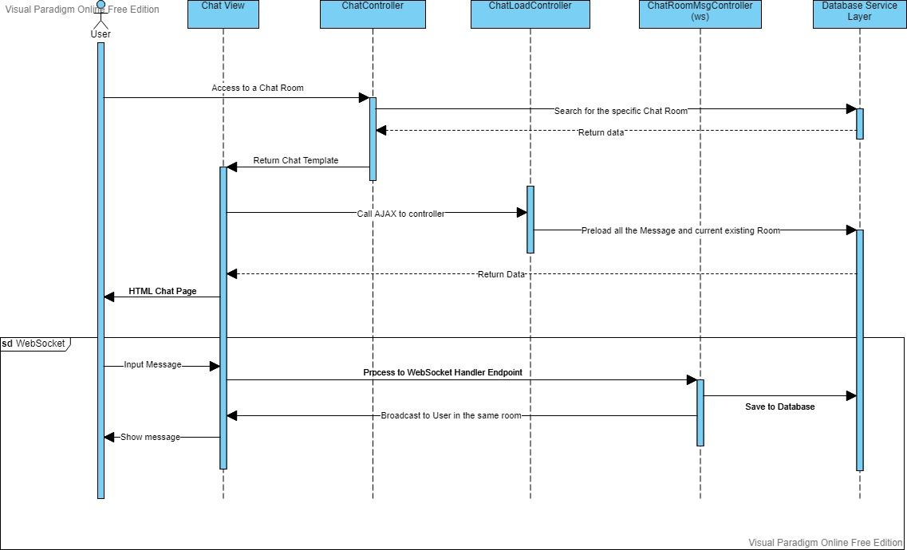

1. **Database Queries**

* findChatRoomWithThesePeople()

SELECT c FROM PrivateChatRoom c WHERE (c.pcrUser1.uId = ?1 AND c.pcrUser2.uId = ?2) OR (c.pcrUser2.uId= ?1 AND c.pcrUser1.uId = ?2)

* findAllChatRoomOfThisPeopleOnly()

SELECT c FROM PrivateChatRoom c WHERE (c.pcrUser1.uId= ?1) OR (c.pcrUser2.uId= ?1)

* grabNewestMessageFromThisRoom()

SELECT c FROM PrivateChatMessage c WHERE c.pmsgDateTime IN (SELECT MAX(p.pmsgDateTime) FROM PrivateChatMessage p WHERE p.pmsgDestination.pcrId = ?1) AND c.pmsgDestination = ?1

# III. Database Tables

## 1. LoginInfo

*[Give some lines about the table here>>*

*[Table fields, in the form of table format as below]*

| **#** | **Field name** | **Type** | **Size** | **Unique** | **Not Null** | **PK/FK** | **Notes** |
| --- | --- | --- | --- | --- | --- | --- | --- |
| 1 | lgId | int |  |  |  | PK | auto increment |
| 2 | lgUsername | nvarchar | 15 | true | true |  |  |
| 3 | lgEmail | nvarchar | 255 | true | true |  |  |
| 4 | lgPassword | varchar | 60 |  | true |  |  |

## 2. Authorization

| **#** | **Field name** | **Type** | **Size** | **Unique** | **Not Null** | **PK/FK** | **Notes** |
| --- | --- | --- | --- | --- | --- | --- | --- |
| 1 | aId | int |  |  |  | PK |  |
| 2 | aName | nvarchar | 60 | true | true |  |  |

## 3. LoginInfo_Authorization

| **#** | **Field name** | **Type** | **Size** | **Unique** | **Not Null** | **PK/FK** | **Notes** |
| --- | --- | --- | --- | --- | --- | --- | --- |
| 1 | lgId | int |  |  | true | FK |  |
| 2 | aId | int |  |  | true | FK |  |

## 4. User

| **#** | **Field name** | **Type** | **Size** | **Unique** | **Not Null** | **PK/FK** | **Notes** |
| --- | --- | --- | --- | --- | --- | --- | --- |
| 1 | uId | int |  |  |  | PK | REFERENCES LoginInfo(lgId) |
| 2 | uName | nvarchar | 256 |  | true |  |  |
| 3 | uDOB | date |  |  | true |  |  |
| 4 | uGender | bit |  |  | true |  |  |
| 5 | uRole | nvarchar | 32 |  | true |  |  |
| 6 | uPhoneNumber | nvarchar | 32 |  |  |  |  |
| 7 | uAddress | nvarchar | 256 |  |  |  |  |
| 8 | uImage | nvarchar | 256 |  |  |  |  |
| 9 | uDescription | nvarchar | 256 |  |  |  |  |
| 10 | uStatus | bit |  |  | true |  | default 1 |

## 5. SkillnExperience

| **#** | **Field name** | **Type** | **Size** | **Unique** | **Not Null** | **PK/FK** | **Notes** |
| --- | --- | --- | --- | --- | --- | --- | --- |
| 1 | sneId | int |  |  |  | PK | auto increment |
| 2 | userId | int |  |  |  | FK |  |
| 3 | sneType | int |  |  |  |  |  |
| 4 | sneDescription | nvarchar | 256 |  |  |  |  |

## 6. Subject

| **#** | **Field name** | **Type** | **Size** | **Unique** | **Not Null** | **PK/FK** | **Notes** |
| --- | --- | --- | --- | --- | --- | --- | --- |
| 1 | subId | int |  |  |  | PK | auto increment |
| 2 | subName | nvarchar | 32 |  | true |  |  |
| 3 | subDesc | nvarchar | 256 |  |  |  |  |

## 

## 7. Level

| **#** | **Field name** | **Type** | **Size** | **Unique** | **Not Null** | **PK/FK** | **Notes** |
| --- | --- | --- | --- | --- | --- | --- | --- |
| 1 | levId | int |  |  |  | PK | auto increment |
| 2 | levName | nvarchar | 32 |  | true | FK |  |
| 3 | levDesc | nvarchar | 256 |  |  |  |  |

## 8. Mentor _Subject

| **#** | **Field name** | **Type** | **Size** | **Unique** | **Not Null** | **PK/FK** | **Notes** |
| --- | --- | --- | --- | --- | --- | --- | --- |
| 1 | mnId | int |  |  |  | FK |  |
| 2 | subjId | int |  |  |  | FK |  |

## 9. Request

| **#** | **Field name** | **Type** | **Size** | **Unique** | **Not Null** | **PK/FK** | **Notes** |
| --- | --- | --- | --- | --- | --- | --- | --- |
| 1 | reqId | int |  |  |  | PK | auto increment |
| 2 | menteeId | int |  |  |  | FK |  |
| 3 | subId | int |  |  |  | FK |  |
| 4 | levId | int |  |  |  |  |  |
| 5 | reqStatus | bit |  |  | true |  | default 0 |
| 6 | reqDesc | nvarchar | 256 |  |  |  |  |
| 7 | reqDate | date |  |  |  |  |  |
| 8 | reqAvailableDate | date |  |  |  |  |  |

## 10. Enrolled

| **#** | **Field name** | **Type** | **Size** | **Unique** | **Not Null** | **PK/FK** | **Notes** |
| --- | --- | --- | --- | --- | --- | --- | --- |
| 1 | enrId | int |  |  |  | PK | auto increment |
| 2 | reqId | int |  |  |  | FK |  |
| 3 | mentorId | int |  |  |  | FK |  |
| 4 | enrDate | date |  |  |  |  |  |

## 

## 11. ChatEndponts

| **#** | **Field name** | **Type** | **Size** | **Unique** | **Not Null** | **PK/FK** | **Notes** |
| --- | --- | --- | --- | --- | --- | --- | --- |
| 1 | cEdId | int |  |  |  | PK | auto increment |
| 2 | userFrom | int |  |  |  | FK |  |
| 3 | userTo | int |  |  |  | FK |  |

## 12. Chat

| **#** | **Field name** | **Type** | **Size** | **Unique** | **Not Null** | **PK/FK** | **Notes** |
| --- | --- | --- | --- | --- | --- | --- | --- |
| 1 | cId | int |  |  |  | PK | auto increment |
| 2 | cUserFrom | bit |  |  |  |  |  |
| 3 | cEndpTo | int |  |  |  | FK |  |
| 4 | cContent | nvarchar | 256 |  |  |  |  |
| 5 | cData | Date |  |  |  |  |  |

## 13. Notify

| **#** | **Field name** | **Type** | **Size** | **Unique** | **Not Null** | **PK/FK** | **Notes** |
| --- | --- | --- | --- | --- | --- | --- | --- |
| 1 | notId | int |  |  |  | PK | auto increment |
| 2 | notType | int |  |  |  |  |  |
| 3 | userReceived | int |  |  |  | FK |  |
| 4 | userFrom | int |  |  |  | FK |  |
| 5 | notStatus | bit |  |  | true |  | default 0 |
| 6 | notDate | Date |  |  |  |  |  |
| 7 | notDesc | nvarchar | 256 |  |  |  |  |

## 14. Comment

| **#** | **Field name** | **Type** | **Size** | **Unique** | **Not Null** | **PK/FK** | **Notes** |
| --- | --- | --- | --- | --- | --- | --- | --- |
| 1 | comId | int |  |  |  | PK | auto increment |
| 2 | userFrom | int |  |  |  | FK |  |
| 3 | userReceived | int |  |  |  | FK |  |
| 4 | comContent | nvarchar | 256 |  |  |  |  |
| 5 | comDate | Date |  |  |  |  |  |