In this example, I selected the current time and created an alias of Time for the column name. Generally, you probably don’t need a dedicated column for the current time, but with this function you can timestamp records for when data is changed. Using the alias allows you to be able to rename that timestamp to whatever suits the project.

Using the SELECT_USER(); function allows you to view who the logged in user is. This can be helpful if you are a system administrator and are troubleshooting a user account or if someone has remained logged in after they have left their computer unattended. This can be helpful if you need to have a talk with them about property security measures.

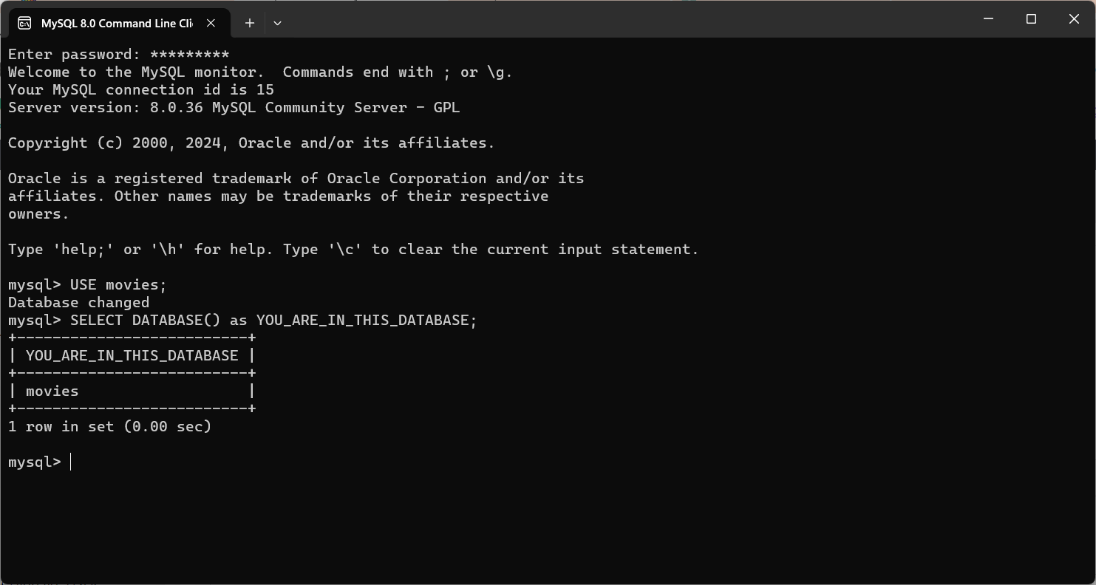Using the SELECT DATABASE(); function returns the name of the database that you are in. This can be helpful when you are working with multiple databases and want to ensure that you are in the correct one before making changes to the database.