**NOMAD EXPERIMENT: A to Z**

**Before You Arrive or Send Your Samples:**

**1.  Confirmation:**

The confirmation of all relevant information for your beamtime is done through our Integrated Proposal Tracking System (IPTS: <http://www.ornl.gov/sci/iums/ipts/>). Before arriving for beamtime, you will need to confirm (Figure 1):

1) Lab Use,

2) Samples,

3) Sample Environment,

4) Safety, and

5) Dates.

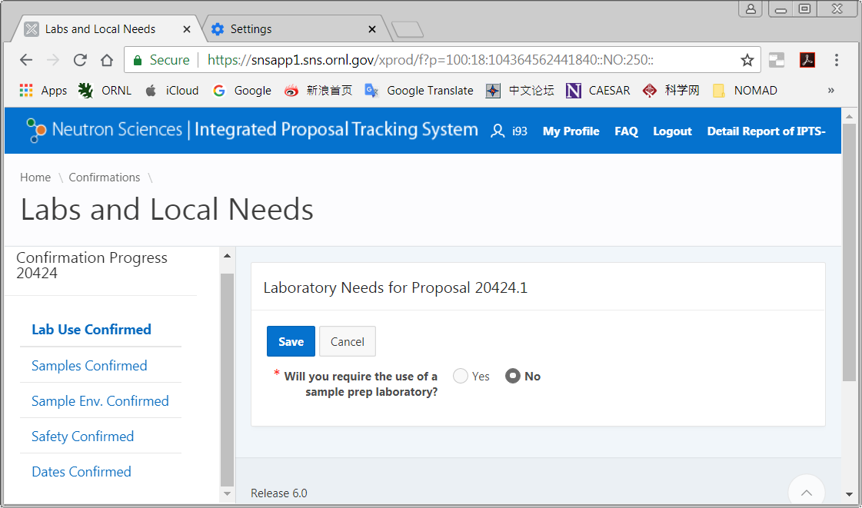

Figure 1. Proposal confirmation screen. All five items shown on the left should be confirmed.

This is a chance to enter the correct sample information and anything that is not confirmed cannot be measured during your beamtime. Adding similar samples as stated in your proposal will most likely trigger no additional review. However, remember if you are entering drastically different samples from your approved proposal they will go through a further approval and may be denied (Figure 2). Samples may also be added after the initial confirmation.

During this confirmation process you will also need to specify whether you want us to waste the sample after neutron measurement or you want it shipped back. **REMEMBER DEPENDING ON THE COMPOSITION OF YOUR SAMPLE, IT MAY GET ACTIVATED IN THE NEUTRON BEAM. THESE SAMPLES WILL BE SHIPPED BACK (IF REQUESTED) AS ACTIVATED MATERIAL.**  If you are not sure if the samples will get activated or not, feel free to contact the instrument team for guidance.

Also at this point you can select dates you are unavailable to be on-site, and add members to your team which will be needed to allow them access to SNS and your data (Figure 3).

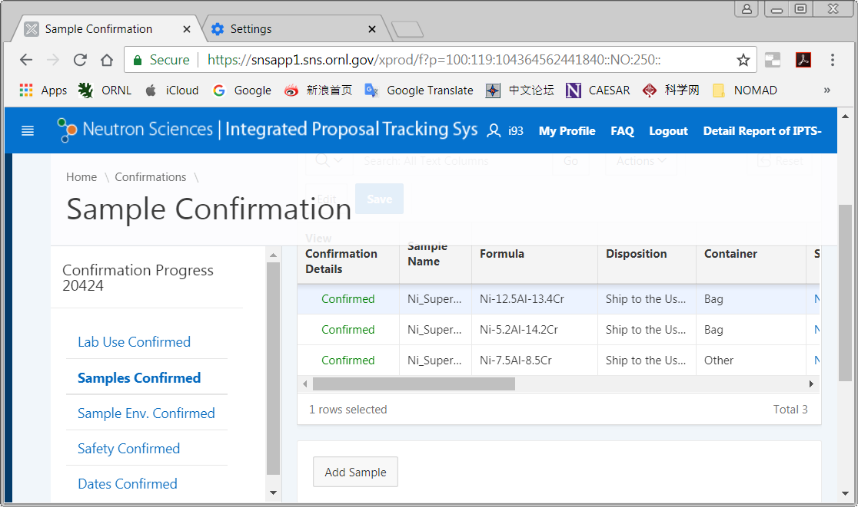

Figure 2. All samples must be in the IPTS system. If they were not on the original proposal, use the "Add Sample" button to add them.

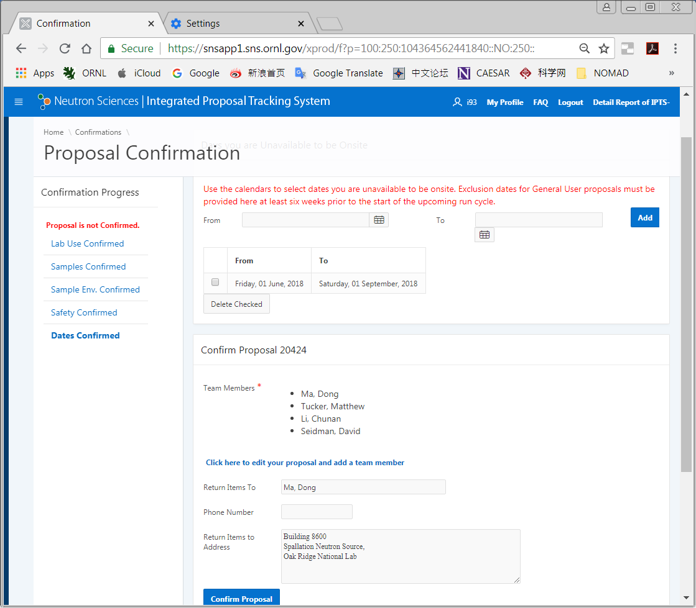

Figure 3. Add any team members who were not originally on the proposal using the link.

**2.  Shipping:**

If you intend to ship samples to SNS prior to your arrival (highly recommended), please note the following shipping addresses that you should use. You should plan for the sample to arrive at SNS at least 7 days prior to your beam time. Please do not put any staff member’s names on it.  If the shipping company insists on having a name, please use **Sam Pell**. For more information, go to <http://neutrons.ornl.gov/users/shipping>.

If you are shipping non-radioactive samples, use the following address:

Recipient: IPTS XXXXX, SNS user sample [Replace the XXXX with your IPTS number]

Oak Ridge National Laboratory/SNS Site

9500 Spallation Drive

Bldg 8600, Rm G-201 <Special requirements (example: freezer or inert gas)>

Oak Ridge, TN 37830

SNS Sample Management Desk phone number: 865-382-8466

**For radioactive samples:**

Recipient: IPTS XXXXX, SNS user sample [Replace the XXXX with your IPTS number]

Oak Ridge National Laboratory / SNS Site

1 Bethel Valley Road

Bldg 7001 <Special requirements (example: freezer or inert gas)>

Oak Ridge, TN 37830

SNS Sample Management Desk phone number: 865-382-8466

If you bring additional equipment or samples that are not placed in the neutron beam, be prepared to carry or ship these back after completion of experiment.

**3.  Training and Access:**

You will be contacted by staff from the user office to schedule training and arrange for badge access to ORNL. Please respond promptly, as the badging process can take some time.

Plan to arrive at SNS, ready to work, the day before your beamtime, especially if you have a large number of samples that will be measured in the sample changer or if your beamtime starts on a weekend. If you arrive on the day of your measurement and the samples are not ready, you will lose precious neutron time from your allocation. Be sure to arrange with your local contact when and where to meet.

There will be several web-based modules to complete before you arrive, including ORNL Site Access, Radiological Worker and Scientific Laboratory training. These are followed by hands-on training once you arrive at SNS. The practical training is offered at 9am (Monday, Wednesday-Friday) or 1pm (Tuesday). Please sign up for the training session that is the day before your beamtime starts. Your training will be valid for two years.

**Once You Arrive:**

**1.   Sample Preparation:**

1. Scientific laboratory staff will work with you to check-in your samples. All samples that will go in the beam must be assigned an identification number. You will be given a barcode tag with this ITEMS number. Each sample must stay with its barcode tag whenever it is not in the beam.
2. Once your samples are checked-in, the scientific laboratory staff will help you setup in the lab to start filling your samples into vanadium cans (6 mm in inner diameter) or glass capillaries (3 mm in inner diameter), whichever work best for your proposed experiment. Choice of vanadium can or glass capillary depends on the quantity of sample available and the nature of the elements. Some elements such as Cd, Gd, B have extremely large absorption for neutron and may not be feasible for measurements. If you are not sure about the cross sections go to the following website, which lists this information for all the elements in the periodic table.

<https://www.ncnr.nist.gov/resources/n-lengths/>

If you do have an element with large absorption go to the following website (Figure 4) for calculating how much the neutrons will penetrate your sample.

<https://www.ncnr.nist.gov/resources/activation/>.

Input information is the composition of the compound, density (recall that you can have at best 50% packing fraction with powders and hence the density is usually half (½) of the calculated density to a good approximation), can thickness and wavelength of neutrons used (typically 1Å).

Following is a calculation done for Li3N (Figure 4). Natural Li has pretty large absorption but in this case 1 Å neutrons will penetrate through 6mm and so the use of a 6mm-diameter can is appropriate. Neutron 1/e penetration depth is the thickness of material that will attenuate a neutron beam to 1/e (about 0.37) of its incident intensity.

1. Once all samples are ready, the samples are loaded in the Linear Sample Changer (or Shifter), which can hold up to 10 samples. Beamline personnel will teach you how to load samples and are usually present to assist.

**Never open a sample can or capillary after it has been in the neutron beam.**  If a sample needs to be removed from a can or a capillary, for example to measure in a different sample environment, contact beamline staff for assistance. There is a special facility, the Post-Beam Sample Handling Lab, for these types of operations.

Other sample environments, like furnaces and cryostats, which mostly use different sample containers, can only allow to measure one sample at a time, so all samples don’t have to be loaded up in one go. However, due to the manual sample changes, it is important to have a sufficient number of team members present to work according to need. Sample changes may occur in the middle of the night and are the responsibility of the users.

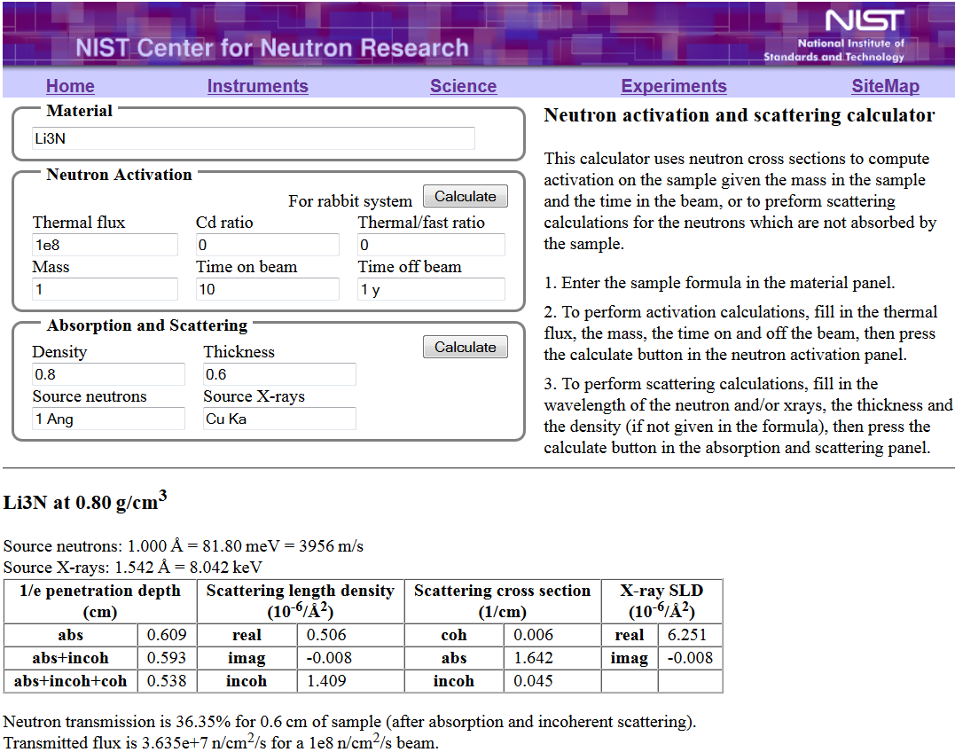

Figure 4. Neutron absorption calculator at https://www.ncnr.nist.gov/resources/activation/.

**2.   Measuring powder patterns and Pair Distribution Functions (PDFs):**

NOMAD is a high-flux, time-of-flight neutron diffractometer for the determination of pair distribution functions (PDFs). This involves the determination of the structure factor S(Q), which is the measured scattered intensity as a function of momentum transfer (Q) after applying background subtraction, flux normalization and appropriate Placzek corrections, followed by Fourier transforming the S(Q) to the PDF. Samples are expected to be isotropic – in which case the PDF depends only on the absolute value of the atomic distance (r).

Right after installing a new sample environment, e.g., the Shifter, the instrument team does calibration runs, which include measurements of diamond, diamond background, vanadium, silicon and the empty instrument. Note that the user is responsible for collecting data from the empty sample container and other calibration data if any other setting of the instrument is used for data collection.

Once you are ready for a sample run, you need to determine how long to collect the data for each diffraction pattern. Of course some of this decision is based on how much time you have been awarded on the instrument. Very often it is worthwhile to start with running the sample for a short time, say 3-5 minutes. This will tell you how well your sample scatters. Once you ascertain that then think about what your goals are to decide the collection strategy.

Once your sample run is started, the data reduction is done automatically, which will be started by your local contact. You can find your reduced data at /SNS/NOM/IPTS-###/shared/autoNOM/ in the SNS data analysis server (https://analysis.sns.gov), where ### is the IPTS number of your experiment (*see* Section 4 for more details).

**3.  Monitoring Data Collection:**

You should monitor your experiment during data collection, periodically checking that everything is running correctly. The SNS Monitor webpage (<https://monitor.sns.gov/report/nom/>), accessible outside ORNL as well, will let you monitor the instrument operating status without being physically present at the beamline. This webpage contains information about the current status of the instrument, such as sample temperature, chopper setting, beam power and detector counts. In addition, it displays a list of recent runs. Clicking on a run number will display an image of the reduced data. You will have to login with your IPTS credentials in order to view the data for your proposal. Other users that are not on your proposal will not be able to see your data.

If you see anything unexpected, tell your local contact. You may also contact the Instrument Hall Coordinator (865-241-4432), particularly at night and on weekends.

We recommend that you do at least preliminary refinements as your data is being collected. This can reveal issues that will change the way you want to collect data. For example, if a reaction occurs more quickly than expected, you may want to stop the data collection early and move on to a different sample.

**4.  Accessing Data:**

1. Go to the user portal and create an XCAMS ORNL Resource account (if you don’t already have an account). This is the same as the account for the IPTS system.

<https://user.ornl.gov/Account/Login.aspx>

If you have forgotten your password, go to https://user.ornl.gov/Account/Login and you will be able to retrieve your password by using the “Forgot your password?” link.

1. To connect to the analysis cluster, go to <http://analysis.sns.gov/> (Figure 5).
   * To use the web-based client in your browser, click the “Launch Session” button. You may also go directly to <https://analysis.sns.gov:8080>. Login with your XCAMS username and password.
   * Alternatively, you can install the Thinlinc client on your machine. Click on the Thinlinc button and follow the steps to install and configure the client (Figure 6). Login credentials will be the same as XCAMS.

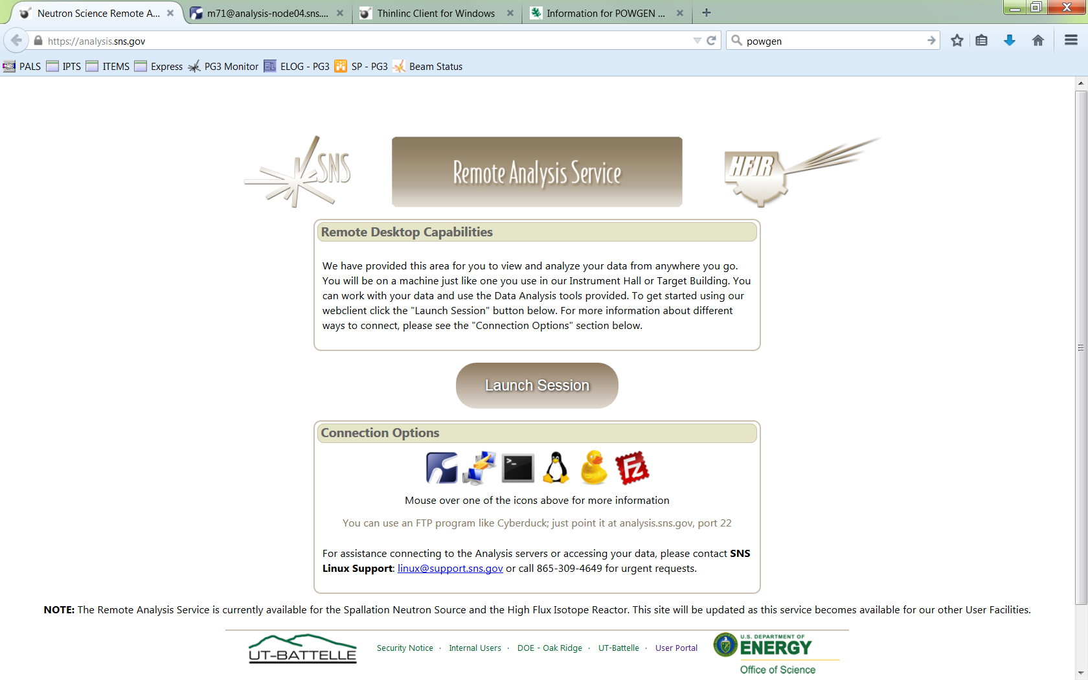

**Web client**

**Thinlinc client**

**FTP**

**SSH**

Figure 5. Access the analysis cluster by going to <http://analysis.sns.gov> and either clicking "Launch Session" or installing the Thinlinc client.

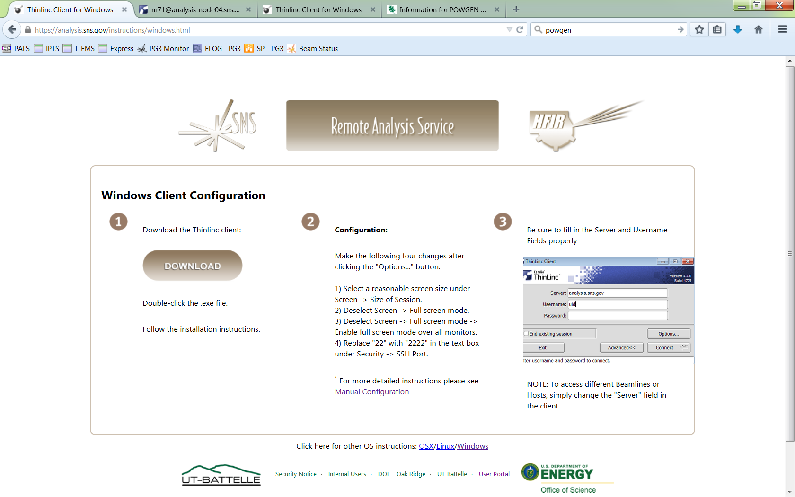

**OSX and Linux instructions**

Figure 6. Thinlinc client installation instructions are available at <https://analysis.sns.gov/instructions/windows.html> .

1. Once you login under your home directory you will see the following folder structure /data/SNS/NOM/IPTS-###, where ### is the IPTS number of your experiment. If you fail to see the IPTS-### folder then try /SNS/NOM/IPTS-###.

**Data autoreduction**

Data is automatically reduced using the default parameters to SofQ, PDF, gofr, GSAS, FullProf and Topas files, which are saved in the corresponding sub-folder bearing the same name in the /SNS/NOM/IPTS-#/shared/autoNOM/ folder. Below are the data files obtained from the autoreduction with XXX denoting the run number:

* los.txt is the logbook of your experiment (updated automatically)
* NOM_XXXSQ.dat – ASCII file of S(Q)-1. You can plot it in gnuplot or any other software
* NOM_XXXftfrgr.gr – G(r) or PDF of your samples
* NOM_XXXftlrgr.gr – same as above, but convoluted with the Lorch function
* NOM_XXXftl.dat, NOM_XXXftf.dat – small g(r)
* NOMXXXtof.gsa – Diffraction pattern in GSAS format
* NOMXXXtof.getN – Diffraction pattern in PDFgetN format
* NOMXXX-n.dat – where n is the bank number, diffraction pattern in FullProf format

**Data reprocessing**

You can of course re-process data with other parameters

* using ADDIE­, a dedicated data reduction software for NOMAD

(*see* /SNS/NOM/shared/ADDIE_manual_20170518.pdf)

* or using IDL codes as described in the *NOMAD’s Data Reduction Guide* (<https://neutrons.ornl.gov/sites/default/files/How%20to%20reduce%20NOMAD%20data_01_28_2016.pdf>)

**Data analysis/refinement**

You can refine your data using the appropriate software based on the types of the reduced data files.

**Extension .gr** files are ready to be used in PDFgui software (http://www.diffpy.org/ ).

* Tutorial video: (https://www.youtube.com/watch?list=UUCyTfdry5UJiiWaS2gTm_A&v=tTQ3oidEHjY ).
* Make sure to join Google-group for more info and useful tips: (<https://groups.google.com/forum/#!forum/diffpy-users>)

**Extension .gsa** files are to be used with GSAS-EXPGUI software (https://subversion.xor.aps.anl.gov/trac/EXPGUI/wiki/InstallWindows). The Instrument parameter file can be found at /SNS/NOM/shared/GSASandPDFgetN folder. Subfolder per year. Use the appropriate one.

**Extension .dat** files are to be used with FullProf package (https://www.ill.eu/sites/fullprof/index.html). Instrument parameter file for each bank can be found at the appropriate /SNS/NOM/shared/GSASandPDFgetN subfolder.

**Extension .getN** files are to be used with PDFgetN software.

* Important! Do not use on-line version. Use PDFgetN-SNS version available at /SNS/NOM/shared/GSASandPDFgetN /PDFgetN-SNS_users.zip.
* You can also find parameter file, manual and settings for the program in the same folder. Remember that PDFgetN-SNS only works for samples measured in standard vanadium cans.

**Extension .xye** files are ready for TOPAS: Again, the data file names themselves tell you which bank they are.

1. Secure ftp or secure shell will allow you to get the data onto your local drive. Two such programs can be downloaded from <http://cyberduck.io/> or <http://filezilla-project.org/download.php?type=client>. Enter the following information to connect to the analysis computers:

Host: analysis.sns.gov  
XCAMS username and password  
Port: 22

**Before You Leave:**

Before you leave, check out with your local contact, either in person or by phone. If your local contact is unavailable, you may check out with another instrument staff member or with the Instrument Hall Coordinator.

Any samples that were checked-in and given an ITEMS barcode tag must be released by SNS staff before you may take them, even if they were never in the neutron beam. There are two forms that must be filled out and approved before you may hand carry. Approval typically takes several days, so if you want to carry your samples back, notify your local contact at the start of your beamtime. It is generally far easier to just let us ship your samples back to you. This also applies to any user-supplied equipment that you brought that went into the beam.

**Publishing Results:**

Finally, when you are ready to publish your data, make sure to check with your local contact regarding authorship and acknowledgement. The facility acknowledgement statement must be included on all papers that present neutron data collected at SNS or HFIR. This statement is:

**[A portion of] This research at ORNL's Spallation Neutron Source was sponsored by the Scientific User Facilities Division, Office of Basic Energy Sciences, U.S. Department of Energy.**