World-class, high-end computing services for Australian research and innovation

FUJITSU-ANU (NCI) COLLABORATION AGREEMENT
Progress Report 4
Reporting period: October 2015 – March 2016

National Computational Infrastructure
NCI Building (143), Ward Road
Australian National University
T: +61 2 6125 9800
E: director@nci.org.au
W: www.nci.org.au

20 March, 2016
Table of Contents
1 BACKGROUND AND CONTEXT 3
1.1 About NCI 3
1.2 About this Project 3
1.2.1 Governance 4
2 PROJECT STATUS 5
2.1 Project A: ACCESS Optimisation Project 5
2.1.1 Project Aims 5
2.1.2 Staff Resources 6
2.1.3 Project A Progress 6
ACCESS-CM2 34
2.2 Project B: Advanced Computational Scaling and Tools Project 43
2.2.1 Project Aims 43
2.2.2 Staff Resources 44
2.2.3 Project B Progress 44
3 PUBLISHED REPORTS AND OTHER DOCUMENTS 62

BACKGROUND AND CONTEXT

About NCI
NCI, Australia’s national research computing service, provides world-class, high-end services to Australian researchers. Its primary objectives are to raise the ambition, impact, and outcomes of Australian research through access to advanced computational and data-intensive methods, support, and high-performance infrastructure.
As an operating unit of the Australian National University (ANU), NCI can trace its lineage back to the ANU Supercomputing Facility, established in the late-1980s, and also to the Australian Partnership for Advanced Computing (APAC), which provided the first, national, high-performance computing (HPC) services from 2000–2007.
Today, NCI operates as a formal Collaboration of the ANU, CSIRO, the Bureau of Meteorology (BoM), and Geoscience Australia (GA), together with partnerships of a number of research-intensive universities, supported by the Australian Research Council. These organisations collectively provide the considerable co-investment that is needed to support the totality of NCI’s present operations.
NCI offers comprehensive and integrated high-performance services covering a wide range of computationally-based research, with particular focus on environmental fields, and in climate and earth system science.

About this Project
ANU (NCI) and Fujitsu Australia Limited (“FAL”), an affiliate of Fujitsu, entered into the ANU-Fujitsu Petascale HPC Agreement for the procurement of a petascale HPC System on June 14,2012 (The “Petascale Agreement”). The Petascale Agreement, (Annex 12 (Schedule 2, Item 9) provides for a synergistic collaboration between Fujitsu and NCI, drawing on the shared strategic goals of Fujitsu and NCI, Fujitsu’s expertise in high-performance computing and computational science, the rich portfolio of research and development of NCI and its collaborators, and NCI’s expertise in applications of high-end computing and data-intensive science.
The Collaboration Plan Annexure (of the Petascale Agreement) sets out a program of research and technical collaboration spanning a period of three (3) years in which Fujitsu and ANU (NCI) establish a deep and broad relationship that will add value to the:
- Directions being pursued by NCI to accelerate Australia’s trajectory in the application and development of high-performance computing and data-intensive science; and
- Strategic directions of Fujitsu in these areas.
In accordance with the primary purposes of the petascale system procurement (provided for in the Petascale Agreement), to:
- Upgrade Australia’s modelling capacity climate change and earth system science;
- Advance high-impact research in Australia through the provision of capability-class computational services; and
- Accelerate the attainment of research outcomes through the up-scaling of HPC applications.
Fujitsu and ANU (NCI) have agreed to undertake jointly this Fujitsu-NCI Collaboration Project (this “Project”), the activities of which will be undertaken within two distinct sub-projects:
- Sub-Project A, the ACCESS Optimisation Project, which will implement computational scaling optimisations for Australia’s principal climate and weather modelling suite, ACCESS (Australian Community Climate and Earth System Simulator) (“Project A”); and
- Sub-Project B, the Advanced Computational Scaling and Tools Project (“Project B”).

Governance
Project Governance
The management of the project activities being undertaken in accordance with the Agreement are overseen by representatives of:
- ANU/NCI: Prof. Lindsay Botten, Contract Delegate
- Fujitsu Limited: Arimichi Kunisawa, Contract Delegate
The Bureau of Meteorology is a contributing partner to the Collaboration Project, with its participation covered by a subcontract between the Australian National University and the Bureau of Meteorology (BoM).
Project Management
The execution of the project is overseen by a Project Steering Committee, the membership of which is drawn from the three contributing organisations: Fujitsu, ANU/NCI, and BoM.
Membership of the Project Steering Committee
Dr Ben Evans (NCI), Chair and Project Leader
Ms Clare Richards (NCI), Senior NCI Project Manager
Dr Ross Nobes (Fujitsu Laboratories of Europe)
Mr Tomohiro Yamada (Fujitsu Japan)
Mr Tim Pugh (BoM)
Mr Robin Bowen (BoM)
The role of the Project Steering Committee is to:
- Monitor progress against the agreed work plan, and update in accord with emerging priorities;
- Draw any issues that may significantly affect progress to the attention of the Project Delegates at an early stage; and
- Conceptualise the work plan for the following year, in keeping with the broad intent of the sub-project, progress made, and new or altered priorities.
NCI uses a collaboration website to manage the project using Atlassian product suite (Confluence). This includes Atlassian (https://nci-rei.atlassian.net/secure/Dashboard.jspa) Agile tracking, plus weekly stand-up meetings to coordinate work.

PROJECT STATUS

Project A: ACCESS Optimisation Project

Project Aims
Table 1 represents the revised deliverables for the ACCESS Optimisation project, based on updated information from the Bureau of Meteorology and CSIRO.
Table 1. ACCESS codes and resolutions targeted for optimisation and analysis
Domain | Yr1 | Yr2 | Yr3
Atmosphere | APS1 (UM 8.2-4)  - Global N320L70 (40km) and pre-APS2 N512L70 (25km)  - Regional N768L70  (~17km)  - City 4.5k | UM10.x (PS36)  Global N768L70 (~17km)  Regional, City | APS3 prep  - UM10.x (PS36/37)  - ACCESS-G (Global) N1024L70 (12km) or N1280L70 (10km)  - Global N512L85 (25km)  - ACCESS-GE Global Ensemble (N216L70) (~60km) (based on UKMOGREPS)  - ACCESS-TC 4km  - ACCESS-R (Regional) 12km  - ACCESS-C (City) 1.5km (3DVar DA)  - ACCESS-CE City Ensemble 2.2km, downscaled global perturbations
Data assimilation | 4D-VARv30 (New Dynamics)  - N216L70, N320L70  BODAS | 4D-VAR | - 4D-VAR v30.1 (EndGame Dynamics) for Global  - 3D-VAR for City  - ETKF for GE  - enKF-C
Ocean | MOM5.1 (inc. OFAM3)  Initial 0.25° and 0.1° L50 | MOM5.1analysis of  0.25° and 0.1° and L50 | MOM5.1 1/10° and 1/30°  - Model Initialisation  - Scaling up to 40+k cores
Ocean |  |  | NEMO 3.4-6 0.25° L75
Ocean |  |  | ROMS (Regional Ocean) for  StormSurge (2D) &  eReefs (3D)
Coupled Systems | Climate: ACCESS-CM  GA6 (UM8.5)+MOM5 with OASIS-MCT  Global N96L38 (135km),  1° and 0.25° ocean. | Climate: ACCESS-CM cont. | Climate: ACCESS-CM2 (AOGCM)  GA7 (UM 10.4+ and GLOMAP aerosol),  Global N96L85, N216L85 (~60km)  MOM5.1 0.25°  CABLE2 (pending)  UKCA aerosols
Coupled Systems |  |  | Earth System: ACCESS-ESM2  - ACCESS-CM2+Terrestrial Biochemistry – CASA-CNP  - Oceanic biogeochemistry – WOMBAT (Matear, CSIRO)  Atmospheric chemistry – UKCA
Coupled Systems | Seasonal Climate: ACCESS-S1 - UK GC2 with OASIS3  N216L85 (~60km) NEMO 0.25° | GC2 – NCI profiling methodology applied | Multi-week and Seasonal Climate: ACCESS-S2 / UK GC3  - Atmos:N216L85 (60km) and NEMO 0.25° L75  OceanMAPS3.1 with  enKF-C
Wave |  | WaveWatch3 v4.18 (v5.08 beta) | AusWave-G 0.4°  AusWave-R 0.1°

Staff Resources
Table 2 below summarises the teams and their funding allocations for staff using the Full Time Equivalent (FTE) representation.
Table 2: Staff Summary
Organisation | FTE Funded  (in place/contract) | FTE In-kind  (in place/contract) | Staff associated with Project A  Access Optimisation
ANU/NCI | 1.5/1.5 | 1.5/1.5 | Dr Ben Evans, Dr Dale Roberts, Dr Marshall Ward, Dr Rui Yang
BoM | 1/1 | 1/1 | Dr Justin Freeman, Dr Ilia Bermous, Dr Milton Woods, Dr Mirko Velic
Fujitsu | — | 0.5/0.5 | Dr Ross Nobes, Dr Balakrishnan Bhaskaran

Project A Progress
The following sections report progress for each of the four components of the project since October 2015.

Part (1): Atmospheric Model: UK Met Office Unified Model (UM)
UM10.4: Implementing MPI-IO
An NCI development of an MPI-IO based UM IO server was undertaken, driven by the needs to improve the scalability of the code, and particularly as in the future the higher resolution requirements will be even more limited by IO. Our changes to an MPI-IO based server commenced earlier in the project from the standard UM 8.4 IO server release, and has undergone significant improvements over the course of the project. The new server configuration has now passed the UK Met Office’s stringent review processes to be accepted into the latest UM 10.4 and all future releases. As part of this process, the UK Met Office also required a suite of integration tests to be met. For example, one such item was the support for continued runs, which required addition of the ability to read dump files with MPI-IO semantics.
To test the improvement in performance and scalability, the MPI-IO IO server was back-ported to the PS36 (UM10.1) release for a well-understood model configuration. The benchmark case was a global atmosphere model configuration with a resolution of N768L70 and a 12 model-hour runtime. In examining the results, the key metric is write time for each file, rather than the absolute runtime for the model. Therefore, a relatively small decomposition (for N768) was chosen: a 1536 core job (24x31+2x12 IO servers) with 2 threads per MPI task. The model execution time was approximately 12 hours, and initial profiling showed that the model did not stall due to IO at any point before MPI-IO was implemented. The use of MPI-IO allowed a small set of standard Lustre optimisations to be applied, namely each file would contain 4 Lustre stripes with a stripe size of 1MB. The UM records both the size of each record and the time it took to write each record, which allows a write speed (inclusive of overhead) to be calculated. There are two dump files written in the 12 hour runs with identical pack size distributions (Figure 1); in total, the dump files contain 3,427 fields distributed between 43 packs with a total file size of 21,946MB.
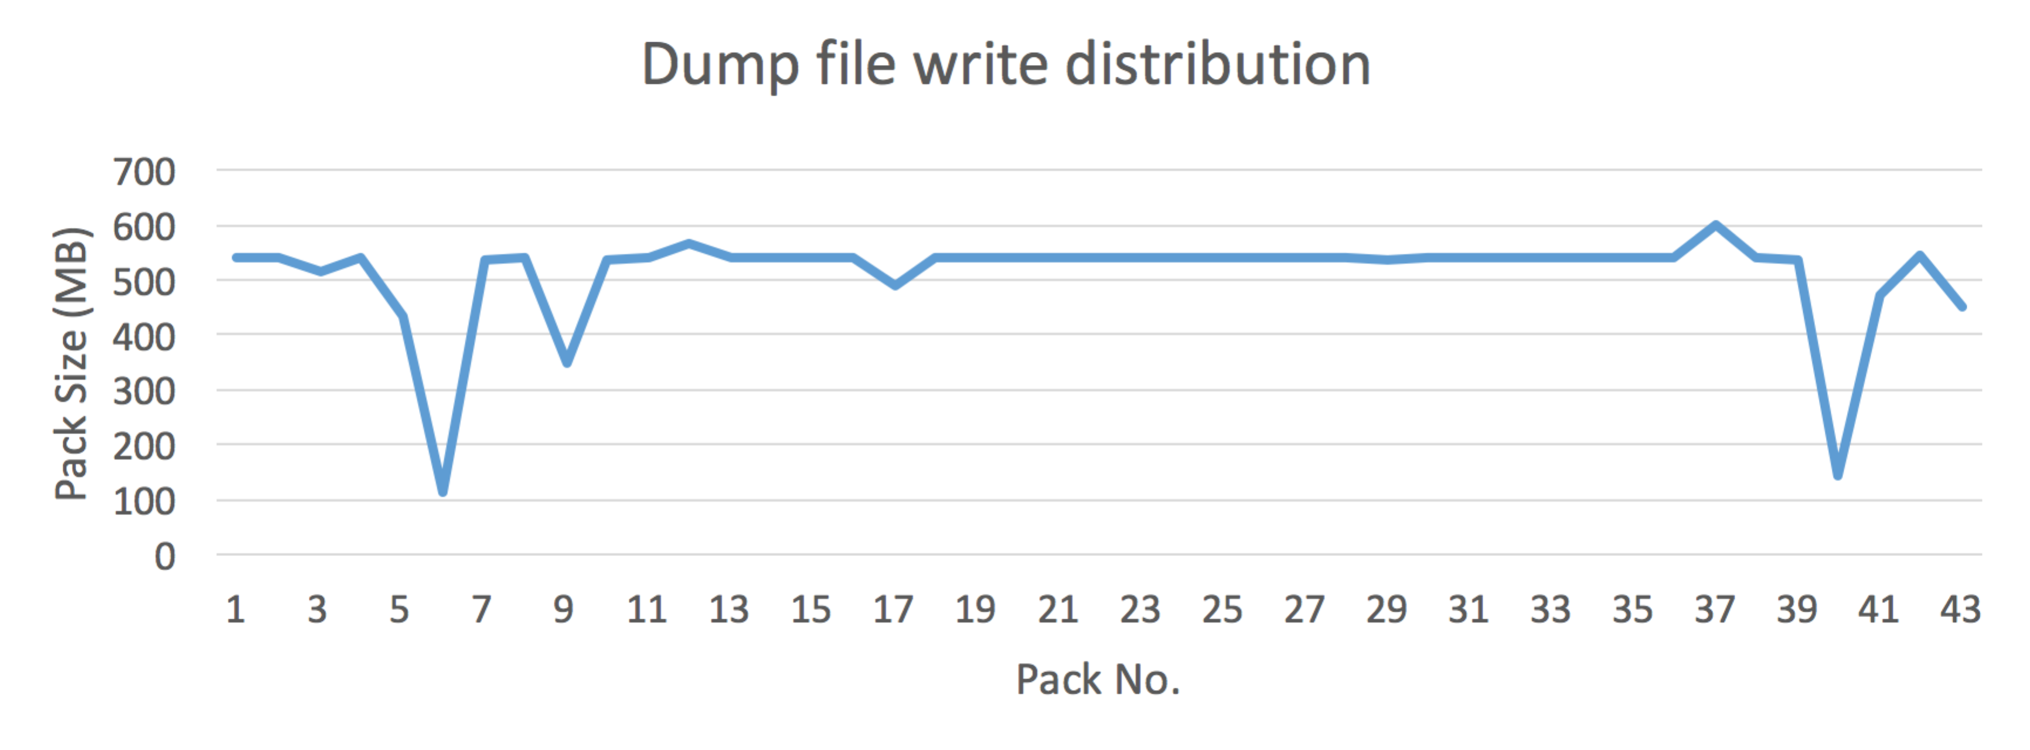Figure 1. Size of each pack in a UM dump file write.
The results of the tests are depicted in Figure 2, where the write bandwidth for each pack for both dump files produced by the mode run, with and without the use of MPI-IO. Note that the significantly slower pack in one of the MPI-IO files was due to the fact that serialised threading was used for these runs, and an MPI call in one of the packs was stalled to allow communication on the listener thread to take place. The average write speeds of the dump files was 847.36 MB/s and 892.51 MB/s respectively with MPI-IO enabled, compared to 283.37 MB/s and 283.03 MB/s respectively without MPI-IO.
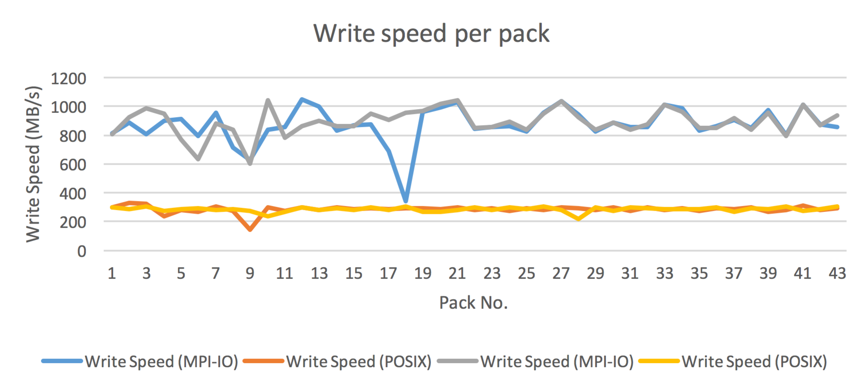
Figure 2. Write speeds per pack for UM dump files with and without MPI-IO.
There is also a significant increase in the IO overhead for compressed STASH files, which contains the diagnostic data, due to the need to exchange more data between MPI ranks before the write operations. As before, we compare two identical files with and without MPI-IO. In this case the files are around 2,565 MB composed of 1826 fields in 23 packs. The write times are shown in Figure 3.
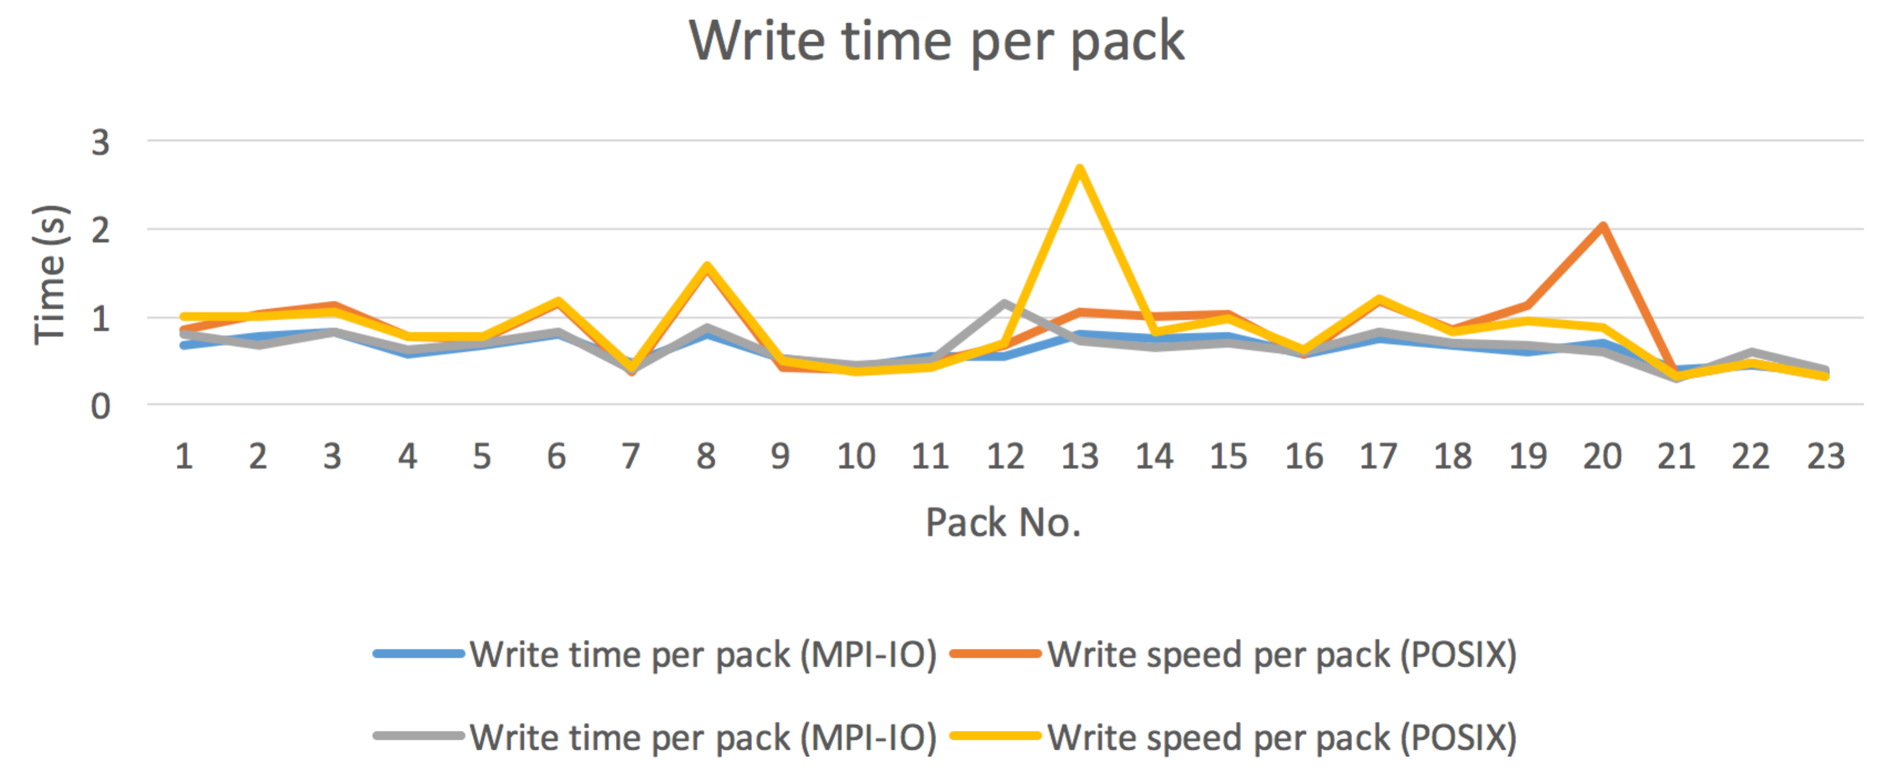
Figure 3. Write speeds for compressed STASH files.
Some additional modifications were considered for the new server implementation, but we decided not to progress for the UM 10.4 release. For example, a ‘split collectives’ capability was tested to allow all disk access to be performed whilst preparing the next record for writing. When tested, using double-buffering for each STASH record, the write performance improved by approximately 5%. This relatively small improvement can be explained by the different overheads of the compressed versus uncompressed records. Given the considerable complexity of the code for this implementation for only 5% performance improvement, it was decided not to continue with this line of optimisation.
Following the acceptance of our MPI-IO based server for UM10.4, the UK Met Office have identified two additional elements of functionality that should be scheduled for the next release of UM (UM10.5). First, in 10.4, the ‘sync’ action performs no special action, whereas in UM10.5 an improvement will be for it to perform the collective ‘MPI_File_sync’ operation. Secondly, filesystem MPI-IO properties should be better integrated with the UM. These filesystems controls are controlled through the model’s namelist feature. However this does not extend to MPI-IO files, which instead can only be controlled independently through a ROMIO_HINTS file provided by the user. The intention is to ensure that the namelist control all properties, which can be transparent to the user.

UM Performance study with OpenMP
Following from the last status report, there has been some additional improvements in using OpenMP in the UM. This work was undertaken in the UM 10.3 release using a global UM model configuration, which was based on a well-used forecast job whose configuration is recorded in NCI cylc suite u-aa501. Table 3 describes the UK Met Office’s UM trac tickets that were created to record the code changes related to this work.

Table 3. List of tickets and related modified sources
Ticket # | Sources | Status
1230 | imp_solver.F90, ni_imp_ctl.F90 | committed to the trunk
1291 | eg_SISL_Init_uvw.F90 | committed to the trunk
1303 | eg_interpolation_eta.F90 | committed to the trunk
1306 | bdy_expl2.F90 | committed to the trunk
1338 | eg_helm_var_rhs.F90 | committed to the trunk
1345 | microphys_ctl.F90 | at the code review stage, to be included in the 10.4 release
1438 | eg_correct_tracers.F90 | committed to the trunk
1441 | scatter_field_mpl.F90, scatter_field_mpl32.F90 | at the sci/tech review stage, requires access to a Cray system
1463 | eg_interpolation_eta.F90 | waiting
1464 | scatter_field_mpl32.F90 | depends on ticket #1441 outcome
1475 | halo_exchange.F90 (swap_bounds_ns_dp, swap_bounds_ew_h1_dp, swap_bounds_cornerless_sp) | waiting
1482 | eg_adjust_vert_bound2.F90 | waiting
1492 | rad_ctl.F90 | waiting
1512 | ni_conv_ctl.F90 | waiting
1557 | lsp_taper_ndrop.F90 | started to work

In the table, “waiting” means that the required changes have already been implemented and tested using the above mentioned forecast job. The UK Met Office then require these changes to be merged into the latest release of the UM (now 10.4) to be suitable to be taken through their acceptance process, which as the same as undertaken for the MPI-IO server changes. This includes a UM 10.4 conformant rose-stem suite being created, and then passed to the Met Office for their detailed review procedure. The Met Office then take the code through several review processes at the scientific and technical level before it would be acceptable for the trunk of the next release (UM 10.5). The code must also be sufficiently mature to ensure it meets the timeline for that release, or the process starts again based on the next release. Two main conditions for accepting the changes are:
- model performance should be better with multithreading
- results are reproducible on all UK Met Office platforms and software stacks based on their software stacks which include Intel and Cray compilers
In the testing on Raijin, the Intel compiler 15.0.1.133 and Intel MPI 5.0.3.048 library were used. Table 4 below records the comparison of the elapsed times between two source versions: the official release was 10.3 and “modified” which includes our changes in the sources made under the first eight tickets from Table 3.

Table 4. Elapsed times for the UM10.3 original and modified sources
N | Run Configuration  (Nt x N x M) | Source version | Number  of cores | Elapsed time
1 | 1x16x30 | 10.3 | 480 | 2069
2 | 1x16x30 | modified | 480 | 2088
3 | 1x24x40 | 10.3 | 960 | 1090
4 | 2x16x30 | 10.3 | 960 | 1106
5 | 2x16x30 | modified | 960 | 1094
6 | 1x30x64 | 10.3 | 1920 | 611
7 | 4x16x30 | 10.3 | 1920 | 619
8 | 4x16x30 | modified | 1920 | 599
9 | 1x48x80 | 10.3 | 3840 | 367
10 | 8x16x30 | 10.3 | 3840 | 410
11 | 8x16x30 | modified | 3840 | 387

The following notations are used in the table:
Nt – number of OpenMP threads;
NxM – horizontal decomposition size.

Additional model performance runs were also made to find decomposition sizes that provide the shortest elapsed times using a single thread on (2^{n} x 480) cores for n=1,2,3.
The efficiency in the OpenMP implementation and other optimisation related changes were checked using system functions omp_get_wtime and mpi_wtime for time measurements of the corresponding code regions modified under the above mentioned tickets.
Analysing results of Table 4 we can make the following conclusions:
- using 4 threads performs ~2% shorter elapsed times in comparison if multithreading is not used
- using 8 threads performs ~6% faster on the same number of threads
We note that, in some cases, multithreading of four level nested loops using the Intel compiler causes a significant performance degradation (up to 3 times) on a single thread. The nature of the problem has not been resolved at this time. As a result, the corresponding elapsed times for the “modified” sources may yet improve over the values included in the table.

Performance of PS36 UM10.1 N768L70 job on partial nodes with hyper-threading
The improvement in throughput performance we discovered by using both partially nodes and Intel hardware hyper-threading has been conveyed to the UK Met Office, who have investigated this further in a short collaborative evaluation.
PS36 UM10.1 sources were compiled with Intel 15.0.1.133 compiler and Intel MPI 5.0.3.048 library. A 3-day forecast model configuration was used to evaluate, using a resolution N768L70 and a decomposition of 2x(24x54+4x12). The results of different system settings are recorded in Table 5. Care was taken to pin MPI tasks to appropriate processors and the results are the best from at least 2 job runs for each run configuration where each job included 3 repeated runs in a loop.

Table 5. Elapsed times comparison using hyper-threading
N | Used cores | Cores per node | KMP_AFFINITY | Hyper threading | Elapsed time
1 | 2688 | 16 | Compact | NO | 1367
2 | 2688 | 16 | Compact | YES | 1627
3 | 2688 | 16 | Scatter | NO | 1369
4 | 2688 | 16 | Scatter | YES | 1266
5 | 3584 | 12 | Scatter | NO | 1128
6 | 3584 | 12 | Scatter | YES | 1231
7 | 3584 | 12 | Compact | NO | 1138
8 | 3584 | 12 | Compact | YES | 1602
9 | 3584 | 12 | compact,1,0 | YES | 1246

When using fully committed nodes, hyper-threading improved performance by ~100sec (rows 3 & 4). Comparing results on rows 1&3, 5&7 and 6&9, the usage of scatter or compact affinity types did not make an appreciable difference in the performance. Using partially committed nodes without hyper-threading improved the run times by 230-240 sec (up to 17.6%). With hyper-threading enabled and KMP_AFFINITY=compact additional permute and offset “1,0” parameters were specified to avoid over-committed cores.
There was also an unresolved issue where hyper-threading on partial nodes has been shown to slow down performance by ~9%.

Part (2): Data Assimilation
4DVAR
A full profile of the global configuration N216L70 of 4DVAR, Figure 4, has been generated with multiple grid decompositions such as 8×48 and 16×48. The executing time of 4DVAR is split between computation (~67%) and MPI communication (~33%).

Figure 4. Time distribution over user and MPI functions of 4DVAR.

The top 5 most time consuming routines contain 2 MPI operations (MPI_Waitall and MPI_Allreduce) and 3 user routines (mpp_tri_solve_exec, gcr_elliptic-operator_adj and gcr_elliptic_operator). A clear pattern emerges in the distribution of the execution times of these functions across MPI ranks, which was determined to be as a result of the spatial decomposition of the model. For example, the MPI peak width or the corresponding computing valley width is 8 and 16 ranks for the 8×48 (Figure 5a) and 16×48 (Figure 5b) decomposition respectively. This profiling work was used in the last status report to investigate the performance dependence on the grid decomposition.

Figure 5a. Time variations over MPI ranks with grid decomposition 8×48.

Figure 5b. Time variations over MPI ranks with grid decomposition 16×48.
The computation imbalance analysis clearly indicates the strong dependence on MPI ranks as shown in Figure 6, which again relies on the decomposition used.

Figure 6. Time dependence on MPI ranks of the top 10 computation imbalanced routines of 4DVAR.
All these routines can be easily located in the call path plot of Figure 7 and they are mainly invoked by two subroutines, i.e. gcr_k_adj and gck_k.
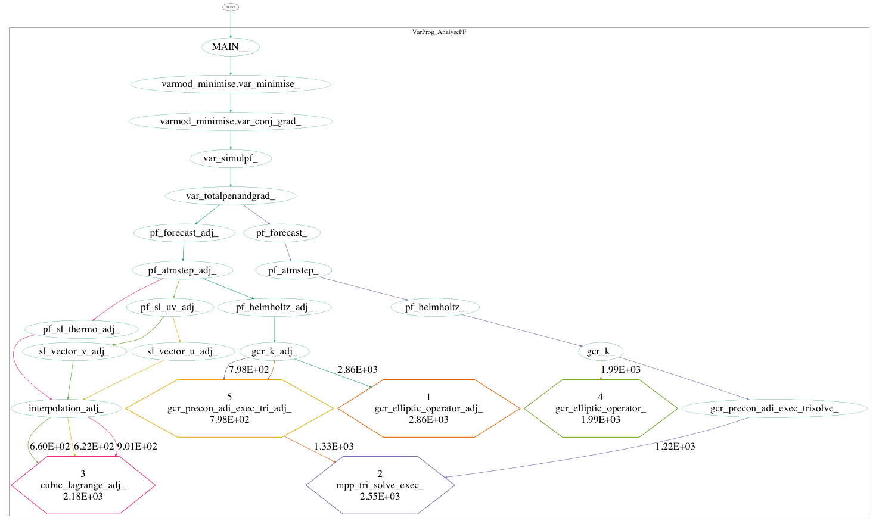
Figure 7. Call paths of top 10 imbalanced routines of 4DVAR.
Specific profiling by using OpenSpeedShop could expose the source line-level hotspots within these routines. For example, the loop (Table 6) takes the most elapsed time within routine GCR_Elliptic_Operator_Adj.

Table 6. The most time-consuming loop in subroutine GCR_Elliptic_Operator_Adj
Exclusive  CPU Time | Line | Source
31.90  426.65  543.02  2747.59  714.08  288.71  1862.94 | 659  660  661  662  663  664  665  666  667 | DO j=j_end_no_halo,j_start_all_rows,-1  DO i=i_end_no_halo-1,i_start_no_halo,-1  first_deriv_y(i,j) = first_deriv_y(i,j) + y_term(i,j,k) * HM_Cyy2(i,j,k)  tt = -(y_term(i+1,j,k) * HM_Cyx1(i+1,j,k) + &  y_term(i,j,k) * HM_Cyx1(i,j,k) ) * 0.25  first_deriv_x(i,j) = first_deriv_x(i,j) + tt * HM_Cyx2(i,j,k)  first_deriv_x(i,j+1) = first_deriv_x(i,j+1) + tt * HM_Cyx2(i,j+1,k)  END DO  END DO

BODAS
The BLUElink Ocean Data Assimilation System (BODAS) is an ensemble optimal interpolation data assimilation (DA) system that calculates background error covariances by using an ensemble of intra-seasonal anomalies derived from a multiyear free running ocean model. BODAS is currently used operationally by the Bureau of Meteorology within the OceanMAPS analysis and forecasting suite.
The current operational version of BODAS now employs parallel preconditioned linear systems solvers through the PETSc library. This upgrade replaces the original serial SVD solver and provides a significant performance improvement in the operational environment.
The parallel solver was benchmarked using a 72-member ensemble of anomalies with the analysis performed over 48 subdomains. Figure 8 and Table 7, below, show the benchmark results for all 48 domains running over 1 to 8 cores.
Table 7. shows the benchmark results for all 48 domains running over 1 to 8 cores.
nproc | Solver | Walltime
8 | petsc -pc_type=jacobi | 13 min 22 sec
4 | petsc -pc_type=jacobi | 14 min 05 sec
1 | petsc -pc_type=jacobi | 15 min 23 sec
1 | svd_robust | 19 min 33 sec

The Krylov subspace solver (KSP) chosen for this example was the unmodified Gram-Schmidt Orthogonalisation method with no iterative refinement (GMRES). We applied a Jacobi preconditioner to the matrix problem. The solve times for each of the 48 domains is shown. The PETSc library exhibited better performance than the serial SVD solve in all cases. The variations in runtimes for each subdomain is due to each domain having a different observation density which results in a variation in matrix size.

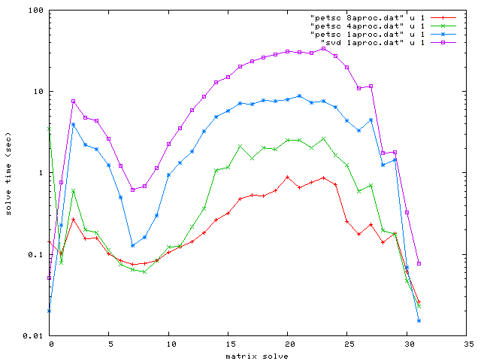
Figure 8. PETSc solve times over varying core counts compared with the original serial SVD solver method
Profiling of the BODAS code indicated that the function called calc_inc(), which calculates the increment field for the analysis, was expensive. Parallelising this function provided an approximate 3x speedup over the serial version:
nproc | Solver | Walltime
1 | petsc pc_type=jacobi serial | 13 min 22 sec
8 | petsc pc_type=jacobi parallel | 5 min 19 sec

Part (3): Ocean Models
MOM5 concurrency
We have extended the concurrent ocean-sea ice simulations previously reported to include a configuration using 7680 ocean CPUs and 1280 sea ice CPUs. The values are shown below:
CPUs | Runtime (s) | CPU Hours | Years / day
960 (s) | 7364.9 | 1966.1 | 11.7
1920 (s) | 3986.8 | 2126.3 | 21.7
2240 (c) | 3347.5 | 2112.4 | 25.8
3840 (s) | 2504.3 | 2776.5 | 34.5
4480 (c) | 1919.6 | 2510.0 | 45.0
8960 (c) | 1500.9 | 3964.8 | 57.6
As a result of this work, the global 0.25° MOM simulations can now output results at nearly 58 model years per day.

MOM5
Global profiling and tracing have been applied to MOM5 over different simulation periods, from 2 days to 3 months, running on 960 ranks. A 2-day analysis result (Figure 9) shows that the computation and MPI communication account for 60% and 40% of execution time, respectively. Within MPI time, the init_exit function takes a large portion due to the short simulation period of 2 days.

Figure 9. The execute time distributions over user-space and MPI functions.
Using both global profiling to investigate the static imbalance statistics, and specific tracing of the dynamic critical path imbalance, indicate that the I/O routines in mpp_io module contribute to large imbalance issues, as shown in Figure 10.

Figure 10. Top 5 imbalanced routines over MPI ranks.
The further I/O profiling analysis from Darshan indicates that the ‘shared reads’ and ‘shared metadata’ are two major I/O operations at the initialization stage, as shown in Figure 11.
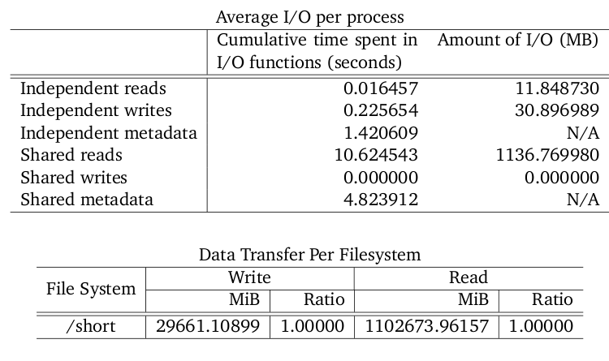
Figure 11. I/O profiling results of MOM5 by using Darshan.
With the contention and imbalance of all MPI ranks sharing the same input files, we resolved that the execution could be better distributed. To address this issue, a combination of netCDF buffer size and the Lustre parameters such as stripe size and stripe number were tested when reading large input files (~1.5GB). The experiments verified that the parallel I/O performance of MOM5 is strongly influenced by these I/O configurations. For example, the I/O time varies between 50 and 200 seconds when using the different configurations shown in Figure 12. The measurement also indicates that the executing time variation mainly arise from the variation in the I/O time. The optimized Lustre and netCDF configurations have now been recommended for running MOM5 on Raijin.
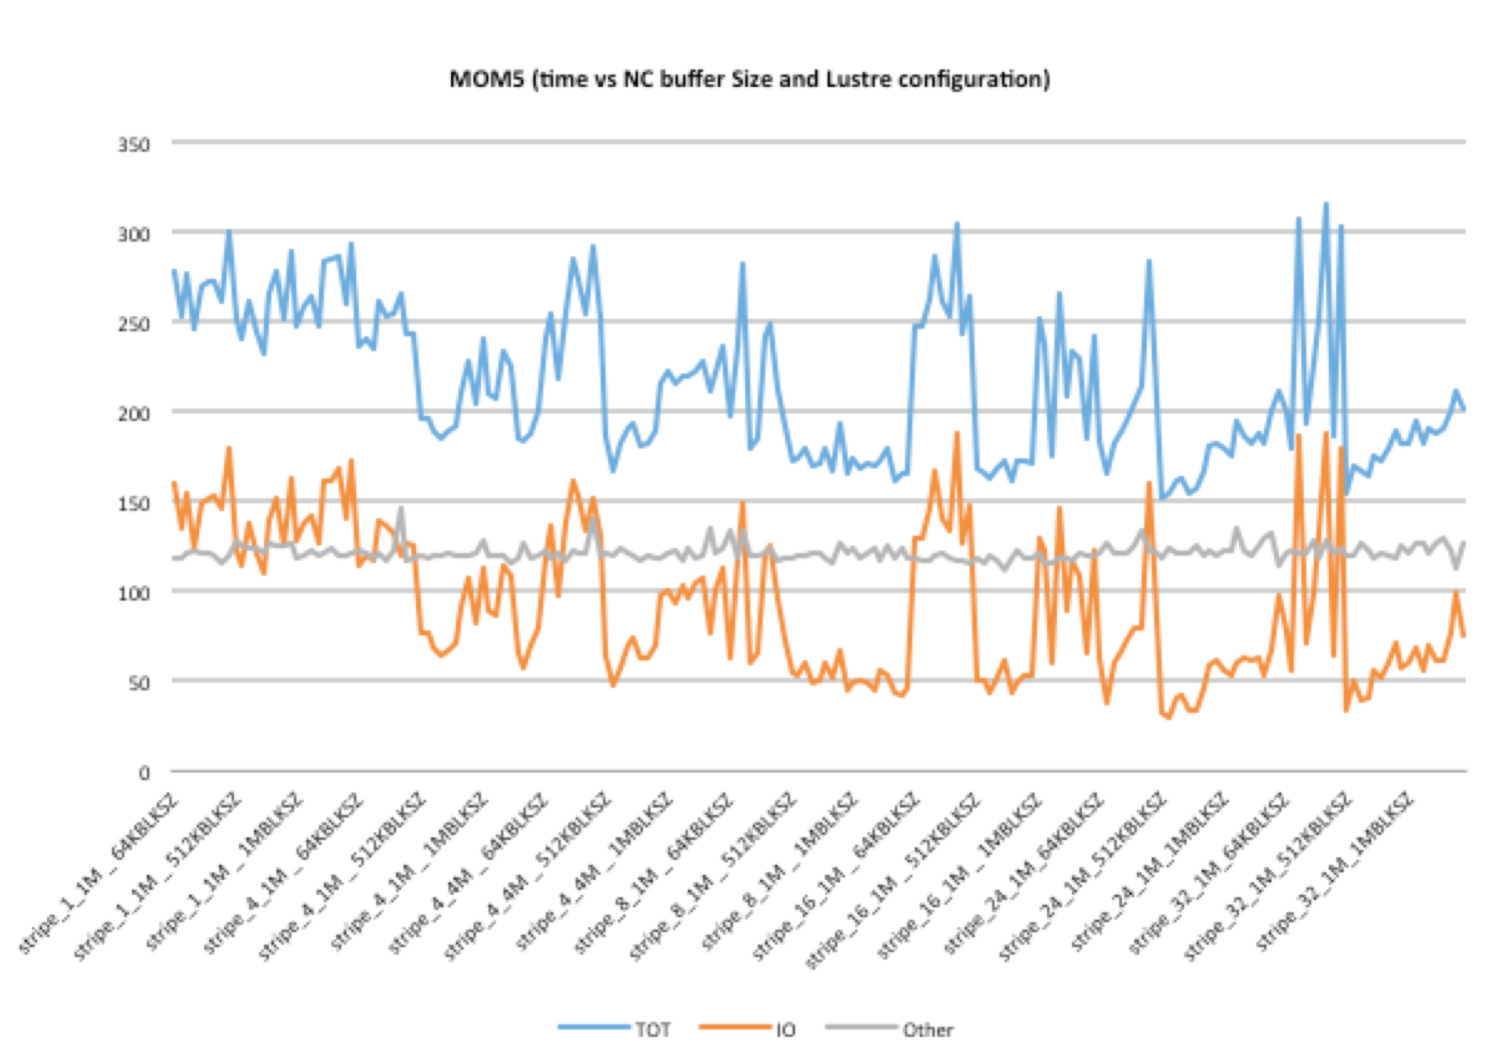
Figure 12. Variations of total executing time (TOT) and I/O time (IO) on a combination of settings with Lustre parameters and netCDF buffer sizes.
The most time consuming routines were also identified and further analysed by applying ‘specific profiling’. For example, two branch structures were identified as the performance bottleneck in the most time consuming user subroutine ‘ppm_limit_sh’ as listed in Table 8.
Table 8. Exclusive CPU time mapping to the source line of routine ‘ppm_limit_sh’ by using the OpenSpeedShop profiler.
Exclusive  CPU Time | Line Source
>>  2.650000  2.420000  74.730000  8.880000  60.230000  18.040000  98.490000  2.830000  95.790000  19.010000  126.580000  25.940000  193.690000  99.940000  1456.360000  43.290000  48.220000  25.910000  71.310000  93.540000  29.730000  19.960000  39.880000  94.600000  247.370000  1742.250000  26.030000  0.620000 | 6582 subroutine ppm_limit_sh(isc,iec,jsc,jec, tracer, d1m, d1p, d1mm, d1pp, aL, aR)  …  6594 do j=jsc-1,jec+1  6595 do i=isc-1,iec+1  6596 ! This block monotonizes the parabola by adjusting the left and right values  6597 ! Limiter from Suresh and Huynh, 1997  6598 Si = tracer(i,j)  6599 Sim1 = Si - d1m(i,j) ! Sim1 = tracer(i-1,j)  6600 Sip1 = Si + d1p(i,j) ! Sip1 = tracer(i+1,j)  …  6612 qAV = 0.5 * ( Si + Sip1 )  6613 x = d1p(i,j) ! = Sip1 - Si  6614 y = 3. * d1m(i,j) ! = 3. * ( Si - Sim1 )  6615 qMP = Si + max(0., min(x, y)) + min(0., max(x,y))  6616 qUL = Si + y  6617 qLC = ( Si + 0.5 * d1m(i,j) ) + fourThirds * dM4m  6618 qMD = qAV - 0.5 * dM4p  6619 qMin = max( min(qMD,Si,Sip1), min(Si,qUL,qLC) )  6620 qMax = min( max(qMD,Si,Sip1), max(Si,qUL,qLC) )  6621 if ( (aR(i,j)-Si)*(aR(i,j)-qMP).gt.1.e-10 ) &  6622 aR(i,j) = min( max( aR(i,j), qMin ), qMax )  6623  6624 qAV = 0.5 * ( Si + Sim1 )  6625 x = -d1m(i,j) ! = Sim1 - Si  6626 y = -3. * d1p(i,j) ! = 3. * ( Si - Sip1 )  6627 qMP = Si + max(0., min(x, y)) + min(0., max(x,y))  6628 qUL = Si + y  6629 qLC = ( Si - 0.5 * d1p(i,j) ) + fourThirds * dM4p  6630 qMD = qAV - 0.5 * dM4m  6631 qMin = max( min(qMD,Si,Sim1), min(Si,qUL,qLC) )  6632 qMax = min( max(qMD,Si,Sim1), max(Si,qUL,qLC) )  6633 if ( (aL(i,j)-Si)*(aL(i,j)-qMP).gt.1.e-10 ) &  6634 aL(i,j) = min( max( aL(i,j), qMin ), qMax )  6635 enddo !i  6636 enddo !j  6637  6638 end subroutine ppm_limit_sh

MOM5 detailed analysis of 0.25-degree global model
This section contains scaling results for the major subcomponents of the MOM5 ocean model based on a 0.25-degree global model configuration.
Main loop overview
The breakdown of runtime for the main loop of the 0.25-degree global model configuration for 960 CPUs is shown in Figure 13.
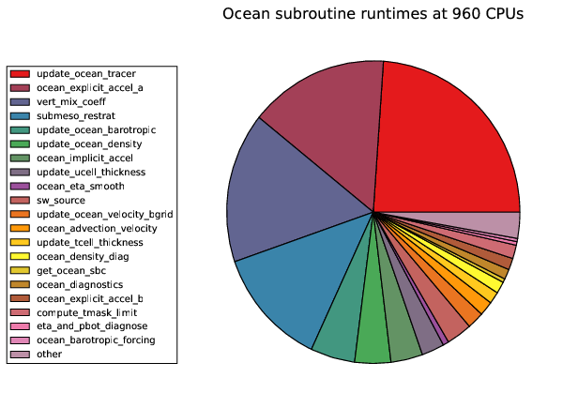
Figure 13. Relative runtimes of the major model subroutines for the ocean time-steps for the global 0.25° model at 960 CPUs.

The model runtime was shown to be dominated by four major subroutines:
- update_ocean_tracer: Finite volume tracer advection
- ocean_explicit_accel_a: Velocity acceleration terms (non-Coriolis)
- vert_mix_coeff: Calculation of KPP and tidal mixing coefficients
- submeso_restrat: Submesoscale parameterisations
The runtimes of these four subroutines are substantially larger than any other parts of the model, and comprise approximately two thirds of the total runtime.
In order to get an accurate timing for each subroutine, MPI_Barrier() calls were inserted between the functions. This results in a slightly greater total runtime, due to the syncing required between runs, but it eliminates any false scaling effects due to internal load imbalances and inconsistent start times. We also note that we used the mean value over all ranks analyse the model, and to construct the figures below. We did not attempt to characterise the internal load imbalances within each subroutine.
Figure 14 shows our investigation of the relative scalability of the major model subroutines, from 120 to 15360 CPUs. We can see that subroutines which were dominant at 960 cores comprise a much smaller share of the total runtime, and that previously negligible functions begin to dominate the total runtime, in particular the following:
- update_ocean_barotropic: Ocean free surface and barotropic velocity solver
- ocean_eta_smooth: Free surface smoothing, required for B-grids
- get_ocean_sbc: Surface boundary condition conversions
- ocean_diagnostics: Periodic global diagnostic updates during model runs
- eta_and_pbot_diagnose: Barotropic diagnostics
- flux_adjust: Surface salinity relaxation
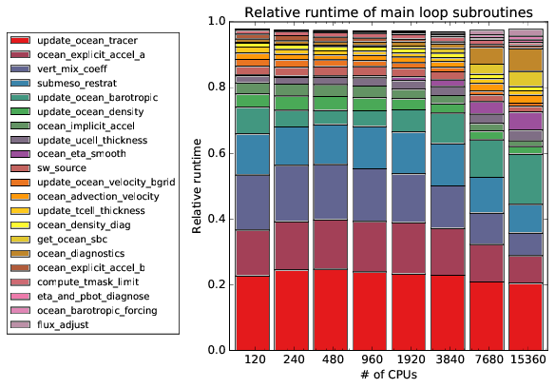
Figure 14. Relative runtime performance for the global 0.25° model from 120 to 15360 CPUs.

We also see that model updates are initially dominated by the computationally expensive three-dimensional calculations, but this dominance shifts from three-dimensional subroutines to the less computational and more communication-dependent two-dimensional subroutines as the CPU count is increased.
Another notable observation is the consistent relative runtime of the tracer advection, despite the smaller proportional runtimes by the other three major subroutines.
From these observations, we can conclude that, despite their dominance in the efficient CPU regime, these three-dimensional functions scale well, with the possible exception of the tracer advection. The two-dimensional functions, on the other hand, show poor scaling and, despite their low computational cost, may be preventing scalability beyond approximately 2000 CPUs.
Subroutine overview
In the section we provide detailed analysis of the major subroutines. Each figure includes a runtime versus CPU count on the left, on logarithmic scales, relative to an optimal scaling curve for 240 CPUs, indicated by a dashed line. The right hand side shows the equivalent efficiency curve, or CPU hour usage relative to the optimal scaling.
120 CPUs was not used as the reference since it required use of the higher memory (64 GByte) nodes, and could have slightly different caching properties. There is some indication of this in the figures below, since the general scaling trends do not begin until 240 CPUs.
Tracer advection
Scalability of the tracer advection subroutine is shown in Figure 15.

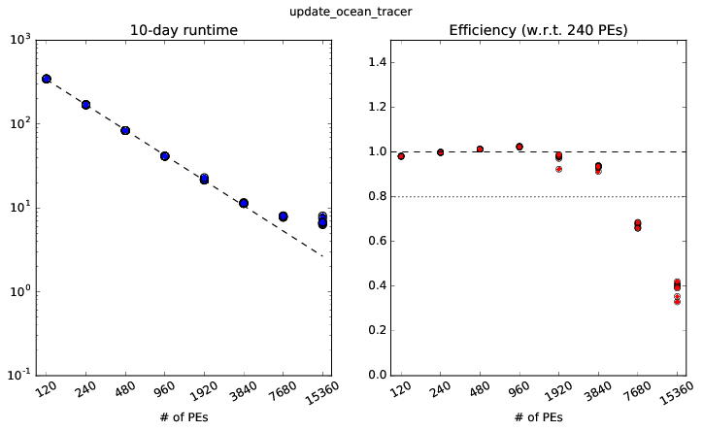
Figure 15. Scalability of the tracer advection
The tracer advection subroutine is consistently the most expensive subroutine in the model, and demonstrates strong scalability up to 3840 CPUs. It uses MDPPM (multidimensional piecewise parabolic method) with flux limiters, and contains both significant calculation and communication work.
The call tree including the major functions is as follows:
- update_ocean_tracer
  - horz_advect_tracer
    - advect_tracer_mdppm
      - ppm_limit_sh
    - vert_diffuse_implicit
    - send_tracer_diagnostics

Because tracer advection occurs over the entire vertical column, it requires significantly more computation per halo update, and we can attribute this to its strong scalability.
As shown in the previous section, a notable performance bottleneck seems to be due to the flux limiter criteria, which requires conditional if-statements within the calculation loops. Scaling problems first appear at 1920 CPUs, and get progressively worse as the number of CPUs is increased. This issue may be solvable by improving the loop structure, which we will investigate more thoroughly in the future.
Non-Coriolis acceleration
Scalability of calculation of non-Coriolis acceleration terms and velocity update is shown in Figure 16.
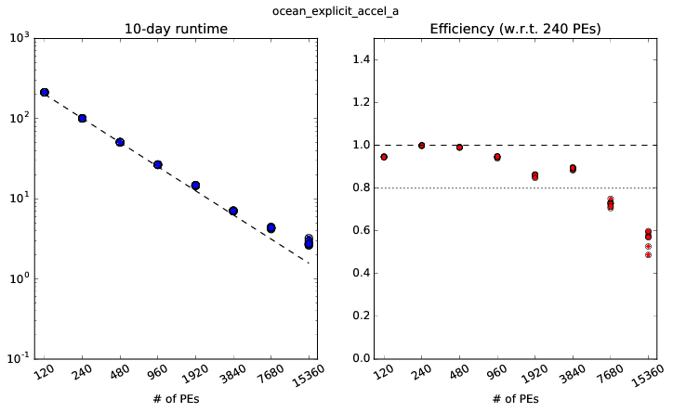
Figure 16. Scalability of the non-Coriolis acceleration terms

This term includes the following accelerations and viscosities:
- ocean_explicit_accel_a
  - bih_friction
  - pressure_force
  - horz_advection_of_velocity
  - vert_advection_of_velocity
  - momentum_source

The Coriolis force is notably absent, and is handled separately for numerical reasons.
As with the tracer advection, this calculation is applied across the vertical column, and shows good scalability up to 3840 CPUs, with acceptance performance to 7680 CPUs.
The runtime for this function is dominated by the biharmonic viscosity calculation, primarily due to the various rate-of-strain calculations required for the Smagorinsky viscosity. The other subroutines show good scalability.
Vertical mixing coefficients
Scalability of vertical diffusion and viscosity coefficients are shown in Figure 17.
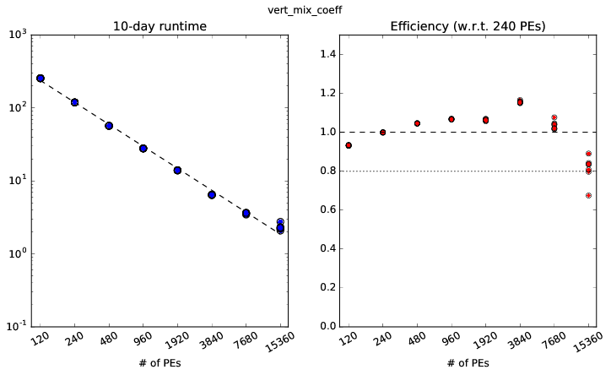
Figure 17. Scalability of vertical mixing coefficient calculations

The call tree is as follows:
- vert_mix_coeff
  - vert_mix_kpp_mom4p1
  - vert_mix_tidal

This subroutine calculates the vertical mixing coefficients used in the KPP and tidal mixing schemes. The KPP calculations are more expensive, with Richardson number calculations comprising the largest share, but both mixing subroutines are substantial.
Given that vertical mixing calculations are primarily based on the state of the water column, with only minor dependencies in the horizontal, there is very strong scalability in these subroutines, arguably up to 15360 CPUs.
The strong scalability of these subroutines mean that they are unlikely to pose a problem in the future, and should be a lower priority in any performance analysis.

Submesoscale restratification
Scalability of the submesoscale parameterisations are shown in Figure 18.
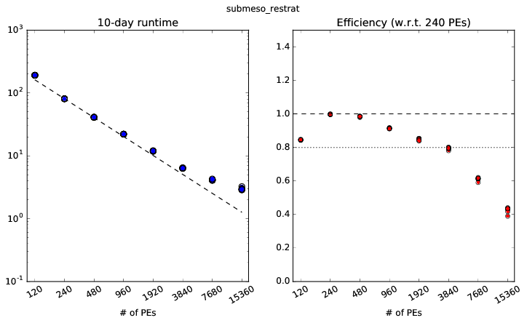
Figure 18. Scalability of the submesoscale parameterisation

The call tree of the major components is as follows:
- submeso_restrat
  - compute_submeso_skewsion
  - compute_psi
  - compute_bldepth

All three subroutines are a significant part of the total runtime.
These subroutines show reasonably efficient scaling up to 3840 CPUs, with significant drop-off at higher CPUs. We cannot comment on the nature of this calculation, but it could represent a scaling bottleneck in the future as we attempt to scale beyond 4000 CPUs, and may need to be investigated in the future.

Barotropic solver
The barotropic solver scalability is shown in Figure 19.

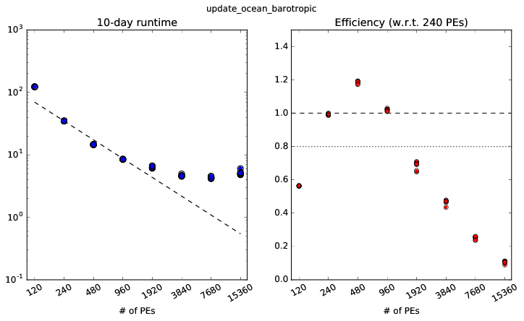
Figure 19. Scalability of the barotropic free surface solver

This subroutine updates the ocean free surface and barotropic velocities. Communication costs are reduced through use of an extended halo, which is 10 grid points wide rather than a single grid point.
Scaling is notably worse in comparison to the earlier subroutines, with poor scalability beyond 960 CPUs and becoming progressively worse as CPUs are increased. By 3840 CPUs, there is no longer any noticeable improvement in runtime, and becomes longer beyond 7680 CPUs.

Free surface smoothing
The scaling of the free surface smoothing calculation is shown in Figure 20.
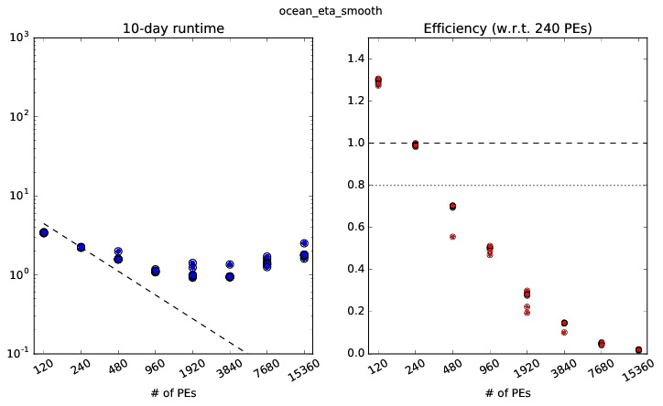
Figure 20. Scalability of the free surface smoother

This function applies a biharmonic smoothing to the barotropic free surface, which is required in all B-grid ocean models. This is required to provide a numerical damping to an undamped nonphysical (zero-eigenvalue) numerical mode created by the B-grid stencil.
Performance of the smoother is even worse than the barotropic timestep solver, with efficiency dropping after 240 CPUs, and with runtimes becoming longer after 1920 CPUs. At higher CPU counts, the free surface smoothing becomes a clear impediment to scalability.
We note that (second order) Laplacian smoothers are preferred to (fourth order) biharmonic solvers for numerical stability reasons, and could be performed at a lower computational cost. Additionally, usage of the C-grid would eliminate the need for a smoothing function. MOM can support models on a C-grid, but it has not been extensively tested.

Surface boundary condition
Scalability of the surface boundary condition calculations are shown in Figure 21.
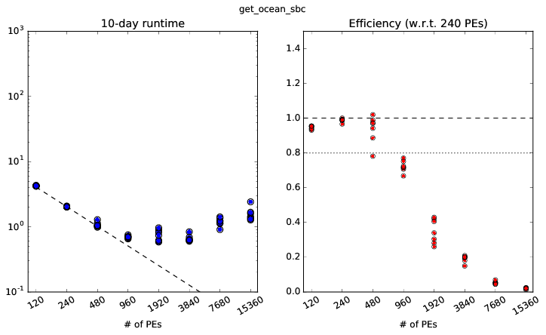
Figure 21. Scalability of the surface boundary condition calculations

This subroutine includes calculations of the various surface boundary flux parameters, such as the conversion of wind, radiation, and freshwater fluxes from the ice-ocean boundary layer into equivalent ocean quantities.
Scalability of this subroutine is similarly poor, with efficiency dropping after 480 CPUs, and slowdown after 1920 CPUs.
As with the free surface solver and smoothing function, the model consists of a large number of two-dimensional loop operations, and becomes communication bound as the CPUs become larger. At very high CPU counts, runtimes become longer and it becomes an explicit impediment to scalability.

Runtime diagnostics
Runtime diagnostic scalability is shown in Figure 22.

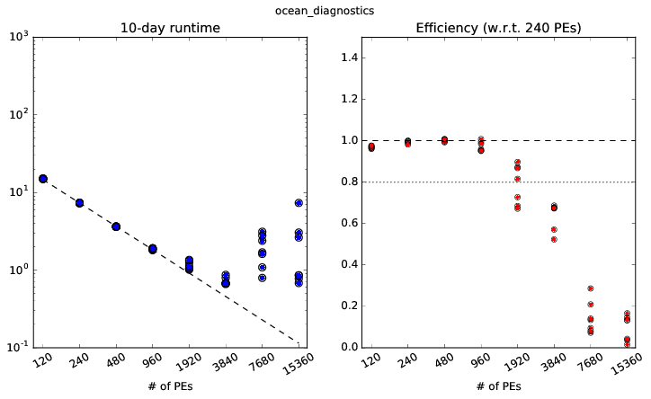
Figure 22. Scalability of runtime diagnostic calculations

This function is used to calculate various global diagnostics used to assess the state of the model during runtime. The output rate is set by the user (once per model day, in this case) and is unrelated to model timestep or any other operational parameters.
Scalability becomes poor after 960 CPUs, and the actual runtime becomes very erratic, varying by many orders of magnitude over different runs.
The function itself consists of a very large number of two-dimensional collectives, approximately 45 per call. We may be seeing a performance bottleneck of our collective operations as the tile size shrinks and CPU count increases.
This function represents a significant bottleneck in future scalability of the code.

Barotropic diagnostics
Barotropic diagnostic scalability is shown in the Figure 23.

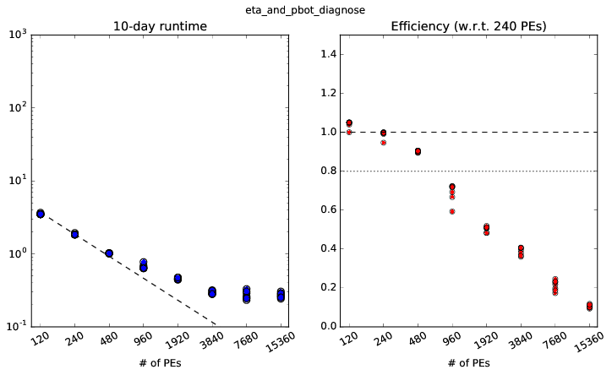
Figure 23. Scalability of the barotropic diagnostic calculations

The subroutine calculates the total sea surface height and associated diagnostics. We note that most of the three-dimensional integration is handled in separate functions (update_ucell_thickness, update_tcell_thickness) and this function is dominated by loops over two-dimensional arrays.
As with many other two-dimensional operations, we see poor scaling beyond 480 CPUs, with no improvement to runtime after 7680 CPUs.

Flux adjustment
Flux adjustment scalability is shown in Figure 24.

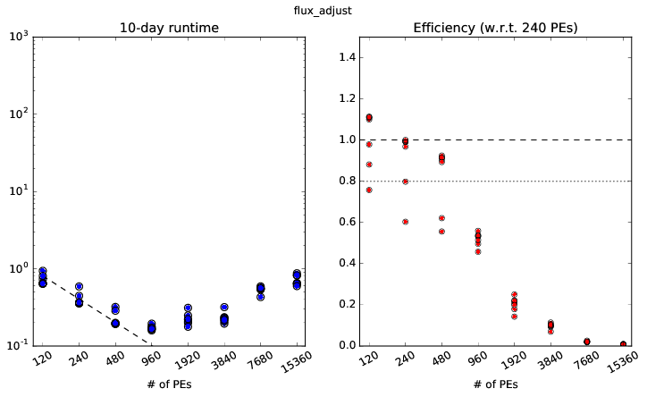
Figure 24. Scalability of the salinity relaxation, and other flux adjustments
The predominant operation in the subroutine is the relaxation of surface salinity, a common adjustment applied to compensate for the inability to accurately model the salinity balance of the ocean.
As another two-dimensional operation, it similarly shows poor scalability. Efficiency drops after 480 CPUs, and runtime abruptly increases after 960 CPUs.

Summary
These scaling results show that the most computationally expensive components of the 0.25° configuration scale up to the thousands of CPUs, but further scalability is impeded by the various two-dimensional calculations required at each timestep.
Improvements in scalability will require a more detailed analysis of these two-dimensional components. We hope to characterise the dependence of the two-and three-dimensional components of the model, and explore the possibility of applying separate parallelisation rules for each class of subroutine.

ACCESS-Opt Storm Surge Hydrodynamic Model (ROMS)
Storm Surge is a Bureau of Meteorology project that will deliver a storm surge warning system for Australia. The service model consists of three development stages, with each phase targeting a specific national region. These stages are 1) the ensemble Queensland system, 2) the ensemble Tropical system and 3) the National system. The Queensland and Tropical components are event driven storm surge forecasting systems whilst the National system will produce daily forecasts of sea level height for the Australian region. The Queensland system comprises a 2 km resolution Regional Ocean Modelling System (ROMS) hydrodynamic model.
The Queensland and Tropical systems are an operational ensemble prediction system. We used the profiling package Tau to identify code hotspots and to measure the cost of operations such as model start up times, file write times and computational loop efficiency. We also conducted scaling tests of the Queensland storm surge model configuration to provide resource usage guidance for the operational centre at the Bureau of Meteorology.
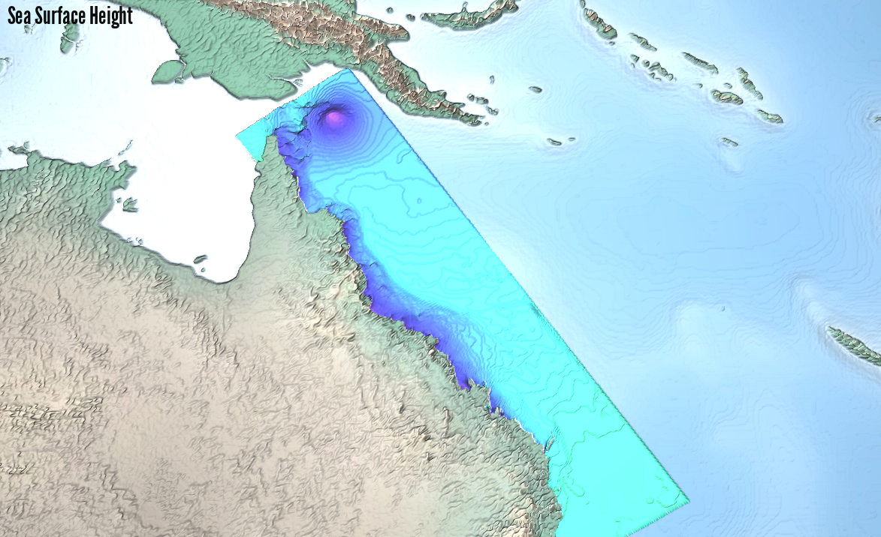
The Queensland storm surge system comprises a 2km resolution model grid spanning 29S-6S and 139E-158E (see Figure 25). The computational grid is a rotated orthogonal grid with 300x1300 grid points. The model scaling test runs were performed over a range of MPI decompositions and the simulation was run for 3.5 model days. For each run, the system outputted the sea surface height, sea surface velocities and atmospheric forcing parameters on the model grid at hourly intervals.
Figure 25. The Queensland storm surge ROMS domain spanning 29S-6S, 139E-158E. The model grid is 2km resolution with 300x1300 grid points. The field shown in the figure is sea surface height anomaly.
Scaling Results
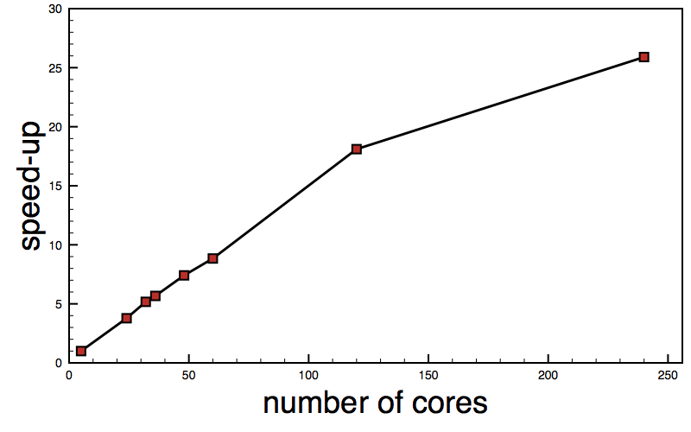
The best runtimes for various core counts is provided in Figure 26. Speed-up is calculated relative to the baseline 5 core ROMS run. The curve in Figure 26 shows that a 120 core MPI model run provides an 18x speedup over the 5 core case and the 240 core MPI model run gave a 26x speed-up relative to the 5 core MPI run for this Queensland model grid configuration. Beyond 120 cores there is a change in speed-up gradient.
Figure 26. Speed-up of the ROMS code as a function of number of cores. The speedup value is calculated relative to the 5 CPU core model runtime.

We also investigated the influence of Lustre striping on model performance. The benchmark Queensland case includes the frequent writing of model output data to a netCDF file. The output frequency was set to 1 hour model time and we wrote 6 fields to disk, including sea surface height anomaly, sea surface velocities and atmospheric air pressure and wind stress interpolated onto the ROMS grid. Models runs with different Lustre striping settings showed no influence on the performance of the model.

Profiling Results
We performed profiling of the ROMS Queensland storm surge configuration using TAU. The TAU profiling reports (see Figure 27) showed the majority of compute time was spent in the time stepping compute loop of ROMS, a subroutine called step2d_tile. The interpolation of atmospheric forcing data onto the rotated Queensland ROMS grid and the writing of output data were shown to not be expensive operations.

TAU profiling of a 64 core ROMS run over the Queensland storm surge grid demonstrated a small load imbalance for this domain decomposition with the first and last processors having less compute work resulting in longer MPI_Wait() times.

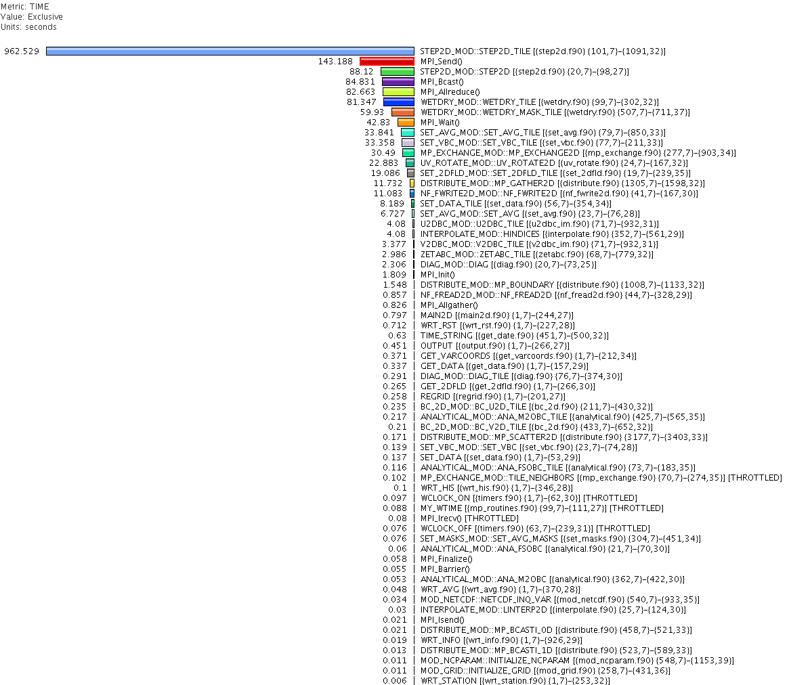
Figure 27. TAU profile report for ROMS running the Queensland storm surge grid.

Outcome
Pre-operational trials of the Queensland storm surge system were performed on Raijin. Each trial run consisted of 1000 hydrodynamic model runs for each of the three different storm systems. Each ensemble member was a 32 core MPI run of ROMS with the Queensland storm surge grid simulating a 3-day forecast. Atmospheric forcing was provided by blending a synthetic tropical cyclone vortex with a background field provided by ACCESS-R. Average ROMS runtimes on Raijin for each of the three storm scenarios are provided in Table 8. These performance results fit within the operational runtime window. Scaling analysis suggests that the ROMS code in the storm surge configuration should scale well to the Tropical system’s larger grid.
Table 8. Average total run times to complete 1000 hydrodynamic ROMS model runs for the Queensland storm surge system running under different storm systems.
 | TC YASI | TC MARCIA | TC ITA
Wall Time | 19 minutes | 23 minutes | 24 minutes

Part (4): Coupled Models: Climate, Seasonal Climate & Earth System Model

ACCESS-CM2
ACCESS-CM2 consists of three models: the MOM5 ocean model, CICE5 sea ice model, and the UM 8.5 atmosphere model, which are coupled using the OASIS3‐MCT coupler. The profiling recorded in Figure 28, was mainly conducted on the A96 configuration - a high-resolution (0.25°) ocean and sea ice models with a low resolution (N96) atmosphere. It shows that the execution time is occupied (in the descending order) in MOM5 (ocean_solo), UM (um_main) and CICE.

Figure 28. Time distribution over user and MPI operators in CM2.

As shown in Figure 29, the performance varies over the MPI ranks for the top 10 time-consuming routines. CICE runs on 192 ranks with most time spent on the MPI_Waitall, MPI_Barrier and MPI_Bcast. The UM runs on 416 ranks, with MPI_waitall, MPI_Barrier and MPI_Allreduce the most time consuming MPI operations. MOM is allocated 960 ranks with MPI_Waitall , MPI_wait and MPI_allreduce the major MPI operations. MOM also spends significant time on 3 routines:
ocean_tracer_advect_mod.ppm_limit_sh
ocean_tracer_advect_mod.advect_tracer_mdppm ocean_bihgen_friction_mod.bihgen_friction
This is consistent with the profiling analysis performed on the stand-alone MOM5 program.

Figure 29. Time variations over MPI ranks of top 10 time-consuming routines in CM2.

A problem in noticeable variation of time between runs has been observed when running CM2. Repeating the same calculation will randomly fall into 2 cases – a long time run and a short time run, as shown in Figure 30.
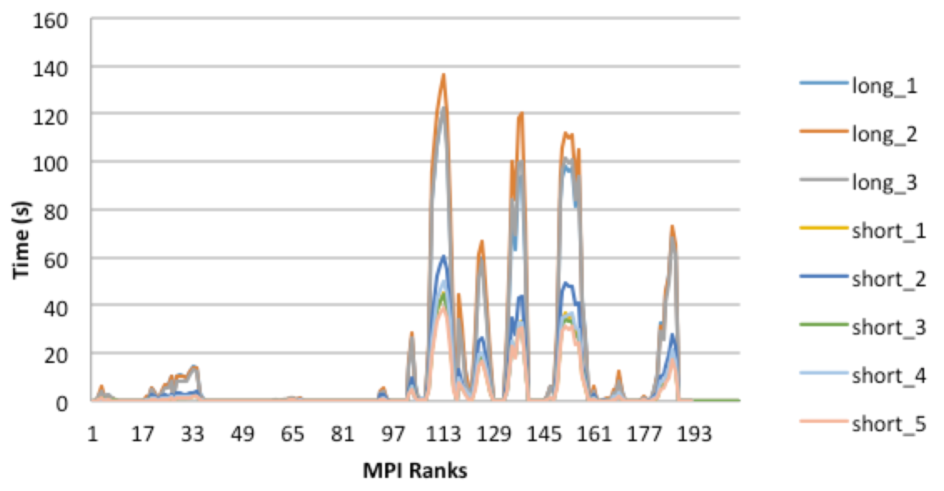
Figure 30. Executing time variation over MPI ranks in repeating the same calculation of CM2. The rank time could be randomly either longer or shorter.

To explore this issue, global profiling analysis was undertaken on both the long time run and short time run simulations, and synchronization points were also set in the code to trace the time on the routines. By comparing the profiling data between each case (Table 9) it was revealed that the the variation comes from a CICE subroutine called ic_flux_set_sfcflux.
Table 9. The time comparison of subroutines between the long run time and short run time cases.
Long-run case | Short-run case
407.22 ice_step_mod.step_therm1_  0.40 ice_blocks.get_block_  40.07 ice_therm_vertical.frzmlt_bottom_lateral_  3194.54 ice_flux.set_sfcflux_  522.62 ice_therm_vertical.thermo_vertical_  1.07 ice_timers.ice_timer_start_  0.28 ice_timers.ice_timer_stop_  50.61 ice_flux.merge_fluxes_ | 407.19 ice_step_mod.step_therm1_  0.39 ice_blocks.get_block_  39.83 ice_therm_vertical.frzmlt_bottom_lateral_  745.93 ice_flux.set_sfcflux_  525.00 ice_therm_vertical.thermo_vertical_  1.11 ice_timers.ice_timer_start_  0.27 ice_timers.ice_timer_stop_  52.73 ice_flux.merge_fluxes

This subroutine allows all MPI ranks concurrently writing messages to a shared file so that the high contentions are produced. After forcing each MPI rank accessing its own log file, the time variation problem was fixed.

Seasonal Climate
The NCI global profiling methodology was applied on the UK Met Office GC2 suite built with OpenMPI 1.8.5 and intel MPI 15.0.1.133. The 2-day profiling analysis (Figure 31) shows that NEMO and UM simulations take major time to run, while the OASIS coupler involved a small amount of MPI communication.

Figure 31. Time distributions of GC2.

The global profiling exposed each component program’s distribution over MPI ranks. The top 10 time-consuming routines are shown in Figure 32. The couple program mainly conduct point-point communication over 8 MPI ranks via MPI_Recv operator. The UM is allocated 184 MPI ranks with MPI_Scatterv as the major MPI operation. NEMO is given 128 MPI ranks with most time spent on the numeric calculations together with moderate MPI collective and point-to-point communications.

Figure 32. The top 10 time-consuming routines of GC2.

The variation of MPI_Waitall time over the MPI ranks of UM and NEMO indicates a load imbalance issue. This can be further addressed by tracing work and the MPMD imbalance profiling analysis that will be undertaken with the assistance of the NCI profiler reporting tool mentioned later in this status report.

Part (5): Wave Models
WAVEWATCH v3 (WW3) primarily solves for the wave activity, a physical quantity related (but not equivalent) to the wave energy density. It is a conserved quantity under certain criteria, and its conservation is closely related to the conservation of phase for a single harmonic wave.
A WW3 experiment specifies multiple timesteps:
- global timestep
- spatial timestep
- spectral timestep
- the timestep for source terms and external forcings
Computationally, the variation in timestep size results in more function calls at higher modes and is a source of load imbalance.
WAVEWATCH supports either MPI or OpenMP parallelisation, with our attention focused on the MPI.

Model Benchmark Configuration
The physical domain is a near-global 0.25°-resolution grid, with the latitude range from 78°S to 78°N. The unmasked numerical domain is 1440 x 625 grid points (or 900,000 grid points). Masking is applied to the domain, removing any land points. This masked domain contains 507,679 physical ocean grid points.
Spectral resolution is defined in ww3_grid.inp and parsed by the ww3_grid function. The parameters used in the benchmark experiment were the following:
- Frequency resolution:
- Lowest frequency:
- Number of frequencies:
- Number of directions:
The number of spectral bins is . Each bin corresponds to a particular wavenumber and direction .
The main model timesteps are the following:
- Global timestep of 900s
- Spatial CFL timestep of 300s
The number of timesteps required per mode can range from 1 to 3, depending on the mode frequency.
The wave activity is a function of both positions and spectral modes, and each timestep contains terms that require integration over either spatial or spectral domains. Efficient parallelisation therefore requires two independent parallelisation methods, one over grid points and the other over spectral models.
In our experiments, there are 1224 mode pairs, and 507,679 grid points, meaning that scalability is limited to 1224 CPUs, and inefficient scaling for simulations of comparable size. Grid points can also limit scalability, but it is unlikely to be an issue in any high resolution studies.
Through our analysis, we determined the following:
- Parallelisation is limited strongly by the number of spectral pairs (1224), and weakly by the number of spatial grid points (500k).
- Timestep calculations scale well up to 512 CPUs, but the spatial advection terms are limited by the communication requirements, which only scale up to 64 CPUs, and show only moderate improvement up to 256 CPUs.
Two major code modifications were undertaken:
- Initialization was hampered by many small 5kB reads over multiple ranks (one per grid point), which were not contiguous in memory. Performance has been restored by allowing a single master rank to read larger contiguous blocks, which then scatters this data to the other ranks.
- Inconsistent write times of output restart files has been resolved by using a new MPI-IO method, which shows significant improvement over the concurrent IO method, and matches the serial IO method in performance, and potentially mitigating any future scaling problems.

These modifications have been provided to the Bureau of Meteorology and UK Met Office to evaluate on their platforms.
Model initialisation
Model initialisation requires the reading of the restart.ww3 input file. In the source code, this is achieved by allowing each MPI rank to independently read its respective spectral data from restart.ww3, which results in simultaneous reads of the same file. Grid points are distributed across the ranks, and each rank issues independent read() calls. In the 0.25° experiment, this requires a total of over 500,000 reads.
We experienced poor IO performance and scalability due to:
- Large number of reads (~500k)
- Small record size (~5k bytes)
- Non-contiguous data
These are shown in Figure 33.
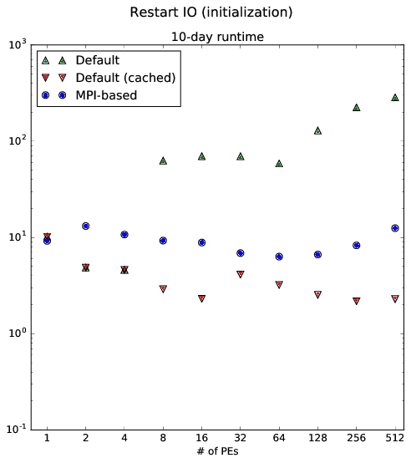
Figure 33. WW3 initialisation IO performance and scalability

The green triangles denote the time to read the restart files on the first model execution, while the red triangles denote the read times for subsequent executions. The performance difference is likely due to Lustre server-side caching of the file, along with local kernel caching, which may mitigate some of the inefficiencies outlined above. Due to the lack of transparency about file caching in Linux, it is unclear if this can be conclusively proven, although it is consistent with cache behaviour.
We focused on the uncached (green) initialisation times, with the most serious performance issue being the scaling inversion observed after 64 CPUs, which was preventing scalable performance.
Initialisation read times were resolved by replacing the small, non-contiguous reads with larger, contiguous reads. Records for all ranks are now read at once, as a single contiguous read, by a single master rank, which then scatters each of the records to its respective MPI rank.
The change means that records are read for all ranks at once, as a single contiguous read, and then scatter the records to their respective ranks via MPI.
The new initialisation method run times are denoted by the blue dots. There is a slightly greater overhead compared to the cache reads (which are comparable to disk read speeds), but the total cost is fixed and does not exhibit the inverse scaling seen in the original read times.
This change should result in improved runtimes for higher CPU counts.

Restart output
A second major performance issue is due to restart output generation. Multiple restart implementations are included in WAVEWATCH, and are configured using the IOSTYP input parameter. We focus on two cases:
- Simultaneous writes by all MPI ranks (IOSTYP = 0)
- Serial IO by a master rank, which gathers all data (IOSTYP = 2)

During initial testing, both methods showed substantial performance degradation, where nearly half of the total runtime was devoted to writing the restart files. In order to mitigate this, we undertook development of an MPI-IO based solution to resolve any performance issues. The relative performance of these methods is discussed below.
There are additional IO modes, which rely on a more general WAVEWATCH IO server model, but they were not investigated in our benchmark cases.
The relative performance of the different restart write methods is shown in Figure 34. The serial IO master rank method is shown in green and the concurrent parallel IO is shown in red. The newer MPI-IO method is shown in blue. Several ensembles were performed for each configuration, and the mean value over ranks for each ensemble is shown.
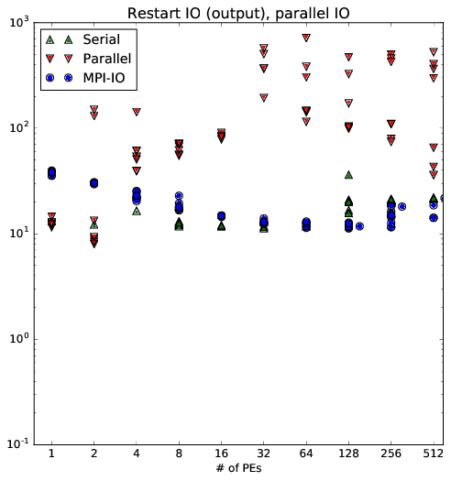
Figure 34. Comparison of restart methods

The first major observation is the strong performance of the serial IO method. Unfortunately, we cannot say what is the cause of this change, though it occurred around the time of the January update of Raijin system software. Prior to this update, the serial IO method was consistently slower than the concurrent IO (approximately 66% slower), and also showed an "inverse scaling" trend, where increasing the number of cores also increased the total restart IO runtime. These observations were the motivation for developing an MPI-IO implementation. However, in its current state, there does not appear to be any performance issues with the serial IO method.
The concurrent parallel IO method shows substantial performance problems. Not only is there an inverse scaling trend, with more cores causing increased runtimes, but the runtime itself is very inconsistent. The implementation is very similar to the method used to read the restart files, which requires too many small non-concurrent 5kB writes. An additional complication is that many ranks are simultaneously sending write requests to the Lustre server, which is causing greater strain on Lustre, so that larger numbers of write requests will lead to greater sensitivity to the state of the Lustre filesystem and more inconsistent runtimes.
We resolved these issues by replacing the concurrent IO writes with an MPI-IO based implementation, shown in blue. This method allows the MPI library to optimise its write requests internally, and avoid any concurrency problems with Lustre. As shown in Figure 36, it shows improved performance up to 16 CPUs, with no scaling problems beyond 512 CPUs.
Although there were ultimately no observed problems with the serial IO method during our final testing, the MPI-IO based solution offers a platform for greater tuning with Lustre, and more robustness over future platforms and system updates.

Project B: Advanced Computational Scaling and Tools Project

Project Aims
Table 10. Deliverables identified for the Advanced Scaling and Tools Project
Profiling Area | Yr2 | Yr3
Profiling Methodology | Create Methodology for profiling codes | Updates to Methodology based on application across more codes
Profiling tools suite | Install and Review:  - Major open source Profiling Tools (Score-P, Scalasca, OpenSpeedShop, PAPI, mpiP, IPM  - Intel Vtune Amplifier, Intel Trace Analyser and Collector (ITAC)
I/O profiling | - Baseline profiling for comparison of NetCDF3, NetCDF4, HDF5 and GeoTIFF and API options (e.g. GDAL).  - Profiling comparison of IO performance of Lustre, NFS  - Compare MPI-I/O comparison vs POSIX on Lustre | - Advanced Profiling HDF5 and NetCDF4 for compression algorithms, multithreading, cache management  - Profiling analysis of Astronomy FITS data file format
Compute Node Performance Analysis | - Partially committing nodes  - Hardware Hyper-threading  - Memory Bandwidth  - Interconnect bandwidth | Evaluating Energy Efficiency vs performance of next generation Intel processors and vectorisation
Software Stacks | - OpenMPI vs IntelMPI analysis  - Intel compiler versions | - OpenMPI vs IntelMPI analysis  - Math Libraries
Analysis of major HPC parallel Algorithms and codes | - Initial Analysis of MPI communications  - Commence analysis of high priority/profile HPC codes, particularly in Earth Systems, Geophysics and Gene Sequencing | - Detailed Analysis of MPI communication dependent algorithms  - Survey of Codes and Algorithms used.
Accelerator Technology Investigation |  | - Intel Phi (Knights Landing)  - AMD GPU

Staff Resources
The table below summarises the teams, and their funding allocations for staff using the Full Time Equivalent (FTE) representation.
Table 11. Funding allocations for staff from participating organisations.
Organisation | FTE Funded  (in place/contract) | FTE In-kind  (in place/contract) | Staff associated with Project B
ANU/NCI | 1/1 | 1/1 | Dr Ben Evans, Dr Rui Yang, Dr Dale Roberts, Dr Marshall Ward
BoM | 0.5/0.5 | 0/0 | Dr Justin Freeman, Dr Ilia Bermous
Fujitsu | — | 1.5/1.5 | Dr Ross Nobes, Mr Jim Enright,  Mr Hiroyuki Kouchi, Mr Shinji Iwane, Mr Tomohiro Yamada

Project B Progress
The sections below outline progress since commencement.

Profiling Methodology
Code profiling aims to understand the program execution behaviour and find points for optimization. It involves multiple optimization steps, spanning code instrumentation, runtime measurement and performance analysis as shown in the Figure 35.

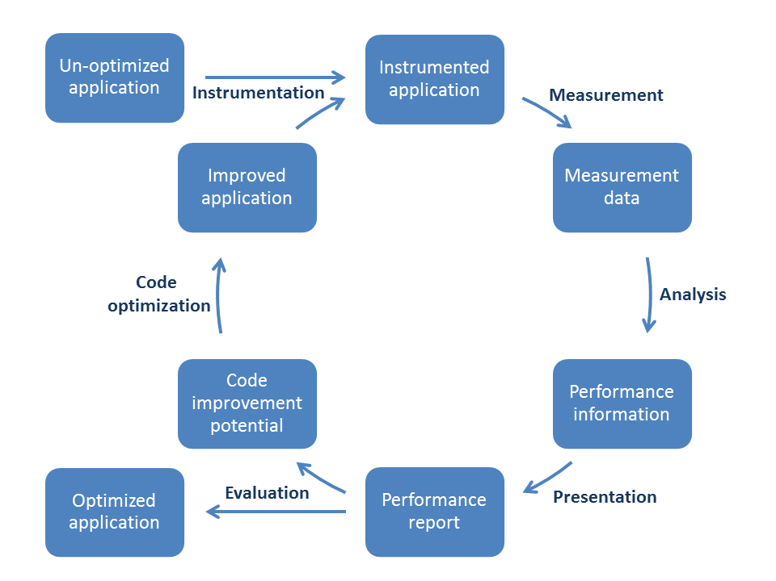
Figure 35. Code optimization cycles

The NCI profiling methodology has been established by applying a variety of analysis tools on codes such as the ACCESS codes and other HPC codes at NCI. The profiling procedure contains 3 major components, as shown in Figure 36. The measurement tools employed in the profiling methodology are not limited to open source tools - any profiling tool with the capability to provide the required message could be integrated in the profiling analysis. In addition, we have developed our own tools, such as the NCI profiler reporting tool noted later in this report.

Figure 36. Components of the NCI profiling procedure.

The general profiling analysis workflow is as follows. Global profiling is firstly conducted to identify the hotspots and performance bottlenecks of an application, followed by tracing to explore the source of these problems. For computation performance tuning, specific profiling can then be used to map the hotspots of a function to the source line.
Global profiling counts a variety of performance metrics at the routine or loop level over the whole execution period. These measurements help to discover the hotspots and performance bottlenecks in the user’s code, and the communication profile from the parallel libraries, such as MPI and OpenMP. The framework of global profiling is demonstrated below.
- General profiling
  - Metrics in the unit of call path
    - Generic metrics
      - CPU time: executing time
      - Visit: number of accessing the call path
      - Computational imbalance: variation in metric (time) values of user routines over ranks/threads.
      - Resource usage: information about the consumed resources and OS events, such as user/system time, memory usage, page faults etc.
      - Hardware counters: performance metrics at the hardware level to identify the programming efficiency, such as CPI, cache miss ratio, memory bandwidth, NUMA effect etc.
    - Parallel libraries metrics
      - Time: time spend on MPI/OpenMP functions such as initializing, finalizing, synchronizing, communication etc.
      - Message size and amount: the data transferred in either point-to-point or collective MPI functions.
      - Communication matrix: the data transferring pattern among all MPI ranks.
  - Measurement tools: ScoreP/Scalasca, TAU, mpiP, Intel Vtune Amplifier, Intel Trace Analyzer and Collector, PAPI, NetBeans Profiler
  - Analysis & Visualization tools: CUBE, NCI profiler reporting tool

- I/O profiling
  - Metrics
    - I/O time: the absolute time on I/O and its weight in the program execution.
    - I/O data access: concurrent or consecutive;
    - I/O transaction unit size: program buffer size;
    - I/O client access: sharing/independent on read/write/metadata operations;
    - I/O amount: data transferred per file system;
    - I/O imbalance: I/O time per MPI rank.
  - Measurement tools: Darshan, ScoreP, Intel Vtune, OpenSpeedShop
  - Analysis tools: NCI profiler reporting tool
The global profiling helps to identify the hottest call paths and routines during the program execution. The rank based statistics are used to explore imbalance issues. From the global profiling we could locate the target regions or issues for future performance optimization activities.

Tracing records the runtime events based on the timeline of the program execution. Tracing can monitor and analyse the communication behaviour to identify hotspots and reasons for poor scaling performance. Together with static global profiling analysis, tracing can provide vital information to address any communication bottlenecks and load imbalance issues.

A framework tracing is listed as below:
- Tracing
  - Metrics
    - Event timeline
    - Performance issue analysis
      - Critical path imbalance
      - Later Broadcast
      - Late Sender/Receiver
      - <many Performance Properties>
  - Measurement tools: Scorep/Scalasca, Intel Trace Analyzer and Collector
  - Analysis & visualization tools: Vampire, CUBE, NCI profiler reporting tool

Specific Profiling maps the performance metrics to the source line of a specific code block. This is achieved by running sampling or simulation based profiling tools on the binary application. Specific profiling normally focuses on hotspots within the user’s code to improve the computational efficiency.
Specific profiling has the following contents:
- Specific Profiling
  - Metrics
    - Time: CPU time mapping to each source line.
    - Hardware performance counts mapping to the source line.
  - Measurement tools: OpenSpeedShop, Valgrind, Intel Vtune Amplifier, HPCToolKit, PAPI

Performance Measuring Tools

NCI Profiler Report Tool
The NCI profiling methodology utilizes various tools to achieve specific goals for each component. The profiling outputs from each of these tools are stored in individual files with profiler-specific formats. To accelerate the analysis process, we are progressively developing a reporting tool that harvests this information and stores in a central profiling resource that collects all necessary metrics, as depicted in Figure 37.

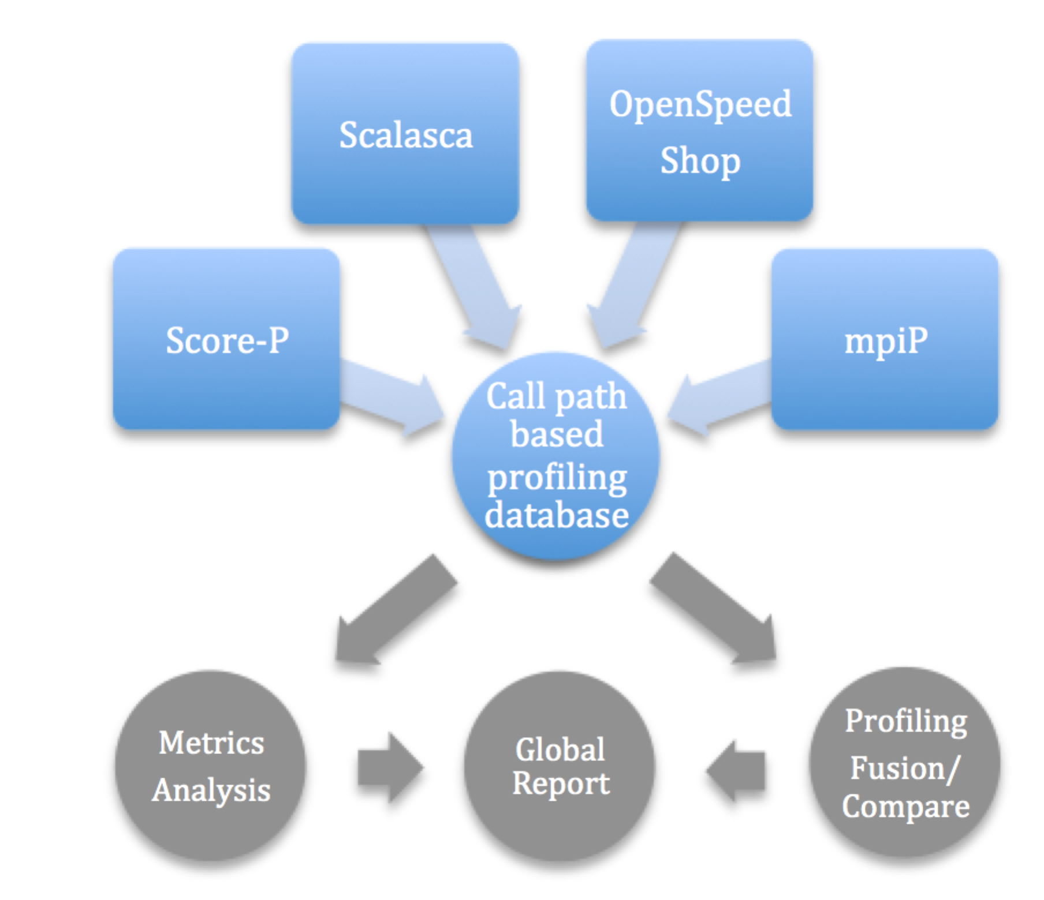
Figure 37. Architecture of NCI automated reporting tool
The post-processing tool first gathers the measurement results from different profiling files and then organizes these profiling data into a central database with ‘call path’ as the primary key. Once stored, a variety of analysis tasks are performed on the centralized database, including specific metric analysis, imbalance analysis, communication analysis, scaling analysis, fusing different profiling components and comparing metrics among multiple runs. The tool can produce a pdf report to create a standard human readable analysis with figures and tables. From the report users can quickly locate the hotspots of the program from the top several time-consuming call paths or regions and identify the imbalance issues from the metrics-rank plots. At this stage, the tool only supports ‘cubex’ format files produced by Score-p and Scalasca. We are progressively adding more profiler file formats as required by our profiling work.
For large-scale applications, profiling data could be easily tens of gbytes in size. The NCI profiler report tool uses a data-packing algorithm to reduce the storage requirement. For example, as listed in Table 12, the size of database produced by the NCI profiler report tool is less than 30% of the native profiling file produced by Scalasca.
Table 12. The storage requirements on profiling data produced by Scalasca and NCI reporting tool
Applications | Profiling file size  by Scalasca | Database size by NCI  reporting tool | Ratio
4DVAR | 609MB | 160MB | 26.27%
ROMS | 883MB | 231MB | 26.16%
GC2 | 1.5GB | 431MB | 28.73%
MOM5 | 13GB | 3.1GB | 23.84%
CM2 | 22GB | 5.0GB | 22.72%

Data formats analysis
We have been conducted a comprehensive suite of baseline benchmarks on common data formats and APIs, so as to explore how to efficiently store and analyse the massive datasets hosted by NCI. A wide range of metrics and parameters were tested so as to provide a thorough understanding of the performance for different storage options on the NCI filesystems. The major metrics employed in the benchmark are listed in Table 13.

Table 13. Metrics used in the serial and parallel IO benchmarks of data formats.
Metrics | Serial IO | Parallel IO
Libraries and Formats
GDAL | ✔
GeoTIFF | ✔
NetCDF Classic | ✔
NetCDF4/HDF5 | ✔ | ✔
MPIIO |  | ✔
POSIX |  | ✔
User Application
Transfer size | ✔ | ✔
File size | ✔ | ✔
Subset section | ✔ | ✔
Concurrency |  | ✔
Access Path
Local file system | ✔ | ✔
Remote web server | ✔
NetCDF4/HDF5
Chunk pattern | ✔ | ✔
Chunk cache | ✔ | ✔
Deflate/compressor | ✔
MPIIO
Independent&Collective |  | ✔
Collective buffering |  | ✔
Data sieving |  | ✔
Lustre File System
Stripe count | ✔ | ✔
Stripe size | ✔ | ✔

Serial IO
IO Library and Format Benchmark
A series of performance benchmarks were conducted on geospatial data from NCI’s local file system and data services. As an example, a Himawari-8 satellite data file was converted into several data formats by using GDAL, netCDF and HDF5 libraries, as listed in Table 14.
Table 14. Data formats and libraries in the geospatial benchmark.
Library | Format
GDAL  (ver 2.0.1) | GTIFF  NC_CLASSIC  NC4
NetCDF  (ver 4.3.3) | NC_CLASSIC  NC4
HDF5  (ver 1.8.15p1) | HDF5

The IOR package was enhanced to support all above libraries and formats for this benchmark.
For all tested data formats, the HDF5 and NC4 (netCDF4) via their own library gained the highest I/O throughputs as shown in Figure 38. The GDAL library adds additional overheads due to its internal data type conversions. Both NC4 and GTIFF (GeoTIFF) have comparable IO performances, which is higher than NC_CLASSIC (netCDF3) format via the GDAL library.

Figure 38. Read and write throughputs of a variety of data formats and libraries in the geospatial benchmark.

Remote Data Access Benchmark
Benchmark was conducted to measure the IO performance via the OPeNDAP protocol in which the target netCDF files locating at UniData THREDDS (TDS) and OPenDAP Inc’s Hyrax servers, respectively. The benchmark configurations are listed in Table 15.

Table 15. The remote data access benchmark configurations.
Locations | Clients | Access pattern | Metrics
Local Lustre File system  THREDDS  Hyrax Server | VDI  Raijin | Contiguous Access  Subset Access | Deflation  Chunk Size  Chunk Cache Size

The benchmark results indicate that the THREDDS server is more performant for this workload than the Hyrax server when accessed from either NCI’s Virtual Desktop Infrastructure (VDI) or Raijin compute nodes (Figure 39). The IO throughput was better with the larger transfer sizes.

Figure 39. Contiguous read throughputs of accessing THREDDS (TDS) and hyrax servers.

Accessing non-deflated files from the THREDDS server is faster than accessing those deflated files due to the efforts on inflating the file at the server side as shown in Figure 40.

Figure 40. Contiguous read throughputs of accessing deflated files at the THREDDS (TDS) server.

Chunk Cache Benchmark
The chunk cache can significantly affect the read throughput. There are 3 parameters that can be adjusted for chunk cache utilization, chunk cache size, total number of chunks being cached and the chunk eviction policy. For example, increasing the chunk cache size from 2MB to 128MB dramatically improves the read performance when accessing the whole file, over a wide range of transfer sizes, as shown in the Figure 41.

Figure 41. Read throughput with chunk cache size of 8MB and 128MB.

Compression Benchmark
Since deflation is widely used within geospatial datasets, we have performed a study of the efficiency of a variety of compression algorithms and parameters for both writing and reading the data. In addition to the native gzip deflation method of HDF5 and netCDF4, several other compressors were also tested via the HDF5 dynamic filter API. The tests included Bzip2, mafisc, spdp and Blosc (blosclz, lz4hc, lz4, SNAPPY, ZLIB). To perform this test we developed our own benchmark program and used a Landsat Level1T dataset as the target file.
In general, the higher compress level produces smaller files, but with lower performance. Bit or Byte shuffling can help to increase the compression ratio, but it also incurs an overhead on rearranging data in memory.
A more recent compression library is Blosc. Blosc divides the native chunk into cache friendly blocks, and then use standard compression algorithms. It also implements the optimized (SSE2) versions of shuffle for 16, 32, and 64 bit element sizes. As shown in Figure 42, blosc/LZ4 and blosc/SNAPPY using BLOSC byte shuffling achieves a comparable compression ratio with the HDF5 and netCDF native deflations, and with significantly improved I/O throughputs, even compared to the non-compressed files.

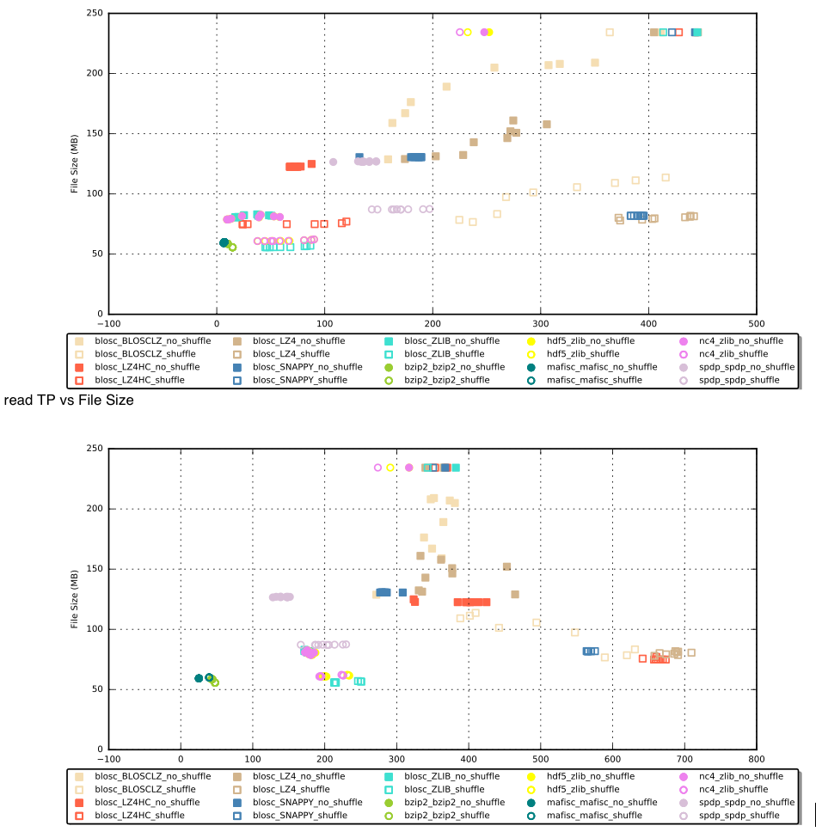Figure 42. The IO performance on accessing Landsat dataset created using selected compressors.

Parallel IO
The revised IOR benchmark package was used to measure the parallel I/O performance of the HDF5 library on the Local (VDI platform) and Lustre file system (Raijin).
IOR configuration Tuning
The following IOR configurations were employed in the benchmark:
- MPI Ranks=[1, 2, 4, 8, 16]
- Interface=[HDF5, MPIIO, POSIX]
- Block size=[1GB, 2GB, 4GB, 8GB]
- Transfer size=[1MB, 4MB, 8MB, 16MB, 32MB]
- Independent or collective 1D contiguous or non-contiguous access

The benchmarking activity showed that:
- Caching provides performance improvements to NCI’s VDI when re-reading files less than 4GB.
- In the benchmark activity, it is necessary to use large bock sizes to fully eliminate caching effects;
- Using large transfer sizes is critical to achieve high I/O performance for HDF5 and MPI-IO. POSIX performance is relatively insensitive to the transfer size.
- The number of MPI ranks should match the number of physical cores of the testing node.

Lustre Tuning
Stripe count and stripe size were employed as the tuneable Lustre file system parameters. It is observed that
- Multiple Lustre OSTs (Lustre stripe number > 1) should be used for achieving higher performance of parallel IO. For example, the parallel read and write performance using 16 MPI ranks could approach 6GB/s or 1.6GB/s respectively on accessing a file across 8 Lustre stripes. As a comparison, the I/O throughput of 16 MPI ranks to access the single striped file is only 400-500MB/s.
- Stripe size should be set to 1MB to match the network transfer buffer size of the IB cards of Raijin.
- Multiple stripe counts does not improve serial IO performance.
- Serial IO performance was independent of the stripe size.

MPI-IO Tuning
The hyperslabs (subsets) can be padded in the following ways, which can be used to test the effect of MPI-IO hints:
- Row major padding: all hyperslabs are interleaved each other in a single row.
Hyperslab Rank 0
Hyperslab Rank 1
Hyperslab Rank 2
Hyperslab Rank 3

- Block padding: hyperslabs interleaved with part of other rank’s hyperslab in a single row.
Hyperslab Rank 0
Hyperslab Rank 1
Hyperslab Rank 2
Hyperslab Rank 3

- Column major padding: each rank accesses its own hyperslab in a contiguous way.
Hyperslab Rank 0
Hyperslab Rank 1
Hyperslab Rank 2
Hyperslab Rank 3

- No chunking for MPI-IO tuning.

From the benchmark it is observed that:
- Independent IO gives the best performance for contiguous access (column major padding).
- Collective IO is better than independent IO for non-contiguous access (column-major and block padding).
- Collective buffering should be set as ‘auto’ in the contiguous read;
- The IO performance could be enhanced with the larger contiguous access length. The enhancements are improved in the order of row major padding, block padding and column major padding.
- Increasing collective buffer size doesn’t bring obvious performance benefits for parallel IO performance.
- Multiple collective aggregator/node (default=1) could enhance the parallel I/O performance. For example, for 8 Ranks/node parallel IO benchmark, using 4-6 aggregators could give rise to the best performance.
- Data sieving has minor effects on the parallel IO performance.

HDF5 Tuning
The revised IOR application to support HDF5 chunking was employed in the HDF5 tuning benchmark. It is noted that:
- The hyperslab should cover the whole chunk if possible, i.e. keep the high data utilization of each chunk.
- Increasing chunk cache size could enhance both read and write performance on accessing the chunked HDF5 files.

Concurrency Tuning
The concurrency tuning aims to determine the core and node arrangement on the parallel IO performance. The tuning results show that:
- Read performance is scalable to the number of both client nodes and cores within the node.
- Write performance is scalable mainly to the number of client nodes rather than cores within the node.

Compute Node Performance Analysis
The age of the processors on Raijin (Sandy Bridge) have started to become a noticeable impediment to resolving issues. For example, there was an optimisation made in scatter_field_mpl32.F90 (ticket #1441). The changes implemented in the corresponding subroutine showed ~40% improvement on Raijin, but the UK Met Office has reported that their Cray system showed a performance degradation of ~40% for the same region. This is directly related to the older style processors becoming less useful for the work that needs to be undertaken and without a suitable system at NCI to resolve the issue.

Software Stacks
Several codes experienced improvements on Raijin system following the system maintenance on 4 January, 2016. Previously a relatively large number (>50) of hanging (37), crashing or very slow execution problems had been detected. The occurrence of such issues has dramatically improved after the software update. There have also been numerous bugs filed with Intel, which are being attended to through the NCI maintenance arrangements.

Analysis of major HPC parallel Algorithms and codes
Distributed Computing Fundamentals
The goal of this investigation is to categorise and evaluate the performance of fundamental aspects of distributed computation, such as data distribution and halo exchange. Whilst the MPI standard provides numerous ways to perform, e.g. a halo exchange, there are situations where it may not be immediately clear which data structures; decomposition algorithms or MPI calls will provide best performance. We intend to explore and implement as many options as possible for such cases in the context of real-world HPC applications, in order to build knowledge in the area.
Thus far, we have begun to explore the performance of cumulative sums over MPI ranks, the algorithms used by MPI_Gather and MPI_Gatherv, and complex data structure manipulation during data distribution using combinations of MPI types and temporary buffering. Future work will include an analysis of halo exchange from both a data structures perspective and from a communication perspective.
Investigation of MPIs Data Distribution
We have investigated MPI’s data distribution among its tasks on a four dimensional grid, facilitating algorithms using complex data transformations. This work is motivated by a use-case in Lattice Quantum Chromodynamics (QCD) though the issue is more generally applicable to almost any MPI application where the domain is distributed.
We have initially tested the use of MPI’s derived data types. The test case is a 32³x64 grid of 4 element vectors, each composed of a 3x3 matrix of double precision complex numbers, effectively a 7 dimensional object. This gives a total data size to distribute of 1.125 Gbytes (1,207,959,552 bytes). The transformation from the layout in the file to the layout required by the solver in memory is as follows:
- Transpose each 3x3 matrix
- Move the 4-vector index from dimension 3 to dimension 7
The original implementation performed these transformations on a subgrid in a temporary buffer on the MPI rank that read the input file, which was then sent to the MPI rank corresponding to the subgrid. It is possible to define a sequence of four MPI types that can perform this transformation without any temporary buffering. This is effectively testing two extreme cases, as there are several ways to combine temporary buffering and MPI types to perform this transformation. The tests were performed on 16 cores (a subgrid size of 32x16³) and 512 cores (a subgrid size of 8⁴) and using a software stack comprised of the Intel v15.0.3.187 compiler and OpenMPI v1.10.0). The results obtained are as follows:
 | Temporary Buffer | No Temporary buffer - MPI types
16 cores (32x16³) | 4.47 s | 4.79 s
512 cores (8⁴) | 3.09 s | 4.19 s

Both cases include a 2.1 second serial section in which MPI rank 0 reads the input file. It is evident that there is a limit to what an MPI library can handle efficiently when using custom types. To explore this further, a third distribution method was implemented, using a single MPI type to send the input data in its original format to a temporary buffer on each MPI rank, and have the data transformations performed on the received subgrid by each MPI process. This took 2.58 seconds in the 16 core case and 2.66 seconds in the 512 core case. These times include 2.1 seconds to read the input file on rank 0. This method of distributing the array is twice as fast on 512 cores as the original implementation, and 5 times faster on 16 cores. This is most likely due to the fact that the data transformations into temporary buffer are relatively costly from a memory bandwidth standpoint. Therefore, by having each MPI rank perform the transformation on its own subgrid, the memory bandwidth of all nodes of the job is better utilised, rather than just that of a single node. This technique gives a general guidance on efficient distribution of large grids where data transformations are required.
Specific Code optimisations
Mod3DMT Optimisation
Mod3DMT is a magnetotellurics solver developed at Oregon State University, and used by Geosciences Australia. The code is predominantly a single threaded, single core application, to which a master-slave approach to distributed parallelism has been added, as well as limited OpenMP threading. Of primary concern to its users has been the code’s excessive memory usage, which forces the Mod3DMT jobs to spend several days in the Raijin PBS queue for large memory nodes. For example, the peak memory usage of the code for the example problem was around 100GB on a single node, restricting the code to the 72 nodes of Raijin with sufficient RAM.
The example problem contains 214 computationally independent, but data dependent problems, on a 170x170x49 grid. This likely provided motivation for choosing a master-slave approach to parallelism rather than a distributed solver approach. The excessive memory requirement comes from the fact that the code needs to retain the fields calculated for all of the independent problems to use in the next iteration of the solver, and chooses to store those solutions on the master MPI process, given the indeterminate placement of the problems among the slave tasks.
Given the relatively small size of the individual solutions (approximately 80MB each), it was decided to use an out-of-core approach to minimise memory usage. Instead of the master MPI rank storing all solutions in RAM, each slave task was modified to write the solution it calculates onto a shared file system. When a slave task needs one of the solution vectors from a previous iteration, rather than transferring data from the master process, the slave will now read the solution vector from the file system. This process is inherently parallel, as each solution vector is stored in a separate file, meaning that the bandwidth of the parallel file system to each compute core can be exploited. By implementing this, the peak memory usage of the master process reduced to around 500MB, compared to the original 70GB, at a cost of around one third of a second per solution vector written. Using Score-P, the total cost of all solution vector reads and writes in the target problem was shown to be around 3 core minutes per iteration.
In principle, a master-distributed-slave approach could be employed to further improve performance and to allow scaling beyond the number of independent field solutions. However, the code employs a Lower-Upper (LU) decomposition for the matrix inversions, which introduces data dependencies within the solver grid. A full re-write of the code would be required in order to allow distribution of the solver. In most instances, the data dependencies are planar within a 3D grid, so at different stages of the solver, different dimensions could be distributed across threads using OpenMP directives.
Initially, Mod3DMT had a scattered OpenMP implementation, with a few key subroutines employing basic OpenMP directives. Furthermore, there were mistakes in the OpenMP that lead to sections of the code being accidentally serialised. Through Score-P profiler guided optimisation, 133 new OpenMP directives were added to the code, increasing coverage from around 2.5% of the code’s runtime, to around 86%. The sections without OpenMP are either memory bound or have prohibitive data dependencies. This, along with reordering loops in a more cache-friendly manner has resulted in a reduction in cost of each independent problem by around a factor of 4 when using 2 OpenMP threads per MPI task. A summary of these improvements for 6 key subroutines that comprise over 50% of the model runtime can be found in Figure 43, and improvements to key vector and scalar operations can be found in Figure 44.

Figure 43. Note that divcgradilu contains a data dependency that prevents any OpenMP threading

Figure 44. dotprod_cvector_f also benefited from the removal of an unnecessary vector creation operation. Though additional vector and scalar operations could be parallelised, their runtimes were short enough such that the overhead introduced by OpenMP exceeded the benefit of multiple threads.
Given the master-slave distribution approach, there is little that could be done to improve performance in that area. Moving to out-of-core vector solution storage has resulted in an improvement in the MPI performance, as the master task no longer needs to distribute the solution vectors, saving 70GB of MPI traffic per iteration.
The rest of the changes to the MPI implementation have been to significantly improve the coding standard. For example, the original meta-scheduling subroutine exclusively used MPI_Send and MPI_Recv calls to manage the worker tasks, which lead to awkward and difficult to interpret sections of code held together by ‘goto’ and ‘continue’ statements. This has been updated with asynchronous receives for the return metadata from each slave task, and MPI_Waitany to trigger dispatch of queued tasks once a slave becomes idle. Whilst functionally identical to the existing code, it takes fewer lines of code to implement and is written to a more modern standard.

GATK
The Genome Analysis Toolkit (GATK) is a Java package for analysis of high-throughput sequencing data. The time profiling analysis has been applied on GATK 3.5 by using the Intel Vtune Amplifier tool and NetBeans profiler.
The workflow of GATK can be divided into 6 steps from reading the original BAM files, writing realigned BAM files and then creating the final VCF files. A major component of the computational within GATK is focused on processing BAM file, an inflatable binary format for storing sequence data. The global profiling analysis revealed that accessing BAM files always involves this inflation or deflation. For example, as listed in Table 16, inflating BAM file is the most time consuming work at step 1.
Table 16. Top 5 hotspots at step 1 of GATK workflow.
Function | Module | CPU Time | CPI
inflate_fast | libzip.so | 969.267s | 0.792
[Unknown stack frame(s)] | [Unknown] | 874.964s | 1.599
read | libpthread.so.0 | 622.335s
htsjdk::samtools::SAMRecord::getAlignmentEnd | [Compiled Java code] | 482.169s | 0.326
org::broadinstitute::gatk::utils::locusiterator::  AlignmentStateMachine::stepForwardOnGenome | [Compiled Java code] | 472.486s | 0.405
GATK also relies on external Htsjdk API and its SAMTools module to process SAM and VCF format files as listed in Table 16. A specific profiling analysis, using Intel Vtune, has been applied on those most time-consuming functions. For example, the branch structures are hotspots within the function stepForwardOnGenome as shown below in Table 17.
Table 17. Hotspots within GATK function stepForwardOnGenome.
LINE | SOURCE | CPU TIME:  self
317 | switch (currentElement.getOperator()) { | 164.576s
318 | case H: // ignore hard clips
319 | case P: // ignore pads
320 | offsetIntoCurrentCigarElement = currentElement.getLength();
321 | break;
322 | case I: // insertion w.r.t. the reference
323 | case S: // soft clip
324 | offsetIntoCurrentCigarElement = currentElement.getLength(); | 0.020s
325 | readOffset += currentElement.getLength(); | 0.100s
326 | break;
327 | case D: // deletion w.r.t. the reference
328 | if (readOffset < 0) // we don't want reads starting with deletion, this is a malformed cigar string | 0.040s
329 | throw new UserException.MalformedBAM(read, "read starts with deletion. Cigar: " + read.getCigarString() + ". Although the SAM spec technically permits such reads, this is often indicative of malformed files. If you are sure you want to use this file, re-run your analysis with the extra option: -rf BadCigar");
330 | // should be the same as N case
331 | genomeOffset++; | 64.334s
332 | done = true;
333 | break;
334 | case N: // reference skip (looks and gets processed just like a "deletion", just different logical meaning)
335 | genomeOffset++;
336 | done = true;
337 | break; | 37.722s
338 | case M:
339 | case EQ:
340 | case X:
341 | readOffset++; | 41.527s
342 | genomeOffset++; | 33.808s
343 | done = true;
344 | break;
345 | default:
346 | throw new IllegalStateException("Case statement didn't deal with cigar op: " + currentElement.getOperator());
347 | }

The resource profiling via NetBeans profiler indicates that GATK requires no more than 3GB memory as shown in Figure 45. As the heap memory is sufficient for the calculations, the garbage collection were not frequently invoked. This point is clearly indicated in Figure 46 as the execution time involved in garbage collection is relative trivial.
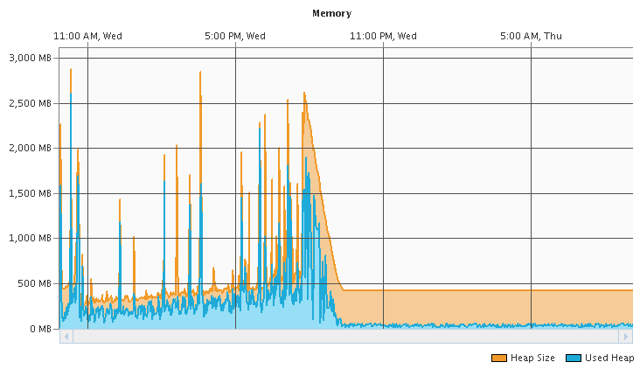
Figure 45. Memory utilzaion of GATK.
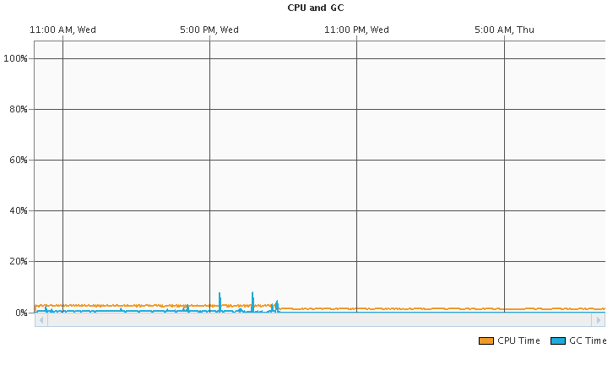
Figure 46. CPU time and garbage collection time of GATK.

Accelerator Technology
At this stage no specific progress has been made working with accelerator technology as no accelerators are yet available to the project. However, UK STFC Daresbury have discussed with us their experiences using early access to Intel Knights Corner (KnC) and the more recent Knights Landing (KnL). The KnL processor will have some noticeable improvement over using the KnC. The KnC uses Interim Many Core Instructions (IMCI) but has some known arithmetic issues such no trapping of floating point exceptions and underflow problems. The Intel compilers also have some issues with the KnC – such as ‘–fp-model strict’ preventing vectorisation (which is used in the Unified Model). In testing KnL, attention will need to focused on vector widths and memory alignments. These were discovered to be the critical issue in achieving performance from this technology; without which these processors perform worse than a regular Intel Xeon processor.

PUBLISHED REPORTS AND OTHER DOCUMENTS
- Marshall Ward presented the work on MOM5 subroutine scaling at the Australian Meteorological and Oceanographic Society (AMOS) 2016 General Meeting.
- Dale Roberts wrote significant work for the MPI-IO server implementation for the UK UM, which has been incorporated in the release notes of 10.4.
- Ben Evans presented redacted versions of the Scaling results for the UK Met Office UM collaborators THIP Working Group.
- Rui Yang wrote technical reports on HDF5 and NetCDF4 for discussions with HDF5 group during a week-long discussion of I/O futures.
- Jim Enright wrote a document “MOM: Porting and Performance on Fujitsu PRIMERGY” on 26 Feb. This report is consistent with the detailed analysis performed by Marshall Ward that has been included in the body of this status report.
- llia Bermous presented performance issues of UM and 4DVAR on Intel Sandy Bridge systems at an UK Met Office seminar, 16 September, 2015.
- All team members produced reports and presentations for a collaboration meeting with Fujitsu staff, 9-13 November, 2015.

