Ütle: writing and browsing the web by speaking Estonian
Solution overview. NewWorkTech Inclusive Digital Innovation Hackathon, TalTech Mektory, Tallinn, 5 and 6 October 2026.

Problem and target users
Ütle (Estonian for “say”) is a Chrome extension that lets people who cannot use their hands write messages and use the web by speaking Estonian. It is for people who cannot type or use a mouse comfortably because of a motor disability, an injury or an illness, and who can speak. Many of them already move the pointer with an eye tracker.
No mainstream hands-free tool works in Estonian. Windows Voice Access, Apple Voice Control and Dragon do not support the language, and Windows voice typing writes Estonian but cannot control the computer. Eye tracking works in any language but is slow for writing, and the eye-tracker user we worked with finds it hard to use with forms and PDF files. Dictation makes mistakes, and correcting one usually needs a keyboard. For him, writing one short message to a friend can take minutes.

Proposed solution
Ütle adds a bar to the bottom of every page in Chrome. The person speaks; the bar shows the words as they are heard and one line saying what was done.
- Messages in the sites people already use. In WhatsApp Web the words appear in the site’s own message box while the person speaks. Saying „saada“ (send) sends the message, and nothing is sent before that.
- Corrections by voice. „Mitte kolm, vaid neli“ (not three, four) replaces the wrong word, „kustuta viimane sõna“ deletes the last word and „võta tagasi“ undoes. The cursor can be moved, and text selected and inserted, as with a keyboard.
- Moving around the browser. „Järgmine vaheleht“ (next tab), „keri alla“ (scroll down), „ava postimees“, „otsi …“ (search). „Näita numbreid“ puts a number on every link and button, and saying a number clicks it, so sites Ütle has never seen can be used too.
- Requests in ordinary words. Common commands are recognised by fixed rules on the computer. A sentence the rules do not recognise, such as „mine youtube’i ja otsi kassivideod“ (go to YouTube and search for cat videos), is sent as text with a description of the page to a Claude language model. The model may answer only with actions from a fixed list, and each action is checked before it runs.
- Forms. Numbers, e-mail addresses and ID codes spoken as words are typed as digits and characters. „Valmis“ (done) moves to the next field and „kinnita“ (confirm) submits. An e-mail address or phone number can be saved once and later inserted by saying „minu e-post“ (my e-mail).
- No hands at any step of use. With an eye tracker, listening switches on while the pointer rests on the bar and off when it leaves. „Puhka“ (rest) stops typing what is heard until „ärka üles“ (wake up), so the person can talk to someone in the room.
Speech is recognised by the Estonian speech recognition model of TalTech’s Laboratory of Language Technology (Tanel Alumäe), which is open source and not our work. It runs on the user’s own computer, so no audio leaves it. The language model receives text and a description of the page, never audio.
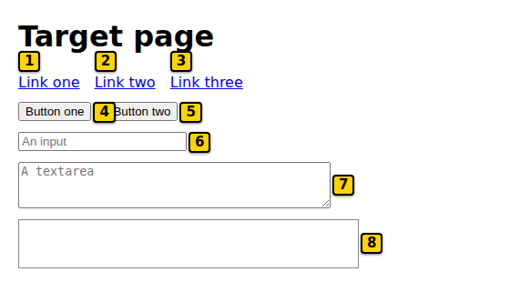 | 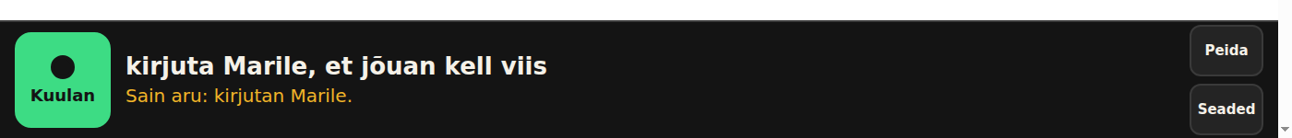  Left: after „näita numbreid“ (show numbers) every link, button and field on a test page has a number, and saying the number clicks it. Right: the bar at the bottom of the page after „kirjuta Marile, et jõuan kell viis“ (write to Mari that I will arrive at five). Ütle answers „Sain aru: kirjutan Marile.“ (Understood: writing to Mari.) and opens the chat. Both screenshots use test pages and made-up names.

Co-creation
The project changed direction on the first day. Our first version was a document editor in which spoken edits were shown as proposals to accept or reject. After talking with an eye-tracker user with a motor disability, who took part as the expert with lived experience, we rebuilt it around three things he said: typing messages is slow, he wants to move around the browser by voice, and it has to be in Estonian, not English. That is why Ütle works inside WhatsApp and the browser and not in a window of its own.
He used the prototype during the hackathon and reported problems three times. Each report led to changes built the same day or night:
- After the first day: commands worked only as exact phrases, so the language model was added for ordinary sentences. Words could end up in the wrong field, so dictation now goes only into a box the person chose. He asked for push-to-talk by looking, editing inside the text, slow scrolling, and commands understood as Estonian speakers pronounce them („juutuba“ for YouTube). Once the speech server fell minutes behind; it now drops old audio instead.
- After the morning demo: the microphone picked up other people talking, so Ütle can learn his voice from eight seconds of speech and ignore other voices. He also wanted to give several steps in one sentence, which now works.
- After the afternoon demo: entering an e-mail address, phone number or ID code was very hard, a long request was acted on too quickly, Ütle once got stuck thinking, and he could not enlarge the page. Spoken forms, saved personal details, more careful handling of long requests, a 25-second limit with „katkesta“ (cancel) to stop everything, and „suurenda“ / „vähenda“ (zoom in, zoom out) were built in response.
His work laptop does not allow installing software, which is why the speech server can now also run hosted on the internet.
[Ralf: add one or two sentences on what the mentors advised and what changed because of it, or delete this line.]

Current development stage
Ütle is a working prototype. Everything described above is built. Dictating and sending in real WhatsApp Web has been done by team members, and the expert used versions of it during the hackathon demos. The rest is tested with about 2,500 automated tests, with recorded Estonian speech run through the real speech model, and on test pages that imitate WhatsApp, Messenger and a Smart-ID login.
Still to do or prove: most features built in the last rounds have not yet been tried with the expert’s own voice; it has not been tested with a real eye tracker; Messenger has not been tried on the real site; and nobody has measured whether it is faster than his current way of writing. It works only in Google Chrome on a computer and only inside web pages. Installing it still needs a developer, because the speech server runs on the same computer. The hosted server is built but not yet running, and the extension is not in the Chrome Web Store.

Potential benefits and next steps
The first group to benefit is people in Estonia whose motor disability makes typing hard but leaves speech usable, together with the carers who now type for them. Later the same approach could serve anyone whose hands are busy or tired, and speakers of other small languages that large voice tools serve badly.
Next steps:
- Test with several users on their own computers and eye trackers for some weeks, and measure the time per message against their current method.
- Run the speech server hosted, so that nothing has to be installed, and publish the extension in the Chrome Web Store.
- Support more everyday sites by name: e-mail, online banking and e-services such as eesti.ee.
- Later, a desktop program that works outside the browser as well.
For this we would need test users through disability organisations, a review of data protection for the hosted option (audio then leaves the computer), and continued cooperation with TalTech’s Laboratory of Language Technology on Estonian speech recognition. Töötukassa funds work-related aids, including software, which is one possible route for users to get Ütle at no cost.

