**Identification of candidates for longer lung cancer screening intervals following a negative CT result**

Hilary A. Robbins,1 Christine D. Berg,2 Li C. Cheung,2, Anil K. Chaturvedi,2 Hormuzd A. Katki2

1Department of Epidemiology, Johns Hopkins Bloomberg School of Public Health, Baltimore, Maryland. Current affiliation: International Agency for Research on Cancer, Lyon, France.

2Division of Cancer Epidemiology and Genetics, National Cancer Institute, Rockville, Maryland

Co-corresponding authors:

Hilary A. Robbins

150 cours Albert Thomas; 69372 Lyon CEDEX 08; France | [RobbinsH@iarc.fr](mailto:RobbinsH@iarc.fr)

Hormuzd A. Katki

9609 Medical Center Dr; 7E592; Bethesda, MD 20892 | [katkih@mail.nih.gov](mailto:katkih@mail.nih.gov) | 240-276-7423

Short title: Lengthening screening intervals during CT screening

Keywords: lung-cancer screening, CT screening, negative CT screen, screening intervals, precision medicine, risk-based medicine, risk modeling, precision prevention, precision screening

Funding: This study was supported in part by the Intramural Research Program of the U.S. National Institutes of Health/National Cancer Institute. H. Robbins was supported by the Cancer Epidemiology, Prevention, and Control Training Grant (NCI T32 CA009314) and by an individual National Research Service Award (NCI F31 CA210660).

Acknowledgment: We thank Dr. Scott Zeger and Dr. Rebecca Landy for their helpful comments on this manuscript. We are also grateful to the anonymous reviewers, whose thoughtful suggestions improved this manuscript.

Role of the sponsor: The NIH approved the final version of the manuscript but had no role in the design and conduct of the study; in the collection, analysis, and interpretation of the data; or in the preparation of the manuscript.

Conflicts of interest: HAR, LCC, AKC, and HAK report no conflict of interest. CDB receives consulting fees from Medial Early Sign, LLC and GRAIL, Inc.

Access to data: Hilary A. Robbins had full access to all of the data in the study and takes full responsibility for the integrity of the data and the accuracy of the data analysis.

JNCI Brief Communication

Abstract – 150/150

Manuscript – 998/1,000

Figures/tables – 2/2

**Abstract**

Lengthening the annual CT screening interval for individuals at lowest risk of lung cancer could reduce harms and improve efficiency. Using data from 23,328 participants in the National Lung Screening Trial who had a negative CT screen (no ≥4mm nodules), we developed an individualized lung-cancer risk model, LCRAT+CT, that updates “pre-screening risk” (calculated using traditional risk factors) with selected CT features. At the next annual screen following a negative CT, risk of cancer detection was reduced among the 70% of participants with neither CT-detected emphysema nor consolidation (median-risk=0.17%, IQR=0.11%-0.29%). However, risk increased for the 30% with CT-emphysema (median-risk=0.51%, IQR=0.32%‑0.81%) and the 0.6% with consolidation (median=1.58%, IQR=1.03%-2.48%). As one example, a threshold of next-screen risk below 0.3% would lengthen the interval for 58% of screen-negatives while delaying diagnosis for only 24% of cancers in screen-negatives. Our results support that many, but not all, screen-negatives might reasonably lengthen their CT screening interval.

Although efficacious, CT lung-cancer screening carries harms including false-positives1–4 and radiation-induced cancers.2,5 Screening uptake has been low6 and there is need to improve efficiency.7 Fortunately, multiple studies show that screen-negative individuals have reduced lung-cancer risk over subsequent screens.8–10 This suggests the possibility of lengthening screening intervals after a negative CT.11–14

However, not all screen-negatives have sufficiently low risk to lengthen intervals.15 It is unclear how to identify appropriate candidates, as existing risk models for screening either combine individuals with negative and abnormal screens16 or only predict current risk.17 Here, we develop a simple model, LCRAT+CT, to predict short-term future lung-cancer risk following a negative CT, accounting for both pre-screening risk-factors and negative-CT features. We suggest how LCRAT+CT could identify candidates for longer screening intervals.

We analyzed 23,328 CT-arm participants in the U.S. National Lung Screening Trial (NLST)1 who had at least 1 negative CT (i.e., no nodules ≥4mm in longest diameter). Among them, most had a negative result at all 3 screens, and 43 interval-cancers and 138 next-screen cancers occurred. First, we calculated individual 1‑year baseline “pre-screening risk” based on risk-factors using the Lung Cancer Risk Assessment Tool (LCRAT).18,19 Next, we selected features of a negative CT that modify the relationship between pre-screening and future lung-cancer risk. Specifically, we fit first-order Markov transition models using log-binomial regression.20,21 LCRAT+CT outputs future risk by raising pre-screening risk to an exponent determined by negative-CT features. We fit separate models for risk between screens (interval-cancer risk) and at the next annual screen (next-screen risk). The **Supplement** describes methodological details for LCRAT, feature selection, and LCRAT+CT model definition.

LCRAT+CT accounts for 4 properties of NLST screening that we observed during model development (details in **Supplement**). First, pre-screening risk strongly affected risk during screening. Second, pre-screening risk encapsulated the effects of individual risk-factors. Third, risk calculations were similar across NLST screens. Fourth, risk calculations were similar among individuals with a recent negative CT, regardless of their prior CT result.

Forty-three interval cancers arose after 56,921 negative screens, yielding 0.08% mean risk (detailed results in **Supplement**). For next-screen cancer, 138 cases were detected following 35,530 negative screens, yielding 0.39% mean risk. The next-screen risk-model included terms for CT-detected emphysema and consolidation. It had good cross-validated internal calibration (138/138.5 cases observed/predicted, p=0.93) and reasonable discrimination (optimism-corrected-AUC=0.73).

Due to variation in pre-screening risk and CT features, next-screen lung-cancer risk was heterogeneous (**Figure 1**). Among the 70% of screen-negatives with neither emphysema nor consolidation on their negative CT, median next-screen risk was reduced nearly 2-fold from 0.31% pre-screening risk to 0.17% (IQR=0.11%-0.29%). In contrast, for the 30% with CT-detected emphysema, risk increased 1.6-fold (median risk=0.51%, IQR=0.32%-0.81%). For the 0.6% with consolidation, risk increased 5-fold (median risk=1.58%, IQR=1.03%‑2.48%).

We examined potential risk thresholds to identify candidates for longer screening intervals (**Figure 2**). We considered next-screen risk only, because CT features did not stratify interval-cancer risk (**Supplement**). We first considered a threshold of 0.3% risk, below which screening is highly preference-sensitive.23 Thirty‑three of 138 (24%) next-screen cancers occurred among the 58% of screen-negatives with risk below 0.3%, meaning that 58% of screen-negatives could lengthen their interval while delaying diagnosis for 24% of cancers. Of these 33 cancers, 55% were stage‑1, some of which might become incurable if diagnosis were delayed. Lower thresholds reduce delayed diagnosis, for example, at 0.15%, 29% would lengthen their interval, but 7% of diagnoses were delayed.

Our findings indicate that reassurance from a negative CT is insufficient to recommend a longer interval for all screen-negatives. Instead, the decision requires comprehensive risk calculations incorporating pre-screening risk and individual CT findings. In practice, to update a screen-negative’s lung-cancer risk with LCRAT+CT, one would simply apply the appropriate exponent (corresponding to CT-emphysema and/or consolidation) to the LCRAT pre-screening risk. If a risk-threshold were established, then a longer interval could be offered to individuals below it, with use of a decision tool. Such an approach to reduce low-value screens in low-risk participants could ultimately reduce the number of false-positives, overdiagnosed lung-cancers, and radiation-induced cancers.

In relation to pre-screening risk, next-screen risk after a negative CT is driven by opposing forces: reduced risk from a negative screen combined with increased detection, some of which is screening-induced overdiagnosis. Estimates of overdiagnosis in CT screening vary, but modeling of long follow-up estimates <9%.28 Since we cannot know which cancers are overdiagnosed, LCRAT+CT estimates total next-screen risk.

Thresholds between 0.10%-0.40% are well within the range of annual risks for 53‑year‑old, ≥30‑pack‑year smokers,19 who are currently recommended to begin screening in 2 years.24 Because such people have a de-facto 2-year “lengthened interval”, their range of 1-year risks implicitly identifies potential thresholds for longer intervals that underlie existing guidelines. We note that the proportions in **Figure 2** are specific to the NLST and may vary with the population risk distribution and over time,25 though the individual risk-benefit tradeoff that they represent might be maintained.

Our study has limitations. External validation of LCRAT+CT is needed to determine its portability outside the NLST. We did not investigate whether other pre-screening risk-models can be substituted for LCRAT. We could not determine the specific length that longer intervals should be, because the NLST used only annual screening. Data from the NELSON and MILD trials support extending to 2 years, but not longer.29–31 Our calculations do not consider that some individuals with deleterious CT features may have reduced life-expectancy and thus lower benefit from annual screening. LCRAT+CT only applies to individuals who fit the NLST definition of screen-negative (i.e. no ≥4mm nodules). Finally, we did not estimate the reduction in screening effectiveness from lengthening intervals.

When considering for whom to lengthen screening intervals, guidelines committees might consider the benefit-harm tradeoff we presented within the broader context of feasibility, acceptability to patients, potential reduction in screening effectiveness, and costs. Like the decision to screen, the decision to lengthen intervals may be highly preference-sensitive for many patients.23 Ultimately, the individualized decision-making offered by our approach may provide an important avenue to improve efficiency and reduce harms in CT screening.

**References**

1. National Lung Screening Trial Research Team, Aberle DR, Adams AM, et al. Reduced lung-cancer mortality with low-dose computed tomographic screening. N Engl J Med 2011;365(5):395–409.

2. Bach PB, Mirkin JN, Oliver TK, et al. Benefits and harms of CT screening for lung cancer: a systematic review. JAMA 2012;307(22):2418–29.

3. Bach PB. Raising the bar for the U.S. Preventive Services Task Force. Ann Intern Med 2014;160(5):365–6.

4. Kinsinger LS, Anderson C, Kim J, et al. Implementation of lung cancer screening in the Veterans Health Administration. JAMA Intern Med 2017;177(3):399–406.

5. de Koning HJ, Meza R, Plevritis SK, et al. Benefits and harms of computed tomography lung cancer screening strategies: a comparative modeling study for the U.S. Preventive Services Task Force. Ann Intern Med 2014;160(5):311–20.

6. Jemal A, Fedewa SA. Lung cancer screening with low-dose computed tomography in the United States - 2010 to 2015. JAMA Oncol 2017;3(9):1278–81.

7. Green AK, Bach P. Model-based eligibility for lung cancer screening: Where theory meets practice. Ann Intern Med 2018;168(3):223–4.

8. Patz EF, Greco E, Gatsonis C, Pinsky P, Kramer BS, Aberle DR. Lung cancer incidence and mortality in National Lung Screening Trial participants who underwent low-dose CT prevalence screening: a retrospective cohort analysis of a randomised, multicentre, diagnostic screening trial. Lancet Oncol 2016;17(5):590–9.

9. Tammemagi MC, Schmidt H, Martel S, et al. Participant selection for lung cancer screening by risk modelling (the Pan-Canadian Early Detection of Lung Cancer [PanCan] study): a single-arm, prospective study. Lancet Oncol 2017;18(11):1523–31.

10. Horeweg N, van Rosmalen J, Heuvelmans MA, et al. Lung cancer probability in patients with CT-detected pulmonary nodules: a prespecified analysis of data from the NELSON trial of low-dose CT screening. Lancet Oncol 2014;15(12):1332–41.

11. van der Aalst CM, Ten Haaf K, de Koning HJ. Lung cancer screening: latest developments and unanswered questions. Lancet Respir Med 2016;4(9):749–61.

12. Field JK, Duffy SW. Lung cancer CT screening: is annual screening necessary? Lancet Oncol 2016;17(5):543–4.

13. Karachaliou N, Sosa AE, Rosell R. Annual or biennial lung cancer CT screening? J Thorac Dis 2016;8(9):2424–6.

14. Ridge CA, Boiselle PM. Optimizing the lung cancer screening interval: the world is waiting. J Thorac Dis 2016;8(10):E1369–70.

15. Kavanagh J, Liu G, Menezes R, et al. Importance of long-term low-dose CT follow-up after negative findings at previous lung cancer screening. Radiology 2018;180053.

16. Schreuder A, Schaefer-Prokop CM, Scholten ET, Jacobs C, Prokop M, van Ginneken B. Lung cancer risk to personalise annual and biennial follow-up computed tomography screening. Thorax 2018;

17. McWilliams A, Tammemagi MC, Mayo JR, et al. Probability of cancer in pulmonary nodules detected on first screening CT. N Engl J Med 2013;369(10):910–9.

18. Katki HA, Kovalchik SA, Berg CD, Cheung LC, Chaturvedi AK. Development and validation of risk models to select ever-smokers for CT lung cancer screening. JAMA 2016;315(21):2300–11.

19. National Cancer Institute. Lung cancer risk assessment tool. Accessed 2018 Apr 17. Available at https://analysistools.nci.nih.gov/lungCancerRiskAssessment/.

20. Diggle P, Heagerty P, Liang K-Y, Zeger S. Chapter 10: Transition Models. In: Analysis of Longitudinal Data, Second Edition. 2013.

21. Wacholder S. Binomial regression in GLIM: estimating risk ratios and risk differences. Am J Epidemiol 1986;123(1):174–84.

22. Gierada DS, Pinsky PF, Duan F, et al. Interval lung cancer after a negative CT screening examination: CT findings and outcomes in National Lung Screening Trial participants. Eur Radiol 2017;27(8):3249–56.

23. Caverly TJ, Cao P, Hayward RA, Meza R. Identifying patients for whom lung cancer screening is preference-sensitive: A microsimulation study. Ann Intern Med 2018;169(1):1–9.

24. Moyer VA. Screening for lung cancer: U.S. Preventive Services Task Force recommendation statement. Ann Intern Med 2014;160(5):330–8.

25. Cheung LC, Katki HA, Chaturvedi AK, Jemal A, Berg CD. Preventing lung cancer mortality by computed tomography screening: The effect of risk-based versus U.S. Preventive Services Task Force eligibility criteria, 2005-2015. Ann Intern Med 2018;168(3):229–32.

26. University of Michigan. shouldiscreen.com. Accessed 2017 May 13. Available at www.shouldiscreen.com.

27. National Cancer Institute. Risk-based NLST Outcomes Tool (RNOT). Accessed 2018 Apr 17. Available at https://analysistools.nci.nih.gov/lungCancerScreening.

28. Ten Haaf K, de Koning HJ. Overdiagnosis in lung cancer screening: why modelling is essential. J Epidemiol Community Health 2015;69(11):1035–9.

29. Horeweg N, van der Aalst CM, Thunnissen E, et al. Characteristics of lung cancers detected by computed tomography screening in the randomized NELSON trial. Am J Respir Crit Care Med 2013;187(8):848–54.

30. Yousaf-Khan U, van der Aalst C, de Jong PA, et al. Final screening round of the NELSON lung cancer screening trial: the effect of a 2.5-year screening interval. Thorax 2017;72(1):48–56.

31. Sverzellati N, Silva M, Calareso G, et al. Low-dose computed tomography for lung cancer screening: comparison of performance between annual and biennial screen. Eur Radiol 2016;26(11):3821–9.

**Figure 1: Effect of features noted on a negative CT screen on risk of next-screen lung-cancer detection among participants in the National Lung Screening Trial**

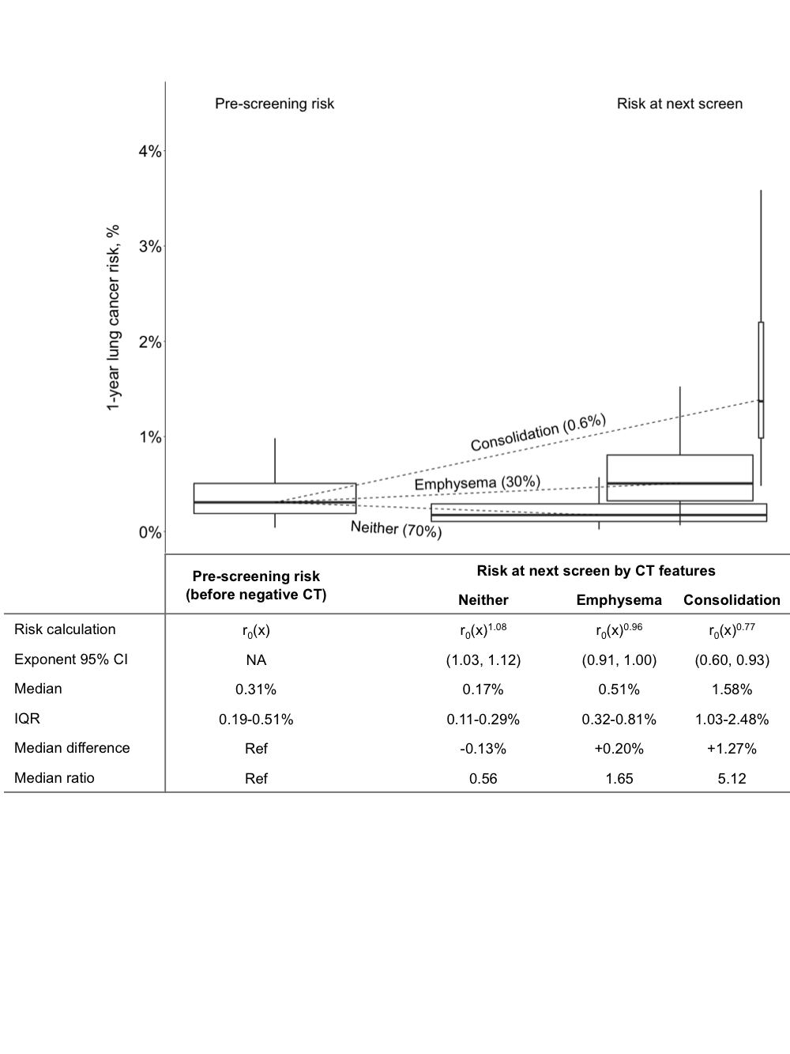

For illustration, this figure was constructed using data from individuals who screened negative at the first NLST screen (T0) and were subsequently at risk for lung cancer at the second screen (T1) (N=18,245). Among these individuals, 30% (N=5,484) had emphysema noted on their negative CT, 0.6% (N=106) had consolidation, and 70% (12,691) had neither (N=36 with both emphysema and consolidation were included in both risk distributions). Pre-screening risk r0(x) was calculated using the Lung Cancer Risk Assessment Tool.18 Outliers are not included in the figure, but are included in the calculations in the table. Within each group of boxplots, boxplot widths are scaled by the percentage of the population represented, boxplot heights represent the interquartile range, and the vertical lines (whiskers) represent the range of data excluding outliers. IQR, interquartile range.

**Figure 2: Potential effect of LCRAT+CT risk thresholds for longer screening intervals among screen-negative participants in the National Lung Screening Trial**

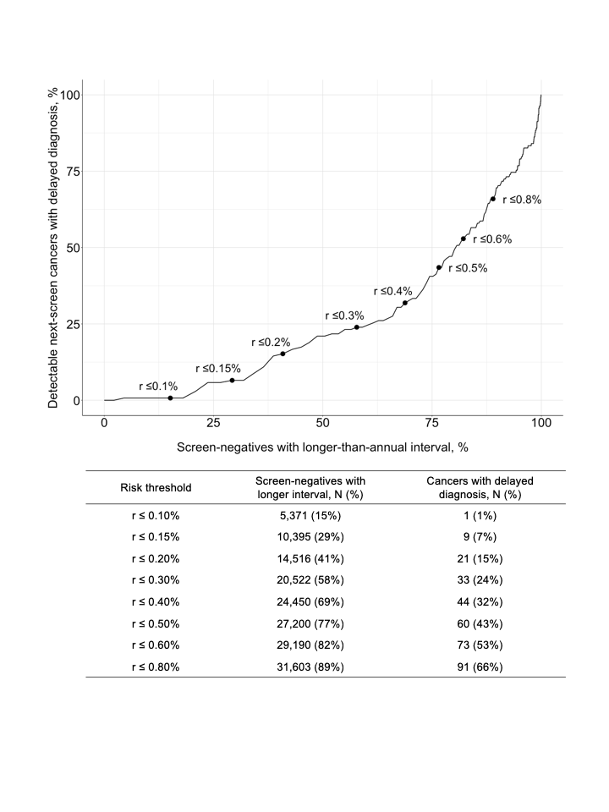

Points and labels indicate potential next-screen risk thresholds for lengthening CT screening intervals beyond 1 year. For example, if the interval were lengthened for those with a predicted next-screen risk ≤0.3%, then the interval would be lengthened for 58% of screen-negatives. Among them, 33 cancers were detected at the next screen and would therefore have their diagnosis delayed (i.e., 33/138 or 24% of all detectable next-screen cancers). Screen-negatives at both T0 and T1 (and corresponding cancers at T1 and T2) were included in this analysis, such that individuals with a negative result at both screens may be included twice.