DICOM Image Viewer Documentation

Date: Jun 29, 2023
Version: 1.0
DICOM Viewer is simple and elegant viewer, designed to work with DICOM files and extract meta data from them.

1. Installation

- Download Python 3
- Extract the archive to a folder of your choice
- Navigate to the folder from your terminal and run project with following command:
$ python DicomViewer.py

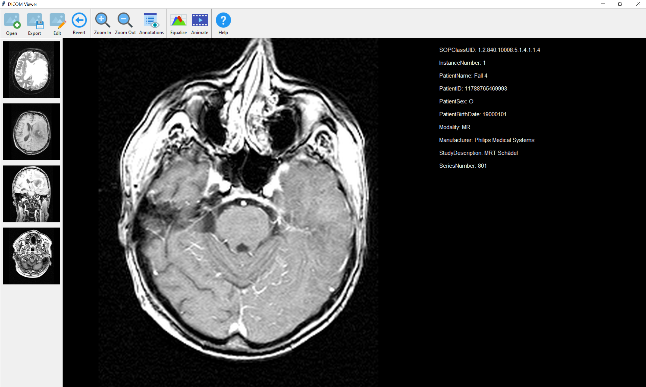

2. User Guide

How to open DICOM images
- Click on Open button
- Click on Open DICOM Image
- Select one or more DICOM files of your choice
- Тhe selected images will be automatically combined by series number (SeriesInstanceUID) and previewed with a thumbnail in the left bar of the program

How to open DICOM archive (.zip)
- Click on Open button
- Click on Open ZIP File
- Select a .zip archive
- Тhe extracted images will be automatically combined by series number (SeriesInstanceUID) and previewed with a thumbnail in the left bar of the program
How to export DICOM images to PNG image files (this feature is in TODO state)
- Click on Export button
- Select images to export: Export Current Image or Export Current Series
- Your files will be exported in 'data' directory under the main project directory

How to edit DICOM images
- Click on Edit button
- Choose a filter or transfromation to aply
- The selected option will be applied to the current image only
- Options include: Sharpen Image, Smooth Image, Rotate 90' CW, Rotate 180' CW, Flip Horizontal, Flip Vertical

How to revert transformations or filters applied on DICOM images
- Click on Revert button
- The operation will be applied to the current image only

How to zoom in or zoom out DICOM images
- Click on Zoom In or Zoom Out button depending on the operation selected
- The operation will be applied to the current image only

How to hide annotation of DICOM images
- Click on Annotations button
- The operation will be applied to the current image only

How to automatically adjust constrast of DICOM images
- Click on Equalize button
- The operation will be applied to the current image only

How to animate a series of DICOM images
- Click on Animate button
- The operation will be applied to the current image only

3. API reference

DicomViewer
- A class implementing the main interface of the application.
- Methods:
initGUI Initialization of graphicаl elements of the main window
loadIcons Initialization of graphicал elements oф the main window
loadMenu Loads main menu
reloadPreviewBar Loads previews of selected DICOM image series
onOpenImgCanvas Loads selected DICOM image
onOpenDICOM Opens DICOM images
onOpenZIP Open archive with DICOM images
onExportImg Exports currently selected DICOM image to other image formats
onExportSeries Exports all images froma a DICOM series to other image formats
onSmoothImg Applies Gaussian Blur filter to DICOM series
onSharpenImg Applies Sharpen filter to DICOM series
onRotateRight90Img Rotate DICOM series to 90 degrees CW
onRotateRight180Img Rotate DICOM series to 180 degrees CW
onFlipHorzImg Flip DICOM series horizontaly
onFlipVertImg Flip DICOM series verticaly
onRevertImg Revert transformations and filters applied on DICOM series
onZoomIn Zooms in the current DICOM image
onZoomOut Zooms out the current DICOM image
onAnnotation Show/Hide annotations of DICOM series
onEqualizeImg Automatically adjust contrast of DICOM series
onDocumentation Shows documentation in browser
onExit Closes the main windows with Escape button

ImgCanvas
- A helper class implementing basic functionality for displaying a selected DICOM series
- Methods:
reset Changes the displayed DICOM image series
description Shows/Hides annotations of DICOM series
zoomin Zooms in the currently displayed DICOM image series
zoomout Zooms out the currently displayed DICOM image series
resize Resizes currently displayed DICOM image series on application request
reindex Scrolls through displayed DICOM image series
redrawAll Refreshes all graphicаl elements used for displaying selected DICOM series
redraw Refreshes displayed DICOM series

DicomController
- A class for collecting data to dispaly on the main widow
- Methods:
readData Gathers data from DICOM image series
writeData Saves data from DICOM images series
generatePreview Generates preview thumbnails for displayed DICOM image series
generateImages Generates images for displayed DICOM image series
generateAttributeData Generates annotations data for displayed DICOM image series
removeDICOM Removes all data for a DICOM image series
getData Returns data gathered from all DICOM series
clearData Clears data gathered from all DICOM series

DicomIO
- A class for basic I/O operations with DICOM images
- Methods:
readDICOM Reads DICOM image series
readZIP Reads /zip archive with DICOM image series
writeDICOM Saves DICOM image series to file

DicomSeries
- A model class holding information from DICOM image series
- Methods:
getSerId Returns SeriesInstanceUID of DICOM image series
setSerId Sets SeriesInstanceUID of DICOM image series
getImageData Returns all image data of DICOM image series
addImage Adds image to DICOM image series
getPreviewImageData Gets Preview thumbnail Image for DICOM image series
getPreviewImageName Gets Preview thumbnail Image name for DICOM image series
anonymizePatientData Deletes patient's infromation from DICOM image
getAttributeData Returns annotation data of DICOM image series
setAttributeData Sets annotation data of DICOM image series
getStrAttributeData Returns annotation data of DICOM image series as string

