Database primary/foreign key update procedure

Martyn Smith  
05/19/2017

The process generally outlined in this document details how to create new auto numbered primary key (PK) fields in each table. It also details how to set up and populate the primary key from the “master_sites” table as a foreign key (FK) in linked tables. This will greatly reduce database bloat and generally complies with well-established database design best practices.

1. Create a new unique ID field as a Primary Key (PK) in “master_sites” table.
   1. Set the Data Type to “AutoNumber”
   2. While the Data Type field is highlighted, at the bottom set the “Indexed” value to “Yes (No Duplicates)”. The primary key field in EVERY table should be set to “Yes (No Duplicates)”.
   3. Give it a description  
        
      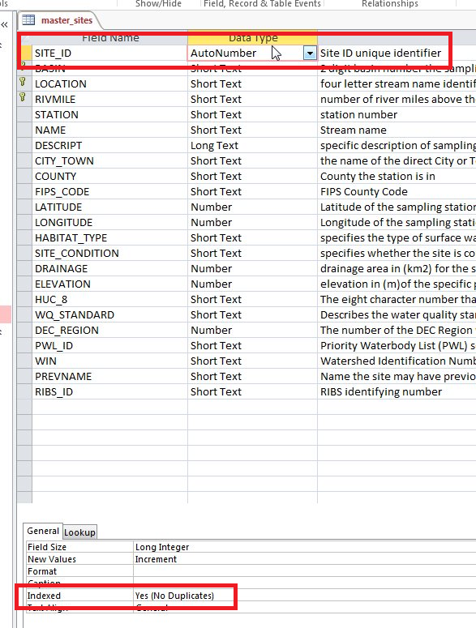
2. In each table that will be linked to “master_sites” table (in this case “master_userperception”, we need to:
   1. Create an appropriately named unique ID autonumbered field (PK) and set “Indexed” to “Yes (No Duplicates)”. In this case we used “OBSERVATION_ID”
   2. Create a “SITE_ID” field that will serve as the Foreign Key (FK) to link back to the “master_sites” table. Set the “Indexed” value to “Yes (Duplicates OK)”  
        
      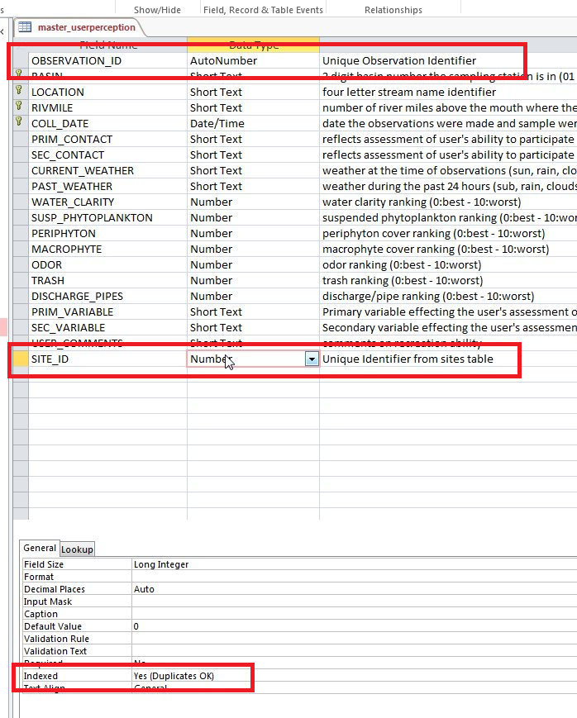
3. Next step is to populate the “SITE_ID” field in each table that will be linked back to the “master_sites” table. This is done in Access using an “UPDATE” query.
   1. Add a new query using “Query Design” button
   2. Add the “master_sites” table and the table you want to add the “SITE_ID” field to. In the screenshot we are using “master_userperception”
   3. In the upper left, change the query type to “Update”
   4. In the bottom panel, select the field “master_userperception.SITE_ID” and the table “master_userperception”  
        
      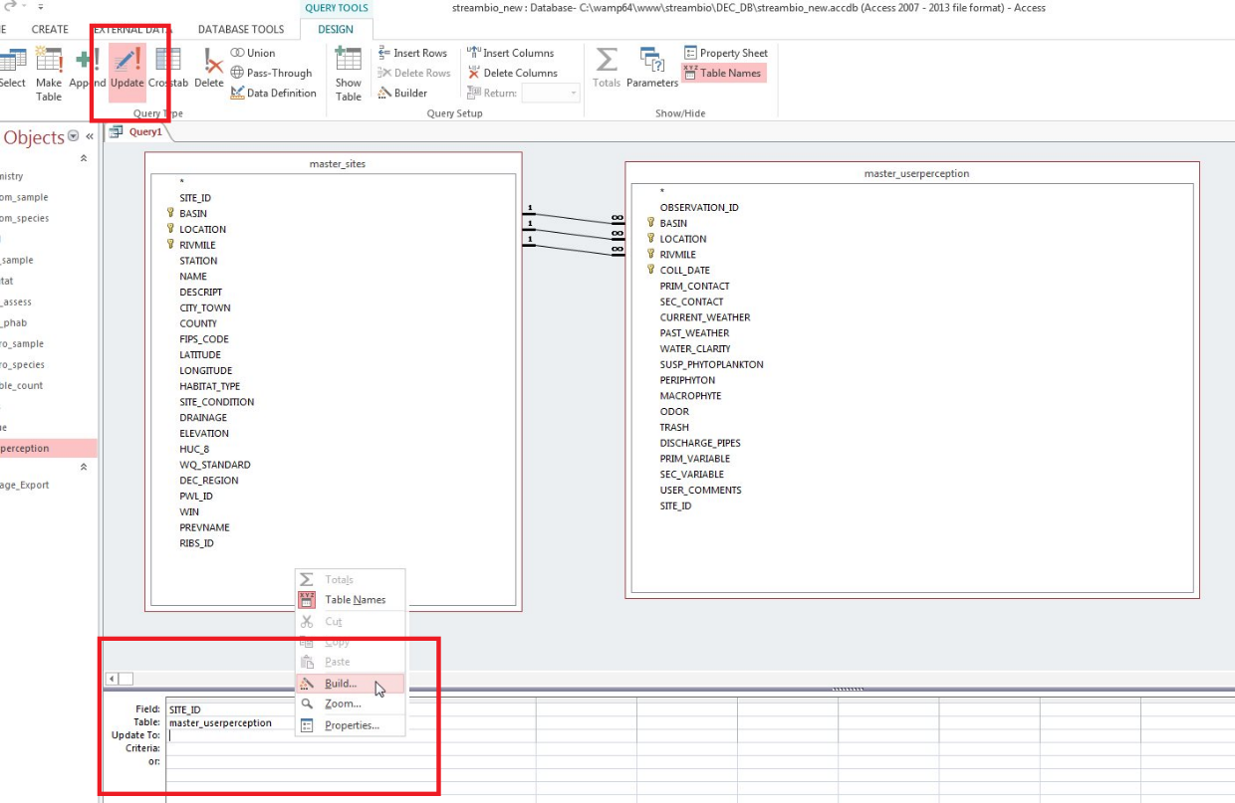
   5. For the third field labelled “Update To” right-click in the blank area and go to “Build”. Select the table “master_sites” and then select the field “SITE_ID”. The top box should look like this when you are done:  
        
      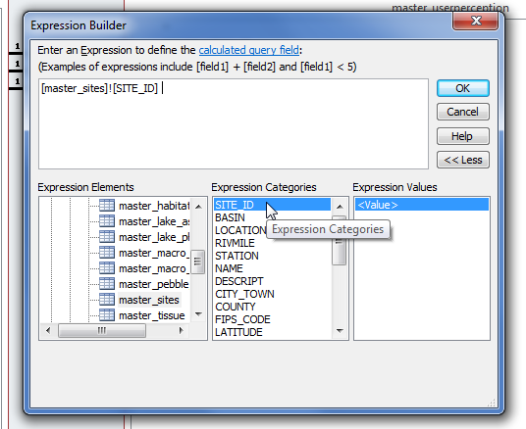
4. Now you should be ready to run the query using the “Run” button in the upper left. Confirm that you now have the “SITE_ID” field in the table that you were linking to:

