**Tunku Abdul Rahman University College**

**AACS2204**

**Object-Oriented Programming Techniques**

**Assignment**

**2021/2022**

Programme : Diploma in Information Technology

Tutorial Group : G5

Date Submitted to Tutor : 17/09/2021

**Team Members:**

|  |  |  |
| --- | --- | --- |
| **No** | **Student Name** | **Student ID** |
| 1. | Cheah Wen Xian | 20PMD06065 |
| 2. | Lee Ting Le | 20PMD06172 |
| 3. | Mikael Koay | 20PMD05367 |
| 4. | Yip Fan | 20PMD00077 |

|  |  |  |
| --- | --- | --- |
| **No.** | **Team Member** | **Task(s) Allocated** |
| **1.** | Cheah Wen Xian | Calculation and finalize process flow |
| **2.** | Lee Ting Le | Design table and test the module |
| **3.** | Mikael Koay | UML creator and variable creator |
| **4.** | Yip Fan | Control process flow and suggestion provider |

**Coursework Declaration**

We confirm that we have read and shall comply with all the terms and conditions of TAR University College’s plagiarism policy.

We declare that this assignment is free from all forms of plagiarism and for all intents and purposes is our own properly derived work.

|  |  |  |  |
| --- | --- | --- | --- |
| **xian** | **le** | **koay** | **yip** |
| Cheah Wen Xian | Lee Ting Le | Mikael Koay | Yip Fan |
| 17/9/2021 | 17/9/2021 | 17/9/2021 | 17/9/2021 |

Signature :

Name :

Date :

Table of Contents

**Task 1 Description** 1

**1.1 Assignment idea** 1

**1.2 User Manual** 2

**1.2.1 Choose Menu** 2

**1.2.2 Choose Option 1** 3

**1.2.3 Choose Option 2** 3

**1.2.4 Select movies** 4

**1.2.5 Choose seat size** 4

**1.2.6 Shows booking details to user** 5

**1.2.7 Shows payment details to user & enter payment amount** 5

**1.2.8 Receipt for regular cinema** 6

**1.2.9 Choose option 3** 7

**1.2.10 Choose meal sets** 7

**1.2.11 Shows booking and payment details** 8

**1.2.12 Receipt for vip cinema** 9

**1.2.13 Choose option 4** 10

**Task 2 UML Diagram** 11

# **Task 1 Description**

## **1.1 Assignment idea**

The case study we selected for this assignment is the cinema front-end reservation and payment system. For this job, we plan to use a driver class, testCinema, to integrate and run all classes. We plan to divide the cinema into two parts, namely ordinary cinema and VIP cinema that open for member. In ordinary movie cinema, we allow users to choose the size of their seats. For large seats, additional fees will be required. In VIP cinema, members default to large seats, and members can choose meals. Different meals will have different prices. After the customer selects a seat or meal, they need to enter the payment. If the payment is greater than the price, an exchange will be given. After the payment is completed, the customer will receive a receipt, and the customer can choose to exit the system or return to the main menu. For the main menu, we will provide 4 options, namely show movie display, ordinary cinema reservation, VIP cinema reservation and exit system. For the on showing movie option, it will display the latest movie details. Before users choose a meal or seat, the system will also ask them to enter personal information. Additional information will be included in the receipt, followed by the total price, selected seats or meals, total payment and exchange amount.

## **1.2 User Manual**

### **1.2.1 Choose Menu**

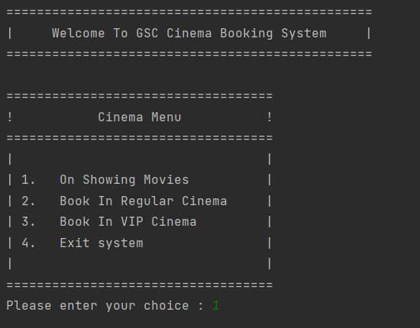

Figure 1: shows the cinema menu



Figure : shows the choice selection

There are 4 options provided in the cinema menu. First, user can select option 1 to 4, if user choose other than this, it will prompt user to enter again.

### **1.2.2 Choose Option 1**

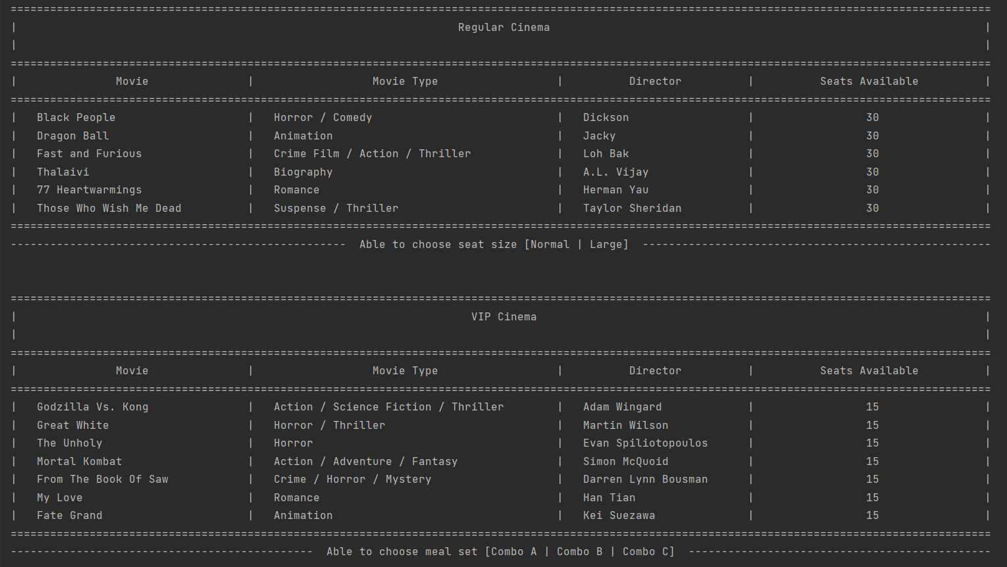

Figure 3: shows the cinema movie list

When user choose option 1, it will display all the movies that are on showing in regular and vip cinema. Other than this, at the bottom of the table will show the special service of each cinema. For example, regular cinema can only choose the seat size while vip cinema can order the meal.

**1.2.3 Choose Option 2**

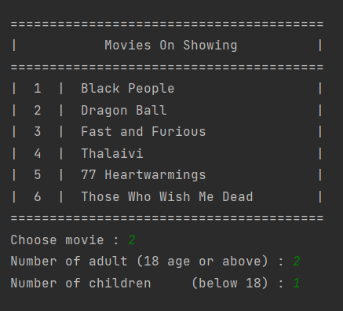

Figure 4: shows the regular cinema booking

After user choose to book the seat in regular cinema, they will need to provide their personal details and there will be some validation inside.

### **1.2.4 Select movies**



Figure 5: shows movies selection

After entering the personal information, the system will show a movies menu and let the user to choose. And also, if the user chooses the number that are not exist in this menu, it will also prompt the user to enter again. After choosing the movie, user will need to enter how many numbers of adult and children are going to watch the movie.

### **1.2.5 Choose seat size**

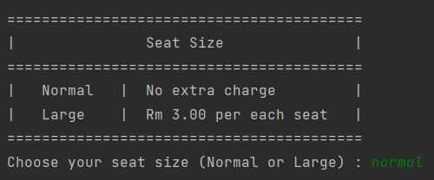

Figure : shows the seat size selection

User can choose the seat size that shows in the menu. Normal will not charge anything to the user while large seat size will charge RM3 per each seat.

### **1.2.6 Shows booking details to user**

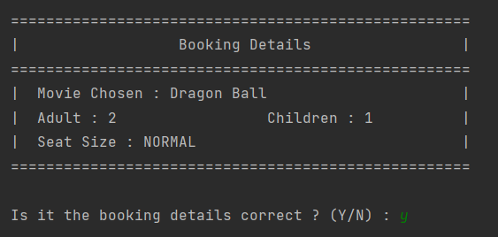

Figure : shows the booking details

User can check their booking details by looking at this table. So, if the booking details are incorrect or user want to change the booking details, he or she can enter ‘n’ to back to the initial cinema menu.

### **1.2.7 Shows payment details to user & enter payment amount**

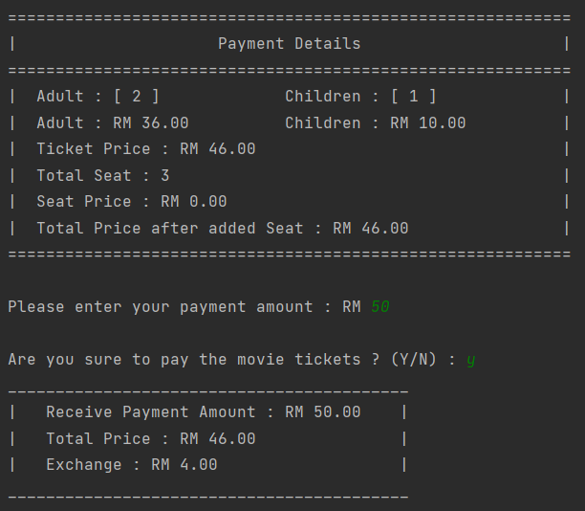

Figure : shows the payment details

After user confirm that the booking details are correct, this table will shows to the user. User can enter the payment amount into the system. If the payment amount entered by user is lower than the total price shows in the table, the system will alert and prompt the user to re-enter the sufficient amount. And a confirmation message will also prompt to user. If user enter ‘y’, the system will show the exchange amount to the user. If user enter ‘n’, the system will back to the cinema menu.

### **1.2.8 Receipt for regular cinema**

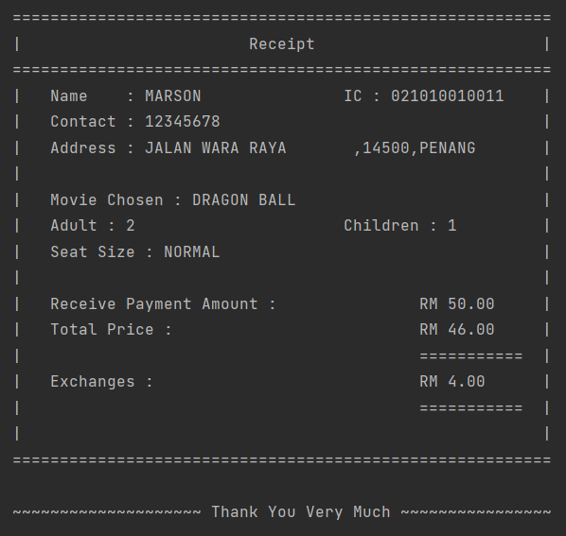

Figure : shows the receipt

When user confirm to pay the money, a receipt table will show on the screen to the user. Inside this receipt will include everything that user entered and chosen such as personal information, booking details and payment details. Last but not least, an appreciative message will display on the bottom of the table.

### **1.2.9 Choose option 3**

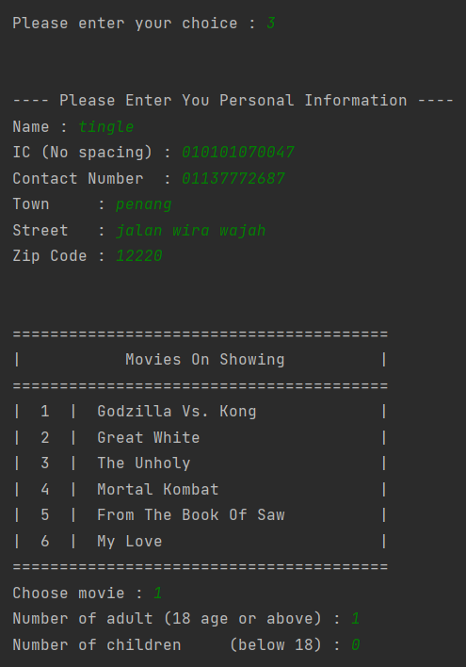

Figure : shows the vip cinema booking

When user choose to book in vip cinema, the process are actually very similar to the regular cinema. User will also need to enter the personal details and select the movie and enter the number of adult and children.

### **1.2.10 Choose meal sets**

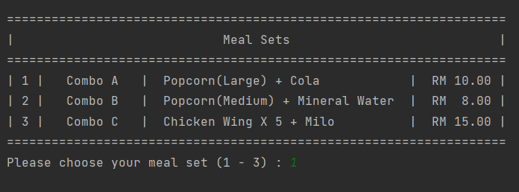

Figure : shows the meal set options

This is different from the regular cinema, because user is able to choose the meal set.

### **1.2.11 Shows booking and payment details**

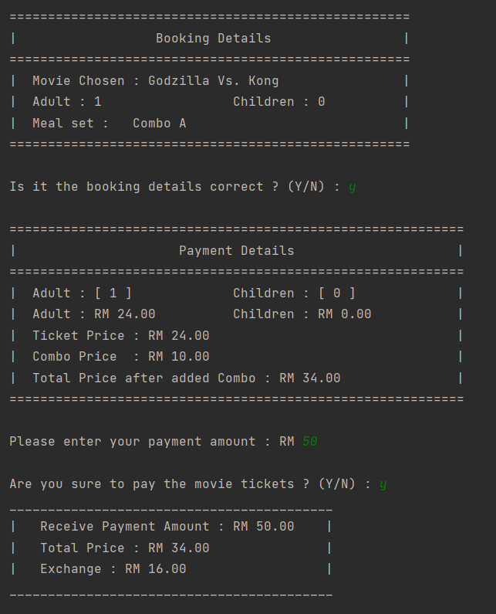

Figure : shows the booking and payment details

User can check the booking details and payment details whether everything is fine. After that, he or she will need to enter the payment amount.

### **1.2.12 Receipt for vip cinema**

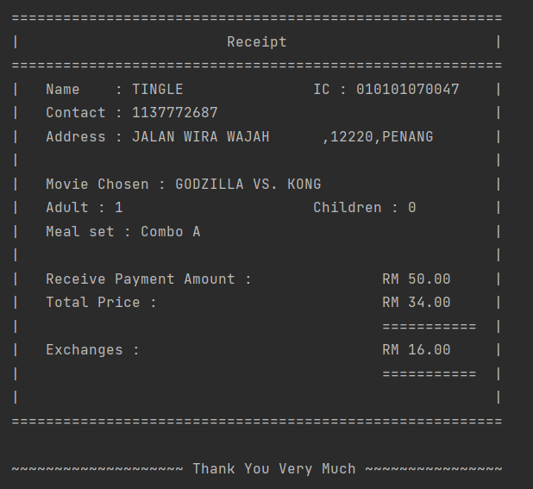

Figure : shows the receipt for vip cinema

### **1.2.13 Choose option 4**

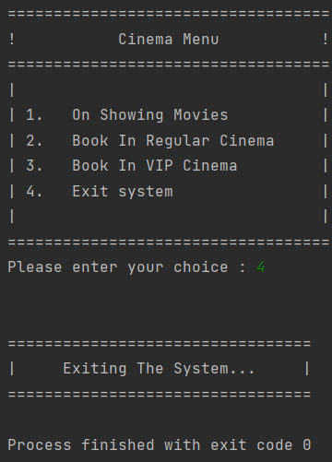

Figure : shows the exit function

When the user choose option 4, the system will automatically terminate and a quitting message will shows to the user.

# **Task 2 UML Diagram**

Figure : shows the UML diagram of the system