We use the Jacoco package to plugin to MVN environment(build).

The detailed configuration as follows:

Jacoco version: 0.7.9

<plugin>

<groupId>org.jacoco</groupId>

<artifactId>jacoco-maven-plugin</artifactId>

<version>0.7.9</version>

<executions>

<execution>

<id>prepare-agent</id>

<goals>

<goal>prepare-agent</goal>

</goals>

</execution>

<execution>

<id>post-unit-test</id>

<phase>test</phase>

<goals>

<goal>report</goal>

</goals>

<configuration>

<!--Sets the path to the file which contains the execution data.-->

<dataFile>target/jacoco.exec</dataFile>

<!--Sets the output directory for the code coverage report.-->

<outputDirectory>target/jacoco-ut</outputDirectory>

</configuration>

</execution>

</executions>

</plugin>

Detailed in the below for each of five systems,

Collection

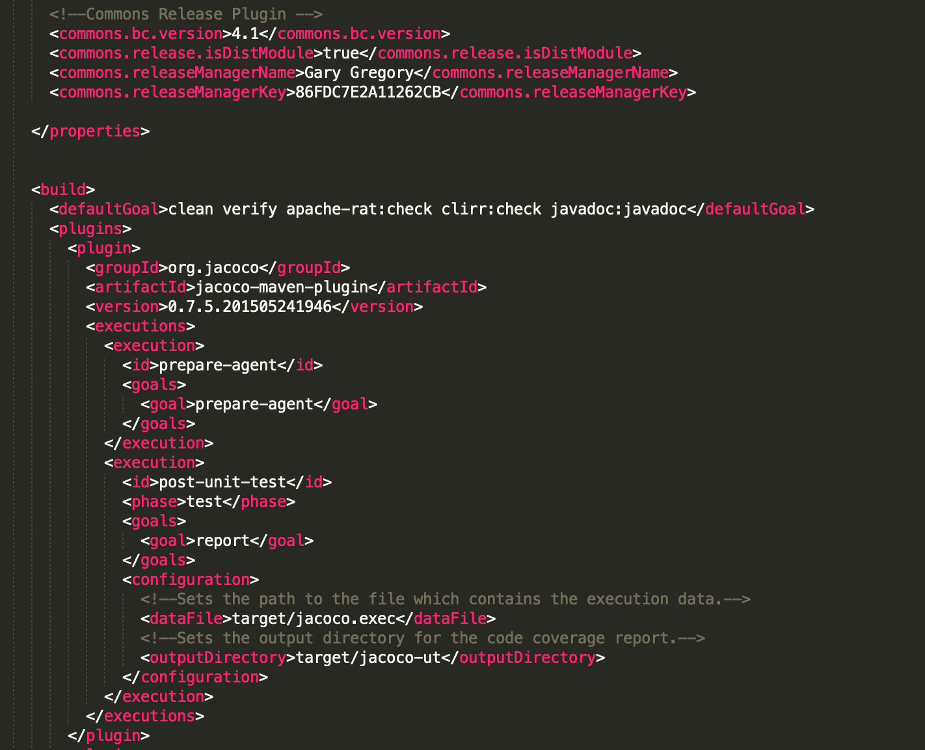

Configuration

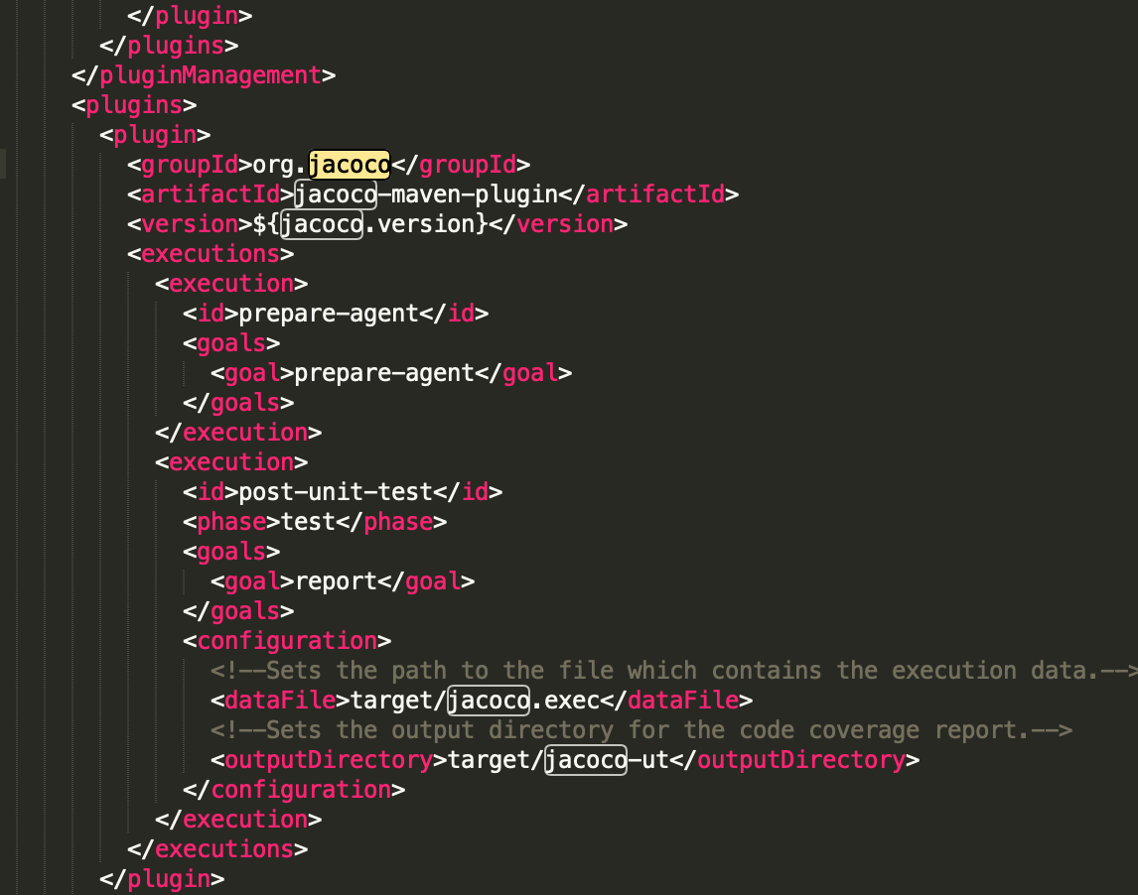

Digester

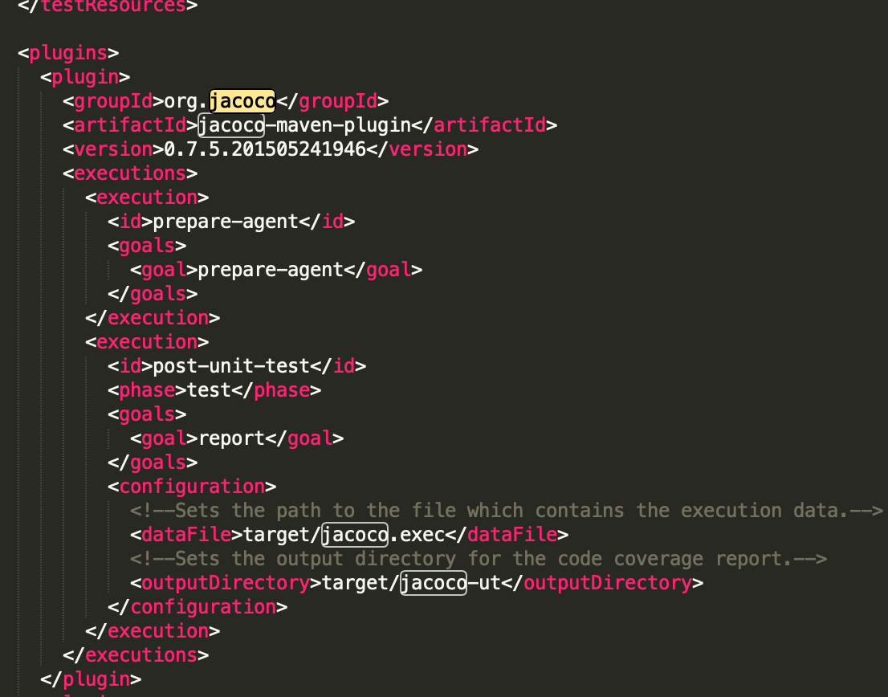

Codec

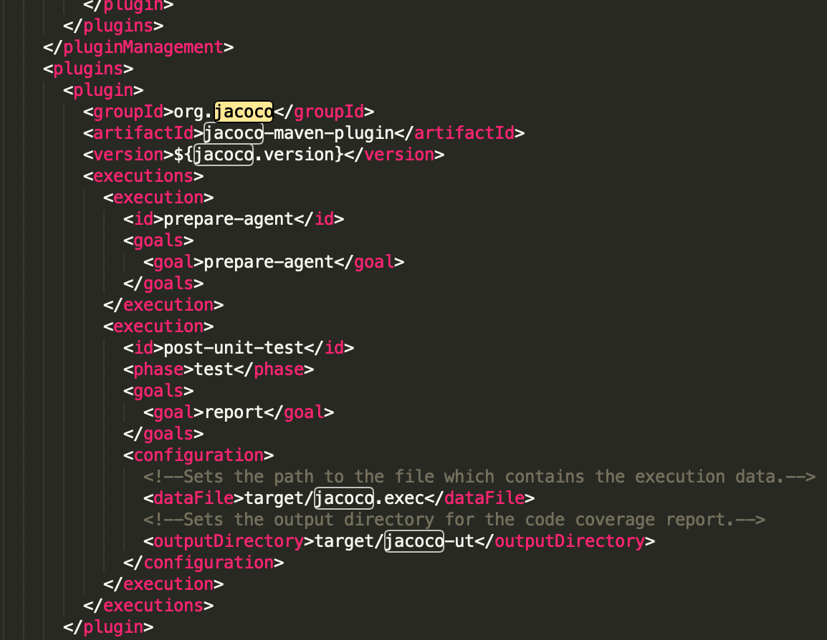

JXpath

