Metric 5

commons-collections4-4.3

Git address：

<https://github.com/apache/commons-collections>

git diff --stat 483cbbbf5a8b3c14edf3e6563e8f8ba380966d47 77e37dbf238d26351edb29e95391e3df75095d01 -- '*.java'

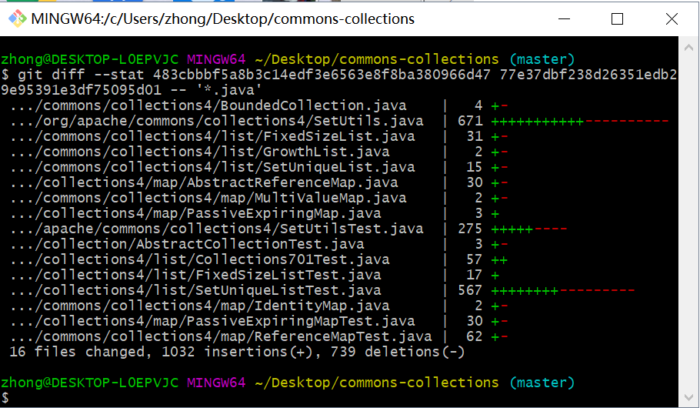

git diff --stat cb157163d7543f942a1391f3ef752ebea1e1b349 483cbbbf5a8b3c14edf3e6563e8f8ba380966d47 -- '*.java'

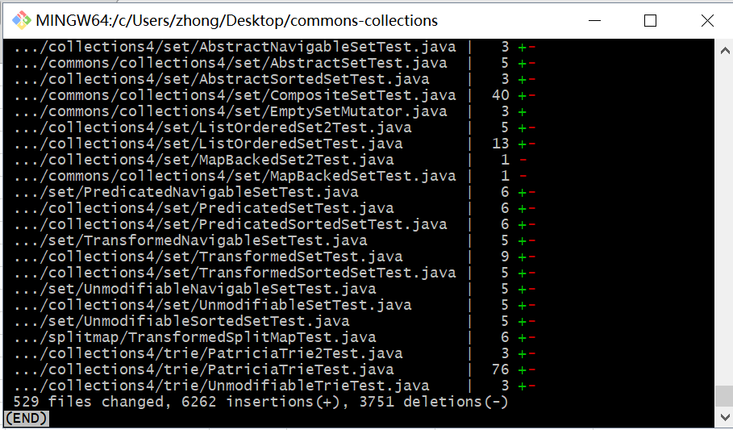

git diff --stat db189926f7415b9866e76cd8123e40c09c1cc67e cb157163d7543f942a1391f3ef752ebea1e1b349 -- '*.java'

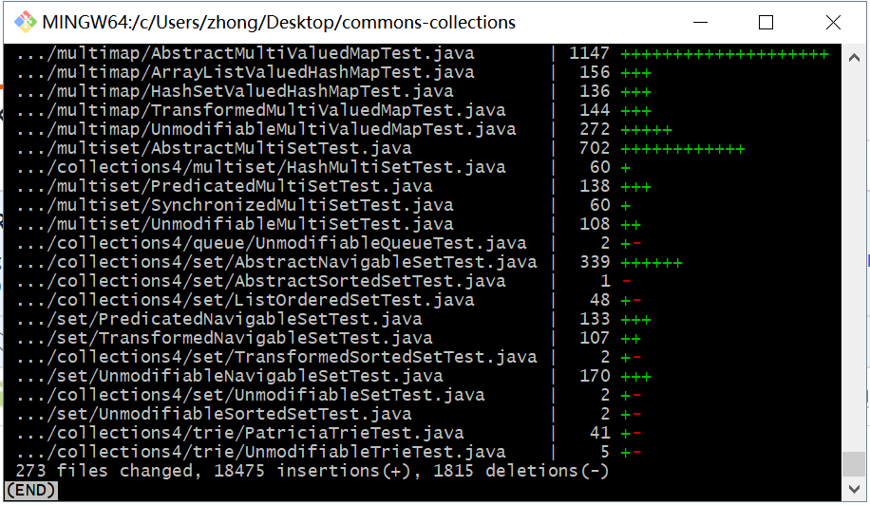

git diff --stat 8e217b44a763565f395268be20e7cff1dedf747b db189926f7415b9866e76cd8123e40c09c1cc67e -- '*.java'

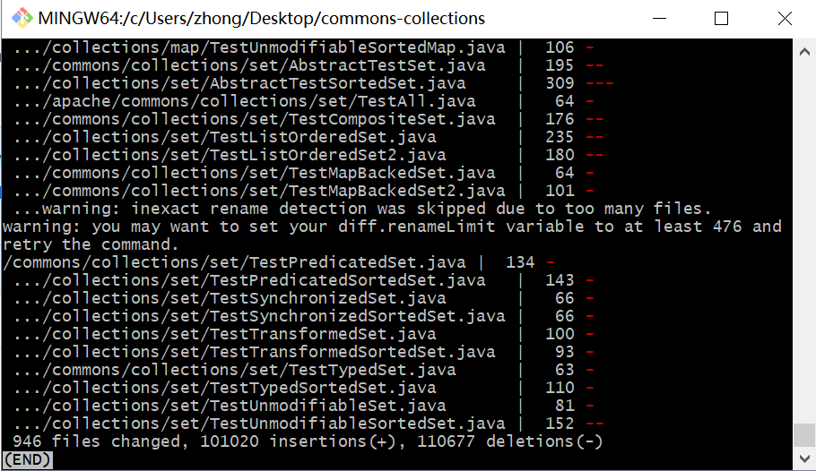

git diff --stat 0af3ae8f26388bcdec42d36bf66a1000a9221754 8e217b44a763565f395268be20e7cff1dedf747b -- '*.java'

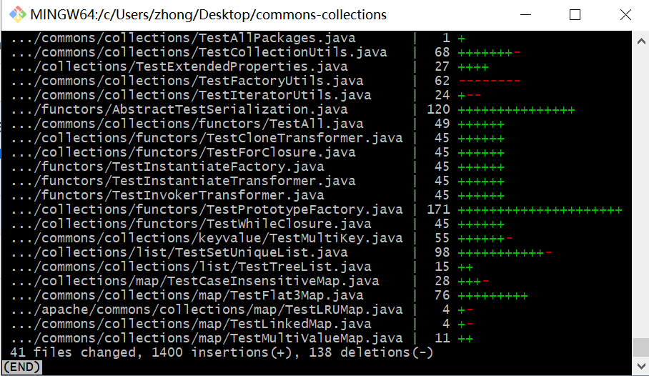

commons-configuration2-2.5

Git address：

<https://github.com/apache/commons-configuration>

git diff --stat 6543cb0b6c283c0d4331dc0baee269b01db00622 dc00a04783ea951280ba0cd8318f53e19acb707f -- '*.java'

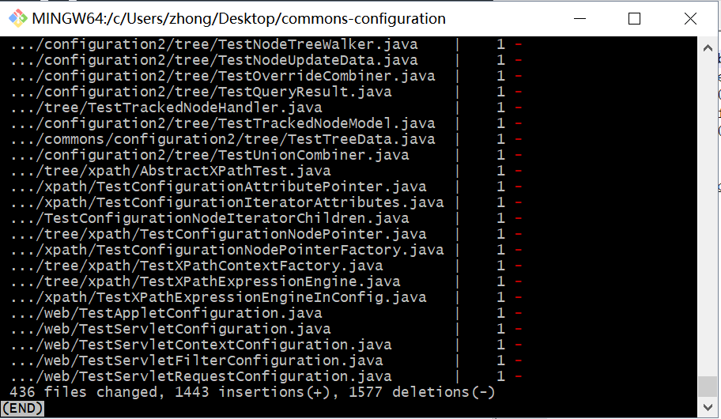

git diff --stat 43bd7dc2e9d73cb5ac9cb2a3caee2285569f87c3 6543cb0b6c283c0d4331dc0baee269b01db00622 -- '*.java'

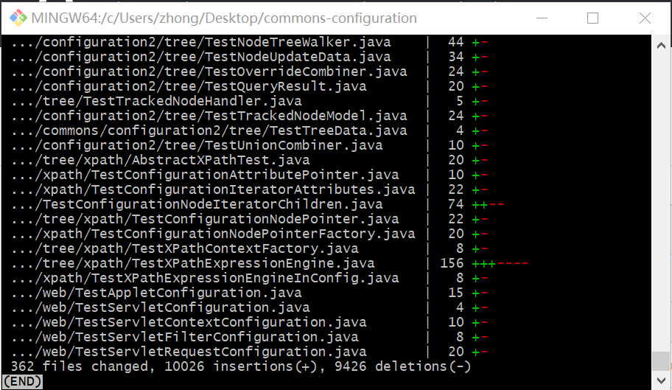

git diff --stat 43bd7dc2e9d73cb5ac9cb2a3caee2285569f87c3 6543cb0b6c283c0d4331dc0baee269b01db00622 -- '*.java'

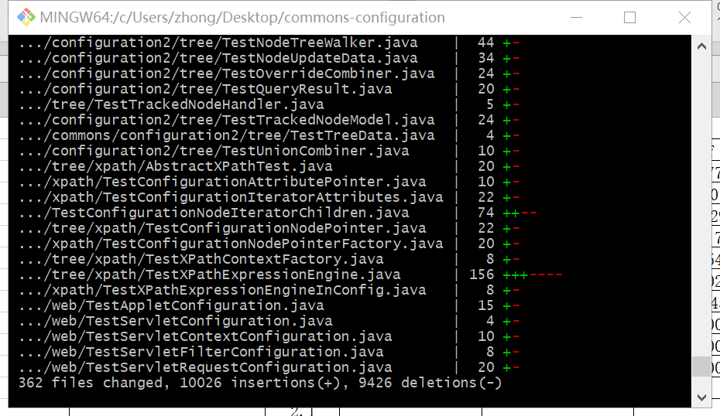

git diff --stat 137997974e0ebd3acd047243f46ddf3b90fa0160 43bd7dc2e9d73cb5ac9cb2a3caee2285569f87c3 -- '*.java'

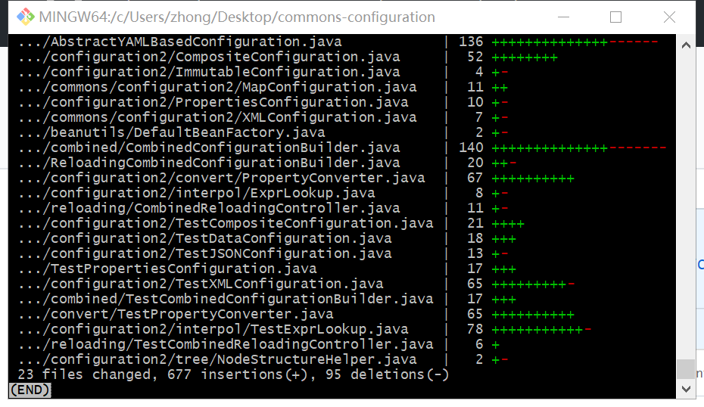

git diff --stat 31c1ab6bed9b9c7686111e00202f555de7471904 137997974e0ebd3acd047243f46ddf3b90fa0160 -- '*.java'

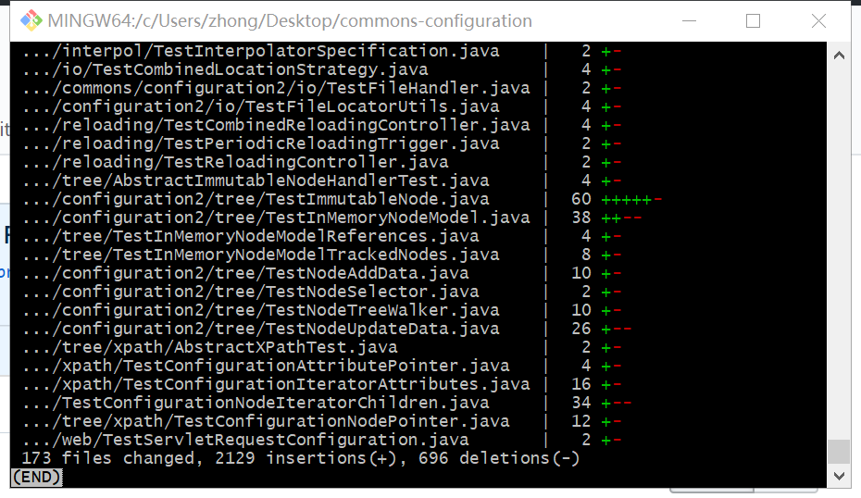

git diff --stat e814fe00bb51256386dd78f3f926aa30d8de6a7c 31c1ab6bed9b9c7686111e00202f555de7471904 -- '*.java'

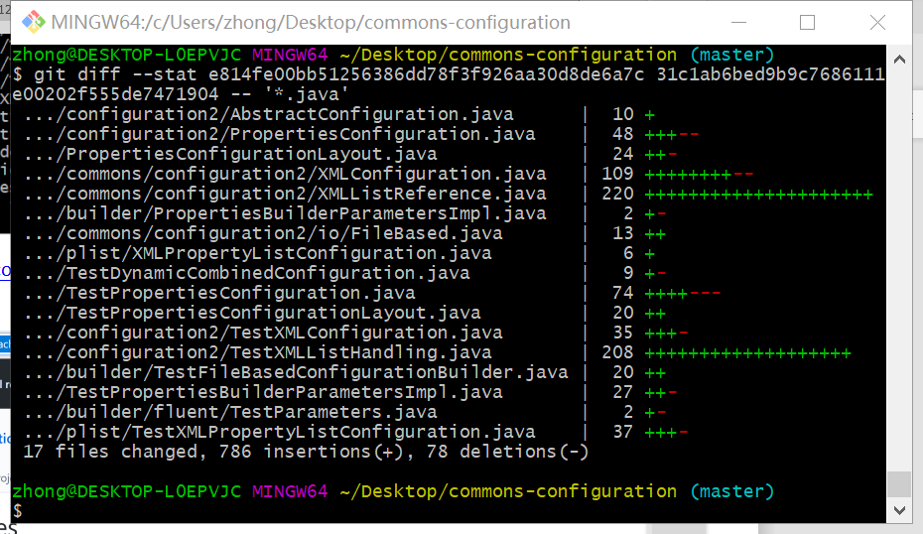

commons_digester

<https://github.com/apache/commons-digester>

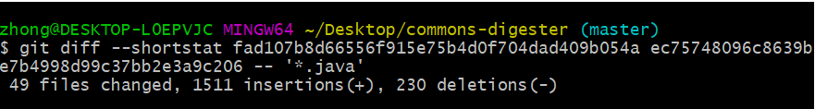

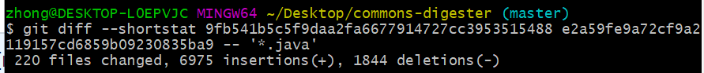

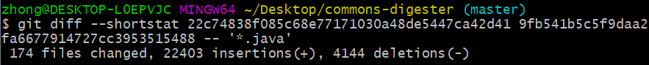

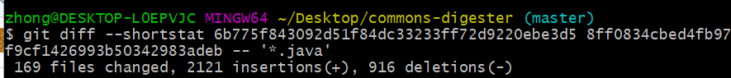

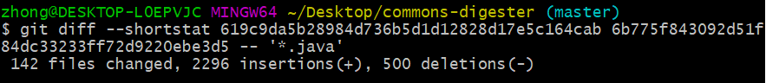

commons-jxpath

<https://github.com/apache/commons-jxpath>

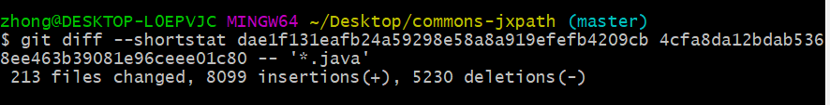

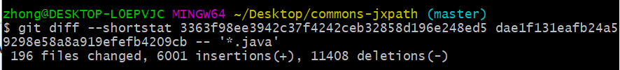

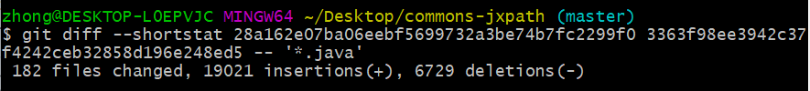

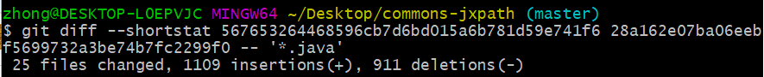

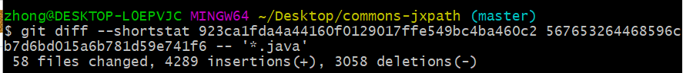

commons-Codec

<https://github.com/apache/commons-codec>

git diff --shortstat 9ceef2231549e95f7868266f38b0c7e1a0a40ed4 0082c9e31747d6f0d5a66dc993d817a00e1451a4 -- '*.java'

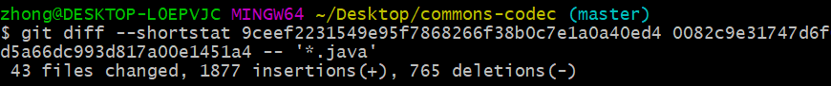

git diff --shortstat e9da3d16ae67f2940a0bbdf982ecec19a0481981 9ceef2231549e95f7868266f38b0c7e1a0a40ed4 -- '*.java'

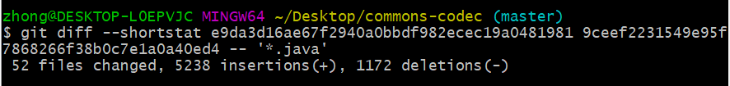

git diff --shortstat 52cfc73491e417366c77c226a7b01b40f7677f9a e9da3d16ae67f2940a0bbdf982ecec19a0481981 -- '*.java'

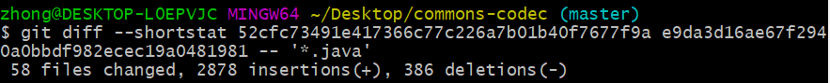

git diff --shortstat aa988a92ce3317077abd4e8414ef501b382d7fc0 52cfc73491e417366c77c226a7b01b40f7677f9a -- '*.java'

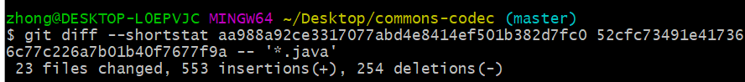

git diff --shortstat 183aa006e80e5c5a4c8c215d104be39cd77f3336 aa988a92ce3317077abd4e8414ef501b382d7fc0 -- '*.java'

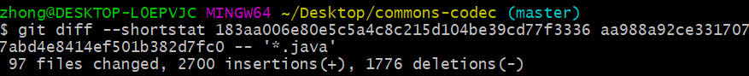

Metric 6

commons-collections4-4.3

Issue-tracking system:

<https://issues.apache.org/jira/projects/COLLECTIONS/issues/COLLECTIONS-714?filter=allopenissues>

<https://issues.apache.org/jira/browse/COLLECTIONS-714?jql=project%20%3D%20COLLECTIONS%20AND%20issuetype%20%3D%20Bug%20AND%20affectedVersion%20%3D%204.3%20%20ORDER%20BY%20priority%20DESC%2C%20updated%20DESC>

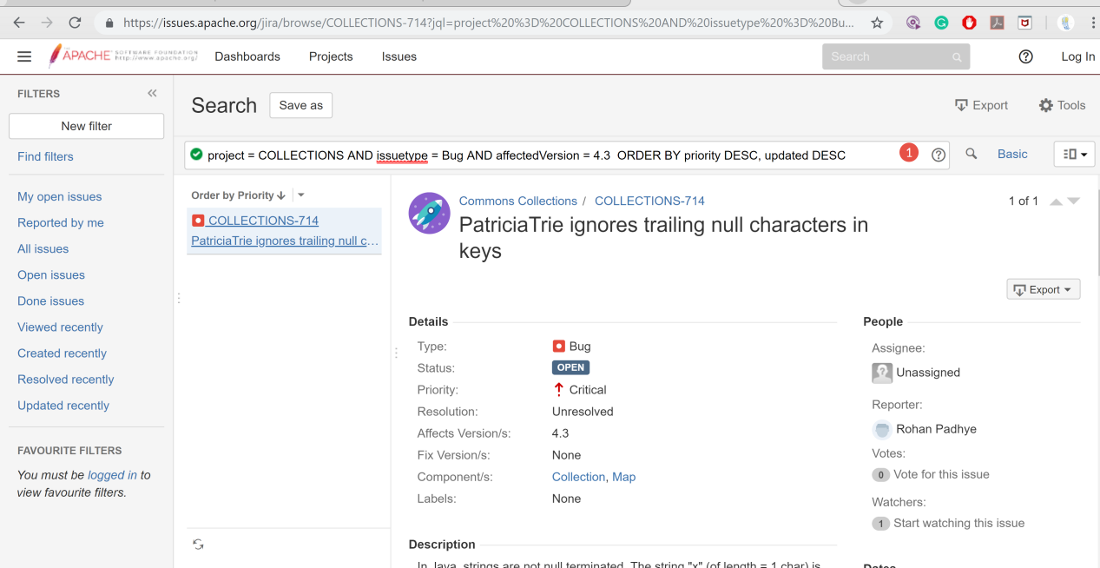

commons-configuration2-2.5

Issue-tracking system:

<https://issues.apache.org/jira/projects/CONFIGURATION/issues/CONFIGURATION-594?filter=allopenissues>

<https://issues.apache.org/jira/browse/CONFIGURATION-749?jql=project%20%3D%20CONFIGURATION%20AND%20type%20%3D%20Bug%20AND%20affectedVersion%20%3D%20latestReleasedVersion()%20%20ORDER%20BY%20priority%20DESC%2C%20updated%20DESC>

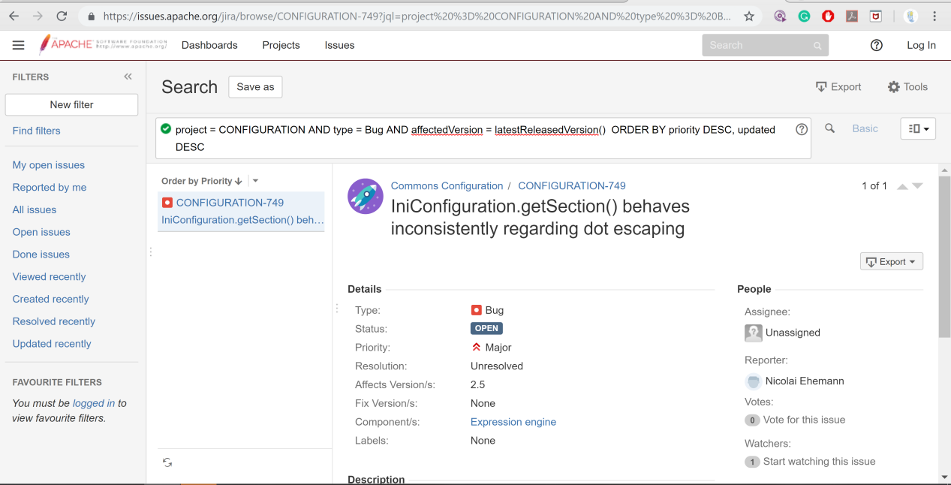

commons_digester3-3.2

[https://issues.apache.org/jira/browse/DIGESTER-191?jql=project%20%3D%20DIGESTER%20AND%20type%20%3D%20Bug%20AND%20affectedVersion%20%3D%20latestReleasedVersion()%20%20ORDER%20BY%20updated%20DESC](https://issues.apache.org/jira/browse/DIGESTER-191?jql=project = DIGESTER AND type = Bug AND affectedVersion = latestReleasedVersion()  ORDER BY updated DESC)

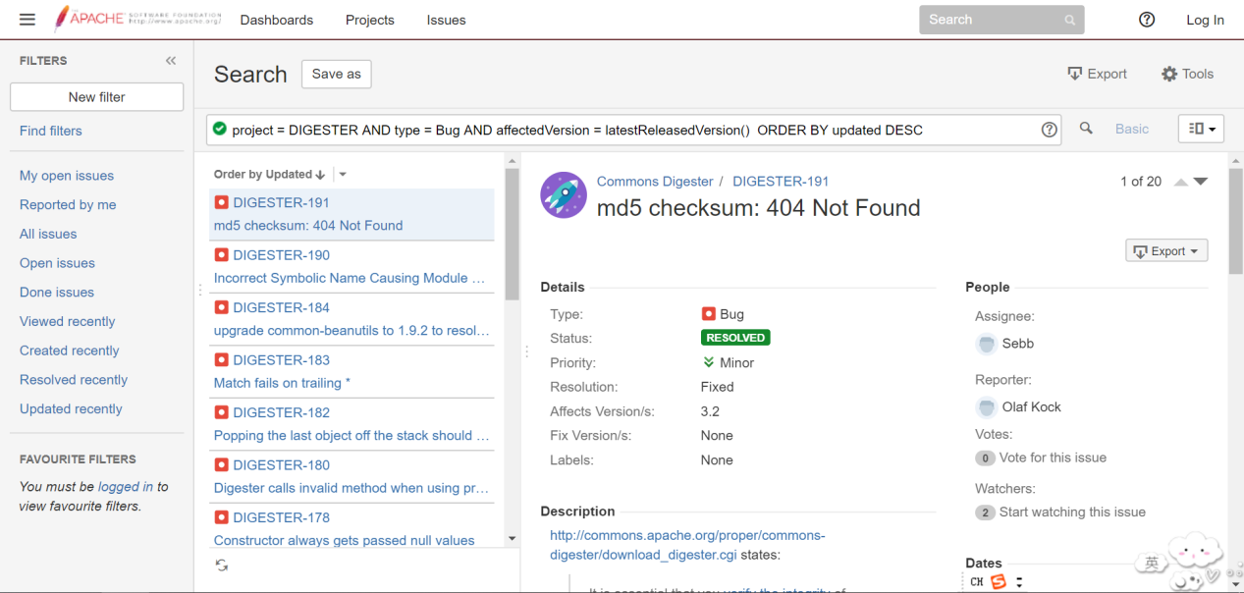

commons-jxpath-1.3

[https://issues.apache.org/jira/browse/JXPATH-194?jql=project%20%3D%20JXPATH%20AND%20type%20%3D%20Bug%20AND%20affectedVersion%20%20%3D%20%20latestReleasedVersion()%20ORDER%20BY%20updated%20DESC](https://issues.apache.org/jira/browse/JXPATH-194?jql=project = JXPATH AND type = Bug AND affectedVersion  =  latestReleasedVersion() ORDER BY updated DESC)

commons-Codec-1.12

[https://issues.apache.org/jira/browse/CODEC-255?jql=project%20%3D%20CODEC%20AND%20type%20%3D%20Bug%20AND%20affectedVersion%20%3D%20latestReleasedVersion()%20%20ORDER%20BY%20priority%20DESC%2C%20updated%20DESC](https://issues.apache.org/jira/browse/CODEC-255?jql=project = CODEC AND type = Bug AND affectedVersion = latestReleasedVersion()  ORDER BY priority DESC, updated DESC)

