**SLOC Recording Report**

**1.Apache-Commons-collections**

**4.3**

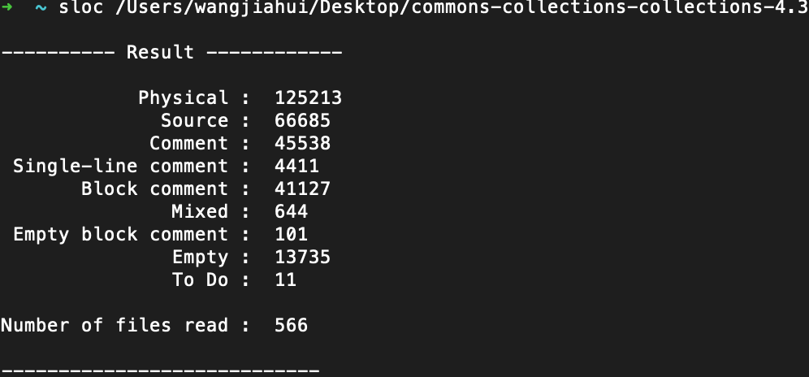

**2. Apache-Commons-configuration**

**2.5**

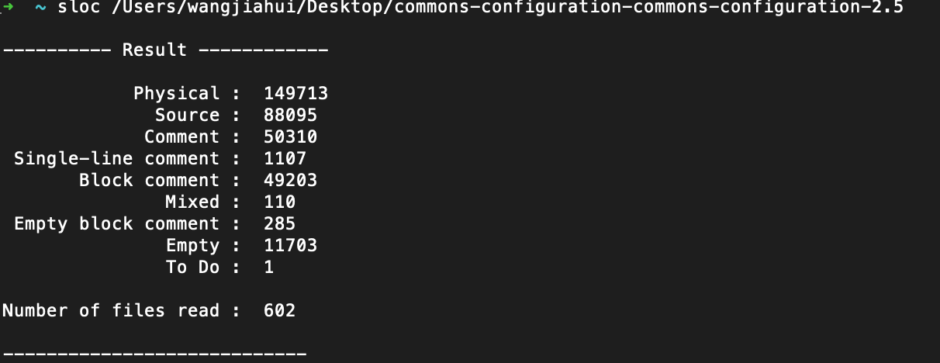

**3. Apache-Commons-digester**

**3.2**

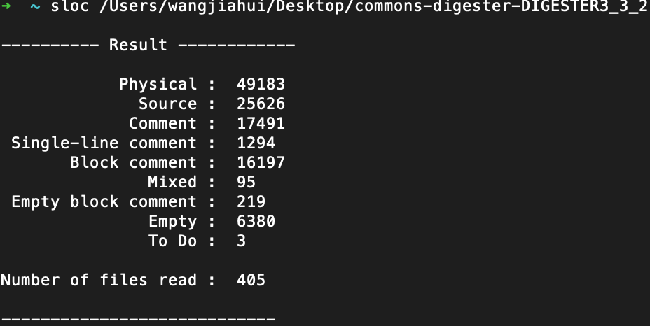

**4. Apache-Commons-JXpath**

**1.3**

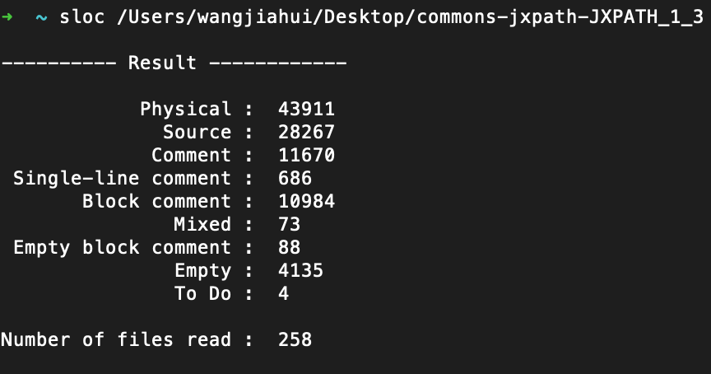

**5. Apache-Commons-Codec**

**1.12**

