1. Write a program to implement the following two functions on string using pointer:

**Submitted By :- Ravi Pandey(075BCT065)**

1. To calculate length of given string
2. To concatenate two strings.

#include <iostream>

using namespace std;

int strLeng(const char * str)

{

    int l=0;

    while(str[l]!='\0')

    {

        l++;

    }

    return l;

}

void concatStr(const char * str1,const char* str2)

{

    int l1 = strLeng(str1);

    int l2=strLeng(str2);

    char *res;

    res = new char[l1+l2];

    for(int i=0;i<=l1;i++)

    res[i]=str1[i];

    for(int i=0;i<=l2;i++)

    res[l1+i]=str2[i];

    cout<<res;

}

int main()

{

    concatStr("DATA","STRUCTURE");

    return 0;

}

OUTPUT:-

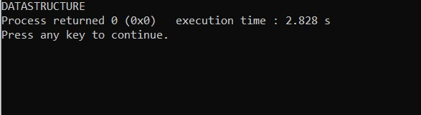

2. WAP to create a structure DATE with its member: day, month and year. Write a function which takes two pointer variables of type DATE to calculate the age of person (i.e. pass structure by reference).

#include <iostream>

using namespace std;

struct DATE

{

  private:

  int year;

  int month;

  int day;

  public:

  DATE(int a=2020,int b=8,int c=31)

  {

      year=a;

      month=b;

      day=c;

  }

friend int calcAge(DATE *,DATE *);

};

int calcAge(DATE * birthYear,DATE* currYear)

{

    int yr,mn,d;

        yr=currYear->year-birthYear->year;

        if(yr<0)

        return -1;

        if(birthYear->month>=currYear->month)

            yr--;

    return yr;

}

void showAge(int age)

{

    if(age==-1)

    {

        cout<<"\nInvalid dates entered.";

    }

    else

    {

        cout<<"\nYou are "<<age<<" years old.";

    }

}

int main()

{

    DATE D1(2000,2,16);

    DATE D2(2020,3,14);

    DATE D3(2005,7,23);

    int age;

    age=calcAge(&D1,&D2);

    showAge(age);

    showAge(calcAge(&D2,&D3));

    showAge(calcAge(&D3,&D2));

}

Output:-

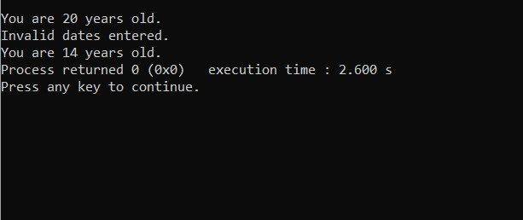

3. WAP to swap the values (of type int, double, char) using function template.

#include <iostream>

using namespace std;

template <class T>

void swAp(T *a, T *b)

{

    T temp;

    temp=*a;

    *a=*b;

    *b=temp;

}

int main()

{

    int a=1,b=2;

    double c=5.1,d=6.34;

    char e='e',f ='f';

    cout<<"The initial data before swapping are:\nInteger\na = "<<a<<" b="<<b;

    cout<<"\nDouble\nc = "<<c<<" d="<<d;

    cout<<"\nChar\ne = "<<e<<" f = "<<f<<endl;

    swAp(&a,&b);

    swAp(&c,&d);

    swAp(&e,&f);

    cout<<"After swapping:\nIntegers\na = "<<a<<" b = "<<b;

    cout<<"\nDouble\nc = "<<c<<" d = "<<d;

    cout<<"\nChar\ne = "<<e<<"f = "<<f;

}

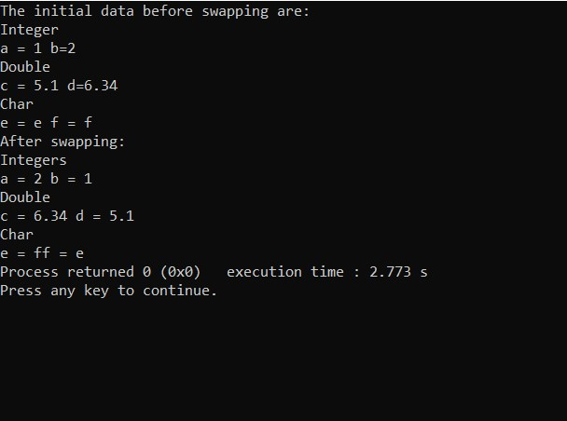Output:-

4. Perform no.3 using class template.

#include <iostream>

using namespace std;

template<class T>

class Swap

{

    T a;

    T b;

    public:

    Swap(T m1=0,T m2=0)

    {

        a=m1;

        b=m2;

    }

    void showProp()

    {

        cout<<"\nA = "<<this->a<<"\tB = "<<b;

    }

    void swapProp()

    {

        T temp;

        temp =a;

        a=b;

        b=temp;

    }

};

int main()

{

    Swap<int> i(5,3);

    Swap<double> d(3.3222,545.3212);

    Swap<char> c('a','b');

    cout<<"\nBefore swapping:";

    i.showProp();

    d.showProp();

    c.showProp();

    i.swapProp();

    d.swapProp();

    c.swapProp();

    cout<<"\nAfter swapping:";

    i.showProp();

    d.showProp();

    c.showProp();

}

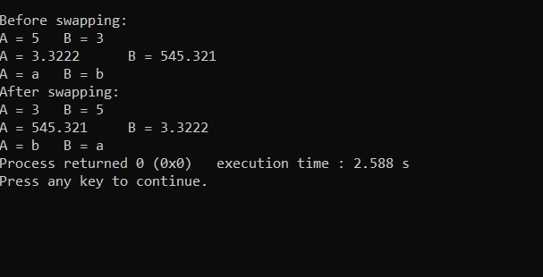Output:-

5. Write a C++ program to perform arithmetic operations on two numbers and throw an exception if the dividend is zero or does not contain an operator. Enter the input as a+b, where ‘a’ and ‘b’ are input numbers and ‘+’ as operator. Check for the valid operators and perform the different operations like addition, subtraction, multiplication and division accordingly.

* *Without Exception Class*

#include <iostream>

using std::cin;

using std::cout;

template <class T>

class ArithmeticOps

{

    public:

    static T operate(T term1,T term2,char op)

    {

        switch(op)

        {

            case '+':

                return term1+term2;

            case '-':

                return term1-term2;

            case '*':

                return term1*term2;

            case '/':

                return term1/term2;

        }

    }

};

int main()

{

    float val1,val2,res;

    char op;

    cout<<"\nEnter Operation:";

    cin>>val1;

    cin>>op;

    cin>>val2;

    if(op=='/' && val2==0)

        cout<<"\nCannot divide by zero!";

    else if(op=='+' || op=='-' || op=='*' || op=='/')

    {

        ArithmeticOps<float> Ar;

        res=Ar.operate(val1,val2,op);

        cout<<"\nThe result is: "<<res;

    }

    else

        cout<<"\nINVALID OPERATOR!";

    return 0;

}

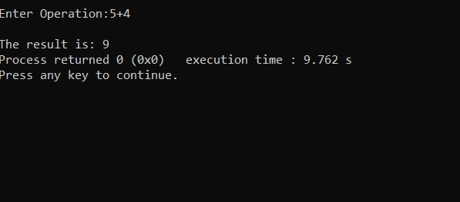Output:-

* *With Exception Class*

#include <iostream>

using namespace std;

class ArithmeticOps

{

    public:

    class ZERO{};

    class OPERR{};

    static float operate(float term1,float term2,char op)

    {

        switch(op)

        {

            case '+':

                return term1+term2;

            case '-':

                return term1-term2;

            case '*':

                return term1*term2;

            case '/':

            {

                if(term2==0)

                throw(ZERO());

                return term1/term2;

            }

            default:

                throw(OPERR());

        }

    }

};

int main()

{

    float val1,val2,res;

    char op;

    cout<<"Enter Operation: ";

    cin>>val1;

    cin>>op;

    cin>>val2;

    try

    {

        res=ArithmeticOps::operate(val1,val2,op);

        cout<<"\nThe result is: "<<res;

    }

    catch(ArithmeticOps::ZERO)

    {

        cout<<"Can't divide by Zero!";

    }

    catch(ArithmeticOps::OPERR)

    {

        cout<<"Invalid Operator!";

    }

}

Output:-

