TRIBHUWAN UNIVERSITY

*Submitted By:*

Ravi Pandey

075BCT065

***Lab 2:Queue***

*Data Structure and Algorithm*

Pulchowk Campus

INTRODUCTION

Queue

Queue is a linear structure which follows a particular order in which the operations are performed. The order is First In First Out (FIFO). It is an ordered list in which insertions are done at one end (rear) and deletions are done at another end (front). A good example of queue is any queue of consumers for a resource where the consumer that came first is served first.

The difference between stacks and queues is in removing. In a stack we remove the item the most recently added; in a queue, we remove the item the least recently added.

Operations on Queue:

* Enqueue: Adds an item to the queue. If the queue is full, then it is said to be an Overflow condition.
* Dequeue: Removes an item from the queue. The items are popped in the same order in which they are pushed. If the queue is empty, then it is said to be an Underflow condition.
* Front: Get the front item from queue.
* Rear: Get the last item from queue.

Circular Queue

In a linear queue, we can insert elements until queue becomes full. But once queue becomes full, we cannot insert the next element even if there is a space in front of queue, which is a limitation. In order to remove this limitation, circular queue is used. In circular queue, last position is connected back to the first position to make a circle. It is also called ‘Ring Buffer’. This enables us to utilize spaces available after removing previous elements.

Double Ended Queue (Deque)

Double ended queue is a generalized form of queue data structure which allows insertion and removal of elements from both the front end and back end. An element can be:

* Added at the beginning
* Added at the end
* Deleted from the front
* Deleted from the end

1)Perform enqueue and dequeue operations in linear queue

**ALGORITHM:**

**Enqueue:**

1. Get the item to insert to the queue from user
2. If rear index == sizeofarray-1 then print overflow message or terminate the program
3. Else Increase the rear index by 1
4. Then insert the item at rear index of the array.

**Dequeue:**

1. Check if the array is empty i.e front index==-1.If so, print underflow or terminate the program
2. If all items have been dequeued i.e. front index==sizeofarray-1 return underflow or terminate
3. Else If array has one or more items then set temp=queue[front] and increse front index by 1
4. Return temp as dequeued item to caller.

**PROGRAM CODE:**

/*WAP to Perform enqueue and dequeue operations in Linear Queue*/

#include <iostream>

using namespace std;

template<class t>

class Queue

{

  int front;

  int rear;

  const int SIZE;

  t * q;

  public:

  Queue(int n):SIZE(n)

  {

      q=new t[SIZE];

      front=-1;

      rear=-1;

  }

  ~Queue()

  {

      delete []q;

  }

  class OVERFLOW{};                         /*Exception for queue is full*/

  class UNDERFLOW{};                        /*Exception for queue is empty*/

  bool isFull()

  {

      if(rear==SIZE-1)

      {

          throw(OVERFLOW());

          return true;

      }

      return false;

  }

  bool isEmpty()

  {

      if(rear==-1 || front==SIZE-1) /*front does not go back after

reaching the end even if space is available*/

      {

          throw(UNDERFLOW());

          return true;

      }

      return false;

  }

  void enqueue(t item)

  {

      if(rear==-1)

      front=0;

              rear++;                /*points rear towards next available space*/

              q[rear]=item;          /*assigns passed data to that location*/

  }

  t dequeue()

  {

      t data;

          data=q[front];     /*returns data pointed by front(Not necessary to do

while performing dequeue operation)*/

          front++;            /*points front towards next element of queue*/

      return data;

  }

  void show()

  {

      cout<<"Queue:\t";

      if(front==SIZE-1)

      cout<<q[front]<<"\t";

      else if(!isEmpty())

      for(int i = front;i<=rear;i++)

      cout<<q[i]<<"\t";

  }

};

int main()

{

    int sizeQ;

    cout<<"Enter Queue Size: ";

    cin>>sizeQ;

    Queue<int> a(sizeQ);

    char op;

    int sel,n;

    do

    {

    try

    {

    cout<<"Enter operation:\n1)Enqueue\n2)Dequeue:\t";

    cin>>sel;

    if(sel==1 && !a.isFull())

    {

        cout<<"Enter data: ";

        cin>>n;

        a.enqueue(n);

        cout<<n<<" enqueued\n";

    }

    else if(sel==2 && !a.isEmpty())

    {

        cout<<a.dequeue()<<" dequeued\n";

    }

    else

    {

        cout<<"Invalid choice!";

    }

    a.show();

    }

    catch(Queue<int>::OVERFLOW)

    {

        cout<<"Queue is full!";

        op=='Y';

    }

    catch(Queue<int>::UNDERFLOW)

    {

        cout<<"Queue is empty!";

        op=='Y';

    }

    cout<<"\nContinue?:";

    cin>>op;

    }while(toupper(op)=='Y' || op=='1');

    return 0;

}

**OUTPUT:**

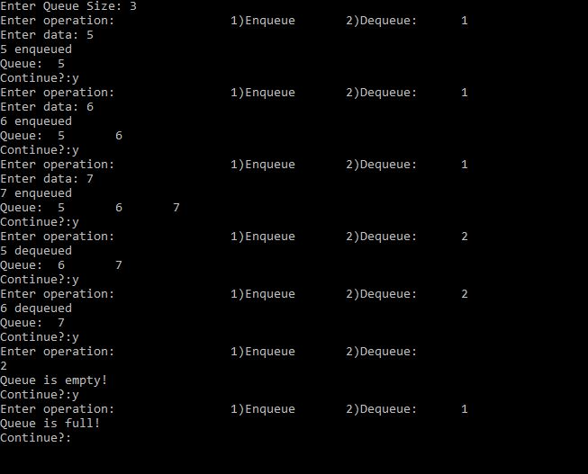

2)Perform enqueue and dequeue operations in Circular queue

**ALGORITHM:**

**Enqueue:**

1. Get the item to insert to the queue from user
2. If front == rear == -1 i.e. queue is empty then, set front=rear=0 and set queue[rear] =item
3. Then check if (rear+1) mod SIZE == front i.e. queue is fulll then, print overflow and terminate process.(modular division is done so that rear does nt exceed the SIZE)
4. Else if queue is partially filled then, increase rear by 1 so that it does not exceed SIZE of array (i.e. rear=(rear+1)mod SIZE) and set queue[rear] to item.

**Dequeue:**

1. Check if the array is empty i.e front index==-1.If so, print underflow or terminate the program
2. If front == rear and rear!=-1 i.e. there is one element remaining in queue then set temp to queue[front] and then set front = rear =-1(queue empty condition)
3. Else when queue is partially filled set temp = queue[front] and then set front=(front+1) mod SIZE
4. Return temp as dequeued item to caller.

**PROGRAM CODE:**

/*WAP to Perform enqueue and dequeue operations in Circular Queue*/

#include <iostream>

using namespace std;

template<class t>

class CQueue

{

  int front;

  int rear;

  int count;

  const int SIZE;

  t * q;

  public:

  CQueue(int n):SIZE(n)

  {

      q=new t[SIZE];

      front=-1;

      rear=-1;

      count=0;

  }

  ~CQueue()

  {

      delete []q;

  }

  class OVERFLOW{};

  class UNDERFLOW{};

bool qCon(int op)

{

    if(((rear+1)%SIZE==front) && op==1)            /*Queue is full*/

    {

        throw(OVERFLOW());

        return false;

    }

    else if((front==rear && front==-1) && op==2)  /*Queue empty condition*/

      {

          throw (UNDERFLOW());

          return false;

      }

      return true;

}

  void enqueue(t item)

  {

      if(front==rear && rear==-1)       /*Queue empty condition*/

      {

          front=0;

          rear=0;

          q[rear]=item;

          count++;

      }

      else if((rear+1)%SIZE==front)     /*Queue is full*/

      {

          //throw(OVERFLOW());          /*handled by qCon()*/

      }

      else                              /*One or more space available in queue*/

      {

          rear=(rear+1)%SIZE;

          q[rear]=item;

          count++;

      }

  }

   t dequeue()

  {

      t data;

      if(front==rear && front==-1)  /*Queue empty condition*/

      {

          //throw (UNDERFLOW());    /*handled by qCon()*/

      }

      else if( front == rear)   /*All items have been dequeued so front and rear

are changed to initial conditions*/

     {

          data=q[front];

          front =-1;

          rear = -1;

      }

      else                          /*Queue has more than 1 item*/

      {

          data=q[front];

          front=(front+1)%SIZE;

          count--;

      }

      return data;

  }

  void display()

  {

      if(qCon(2))

      {

          int i=front;

          int num=0;

          bool loop=true;

          cout<<"Queue: ";

          while(loop && num<=count)

          {

              if(count==1)

              {

                  cout<<q[i]<<"\t";

                  loop=false;

              }

              else

              {

            cout<<q[i]<<"\t";

            if(i==rear && i==0)

            {

                loop=false;

            }

            else if(i==SIZE-1 && i==rear)

                {

                    cout<<q[i]<<"\t";

                    loop=false;

                }

            else

            {

                i=(i+1)%SIZE;

                if(i==rear)

                {

                    cout<<q[i]<<"\t";

                    loop=false;

                }

            }

              }

            num++;

          }

      }

  }

};

int main()

{

    int sizeQ;

    cout<<"Enter Queue Size: ";

    cin>>sizeQ;

    CQueue<int> a(sizeQ);

    char op;

    int sel,n;

    do

    {

    try

    {

    cout<<"Enter operation:\t1)Enqueue\t2)Dequeue:\t";

    cin>>sel;

    if(sel==1)

    {

        if(a.qCon(sel))

        {

        cout<<"Enter data: ";

        cin>>n;

        a.enqueue(n);

        cout<<n<<" enqueued.\n";

        }

    }

    else if(sel==2)

    {

        if(a.qCon(sel))

        {

            cout<<a.dequeue()<<" dequed.\n";

        }

    }

    else

    {

        cout<<"Invalid choice!";

    }

    a.display();

    }

    catch(CQueue<int>::OVERFLOW)

    {

        cout<<"Queue is full!";

        op=='Y';

    }

    catch(CQueue<int>::UNDERFLOW)

    {

        cout<<"Queue is empty!";

        op=='Y';

    }

    cout<<"\nContinue?:";

    cin>>op;

    }while(toupper(op)=='Y' || op=='1');

    return 0;

}

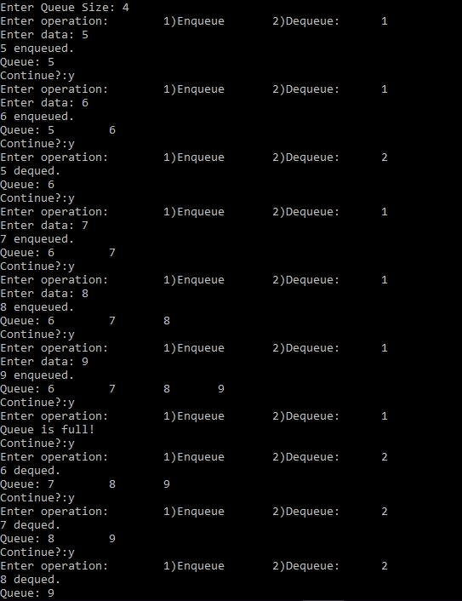**OUTPUT:**

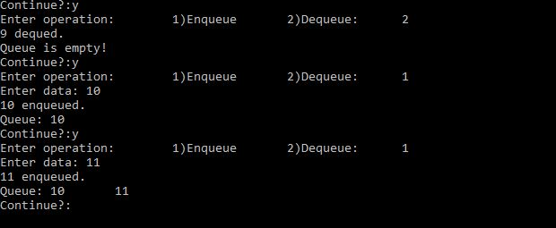

3)Perform operations in Deque(Double Ended Queue) for:

1. Add at beginning
2. Add at end
3. Delete from beginning
4. Delete from end

**ALGORITHM:**

**Add at Beginning:**

1. Get the item to insert to the deque from user.
2. Check if the deque is empty.If so, set both front and rear to 0 and deque[front]=item.
3. If the deque is full(i.e. (front =0 and rear=SIZE-1) or front=rear+1 then, set print overflow and terminate process.
4. To add at beginning,front is reduced by 1 (front--) except when front=0 ,in which case, front is set to front=SIZE-1(Circular queue approach) and then deque[front] is set to the item provided by user.

**Add at End:**

1. Get the item to insert to the deque from user.
2. Check if the deque is empty.If so, set both front and rear to 0 and deque[rear]=item.
3. If the deque is full(i.e. (front =0 and rear=SIZE-1) or front=rear+1 then, set print overflow and terminate process.
4. To add at end,rear is increased by 1 (rear++) except when rear=SIZE-1, in which case, rear is set to zero(Circular queue approach) and then deque[rear] is set to the item provided by user.

**Delete from Beginning:**

1. If the deque is empty(rear==front==-1) print underflow and terminate process.
2. When deque has only one element((front==rear) and front!=-1), set temp=deque[front] and then set both front and rear to -1(front=rear=-1).
3. If front==SIZE-1 then set temp=deque[front] and then set front=0.
4. In all other cases set temp=deque[front] and increase front by 1(front++).
5. Return temp as deleted element to caller.

**Delete from End:**

1. If the deque is empty(rear==front==-1) print underflow and terminate process.
2. When deque has only one element((front==rear) and front!=-1), set temp=deque[rear] and then set both front and rear to -1(front=rear=-1).
3. If rear==0 then set temp=deque[rear] and then set rear= SIZE-1(Circular queue approach).
4. In all other cases set temp=deque[rear] and decrease rear by 1(rear--).
5. Return temp as deleted element to caller.

**PROGRAM CODE:**

/*WAP to Perform operations in Deque( Double ended queue) for:

a. Add at beginning

b. Add at end

c. Delete from beginning

d. Delete from end*/

#include <iostream>

using namespace std;

template <class t>

class Deque

{

    const int SIZE;

    int front;

    int rear;

    int count;

    t * d;

    public:

    class OVERFLOW{};

    class UNDERFLOW{};

  Deque(int n):SIZE(n)

  {

      d=new t[SIZE];

      front=-1;

      rear=-1;

      count=0;

  }

  ~Deque()

  {

      delete []d;

  }

  void addBegin(t item)

  {

      if((front==0 && rear==SIZE-1) || (front==rear+1)) /*Deque full condition*/

      {

          throw(OVERFLOW());

      }

      else if(front == rear && rear==-1)                /*Initial condition*/

      {

          front =0;

          rear=0;

          d[front]=item;

          count++;

      }

      else if(front ==0)      /*front-- becomes 0 which is not required outcome*/

      {

          front =SIZE-1;

          d[front]=item;

          count++;

      }

      else

      {

          front--;

          d[front]=item;

          count++;

      }

  }

  void addEnd(t item)                               /*Deque full condition*/

  {

      if((front==0 && rear==SIZE-1) || (front==rear+1))

      {

          throw(OVERFLOW());

      }

      else if(front==rear && rear==-1)              /*Initial Condition*/

      {

          front=0;

          rear=0;

          d[rear]=item;

          count++;

      }

      else if(rear==SIZE-1)

      {

          rear=0;

          d[rear]=item;

          count++;

      }

      else

      {

          rear++;

          d[rear]=item;

          count++;

      }

  }

 t delBegin()

  {

      t data;

      if(front==rear && rear==-1)

      {

          throw(UNDERFLOW());

      }

      else if(front == rear)

      {

          data= d[front];

          front=-1;

          rear=-1;

          count--;

      }

      else if(front==SIZE-1)

      {

          data= d[front];

          front=0;

          count--;

      }

      else

      {

          data=d[front];

          front++;

          count--;

      }

      return data;

  }

  t delEnd()

  {

      t data;

      if(front==rear && rear==-1)

      {

          throw(UNDERFLOW());

      }

      else if(front == rear)

      {

          data= d[rear];

          front=-1;

          rear=-1;

          count--;

      }

      else if(rear==0)

      {

          data= d[rear];

          rear=SIZE-1;

          count--;

      }

      else

      {

          data=d[rear];

          rear--;

          count--;

      }

      return data;

  }

  void display()

  {

      if(front==rear && rear==-1)

      {

          throw(UNDERFLOW());

      }

      else

      {

          int i=front;

          int num=0;

          bool loop=true;

          cout<<"\t\tDeque: ";

          while(loop && num<=count)

          {

              if(count==1)

              {

                  cout<<d[i]<<"\t";

                  loop=false;

              }

              else

              {

            cout<<d[i]<<"\t";

            if(i==rear && i==0)

            {

                loop=false;

            }

            else if(i==SIZE-1 && i==rear)

                {

                    cout<<d[i]<<"\t";

                    loop=false;

                }

            else

            {

                i=(i+1)%SIZE;

                if(i==rear)

                {

                    cout<<d[i]<<"\t";

                    loop=false;

                }

            }

              }

            num++;

          }

      }

  }

};

int main()

{

    int sizeQ;

    cout<<"Enter Dueqe Size: ";

    cin>>sizeQ;

    Deque<int> a(sizeQ);

    char op;

    int sel,n;

    do

    {

    try

    {

    cout<<"Enter operation: \n1)Add at Begining\t2)Add at end\t3)Delete from Begining\t4)Delete from End\t";

    cin>>sel;

    switch (sel)

    {

        case (1):

        {

            cout<<"Enter data: ";

            cin>>n;

            a.addBegin(n);

            break;

        }

        case (2):

        {

            cout<<"Enter data: ";

            cin>>n;

            a.addEnd(n);

            break;

        }

        case(3):

        {

            cout<<a.delBegin()<< " deleted\n";

            break;

        }

        case(4):

        {

            cout<<a.delEnd()<<" deleted\n";

            break;

        }

        default:

        {

            cout<<"Invalid choice!";

        }

    }

    a.display();

    }

    catch(Deque<int>::OVERFLOW)

    {

        cout<<"Deque is full!";

        op=='Y';

    }

    catch(Deque<int>::UNDERFLOW)

    {

        cout<<"Deque is empty!";

        op=='Y';

    }

    cout<<"\nContinue?:";

    cin>>op;

    }while(toupper(op)=='Y' || op=='1');

    return 0;

}

**OUTPUT:**

