CSC 540 Project 1

Dustin Lambright, Darshan Bhandari, Guanxu Yu, Leonard Kerr, Yuchen Sun

# ER Diagram

Before describing the details of each table, I would like to go over the notation choices and explanations for our diagram. The diagram can be found on the last page (Figure 1**Error! Reference source not found.**).

We decided to use crows foot notation and include our attributes in line for each table. We believe this increases readability and allows for a clearer high level view. However, due to notation changes from class, I’ve assembled a table to describe the meaning of each symbol.

|  |  |
| --- | --- |
| Symbol | Meaning |
|  | This table has at most one of this relationship |
|  | This table has many of this relationship |
| Solid Line | There is at least one of this relationship (identifying) |
| Dotted Line | There can be 0 of this relationship (non-identifying) |
|  | Key attribute (Red are foreign) |
|  | Non-key attributes (Blue are required, red are foreign, white are not required) |

### User

Description: The base user table. Contains login information, first name, and last name.

Keys: **id**

Constraints: All fields must be non-null

### Graduate

Description: Users that are graduate students.

Keys: **grad_id** (FK on User.id)

Constraints: None

### Instructor

Description: Users that are instructors.

Keys: **inst_id** (FK on User.id)

Constraints: None

### Student

Description: Users that are students (graduate and undergraduate).

Keys: **student_id** (FK on User.id)

Constraints: None

### TAFor

Description: A **relationship** table, relates graduate students to courses that they TA for.

Keys: **ta_id** (FK on Graduate.grad_id), **course_id** (FK on Course.course_id)

Constraints: None

### EnrolledIn

Description: A **relationship** table, relates students to courses that they are enrolled in.

Keys: **student_id** (FK on Student.student_id), **course_id** (FK on Course.course_id)

Constraints: On courses where graduate is true, student_id must exist in graduate table.

### Course

Description: Table containing basic information for a course.

Keys: **course_id**

Constraints: Start date must be before end date  
 Number enrolled must be less than max enrolled  
 Course id must match regex ‘[A-Z]{3}[0-9]{3}”  
 All fields must be non-null except num-enrolled and graduate

### Exercise

Description: Table containing basic information for an exercise, **weak entity**.

Keys: **course_id** (FK on Course.course_id), **ex_id**

Constraints: Minimum difficulty must be below maximum difficulty  
 Start date must be before end date  
 Number of attempts must be greater than 1  
 Scoring policy must be one of (‘last’, ‘average’, ‘highest’)  
 All fields must be non-null  
 Both difficulties must be between 1-5

### ExQuestions

Description: A **relationship** table, relates exercises to the questions in them.

Keys: **ex_id** (FK on Exercise.ex_id), **ques_id** (FK on Question.ques_id)

Constraints: None

### Question

Description: A table to store questions, contains the basic information.

Keys: **ques_id**

Constraints: All fields except hint must be non-null.  
 Difficulty must be between 1-5

### Answer

Description: An answer table for a question, can be right or wrong and optionally contain parameters, **weak entity.**

Keys: **ques_id** (FK on Question.ques_id), **ans_id**

Constraints: All fields must be non-null except param_id (if there are no parameters)

### Parameters

Description: A table for storing parameters for both questions and answers, **weak entity**.

Keys: **ques_id** (FK on Question.ques_id), **param­_id**

Constraints: id must be unique, all fields must be non-null

### AttAnswers

Description: A **relationship** table which stores the answers for each question on an exercise attempt.

Keys: **att_id** (FK on Attempt.att_id), **ans_id, ques_id** (Both FK on Answer.ans_id and Answer.ques_id)

Constraints: None

### Attempt

Description: A table to store basic information about an attempt, **weak entity**. Cascades on deletion of exercise, course, or student.

Keys: **att_id**

Constraints: All fields must be non-null

### Topic

Description: Table to store topics.

Keys: **topic_id**

Constraints: All fields must be non-null

### CourseTopic

Description: A **relationship** table which stores the topics for each course.

Keys: id

Constraints: None

# Constraints

* **Number of students enrolled in a course should not surpass max enrolled in Course table.  
  Trigger(s):** EnrollStudent, CheckEnrolled, DropStudentThis constraint was met by creating 3 triggers, two which update Course.num_enrolled when a student is added/dropped from a course, and then a last trigger which ensures num_enrolled never exceeds max_enrolled.
* **Students should only be able to attempt exercises for the courses they’re in.  
  Trigger(s):** AttExerciseThis constraint we implemented as a trigger which queries the enrolledin table before making an insertion on the attempts table.
* **Only graduate students should be able to enroll in graduate courses.  
  Trigger(s):** GradEnrollThis constraint was implemented as a trigger on insert to enrolledin which checks if the course is graduate, then queries the graduate table if it is.
* **TAs should not be able to enroll in classes that they are assisting.  
  Trigger(s):** GradEnrollThis constraint was implemented as a trigger on insert into the enrolledin which checks if there is an entry in the TAfor table with the same user id and course id.
* **Number of attempts should be limited by num_attempts in exercise table.  
  Trigger(s):** NewAttemptThis was achieved through a trigger which keeps track of current attempt number, checking against num_attempts in the exercise table.

### Constraints Implemented in the Application

* **Students should only be able to attempt exercises that are currently open.**This constraint was implemented on the application side, because if we used CURDATE() to check attempts as we made them, then we couldn’t load the sample data.

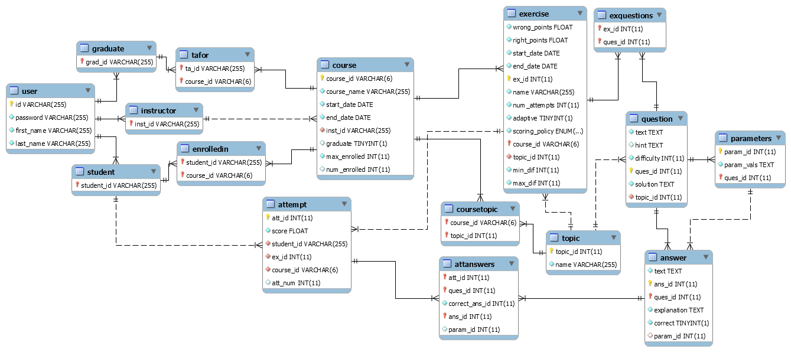

Figure . Our EER Diagram