**Overview**

[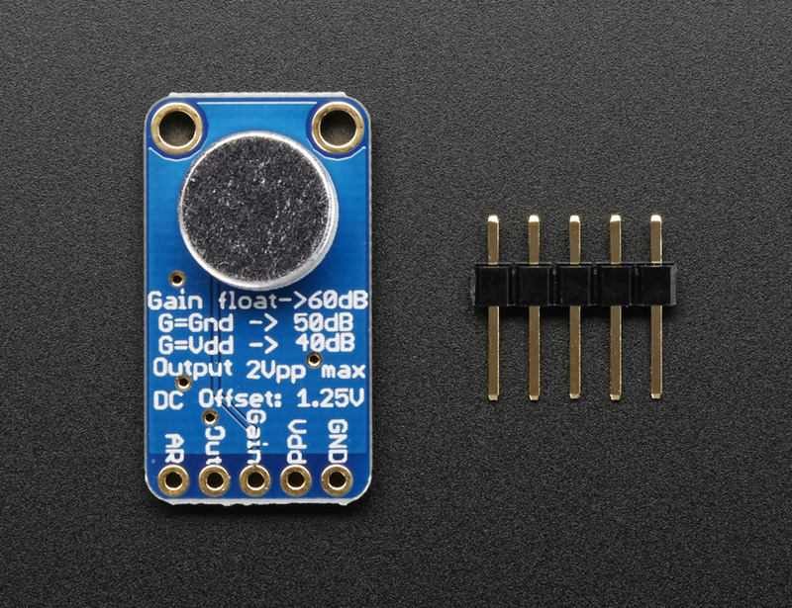](https://learn.adafruit.com/assets/14304)

This fancy microphone amplifier module is a step above the rest, with built in automatic gain control. The AGC in the amplifier means that nearby 'loud' sounds will be quieted so they don't overwhelm & 'clip' the amplifier, and even quiet, far-away sounds will be amplified. This amplifier is great for when you want to record or detect audio in a setting where levels change and you don't want to have to tweak the amplifier gain all the time.  
  
The chip at the heart of this amp is the [MAX9814](http://www.maximintegrated.com/datasheet/index.mvp/id/5433), and has a few options you can configure with the breakout. The default 'max gain' is 60dB, but can be set to 40dB or 50dB by jumpering the **Gain** pin to VCC or ground. You can also change the Attack/Release ratio, from the default 1:4000 to 1:2000 or 1:500. The ouput from the amp is about 2Vpp max on a 1.25V DC bias, so it can be easily used with any Analog/Digital converter that is up to 3.3V input. If you want to pipe it into a Line Input, just use a 1uF blocking capacitor in series.  
  
Each order comes with one assembled and tested board, with electret mic pre-soldered on, and a small piece of header.

[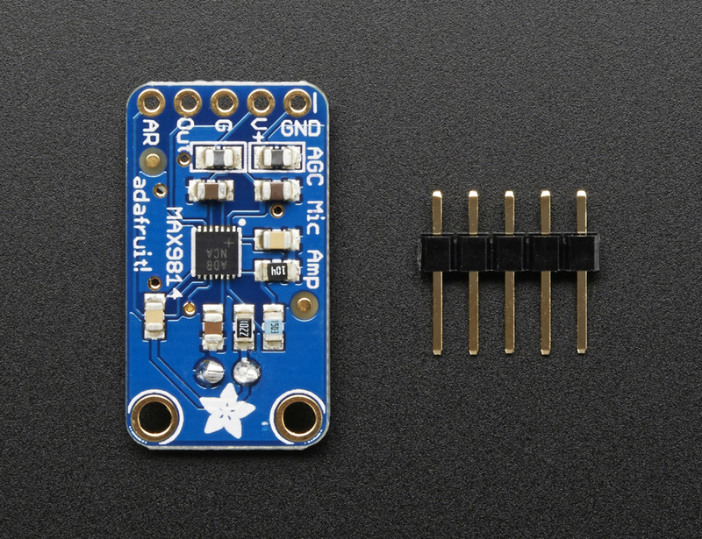](https://learn.adafruit.com/assets/14305)

Specifications:

* Supply Voltage: 2.7v-5.5v @ 3mA current
* Output: 2Vpp on 1.25V bias
* Frequency Response: 20Hz - 20 KHz
* Programmable Attack and Release Ratio
* Automatic gain, selectable max from 40dB, 50dB or 60dB
* Low Input-Referred Noise Density of 30nV/
* Low THD: 0.04% (typ)