Use Cases and Logical Architecture

* XID:
* Name:
* Project Title:

**Provide at least 6 Use-cases describing the functionality of the proposed system**

## Section 1: For Each Use Case:

|  |  |
| --- | --- |
| Title (goal) | What is the name of this function? |
| Primary Actor | Who is the user? |
| Story | Describe in detail what happens here |

## Section 2: Prototype Schedule, Winter Semester 2017

|  |  |
| --- | --- |
| Iteration #1, Complete 25/10/2017 | List the use cases to be delivered for this prototype |
| Iteration #2 Complete 15/11/2017 | List the use cases to be delivered for this prototype |
| Iteration #3 Complete 13/12/2017 | List the use cases to be delivered for this prototype |

## 

## 

## Section 3: Logical Architecture

In this section use [www.draw.io](http://www.draw.io) to show how your architecture is distributed. Your architecture should to show:

Software Components

Databases

App engines

Mobile platforms

APIs and languages (per component)

Deployment EG REStful, JDBC, sessionless etc

Security e.g. Https, certificates, authentication, etc.

Here is an AWS sample architecture:

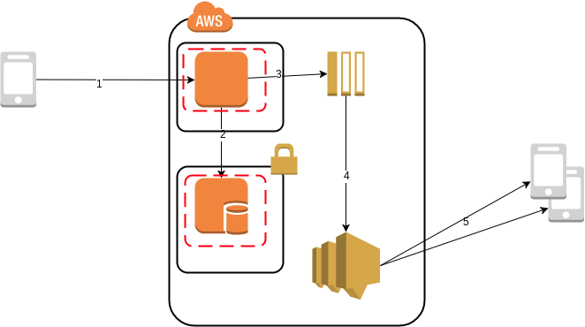

## Logical Architecture Discussion

* Discuss each component of your architecture
* Add numbers to the arrows and discuss the flow of data