**Report Dashboard: Lab2: Google Data Studio**

Marta Almagro

Annunziata Alvarez-Cascos

Beltran Valero

Gracia Estrán

Link to the Dashboard: https://lookerstudio.google.com/reporting/9ad45eba-e846-4f07-8a8b-cd48a5878ed8/page/p_eepl341ybd/edit

In our dashboard we included a filter to select which year we wanted to focus on in our plots. Furthermore, we had to change the type of the columns ‘Total’ and ‘CNAE_code’ to numeric.

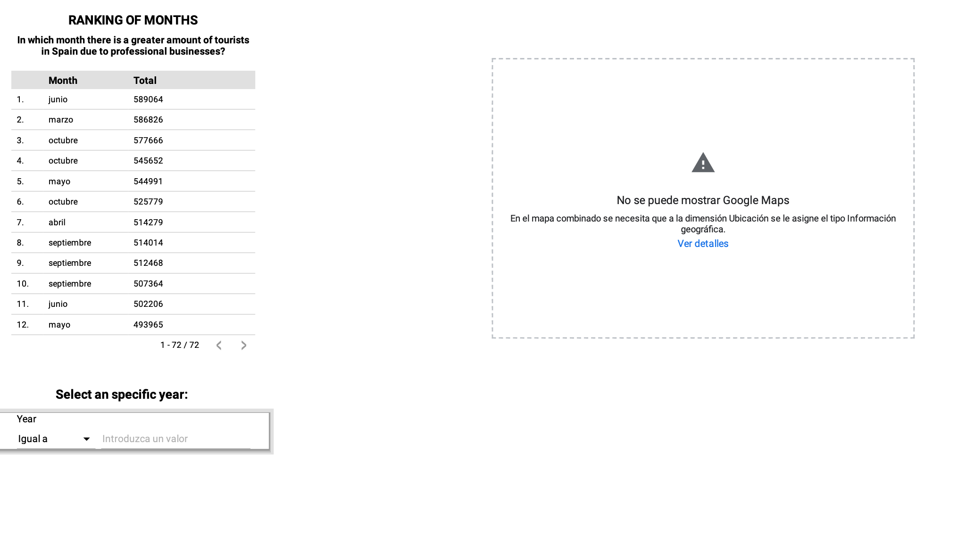

1. **A highlight box with total results:**

A highlight box has been implemented to showcase the percentage of employed people. The filter applied ensures that the data is limited to the unit "Porcentaje" and excludes both genders ("Sexo not ambos").

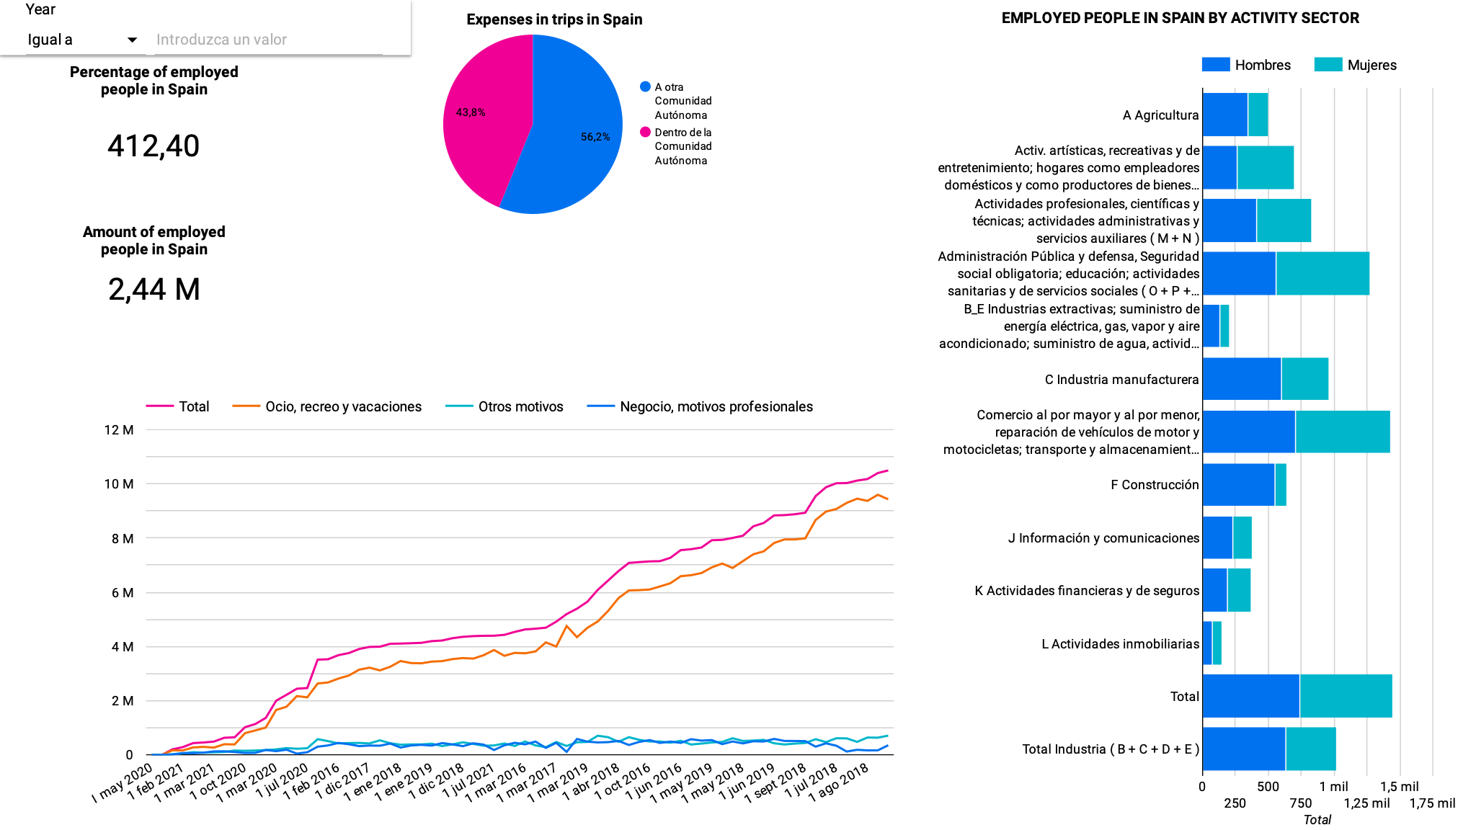

1. **A chart with a time series.**

In this plot we filter ‘tipo_dato’ by ‘Dato Base’ to see the reason why these trips have been done and their respective date



1. **A pie chart.**

We exclude from the ‘Tipo de destino’ column ‘España’ and filter ‘tipo de dato’ by ‘valor absoluto’ to show from the total expenses in trips of Spain, which are to go to another community or inside it.



1. **A bar chart.**

We created this barchart in order to visualize the employed people in Spain by each sector and we colored the sex to see the difference porcentajes.



1. **A table summarizing results.**

In this table we show the ordered months where there are more tourists in Spain, ordered by the ‘Total’ column.



1. **A map that represents the data by CCAAs.**

This map shows the number of trips per community.

