**BGP- Border Gateway Protocol**

**BGP:**

* Assegura conectividade da internet
* É maioritariamente usado para routing entre Sistemas Autónomos
* Sistemas Autónomos são uma rede que estão a ser “governados” por uma única administração
  + Uma ou mais redes que têm politicas em comum

**AS Numbers:**

* 2 bytes
* Um ID e único
* RFC 4271 defines an AS number as 2-bytes
  + Private AS Numbers = 64512 through 65535
  + Public AS Numbers = 1 through 64511
  + 39000+ have already been allocated
  + We will eventually run out of AS numbers
* Eventualmente será preciso expandir de 2 bytes para 1 byte
* RFC4893 defines BGP support for 4-bytes AS numbers
  + 4,294,967,295 AS numbers
  + As of January 1, 2009, all new Autonomous System numbers issued will be 4-byte by default, unless otherwise requested.
  + The full binary 4-byte AS number is split two words of 16 bits each
    - Notation: <higher2bytes>.<lower2bytes> em decimal
    - Example1: AS 65546 is represented as “1.10”
    - Example2: AS 50000 is represented as “0.50000”

**Relações de Vizinhança**

* Geralmente manualmente configurável pelo administrador
* Cada sessão de vizinhança corre por **TCP porta 179**
  + **Assegura a entrega de dados**
* O estabelecimento de relações de vizinhança chama se peering
* Peers (routers) fazem troca de informação para todos os routeres quando a sessão é estabelecida pela primeira vez
* Updates são feitos quando ocorre mudança de topologia ou mudança de politicas
* **KeepAlive** Messages
  + Evita peridodos de inatividade
  + KeepAlive messages curtas podem ser mudadas se requeridas.

**Internal BGP (iBGP) & External BGP (eBGP)**

* Relações de vizinhança podem ser estabelecidas entre
  + Routers do mesmo sistema autonomo-- **Internal BGP (iBGP)**
  + Routers de diferentes sistemas autónomos- **External BGP (eBGP)**
* Routers que implementem relações de vizinhança são chamados **Autonomous System Border Router (ASBR)**
* eBGP’s são usandos entre AS
* IBGP’s são usandos dentro de AS
* Um router BGP **NUNCA** reencaminha um caminho aprendido por um iBGP para outro iBGP mesmo que seja o melhor camimho.
* Um router BGP reencaminha os caminhos aprendidos entre um eBGP para outro eBGP e iBGP peers.
* iBGP routers num sistema autonomo têm de manter um sessão iBGP com todos os outros iBGP routers dentro desse sistema.
  + iBGP mesh
  + informação de routing completa
  + Usam muitas vezes OSPF
  + Outros metdos podem ser usados

**Single-homed (or Stub) AS**

* Quando um sistema autonomo so tem um router ASBR
* Uma única fonte de ISP(internet provider)
* Um único meio de aceder à internet

**Multi-homed Non-transit AS**

* Tem mais que um router ASBR(border Router)
* Multiplos pontos de acesso à internet
* Não transporta tráfego para outros AS.

**Multi-homed Transit AS**

* O mesmo escrito que o anterior, a diferença é que neste caso existe transporto de tráfego de uma AS para outra.

**Path Vector**

* BGP é um protocol Path-Vector
* É parecido ao Distance-Vector protocol mas aqui tambem é guardada a informação numa lista dos AS atravessados pelo router.
  + An EBGP speaker adds its own AS to this list before forwarding a route to another EBGP peer
  + An IBGP speaker does not modify the list because it is sending the route to a peer within the same AS
  + Esta lista não pode ser usada para detetar IBGP loops.

**BGP Messages**

* **Open message**s são usadas para estabelecer sessões BGP
  + Open ->
  + <-Open
* **KeepAlive**: messages are exchanged whenever the keepalive period is exceeded, without an update being exchanged.
  + KeepAlive->
  + <-KeepAlive
* **Update messages**: messages are used to send routing prefixes, along with their associated BGP attributes (such as the AS-PATH).
  + Withdrawn routes: Lista de ips de redes que já não estão disponíveis
  + Atributos Path: parâmetros usados para definr routing e politicas.
  + Netword Layer reachability: Lista de ips de rede que estão disponíveis
* **Notification:** messages are sent whenever a protocol error is detected, after which the BGP session is closed.
  + Fin,push->
  + <-Ack
  + <-Fin,Push
  + Ack->

**BGP attributes**

* É uma métrica usada para descrever características de o caminho BGP
* Estão contidos no updates messages
* Optional attributes can be further subcategorized as transitive or nontransitive. Routers must advertise the route with transitive attributes to its peers even if it does not support the attribute locally. If the path attribute is nontransitive, the router does not have to advertise the route to its peers.
* São mandados entre BGP peers(routers que estabelecerem comunicação)
  + **Well-known Mandatory (included in BGP updates)** 
    - AS-path, Next-hop, Origin.
  + **Well-known Discretionary (may or may not be included in BGP updates)**
    - Local Preference, Atomic Aggregate.
  + **Optional Transitive (may not be supported by all BGP implementations)**
    - Aggregator, Community, AS4_Aggregator, AS4_path.
  + **Optional Non-transitive (may not be supported by all BGP implementations)** 
    - If the neighbor doesn't support that attribute it is deleted : Multi-exit-discriminator (MED).
  + **Cisco-defined (local to router, not advertised)** 
    - **Weight**

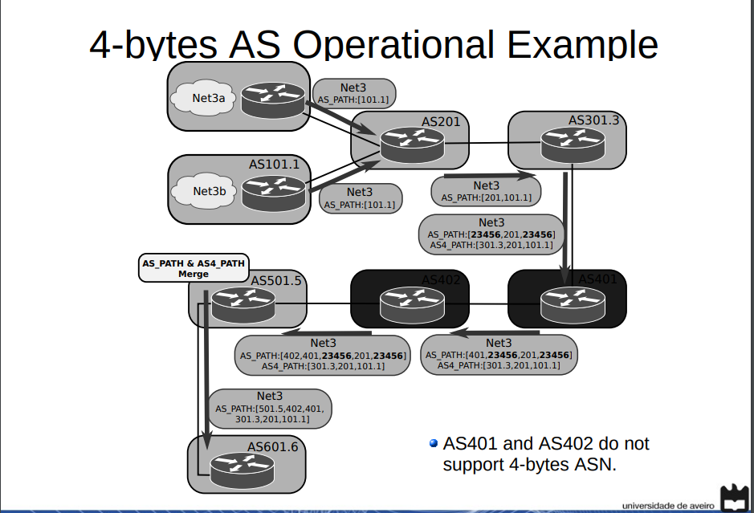

**Well-known Mandatory (included in BGP updates)**

1. **PATH**:

The AS path is a well-known mandatory attribute that contains a list of AS numbers in the path to the destination.

When a route advertisement passes through an autonomous system, the AS number is added to an ordered list of AS numbers that the route advertisement has traversed.

Each AS prepends its own AS number to the AS path. The AS path describes all the autonomous systems a packet would have to travel to reach the destination IP network. It is used to ensure that the path is loop-free.(?confirmar)

When the AS path attribute is used to select a path, the route with the fewest AS hops is preferred. In the case of a tie, other attributes, such as MED, break the tie.

1. **Origin:**

Indicates how BGP learned about a particular route.

Este atributo é recebido pelo router de origem BGP.

3 tipos:

* IGP (0) (se a routa é interior ao sistema autonomo que o criou),
* EGP(1)
* Incomplete(2) (se a rota esta a ser aprendida por outros protocolos)
* IGP lower than EGP, EGP lower than incomplete

In terms of choosing a route based on [origin, BGP](https://www.ccexpert.us/bgp-commands/set-origin.html" \o "set origin BGP Commands) prefers routes that have been verified by an IGP over routes that have been learned from EGP peers, and BGP prefers routes learned from eBGP peers over incomplete paths.

1. **Next-Hop Attribute**

* The eBGP next-hop attribute is the IP address that is used to reach the advertising router
* For eBGP
  + the next-hop address is the IP address of the connection between the peers
* For iBGP, the eBGP next-hop address is carried into the local AS
  + By configuration the AS border router can be the next-hop to iBGP neighbors

**Well-known Discretionary**

1. **Local preference Atributte**

* Usado para escolher um ponto de saída para o sistema autónomo(para pacotes de Internet)
  + Escolhem o valor mais alto é
* Essa preferência local é propagada pelo sistema autonomo local
* It is a well-known discretionary attribute used between iBGP peers and is not passed on to external BGP peers
* Pode ser diferente para diferentes routers
* is passed on to iBGP peers unlike Weight Attribte.
* If multiple paths exist, **Local Preference BGP** informs iBGP routers how to exit the AS ie which path to prefer for outgoing traffic.

**2: Atomic Aggregate**

* informs BGP peers that the local router used a less specific (aggregated) route to a destination without using a more specific route.
* The atomic aggregate attribute lets the BGP peers know that the BGP router used an aggregated route.

**Optional Non-transitive (may not be supported by all BGP implementations**

1. **Multi-Exit Discriminator Attribute (MED)**

* Atributo métrico usado com sugestão para um sistema autonomo externo.
* the preferred path into the AS when multiple paths into the AS exist.
* O AS externo que receve os MED’s pode estar a usar outros BGP atributos para a seleção da routa
* The MED attribute is not used with iBGP peers.
* O **valor mais baixo** é usado preferencialmente
* MED é usado para influenciar o tráfego que vem.

**Optional transitive**

1. **AS4_PATH** attribute has the same semantics as the AS_PATH attribute, except that it is optional transitive, and it carries 4-bytes AS numbers.
2. **Aggregator Attributes:**
   1. **Atomic Aggregate:** Is used to alert routers that specific routes have been aggregated into a less specific route. When aggregation like this occurs, more specific routes are lost.
   2. **Aggregator:** Provides information about which AS performed the aggregation. And the IP address of the router that originated the aggregate.

**3.Community Attribute:**Agrupa caminhos que partilhem propriedades em comum para que politicas possam ser aplicadas a esse grupo/nível.

A BGP community is bit of “extra information” that you can add to one of more prefixes which is advertised to BGP neighbors. This extra information can be used for things like traffic engineering or dynamic routing policies.

Predefined community attributes are:

* no-export : Do not advertise this route to EBGP peers
* no-advertise: Do not advertise this route to any peer
* Internet: Advertise this route to the Internet community; all routers in the network belong to it (to all neighbooors)

**Weight Attribute**

* É da cisco
* Atributo que é local ao router
* The difference between weight and local atributte is that weight is configured locally and is not exchanged in BGP updates
* On the other hand, the local preference attribute is exchanged between iBGP peers and is configured at the gateway router.
* Se um router aprende mais um caminho para o mesmo destino o caminho com o **maior weight** vai ser adotado.

**BGP Path Selection:**

* BGP seleciona um único caminho como melhor caminho.
* Ordem dos Critério:
  1. Largest weight (Cisco only)
  2. Largest local preference
  3. Path that was originated locally
  4. Shortest path
  5. Lowest origin type
  6. Lowest MED atribute
  7. Prefer the external path over the internal path
  8. Closest IGP neighbor

**Multi-Protocol Border Gateway Protocol (MP-BGP)**

* Extensão ao protocolo BGP
* Carrega informação de routing sobre outros protocolos/famílias
  + IPV6 Unicast
  + Multicast
  + 6PE ipv6 over iv4 backbone
  + Multi-Protocol Label Switching(MPLS) VPN
* Troca de Multi-Protocol Reachability Information
* Atributos:
  + New non-transitive and optional attributes(MP_REACH_NRLI + MP_UNREACH_NLRI)
    - MP_REACH_NRLI: carrega o conjunto de destinos que estão ao dispor/dentro do limite com as informações do next-hop para ser usada para fazer fowarning
    - MP_UNREACH_NLRI os destinos que estão fora de alcance:
  + Attribute contains one or more triples:
    - Address Family Information (AFI) with Sub-AFI(informações do protocolo)
    - Informação do Next-hop(da mesma família)
  + Informações de reachability.

**MP-BGP Negotiation Capabilities**

1. MP-BGP routers estabelecem sessões através de open messages
   1. Estas mensagens contêm parâmetros opcionais
   2. If OPEN parameters are not recognized, BGP session is terminated
   3. A new optional parameter: CAPABILITIES
      1. Multi-Protocol extensions (AFI/SAFI)
      2. Route Refresh
      3. Outbound Route Filtering

**MP-BGP New Features for IPv6**

* IPv6 Unicast
* IPv6 MultiCast
* IPv6 and label (6PE)
* IPv6 VPN (6VPE)

**Private BGP AS**

* Private autonomous system (AS) numbers range from 64512 to 65535
* It is not recommended that you use a private AS number when planning to connect to multiple ISPs in the future

**BGP Route Reflectors**

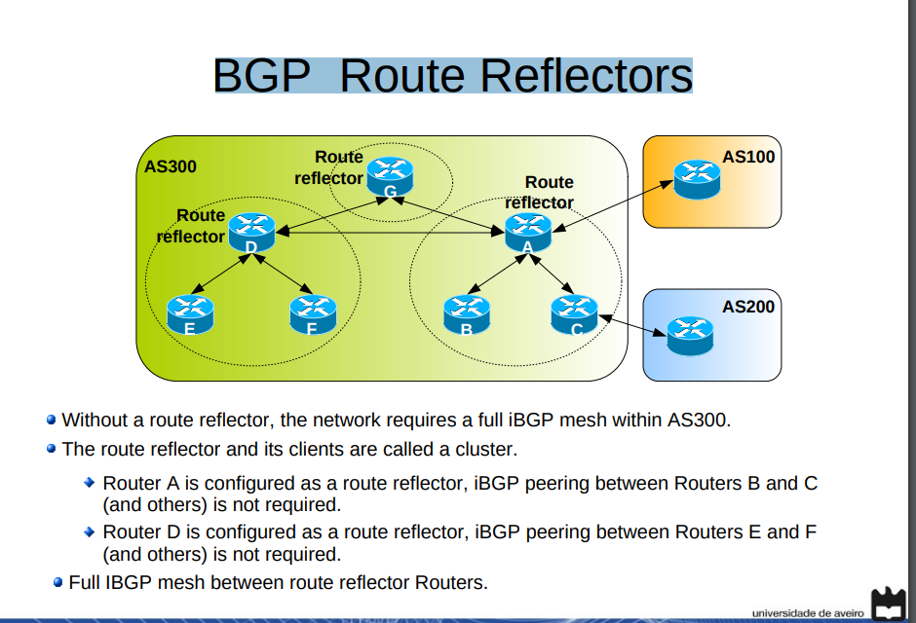

**Routes Distribition**

* Redistributing IGP routes by BGP will:
  + Simplify BGP configuration (advantage)
  + And BGP will announce only internal networks with connectivity (advantage)
* Redistributing BGP routes by IGP protocols will:
  + Make internal routes know all external routes (disadvantage/advantage?
  + Increase routing tables size in internal routers (disadvantage)
    - Decrease routing time, imposes memory requirements, ...
  + Avoid the usage of internal default routes (disadvantage/advantage?)

**BGP Filtering**

* By default BGP processes announce every network path that receives
* Sending and receiving BGP updates can be controlled by using a number of different filtering methods.(route naos, prefix lists…)
* BGP updates can be filtered (route information, path information, communities)
* Melhores práticas:
  + - Block all IPv4 private networks
    - Announce default routes only to peers where a traffic transport contract exists.
    - Accept default routes only from peers that provide a traffic transport service.