PROJECT CANVAS
Eurovision 2015–2025 · Marta Prandin · Albert School Data Projects

1 Title & pitch  Eurovision Voting Blocs, 2015–2025.  Songs matter — but neighbours vote for neighbours. | 2 SMART question + hypotheses  Q: Across Eurovision finals 2015–2025, do song features and country-region predict final rank, and is there voting-bloc bias?  H1: English-language songs rank ≥3 places higher.  H2: Each region gives ≥3 bonus points to its own.  H3: Televote bias > jury bias × 1.5.

3 Audience & decision  A music journalist writing the annual Eurovision preview.  Decides: which 2-3 storylines lead the article. | 4 Data sources  • Kaggle CSV (1975–2024) — primary.  • Wikipedia year-pages — fills 2025 gap.  • eurovision.tv — fallback only.

5 Variables  • country, year, song, artist, language  • tempo, key, running_order  • jury_points, televote_points, final_rank  • voter→performer pair scores (~11k rows) | 6 Sketch of final chart  Bar per country, grouped by region. Bonus points to neighbours. (Redraw on paper for class.)  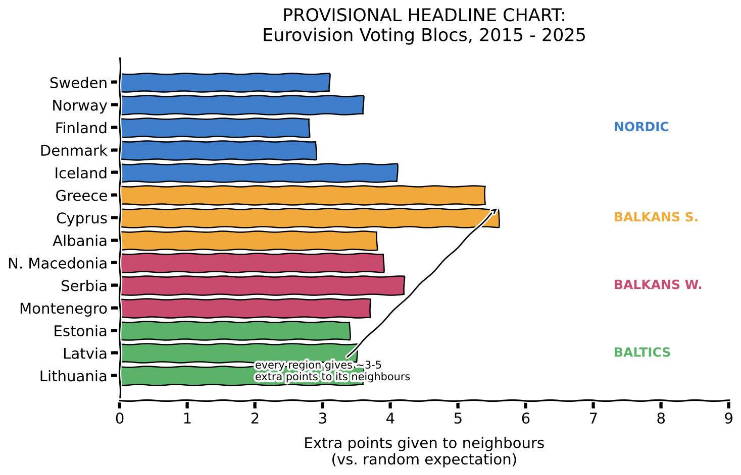

7 Risks & mitigations  • Layout breaks → switch to Wikipedia tables.  • No tempo data → drop tempo, keep language + region.  • Sample too small (n≈280) → bootstrap CIs, drop H3.  • Time slipping → cut features, ship the bloc story. | 8 Definition of done  • Notebook runs end-to-end on a fresh machine.  • 3 polished charts (language, blocs, jury vs televote).  • 10-min talk + 1 paragraph per hypothesis.  • Public GitHub repo with README + raw data.
Note: field 6 will be redrawn on paper. Image above = planning sketch.

