Paper title here
Times new Roman 16pt All CAPS
Paper Size → Letter (8.5 * 11)
No of Columns → 2
Column Width → 2.8
Column Spacing → 0.2

¹FIRST AUTHOR, ²SECOND AUTHOR
Author names should be ALL CAPS
Times new Roman 10pt .
Affiliations should be Capital Each Word Times new Roman 10pt

¹Designation, Affiliation, Department of xxx, xxx, Country
²Designation. Affiliation, Department of xxx, xxx, Country
E-mail: ¹xxx@www.com, ²xxx@abc.com
H 1: 1. TIMES NEW ROMAN 10PT ALL CAPS BOLD
H 2: 1.1 Times New Roman 10pt Capitalize Each Word Bold
H 3: 1.1.1 Times new roman 10pt sentence case bold

Abstract

E-commerce industry is growing rapidly in Indonesia, along with the increasing number of internet users and number of online shops is also growing. One of e-commerce type is online auction, a buy and sell method that integrates auction mechanism and the internet. In the interaction between online auction actors (buyers and sellers), inevitable failure/dissatisfaction of online auction transactions sometimes found. Started by analysing research of ”Online auction service failures in Taiwan: Typologies and recovery strategies”, through users survey, author want to build online auction application along with additional added values and suggestions from the research. Analysis and observation are also conducted, especially in user experience aspects, design and transaction flow local e-commerce platforms that are commonly used in Indonesia, in purpose to make the application suits Indonesian’s users better. In hope that this application could reduce/prevent the expected failures in online transactions and open up online auction opportunity to enliven the e-commerce industry in Indonesia.
Keywords: Bidding, Online Auction, Service Typologies, Typologies and Strategies, E-Commerce

- Introduction

Bidding is a transaction process of selling and buying goods or services by offering amount of prices to the seller, and afterwards selling goods to the highest bidder. Currently trading transactions can be done through various ways, such as using e-commerce, or through social media. Slightly different from conventional auction process, since auctioneer is not limited to the auctioon rooms, but can do the bidding process anywhere and anytime by using the online-auction application. Online auction also brings many benefits and not time-consuming because anyone, anytime and anywhere the auction process can be done without having to go to certain agencies and do the auction in the conventional way. Similar applications already been built, but many aspects are lacking in the application, such as unreliable information (goods stock are already exhausted), unclear bussiness process, lack of the clarity of the inforation, and bad information (the information provided prior to the item is not the same with the actual item).
The process flow that is underestimated by the online auction application developers to be several powerful reasons why online auction is still less desirable. This research objectives are to find create an application that improves and aid some weaknesses that still exist in online auction, and also improves the image of online auction application so as to increase public interest towards online auction
- Background

Objectives

Limitations

- lELANGAPA: THE IMPROVED ONLINE AUCTION APPLICATION
Our proposal, Lelangapa, is a online auction platform that centered its customer and make the application well-tailored to the customers. Its aim is to create auction process is so easy and comfortable and create a long-lasting software as its maintainability and security are concerned as well. Therefore, there are two aspects concerned in this study: user experience and maintainability.

Base Paper Analysis
According to the existing e-commerce applications, the most common problem is user dissatisfaction. A company is said to have customer dissatisfaction is due to a failure in its service. A customer may very well decide to complain after experiencing dissatisfaction with a company's services, and if not handled properly, this can be fatal to the reputation and the trustee of the user to
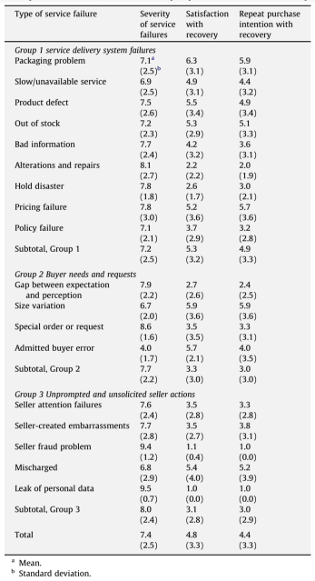

Figure 1: Service Failures

such an application. Therefore, study conducted on this topic specifically in the field of online auction applications, analyzes user failures and dissatisfaction, along with solutions offered by application users to correct service failures.
Figure 1 describe the types of failures that have been experienced by the users of the application as well as the fatalities / adverse effects of such failures on user trust. In Figure 2, the user satisfaction level is presented against the given recovery solution. Based on the results of these analyzes and matching these Final Limitations, the added features other than the basic features of online auction applications as the added value are as follows:
1. Chating feature, to reduce the possibility of Bad Information where expectations and perceptions of goods being auctioned between Buyer and seller are not same and Special Needs; and
Figure 2. Bussiness Engineering Aspects
2. Feature of voucher coupon (Discount and Correction Plus) which can be free shipping or discount

Bussiness Engineering Analysis
Auction is one method of exchange of goods and services with different pricing methods with trade. Therefore, the auction is also included in the business category. What's interesting is that when businesses are bundled with technology or so-called e-commerce, things simply translate into a complex interactive system where the main purpose is to attract visitors / users to complete a transaction. This is certainly crucial, crucial, and challenging to complete. In achieving success and high levels of competition, it must provide the service with a positive user experience (UX) impression for its users. Morville [29, p.27], in his study, states that UX is covered in 6 essential aspects, namely:
a. Useful
b. Usable
c. Findable
d. Desirable
e. Accessible, and
f. Credible.
Important findings of interest in the influence of user experience, are as follows quoted from a source are as follows:
a. Familiarity – that can be defined as the familiarity or the similarity level related to the similar system actually could build trust level that suggest the users to finish the transaction in the application;
b Usability which allows users to complete transactions easily; and
c. Psychological aspects such as color selection, the use of appropriate icons, such as the padlock icon on the payment page can impress the security of the user
These aspects are summarized in Figure 2.
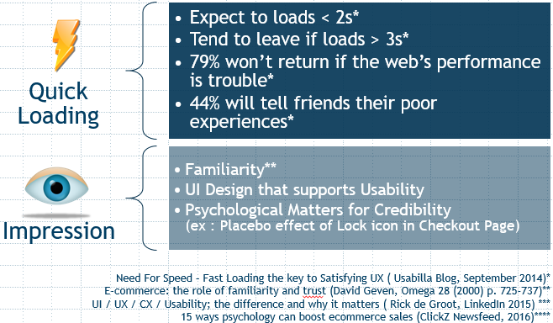

Technical Analysis
To create a successful application, of course, many aspects that must be considered. In addition to the quality of applications that will be created, as well as its resistance to change because e-commerce is something that is very rapidly changing due to highly competitive competitors and technological encouragement that make better effectiveness and efficiency.
From the aspect of software engineering itself, software engineering is intended to software development,, compared to the individual programming. These supports includes:
a) evolution
b) design
c) supporting program specification [30].
Based on these criteria, then every point needs to be considered in order to develop an application that is not only successful, but also survive in the competition. In business terms, this is called risk management & planning.

Testing & Assesment
The application testing is concerned on three aspects: a) speed, b) user experience and c) maintainability. Those three aspects assessment process will be described on the next section.

Speed Testing
The tests were carried out using criteria referring to the Research of an Instrument Measuring User Satisfaction of the Human-Computer Interface [31], as follows:
1. Web Design & Impression
2. Clarity & System Consistency
3. Ease of Use
4. Clarity of process status
5. Clear error message
6. Speed
7. Overall Rating
8. Level of recommendation on friends
The test was conducted on July 8, 2017 at Wonorejo Seed Garden, by arbitrarily selecting the respondents currently in the garden. Then, respondents were asked to use pre-existing applications (balelang.com) and this final application for a few minutes, and after enough, then the respondents filled out the questionnaires that had been given.

User Experience Assesment
The tests were carried out using criteria referring to the Research of an Instrument Measuring User Satisfaction of the Human-Computer Interface [31], as follows:

1. Web Design & Impression
2. Clarity & System Consistency
3. Ease of Use
4. Clarity of process status
5. Clear error message
6. Speed
7. Overall Rating
8. Level of recommendation on friends
This test was conducted on July 8, 2017 at Wonorejo Seed Garden, by arbitrarily selecting the respondents currently in the garden. Then, respondents were asked to use pre-existing applications (balelang.com) and this final application for a few minutes, and after enough, then the respondents filled out the given questionnaires.

Maintainability Assesment
The tests were carried out using criteria referring to the A Software Maintainability Evaluation Methodology paper [32]. This paper states that there are 2 basic criteria of maintainability assessment with different weight, ie documentation (weight: 40%) and source code (weight: 60%). According to the paper, there are 5 main factors of maintainability, which are as follows:
1. modularity;
2. descriptiveness;
3. consistency;
4. simplicity; and
5. trackability
This test is done by spreading the online form by using the Google Form media. Respondents who are targeted are respondents with software engineer background with the aim that the respondents can compare the experience of these respondents with the quality of maintainability this final task.

- DESIGN & Implementation

Usecase Design
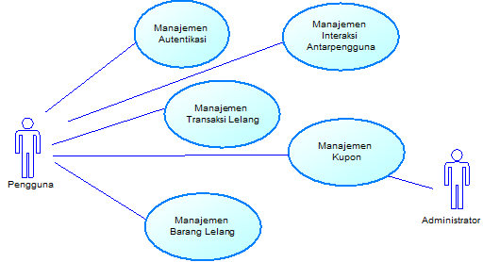
The usecase diagram is defined on Figure 3.
Figure 3. Application’s Use Cases Design
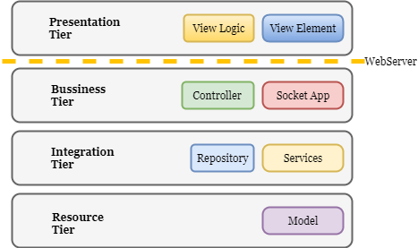
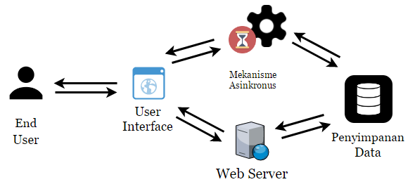
Figure 3. Application’s Tiers
Figure 4. Bussiness Engineering Aspects

Application Structure
Application’s Structure are built to accommodate the needs of flexibility and maintainability. The tiers, can be seen at Figure 3 are classified as follows:
1) Presentation tier, responsible for view and view logic in the user's browser sphere;
2) Business tier, is the logic of business application process;
3) Integration tier, is the integration of data processing and external services management; and
4) Resource tier, responsible for data access layer.
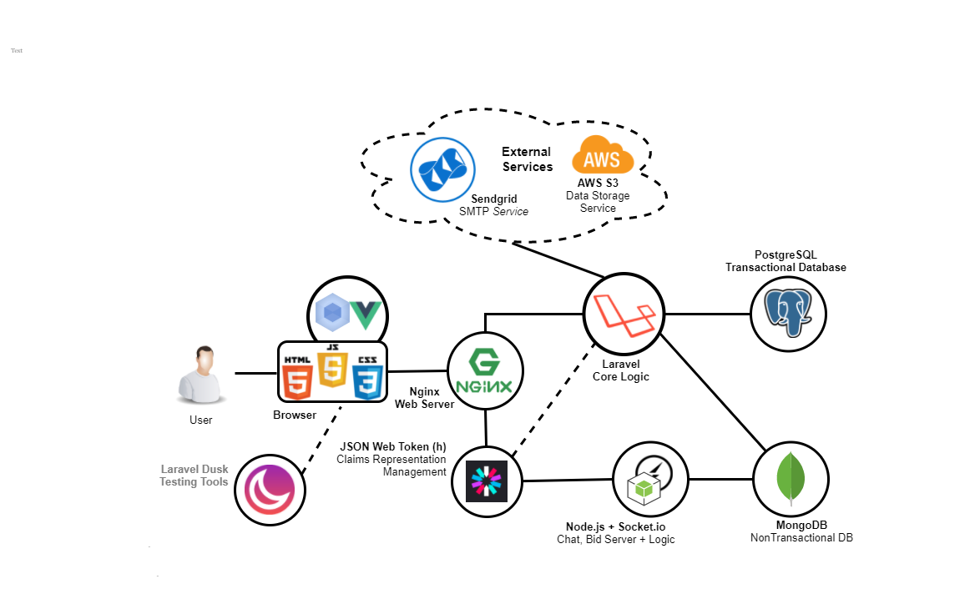
Figure 5.Application Architecure and Technology Choosements

Application Architecture
Application architecture is carefully considered as e-commerce applications are prone to feature changes and additions.
The A
The essential/foundation architecture of this application can be seen on Figure 4, and its derivation to technology choosements can be seen on Figure 5.
External services usage is used as the concern of scalability aspects of the application, and the technology choosements is carefully considered since Amazon S3 is well known as the best cloud storage provider in its class. The SMTP relay external services is also used as the requirements of automated email confirmation is needed in this application.
- Testing
As defined before, the testing is concerned into three aspects: speed, user experience and maintainability assessment. These three will be explained in the next section.

User Experience Testing

- conclusion and suggestion
Manuscripts must be in English (all figures and text) and prepared on Letter size paper (8.5 X 11 inches) in two column-format with 1.3 margins from top and .6 from bottom, and 1.25cm from left and right, leaving a gutter width of 0.2 between columns.

Centered at top of the first page should be the complete title of the manuscript, followed by name(s) of author(s), affiliation(s), mailing and email address(es). This is followed by the abstracts under the heading ABSTRACT, keywords under the heading Keywords and followed by the text. The text should be typed in single space, using a font similar to the one used in this text (Times, 10 points). Paragraphs should be separated by single spacing. Each manuscript should not exceed 10 pages including illustrations and tables.

Sections and Subsections
Sections and subsections should be numbered and titled as 1.0, 2.0, etc. and 1.1, 1.2, 2.1, 2.2, 2.2.1, etc. Capital letters should be used for the section titles. For subsections, the first letter of each word should be in capital letter and followed by small letters. One line space should be given above the sub section while no space should be given below the heading and text

Identification of sub subsections
Subsub section has to be in sentense case with no spacing above or blow the srat of it.

3. TABLES AND FIGURES

Figures should be labeled with "Figure" and tables with "Table" and should be numbered sequentially, for example, Figure 1, Figure 2 and so on (refer to table 1 and figure 1). The figure numbers and titles should be placed below the figures, and the table numbers and titles should be placed on top of the tables. The title should be placed in the middle of the page between the left and right margins. Tables, illustrations and the corresponding text should be placed on the same page as far as possible if too large they can be placed in singly column format after text. Otherwise they may be placed on the immediate following page. If its size should be smaller than the type area they can be placed after references in singly column format and referenced in text

