Combining Bussiness, E-Commerce and Software Engineering – Case Study of Online Auction

**Ronauli Sidabukke, Rully Soelaiman, Rizky Januar Akbar**

Institut Teknologi Sepuluh Nopember

Jl. Arief Rahman Hakim, Surabaya 60111 Indonesia   
e-mail: sidabukke.ronauli13@mhs.if.its.ac.id, rully@is.its.ac.id, rizky@if.its.ac.id

***Abstract***

*E-commerce is a combination of digital world and auction deals. In Indonesia, as there is an increasing number of Internet users and the proliferation of online business or often called an online shop. One type of transaction is an auction, the method of sale and purchase that integrates the auction mechanism with the Internet.*

*In the interaction between online auctioneers (sellers and buyers) there must be a failure / dissatisfaction in online auction transactions. Lifting from the paper "Online auction service failures in Taiwan: Typologies and recovery strategies" which deals with fault analysis and strategy through surveys of auction app users Online in Taiwan, the author builds an online auction application along with additional features and suggestions from the paper.*

*In addition, the author also analyzes e-commerce applications commonly used in Indonesia both user experience and flow of transactions, and add some features to better suit the general online buying transactions in Indonesia..*

***Keywords****: online auction, strategies, e-commerce, typologies*

**1. Introduction**

Auction is the process of buying and selling goods or services by offering to the bidder, offering a higher bid price, and then selling the goods to the highest bidder [1]. Currently trading transactions can be done through various ways, such as using e-commerce, or through social media, or can be auctioned in online auction applications. Slightly different from sales techniques in online auctions, because these apps are accessible to many people, of course auction-eer is not limited to auction space only, but can come from anywhere as long as they access the app. This online auction of course brings many benefits, in addition to more efficient and cost efficient, and also not time-consuming because anyone, anytime, anywhere can bid or auction goods without having to go to certain agencies and do auction in a conventional way.

Similar applications have been numerous, but many aspects are lacking in the app, such as information from unreliable auctions (eg stocks of goods are already exhausted), unclear process channels that confuse application users, lack of clarity, Atkan was not in accordance with the information at the time of the product auction (bad information) [2].

The process flow that is underestimated by the online auction application developers is a number of strong reasons why online auctions are less desirable [3]. In addition, the business field that demands rapid changes must of course be adapted so that the application is flexible with high maintainability.

**2. Research Method**

This research is conducted by reviewing journals related to e-commerce and strategy. In addition, this research is also combined with previous application build experience. With agile and incremental methods.

**2.1. Base Paper Analysis**

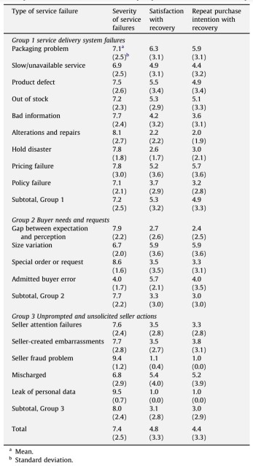A paper raised this topic specifically in the field of online auction applications, analyzing user failures and dissatisfaction, along with solutions offered by application users to correct the failure of the service. Some types of failures that have been experienced by the users of the application as well as the fatalities/adverse effects of such failures on user trust are describedBased on the results of the analysis and matching with this Final limit, the added features other than the basic features of online auction application as an added vaue are as follows:

Figure . Fatality of Typologies in Online Auction Services

1. Chat feature, to reduce the possibility of Bad Information where expectations and perceptions of goods auctioned between buyers and sellers are not the same and Special Needs; and

2. Feature of voucher coupon (Discount and Correction Plus) which could be in a form of free shipping coupon or discount coupon.

**2.2. Bussiness Analysis**

Auction is one method of exchange of goods and services with different pricing methods with trade. Therefore, the auction is also included in the business category. What's interesting is that when businesses are bundled with technology or so-called e-commerce, things simply translate into a complex interactive system where the main purpose is to attract visitors / users to complete a transaction. It is certainly very crucial, important, and challenged to solve it.

In achieving success and high levels of competition, it must provide the service with a positive user experience (UX) impression for its users. Morville [4, p. 27], in his study, states that UX is covered in 6 essential aspects, that is useful, usable findable, desirable accessible and credible. Important findings of interest in the influence of user experience, are as follows quoted from a source are as follows:

A. User tend to leave if a page loads more than 3 seconds;

B. 79% of users will not return if the web's performance and experience is poor; And

C. 44% of users will tell the poor experiences to their friends.

D. Familiarity - which can be defined as a familiarization level or similarity with a similar system may establish a trust so that it mensugesti the user to complete the transaction;

E Usability that allows users to complete transactions; and

F. Psychological aspects such as color selection, use of appropriate icons, such as the padlock icon on the checkout page can create an impression of secure checkout – even though the addition of that icon isnt mean anything in the technical/coding aspects.

**2.3. Technical Analysis**

Bussiness is who changes faster, adapt faster is the winner. To create a successful application, of course many aspects that must be considered. In addition to the quality of applications that will be created, as well as its resistance to change because e-commerce is something that is very rapidly changing due to highly competitive competitors and technological encouragement that make better effectiveness and efficiency. From the aspect of software engineering itself, software engineering is intended to support / support software development rather than individual programming. This includes: a) evolution B) design c) supporting program specification [5]. Based on these criteria, then every point needs to be considered in order to develop an application that is not only successful, but also survive in the competition. In business terms, this is called risk management & planning.

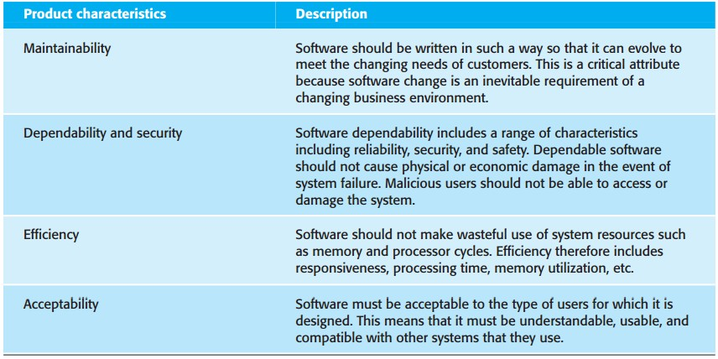

Figure Essential Attributes of Good Software [5]

**3. Design & Implementation**

**3.1. Application Structure**

Lelangapa – the address of the research’s application – is carefully designed to accomodate future changes, such as features or technology changes. This application designed at initiation to be consisted in 4 tiers that can be seen on Figure 3. These tiers are built to accommodate flexibility and maintainability needs. The tiers are classified as follows:

1) Presentation tier, responsible for view and view logic in the user's browser sphere;

2) Business tier, is a logic of business process aplications;

3) Integration tier, is the integration of data processing and external services management; and

4) Resource tier, responsible for data access layer.

Figure . Application's Architecture Fundamentals

Figure . Application Tiers

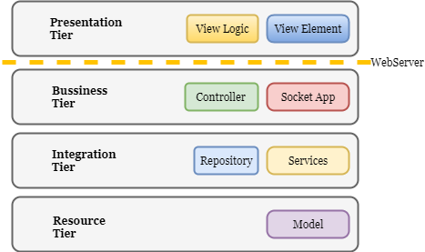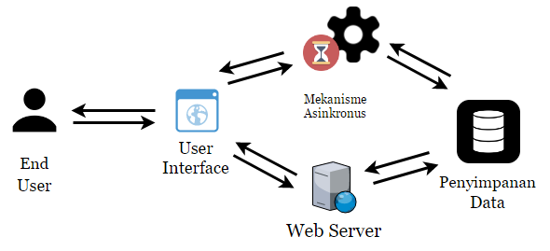**3.2. Application Architecture**

To accomplish the realtime requirement of the bididng process, a asinchronous mechanism should be added to the application fundamental architecture. After reconsidering and carefully chosing the technology usage of this application development, the technology and architecture is defined in Figure 5.

The notable points of some technology choosements in application architecture is explained as follows:

1. JSON Web Token is added to secure the massive socket connection to the realtime application that is built with Node.js and Socket.io
2. Node.js and Socket.io is chosen because of its well-documented source code and equipped many features or libraries, the same argument also applies with Nginx, Laravel, AWS S3, MongoDB and Vue.js as well.
3. Vue.js is chosen because of it is default-packaged with Laravel and its easiness of use.

Figure Application Architecture and Technology Choosements

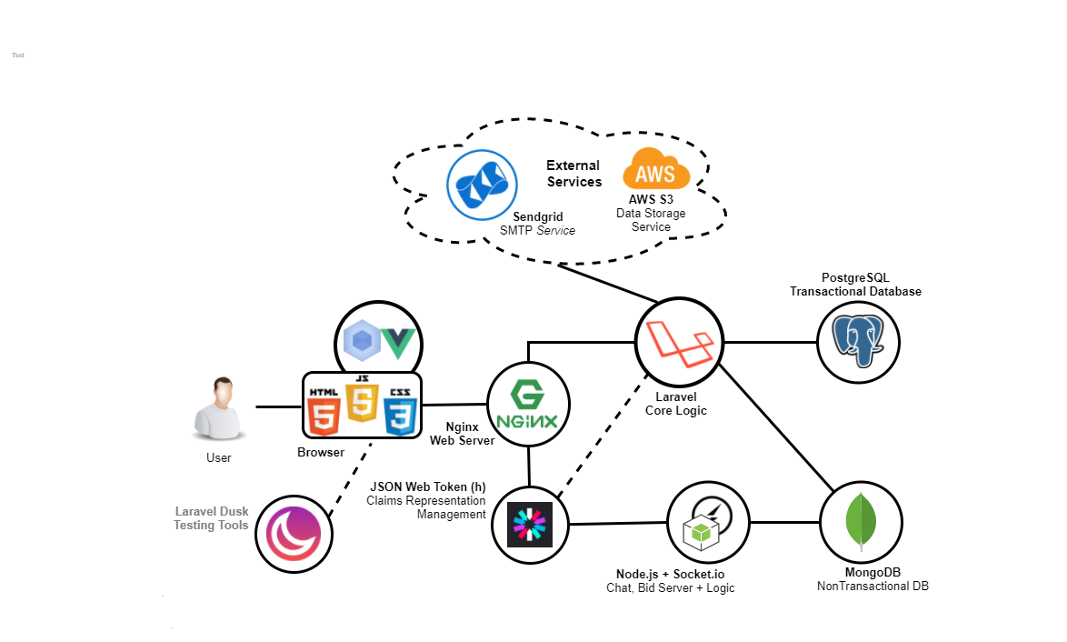

**3. Results and Discussion**

Figure User Experience Assesment Result

Lelangapa’s main concern of evaluation in this research is round up in three aspects: user experience, maintainability and speed since this is the main observation in this research.

**3.1. User Experience Assesment**

The tests were carried out using criteria referring to the Research of an Instrument Measuring User Satisfaction of the Human-Computer Interface [6], as follows:

1. Web Design & Impression

2. Clarity & System Consistency

3. Ease of Use

4. Clarity of process status

5. Clear error message

6. Speed

7. Overall Rating

8. Level of recommendation on friends

This test was conducted on July 8, 2017 at Wonorejo Seed Garden, by arbitrarily selecting the respondents currently in the garden. Then, respondents were asked to use pre-existing apps (balelang.com) and this final application for a few minutes, and once considered sufficient, then the respondents filled out the questionnaire that had been given. The result can be seen on Figure 6.

From the conclusion, can be concluded that the user experience impression is better, and user experiencenya score slightly above other similar systems. The difference is quite significant is recommendation, ease of use and good web design. However, the concern is the difference in performance is still very small. This is related to the test speed test in the Speed Testing section.

**3.2. Maintainability Assesment**

The tests were carried out using criteria referring to the A Software Maintainability Evaluation Methodology paper [7]. This paper states that there are 2 basic criteria of maintainability assessment with different weight, ie documentation (weight: 40%) and source code (weight: 60%). According to the paper, there are 5 main factors of maintainability, which are as follows:

1. modularity;

2. descriptiveness;

3. consistency;

4. simplicity; and

5. trackability

This test is done by spreading the online form by using the Google Form media. Respondents who are targeted are respondents with software engineers background with the aim that respondents can compare the experience of these respondents with the quality of maintainability of this final task.The statistics of the respondents can be seen on Figure 7.

The resulf of the maintainability assesment can be seen on Figure 8, where the average of there result is 77%, that is 96% accomplishment through the evaluator agreement goal (the research stated that the evaluator agreement goal is 80%). Furthermore, it still needs more improvements such as providing online documentation (like JIRA), more specific and descriptive readme.

Figure Maintainability Respondents Statistics



Figure Maintainability Assesment Result

**3.3. Speed Testing**

The average results of the loading and request speeds of the system are as follows, in accordance with the segmentation that has been presented in the Speed Test section:

1. DOM Loading: 104.2 ms

2. Scripting: 914.6 ms

3. Rendering: 313.7 ms

Comparison visualization / comparison between the three segments can be seen in Figure 5.1. Speed testing is done using Google Chrome Developer Tools, where for each use case is tested with loading time segmentation as follows a) Loading DOM b) Scripting c) Rendering. The overall average page loading is 3.2 seconds (over 6% of the target). To analyze by visualizing each segment in Figure 9 and 10. Using the Light-house tool, scripting takes a very large time (almost 75-% loading time) for image loading, which turns out to be a common problem on e-commerce websites, using image optimization techniques.

**4. Conclusion**

From the process of design, implementation and testing of the system, can be drawn some conclusions follows:

1. Quality of design and system design and system flexibility is very important in the design of online trading applications, because the nature of the changes very quickly.

2. User Experience is a very important factor in the success of online trading platform.

3. In addition to user experience, maintainability is also very important in software development.

Here are some suggestions prior for further development:

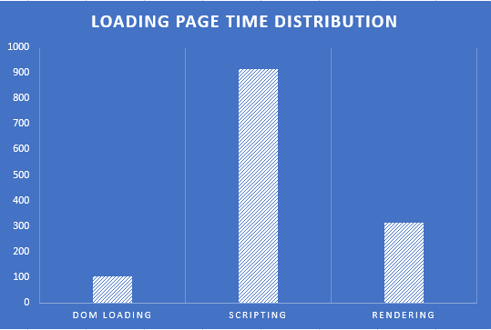1. Involving capable and credible parties and experts in legal and bussiness to establish the flow, improve create a monitoring flow for a safer, credible auction process.

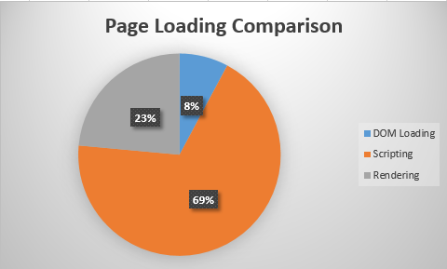

Figure Page Loading Comparison

Figure Loading Page Time Distribution

2. Learn the successful online auction platform overseas, which is learning the ideas, the flow of activity and the use of user experience and usability rules in the website and its impact on revenue.

**References**

[1] BalaiLelang, “Sejarah Lelang di Indonesia.” [Online]. Available: https://www.balailelang.co.id/index.php/sejarah-lelang/ sejarah-lelang-di-indonesia

[2] Y.-F. Kuo, S.-T. Yen, and L.-H. Chen, “Online auction service failures in Taiwan: Typologies and recovery strategies,” Science Direct, vol. 10, pp. 183–193, Oct. 2016.

[3] “Sistem Lelang Online Masih Bermasalah.” [Online]. Available: http://www.saidabdullah.info/index.php/issues/ 394-sistem-lelang-online-masih-bermasalah

[4] T. G. Laia Bonastre, “A set of heuristics for user experience evaluation in e-commerce websites,” ACHI 2014 : The Seventh International Conference on Advances in Computer- Human Interactions, pp. 27–34, 2014.

[5] I. Sommervile, Software Engineering, 9th ed. United States of America: Addison-Wesley. All rights reserved, Oct. 2009.

[6] J. P. Chin, V. A. Diehl, and K. L. Norman, “Development of an Instrument Measuring User Satisfaction of the Human-Computer Interface,” Proceedings of ACM CHI’88 Conference on Human Factors in Computing Systems, May 1998.

[7] D. E. PEERCY, “A Software Maintainability Evaluation Methodology,” IEEE TRANSACTIONS ON SOFTWARE ENGINEERING,, vol. SE-7, no. 4, pp. 343–351.