ID 1

Name: There is no <Edit> option.

Reproduction steps:

1. Enter page https://naucz-sie-testowac.czyitjestdlamnie.pl

2. Click yellow button <+> and fill in the fields <Name>, <Amount>, <Date>.

3. Click green ‘tick’ button.

4. Your expense is on the list.

5. Hover the mouse over your expense.

Actual result:

You can’t see ‘edit’ button, there is an empty space between blue and red button.

Expected result:

When you hover mouse over the added expense you can see ‘edit’ button and it should be active.

Przeglądarka:

Chrome wersja 106.0.5249.119 (64-bitowa)

Środowisko:
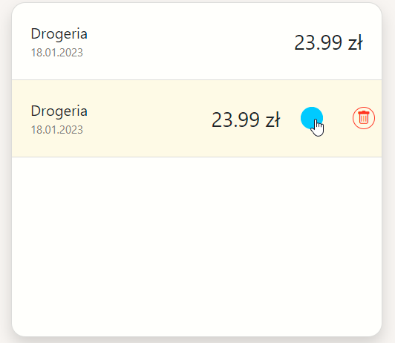
https://naucz-sie-testowac.czyitjestdlamnie.pl/ wersja z dnia 18.01.2023

