**ML -US NATIONAL FLIGHTS DELAY**

**JANUARY-JUNE- 2024**

**1. DATA LOADING AND PREPARATION**

The first section focuses on loading and preprocessing the data.

* **Removing unnecessary columns**: Unused columns are dropped from the dataset.
* **Handling missing values (NaN)**: There are 49,510 cancelled flights, with no ARR_TIME. We proceed to delete these  flights as will not have delete time
* **Converting categorical variables**: The day of the week and the month are converted into numerical values to make them more suitable for machine learning models.

These transformations are crucial for ensuring that machine learning models work with clean and well-structured data.

**2. TRAIN TEST-SPLIT**

Next, the data is split into a training set (80%) and a testing set (20%) using train_test_split. This is a standard practice in machine learning to evaluate model performance on data that wasn't seen during training.

This split is essential to prevent overfitting and to ensure that the model generalizes well on unseen data.

**3. VARIABLES (Categorical and Numerical)**

Each variable in the DataFrame is classified based on its type:

* **Categorical variables** (ORIGIN_CITY_NAME,DEST_CITY_NAME ).
* **Numerical variables** (MONTH, DAY_OF_MONTH, DAY_OF_WEEK, CRS_DEP_TIME,CRS_ARR_TIME ).

A dictionary of categorical and numerical variables is created to make further processing and transformation easier.

This classification helps apply appropriate preprocessing techniques, such as encoding or normalization, based on the type of variable.

**4. ENCODING**

The code creates a mapping of the origin and destination cities to unique numerical values. This process, called **encoding**, transforms categorical variables into values that machine learning models can understand.

Additionally, a **logarithmic transformation** is applied to variables like "Month" and "Day of the Week" to improve the data distribution and avoid bias.

These transformations enhance the model’s ability to handle categorical variables and ensure better handling of numeric distributions.

**5. NORMALIZATION**

The next step is to **normalize** the numerical variables (such as delays, flight times) using StandardScaler and the categorical using OneHotEncoder. This is essential to ensure that the models, work efficiently without some variables dominating others due to their scale.

Normalization improves the convergence and accuracy of models, especially for algorithms like logistic regression or neural networks.

**6. MACHINE LEARNING MODELS**

The code implements three machine learning models:

* **Random Forest Regressor**: A decision tree-based model used to predict flight arrival times (ARR_TIME).
* **XGBoost Regressor**: A boosting algorithm that uses decision trees and is popular for handling large datasets and providing strong predictions.
* **LightGBM Regressor**: Similar to XGBoost but more efficient in terms of computational time and resources, especially for large datasets.

The models are trained using the training set (X_train and y_train) and evaluated using the test set. These three models are highly effective for predicting continuous values like flight arrival times. Comparing their results:

- Random Forest is not competitive. It shows a much higher MSE than the other models, indicating that Random Forest has a worse fitting ability. It also has the smallest R²

-XGBoost has metrics that indicate an excellent fit

- LightGBM has slightly better metrics than XGBoost, making it the best model for this case.  
Conclusion :**LightGBM is the best model**, followed closely by XGBoost, while Random Forest lags behind in comparison.

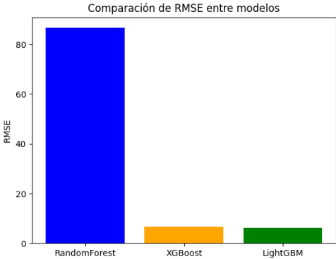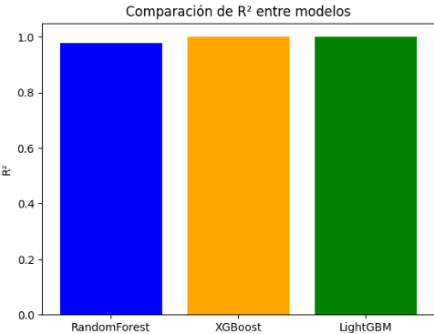

**7. HYPERPARAMETER**

Using **RandomizedSearchCV**, a randomized search is performed to find the optimal hyperparameters for each model. This ensures the models are fine-tuned for maximum performance.

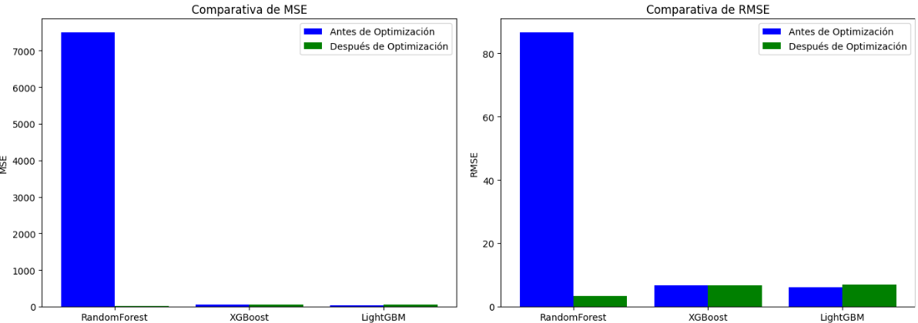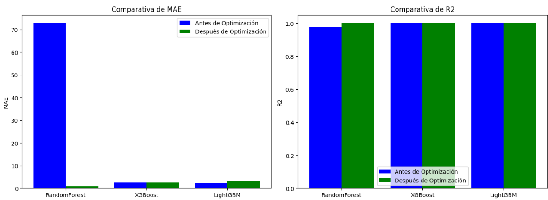

- Random Forest achieves significantly better performance on all metrics after optimization compared to the default values ​​shown in the first code. Is the bhe best model among the three, with the best MSE, RMSE, MAE, and a near-perfect R².

- XGBoost is still a solid choice, but it does not outperform Random Forest on any of the metrics.

- LightGBM, while efficient, has shown somewhat inferior performance compared to XGBoost and Random Forest after optimization.

Conclusion

- **Random Forest is the best model** for this dataset, as it has the best performance on all key metrics after optimization.

- XGBoost is a second competitive option, but if you are looking for the most accurate model, Random Forest is the optimal choice.

- LightGBM, despite its good ability to handle large volumes of data, does not offer the best fit in this case.

**8. RESULTS**

After calculating the ARR_TIME again, we will proceed to do some analysis in order to see the delays across the country.

For that analysis we will create the following columns:flight duration,absolute delay ,relative delay

We need to know, that unlike Europe, the refund policy for flight delays in the U.S. varies based on the airline, as there is no federal law requiring airlines to compensate passengers for delays.

U.S. airlines are not required to offer refunds for delays unless the delay results in a significant schedule change, and the passenger chooses not to take the flight.

Some airlines may provide vouchers, meal compensation, or hotel stays for long delays (e.g., 4+ hours), but this is not universal.

For delays while on the tarmac, the Department of Transportation (DOT) mandates:Domestic flights: Passengers must be allowed to deplane after 3 hours unless it is unsafe.

International flights: The limit is 4 hours.

Airlines must provide water, snacks, and working lavatories during tarmac delays.

**1. BUSINESS NEEDS: Improve flight- air connections that present a long delays**

🡪 ANALYSIS RESULTS

* The flight with the longest delay is Phoenix, AZ - Durango, CO

* The flight with the shortest delay is Chicago, IL - New York, NY

🡪 SOLUTIONS

* Adjust schedules

* Explore alternate routing:

* Dedicated extra resources

🡪 NEXT STEPS

* Analyze the reasons of the delays (weather, aircraft, passenger volume etc)

* Perform a root-cause analysis of delays for the Phoenix-Durango route in order to improve the long delays

* Analyze the success of the Chicago-New York route to identify transferable strategies to other airports.

**2. BUSINESS NEEDS: Improve airport efficiency.**

🡪 ANALYSIS RESULTS

* The month with the most delays is February

* The day of the week with the most delays is Saturday

🡪 SOLUTIONS

* Staff Preparedness

* Winter Operations Optimization:Create contingency plans for severe weather, including backup staffing and rebooking policies

🡪 NEXT STEPS

* Dive Deep detail by airport in order to improve customer satisfaction

* Analyze the specific causes of delays in February and Saturdays (e.g., winter season, staffing, maintenance).

* Identify the peak times within February and Saturdays to target improvement

**3. BUSINESS NEEDS: Reduce flight delays**

🡪 ANALYSIS RESULTS

* Origin cities with significant delays :Brunswick, GA; Santa Rosa, CA; Helena, MT

* Destination cities with the highest absolute delays (e.g., Durango, CO; Fairbanks, AK; Grand Junction, CO).

🡪 SOLUTIONS

* Collaborate with Airports and Airlines in those airports

* Test alternate flight paths or scheduling adjustments for delay-heavy routes

🡪 NEXT STEPS

* Identify if delays are due to external factors (e.g., weather) or internal inefficiencies

**4. BUSINESS NEEDS: Reduce operating costs for airlines**