COMP304(Sec 401) – Midterm Screenshots

Marta Polishchuk
Centennial College
COMP304 – Mobile Apps Development
Dr. Vinay Vaithilingam
June 23, 2026
Emulator is not working I don’t have time to troubleshoot (UPDATE BELOW)
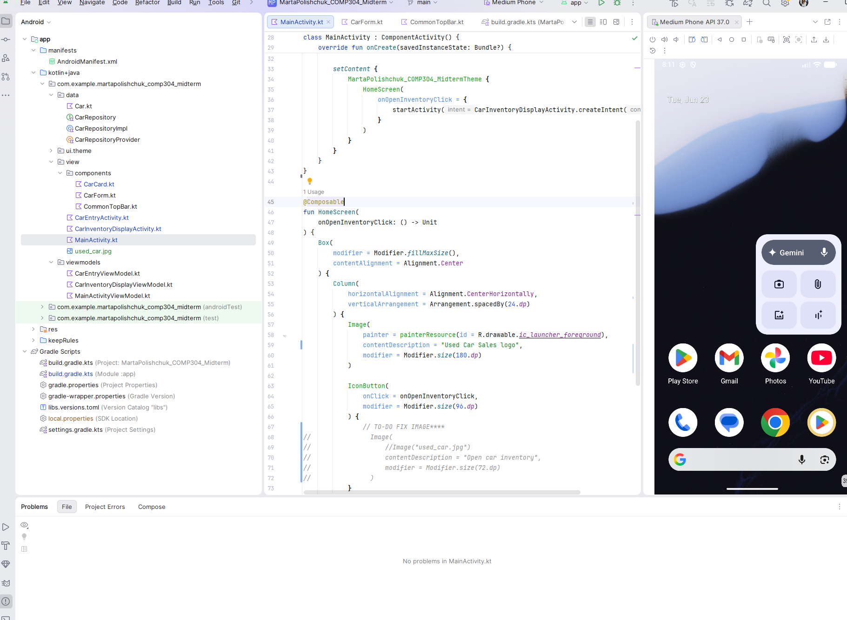
My app doesn’t show any errors and I tried on multiple emulators
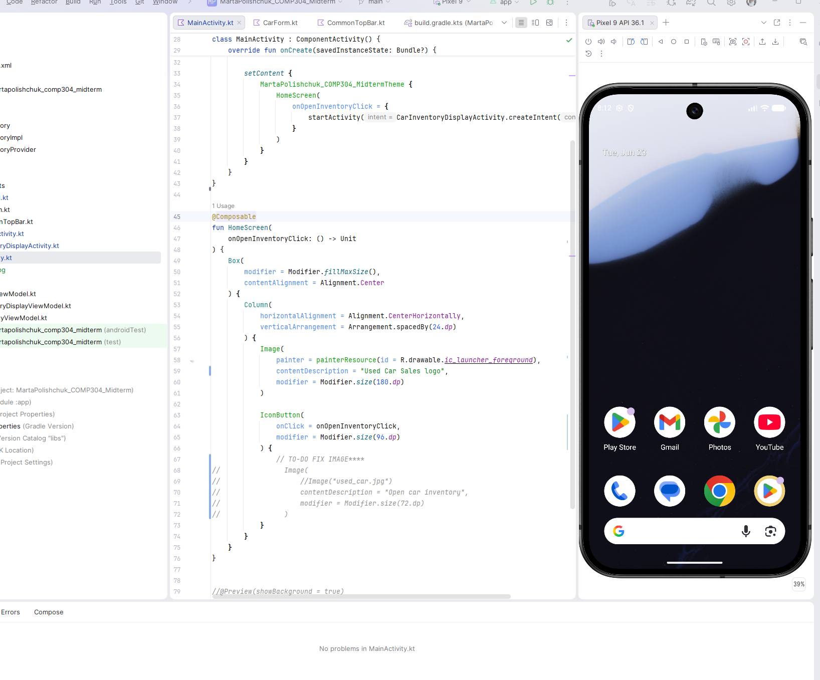

I FIXED IT!

Main Activity
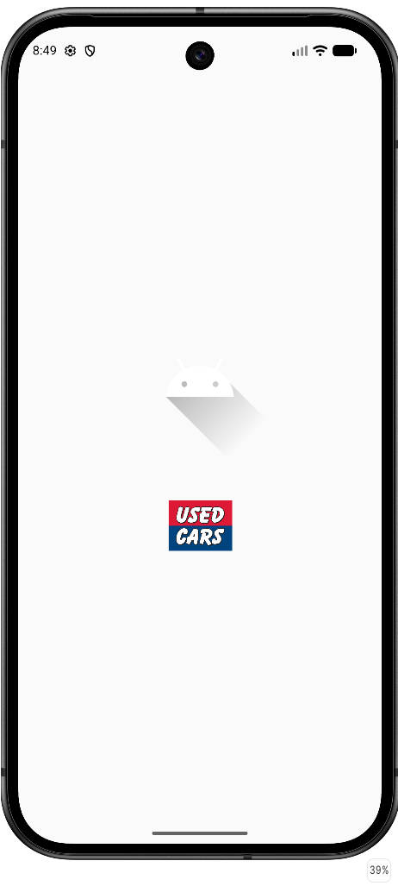
Third Activity (View Car Inventory List)
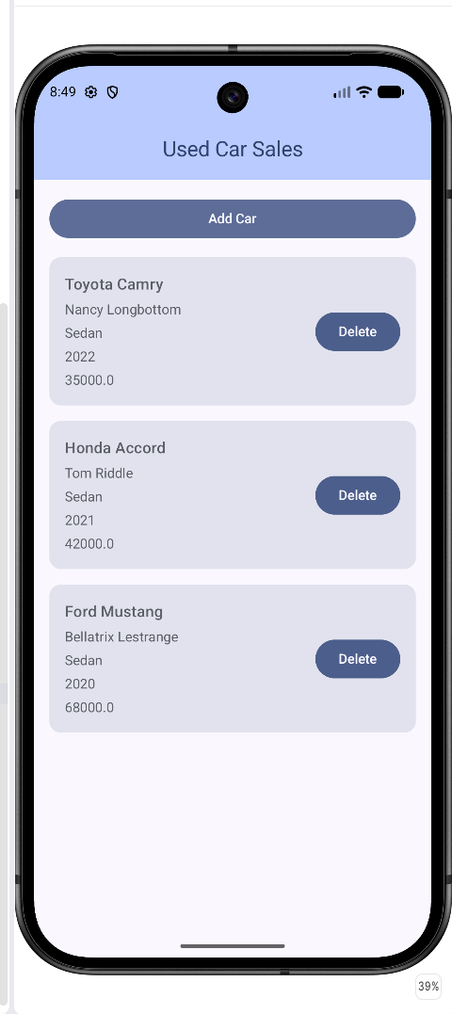

Second Activity (Car Entry Screen)
