Macro Energy System Modelling Project: Modelling Energy Systems with PyPSA

- PyPSA (Python for Power System Analysis) is written in Python 3 so the first thing that you need to do is to install Python 3 on your computer.

- If you have never used Python before, there are many good courses online. I can recommend the followings.
https://www.edx.org/course/analyzing-data-with-python
https://www.edx.org/es/course/using-python-for-research
Datacamp also offers free courses, including practical exercises that might be useful for you. See, for instance: https://www.datacamp.com/courses/intro-to-python-for-data-science
Students from previous years have recommended the following videos presenting the pandas package:
https://www.youtube.com/watch?v=ZyhVh-qRZPA&list=PL-osiE80TeTsWmV9i9c58mdDCSskIFdDS
- If you have never used Python, but you have previous experience with Matlab, you may like the Spyder interface, which behaves very similar to Matlab.

- Python is a programing language. Packages are built using this language, e.g. pandas, numpy, matplotlib, pypsa.
When we are writing a piece of code, we can benefit from functions that are included in packages previously developed by other people. To do that we need to (a) install that package on our computer and (b) import it in our script. One easy way of using Python is through Anaconda because it allows a simple way of installing the packages that we need. Anaconda is available for Windows, Mac OS X and GNU/Linux. You can install it from the following link.
https://docs.anaconda.com/anaconda/install/

- We can create an environment to include a group of packages. Open the Anaconda navigator, select “Environments” and create a new environment with a new name (Figure 1). Select Python 3.9 when you create the new environment.

- Now, you can install PyPSA in your new environment. The window on the right shows the installed packages. First, you need to add the channel conda-forge. To do that, click on “Channels”, “Add …” and write “conda-forge”. Conda-forge is similar to a library where developers make their packages available. Second, you need to install PyPSA. Selected the option “All” and look for PyPSA. Select the package and “Apply”. (Figure 2).
Alternative way: Click on the "play/pause" button present on the environment name.
Click "Open terminal" from your environment.
In the terminal type "conda config --add channels conda-forge" (Figure 3)
In the terminal type "conda install pypsa" (Figure 4)

Additional instructions for PyPSA installation on other systems can be found in:
https://pypsa.readthedocs.io/en/latest/installation.html

- PyPSA uses an external solver to solve optimization problems. We use Gurobi as solver and we need to get a license for that.
To install Gurobi: Click on the "play/pause" button present on the environment name.
Click "Open terminal" from your environment.
In the terminal type "conda config --add channels http://conda.anaconda.org/gurobi" (Figure 5)
In the terminal type "conda install gurobi" (Figure 6)

Now, you need to get a free academic license to use Gurobi, follow the instructions in the link. You will need to register and log in to get a license.
https://www.gurobi.com/downloads/free-academic-license/
Once you have registered, run the grbgetkey command to install the license on your computer:
- Go to “My Account” → “My Licenses” → “Review your current licenses” → click on the license that you have created → At the bottom, you will see the exact command.
  - grbgetkey xxxxxxxx-xxxx-xxxx-xxxx-xxxxxxxxxxxx
If you are using MacBook you might have to specify the full path similar to:
  - /Library/gurobi952/macos_universal2/bin/grbgetkey xxxxxxxx-xxxx-xxxx-xxxx-xxxxxxxxxxxx

- Install also the packages named pandas and matplotlib, we will use them to read data from csv files and to plot data.

- If you have questions on PyPSA there are two useful repositories of information.
First, the PyPSA documentation is available in the following link.
https://pypsa.readthedocs.io/en/latest/index.html
Second, there is a forum/mailing list where PyPSA users share questions, problems, and solutions. You can search there, and someone might have already solved the problem that you are facing.
https://groups.google.com/g/pypsa

- The first thing that we will do is to run a very simple case to test that everything is working properly.
We will be using a Jupyter notebook for this. Jupyter notebooks are documents in which we can include both code and text (to explain the code). Hence, they are very useful to learn new programs and to show examples.
Save the Jupyter notebook named “testing.ipynb” to your computer. Select “Home” in Anaconda, install and launch Jupyter notebook and open the file.
Follow the instructions in “testing.ipynb” to check that everything is working.

- If you prefer to use the Spyder interface (which behaves very similar to Matlab), you can just open de notebook with jupyter, select “File/Download as Python (.py)” and open it with Spyder.

- Now we can start with the real exercise. The description is included in the Jupyter notebook named “MESM_project.ipynb”

List of common errors and solutions
a. Gurobi is not working and you have checked that the installation of Gurobi and its license work properly.
You can use an alternative optimizer to get the solution. For instance, you can try the GLPK optimizer.
To do that:
(1) Download the GLPK optimizer from https://sourceforge.net/projects/winglpk/ and unzip the folder
(2) Open the folder ‘\winglpk-4.65\glpk-4.65\w64’ and copy the application files (glpsol, glpk_4_65.dll, glpk_4_65_java.dll, libglpk_cli_native.dll, libglpk-cli.dll to the following folder in your computer ‘C:\Windows\System32’)
(3) When you are solving the network indicate that you want to us GLPK
network.optimize(solver_name='glpk')

b. When trying to install pypsa, you receive an error because you do not have administrator privileges.
Open Anaconda with Administrator privileges, and then create the environment, install pypsa and follow the other instructions. This solution does not work if the environment has been previously created without Administrator privileges.

c. You have created the network but when you try to solve it, the optimizer does not find an optimal solution.
Check that you have properly added the loads, generators, and links and that the time series input to those elements is correct.
The network object contains all the information. You can check the properties of the loads, generators, and links by writing
> network.loads
> network.generators
> network.links
You can check the time series of the electricity demand input in the load (p) and the time of the capacity factor input in the generators (p_max_pu) by writing
> network.loads_t.p
>network.generators_t.p_max_pu

If any of the time series includes NaN instead of values. It is probably because when you created the generator the index of the time series did not correspond to the index of the network (the snapshots that you have defined). You can check the index by writing
> network.snapshots
> CF_wind.index
If the index does not correspond, the data is not properly added to the network. One way of circumvent this is by adding g(as p_max_pu) CF_wind.values instead of CF_wind

Figures
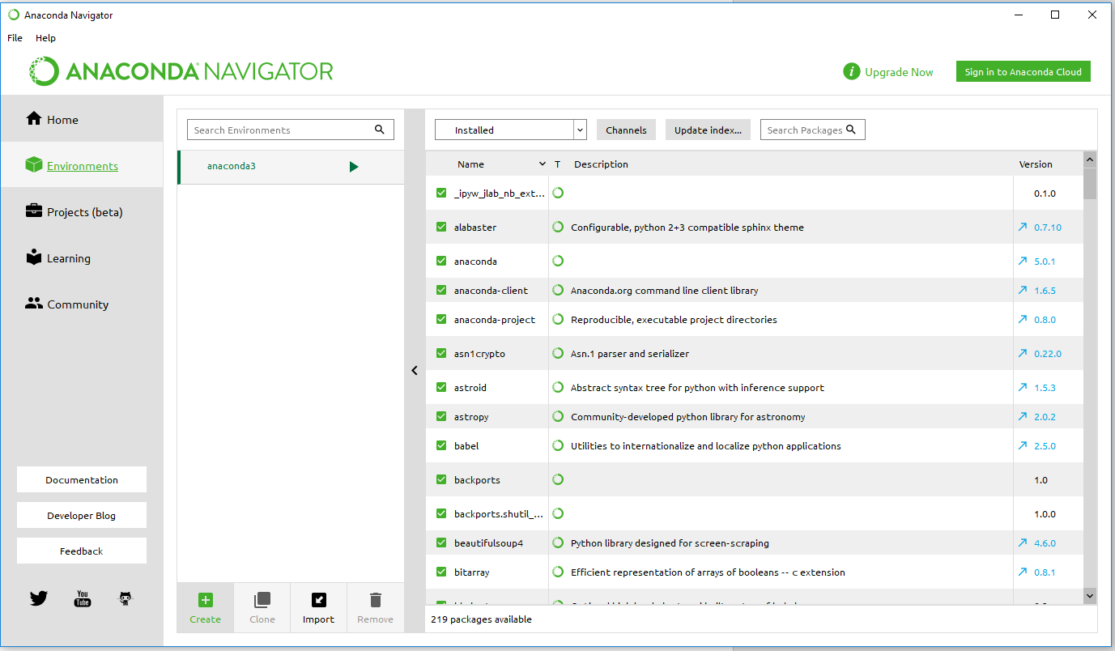
Figure 1. Creating a new environment in Anaconda.
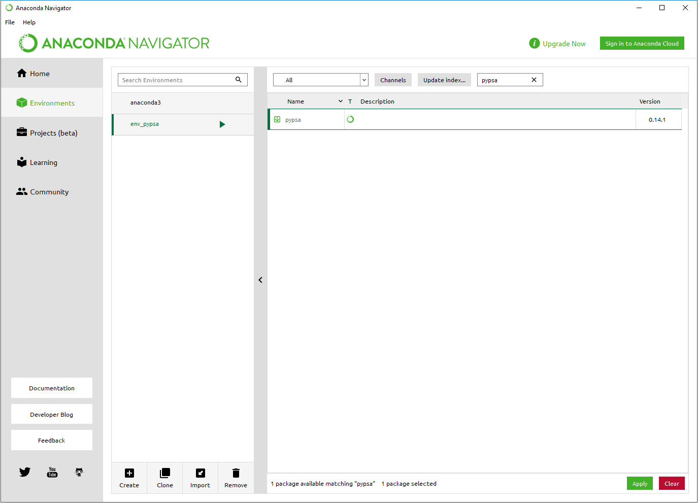
Figure 2. Installing PyPSA in the new environment named “env_pypsa”. You can install the latest version available (pypsa 0.25.1). Try “Update index …” if it does not appear.
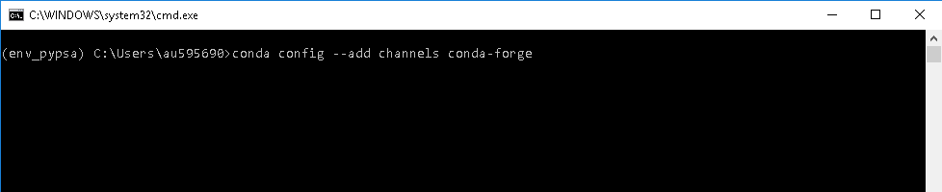
Figure 3. Adding the conda-forge channel using the terminal.

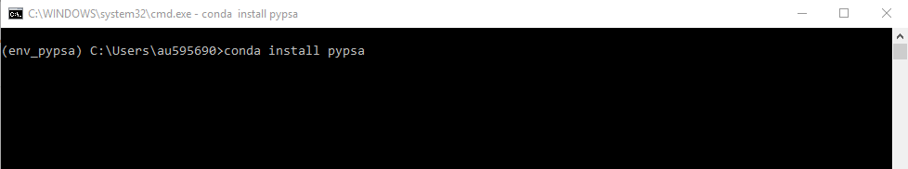
Figure 4. Installing PyPSA in the new environment using the terminal.

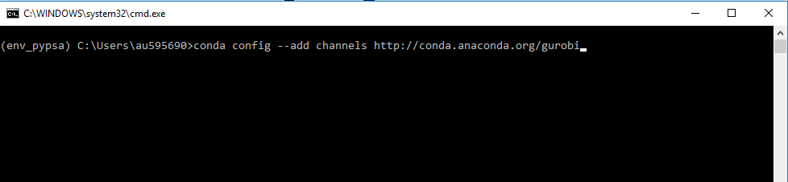
Figure 5. Adding the channel to the new environment to install Gurobi.

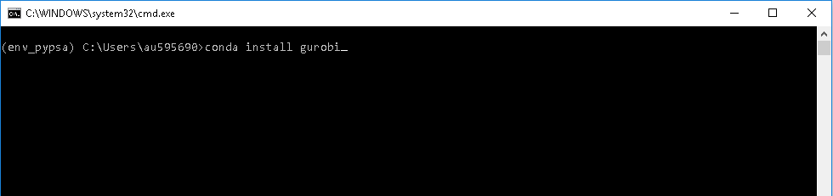
Figure 6. Installing Gurobi in the new environment.

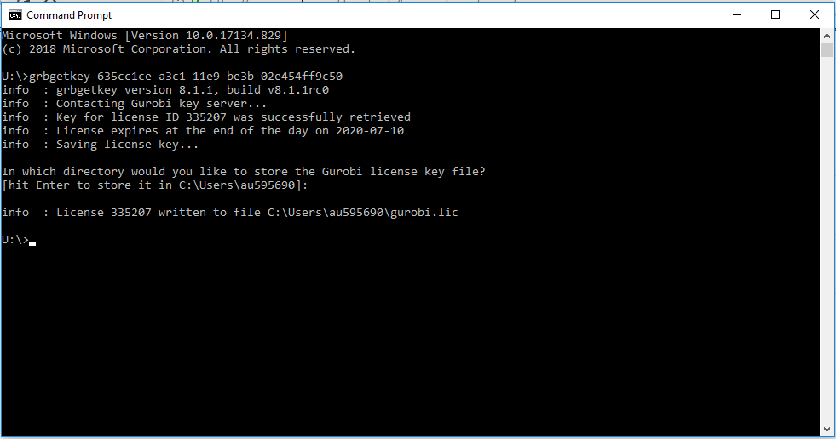
Figure 7. Installing Gurobi academic license in your computer.

