**SOLAR ENERGY PROJECT 2: Modelling the solar photovoltaic installation on the rooftop of Navitas building**

For this project, you are expected to work in groups of 2 students. You only need to deliver one project report per group. The deadline to deliver the project is November 20, 2022.

In this project, we will model the electricity generated by the solar photovoltaic installation on the rooftop of Navitas building and we will compare it with experimentally measured data.



*Figure 1. Navitas photovoltaic installation.*

1. Model the hourly global radiation on a horizontal surface *G(0,t)* in Aarhus during 2018. Assume that the clearness index is *Kt*=0.7 for every hour. Plot the global radiation on a horizontal surface for the first week of February and the first week of June 2018.

You need to solve the equations for the Sun position and global horizontal irradiance. You can write the equations in Python, Matlab, Excel, or use some existing code.

For instance, you can use [this collection of equations in Python](https://github.com/martavp/SOLAR_ENERGY_project/tree/master/solarfun)  or write a query at the SOLPOS webpage by NREL <https://midcdmz.nrel.gov/solpos/solpos.html>

If you are using Excel, you can limit the time series to the hourly values included in the first week of February and the first week of June 2018. I recommend that you to try to write the equations by yourself and model the complete year.

Note: Solar position and irradiance equations can be found at the lecture slides, as well as in Appendix A of the paper provided in the section Further Readings of the lecture VII. Solar radiation.

1. The weather station at Navitas measures several parameters, including cloud cover, which we can use as a proxy to estimate the diffuse fraction *FD* in every hour.

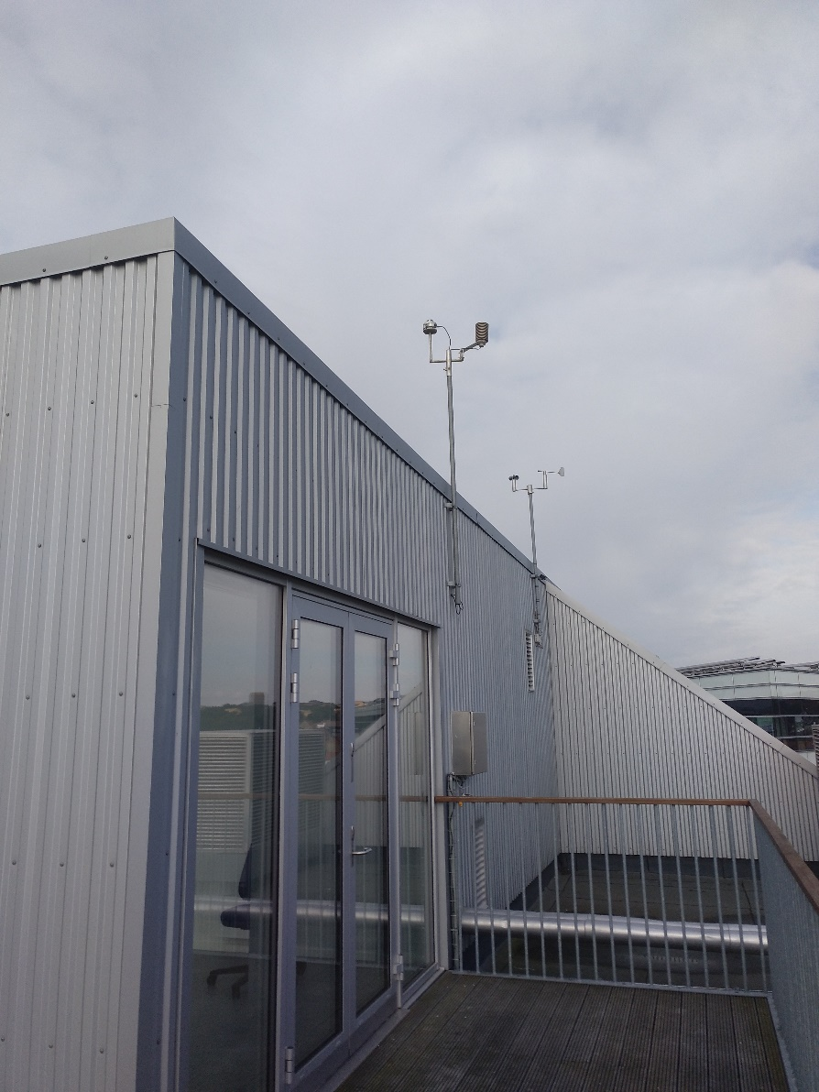

*Figure 2. Weather station*

The data measured in the weather station can be accessed following [these instructions](https://github.com/martavp/SOLAR_ENERGY_project/blob/master/weather_station/Application%20Programming%20Interface%20-%20Weather%20.pdf). You will get a json file with the requested data. Download the cloud cover ratio and temperature data.

In order to help you, I have downloaded the hourly data for 2018 using [this script](https://github.com/martavp/RET_project/blob/master/weather_station/process_weather_data.py) and saved it in a [csv file that you can get here](https://github.com/martavp/RET_project/blob/master/weather_station/weather_data.csv). You can read this file in Python, MATLAB or open it with Excel.

1. Let’s assume that diffuse fraction can be calculated as *FD* = Cloud cover/100. Estimate the direct and diffuse radiation on the horizontal surface in Aarhus.
2. Now, we will start modelling the irradiance on the surface of PV modules. You can assume that the modules are south oriented and have a tilt angle of 13⁰.
3. Model the direct, diffuse, and albedo irradiance on the PV modules. Select one of the models for diffuse radiation that we have discussed in class (either the isotropic sky or the circumsolar diffuse radiation). Assume that reflectivity is ρ=0.05. Plot the global radiation on the surface of the PV modules for the first week of February and the first week of June 2018.
4. The installation comprises of 1000 PV modules of monocrystalline Silicon with a rated power of 255 Wp. The characteristics of the solar module can be found [here](https://github.com/martavp/RET_project/blob/master/pv_data/Sainty%20Solar%20255%20mono.pdf). Estimate the power produced by the installation at every hour taking into account the irradiance at the entrance of the PV modules and the power decrease due to ambient temperature.
5. The power produced by the installation is measured every hour. The Facility Management at Navitas has provided the file “[CTS Data Aflæsning Strom.xls](https://github.com/martavp/RET_project/blob/master/pv_data/CTS%20Data%20Aflæsning%20Strom.xlsx)”. Plot the measured production for the first week of February and the first week of June 2018.
6. Calculate the relative root mean square error (RMSE), or the RMSE divided by the mean value, between the modelled generation and the historical measurements. Calculate the error using hourly generation values, as well as aggregating them per day, week, and month. How does the error change when we considered longer time periods?
7. Write a short report including your plots and main results. Maximum length 5 pages.