SOLAR ENERGY PROJECT 2: Modelling the solar photovoltaic installation on the rooftop of Navitas building

In this project, we will model the electricity generated by the solar photovoltaic installation on the rooftop of Navitas building and we will compare it with experimentally measured data.

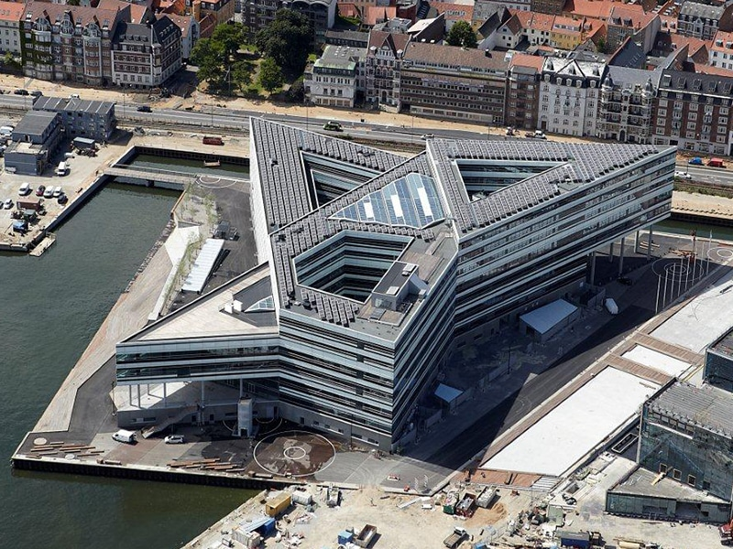
Figure 1. Navitas photovoltaic installation.
- Model the hourly global radiation on a horizontal surface G(0,t) in Aarhus during 2018. Assume that the clearness index is Kt=0.7 for every hour. Plot the global radiation on a horizontal surface for the first week of February and the first week of June 2018.
You need to solve the equations for the Sun position and global horizontal irradiance. You can write the equations in Python, Matlab, Excel, or use some existing code.
For instance, you can use this collection of equations in Python or write a query at the SOLPOS webpage by NREL https://midcdmz.nrel.gov/solpos/solpos.html
If you are using Excel, you can limit the time series to the hourly values included in the first week of February and the first week of June, 2018. I recommend that you to try to write the equations by yourself and model the complete year.
Note: Solar position and irradiance equations can be found at the lecture slides, as well as in Appendix A of the paper provided in the section Further Readings of the lecture VII. Solar radiation.

- The weather station of Navitas measures several parameters, among them, the cloud cover which we can use as a proxy to estimate the diffuse fraction FD in every hour.

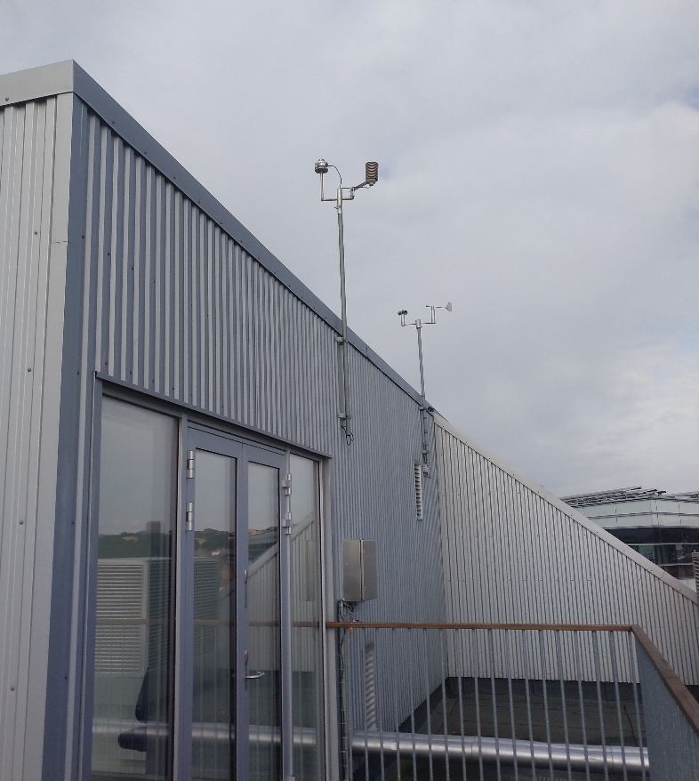
Figure 2. Weather station

The data measured in the weather station can be access following these instructions. You will get a json file with the requested data. Download the cloud cover ratio and temperature data.
In order to help you, I have downloaded the hourly data for 2018 using this script and save it in a csv file that you can get here. You can read this file in python, Matlab or open in Excel.
- Assume that diffuse fraction can be calculated as F = Cloud cover/100. Estimate the direct and diffuse radiation on the horizontal surface in Aarhus.
- Now we will start modelling the irradiance on the surface of PV panels. Go to the installations at the rooftop of Navitas (you can get there by the stairs close to room 06.138) and measure the orientation and inclination of the solar panels. You can use your phone to get some apps that include a compass and a level gauge. Annotate the orientation and tilt angle of the PV panels.
- Model the direct, diffuse, and albedo irradiance on the solar panels. Assume that reflectivity is ρ=0.05. Plot the global radiation on the PV panels surface for the first week of February and the first week of June, 2018.
- The installation comprises 1000 solar panels of monocristaline Silicon with a rated power of 255 Wp. The characteristics of the solar panel can be found here. Estimated the power produced by the installation at every hour taking into account the irradiance at the aperture of the solar panels and the power decrease due to ambient temperature.
- The power produced by the installation is measured every hour. The Facility Management at Navitas has provided the file “CTS Data Aflæsning Strom.xls”. Plot the measured production for the first week of February and the first week of June, 2018.
- Calculate the relative root mean square error (RMSE), that is the RMSE divide by the mean value, between the modelled generation and the historical measurements. Calculate the error using hourly generation values, as well as aggregating them per day, week and month. Does the error change when we considered longer time periods?
- Write a short report including your plots and main results.

