**User Guide for Interactive U.S. Map of Respiratory Deaths and Air Pollution by County**

DEATH_and_POLLUTION Group

CSE 583, Fall 2019

**Step 1:**

Clone the following GitHub project repository using the command:

git clone <https://github.com/nghitrampham/DEATH_and_POLLUTION.git>

**Step 2:**

Navigate to the Interactive_Map/ directory by following the below path within the cloned GitHub Repo:

“/DEATH_and_POLLUTION/air_pollution_death_rate_related/Interactive_Map”

This directory will contain the following files:

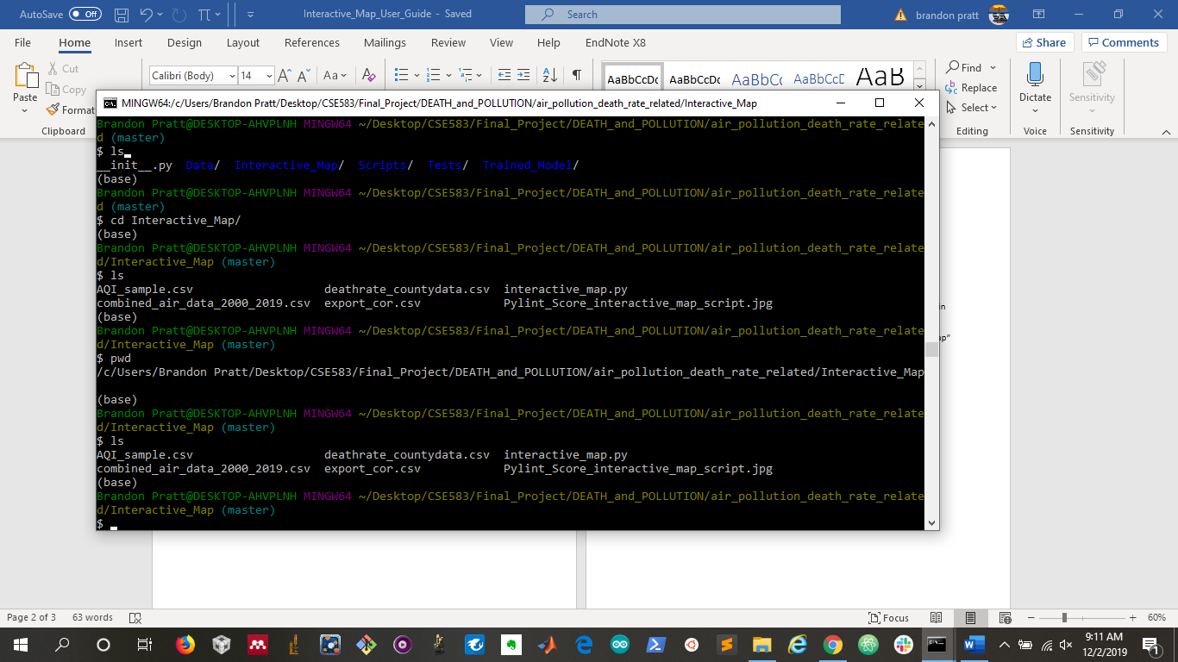

**Step 3:**

Run the python module called “interactive_map.py” to generate the html link for the interactive map (see below):

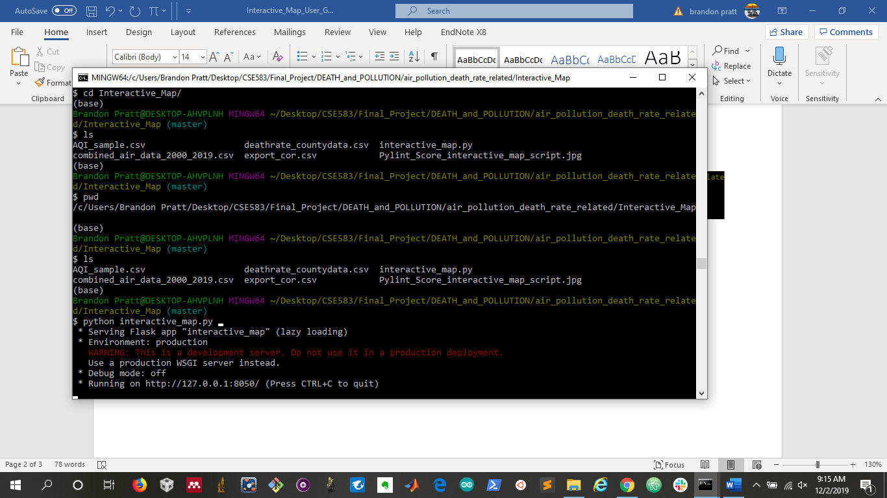

**Step 4:**

Copy the generated html link (i.e. <http://127.0.0.1:8050/>) and paste it into a web browser (e.g. Google Chrome) to launch the interactive map interface:

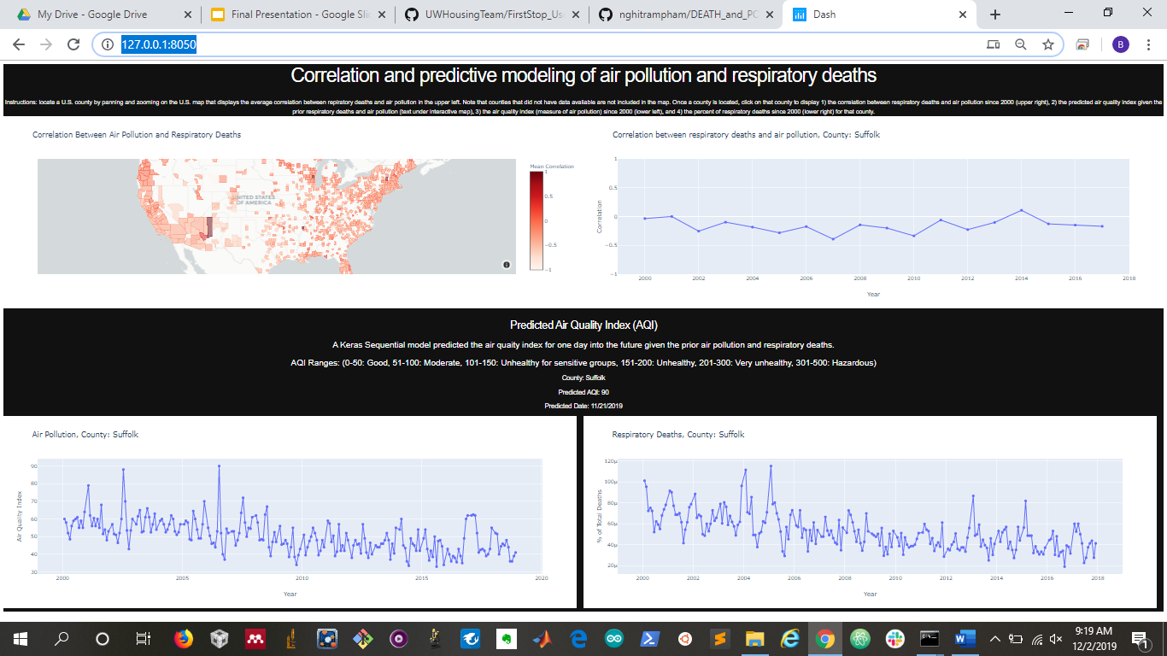

PASTE LINK HERE

*Interactive map launched through Chrome.*

**Step 5:**

Browse the startup interface to understand get of the interfaces components (description of interface components highlighted below):