# Quick Start Guide to HealthVault SDK

Author: Mark Arteaga

Date: July 31, 2012

Getting started with HealthVault is fairly easy and there are a few things to be aware of before starting. To get things started with the SDK you will require Visual Studio 2010 but after the initial setup, we’ll be using Visual Studio 2012 RC.

## MSDN Documentation

We will not be covering HealthVault from an architecture perspective and all technical aspect of HealthVault, but I do recommend you get familiar with it by reading the MSDN documentation. Here are a list of links I found useful during development of Asthma Journal

1. [Getting Started With Microsoft HealthVault SDK](http://msdn.microsoft.com/en-ca/healthvault/bb802509.aspx)
2. [Microsoft HealthVault How To Guides](http://msdn.microsoft.com/en-ca/healthvault/cc300157)
3. [Microsoft HealthVault Platform Overview](http://msdn.microsoft.com/en-ca/healthvault/jj127438)
4. [Microsoft HealthVault Application Integration Recommendations](http://msdn.microsoft.com/en-us/library/ff803594)

## URLs for HealthVault

There are also some URLs that you should be aware of as HealthVault has a production environment and a Pre-production environment (PPE). For a complete list see [HealthVault documentation](http://msdn.microsoft.com/en-ca/healthvault/jj127014#HealthVaultInstanceConfigurations) but here is a list of PPE URLs (note: the US PPEs will work outside of US)

| **Configuration** | **Value** | **Description** |
| --- | --- | --- |
| Shell PPE URL | <https://account.healthvault-ppe.com/> | Used by developers to create HealthVault accounts for developing and testing applications in U.S. PPE. |
| Platform PPE URL | <https://platform.healthvault-ppe.com/platform> | The HealthVault platform service URL for U.S. PPE. |
| Platform PPE IP Range | 65.55.202.96/27 | The IP range for U.S. HealthVault platform PPE. |
| Application Configuration Center (ACC) | <https://config.healthvault-ppe.com> | The ACC URL for creating and managing apps in the U.S. HealthVault instance. |

The following is a ‘quick start’ guide to getting started and will get you up and running relatively quickly.

1. Make sure you have **Visual Studio 2010** installed as the SDK tools depend on this
2. You will need a Windows Live Id to use HealthVault. I recommend you create a new one for testing purposes and not use your existing one. Go to [account.live.com](http://account.live.com/) to create a new one or manage your existing one.
3. Install the Microsoft HealthVault SDK at <http://www.microsoft.com/en-us/download/details.aspx?id=3418>

## HealthVault Application Manager

The purpose of HealtVault App Manager is to quickly create a template application that will access HealthVault. It also has a direct link to Application Configuration Center which is another step required to get your HealthVault app up and running.

One of the drawbacks of the App Manager is it creates a ASP.NET WebForms template. You can use WebForms, but we will be converting it to ASP.NET MVC 4 web application instead of using WebForms.

### Creating Your App

HealthVault App Manager will create a ‘starter’ app to get you up and running and will also create a certificate for you that will be require to upload to HealthVault PPE Server.

To create your HealthVault App follow these steps

1. Once the installation is complete, open the following directory **%program files%\Microsoft HealthVault\SDK\Tools** in an explorer window and run **ApplicationManager.exe**  
   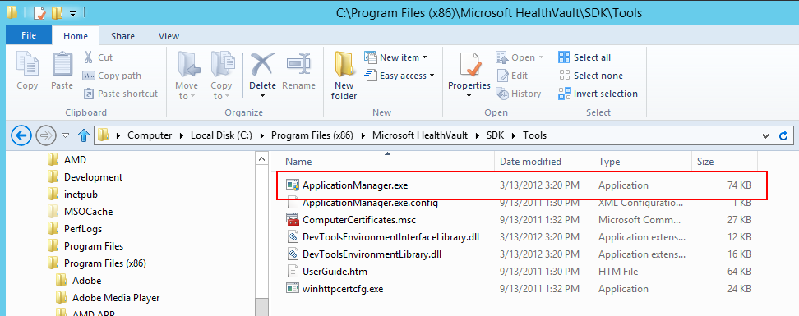
2. **HealthVault Application Manager v1.1** will start up which will leave you with a screen as follows  
   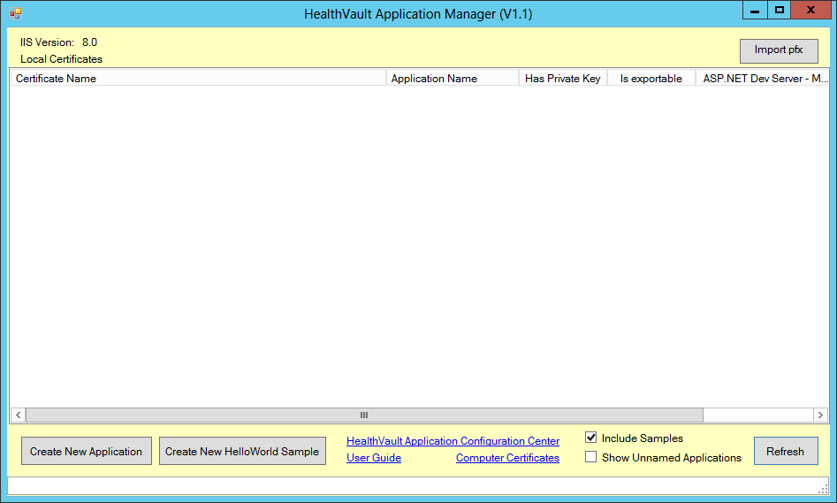
3. Click on **Create New Application**
4. A **Create New Application** dialog will appear as follows  
   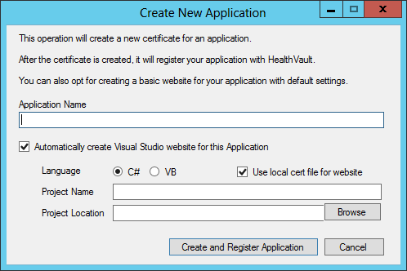
5. Type in the name of your application, select the language and make sure **Use Local cert file for website** is checked
6. [Optional] Change the **Project Name** if required
7. Select a **Project Location** to save the files to
8. Click on **Create and Register App.** This will create a Visual Studio 2010 project and start off a browser session so you can register the application.

Next we will continue the setup of the application and register the application with HealthVault and walkthrough the Visual Studio project generated

#### Registering your App with HealthVault

When we register our application with HealthVault, we are essentially giving HealthVault servers our certificate generated in the previous section so it can authenticate our requests. The certificate is used by the HealthVault SDK to encrypt any requests to the HealthVault server, and the HealthVault server can decrypt the data.

The following is a walkthrough of registering your app with HealthVault PPE environment

1. In the browser session that was opened in **Step 6** of creating your app enter your Live Id Credentials. If you do not have one, create a new one. You can also use OpenId or Facebook, but the walkthrough will assume you are using LiveId  
   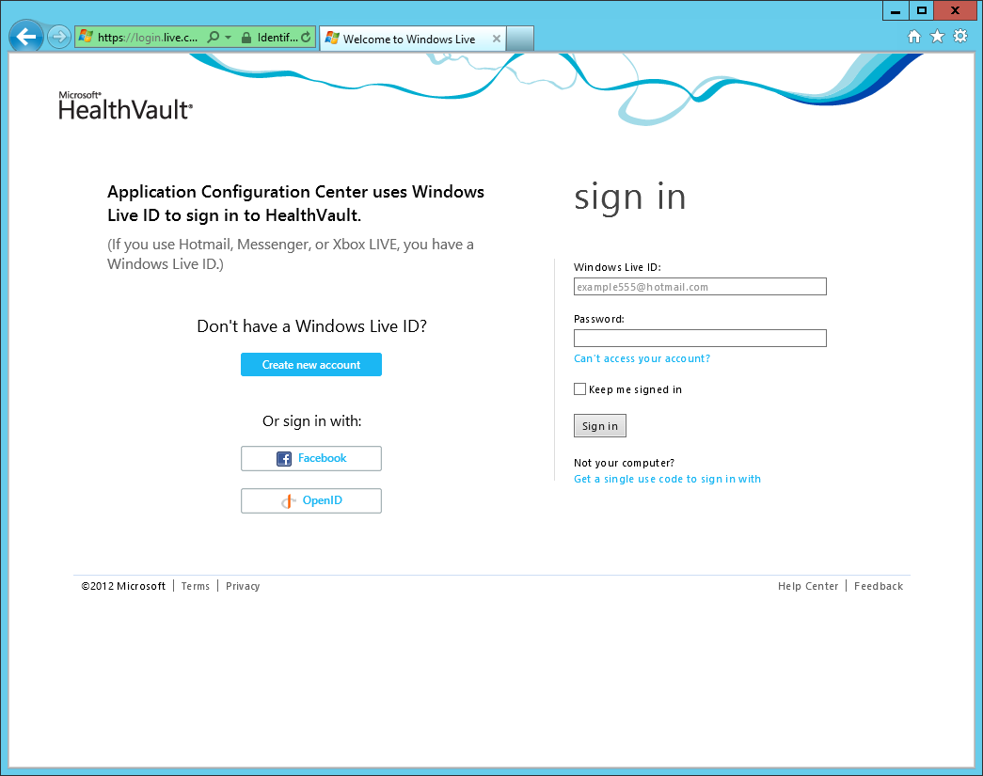
2. Once signed in you will be taken to a ‘Terms and Conditions’ page for HealthVault which you must accept to create the application. Check the **I accept the terms and conditions** then click the **Create application** button.  
   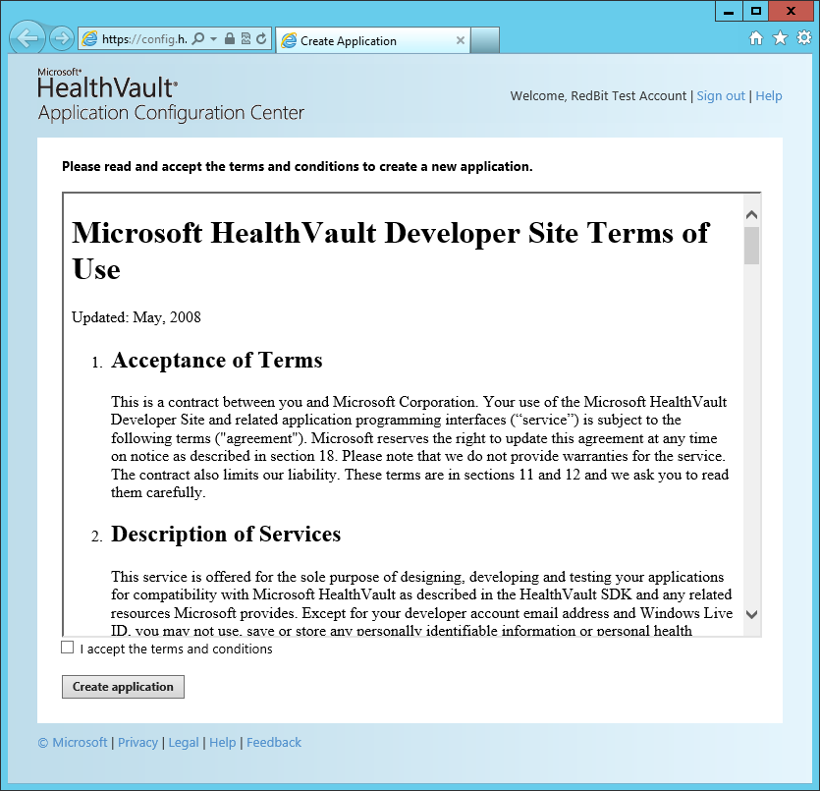
3. The Application Configuration Center page will be shown with your newly created app displayed. NOTE: You can also manually create the app and upload cert but I will leave that to the reader to explore.   
   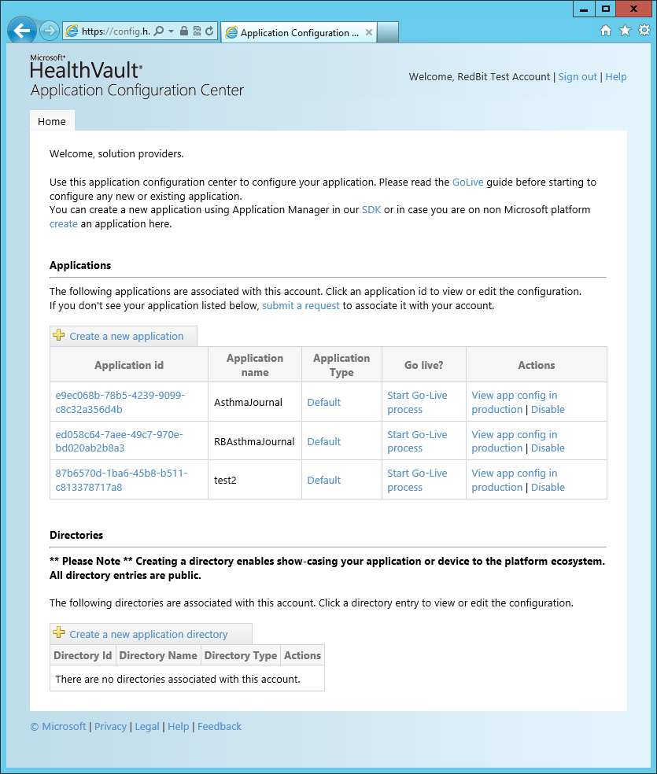

#### Configuring HealthVault App Rules

The HealthVault app requires rules for online and offline data access. In the next steps we will be configuring **Online Rules**

1. Click on your newly created app. This will take you into the configuration page.
2. Click on the **Online Rules** tab and click **Edit** for rule named **default name.**
3. [Optional] Change the **Rule Name**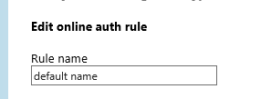
4. [Optional] Set the **Why String**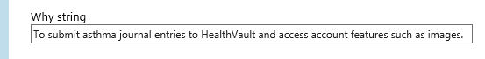
5. For **Permissions** select All  
   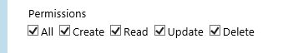
6. For Asthma Journal we will need the following data types. Select the ones you need for your specific purposes.
   1. Application Data Reference
   2. Application-Specific Information
   3. Basic Demographic Information
   4. Personal Demographic Information
   5. Personal Image
7. [Optional] The following are option when in development but should be set for production
   1. **Information Tab** - set the various values as required
   2. **Localize Tab –** set more application specific information

## HealthVault Sample Application

Now that our HealthVault app is setup with the HealthVault pre-production environment, we can finally look at the source code that was generated by the HealthVault Application Manager Utility.

When you created the app with HealthVault Application Manager, Visual Studio 2010 instance was launched with the project loaded. The project contains minimal files

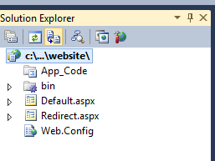

Running the project, will require you to log into HealthVault with your Live Id and will display some of the app properties from HealthVault.

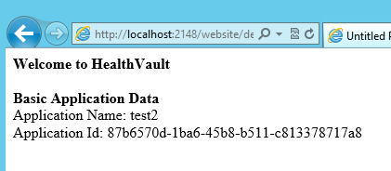

The following sections will cover some key items to be aware of in the project and integrating with HealthVault

### Web.Config Settings

Web.Config contains various settings that the HealthVault SDK uses to allow you to communicate with the HealthVault servers.

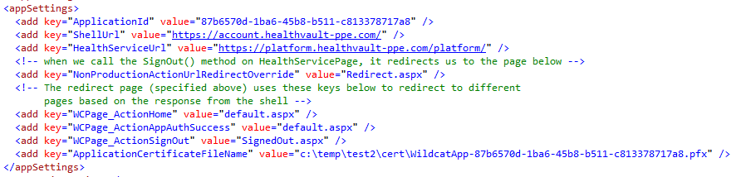

The following are a brief explanation of the keys

1. **ApplicationId** – The GUID that was setup in the Application Configuration Center
2. **ShellUrl** – Defines the location where the user will log in. Needs to be changed when going production
3. **HealthServiceUrl –** Defines the location where all requests to HealthVault will go through. Needs to be changed when going production
4. **NonProductionActionUrlRedirectOverride –** page to re-direct to in non-production environments
   1. **WCPage_ActionHome, WCPage_ActionAppAuthSuccess, WCPage_ActionSignOut –** variables used for redirection depending on the response from the shell url request (usually a login request)
5. **ApplicationCertificateFileName –** the name of the file to use to encrypt the requests to HealthVault. This should be the same file that was uploaded to HealthVault when the app was created with the HealthVault Application Configuration Manager

### HealthVaultServicePage Class

When using ASP.NET Webforms, you can have your pages inherit from Microsoft.Health.Web.HealthVaultServicePage instead of System.Web.UI.Page. The HealthVaultServicePage handles a lot of the communication handling with HealthVault via the SDK.

## Code Walkthrough

The code in the sample application is very straight forward and just shows the application name and the application ID from HealthVault. Here is the relevant HTML code

<b>Welcome to HealthVault</b> <br /><br />

<b>Basic Application Data</b> <br />

<asp:Label ID="AppName" runat="server" Text="Application Name: " /><br />

<asp:Label ID="AppId" runat="server" Text="Application Id: "/><br />

And the C# codebehind is as follows

ApplicationInfo info = ApplicationConnection.GetApplicationInfo();

AppName.Text += info.Name;

AppId.Text += info.Id.ToString();

The HealthServicePage.ApplicationConnection object will be one of the main properties you use to get information in and out of HealthVault which we will look at in the next section. In the code sample above, we are just getting the app name and the app Id that was setup in HealthVault.

Running the web app produces the following results



### Adding Some Code

To make the page a bit more interesting , we’ll go ahead and add some code to accomplish the following

1. Display the signed in person’s name
2. Display the signed in person’s birth year

#### Get the Person Details

Add the following to Default.aspx under the AppId asp:label

<asp:Label ID="name" runat="server" Text="Name: "/><br />

<asp:Label ID="bday" runat="server" Text="DOB: "/><br />

Add the following C# method to Default.aspx.cs

/// <summary>

/// Generic method to get data from healthvault depending on the TypeId

/// </summary>

/// <typeparam name="T"></typeparam>

/// <param name="typeID"></param>

/// <returns></returns>

T GetSingleValue<T>(Guid typeID) where T : class

{

// create a searcher to get data from healthvault

HealthRecordSearcher searcher = PersonInfo.SelectedRecord.CreateSearcher();

// create a filter to add to the search

HealthRecordFilter filter = new HealthRecordFilter(typeID);

searcher.Filters.Add(filter);

// make the request to find the data

HealthRecordItemCollection items = searcher.GetMatchingItems()[0];

// return the data if available

if (items != null && items.Count > 0)

{

return items[0] as T;

}

else

{

return null;

}

}

The code is commented so will not walk through line by line. In a nutshell, this method will allow us to get a value from HealthVault depending on the typeId being passed. More on typeId in the next part, bu first add the following under the line where AppId gets set in Default.aspx.cs

// set the persons name

name.Text += PersonInfo.Name;

// attempt to get the birthdate of the user

Basic basic = GetSingleValue<Basic>(Basic.TypeId);

if (basic != null && basic.BirthYear.HasValue)

bday.Text += (basic.BirthYear.ToString());

Again, code is commented so I’ll only focus on the GetSingleValue method as promised. You will notice that we pass a Basic.TypeId which is a GUID. HealthVault defines some standard data types that you can use to get or add data to like [Allergy](http://msdn.microsoft.com/en-us/library/microsoft.health.itemtypes.allergy.aspx) or [BloodPresure](http://msdn.microsoft.com/en-us/library/microsoft.health.itemtypes.bloodpressure.aspx). [Basic](http://msdn.microsoft.com/en-us/library/microsoft.health.itemtypes.basic.aspx) type, contains the information of the person signed in such as Birthdate and ‘is not considered personally identifiable information’ according to the MSDN Documentation. Every [HealthVault.ItemTypes](http://msdn.microsoft.com/en-us/library/microsoft.health.itemtypes.aspx) contains a GUID that identifies the type in the system, and this GUID is used to perform the search to retrieve the data.

Running the code will produce the following results.

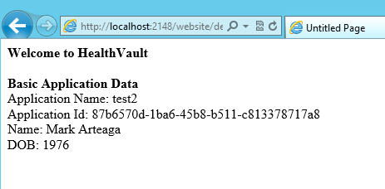

## HealthVault Source Code

Microsoft HealthVault SDK does come with source code and can be found under %ProgramFiles%\Microsoft HealthVault\SDK\Source\HealthVaultDLLSource.zip.

In the development of Asthma Journal using MVC, having the source code was instrumental in integrating HealthVault with ASP.NET MVC. We will cover that topic in more detail in the next article.

## Conclusion

In this article, we covered getting started developing with HealthVault and using HealthVault Application Manager to get a sample application up and running. We also walked through setting up access rights for the application in HealthVault Application Configuration Center portal to allow us access to the appropriate data within HealthVault. In the next article, we’ll cover getting HealthVault SDK integrated with an ASP.NET MVC web application.