# Deploying HealthVault Application to Windows Azure

Author: Mark Arteaga

Date: July 31, 2012

In this article we’ll look at deploying a HealthVault application to Windows Azure. We will not go through a step by step process as the [Windows Azure](http://www.windowsazure.com) site has all the details in their article [How To Create and Deploy a Cloud Service](http://www.windowsazure.com/en-us/manage/services/cloud-services/how-to-create-and-deploy-a-cloud-service/). Instead, we’ll look at some the key items you have to do to get your application running on Windows Azure.

We’ll be working with the final source code from the previous article Using ASP.NET MVC To Store Custom Data into HealthVault.

## Setting Up Local Project

1. Navigate to <http://manage.windowsazure.com> and create a new cloud service
2. Open up the Samples.HvMvc project in Visual Studio 2012 RC
3. Right Click on the project and click on **Add Windows Azure Cloud Service Project**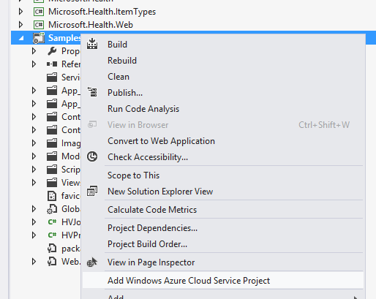
4. You will see a new **Cloud Project** added called **Samples.HvMvc.Azure**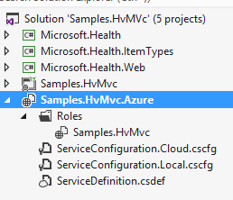
5. Compile the project

At this point you will get compilation errors and the next few steps will resolve these

1. Right click on **Samples.HvMvc** project and click **Properties**
2. Click on **Application**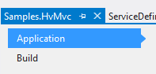
3. Change the **Target Framework** to 4.0   
   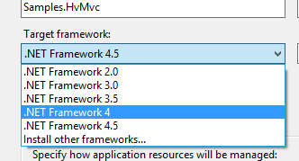
4. Click **Yes**  in the following dialog  
   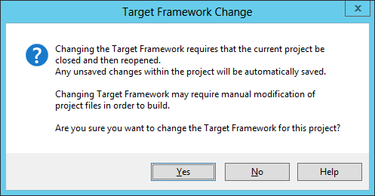
5. Open **AccountModels.cs**  in the **Models** directory and add the following using statement   
   using System.Web.Mvc;
6. Right click on **Samples.HvMvc.Azure** and click on **Manage NuGet Projects**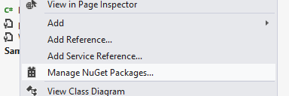
7. Click on **Installed packages** and uninstall **Entity Framework 5.0.0-rc**
8. Click on **Online -> All**
9. Search for **Entity Framework**
10. Install **Entity Framework 4.3.1**
11. Compile the project and run
12. If you are presented with the following dialog you must restart VS 2012 RC in admin/privileged mode and attempt to run the project.  
    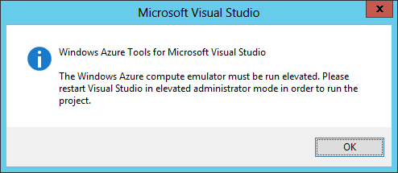

### Updating CSCFG File

Since we are using ASP.NET MVC with .NET Framework 4.0 we need to make sure our OS running on Azure is Windows Server 2008 R2. To do this we need to update our ServiceConfiguration.Cloud.cscfg file. For more information on the format of the file see [Windows Azure Service Configuration Schema](http://msdn.microsoft.com/en-us/library/windowsazure/ee758710.aspx).

1. In the **Samples.HvMvc.Azure** project open **ServiceConfiguration.Cloud.cscfg**
2. Locate osFamily="1"
3. Change to osFamily="2"
4. Save the file

## Create a SQL Azure Database

Because we are using a local database, when we push to Azure we are going to have to setup a SQL Azure Database. See [How to Use SQL Database in .NET Applications](http://www.windowsazure.com/en-us/develop/net/how-to-guides/sql-database/) on MSDN to setup a database.

### Update web.config

When you have created your SQL Azure Database, get the connection string and replace your DefaultConnection connection string in your web.config. NOTE: you can also use Web.Release.config but I’ll leave that as an exercise for the reader.

## Deploying to Windows Azure

Deploying to Azure is fairly easy and [www.windowsazure.com](http://www.windowsazure.com) has a series of articles called [Publishing Windows Azure Applications to Windows Azure from Visual Studio](http://msdn.microsoft.com/en-us/library/windowsazure/ee460772) if you are not familiar with the process. Here is a quick overview of the steps

1. Right click on **Samples.HvMvc**
2. Click on **Publish to Windows Azure**
3. In the resulting dialog, choose the subscription to use and click **Next**
4. In **Common Settings** tab, select the appropriate options
5. In **Advance Settings** tab, select the appropriate options
6. Click **Next**
7. Click **Publish** to start the process

Once the process is complete (takes from 10-20mins), you can navigate to the site (in my example hvtest.cloudapp.net) to view the web app.

## Conclusion

In this article, we went through the process of taking our sample ASP.NET MVC app and setting it up to be deployed to Windows Azure WebRole.

In the next article, we’ll go through how to retrieve the avatar image of a HealthVault user and display it in the web interface.