McAfee Solidcore File Integrity Monitoring Over Axiom/BOSS Servers

The items listed in the Rule Groups below show EVERYTHING that is being monitored on the BOSS servers. Below are screen shots showing any custom rules for the BOSS servers.

Revision History: 9/9/11 Brooke Covert  
 10/25/11 Brooke Covert  
 2/17/11 Brooke Covert  
 5/31/12 Brooke Covert   
 8/13/12 Brooke Covert  
 11/20/12 Brooke Covert - updated server list screen shots  
 2/27/13 Brooke Covert - Audit Review, no changes  
 5/22/13 Brooke Covert - Audit Review, no changes  
 8/15/13 Brooke Covert - updated server list screen shots  
 11/13/13 Brooke Covert - updated server list screen shot  
 05/15/14 Brooke Covert - Audit Review, no changes  
 08/21/14 Brooke Covert - Audit Review, no changes

11/10/14 Nick Ormsby - Audit Review, no changes

05/12/15 Nick Ormsby - Updated server list screen shots

12/4/15 Joel Terry -Updated Server list Screen Shots

# Rule Info:

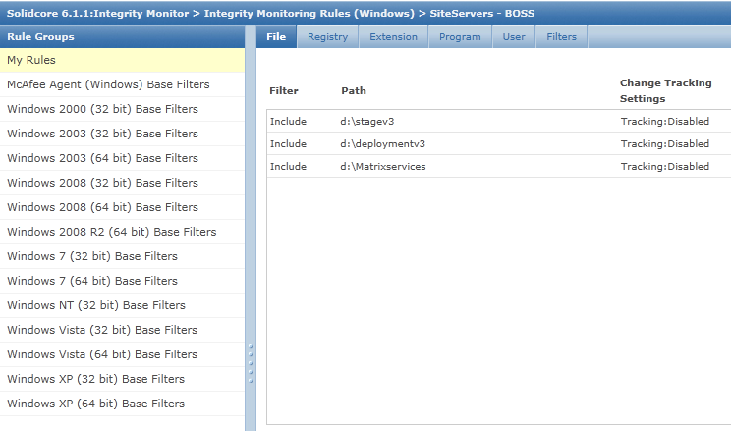

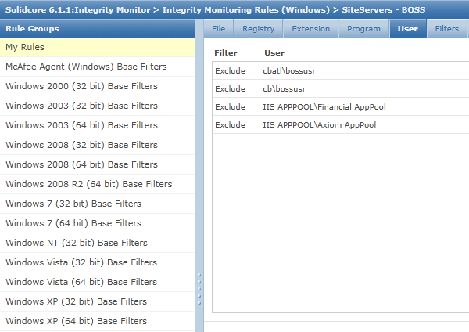

# What Groups Above Rule is Assigned to:

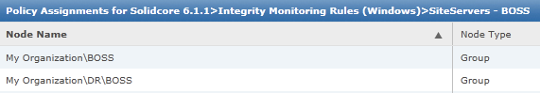

# Servers in Above Groups:

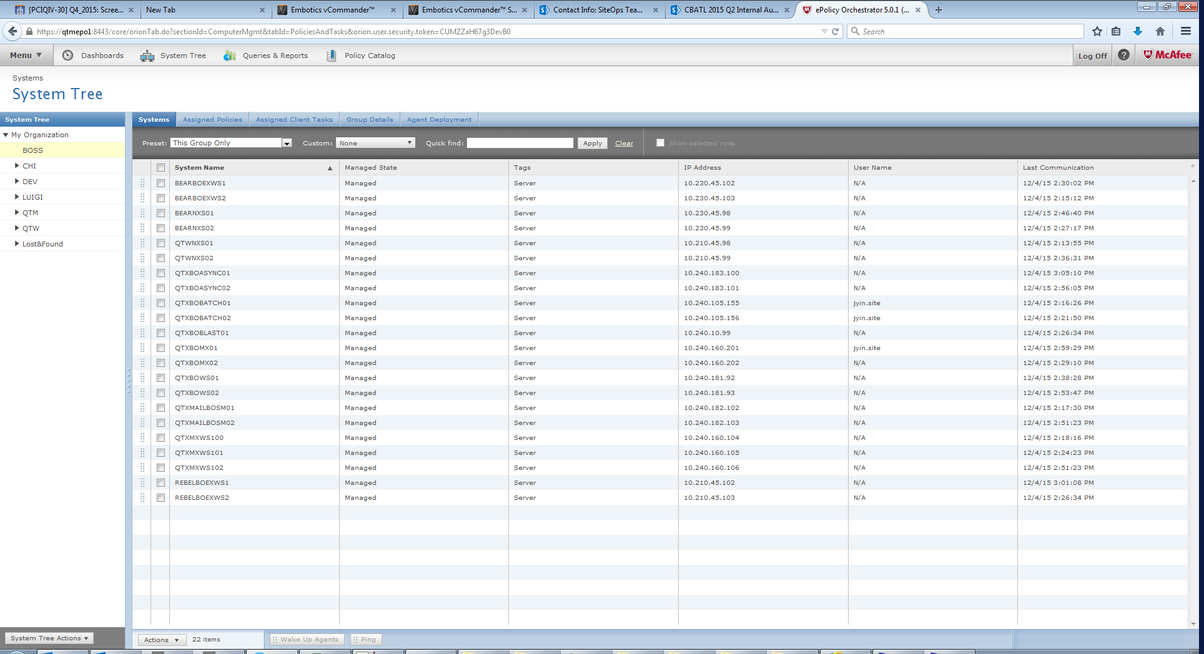

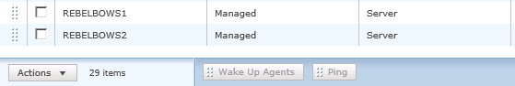

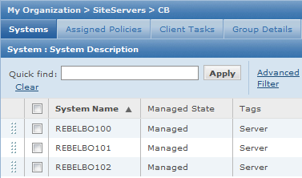

# Automatic Response Trigger:

