Message Processing Application
Design, Development and Test

Published Date | 1st June 2017
Version | 1.0
Author | Martin Gilfoyle
Amendment History
Date Issued | Version | Reason for Change
June 2017 | 0.1 | Initial Draft for Comment
Document References
Document | Version | Hyperlink

Contents
1. Introduction 2
2. Interface Specification 2
2.1. Overview 2
2.2. Representation 2
2.3. Message Examples 2
2.3.1. Type1 Message – sale without quantity 2
2.3.2. Type2 Message – sale with quantity 2
2.3.3. Type3 Message – sale and adjustment with sale quantity 5
2.3.4. Type3 Message sale and adjustment without sale quantity 5
2.4. Field Data Type Mapping 5
2.5. Validation 6
3. Design Decisions 6
3.1. How to interpret sale type 6
3.1.1. Requirement: 6
3.1.2. Options 6
3.1.3. Decision 6
3.2. Whether to apply current adjustment to current sale 6
3.2.1. Requirement: 6
3.2.2. Options 6
3.2.3. Decision 6
3.3. How to implement idempotence 7
3.3.1. Requirement: 7
3.3.2. Options 7
3.3.3. Decision 7
4. Domain Model 7
5. Class Model 7
6. Dependencies 8
7. Packaging and Deliverables 8
8. Application Execution 8

Introduction

The document covers the following:
- Interface specification with examples, data mappings and validation.
- Design decisions that have been made.
- Diagram of the domain model.
- Diagram of the class model.
- Development and application dependencies.
- What is packaged as a deliverable.
- How to run the program.

Interface Specification

Overview
A message notifying you of a sale could be one of the following types:
- Message Type 1 – contains the details of 1 sale E.g apple at 10p
- Message Type 2 – contains the details of a sale and the number of occurrences of that sale. E.g 20 sales of apples at 10p each
- Message Type 3 – contains the details of a sale and an adjustment operation to be applied to all stored sales of this product type. Operations can be add, subtract, or multiply e.g Add 20p apples would instruct your application to add 20p to each sale of apples you have recorded.

Representation
The application has been designed to implement receipt of JSON messages – this is anticipated to be single message processing. For the purpose of testing an array of JSON messages can be processed.
The following examples illustrate how each of the message types are implemented in JSON.

Message Examples

Type1 Message – sale without quantity
{
"company": "Company",
"id": 1,
"product": "Product1",
"sale": {
"amount": 10.0
}
}

Type2 Message – sale with quantity

{
"company": "Company",
"id": 1,
"product": "Product1",
"sale": {
"amount": 10.0,
"amount": 20
}
}

Type3 Message – sale and adjustment with sale quantity

{
"company": "co",
"id": 1,
"product": "Product1",
"sale": {
"amount": 10.0,
"quantity": 5
},
"adjustment": {
"operation": "ADD",
"amount": 1.5
}
}

Type3 Message sale and adjustment without sale quantity

{
"company": "co",
"id": 1,
"product": "Product1",
"sale": {
"amount": 10.0,
"quantity": 5
},
"adjustment": {
"operation": "ADD",
"amount": 1.5
}
}

Field Data Type Mapping
The following table summarises the fields implemented in the message with details of their data type mappings for both JSON and the target Java type respectively.

Name | JSON Type | Java Type
company | string | String
identifier | Number | long
product | string | String
sale | Object
sale.amount | Number | double
sale.quantity | Number | long
adjustment | Object
adjustment.operation | string – valid values (“ADD”, “SUBTRACT”, “MULTIPLY”) | String
adjustment.operation | Number | float

Validation
Simple validation has been implemented – note that there is no schema. An exception will be thrown for messages failing validation.

Design Decisions

How to interpret sale type

Requirement:
“After 50 messages your application should log that it is pausing, stop accepting new messages and log a report of the adjustments that have been made to each sale type while the application was running.”

Options
For the above requirement it was not clear what was meant by sale type. Two possibilities were considered:
- adjustments for each sale type implying type of product;
- or, adjustments for each instance of a sale.

Decision
The first option has been implemented.

Whether to apply current adjustment to current sale

Requirement:
“Message Type 3 – contains the details of a sale and an adjustment operation to be applied to all stored sales of this product type.”

Options
For the above requirement it was not clear whether an adjustment should be applied to the current sale in the same message. Two possibilities were considered:
- Apply adjustment to all previously stored sales not including that in the current message;
- or, apply adjustment to all previously stored sales plus the current sale in the same message..

Decision
The first option has been implemented.

How to implement idempotence

Requirement:
There is no specific requirement but it is good practice to prevent the ability to reprocess the same message.

Options
- Implement a single unique integer identifier
- Implement a unique identifier as a combination of company and integer identifier
- Implement unique identifier as a combination of company, integer identifier and product

Decision
The second option has been implemented.

Domain Model

The purpose of the application poduce:
- A report of products sales
- A report of product adjustments

A transaction is either a sale or an adjustment of a product.
The domain model is illustrated below.

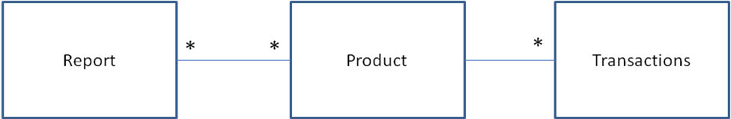

Class Model

The diagram below provides a high level view of the key classes used to implement the solution.

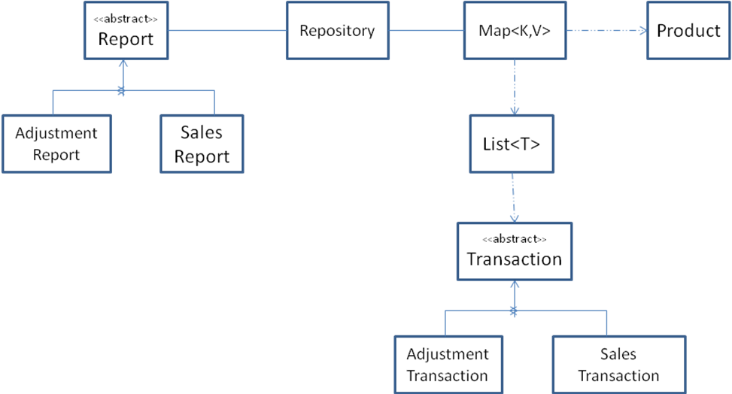

Dependencies
Tooling and application dependencies are as follows:
- The application has been developed using Maven.
- The application has been tested using JUnit.
- The application uses a simple, third party JSON parser.

Packaging and Deliverables
A single zip file is provided containing the following:
- Application classes.
- JUnit tests.
- JUnit test results.
- An executable jar with library dependencies included.
- Test data file resources – testFileFull.jsn.
- A maven POM file.

Application Execution

The application is invoked as follows:

java -cp target\messagetest-0.0.1-SNAPSHOT.jar com.ms.techtest.ProcessMessage <Filename>

Please note: TestFileFull.jsn has been provided for test purposes.

