easyBook by Marshe Co.

Martha Czerwik - ux developer, i/o developer, debugging and testing

Shaheer Syed - ux developer, i/o developer, debugging and testing

What is it that your application is going to do?

Our application is a booking application for South African resorts. Users will be provided with a customizable resort experience. Users will select their travel dates, types and number of guests (how many adults and children), and will be shown available resorts in the country. They will then go through steps to select room types, additional activities to book (each resort will have specific activities, and certain ones are not family-friendly), and will end off on a confirmation and payment page.

Who do you see as being a user for the app?

Families, travelers, vacationers - parents with children, or users over 18 (anyone can use it but you need to be over 18 to purchase).

Sketches of the app screen(s) along with brief explanations of the controls that make them up. Hand drawn sketches are acceptable however they must be neat and professional in appearance.

The images below represent the process of what the user might go through **in-order** as he or she goes through the booking process.

1. User will select when they would like to book their trip, and how many people will be going on the trip (how many adults and how many children). A calendar will pop up when the user clicks on calender (user will pick start and end date).

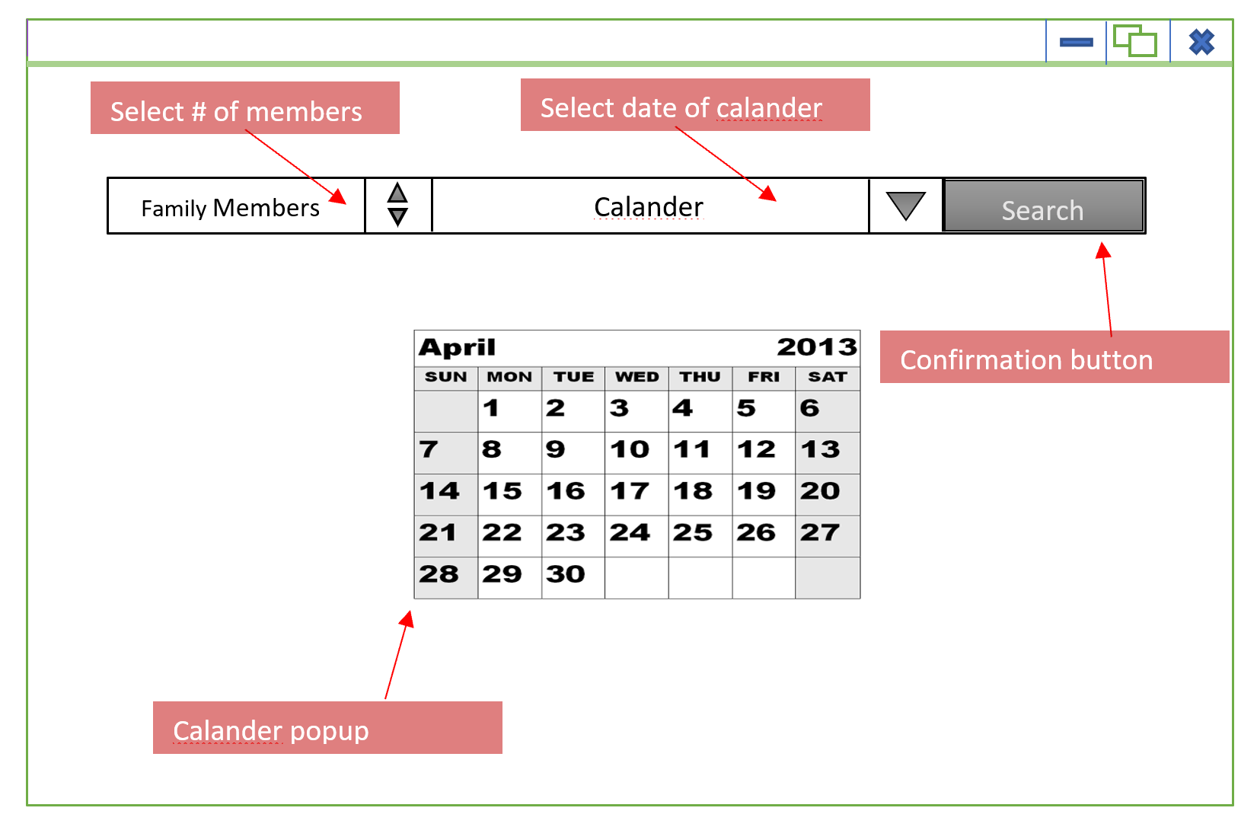

2. Based on dates selected by the user, available resorts will show up on the screen. The user will select which one they would like and continue. The user will be able to view the images like a slideshow (one image will be larger or fully opaque, while the others are smaller or more transparent), and can move through the images. When selected, that image will have a stronger outline or similar effect.

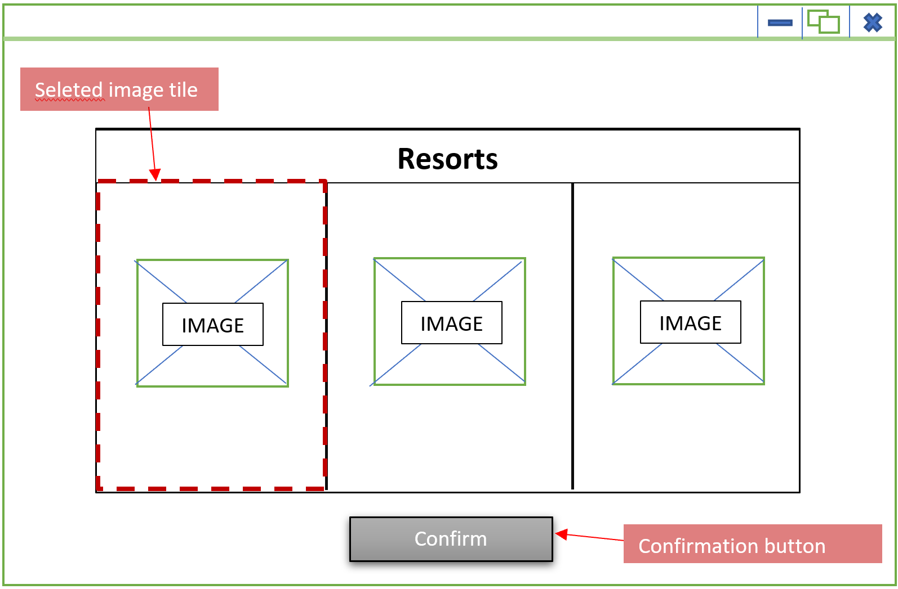

3. The next screen takes the user to selection of room type - similar idea to the last screen, or maybe with hovers this time to make the image larger and show a description of the 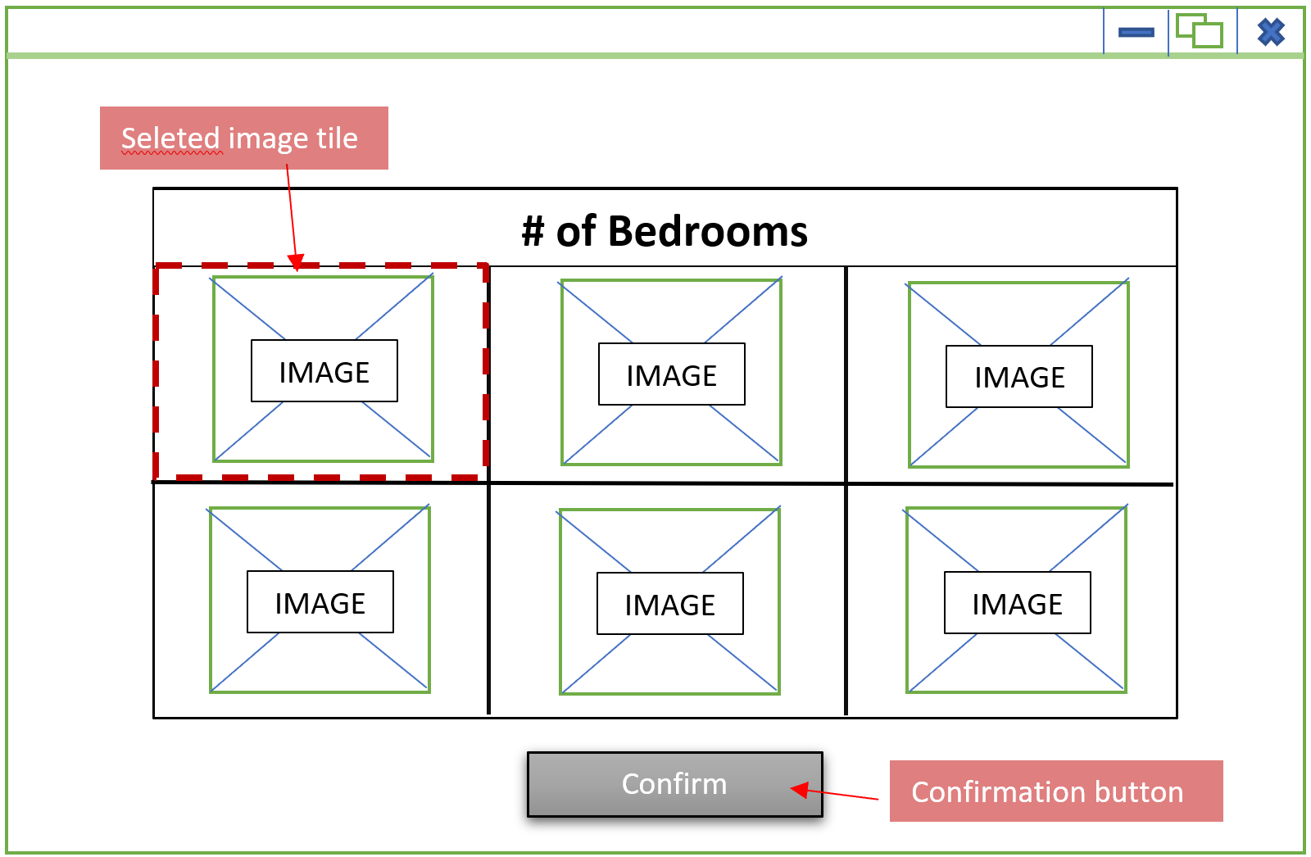

4. The user is then prompted to select additional activities they can book (for an extra price).

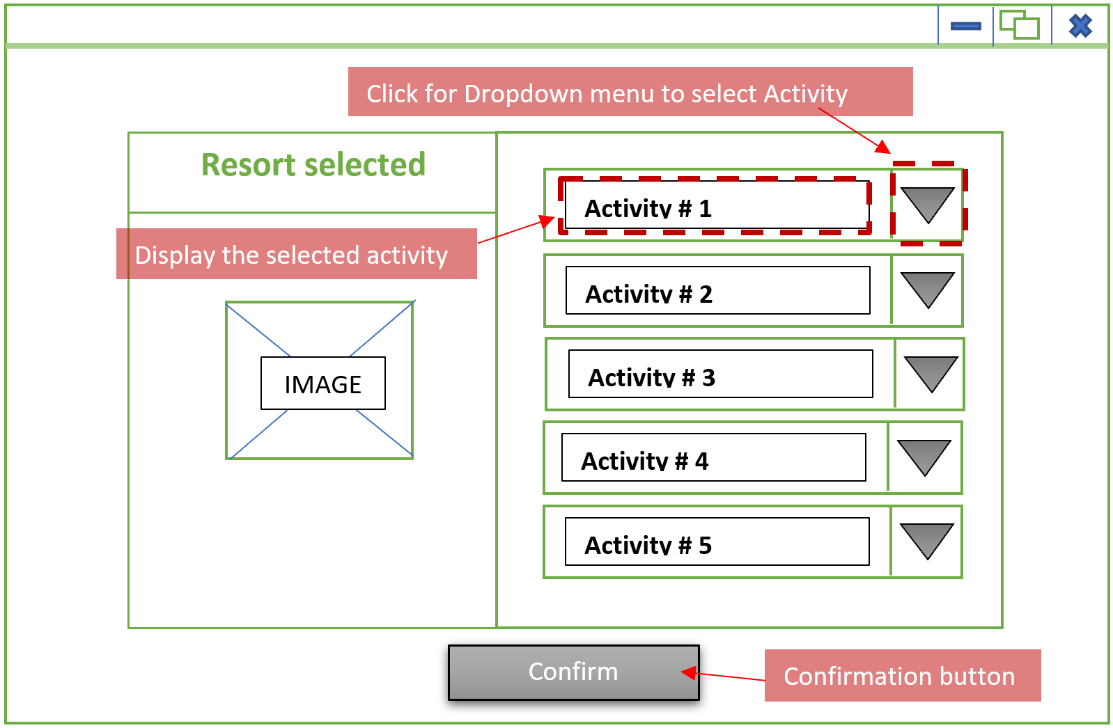

5. Depending on how many children are included in the trip, the following disclaimer message will pop up if the user selects an activity that is not “family-friendly”. The user can still select them, but they need to confirm seeing the message before continuing.

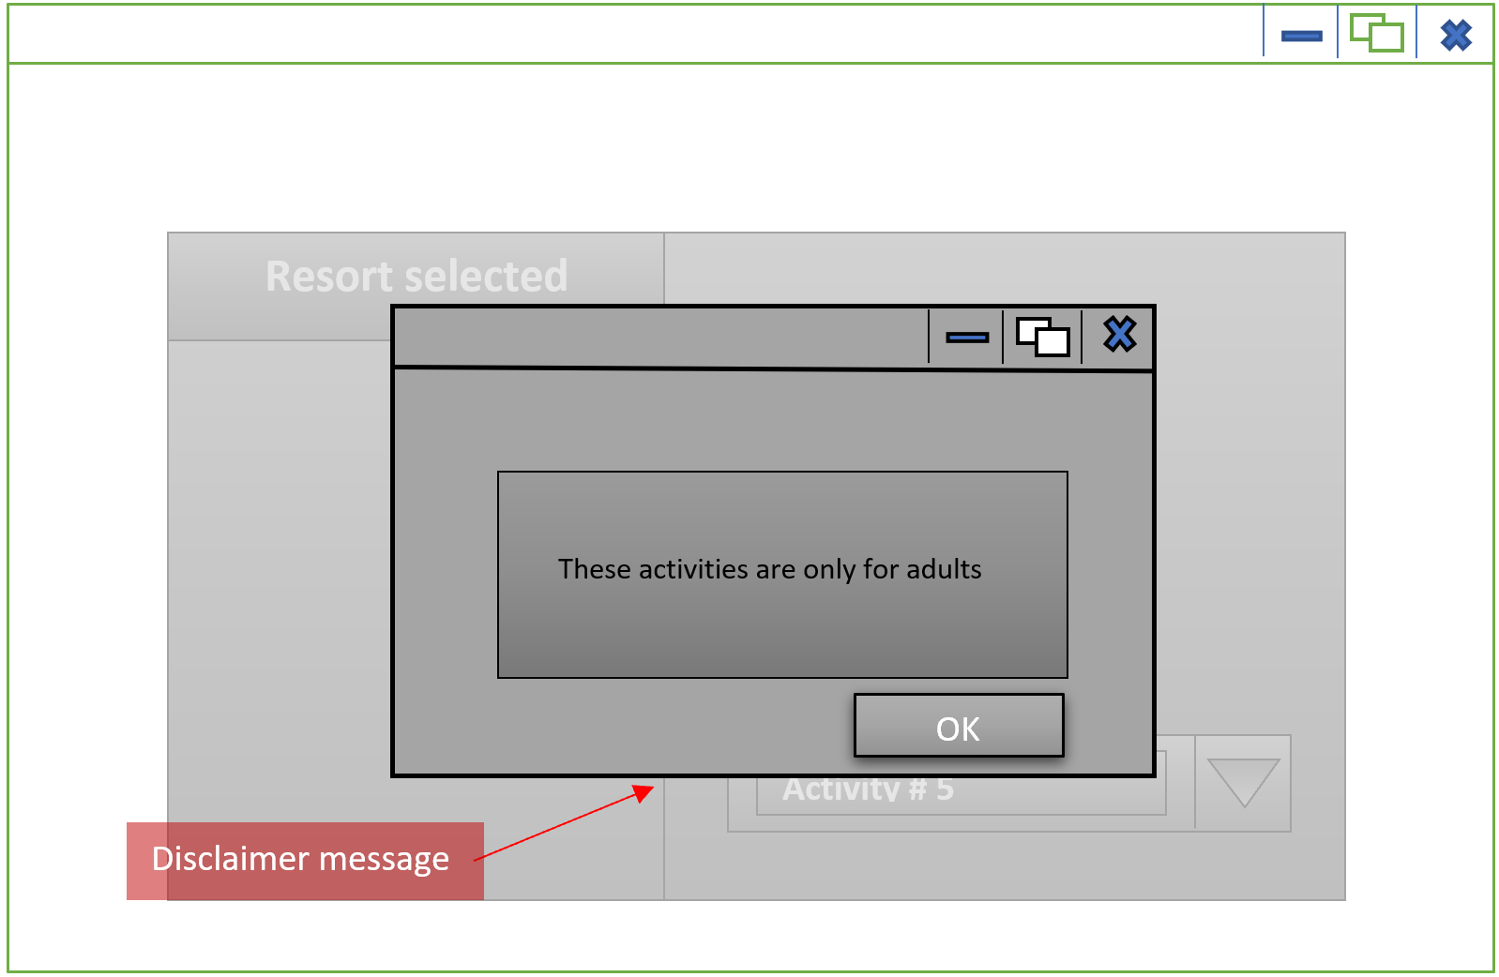

6. The user will see their receipt (confirmation of selections), and if they confirm all information, payment information will unlock (aren’t able to input information until they confirm details).

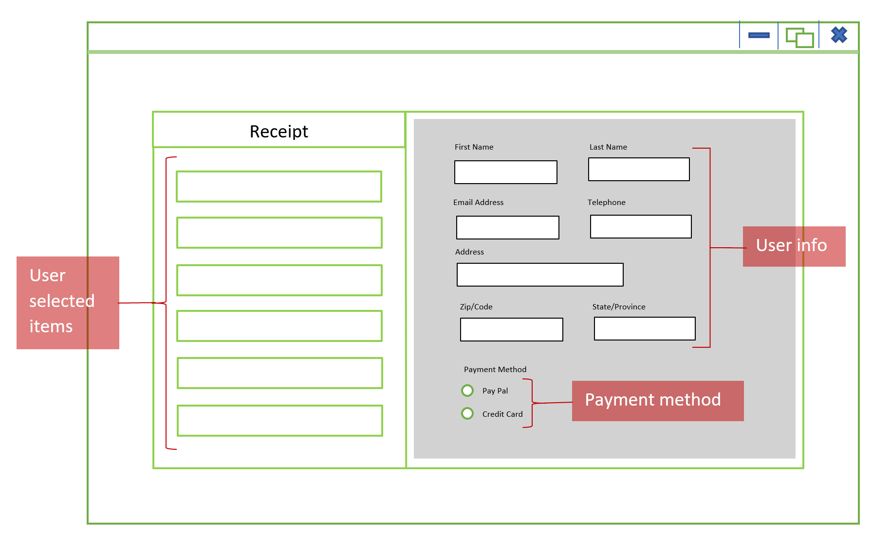

UML diagram(s) of the classes that comprise your app.

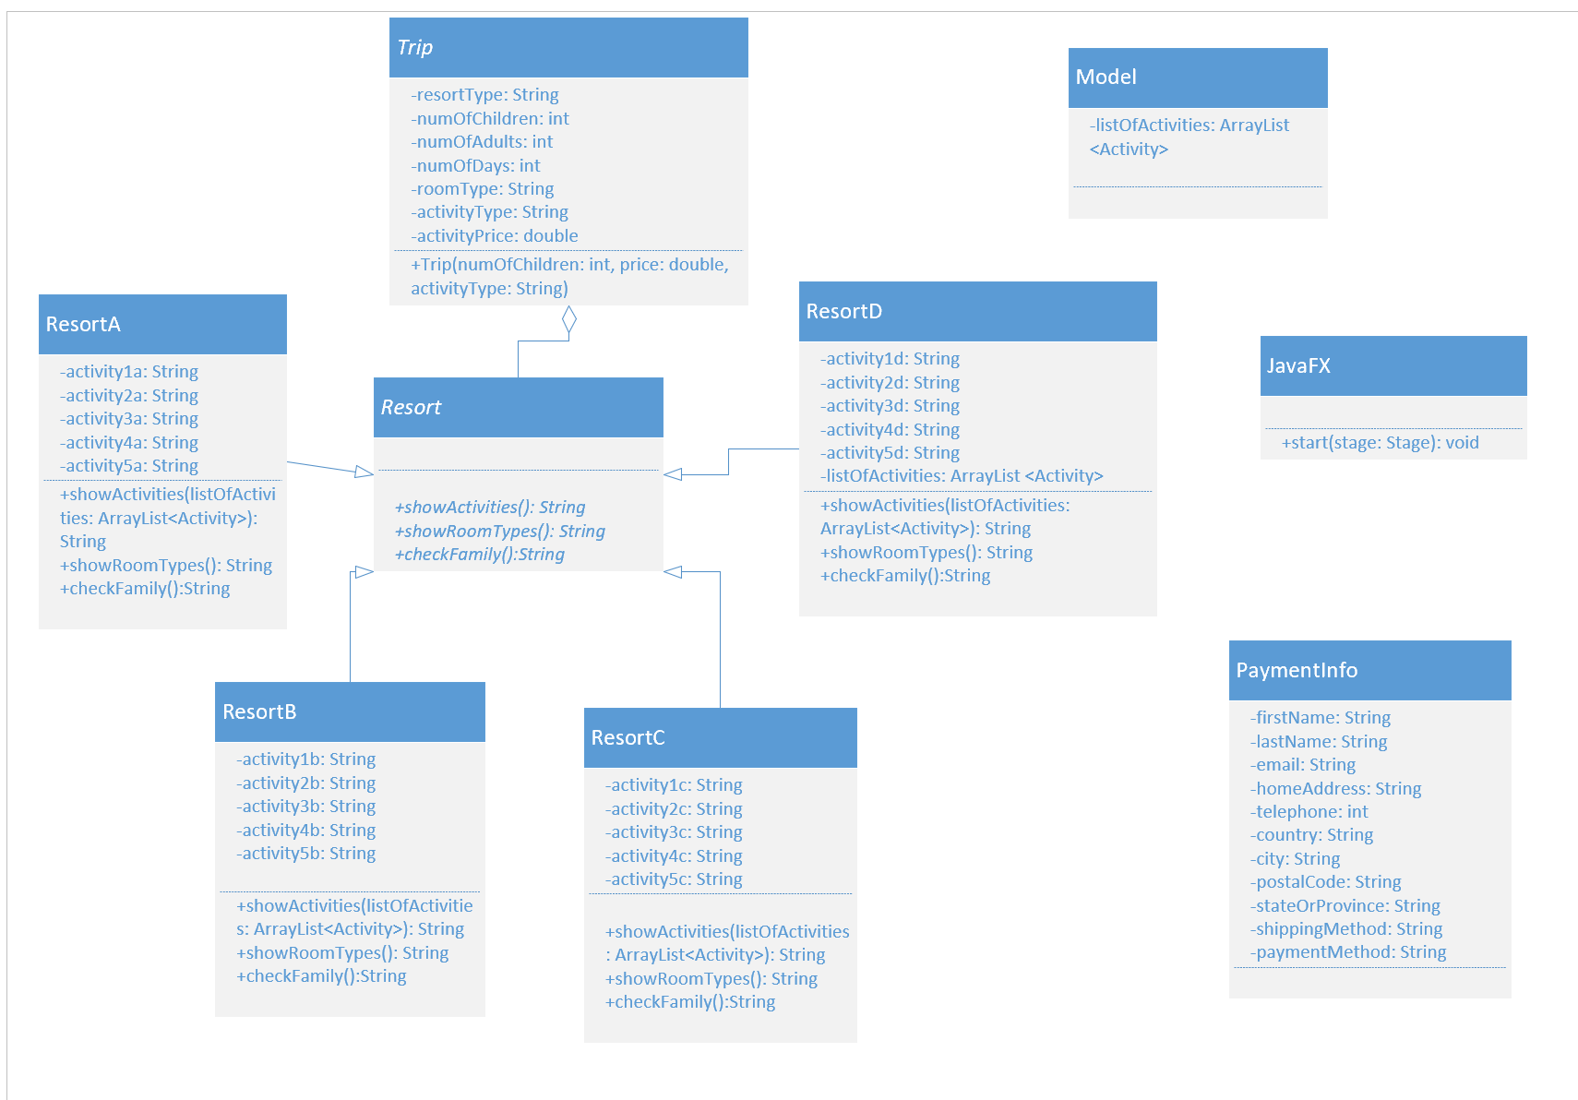

*not clear how many resorts we will have on the app yet, or what exact activities will be.

Discussion on your choice of OOP constructs you are going to use (i.e. inheritance, interfaces, etc.)

We will be using inheritance, abstraction and aggregation. All resort classes (resortA, resortB, etc.) will inherit the same methods from the abstract class Resort. Resort will also inherit properties from the abstract class Trip through aggregation - this is where the object Trip will be created.

What type of data your app will be reading and/or writing.

Our app will read user input - the user will select options and the output results will change based on the selections made. Each following output page will depend on the choices the user makes. Our app may also take information from outside files (to create the activities, we can take information from websites in order to find information such as which company organizes it and what the listed price is).