Erd diagram

**Property**



|  |  |
| --- | --- |
| **PK** | PropertyID |
|  | Address |
|  | Type |
|  | Status |
|  | Price |
|  | MaintenaceSchedule |



|  |  |
| --- | --- |
| **PK** | AgreementID |
| **FK** ref Property | PropertyID |
| **FK** ref Client | ClientID |
|  | StartDate |
|  | EndDate |
|  | RentAmount |

**Rental_agreement**



**Client**

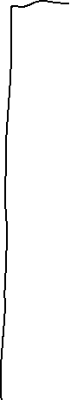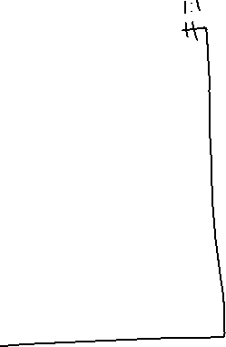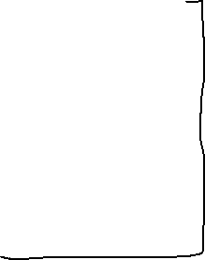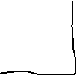

|  |  |
| --- | --- |
| **PK** | ClientID |
|  | FirstName |
|  | SecondName |
|  | Email |
|  | Phone |
|  | Clienttype |

**Payment**



|  |  |
| --- | --- |
| **PK** | PaymentID |
| **FK ref** Rental_Agreement | AgreementID |
|  | PaymentDate |
|  | AmountPaid |
|  | PaymentStatus |

**Maintenance**

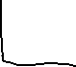

|  |  |
| --- | --- |
| **PK** | MaintenanceID |
| **FK ref Property** | PropertyID |
|  | ScheduledDate |
|  | MaintenanceType |
|  | Cost |