2023 - 2024
BACHELOR Degree program international business management
Monte Carlo Simulation : Renewable Energy Growth

MARTHA GEOFFREY KABAKAKI

SPECIALIZATION IN DATA SCIENCE, PROTECTION, & SECURITY
CAMPYS DE VEST, ZANDPOORTVEST, 2800 MECHELEN, BELGIUM

ABSTRACT
Scientists assert that global carbon emissions must be halved by 2030 to prevent catastrophic climate impacts (Phadke, A., Paliwal, U…, 2020). Transitioning to renewable energy sources is essential for addressing global climate change and ensuring sustainable energy security. The shift toward a clean electricity system has gained momentum recently, driven by declining costs of solar and wind technologies (United States Department of State…, 2021). Building on this progress, several countries, including the United States, have set targets for increasing renewable energy capacity (United States Department of State…, 2021). These targets focus on boosting annual renewable capacity additions to replace unregulated fossil fuel-based capacity within specific timeframes (United States Department of State…, 2021).
To support the planning of annually adding substantial renewable capacity to replace unregulated fossil fuel-based capacity, this research presents the development of a web-based simulation platform. The platform utilizes Monte Carlo simulation to model the transition in energy capacity, offering insights into effective strategies for increasing renewable energy deployment while phasing out non-renewable sources to meet their respective targets over a specified period. The simulation process involves random sampling of yearly data and multiple simulations to generate a distribution of possible outcomes. These outcomes are analysed to calculate confidence intervals and percentiles, providing insights into the variability of cumulative pathways.
The findings show that the model demonstrate that the U.S. renewable energy capacity targets are largely feasible, yet the model may be overly optimistic due to its reliance on probabilistic approaches that do not fully account for real-world challenges such as policy delays, market fluctuations, and regional differences in energy infrastructure. While the model offers enhanced decision-making capabilities by visualizing data and simulating various strategies, it lacks sophistication in accounting for political, economic, and technological uncertainties. The platform's key advantages include improved strategy development and decision-making through probabilistic insights, but its disadvantages are the computational intensity of Monte Carlo simulations and the need for user knowledge in interpreting results.
TABLE OF CONTENTS
1. INTRODUCTION 8
1.1. Background Information 8
1.2. Problem Statement 8
1.3. Objective 9
1.4. Target Audience 9
2. LITERATURE REVIEW 10
2.1. Monte Carlo Simulation (MCS) 10
2.1.1. Introduction 10
2.1.2. Historical Development 10
2.1.3. Theoretical Foundations 10
2.1.4. Methodology 11
2.1.5. Applications of Monte Carlo 12
3. METHODOLOGY 13
3.1. The Platform Implementation 13
3.1.1. Python 13
3.1.2. Flask 13
3.1.3. Redis 13
3.1.4. NumPy 14
3.1.5. Pandas 14
3.1.6. Plotly 14
3.1.7. HTML & CSS 14
3.2. The Platform 14
3.2.1. Homepage 14
3.2.2. About page 16
3.3. Model Definition 17
3.3.1. Dependent Variables 17
3.3.2. Independent Variables 17
3.3.3. Data Types & Collection 18
3.3.4. The Model 18
3.3.5. Monte Carlo Simulation 21
3.4. Statistical Analysis & Visualization 22
3.4.1. Renewable & Non-renewable Final Capacities 22
3.4.2. Renewable & Non-renewable Cumulative Capacities 22
4. DEMONSTRATION & DICUSSION 24
4.1. Demonstration 24
4.1.1. Pre-project Simulation Inputs 24
4.1.2. Pre-project Simulation Outputs 24
4.1.3. Project Progress Simulation Inputs 26
4.1.4. Project Progress Simulation Outputs 27
4.2. Discussion 29
4.2.1. Advantages 30
4.2.2. Disadvantages 30
5. CONCLUSION 31
5.1. Recommendations 31
5.1.1. Advanced Computational Techniques 31
5.1.2. Incorporation of Advanced Modelling Techniques 31
5.1.3. Experts Engagement & Validation 32
5.1.4. Model Continuous Updates 32
5.1.5. User-friendly Interface Enhancements 32

LIST OF FIGURES
Figure 1: Homepage 14
Figure 2: Pre-project Simulation section 15
Figure 3: During Project Progression Simulation section 15
Figure 4: Model Results section 16
Figure 5: Footer section 16
Figure 6: Renewable Capacity Simulation 25
Figure 7: Non-renewable Capacity Simulations 25
Figure 8: Renewable Final Capacities 25
Figure 9: Non-renewable Final Capacities 25
Figure 10: Renewable Capacity Percentiles 26
Figure 11: Non-renewable Capacity Percentiles 26
Figure 12: Renewable Capacity Simulations 28
Figure 13: Non-renewable Capacity Simulations 28
Figure 14: Renewable Final Capacities 28
Figure 15: Non-renewable Final Capacities 28
Figure 16: Renewable Capacity Percentiles 29
Figure 17: Non-renewable Capacity Percentiles 29

LIST OF TABLES
Table 1: Pre-project Simulation Inputs 17
Table 2: During Project Progression Inputs 18
Table 3: Assumed U.S. Pre-Project Simulation Inputs 24
Table 4: Assumed U.S. Project Progress Simulation Inputs 27

ACKNOWLEDGEMENT
I would like to express my gratitude to our Almighty God who leads, guides, and gives me revelation, wisdom, knowledge, and understanding in everything that I do. The LORD is my shepherd; I shall not want. He maketh me to lie down in green pasture. He leadeth me beside the still water. He restore my soul. He leadeth me in the paths of righteousness for his name sake.
I would like to express my gratitude to my thesis mentor, Charlie Beirnaert, whose guidance, assistance, and invaluable feedback significantly contributed to the completion of this work. His unwavering support and willingness to address all my inquiries were truly appreciated. I am honoured to have been mentored by Charlie Beirnaert, and I am thankful for his extensive knowledge and expertise in the field of data science and energy.
I am also deeply thankful to my family and friends, including my mom, Deonisia Max Karumuna, my dad, Geoffrey Kabakaki, my sisters, Mariapia Geoffrey, and Merina Geoffrey, my brother, Gerald Geoffrey, and my friends, Rex Atsu Akenji, Sylvia Dankwa, Ananya Gyanmote, Yarni Van Zeebroeck, Roji Pun, and Alissa Alkhova, whose unwavering support and encouragement, were instrumental in completing my thesis. I would like to extend special thanks to my mother, who provide me with any assistance I needed. Mom helped in reading and correcting my thesis. Dad and Mom, I love you.

INTRODUCTION

Background Information
Climate change is already causing significant damage to the world, manifesting in extreme heat, floods, storms, wildfires, and other climate-driven impacts (United States Department of State…, 2021). These effects lead to health degradation, injuries, deaths, economic hardship, and damage to the earth’s ecosystems (United States Department of State…, 2021). All these impacts are from warming of roughly $1.0℃$ and the science is clear that, without faster global action, these impacts will become much more frequent and severe (United States Department of State…, 2021). According to the United States Department of State and the United States Executive Office of the President, the report from the Intergovernmental Panel on Climate Change (IPCC) illustrates the need to limit warming to $1.5℃$ to avoid these severe climate impacts and risks (2021, p. 3). Achieving global net-zero emissions by 2050 is how nations around the globe will keep $1.5℃$ within reach and prevent unacceptable climate change, impacts and risks (United States Department of State…, 2021).
There are potential solutions to the environmental impacts associated with the harmful pollutant emissions, and renewable energy is among them (Dincer, 2000). The energy resources have been split into three categories: fossil fuels (non-renewables), renewable resources, and nuclear resources (Panwar, Kaushik, & Kothari, 2011). The main source of global warming and climate change is the use of fossil fuels, which increases greenhouse gas emissions (Kocak, Ulug, Oralhan, 2023). However, the world still provides approximately 81% of its energy needs from fossil resources such as oil, natural gas, and coal (Kocak, Ulug, Oralhan, 2023). There is a consensus that the way to achieve the emission reduction target is to switch from fossil energy to renewable sources (Kocak, Ulug, Oralhan, 2023).
Renewable sources include solar energy, wind energy, biomass energy, geothermal energy, and hydropower energy (Renewable energy explained, 2023). Renewable energy is “energy from sources that are naturally replenishing but flow-limited; renewable resources are virtually inexhaustible in duration but limited in the amount of energy that is available per unit of time” (Renewable energy explained, 2023). Renewable energy is an important solution alternative for mitigation of greenhouse gas emission and reducing global warming as renewable technologies are clean sources of energy (Panwar, Kaushik, & Kothari, 2011). The use of renewable energy minimize environmental impacts, produce minimum secondary wastes, and are sustainable based on current and future economic and social societal needs (Panwar, Kaushik, & Kothari, 2011). Renewable energy provides critical economic and political benefits by reducing energy dependency while improving health conditions and quality of life through cleaner air and the environment (Kocak, Ulug, Oralhan, 2023). Energy dependency shows the degree of reliance a country has on imports to satisfy its energy demands (What is Energy Dependency, 2022).

Problem Statement
Therefore, it is crucial to accelerate the global transition to renewable energy to combat climate change and ensure sustainable development. Promoting the deployment of renewable energy is a top priority to address the global climate challenge and achieve carbon neutrality (Wang, Jin, Qin, Su, & Umar, 2024). At present, implementing sustainable energy and completing the energy transition are central to the energy strategies of various countries worldwide because of the declining costs of solar and wind technologies (Wang, Jin, Qin, Su, & Umar, 2024). For instance, United States’ renewable capacity additions have been growing rapidly in the past decade and are more closely approaching levels that will be needed to sustain the overall decarbonization trend needed to reach the 2050 goal (United States Department of State…, 2021). As countries strive to increase their annual renewable capacity additions, the need for models to support the planning of annually adding substantial renewable capacity to replace unregulated fossil fuel-based capacity has never been greater.

Objective
The research objective is to develop a web-based simulation platform that employs Monte Carlo simulation to model the transition in energy capacity, offering insights into effective pathways for increasing renewable energy deployment while phasing out non-renewable sources to meet their respective targets over a specified period. Before or during a project is underway, the platform helps annual renewable energy capacity deployment planning by enabling stakeholders to run various simulations to explore different strategies of renewable energy expansion. The platform generates actionable insights into the rate and scale of annual renewable energy capacity adoption required to meet capacity targets.

Target Audience
The platform targets a diverse audience comprising energy planners, policymakers, and scholars. Energy planners utilize the platform for potential growth pathways of renewable energy capacity, aiding strategic planning and investment decisions. Policymakers may leverage the insights provided by the simulations to inform policy and regulation decisions, considering the impact on renewable energy adoption. Scholars engage with the platform for academic and research purposes, exploring various strategies and analysing the effectiveness of different strategies in promoting renewable energy deployment.
The introduction sets the stage for the subsequent chapters: Chapter 2 examines the literature review of Monte Carlo simulation; Chapter 3 presents the methodology used for developing the model; Chapter 4 presents the discussion; Chapter 6 draws the conclusions and recommendations.

LITERATURE REVIEW

Monte Carlo Simulation (MCS)
The platform uses Monte Carlo simulation to model the transition in energy capacity, offering insights into effective pathways for increasing renewable energy deployment while phasing out non-renewable sources to meet their respective targets over a specified period. Monte Carlo is chosen over traditional deterministic models because of its ability to handle uncertainty and provide a probabilistic range of outcomes. Therefore, this chapter reviews the history, principles, benefits, challenges, and limitations of Monte Carlo simulation.

Introduction
Monte Carlo simulation (MCS) has evolved as a crucial computational technique for understanding and predicting the behaviour of complex systems under uncertainty (Kang et al., 2009). Its origins and development trace back to significant scientific and mathematical innovations, making it indispensable in various fields today (Harrison, 2010).

Historical Development
The conceptual origins of MCS date back to the 18th century with the work of Georges Louis LeClerc, Comte de Buffon, who employed random methods in his studies, most notably in the Buffon’s needle experiment to estimate the value of π (Harrison, 2010). This experiment is often regarded as the first example of MCS (Harrison, 2010). In the late 19th and early 20th centuries, scientists such as E. L. De Forest, G. H. Darwin, F. Galton, and W. S. Gosset employed simulation to experimentally confirm theories, analyse data, and supplement intuition in mathematical statistics (Harrison, 2010). However, modern simulations reverse this approach by treating deterministic problems through finding probabilistic analogues and solving them probabilistically, providing insights into complex, analytically, intractable systems (Harrison, 2010).
The systematic development and application of modern MCS occurred during the Manhattan Project in World War II, led by John von Neumann and Stanislaw Ulam (Harrison, 2010). They utilized MCS to address problems related to neutron travel in radiation shielding, naming the technique after the Monte Carlo Casino in Monaco to emphasize the method's reliance on randomness (Harrison, 2010).

Theoretical Foundations
Monte Carlo simulation relies on random sampling to understand the behaviour of a system (Okutan, 2024). This process involves modelling a system with probability density functions, repeatedly sampling from these probability density functions, and then computing the statistics of interest (Harrison, 2010). This approach allows for the exploration of complex systems where analytical solutions are infeasible due to the problem's intractability or the high computational cost of experiments (Harrison, 2010; What Is Monte Carlo Simulation?, 2021).

Methodology
There is no single Monte Carlo method, but the core methodology of Monte Carlo simulation can be broken down into several key steps (Harrison, 2010):

Model definition
A mathematical model that accurately represents the system under study is developed. This includes determining the desired outputs, defining inputs, and specifying how these inputs will be processed to generate outputs (Harrison, 2010). The output, the dependent variable, is determined by identifying the variable to be predicted or analysed (Frost). This could be an outcome measure, a performance metric, or any variable of interest that depends on the independent variables (Frost). The inputs, the independent variables, also known as risk or predictor variables, are determined by identifying the factors that influence the dependent variable (Frost).

Probability Distributions
The type of distribution for each independent variable is identified by choosing an appropriate probability distribution that best represents the variability and uncertainty of the variable. Common distributions include What Is Monte Carlo Simulation?, 2021):
- Normal probability distribution: Also known as the Gaussian distribution, it is a continuous probability distribution characterized by a symmetric, bell-shaped curve, with the highest probability density at the mean and tapering off equally on both sides (Unit 4: Modelling data distributions). It is suitable for variables that tend to cluster around a central value with decreasing frequency as you move away from the mean (Unit 4: Modelling data distributions).
- Uniform probability distribution: A continuous probability distribution where all outcomes are equally likely within a specific range (OpenStax, 2023). In a uniform distribution, the probability density function is constant, meaning each interval of values within the range has an equal probability of occurring (Weisstein)..
- Exponential probability distribution: This is a continuous probability distribution that describes the time between events in a Poisson process (Weisstein). It is characterized by a rapid decline in probability as the time between events increases, often used to model waiting times or lifetimes of certain processes (Frost).
- Triangular probability distribution: A continuous probability distribution shaped like a triangle, defined by a minimum, maximum, and mode (peak value) (Devore, J. L., 2015). It is commonly used when the actual distribution is unknown, but a rough estimate of the most likely value (mode) is available (Devore, J. L., 2015). It assumes a linear increase in probability up to the mode and a linear decrease after the mode (Devore, J. L., 2015).

Simulations
Random number generators are utilized to produce random values for each independent variables based on its defined probability distribution (Harrison, 2010). The predictive model is then run repeatedly, each time using a different set of randomly generated values for the independent variables (Harrison, 2010). The resulting values of the dependent variable are captured from each simulation run What Is Monte Carlo Simulation?, 2021).

Analysis of Results
The results from all simulation runs are analysed to derive insights. Summary statistics such as mean, variance, standard deviation, and correlation coefficients, may be computed to understand the distribution and variability of the predicted outcomes. The results may then be visualized using histograms, line plots, or etc., to gain insights.

Interpretation and Decision Making
The insights are interpreted to understand the implications for decision-making.. The insights gained from the simulation may be used to inform strategic decisions, optimize resource allocation, or manage risks effectively.

Applications of Monte Carlo
Monte Carlo simulation is widely used across various domains, including finance, engineering, business, etc. In finance, analysts use Monte Carlo simulation to predict stock prices, evaluate financial risks, and formulate investment strategies by considering numerous risk factors (What Is the Monte Carlo Simulation?, 2022); In engineering, engineers utilize Monte Carlo simulation to estimate product durability and failure rates under different operating conditions (What Is the Monte Carlo Simulation?, 2022). In business, leaders employ Monte Carlo simulation for decision-making under uncertainty, such as budgeting and forecasting sales (What Is the Monte Carlo Simulation?, 2022).

METHODOLOGY
This chapter outlines the approach taken to develop and implement the model for transitioning in energy capacity, offering insights into effective pathways for increasing renewable energy deployment while phasing out non-renewable sources to meet their respective targets over a specified period

The Platform Implementation
All development work was conducted using Visual Studio Code, a versatile code editor known for its robust support for various programming languages and development tools (Visual Studio Code). The web-based simulation platform is implemented using Python and several libraries, and standard web technologies:

Python
The primary programming language used for developing the model. Python is chosen due to its simplicity and the extensive libraries it offers for scientific computing (Van Rossum & Drake, 2009).

Flask
A lightweight web framework for Python, Flask facilitated the development of the web application that hosts the model, providing a user-friendly interface (Grinberg, 2018).

Redis
Redis is employed as an in-memory data structure store for caching and managing session data to enhance the performance and scalability of web applications (Carlson, 2013). A session refers to the temporary storage of user-specific fata during a user’s interaction with an application (Redis as a session store). The platform is configured to use Redis as the backend for session storage, providing a robust and scalable solution for managing session data. In the web application, data is managed through sessions to ensure persistence and improve user interactions by storing information. When a user submits a form, the form data is converted into a dictionary and saved in the session, preserving user inputs across different requests and page navigations.

Additionally, the results data generated from model simulations are also stored in sessions. This ensures that both input and output data are readily accessible throughout the user's interaction with the platform by seamlessly retrieving and displaying the simulation results. By leveraging Redis, the application benefits from fast access to session information and can handle a large volume of concurrent sessions, supporting a seamless user experience.

NumPy
A crucial package for scientific computing in Python, NumPy supports large multi-dimensional arrays and matrices and provides a collection of mathematical functions to operate on these arrays (Oliphant, 2006).

Pandas
Built on top of NumPy, Pandas offers data structures and operations for manipulating numerical tables and time series, aiding in the data manipulation and analysis processes (McKinney, 2010).

Plotly
This graphing library was used to create interactive plots and visualizations essential for analysing and presenting the simulation results (Plotly Technologies, 2015). Plotly provided interactive features such as hover text and zooming, which further enhanced user interactions with the plots to gain deeper insights into the resulting visualizations from the simulation results.

HTML & CSS
Standard technologies for styling and structuring web pages, CSS and HTML were used in conjunction with Flask to design the user interface of the web application (Meyer, 2007; W3C, 2014).

The Platform
The platform has two pages, the home page and the about page. The following is the user’s experience throughout the platform.

Homepage
The user gets to see the following when he or she first comes to the platform. When the user clicks on ‘Run Simulation’ button or ‘Simulations’ link, the page scrolls to the ‘Pre-project Simulation’ form shown in Figure 2.
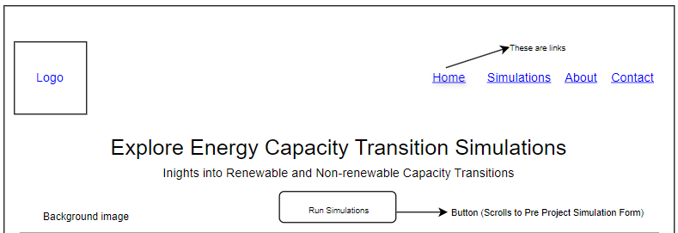
Figure 1: Homepage
Before a project is underway, the platform helps annual renewable energy capacity deployment planning by enabling stakeholders to run various simulations to explore different strategies of renewable energy expansion. Therefore, as Figure 2 shows, the user gets to input data for before a project is underway in the ‘Pre-project Simulation’ form. When the user clicks on ‘Run Simulation’, the page scrolls to the ‘Model results’ section shown in Figure 4 to see the model results.
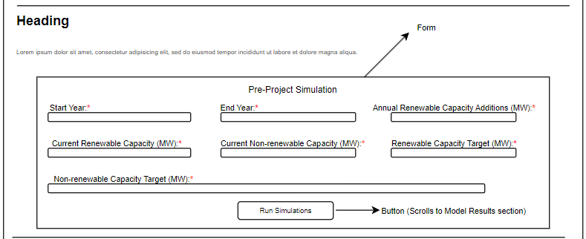
Figure 2: Pre-project Simulation section
During a project is underway, the platform helps annual renewable energy capacity deployment planning by enabling stakeholders to run various simulations to explore different strategies of renewable energy expansion. Therefore, as Figure 3 shows, the user gets to input actual data for during a project is underway in the ‘During Project Progression Simulation’ form. The actual data are yearly data from the start of the implementation year to the present. When the user clicks on ‘Run Simulation’, the page scrolls to the ‘Model Results’ section shown in Figure 4 to see the model results. The actual data gets also added to the ‘Actual Data of Capacity Additions and Retirements’ table, where the user may delete or update the actual data.
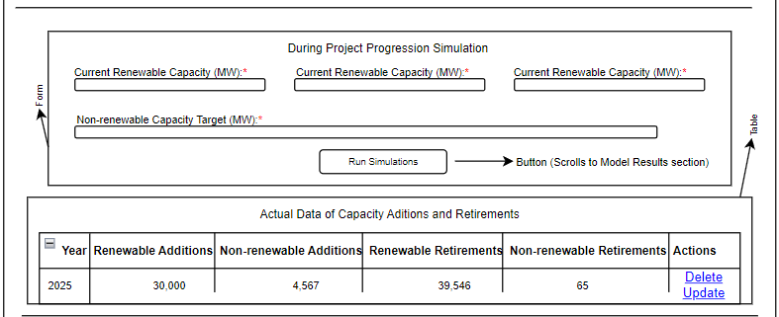
Figure 3: During Project Progression Simulation section
Figure 4 below, shows the ‘Model Results’ section where actionable insights into the rate and scale of annual renewable energy capacity adoption required to meet capacity targets are presented. The insights are visualized into the following, histograms and line plots.
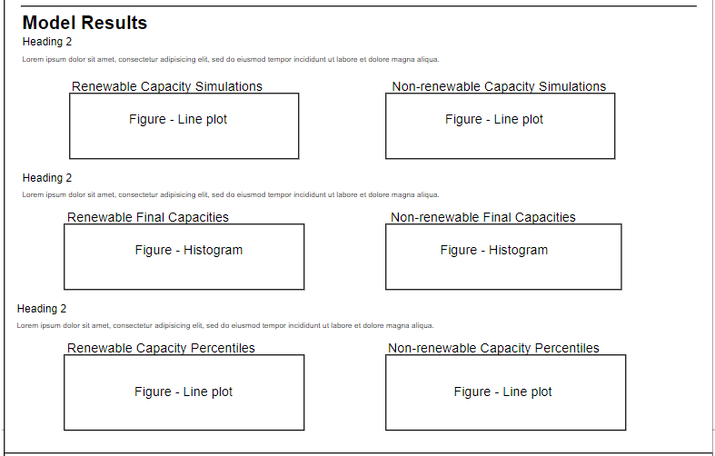
Figure 4: Model Results section
Figure 5 below, shows the footer of the website, where the use gets about, contact, and related sites information.
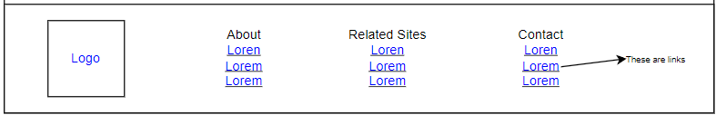
Figure 5: Footer section

About page
The about page is about the following: the mission, vision, values, and benefits or advantages of the platform. The benefits or advantages of the platform are discussed in the discussion section.

Mission
The mission is for countries to use the platform to explore renewable energy capacity deployment strategies.

Vision
The visions is for stakeholders to find the platform credible.

Values
The following are the values of one’s judgement of the platform:
- Facilitate decision-making.
- Exploration of strategies.

Model Definition
Defining the model includes determining the desired outputs (dependent variables), defining inputs (independent variables), and specifying how these inputs are processed to generate outputs.

Dependent Variables
The dependent variable, the variable to be predicted, is the cumulative capacities or pathways and for both renewable and non-renewable energy.

Independent Variables
Before or during a project is underway, the platform helps annual renewable energy capacity deployment planning by enabling stakeholders to run various simulations to explore different strategies of renewable energy expansion. The platform generates actionable insights into the rate and scale of annual renewable energy capacity adoption required to meet capacity targets. Therefore, before any project begins, Table 1 shows the independent variables that influence the dependent variables. The independent variables allows the model to help stakeholders plan annual renewable energy capacity deployment by enabling various simulations to explore different strategies of renewable energy expansion. This section is the ‘Pre-project Simulation’ in the platform.
Inputs | Explanation
Start year | The initial year of the simulation.
End year | The final year of the simulation.
Expected annual renewable capacity addition (MW) | The expected yearly increase in renewable energy capacity.
Current renewable capacity (MW) | The existing capacity of renewable energy.
Current non-renewable capacity (MW) | The existing capacity of non-renewable energy.
Target renewable capacity (MW) | The desired capacity of renewable energy by the end year.
Target non-renewable capacity (MW) | The desired capacity of non-renewable energy by the end year.
Table 1: Pre-project Simulation Inputs

During the project, Table 2 shows the independent variables that also influence the dependent variables. The independent variables are actual yearly data from the start of the implementation year to the present. This section is the ‘During Project Progression Simulation’ in the platform.
Inputs | Explanation
Year | The specific year for the data entry.
Actual renewable additions (MW) | The actual increase in renewable energy capacity for that year.
Actual non-renewable addition (MW) | The actual increase in non-renewable energy capacity for that year.
Actual renewable retirement (MW) | The actual decrease in renewable energy capacity for that year.
Actual non-renewable retirement (MW) | The actual decrease in non-renewable energy capacity for that year.
Table 2: During Project Progression Inputs

Data Types & Collection
The inputs and outputs of the system are both quantitative data. The data collection method for the inputs involves self-reported data entry through the platform’s input forms. Specifically, users manually enter data into these forms, and the platform collects, stores, and utilize this data. This approach ensures that the data, which is numerical and essential for simulations, reflects users' direct input. The platform facilitates the collection of data for both ‘pre-project and ‘during project progression’.

The Model
The model is designed for transitioning in energy capacity, offering insights into effective pathways for increasing renewable energy deployment while phasing out non-renewable sources to meet their respective targets over a specified period. The model employs triangular and uniform distributions to generate values for renewable and non-renewable energy additions and retirements to simulate annual changes in renewable and non-renewable energy capacities.

Triangular Probability Distributions
- Renewable Capacity Additions
Potential annual additions to renewable energy capacity are randomly generated based using triangular distribution. Each year, a random value is based on the following values: High values have $30$% of probability, medium values have 50% of probability, and low values have 20% of probability.
The ranges for each weight category are determined relative to the ‘expected annual renewable capacity addition (MW)’:
- High values are between ‘$expected annual renewable capacity addition (MW) x 1.25$’ and $expected annual renewable capacity addition (MW) x 1.5$
- Medium values are between ‘$expected annual renewable capacity addition (MW) x 0.75$’ and ‘$expected annual renewable capacity addition (MW) x 1.25$’
- Low values are between ‘$expected annual renewable capacity addition (MW) x 0.4$’ and $expected annual renewable capacity addition (MW) x 0.75$
For example, if the ‘expected annual renewable capacity addition (MW)’ is $60,000 MW$, the ranges would be:
- High values, between $75,000$ ($60,000 x 1.25$) and 90$,000$ ($60,000 x 1.5$)
- Medium values, between $45,000$ and $75,000$ ($60,000 x 0.75$ and $60,000 x 1.25$)
- Low values, less than $24,000$ ($60,000 x 0.4$) and $45,000$ ($60,000 x 0.75$)
The weights are configured this way due to the declining costs of renewable energy technologies, particularly solar and wind, making it more likely for countries to achieve or even exceed their ‘expected annual renewable capacity additions (MW)’. Studies indicate that the cost of solar photovoltaic modules and wind turbines has significantly decreased over the years, making these technologies more affordable and accessible (International Renewable Energy Agency, 2020; BloombergNEF, 2021). Consequently, this research assumes that there is a higher probability ($50\%$) that a country will deploy a capacity within the expected range, a significant chance ($30\%$) that they will exceed this amount, and a smaller chance ($20\%$) that they will deploy less than expected due to potential factors including political, economic, and technological challenges.
- Non-renewable Capacity Additions
Potential annual additions to non-renewable energy capacity are randomly generated using a normal and uniform distribution. The normal distribution is the probability between high, medium, and low values. The uniform distribution is used to generate a random value from the range.
- High values have 10% of probability, and they are values between 40,000 MW and 100,000 MW. This scenario represents scenarios where significant investments in non-renewable sources are made, potentially due to high energy demand, economic constraints, or slower-than-expected deployment of renewable energy technologies.
- Medium values have 35% of probability, and they are values between 10,000 MW and 40,000 MW. This scenario represents moderate investments in non-renewable capacity, balancing the need for energy security with the ongoing shift towards renewable energy sources.
- Low values have 55% of probability, and they are values between 0 MW to 10,000 MW. This scenario reflects minimal investments in non-renewable sources, aligning with a strategic emphasis on renewable energy expansion and minimal reliance on non-renewable energy additions (Renewable Energy Market…, 2023).
The probability distribution, heavily weighted towards lower non-renewable additions, aligns with the global trend of declining investments in fossil fuels in favour of renewable sources.
- Renewable Capacity Retirements
Potential annual retirements of renewable energy capacity are randomly generated using normal and uniform distribution. The normal distribution is the probability between high, medium, and low values. The uniform distribution is used to generate a random value from the range.
- High values have 10% of probability, and they are values between 40,000 MW and 100,000 MW. This scenario represents significant retirements due to the natural aging of infrastructure, maintenance cost, or policy-driven initiatives aimed at replacing outdated installations with newer, more efficient technologies. Solar panels and wind turbines, for example, have typical lifespans of 20-25 years and 20-30 years, respectively (Renewable Power Generation Costs in 2019, 2020). As these installations age, their likelihood of retirement increases, especially if maintenance becomes uneconomical.
- Medium values have 35% of probability, and they are values between 10,000 MW and 40,000 MW. This scenario represents moderate retirements, balancing the natural lifecycle of installations because of the ongoing need to maintain energy supply. Technological advancements also play a role here, as newer, more efficient technologies become available, prompting earlier retirements of older systems to take advantage of improvements in cost and performance (New Energy Outlook, 2024; Bloomberg Finance LP, 2024).
- Low values have 55% of probability, and they are values between 0 MW to 10,000 MW. This scenario reflects minimal retirements, which could occur during periods of reinvestment in existing infrastructure. In these cases, aging installations might be upgraded or refurbished rather than decommissioned, ensuring continued use and avoiding the costs associated with complete retirement and replacement.
By incorporating these ranges and probabilities, the model accurately simulates a variety of retirement scenarios, providing valuable insights into the long-term planning and management of renewable energy capacity. This variability ensures that simulations reflect the complex and evolving landscape of renewable energy deployment and decommissioning, supporting more informed decision-making for energy stakeholders.
- Non-renewable Capacity Retirements
The same as renewable energy additions, the ranges for each weight category are determined in the same way, relative to the ‘expected annual renewable capacity addition (MW)’, but the high, medium, and low values have different probabilities.
- High values have 10% of probability: This scenario is the least likely scenario because a significant amount of non-renewable energy capacity is retired. This research assumes that countries are not rapidly retiring large amounts of non-renewable energy at the same pace as they are deploying renewable energy. Factors contributing to this slower retirement pace may include existing infrastructure investments, and the gradual nature of policy shifts.
- Medium values have 50% of probability: This scenario is the most likely scenario because a moderate amount of non-renewable energy capacity is retired, aligning with current global trends and incremental policy advancements towards cleaner energy. It reflects a balanced approach where retirements are influenced by steady progress in renewable energy adoption and gradual phasing out of older, less efficient non-renewable energy.
- Low values have 40% of probability: This scenario accounts for situations where there are slower policy implementations, continued investments in maintaining existing non-renewable infrastructure, etc.

Yearly Adjustments
In the ‘pre-project, the simulation calculates yearly changes in energy capacities by adjusting the ‘current renewable capacity (MW)’ and ‘current non-renewable capacity (MW)’ based on the generated additions and retirements. From ‘start year’ to ‘end year’:
- Adjustments of renewable capacity: ‘Current renewable capacity (MW)’ is increased by the generated renewable additions for the year and is decreased by the generated renewable retirements for the year.
- Adjustments of non-renewable capacity: ‘Current non-renewable capacity (MW)’ is increased by the generated non-renewable additions for the year and is decreased by the generated non-renewable retirements for the year.
In the ‘during project progression’, the yearly adjustments are carried out by modifying the renewable and non-renewable energy capacities based on both random generated values or actual data. From ‘start year’ to ‘end year’, the process involves the following steps:
- Identification of current year: The model identifies the current year within the specified period.
- Incorporation of actual data: When actual data for the current year is available, it updates the random values for renewable and non-renewable additions and retirements with the actual data. If actual data is not available, it is the random generated value, then
- Adjustments of renewable capacity: ‘Current renewable capacity (MW)’ is increased by the value of renewable additions for that year, and is then decreased by the value of renewable retirements for that year.
- Adjustments of non-renewable capacity: ‘Current non-renewable capacity (MW)’ is increased by the value of non-renewable additions for that year, and is then decreased by the value of non-renewable retirements for that year.
The updated capacities are then stored for each year to track the cumulative capacities.

Monte Carlo Simulation
The Monte Carlo method enhances the robustness of the model by performing multiple simulation to capture a wide range of possible outcomes. The simulation is performed for $1000$ simulations, generating a distribution of possible cumulative capacities for both renewable and non-renewable energy.

Statistical Analysis & Visualization
The following explains the transformation of the data, analysis conducted, the resulting visualizations of the output (cumulative results or pathways), dependent variable, of the model, displayed in the platform.

Renewable & Non-renewable Final Capacities
The 2.5th and 97.5th percentiles are calculated to determine the 95% confidence interval, representing the lower and upper bounds for the final capacities of both renewable and non-renewable energy. The resulting visualization is displayed as a histogram, which shows the frequencies of the final capacities. These histograms for the final capacities of both renewable and non-renewable energy includes annotations for the ‘renewable capacity target (MW)’ and ‘non-renewable capacity target (MW)’ and the median value. Including the capacity target in the visualization allows for an easy comparison between the actual outcomes and the desired target, highlighting how often the target is met or exceeded. This is vital for decision-makers who need to assess the feasibility of achieving specific energy capacity target. Displaying the median provides insight into the central tendency of the data, giving a sense of the typical outcome. By visualizing the spread and central tendency of final capacities, stakeholders can better assess the risk of not meeting the capacity target. This understanding is essential for planning and making informed decisions about energy investments, and resource allocation. In addition, the confidence intervals are shaded to indicate the range within which the majority of results fall, emphasizing the variability of the simulations.

Renewable & Non-renewable Cumulative Capacities
The cumulative results or pathways for both renewable and non-renewable capacities are plotted. It is crucial to visualize the cumulative results to understand the distribution and the outcomes effectively. The plots for renewable and non-renewable capacities use different colours to differentiate between results that meet the ‘renewable capacity target (MW)’ or ‘non-renewable capacity target (MW)’ and those that do not. The results that meet the target are in green, and the results that do not meet the target are in orange. This colour-coding is essential as it quickly highlights the pathways that achieve the desired target, allowing for an immediate visual assessment of success rates. The plots also help identify trends and outliers, providing a clear picture of the performance and reliability of the energy capacity pathways.
The yearly percentiles for the cumulative results or pathways for both renewable and non-renewable capacities are calculated. The yearly percentiles for both renewable and non-renewable capacities are visualized in line plots to show how the energy capacities evolve throughout the specified period. These line plots include percentile lines including, the 90th percentile line, 75th percentile line, 50th percentile line, 25th percentile line, and 10th percentile line in different colours, which illustrate the distribution of outcomes over the years. Additionally, ‘renewable capacity target (MW)’ and ‘non-renewable capacity target (MW)’ lines are included, allowing for a clear assessment of when the percentiles meet or exceed the target. This percentile based analysis enables stakeholders to gauge risks, track performance, and identify trends, offering benchmarks to assess yearly progress against renewable and non-renewable capacity targets. Ultimately, it helps stakeholders focus on areas where intervention may be needed to stay on track with long-term energy transition targets.

DEMONSTRATION & DICUSSION

Demonstration

Pre-project Simulation Inputs
The United States is used as an example to demonstrate the use of the model. In 2021, the United States Department of State and the United States Executive Office of the President outlined a pathway to achieve net-zero emissions by 2050, requiring the deployment of 60-70 GW of zero-carbon technologies annually. For this simulation, we assume the current year is 2022. The U.S. plans to deploy 65 GW per year from 2023 onwards, aiming to reach a target of 1,500,000 MW of zero-carbon capacity by 2050, while reducing non-renewable capacity to 100,000 MW. This assumption, 1,500,000 MW, is made to reflect a significant increase in renewable energy capacity, necessary to meet the net-zero emissions target by 2050. Achieving net-zero emissions means balancing greenhouse gas emissions with removals, not eliminating all non-renewable sources (What Is Net Zero? | National Grid Group, 2015). The 100,000 MW target for non-renewable capacity allows for grid stability and offsets remaining emissions while focusing on renewable energy growth. Table 3 displays the pre-project simulation inputs from the given information.
Inputs | Value
Start year | 2022
End year | 2050
Expected annual renewable capacity addition (MW) | 65,000 MW
Current renewable capacity (MW) | 332,151 MW (U.S Energy Information Administration, 2022).
Current non-renewable capacity (MW) | 724,217 MW (U.S Energy Information Administration, 2022)
Renewable capacity target (MW) | 1,500,000 MW
Non-renewable capacity target (MW) | 100,000 MW
Table 3: Assumed U.S. Pre-Project Simulation Inputs

Pre-project Simulation Outputs
After inputting Table 3 data and running the simulation on the platform, the following results are displayed.
The simulations below illustrate the projected growth in renewable energy capacity and the decline in non-renewable energy capacity from 2023 to 2050. The green lines in both figures represent the pathways that meet the target, and the orange lines in both figures represent the pathways that don’t meet the target.

Capacity Simulations
In the following figures, the green colour represents simulations that meet the capacity target, and the orange colour represents simulations that do not meet the capacity target.
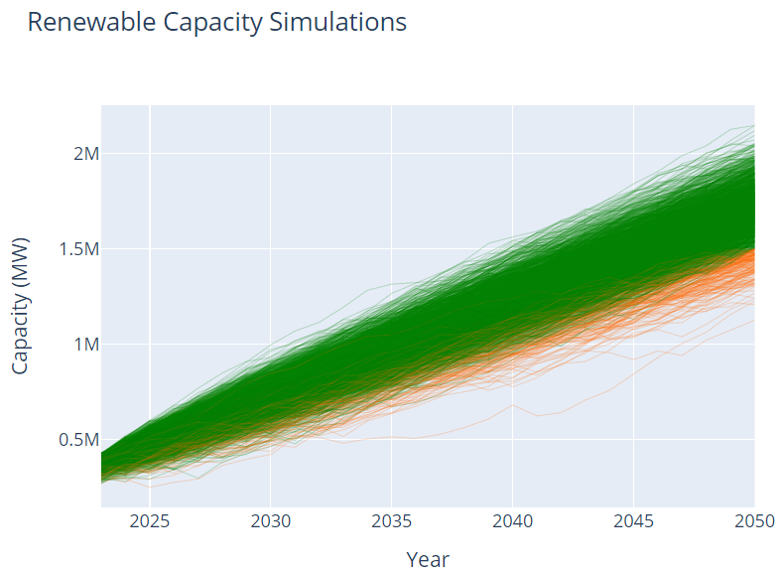
Figure 6: Renewable Capacity Simulation
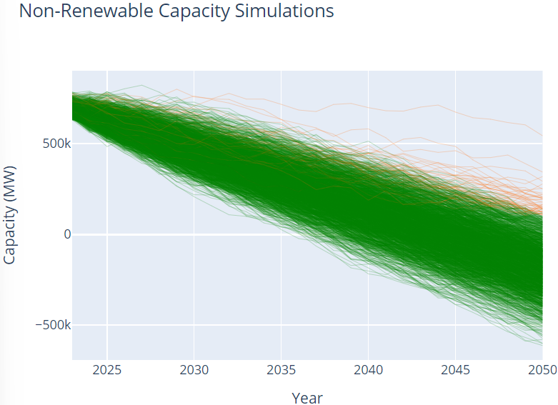
Figure 7: Non-renewable Capacity Simulations
Figure 6 illustrates that renewable capacity is projected to increase significantly over the simulation period, with most scenarios showing a steady rise towards the target of 1,500,000 MW and potentially exceeding it by 2050.
Figure 7 illustrate that non-renewable capacity is projected to decline substantially, reach and potentially falling below the target of 100,000 MW by 2050 in most scenarios.

Final Capacities

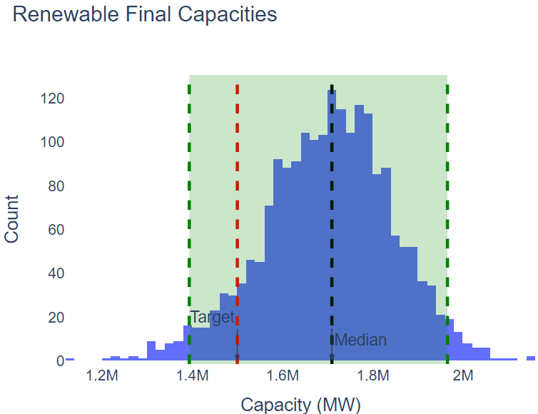
Figure 8: Renewable Final Capacities
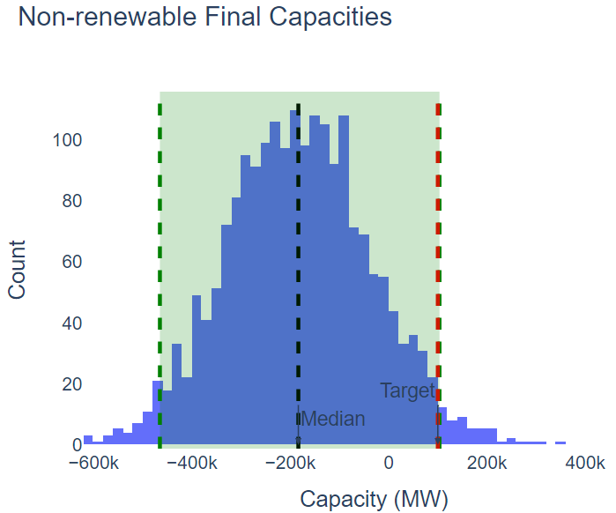
Figure 9: Non-renewable Final Capacities

Figure 8 shows that the distribution of the renewable final capacities is well above the target, indicating that most pathways exceed the 1,500,000 MW renewable capacity target.
Figure 9 shows that the distribution of non-renewable final capacities is skewed below the target, indicating that most pathways fall below the non-renewable target

Capacity Percentiles
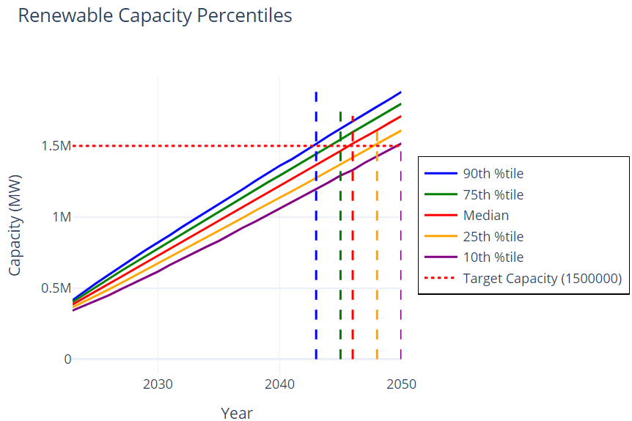
Figure 10: Renewable Capacity Percentiles
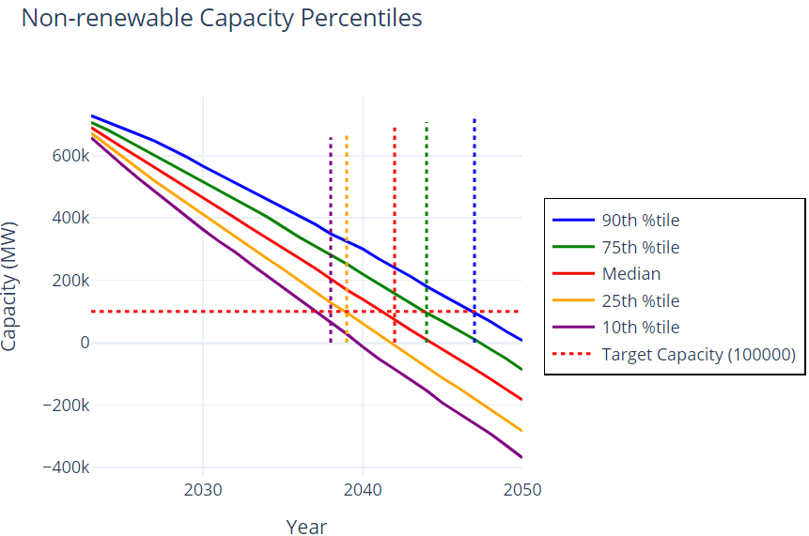
Figure 11: Non-renewable Capacity Percentiles

Figure 10 shows that the goal of deploying 65 GW per year to meet the renewable capacity target is achievable even before 2050, as the goal is met by the 90th percentile in 2043, 75th percentile in 2045, 50th percentile in 2046, 25th percentile in 2048, and 10th percentile in 2050.
Figure 11 shows the goal of meeting non-renewable capacity target is achievable, as the goal is met by the 10th percentile in 2038, 25th percentile in 2039, 50th percentile in 2042, 75th percentile in 2044, 90th percentile in 2047.

The U.S. may run various simulations to explore other pathways. However, let's assume the U.S. decides to start implementing this pathway of deploying 65 GW per year to achieve net-zero emissions by 2050 as the results show it is an achievable goal.

During Project Progression Simulation Inputs
For this simulation, the plan of deploying 65 GW of zero-carbon technologies is underway, and we assume it is now the year 2034. The U.S. is interested in knowing if they are still on track to achieve net-zero by 2050. To run this simulation, actual data of renewable and non-renewable additions and retirements from the year 2023 to the year 2033 needs to be inputted for the simulation to generate projections for the remaining years. As this is just a demonstration, U.S. Energy Information Administration (EIA) additions and retirements from 2023 to 2027 are used as actual data. The remaining years of additions and retirements are generated random numbers.

Year | Renewable Addition | Non-renewable Addition | Renewable Retirement | Non-renewable Retirement
2023 | 32,969 | 7,849 | 203 | 14,739
2024 | 44,661 | 2,624 | 13 | 4,451
2025 | 27,848 | 5,476 | 5 | 14,013
2026 | 15,184 | 4,475 | 4 | 7,909
2027 | 10,481 | 2,191 | 56 | 9,850
2028 | 63,098 | 8601 | 553 | 66,141
2029 | 56,912 | 4735 | 694 | 62,809
2030 | 49,020 | 2208 | 238 | 58,577
2031 | 60,003 | 5855 | 420 | 56,248
2032 | 65,947 | 3993 | 250 | 53,027
2033 | 62,674 | 1000 | 332 | 49,714
Table 4: Assumed U.S. During Project Progression Simulation Inputs

Project Progress Simulation Outputs
After inputting Table 4 data and running the simulation on the platform, the following results are displayed.

Capacity Simulations
In the following figures, the green colour represents simulations that meet the capacity target, and the orange colour represents simulations that do not meet the capacity target.
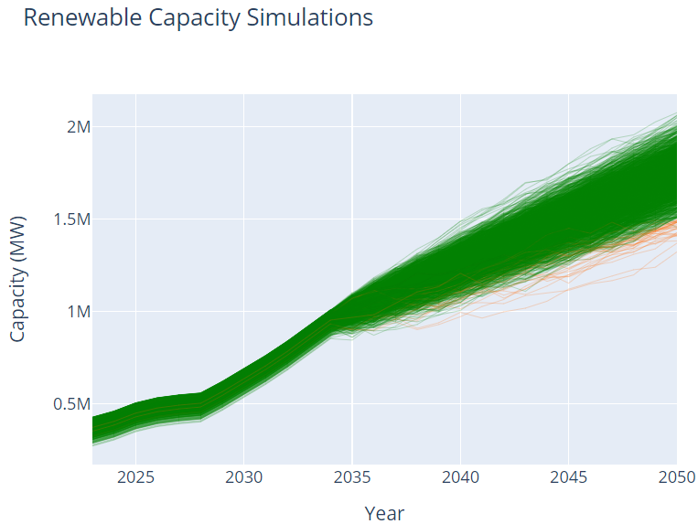
Figure 12: Renewable Capacity Simulations
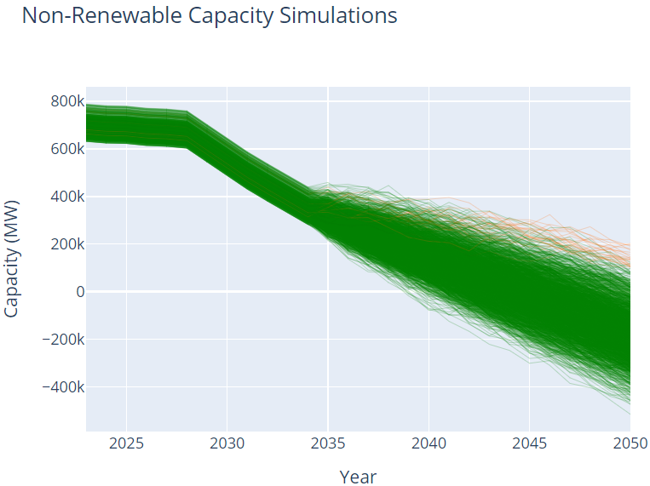
Figure 13: Non-renewable Capacity Simulations

Figure 12 illustrates the projected growth of renewable energy capacity for the remaining years, with most simulations showing a consistent increase towards the 1,500,000 MW target and surpassing it by 2050.
Figure 13 illustrates the significant decline in non-renewable capacity, with most pathways reaching and falling below the target of 100,000 MW by 2050.

Final Capacities
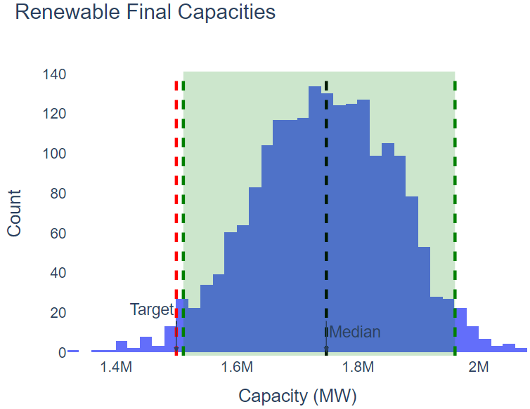
Figure 14: Renewable Final Capacities

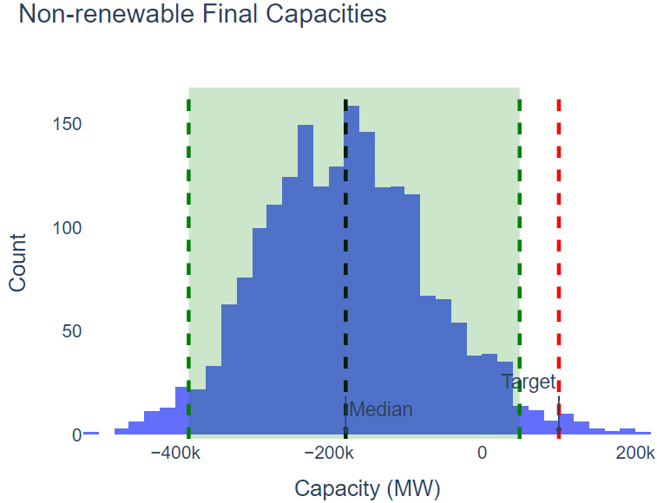
Figure 15: Non-renewable Final Capacities
Figure 14 illustrates that the final renewable capacities are predominantly above the target, suggesting that the majority of pathways in the remaining years comfortably exceed the 1,500,000 MW renewable capacity target.
Figure 15 demonstrates that the distribution of non-renewable final capacities in the remaining years is skewed below the target, indicating that most pathways fall below the non-renewable capacity target.

Capacity Percentiles
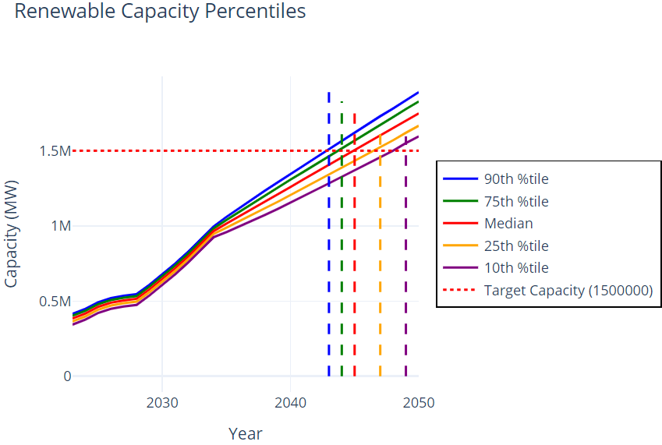
Figure 16: Renewable Capacity Percentiles
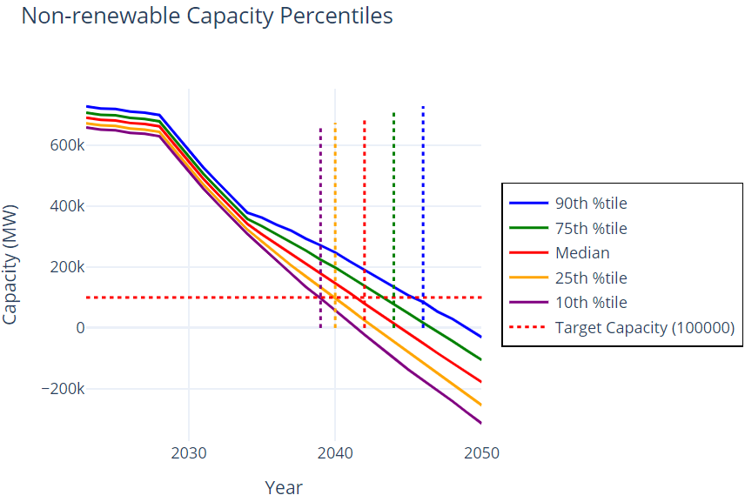
Figure 17: Non-renewable Capacity Percentiles

Figure 16 shows that the goal of adding 65 GW of renewable capacity annually is attainable ahead of 2050. The goal is reached by the 90th percentile in 2044, 75th percentile in 2045, 50th percentile in 2046, 25th percentile in 2048, and 10th percentile in 2050.
Figure 17 indicates that the reduction in non-renewable capacity to meet the target is feasible, with the 10th percentile achieving the goal in 2039, 25th percentile in 2040, 50th percentile in 2042, 75th percentile in 2044, 90th percentile in 2046

Discussion
The simulation results presented in the demonstration provides a useful perspective on the projected capacity trends for renewable and non-renewable energy in the United States based on the assumptions made. However, while the results shows that the U.S. goal to achieving its renewable energy target is largely feasible, there are several limitations and important considerations that suggest the model may be overly optimistic. This is because the model captures current and anticipated trends such as technological advancements and cost reductions by incorporating probabilistic approaches that align with the decreasing costs of renewable energy technologies, the increasing global emphasis on sustainability, and reduced investments in retirements of non-renewable energy infrastructure.
The probability distributions of the model takes into account the factors influencing energy transitions including political, economic, and technological challenges, but not in a sophisticated or highly developed way. Because the model does not take the data from the factors into account but uses probability distributions to determine the outcome of the simulation. The mentioned factors in more detail include, delays in policy implementation, market fluctuations, supply chain disruptions, or public oppositions to new infrastructure projects. Moreover, technological breakthroughs in storage, transmission, and renewable energy generation may accelerate deployment, but their absence or slower-than-expected development could delay capacity additions.
Another limitation is the generality of the model. While the United States is used as a demonstration case, the model is not tailored to specific national or regional contexts. The model does not capture the unique energy dynamics that vary significantly between countries and regions. For instance, the availability of renewable resources, grid infrastructure readiness, regulatory environments, and financial incentives differ widely across states within the U.S. itself, and these regional nuances can significantly affect the pace of energy transition. The same level of generalization would be even less accurate when applied to other countries with different energy mixes, policy environments, and economic capacities.

Advantages
The following are advantages of the platform.

Enhanced Decision-Making
The model facilitates informed decision-making by allowing stakeholders to explore various strategies for renewable energy expansion. By simulating different strategies, stakeholders can identify the most effective approaches for achieving renewable energy capacity target and minimizing reliance on non-renewable sources.
The platform’s ability to visualize complex data through histograms and line plots enhances user’s comprehension. The line plots and histograms have annotations that annotates when the pathways reach the targets, thus improving the overall decision-making process.

Informed Strategy Development
The platform provides a probabilistic view of potential outcomes, offering insights into the variability and uncertainty of energy capacity transitions. This allows stakeholders to understand the range of possible future pathways and develop strategies that are robust under various conditions.

Disadvantages
The following are the disadvantages of the platform.

Computational Intensity
Monte Carlo simulations is computationally intensive, especially when dealing with a large number of simulation or complex models. The performance of SOLARWINDS may be impacted if the computational resources are not adequately scaled to handle extensive simulations, potentially leading to longer processing times and reduced responsiveness.

User Expertise
Effective use of the platform requires users to have a certain level of expertise in energy planning and simulation. The platform provides valuable insights, therefore, stakeholders need to understand how to interpret the results and apply them to their specific contexts.

CONCLUSION
This chapter presents the conclusion by summarizing everything on why the web-based simulation platform was created including stating the problem statement, the research objective, methodology undertaken and the discussion. The chapter also presents the recommendations for the platform.
There is a pressing need to facilitate the transition to renewable energy sources. This transition is crucial to address global climate change and energy security concerns. Hence, the research objective was to develop a web-based simulation platform that employs Monte Carlo simulation to model the transition in energy capacity, offering insights into effective pathways for increasing renewable energy deployment while phasing out non-renewable sources to meet their respective targets over a specified period. However, the model has limitations that may make its outcomes overly optimistic. While it incorporates factors like political, economic, and technological challenges, it does so through generalized probability distributions rather than incorporating detailed, real-world data. This limits its ability to account for delays in policy implementation, market fluctuations, or the pace of technological development. Furthermore, the model is highly generalized and does not capture the unique energy dynamics, infrastructure readiness, or regulatory environments that vary significantly across regions and countries, reducing its accuracy when applied to specific contexts.
In conclusion, the web-based simulation platform represents a significant step forward in planning, and strategizing the transition to renewable energy. Overall, the research process highlights the importance of continuous refinement, and collaboration. By addressing its current limitations and implementing the recommended enhancements, future research can enhance the accuracy and the reliability of the model.

Recommendations
In the process of developing the web application and considering its implications for renewable and non-renewable energy capacity projections, several key insights and recommendations for future research and practical applications emerge.

Advanced Computational Techniques
Implementing advanced computational techniques to help mitigate the computational demand of Monte Carlo simulation so that the technologies can speed up the simulation process and allow for handling larger datasets more efficiently.

Incorporation of Advanced Modelling Techniques
Incorporating advanced modelling techniques can significantly improve the accuracy of simulations by better capturing the complex patterns of energy systems. This enhancement provides more realistic and reliable predictions, thereby increasing the platform's overall utility. To achieve this, refining the underlying Monte Carlo simulation model is essential. Future research should focus on integrating advanced modelling techniques to enhance predictive capabilities, utilizing complex relationships for more accurate energy capacity projections.

Experts Engagement & Validation
Engaging experts in the validation and refinement process is critical in practical applications, as their input provides valuable perspectives on model assumptions that ensures the relevance and credibility of projections. Collaboration with experts from diverse fields, including energy economics, policy analysis, and environmental science, enriches the modelling process and leads to more holistic and robust energy capacity projections.

Model Continuous Updates
Adopting an approach to model development and refinement is essential for practical applications. Regular updates on the model based on advancements in modelling techniques can enhance the utility and accuracy of the model.

User-friendly Interface Enhancements
Enhancing the user interface to be more intuitive and user-friendly, along with providing detailed tutorials, help sections, and interactive guides, can significantly improve user engagement and satisfaction. Additionally, enabling users to adjust various parameters and immediately see the impact on simulation outcomes, would facilitate more precise planning and risk assessment, offering deeper insights.

REFERENCES
Carlson, J. L. (2013). Redis in Action. Manning Publications. https://pepa.holla.cz/wp-content/uploads/2016/08/Redis-in-Action.pdf
Devore, J. L. (2015). Probability and statistics for engineering and the sciences (9th ed.). Cengage Learning.
Dincer, Ibrahim (2000). Renewable energy and sustainable development: a crucial review. Renewable & Sustainable Energy Reviews, 4(2), 157–175. https://doi.org/10.1016/s1364-0321(99)00011-8
Frost, J. Exponential Distribution: Uses, Parameters & Examples. https://statisticsbyjim.com/probability/exponential-distribution/#:~:text=The%20exponential%20distribution%20is%20a,decline%20as%20data%20values%20increase.
Frost, J. Independent and Dependent Variables: Differences & Examples. https://statisticsbyjim.com/regression/independent-dependent-variables/
Grinberg, M. (2018). Flask Web Development: Developing Web Applications with Python. O'Reilly Media. https://coddyschool.com/upload/Flask_Web_Development_Developing.pdf
Harrison, R. L. (2010). Introduction to Monte Carlo Simulation. AIP Conference Proceedings. https://doi.org/10.1063/1.3295638
How to build and visualise a Monte Carlo simulation with Python and Plotly. (2023, January 6) Shedload of Code. https://www.shedloadofcode.com/blog/how-to-build-and-visualise-a-monte-carlo-simulation-with-python-and-plotly
Kang, D. S., M. F. K. Pasha, & Lansey, K. (2009). Approximate methods for uncertainty analysis of water distribution systems. Urban Water Journal, 6(3), 233-249. https://doi.org/10.1080/15730620802566844
Kocak, E., Ulug, E. E., & Oralhan, B. (2023). The impact of electricity from renewable and non-renewable sources on energy poverty and greenhouse gas emissions (GHGs): Empirical evidence and policy implications. Energy, 272, 127125–127125. https://doi.org/10.1016/j.energy.2023.127125
McKinney, W. (2010). Data Structures for Statistical Computing in Python. Proceedings of the 9th Python in Science Conference. https://www.researchgate.net/publication/340177686_Data_Structures_for_Statistical_Computing_in_Python
Meyer, E. A. (2007). CSS: The Definitive Guide. O'Reilly Media. https://www.oreilly.com/library/view/css-the-definitive/9781098117603/
Microsoft. (2015). Visual Studio Code. Microsoft. https://code.visualstudio.com/
‌Moriarty, P., & Honnery, D. (2012). What is the global potential for renewable energy? Renewable & Sustainable Energy Reviews, 16(1), 244–252. https://doi.org/10.1016/j.rser.2011.07.151
New Energy Outlook 2024 | BloombergNEF | Bloomberg Finance LP. (2024). BloombergNEF. https://about.bnef.com/new-energy-outlook/
Okutan, P. (2024, July 2). Exploring Uncertainty with Monte Carlo and Agent-Based Models. https://medium.com/@pelinokutan/exploring-uncertainty-with-monte-carlo-and-agent-based-models-72cfe78ca763
Oliphant, T. E. (2006). A guide to NumPy. Trelgol Publishing. https://web.mit.edu/dvp/Public/numpybook.pdf
OpenStax. (2023). 5.3: The Uniform Distribution. LibreTexts. https://stats.libretexts.org/Courses/Los_Angeles_City_College/Introductory_Statistics/05%3A_Continuous_Random_Variables/5.03%3A_The_Uniform_Distribution
Panwar, N.L., Kaushik, S. C., & Kothari, S. (2011). Role of renewable energy sources in environmental protection: A review. Renewable & Sustainable Energy Reviews, 15(3), 1513–1524. https://doi.org/10.1016/j.rser.2010.11.037
Phadke, A., Paliwal, U., Abhyankar, N., McNair, T., Paulos, B., Wooley, D., O’Connell, R., (2020). PLUMMETING SOLAR, WIND, AND BATTERY COSTS CAN ACCELERATE OUR CLEAN ELECTRICITY FUTURE. https://www.2035report.com/wp-content/uploads/2020/06/2035-Report.pdf?hsCtaTracking=8a85e9ea-4ed3-4ec0-b4c6-906934306ddb%7Cc68c2ac2-1db0-4d1c-82a1-65ef4daaf6c1
Plotly Technologies Inc. (2015). Plotly for Python. Plotly Technologies Inc. https://plotly.com/python/
Redis as a session store. Redis. https://redis.io/docs/manual/session
‌Renewable energy explained - U.S. Energy Information Administration (EIA). (2023). Eia.gov. https://www.eia.gov/energyexplained/renewable-sources/
Renewable Energy Finance: Green Bonds. (2021). International Renewable Energy Agency (IRENA).
Renewable Energy Market – North America, Europe, EMEA, APAC: US, Canada, China, Germany, UK – Forecast 2023-2027. (2023, February). Technavio. https://www.technavio.com/report/renewable-energy-market-industry-analysis.
Renewable Power Generation Costs in 2019. (2020, June 2). Irena.org. https://www.irena.org/publications/2020/Jun/Renewable-Power-Costs-in-2019 ‌
Taylor, M. Al-Zoghoul, S. Ralon, Pablo. (2023, August 29). Renewable Power Generation Costs in 2022. Irena.org. https://www.irena.org/Publications/2023/Aug/Renewable-Power-Generation-Costs-in-2022.
‌United States Department of State and the United States Executive Office of the President. (2021). THE LONG-TERM STRATEGY OF THE UNITED STATES Pathways to Net-Zero Greenhouse Gas Emissions by 2050. https://www.whitehouse.gov/wp-content/uploads/2021/10/US-Long-Term-Strategy.pdf
U.S. Energy Information Administration. (2022). Eia.gov. SAS Output. https://www.eia.gov/electricity/annual/html/epa_04_03.html
U.S. Energy Information Administration. (2022). Eia.gov. SAS Output. https://www.eia.gov/electricity/annual/html/epa_04_06.html
U.S. Energy Information Administration. (2023). Eia.gov. SAS Output. https://www.eia.gov/electricity/annual/html/epa_04_05.html
Van Rossum, G., & Drake, F. L. (2009). Python 3 Reference Manual. CreateSpace. https://dl.acm.org/doi/book/10.5555/1593511
Visual Studio Code. (n.d.) Microsoft. https://code.visualstudio.com/
Wang, X., Jin, W., Qin, M., Su, C.-W., & Umar, M. (2024). Pushing Forward the Deployment of Renewable Energy: Do Cross-National Spillovers of Policy Instruments Matter? Energy, 131643–131643. https://doi.org/10.1016/j.energy.2024.131643
Weisstein, Eric W. Exponential Distribution. From MathWorld—A Wolfram Web Resource. https://mathworld.wolfram.com/ExponentialDistribution.html
Weisstein, Eric W. Uniform Distribution. From Wolfram—A Wolfram Web Resource. https://mathworld.wolfram.com/UniformDistribution.html
‌What is Energy Dependency | IGI Global. (2022). Igi-Global.com. https://www.igi-global.com/dictionary/the-review-of-multi-criteria-decision-making-in-the-renewable-energy-industry-of-turkey/48196
What Is Monte Carlo Simulation? | IBM. (2021, September 23). Ibm.com. https://www.ibm.com/topics/monte-carlo-simulation
What is net zero? | National Grid Group. (2015). Nationalgrid.com. https://www.nationalgrid.com/stories/energy-explained/what-is-net-zero#:~:text=Put%20simply%2C%20net%20zero%20refers,emission%20reduction%20and%20emission%20removal.
What is The Monte Carlo Simulation? - The Monte Carlo Simulation Explained - AWS. (2022). Amazon Web Services, Inc. https://aws.amazon.com/what-is/monte-carlo-simulation/#:~:text=The%20Monte%20Carlo%20simulation%20is,on%20a%20choice%20of%20action.
World Wide Web Consortium (W3C). (2014). HTML5: A vocabulary and associated APIs for HTML and XHTML. W3C. https://html.spec.whatwg.org/multipage/
‌

