# Clinical Code Clustering

Website to automatically detect an optimal number of centroids, process and cluster claim data.

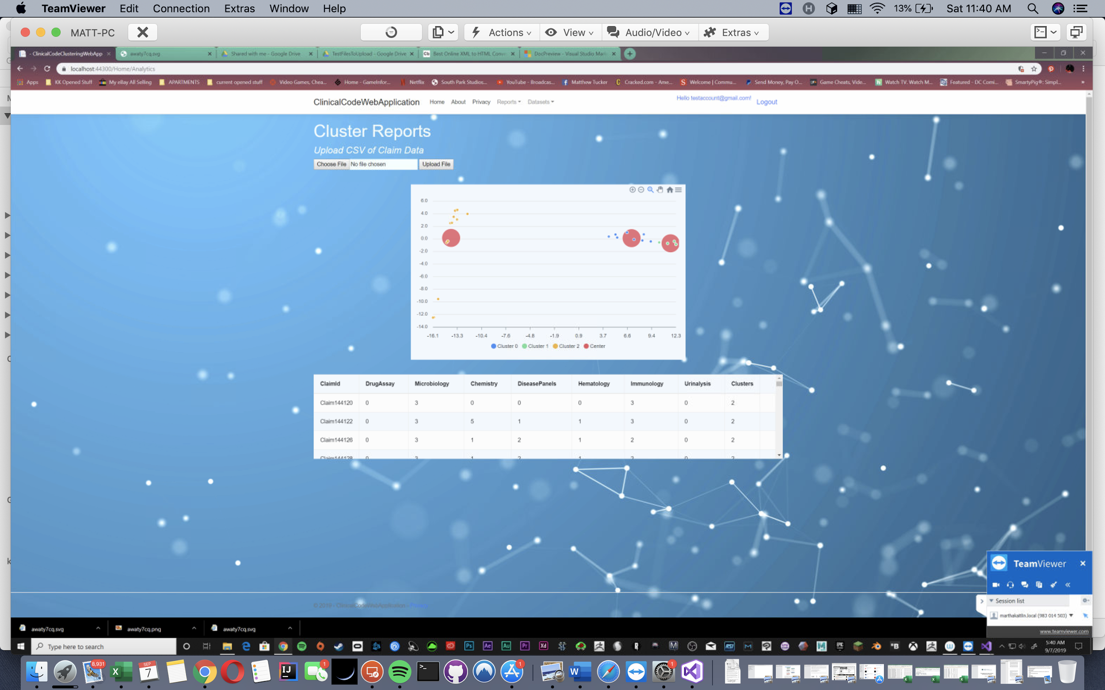

## Development Environment

Visual Studio 2019 .Net Core 2.2

## File Structure

1. Src
   1. Src
      1. ClinicalCodeClusteringWebApp
      2. tests
   2. TestFilesto Upload - use these for website
   3. XML of all documentation - also in about page of the website.
2. Dissertation
   1. Dissertation in pdf form
   2. Participant Ethics Checklist
   3. DeclarationForm
   4. Supporting Documents
      1. 2018 Claims Data from the California Department of Health
      2. Raw Elbow Test Results
      3. Raw Claim Data Results